Supplementary data for
Half-life Extension Enhances Drug Efficacy in Adeno-Associated Virus Delivered Gene Therapy
Huifang Wu ª, Dan Hu ª, Quanxiao Li ª, Chunyu Wang ª, Xiaoyi Zhu ª, Wei Li ^{b}, Binfan Chen a, Ping Ji ª, Keke Huang ª, Ailing Huang ª, Jinghe Huang ª, Dimiter S. Dimitrov ^{b}, Yanling Wu ^{a,c,}*, Tianlei Ying ^{a,c,}*
ª MOE/NHC Key Laboratory of Medical Molecular Virology, Shanghai Institute of Infectious Disease and Biosecurity & School of Basic Medical Sciences, Fudan University, Shanghai 200032, China
^{b} Department of Medicine, University of Pittsburgh, Pittsburgh, PA 15261, USA
^{c}Shanghai Engineering Research Center for Synthetic immunology, Shanghai 200032, China
Fig. S1. Characterization of BsAb and BsAb-sFc. (A) The binding affinity of sFc, BsAb-sFc and BsAb to gp140 and CD16A were measured by Octet-RED. (B) Proteins at a concentration of 0.25 mg·mL^{–1} in PBS (pH 7.4) were analyzed via dynamic light scattering. The three curves that almost overlap with each other in each subfigure represent three separate measurements. (C) Plots of the change in fraction folded (calculated from circular dichroism molar ellipticity at 216 nm) for sFc, BsAb and BsAb-sFc. (D) Proteins were concentrated to 1 mg·mL^{–1} in PBS, followed with incubation at 4 °C or 37 °C for 1, 3, and 7 days respectively, and their stability was tested by SDS-PAGE. (E) Neutralization titers of mD1.22, BsAb, and BsAb-sFc against a panel of 19 pseudovirus subtypes. (F) Flow cytometry analysis of the infection of AAV8-RFP in HepG2 and Huh7 cells. (G) Representative histogram showing the quantification of infection rate of AAV8-RFP virus in HepG2 and Huh7 cells. vg: vector genomes
Fig. S2. Immunofluorescence detection of AAV8-RFP expression. (A) Representative images of the AAV8-RFP virus (red) infected HepG2 and Huh7 cells. DAPI staining was also performed (blue). A merged image of the double staining is presented. (B) Detection of anti-BsAb-sFc antibodies of mouse sera at different times.

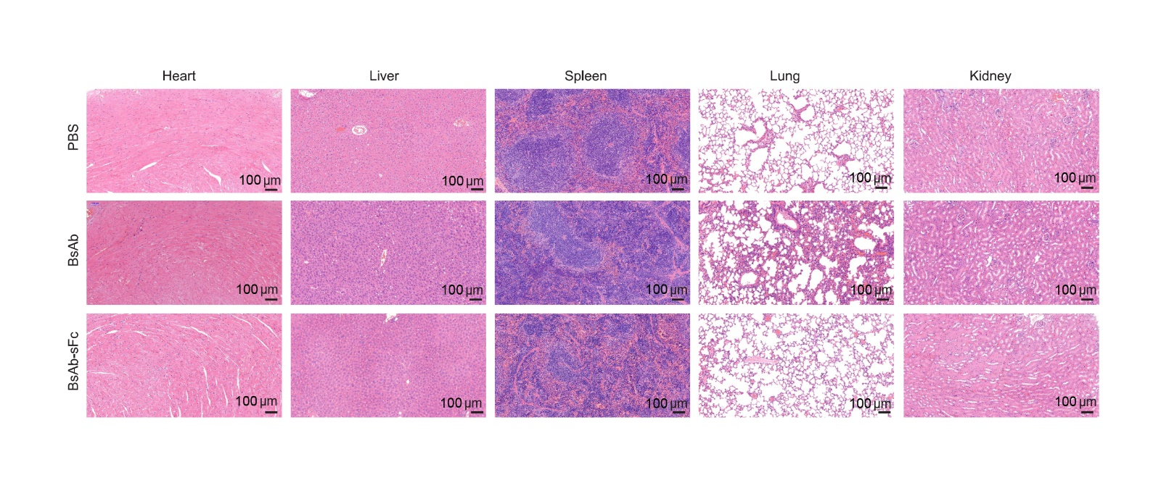
Fig. S3. Representative images of H&E staining. Representative images of the H&E staining of heart, liver, spleen, lung, kidney sections from the animals treated with the highest dose (1 × 10¹³ vg per mouse) of AAV8-BsAb and AAV8-BsAb-sFc virus.

Fig. S4. Representative images of animals and livers. (A) Pharmacokinetics of FGF21 and Fc-FGF21. (B)–(D) The images of mice administered with (B) 1 × 10¹⁰, (C) 1 × 10¹¹, (D) 1 × 10¹² vg per mouse of AAV8-FGF21 or AAV8-Fc-FGF21.

Fig. S5. Characterization of fat in AAV8-FGF21 or AAV8-Fc-FGF21 treated animals. (A)–(C) Micro-CT 3D images of subcutaneous (yellow), visceral (green), and brown adipose tissue (red) distribution. (D)–(F) Quantification of different adipose tissue contented with software. The mice were administered with (A, D) 1 × 10¹⁰, (B, E) 1 × 10¹¹, (C, F) 1 × 10¹² vg per mouse of AAV8-FGF21 or AAV8-Fc-FGF21 virus. In (D)–(F), administered with 1 × 10¹⁰ vg per mouse: AAV8-FGF21 (n = 5), AAV8-Fc-FGF21 (n = 5); administered with 1 × 10¹¹ vg per mouse: AAV8-FGF21 (n = 5), AAV8-Fc-FGF21 (n = 5). Administered with 1 × 10¹² vg per mouse: AAV8-FGF21 (n = 5), AAV8-Fc-FGF21 (n = 5). All values are expressed as mean ± SEM. Data are analyzed by one-way ANOVA with Tukey post hoc correction.

Fig. S6. Bone parameters in mice treated with 1 × 10¹⁰ vg per mouse of AAV8-FGF21 and AAV8-Fc-FGF21. (A) Representative images of the trabecular bone of the tibial. (B)–(D) Quantification of bone trabecular parameters by µCT. (E)–(J) Quantification of bone mass parameters by µCT. Tibial from mice treated with 1 × 10¹⁰ vg per mouse of AAV8-RFP (n = 5), AAV8-FGF21 (n = 5), and AAV8-Fc-FGF21 (n = 5). All values are expressed as mean ± SEM. In (B)–(J) data are analyzed by one-way ANOVA with Tukey post hoc correction. *P < 0.05, **P < 0.01, ***P < 0.001. BMD: bone mineral density; Tb.N: trabecular number; Tb.Th: tissue volume; Tb.Sp: trabecular thickness.

Fig. S7. Bone parameters in mice treated with 1 × 10¹¹ vg per mouse of AAV8-FGF21 and AAV8-Fc-FGF21. (A) Representative images of the trabecular bone of the tibial. (B)–(D) Quantification of bone trabecular parameters by µCT. (E)–(J) Quantification of bone mass parameters by µCT. Tibial from mice treated with 1 × 10¹¹ vg per mouse of AAV8-RFP (n = 5), AAV8-FGF21 (n = 5), and AAV8-Fc-FGF21 (n = 5). All values are expressed as mean ± SEM. In (B)–(J) data are analyzed by one-way ANOVA with Tukey post hoc correction. *P < 0.05, **P < 0.01, ***P < 0.001.

Fig. S8. Bone parameters in mice treated with 1 × 10¹² vg per mouse of AAV8-FGF21 and AAV8-Fc-FGF21. (A) Representative images of the trabecular bone of the tibial. (B)–(D) Quantification of bone trabecular parameters by µCT. (E)–(J) Quantification of bone mass parameters by µCT. Tibial from mice treated with 1 × 10¹² vg per mouse of AAV8-RFP (n = 5), AAV8-FGF21 (n = 5), and AAV8-Fc-FGF21 (n = 5). All values are expressed as mean ± SEM. In (B)– (J), data are analyzed by one-way ANOVA with Tukey post hoc correction. *P < 0.05, **P < 0.01, ***P < 0.001.

Fig. S9. Representative images of animals in the db/db mouse model. (A) Wild-type mice (n = 6) and db/db mice (n = 6) in the control group were injected with the AAV8-RFP virus, and db/db mice in the experimental group were injected with the AAV8-FGF21 (n = 6) or AAV8-Fc-FGF21 (n = 6) virus, and then the body weight was monitored. All the mice were treated with 1 × 10¹¹ vg per mouse of AAV8 virus. (B) Representative images of animals belonging to all experimental groups as in (A). All values are expressed as mean ± SEM. All data are analyzed by one-way ANOVA with Tukey post hoc correction. *P < 0.05, **P < 0.01, ***P < 0.001.

Fig. S10. Characterization of lipid panel and kidney biochemical in db/db mice. (A)–(H) Lipid serum levels of (A) total protein (TP), (B) serum cholinesterase (CHE), (C) albumin protein (ALBP), (D) triglycerides (TRIG), (E) cholesterol (CHOL), (F) low-density lipoprotein cholesterol (LDL), (G) high-density lipoprotein cholesterol (HDL), and (H) low-density lipoprotein cholesterol (LDLP). (I)–(K) Kidney biochemical in serum, (I) uric acid (UA), (J) urea nitrogen (UN), (K) creatine kinase (CK). All serum from db/db mice treated with 1 × 10¹¹ vg per mouse of AAV8-RFP, AAV8-FGF21, and AAV8-Fc-FGF21 virus. All values are expressed as mean ± SEM. All data are analyzed by one-way ANOVA with Tukey post hoc correction. *P < 0.05, **P < 0.01, ***P < 0.001.

Fig. S11. Representative images of livers and the effect of AAV8-FGF21 and AAV8-Fc-FGF21 treatment in the db/db mouse model. (A) Representative images of livers belonging to all experimental groups. (B) Weight of the heart, liver, spleen, lung, and kidney from mice treated with AAV8-RFP, AAV8-FGF21, and AAV8-Fc-FGF21. (C) H&E staining of liver.

Fig. S12. Effects of AAV8-FGF21 or AAV8-Fc-FGF21 on metabolism in the db/db mouse model. (A) O₂ consumption in mice treated with AAV8-RFP, AAV8-FGF21, and AAV8-Fc-FGF21 over 24 hours. Black shading indicated night time. (B) CO₂ production in mice treated with AAV8-RFP, AAV8-FGF21, and AAV8-Fc-FGF21 over 24 hours. (C) respiratory exchange ratio (RER) in mice treated with AAV8-RFP, AAV8-FGF21, and AAV8-Fc-FGF21 over 24 hours. (D) Heat production in mice treated with AAV8-RFP, AAV8-FGF21, and AAV8-Fc-FGF21 over 24 hours. (E) Motion in the XY-plane in mice treated with AAV8-RFP, AAV8-FGF21, and AAV8-Fc-FGF21 over 24 hours. All values are expressed as mean ± SEM. All data are analyzed by one-way ANOVA with Tukey post hoc correction. *P < 0.05, **P < 0.01, ***P < 0.001.

Fig. S13. Representative images of the H&E staining of fat sections obtained from db/db mice. (A) Weight of the white adipocytes tissue depots. (B) H&E staining of BAT. (C) H&E staining of WAT tissue. (D) Immunohistochemistry for the macrophage-specific marker F4/80 in WAT sections from animals. The micrographs illustrated the presence of crown-like structures in the WAT.

Fig. S14. No bone abnormality was observed in AAV8-FGF21 and AAV8-Fc-FGF21 treated animals. (A)–(H) Bone parameters in mice treated with AAV8-FGF21 and AAV8-Fc-FGF21. The μCT analysis of trabecular from db/db mice treated with 1 × 10¹¹ vg per mouse of AAV8-RFP (n = 6), AAV8-FGF21 (n = 6), and AAV8-Fc-FGF21 (n = 6). All values are expressed as mean ± SEM. All data are analyzed by one-way ANOVA with Tukey post hoc correction. *P < 0.05, **P < 0.01, ***P < 0.001.

Fig. S15. Representative images in the DIO mouse model. Mice were administered with 1 × 10¹¹ vg per mouse of AAV8-FGF21 or AAV8-Fc-FGF21.

Fig. S16. Characterization of lipid panel and kidney biochemical in DIO mice. (A) Representative images of livers belonging to all experimental groups of the study in DIO mouse model. (B)–(F) Lipid serum levels of (B) serum adiponectin concentration, (C) serum cholinesterase (CHE), (D) albumin protein (ALBP), (E) total protein (TP), and (F) low-density lipoprotein cholesterol (LDLP). (G)–(I) Kidney biochemical in serum, (G) creatine kinase (CK), (H) urea nitrogen (UN), (I) uric acid (UA). All serum from DIO mice treated with 1 × 10¹¹ vg per mouse of AAV8-RFP (n = 6), AAV8-FGF21 (n = 6), and AAV8-Fc-FGF21 (n = 6). All values are expressed as mean ± SEM. All data are analyzed by one-way ANOVA with Tukey post hoc correction. *P < 0.05, **P < 0.01, ***P < 0.001.
Fig. S17. Representative images of the H&E staining of fat sections obtained from DIO mice. (A) Representative images WAT belonging to all experimental groups of the study in the DIO mouse model. (B) H&E staining of BAT. (C) H&E staining of WAT tissue.

Fig. S18. FGF21 and Fc-FGF21 treatment decreased bone mass in the DIO mouse model. (A)–(H) Bone parameters were observed in AAV8-FGF21 and AAV8-Fc-FGF21 treated animals. The μCT analysis of trabecular from DIO mice treated with 1 × 10¹¹ vg per mouse of AAV8-RFP (n = 6), AAV8-FGF21 (n = 6), and AAV8-Fc-FGF21 (n = 6). All values are expressed as mean ± SEM. All data are analyzed by one-way ANOVA with Tukey post hoc correction. *P < 0.05, **P < 0.01, ***P < 0.001.

