Supplementary data for

One-step Synthesis of Structurally Stable CO₂-Philic Membranes with Ultra-High PEO Loading for Enhanced Carbon Capture
Bin Zhu ª, Shanshan He ª, Yadong Wu ª, Songwei Li ^{b}, Lu Shao ^{a,}*
ª MIIT Key Laboratory of Critical Materials Technology for New Energy Conversion and Storage, State Key Laboratory of Urban Water Resource and Environment, School of Chemistry and Chemical, Harbin Institute of Technology, Harbin 150001, China
^{b} Key Laboratory of Materials Processing and Mold (Zhengzhou University), Ministry of Education, National Engineering Research Center for Advanced Polymer Processing Technology Department of Chemical Engineering, Zhengzhou University, Zhengzhou 450002, China
* Corresponding author.
E-mail address: shaolu@hit.edu.cn (L. Shao)
Keywords: Membrane separation; Gas separation; CO₂ capture; CO₂-philic membrane; Poly (ethylene oxide)

Gas permeation test
Pure gas permeability was tested in the sequence H₂, N₂, CH₄ and CO₂ and conducted by a homemade constant volume/variable pressure method apparatus like our previous work ¹. The feed pressure was maintained at 3.5 bar and the test temperature was at 35 ℃ unless specified. The gas permeability ($P_{i}$, Barrer, 1 Barrer = 10⁻¹⁰ cm³ (STP) cm cm⁻² s⁻¹ cmHg⁻¹) was calculated by the following equation (1):
$P_{i}=\frac{273×{10}^{10}}{760}\frac{Vl}{AT(p_{0}×76/14.7)}\frac{dp}{dt}$ (1)
where $V$ is the volume of the downstream chamber (cm³), $l$ is the membrane thickness (cm) obtained by a micrometer calipers, and each membrane was measured nine times and averaged, $A$ is the effective membrane area (cm²), $T$ and $p_{0}$ refer to the operating temperature (K) and pressure (psi), and $dp/dt$ means the increase rate of downstream-pressure.
Diffusion (D) and solubility (S) coefficients can be obtained by the time-lag method according to equation (2) and (3):
$D=\frac{l^{2}}{6θ}$ (2)
$P=D×S$ (3)
where $θ$ is the diffusion time lag. The unit of D and S is cm² s⁻¹ and cm³ (STP) cm⁻³ cmHg⁻¹ respectively.
The gas selectivity ($α$)can be calculated by the ratio of gas permeability as shown in equation (4):
$α=\frac{P_{A}}{P_{B}}=\frac{D_{A}}{D_{B}}×\frac{S_{A}}{S_{B}}$ (4)
Calculation of crystalline degree
The degree of crystallinity was calculated from the following equations
$$χ_{C}=\frac{{ΔH}_{m}}{{ΔH}_{m}^{0}}$$
where ${ΔH}_{m}$ are the apparent melting enthalpy by integrating the areas under the corresponding melting peaks, and ${ΔH}_{m}^{0}$ is the heat of melting per gram of 100% crystalline polymer. The ${ΔH}_{m}^{0}$ of PEO and PA6 are 166.4 J/g and 230.0 J/g, respectively.²
Figure S1. Area swelling of PMEA and SPM membranes after soaking in water for 72 h.
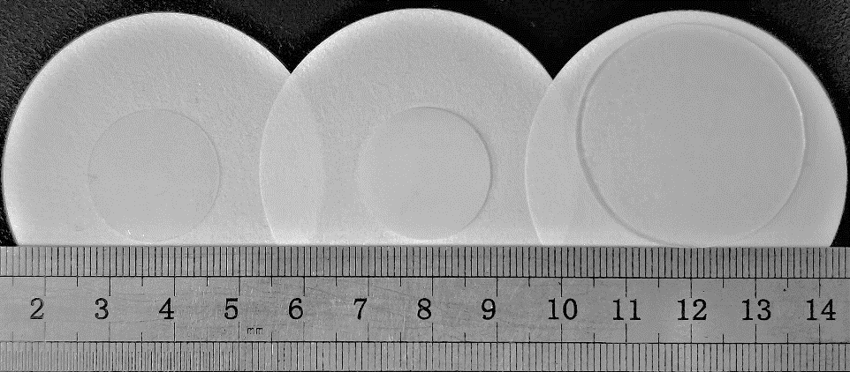
Figure S2. Digital picture of swollen membranes in water for 72 h. (The initial diameter of dry films is 2 cm)
Pebax
PMEA-70
SPM-90
As shown in Figure S1 and S2, PMEA membranes have exhibited similar area swelling with neat Pebax membrane indicating the free PEGMEA failed to cause a structural shift at swelling state. On the contrary, the SPM membranes has shown a totally different property due to the self-polymerization structure which enables SPM-90 with a potent swelling capability up to 41 times greater than that of pure Pebax membrane. Combined with the Figure 1a and 1b, it can be concluded that SPM membrane has a superiorly structural stability compared with unreacted PMEA membranes.Figure S3. Stress-strain curves of Pebax, PMEA, and SPM membranes.
It is obvious that the embedment of PEGMEA deteriorates the mechanical strength of Pebax matrix due to the plasticization effect, but the self-polymerization process multiplies inter-chain interactions so that the maximal loading of PEGMEA in SPM membrane can reach 90 wt.%. What’s more, the increased dynamic entanglements provide the structure with firm interlocking to reinforce the polymer chains and keep the membrane from breakup. In other word, the SPM has shown better mechanical stability than traditional low-molecular weight PEO composite material which allows the membranes to meet wider industrial applications.
Figure S4. XPS curves of Pebax and SPM-90 membranes.

Figure S5. FT-IR curves of Pebax and SPM-90 membranes.

Figure S6. TGA and DTG curves of SPM and PMEA membranes. a, b) SPM membranes, c, d) PMEA membranes
The thermal stability of SPM and PMEA membrane was obtained by TGA analysis in Figure S6. Notably, the weight loss before 150 °C is as a result of absorbed moisture. Besides, both SPM and PMEA membranes have shown a similar thermal property due to the analogous chemical structure, and there is a one-step weight loss profile and the pyrolysis takes place between 350 °C and 450 °C.
Figure S7. WAXD curves of SPM membranes.
The crystallinity of SPM membranes was studied by the WAXD in Figure S7. It is obvious that there are two distinct peaks in the WAXD curve of Pebax membrane at 2θ = 21 ° and 24 °, which are corresponding to the amorphous domain of soft PEO phase and crystalline domain of hard PA6 phase ³. As the content of PEGMEA increased, the intensity of PA6 peak gradually decreased and the broad peak get sharper. This suggests that the poly-PEGMEA destroys the microstructure of Pebax membranes, leading to reduced crystallinity and increased amorphous domain in the SPM membrane, which is in perfect accord with the above DSC result.Figure S8. The effect of feed pressure on the N₂ permeability of PMEA-70 and SPM-90.

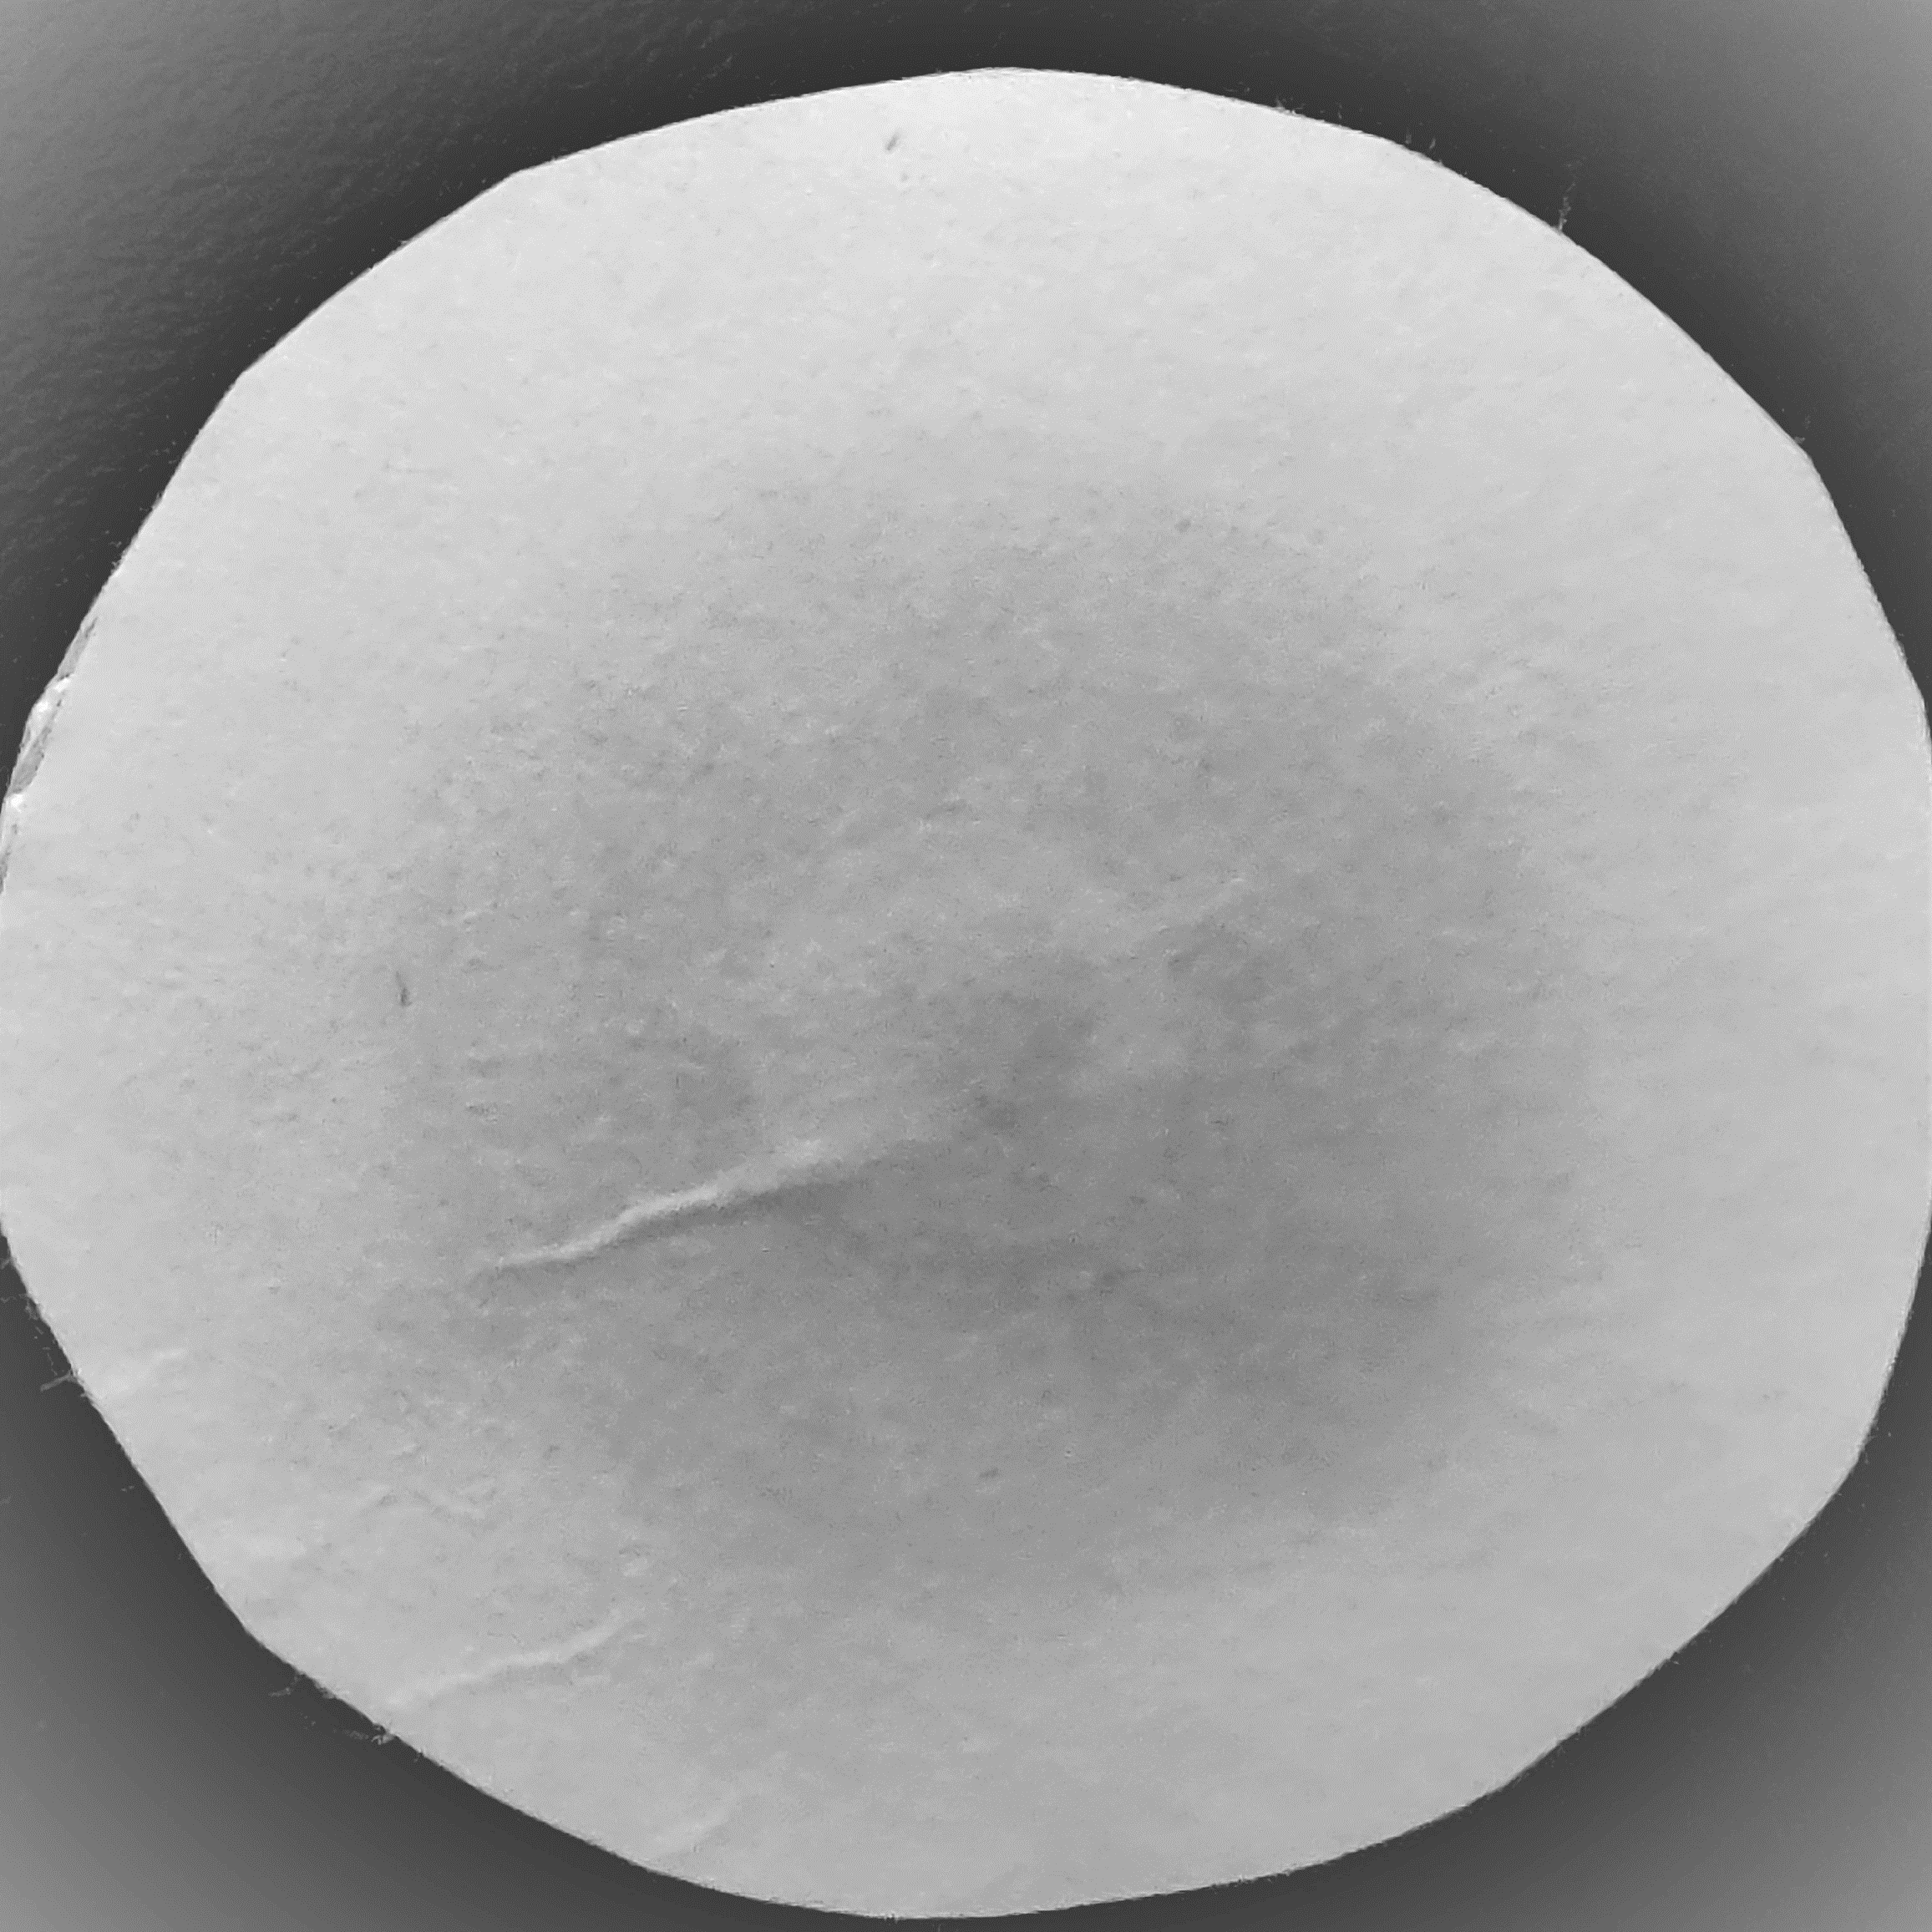
Leaching out effect
PMEA-70
SPM-90
Figure S9. Digital pictures of SPM-90 and PMEA-70 membranes after pressure test.
Figure S10. Gas permeability and selectivity of SPM-90 membrane compared with neat Pebax membrane as a function of operating temperature at 3.5 bar.

Table S1 Surface element content from the XPS result.
Sample | C 1s (at.%) | N 1s (at.%) | O 1s (at.%)
Pebax  SPM-90 | 73.32  71.53 | 5.77  0.76 | 20.91  27.71

Table S2 Gas diffusivity and solubility coefficients in Pebax and SPM membranes
Sample | D(CO₂)ª | S(CO₂)^{b} | D(N₂)ª | S(N₂)^{b} | D(CH₄)ª | S(CH₄)^{b}
Pebax | 0.84 | 1.19 | 1.15 | 0.020 | 0.60 | 0.11
SPM-10 | 0.93 | 1.39 | 1.23 | 0.022 | 0.70 | 0.12
SPM-30 | 1.51 | 1.89 | 2.27 | 0.027 | 1.39 | 0.14
SPM-50 | 1.65 | 2.30 | 2.57 | 0.032 | 1.59 | 0.16
SPM-70 | 1.82 | 2.60 | 2.90 | 0.036 | 1.98 | 0.16
SPM-90 | 2.32 | 2.90 | 3.67 | 0.039 | 2.76 | 0.18
ª Diffusivity coefficient [cm²/s]×10⁶
^{b} Solubility coefficient [cm³ (STP)/cm³ cmHg]×10².

Table S3 Activation energy E_{P} (kJ/mol) of gas permeability in Pebax and SPM-90 membranes.
Sample | E_{p} (kJ/mol) |  | R²
Sample | CO₂ | N₂ | CO₂ | N₂
Pebax  SPM-90 | 7.1  4.3 | 16.4  15.1 | 0.9834  0.9912 | 0.9849  0.9772

REFERENCE

1. Jiang, X.; Li, S.; He, S.; Bai, Y.; Shao, L., Interface manipulation of CO₂–philic composite membranes containing designed UiO-66 derivatives towards highly efficient CO₂ capture. J. Mater. Chem. A 2018, 6, (31), 15064-15073.
2. Kim, N. U.; Park, B. J.; Park, M. S.; Park, J. T.; Kim, J. H., Semi-interpenetrating polymer network membranes based on a self-crosslinkable comb copolymer for CO₂ capture. Chem. Eng. J. 2019, 360, 1468-1476.
3. Thankamony, R. L.; Li, X.; Das, S. K.; Ostwal, M. M.; Lai, Z., Porous covalent triazine piperazine polymer (CTPP)/PEBAX mixed matrix membranes for CO₂/N₂ and CO₂/CH₄ separations. J. Membr. Sci. 2019, 591, 117348.

