Supplementary data for
Multi-omics analysis provides insight into the possible molecular mechanism of hay fever based on gut microbiota
Pei Han^{a#}, Li-Sha Li^{b#}, Zi-Xi Wang^{b#}, Lin Xi^{c#}, Hang Yuª, Lin Congª, Zheng-Wei Zhangª, Jie Fuª, Ran Pengª, Li-Bin Panª, Shu-Rong Maª, Xue-Yan Wang^{d}, Hong-Tian Wang^{d}, Xiang-Dong Wang^{e}*, Yan Wangª*, Jin-Lyu Sun^{b}*, Jian-Dong Jiangª*
ª State Key Laboratory of Bioactive Substance and Function of Natural Medicines, Institute of Materia Medica, Chinese Academy of Medical Sciences & Peking Union Medical College, Beijing 100050, China
^{b} Department of Allergy, National Clinical Research Center for Dematologic and Immunologic Diseases, Beijing Key Laboratory of Precision Medicine for Diagnosis and Treatment on Allergic Diseases, Peking Union Medical College Hospital, Chinese Academy of Medical Sciences & Peking Union Medical College, Beijing 100730, China
^{c} Department of Allergy & Department of Otorhinolaryngology Head and Neck Surgery & Key Laboratory of Otolaryngology Head and Neck Surgery, Ministry of Education, Beijing Tongren Hospital, Capital Medical University, Beijing 100005, China
^{d} Department of Allergy, Beijing Shijitan Hospital, Capital Medical University, Beijing 100038, China
^{e} Beijing Key Laboratory of Nasal diseases, Beijing Institute of Otolaryngology, Beijing Tongren Hospital, Capital Medical University, Beijing 100005, China

Supplementary method
300 µL of methanol containing 10 μg·mL^{–1} of succinic-d₄ acid as internal standard was added to 100 µL plasma or fecal water for protein precipitation. After centrifuging for 10 min at 2450 rpm at 4 °C, 100 µL of supernatant was transferred to a new vial. Then all the samples were dried down under a stream of N₂. Subsequently, 50 µL of O-methoxyamine-hydrochloric acid (MOX) in pyridine (20 mg·mL^{–1}; Sigma Aldrich, USA) was added to the residue and kept at 70 °C for 30 min. Samples were then dried down again and reconstituted in a 1:1 (v/v) solution of acetonitrile and the derivatizing agent N,O-bis(trimethylsilyl)trifluoroacetamide with 1% trimethylchlorosilane; Sigma Aldrich, USA). The derivatization process was operated at 70 °C for 1 h. Samples were centrifuged again and pipetted to new high performance liquid chromatography (HPLC) vials with inserts.
1 μL of sample was injected in the split mode with a split ratio of 1:60. The initial oven temperature was maintained at 60 °C for 5 min, and then raised to 300 °C at a rate of 10 °C·min^{–1}，holding for 5 min. The temperatures for injection, ion source and interface were set at 280, 200, and 300°C, respectively. Mass data were collected in SCAN mode (m/z = 50–600 Dalton) with an event time 0.2 s. Quality control (QC) samples made from pooled corresponding samples were injected periodically.

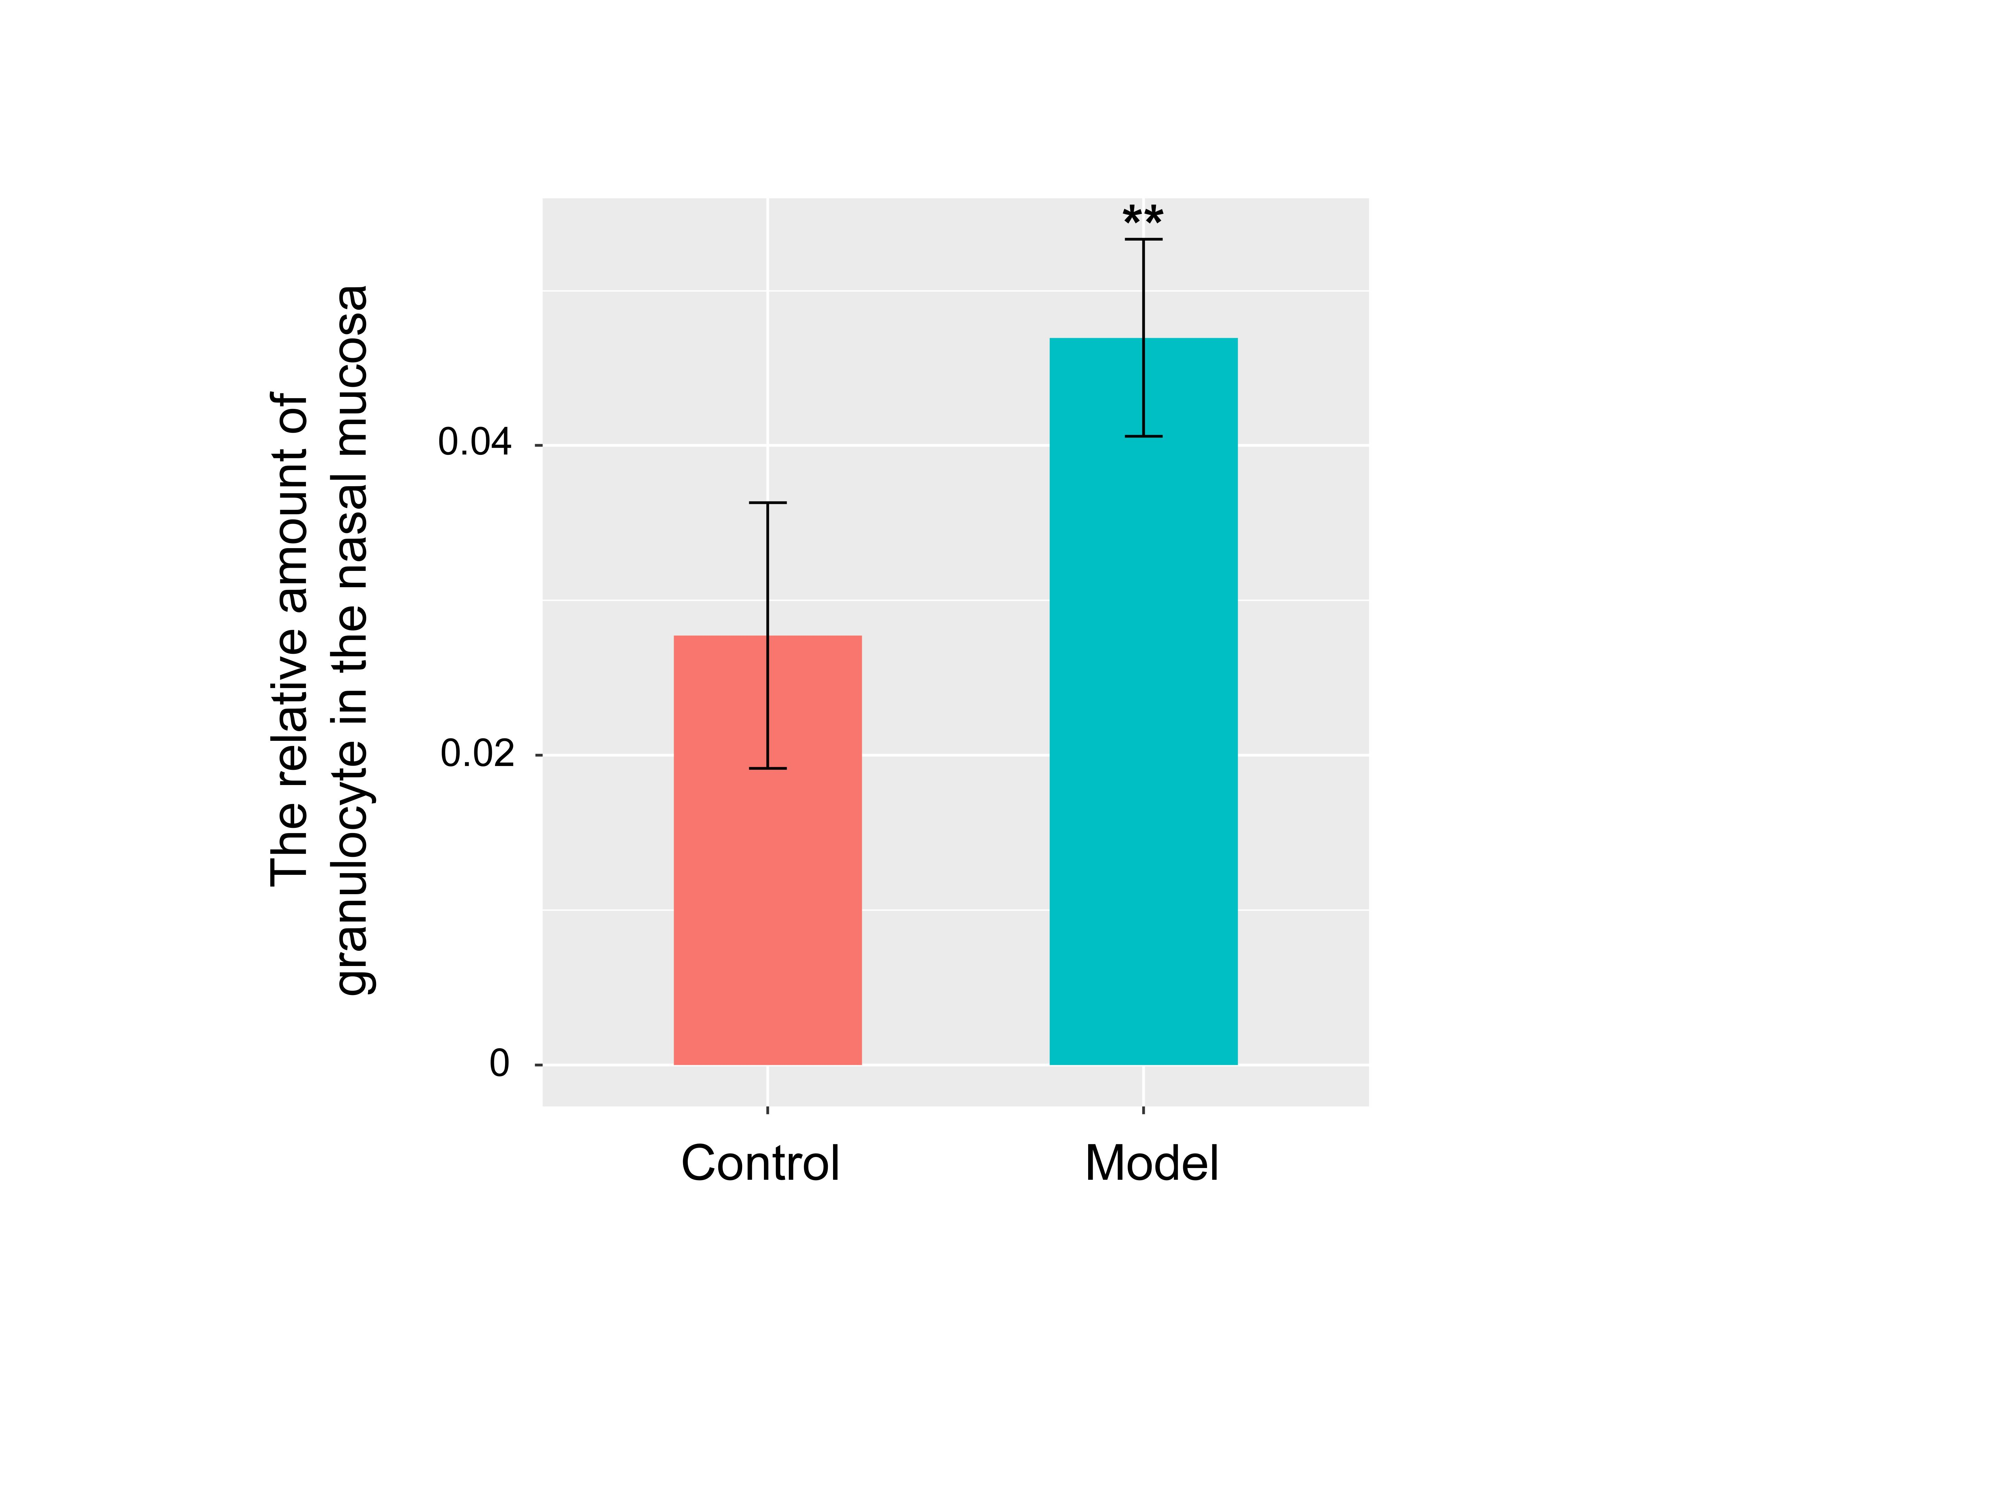
Fig. S1. The relative amount of granulocyte in the nasal mucosa between control and model group.

