Supplementary data for

A Double-Layer Polysaccharide Hydrogel (DPH) for the Enhanced Intestine-Targeted Oral Delivery of Probiotics
Wen-Can Huang ^{a,c}, Wenjie Wang ^{a,c}, Wei Wang ^{a,c}, Yanan Hao ^{a,c}, Changhu Xue ^{a,b,}*, Xiangzhao Mao ^{a,b,c,}*
ª Qingdao Key Laboratory of Food Biotechnology, College of Food Science and Engineering, Ocean University of China, Qingdao, China
^{b} Laboratory for Marine Drugs and Bioproducts of Qingdao National Laboratory for Marine Science and Technology, Qingdao, China
^{c} Key Laboratory of Biological Processing of Aquatic Products, China National Light Industry, Qingdao, China

* Corresponding author.
E-mail address: XXX@XXX (C. Xue), XXX@XXX (X. Mao)

S1 Materials
The chloroacetic acid, ethanol, sodium hydroxide, hydrogen chloride, carboxymethyl cellulose, isopropanol, sodium periodate, hydrochloric acid, potassium bromide, ethylene glycol, and dimethyl sulfoxide (DMSO) were purchased from Sinopharm Chemical Reagent Co., Ltd., China. Chitosan, trypsin, pepsin, and sodium alginate were purchased from Macklin Biochemical Co., Ltd., China. MRS Agar and PBS were purchased from Solarbio Science & Technology Co., Ltd., China. Propidium iodide, propionic acid, butyric acid, and valeric acid were purchased Sigma-Aldrich Inc., USA.
S2 Determination of SCFA content
SCFA concentrations in the intestine were detected using gas chromatography–mass spectrometry (Shimadzu, QP2010-Ultra). In brief, the collected feces were diluted with deionized water, followed by vortexing, sonication, and centrifugation. Then, the supernatants were filtered for analysis.
S3 Results
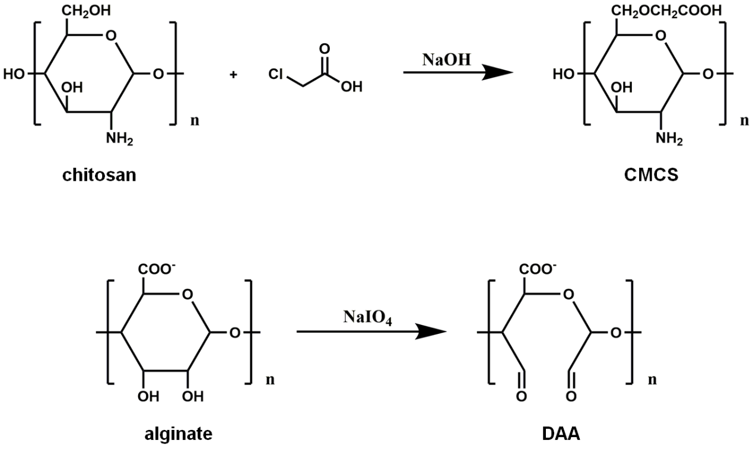
Fig. S1. Preparation of CMCS and DAA.
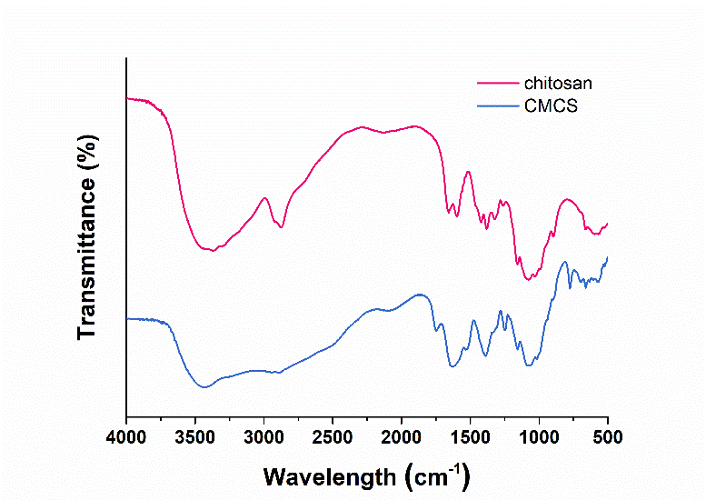
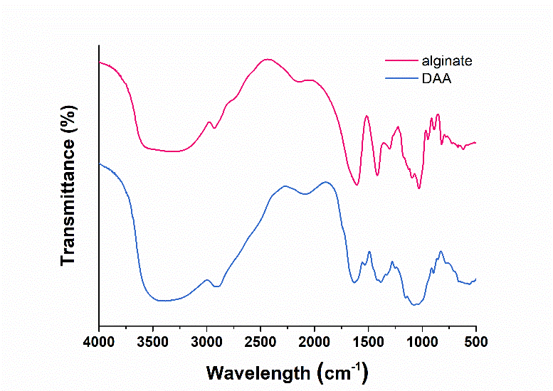
Fig. S2. FT-IR spectrum of chitosan, CMCS, alginate, and DAA.
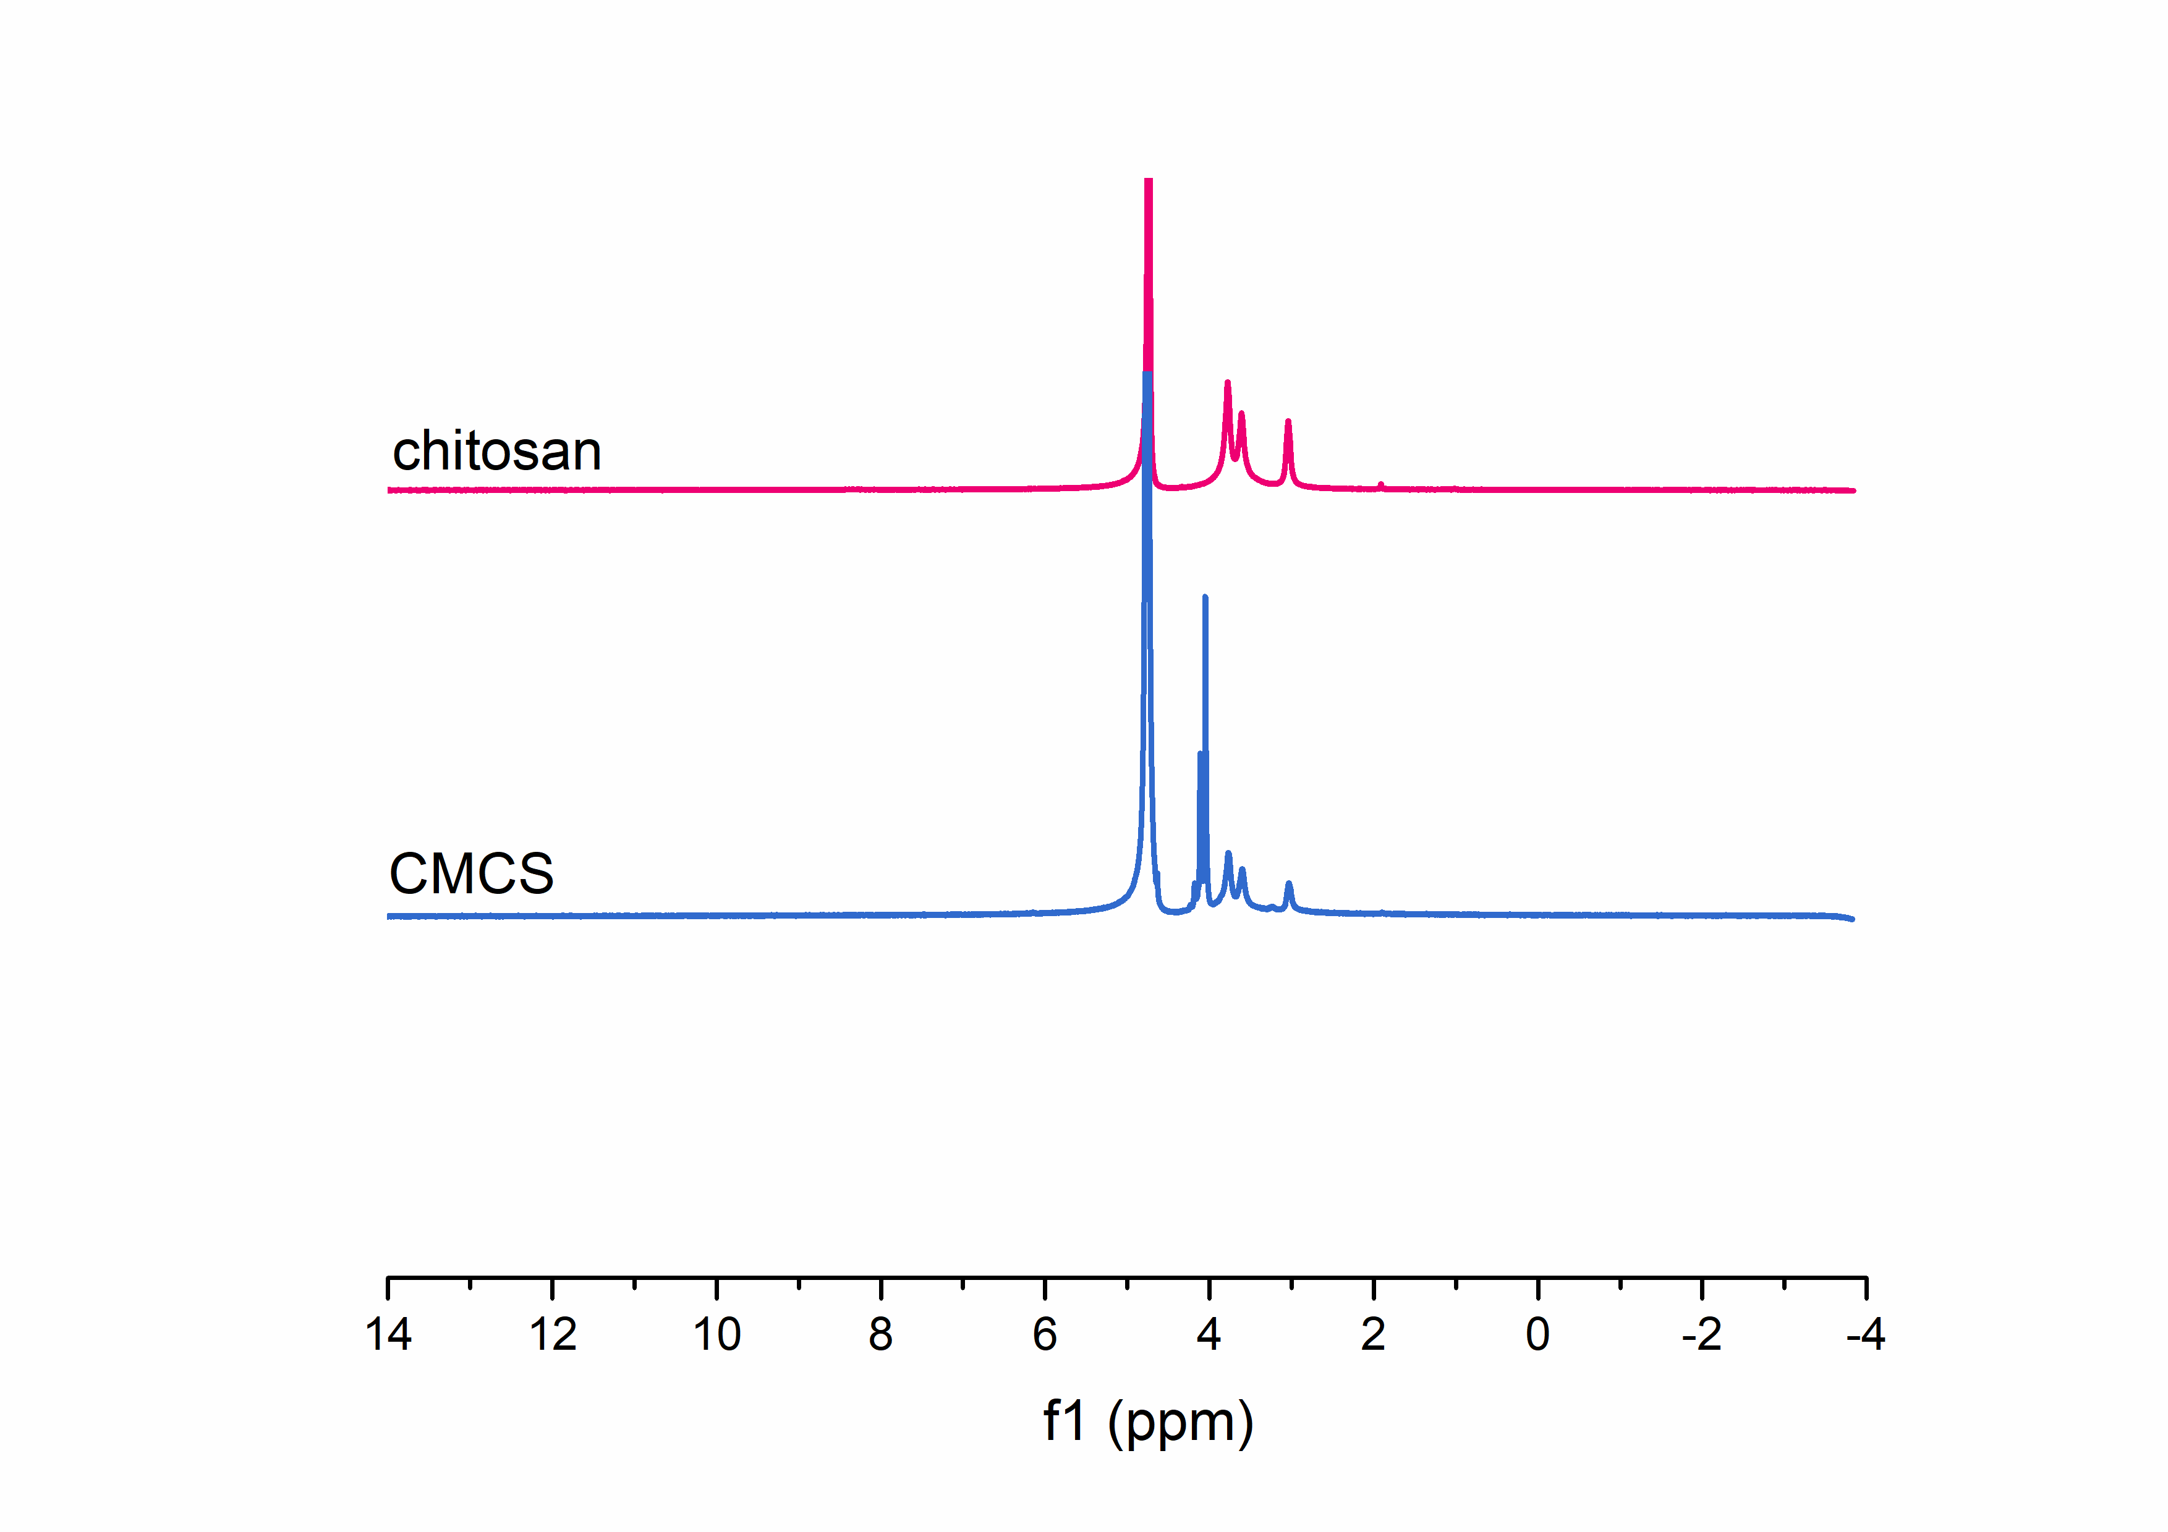
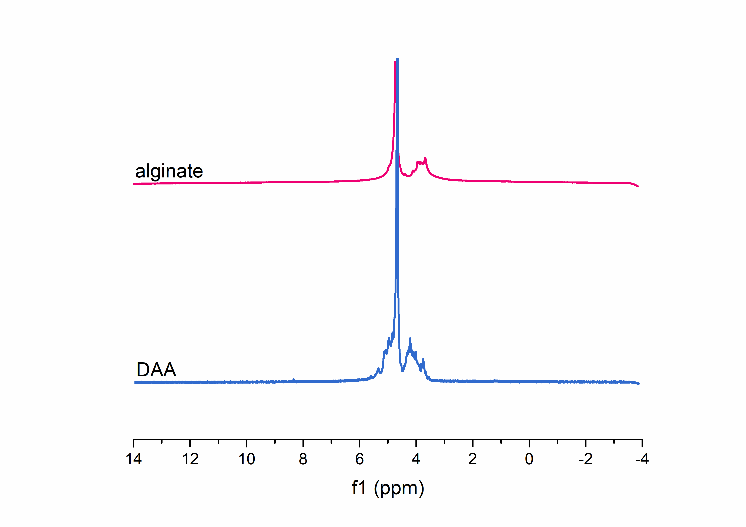
Fig. S3. ¹H-NMR spectra of chitosan, CMCS, alginate, and DAA.
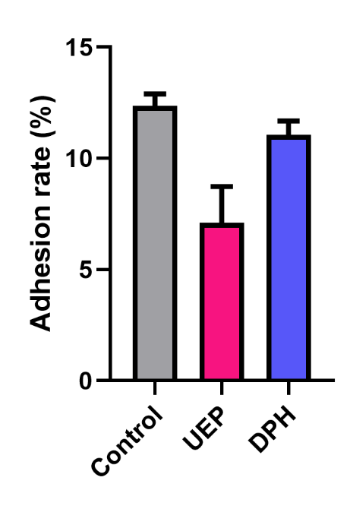
Fig. S4. Adhesion of the probiotics to the Caco-2 cells.
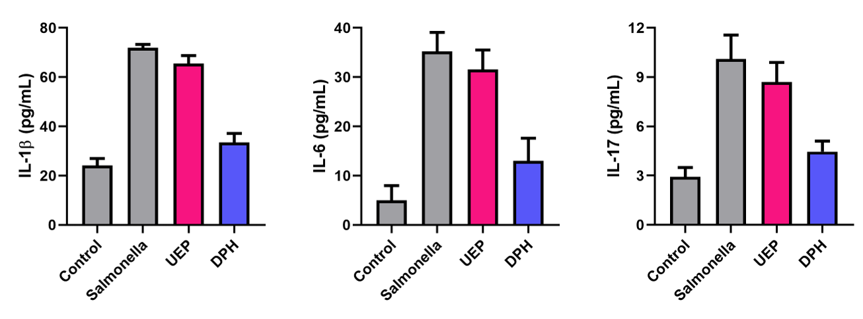
Fig. S5. Levels of proinflammatory cytokines.
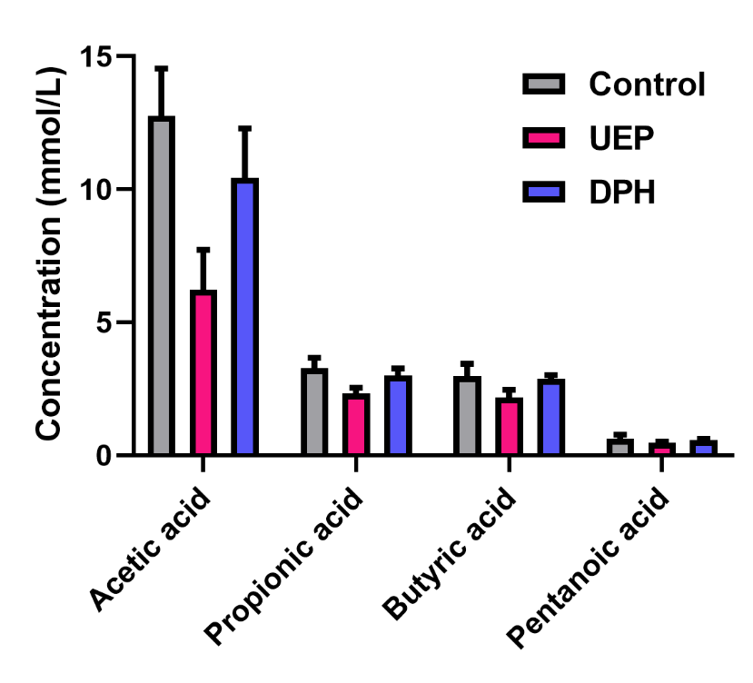
Fig. S6. Production of SCFAs in the intestines.

