Supplementary data for

Remodeling Isoprene Pyrophosphate Metabolism for Promoting Terpenoids Bioproduction
Xianhao Xu ^{a,b}, Xueqin Lv ^{a,b}, Shixiu Cui ^{a,b}, Yanfeng Liu ^{a,b}, Hongzhi Xia ^{c}, Jianghua Li ^{a,b}, Guocheng Du ^{a,b}, Zhaofeng Li ^{d}, Rodrigo Ledesma-Amaro ^{e}, Jian Chen ^{b,}*, Long Liu ^{a,b,}*
ª Key Laboratory of Carbohydrate Chemistry and Biotechnology, Ministry of Education, Jiangnan University, Wuxi 214122, China
^{b} Science Center for Future Foods, Ministry of Education, Jiangnan University, Wuxi 214122, China
^{c} Richen Bioengineering Co., Ltd., Nantong, 226000, China
^{d} State Key Laboratory of Food Science and Technology, Jiangnan University, Wuxi 214122, China
^{e} Department of Bioengineering and Centre for Synthetic Biology, Imperial College London, London SW7 2AZ, UK

Corresponding authors.
E-mail: jchen@jiangnan.edu.cn (J. Chen), longliu@jiangnan.edu.cn (L. Liu)

Table S1
Plasmids used or constructed in this study
Names | Characteristics | Reference
Plasmids
pHT01 | Amp, Cm, pBS72 origin, E.coli-B.subtilis shuttle vector | Lab stock
pHT01-P43-GFP | pHT01 derivate, inserted P43-GFP | Lab stock
pSTOP 1622 | Amp, Tet, OriU origin, xylR-P_{xylA}, E.coli-B.subtilis shuttle vector | Lab stock
pHT01-yteJU-GFP | pHT01-P43-GFP derivate, containing PdhR box in the upstream of P_{yteJ} | Lab stock
pHT01-yteJM-GFP | pHT01-P43-GFP derivate, containing PdhR box in the middle of P_{yteJ} | Lab stock
pHT01-D1-GFP | pHT01-P43-GFP derivate, PdhR box is directly downstream from the +1 bit of P43 | Lab stock
pHT01-D3-GFP | pHT01-Box1-GFP derivate, PdhR box is 2 bp downstream from the +1 bit of P43 | Lab stock
pHT01-D11-GFP | pHT01-Box1-GFP derivate, PdhR box is 10 bp downstream from the +1 bit of P43 | Lab stock
pHT01-fabHA-GFP | pHT01-P43-GFP derivate, ΔP43::P_{fabHA} | This study
pHT01-fabHB-GFP | pHT01-P43-GFP derivate, ΔP43::P_{fabHB} | This study
pHT01-fabI-GFP | pHT01-P43-GFP derivate, ΔP43::P_{fabI} | This study
pHT01-PfapR-fapR-fabI-GFP | pHT01-fabI-GFP derivate, insert P_{fapR}-fapR | This study
pHT01-PxylA-fapR-fabI-GFP | pHT01-fabI-GFP derivate, insert P_{xylA}-fapR | This study
pHT01-P43FU-GFP | pHT01-P43D-GFP derivate, containing FapR box in the upstream of “-35” region of P43 | This study
pHT01-P43FD-GFP | pHT01-P43D-GFP derivate, containing FapR box in the downstream of “-10” region of P43 | This study
pHT01-P43F1-GFP | pHT01-P43D-GFP derivate, containing FapR box in the downstream of “+1” region of P43 | This study
pHT01-P43FD180-GFP | pHT01-P43FD-GFP derivate, ΔBox::Box180D | This study
pHT01-PxylA-fapR-P43FD180-GFP | pHT01-P43F180D-GFP derivate, insert P_{xylA}-fapR | This study
pHT01-fapR^{Ser}-GFP | pHT01-PxylA-fapR-P43F180D-GFP derivate, fapR::fapR^{Ser} | This study
pHT01-fapR^{Glu}-GFP | pHT01-PxylA-fapR-P43F180D-GFP derivate, fapR::fapR^{Glu} | This study
pHT01-fapR^{Asp}-GFP | pHT01-PxylA-fapR-P43F180D-GFP derivate, fapR::fapR^{Asp} | This study
pHT01-fapR^{Lys}-GFP | pHT01-PxylA-fapR-P43F180D-GFP derivate, fapR::fapR^{Lys} | This study
pHT01-fapR^{Gly}-GFP | pHT01-PxylA-fapR-P43F180D-GFP derivate, fapR::fapR^{Gly} | This study
pHT01-fapR^{Ala}-GFP | pHT01-PxylA-fapR-P43F180D-GFP derivate, fapR::fapR^{Ala} | This study
pHT01-fapR^{Leu}-GFP | pHT01-PxylA-fapR-P43F180D-GFP derivate, fapR::fapR^{Leu} | This study
pHT01-fapR^{His}-GFP | pHT01-PxylA-fapR-P43F180D-GFP derivate, fapR::fapR^{His} | This study
pHT01-fapR^{Val}-GFP | pHT01-PxylA-fapR-P43F180D-GFP derivate, fapR::fapR^{Val} | This study
pHT01-fapR^{Tyr}-GFP | pHT01-PxylA-fapR-P43F180D-GFP derivate, fapR::fapR^{Tyr} | This study
pHT01-fapR^{Phe}-GFP | pHT01-PxylA-fapR-P43F180D-GFP derivate, fapR::fapR^{Phe} | This study
pHT01-fapR^{Gln}-GFP | pHT01-PxylA-fapR-P43F180D-GFP derivate, fapR::fapR^{Gln} | This study
pHT01-fapR^{Met}-GFP | pHT01-PxylA-fapR-P43F180D-GFP derivate, fapR::fapR^{Met} | This study
pHT01-fapR^{Thr}-GFP | pHT01-PxylA-fapR-P43F180D-GFP derivate, fapR::fapR^{Thr} | This study
pHT01-fapR^{Cys}-GFP | pHT01-PxylA-fapR-P43F180D-GFP derivate, fapR::fapR^{Cys} | This study
pHT01-fapR^{Ile}-GFP | pHT01-PxylA-fapR-P43F180D-GFP derivate, fapR::fapR^{Ile} | This study
pHT01-fapR^{Asn}-GFP | pHT01-PxylA-fapR-P43F180D-GFP derivate, fapR::fapR^{Asn} | This study
pHT01-fapR^{Pro}-GFP | pHT01-PxylA-fapR-P43F180D-GFP derivate, fapR::fapR^{Pro} | This study
pHT01-grac100 | pHT01-P43-GFP derivate, Pgrac100:: P43 | This study
pHT01-GAP-GFP | pHT01-P43-GFP derivate, P_{GAP}:: P43 | This study
pHT01-grac100-fabI | pHT01-grac100 derivate, antisense promoter P_{fabI} is inserted into the 3’-end of gfp | This study
pHT01-grac100-P43FD | pHT01-grac100 derivate, antisense promoter P43FD is inserted into the 3’-end of gfp | This study
pHT01-grac100-P43FD180 | pHT01-grac100 derivate, antisense promoter P43FD180 is inserted into the 3’-end of gfp | This study
pHT01-grac100-fabIQ | pHT01-grac100-fabI derivate, core region of P_{fabI} was removed | This study
pHT01-grac100-P43FDQ | pHT01-grac100-P43FD derivate, core region of P43FD was removed | This study
pHT01-grac100-P43FD180Q | pHT01-grac100-P43FD180 derivate, core region of P43FD180 was removed | This study
pHT01-grac100-fabIG | pHT01-grac100-fabI derivate, the “-35” region of P_{fabI} was instead by the “-35” region of Pgrac100 | This study
pHT01-grac100-P43FD180G | pHT01-grac100-P43FD180 derivate, FapR box (P43FD180):: FapR box (P_{fabI}) | This study
AyteJM-P43FD180 | pHT01-yteJM-GFP derivate, FapR Box180 was insert into the downstream of yteJM | This study
AyteJU-P43FD180 | pHT01-yteJU-GFP derivate, FapR Box180 was insert into the downstream of yteJU | This study
AyteJMG-P43FD180 | AyteJM-P43FD180 derivate, the “-35” region of yteJM was instead by the “-35” region of Pgrac100 | This study
AyteJUG-P43FD180 | AyteJU-P43FD180 derivate, the “-35” region of yteJU was instead by the “-35” region of Pgrac100 | This study
AyteJU1-P43FD180 | AyteJU-P43FD180 derivate, PdhR Box is 1 bp upstream from the “-35” region of yteJU | This study
AyteJU2-P43FD180 | AyteJU-P43FD180 derivate, PdhR Box is 2 bp upstream from the “-35” region of yteJU | This study
AyteJU3-P43FD180 | AyteJU-P43FD180 derivate, PdhR Box is 3 bp upstream from the “-35” region of yteJU | This study
AyteJU4-P43FD180 | AyteJU-P43FD180 derivate, PdhR Box is 4 bp upstream from the “-35” region of yteJU | This study
AyteJU5-P43FD180 | AyteJU-P43FD180 derivate, PdhR Box is 5 bp upstream from the “-35” region of yteJU | This study
AyteJU6-P43FD180 | AyteJU-P43FD180 derivate, PdhR Box is 6 bp upstream from the “-35” region of yteJU | This study
AyteJU7-P43FD180 | AyteJU-P43FD180 derivate, PdhR Box is 7 bp upstream from the “-35” region of yteJU | This study
AyteJU8-P43FD180 | AyteJU-P43FD180 derivate, PdhR Box is 8 bp upstream from the “-35” region of yteJU | This study
AyteJU9-P43FD180 | AyteJU-P43FD180 derivate, PdhR Box is 9 bp upstream from the “-35” region of yteJU | This study
AyteJU10-P43FD180 | AyteJU-P43FD180 derivate, PdhR Box is 10 bp upstream from the “-35” region of yteJU | This study
AyteJUG1-P43FD180 | AyteJUG-P43FD180 derivate, PdhR Box is 1 bp upstream from the “-35” region of yteJUG | This study
AyteJUG2-P43FD180 | AyteJUG-P43FD180 derivate, PdhR Box is 2 bp upstream from the “-35” region of yteJUG | This study
AyteJUG3-P43FD180 | AyteJUG-P43FD180 derivate, PdhR Box is 3 bp upstream from the “-35” region of yteJUG | This study
AyteJUG4-P43FD180 | AyteJUG-P43FD180 derivate, PdhR Box is 4 bp upstream from the “-35” region of yteJUG | This study
AyteJUG5-P43FD180 | AyteJUG-P43FD180 derivate, PdhR Box is 5 bp upstream from the “-35” region of yteJUG | This study
AyteJUG6-P43FD180 | AyteJUG-P43FD180 derivate, PdhR Box is 6 bp upstream from the “-35” region of yteJUG | Lab stock
AyteJUG7-P43FD180 | AyteJUG-P43FD180 derivate, PdhR Box is 7 bp upstream from the “-35” region of yteJUG | This study
AyteJUG8-P43FD180 | AyteJUG-P43FD180 derivate, PdhR Box is 8 bp upstream from the “-35” region of yteJUG | This study
AyteJUG9-P43FD180 | AyteJUG-P43FD180 derivate, PdhR Box is 9 bp upstream from the “-35” region of yteJUG | This study
AyteJUG10-P43FD180 | AyteJUG-P43FD180 derivate, PdhR Box is 10 bp upstream from the “-35” region of yteJUG | This study
OyteJU-P43FD180 | pHT01-yteJU-GFP derivate, P43FD180 was insert into the downstream of yteJU | This study
OP43FD180-yteJU | pHT01-yteJU-GFP derivate, P43FD180 was insert into the upstream of yteJU | This study
OyteJU100-P43FD180 | OyteJU-P43FD180 derivate, 100 bp yeeZ coding sequence was inserted between yteJU and P43FD180 | This study
OyteJU200-P43FD180 | OyteJU-P43FD180 derivate, 200 bp yeeZ coding sequence was inserted between yteJU and P43FD180 | This study
OyteJU300-P43FD180 | OyteJU-P43FD180 derivate, 300 bp yeeZ coding sequence was inserted between yteJU and P43FD180
OyteJU400-P43FD180 | OyteJU-P43FD180 derivate, 400 bp yeeZ coding sequence was inserted between yteJU and P43FD180 | This study
OyteJU500-P43FD180 | OyteJU-P43FD180 derivate, 500 bp yeeZ coding sequence was inserted between yteJU and P43FD180 | This study
pHT01-Beta | pHT01-P43-GFP derivate, gfp::P43-crtE-crtY-P_{veg}-crtI-crtB | This study

Table S2
Primers used in this study
Names | Sequence
Zai_fapRF | ATGGGTAAGGGAGAAGAACTTTTCAC
Zai_fapRR | TTCCGGCATTCCGCTTTGTTTT
fabHAF | AACAAAGCGGAATGCCGGAATATGCATGTAATTAATCGTCTCTTCGT
fabHAR | AGTTCTTCTCCCTTACCCATTAGGGAAGACTCCTTTATATCTTAAATTTAGAAGA
fabHBF | AACAAAGCGGAATGCCGGAAATGAACGCCGCCTTCCAG
fabHBR | AGTTCTTCTCCCTTACCCATATGAATCACTCCTTATGGTCAGATTATAACA
fabIF | AGTTCTTCTCCCTTACCCATATGTATAAAGCCTCCTATATTTAATAAAGACA
fabIR | AACAAAGCGGAATGCCGGAAAGCATCCATCAGGCATTTGAG
FapRU-F | ATATACTACTATTAGTACCTAGTCTTAATTAGAAATGGGCGTGAAAAAAAGCG
FapRU-R | AGGTACTAATAGTAGTATATAATTAAAAATGTAAAATAAATGTAAGAATTTTCAGCCAT
FapRD-F | CTACTATTAGTACCTAGTCTTAATTATAAAGTGATAGCGGTACCCTCGA
FapRD-R | AGACTAGGTACTAATAGTAGTATATAATTATTTTACATAATCGCGCGCTTTTTT
FapR1-F | ACTACTATTAGTACCTAGTCTTAATTGTGATAGCGGTACCCTCGAGA
FapR1-R | GACTAGGTACTAATAGTAGTATATAATTTTTATATTTTACATAATCGCGCGCTTTTT
P43FDTUF | ATTTTACATAATCGCGCGCTTTTT
P43FDTUR | AGCGCGCGATTATGTAAAATWAAAAWWSSWWAWWATTAGTACCTGRTACTAATAATAAAGTGATAGCGGTACCCTCG
FabI_VegF | CACTTCCCATACATAGCATCCATCAGGCATTTGAG
FabI_VegR | ATGTATAAAGCCTCCTATATTTAATAAAGACA
FapR_vegF | ATAGGTGGTTTATGAATGTTTTGAACGATACATGTCAAAGCG
FapR_vegR | ATGTAAAAGGAGGTGAAATGTACACATGAGAAGAAATAAGAGAGAACGCCAGGA
PvegF | CTCATGTGTACATTTCACCTCCTTTTACATTTATTGTACAACACGAGCCCATT
PvegR | GATGCTATGTATGGGAAGTGCTCCGTAATACG
Zai_VegF | ATATAGGAGGCTTTATACATATGGGTAAGGGAGAAGAACTTTTCACT
Zai_VegR | TATCGTTCAAAACATTCATAAACCACCTATCAGGATCCACAGG
FapRF_xyl | TTATGAATGTTTTGAACGATACATGTCAAAGC
FapRR_xyl | ATGAGAAGAAATAAGAGAGAACGCCAGG
PIAN_xylAF | TTCCTGGCGTTCTCTCTTATTTCTTCTCATCATTTCCCCCTTTGATTTAAGTGAACAA
PIAN_xylAR | CCTATCAGGATCCACAGGGTCTAACTTATAGGGGTAACACTTAAAAAAGAAT
Z_PHTF_xyl | TATAAGTTAGACCCTGTGGATCCTGATAGGT
Z_PHTR_xyl | TTTGACATGTATCGTTCAAAACATTCATAAAATACTAGTATAAAAAACGCCCGGCGG
P_GAPF | GCCGCAAGGAATGGTGCATGCATGCGCGTAATGCTTAGGCACAGG
P_GAPR | CTCGAGGGTACCGCTATCACTGCCTGTAAAATTACAAAAACCTTACGC
Z_GAPF | GTGATAGCGGTACCCTCGAGAAAA
Z_GAPR | CATGCACCATTCCTTGCGGCACCACCTATCAGGATCCAGTTGC
Fan_180DF | CATTGAACATACGGTTGATTTAATAACTGACAAACATCACCCTCTTGCT
Fan_180DR | TGGATGAACTGTACAAATAATTTTTTTCCTCCTTTTCTCGAGGGTAC
Fan_ZaiF | TTATTTGTACAGTTCATCCATGCCATGTG
Fan_ZaiR | AATCAACCGTATGTTCAATGGCTGT
Fan_fabIF | CATTGAACATACGGTTGATTAGCATCCATCAGGCATTTG
Fan_fabIR | TGGATGAACTGTACAAATAAATGTATAAAGCCTCCTATATTTAATAAAGACA
Qu_fabIF | TTATGATATGATAGGAATTAAGATCAGGTACTAATACT
Qu_fabIR | TAATTCCTATCATATCATAAAATCAACCGTATGTTCAATGGCTG
Qu_180DF | AAAAATACGTTATAATTAGTACCTGGTACTAATAATAAAGTG
Qu_180DR | ACTAATTATAACGTATTTTTAATCAACCGTATGTTCAATGGC
Qu_DF | AATTATATACTACTATTAGTACCTAGTCTTAATTATAAAGTG
Qu_DR | ACTAATAGTAGTATATAATTAATCAACCGTATGTTCAATGGC
Tu_fabIGF | CTTTTGCGTTTGCTACGGTANNNNNTTGAAANNNNNNNNNNNATATGATATGATAGGAATTAAGATCAGGTACT
Tu_fabIGR | TACCGTAGCAAACGCAAAAGA
Yu_yteJUF | AATACGTTATAATTAGTACCTGGTACTAATAATGAGAGAGTTTAGGAAAAAGGAGGAGA
Yu_yteJUR | GGTACTAATTATAACGTATTTTTTATACGATTCAATATGAAAAATGTTTCAATTGGTCT
Yu_yteJMF | GTACCAGGTACTAATTATAACGTATTTTTTATACGATTGGTCTTACCAATTTTCAACTTC
Yu_yteJMR | TTATAATTAGTACCTGGTACTAATAATGAGAGAGTTTAGGAAAAAGGAGGAGAA
Pgrac100UF | GAAGGGAGATATGTTATTATAAAAATACGTTATAATTAGTACCTGGTACTAATAATGA
Pgrac100UR | ATAATAACATATCTCCCTTCCAATTTCAAATTGGTCTTACCAATCTTCATGAGAAAGCT
Pgrac100MF | TTTATAATAACATTGGTCTTACCAATTTTCAACTTCATGAGAAAGCTCCGG
Pgrac100MR | AAGACCAATGTTATTATAAAAATACGTTATAATTAGTACCTGGTAC
DP_P180F | AAAGGAGGAGAAAAATAAATACAGCCATTGAACATACGGTTGA
DP_P180R | CTTCTCCCTTACCCATTTTTTTTCCTCCTTTTCTCGAGGGTACC
ZD_PyteJUF | CAATGGCTGTATTTATTTTTCTCCTCCTTTTTCCTAAACTCTCTC
ZD_PyteJUR | AAGGAGGAAAAAAAATGGGTAAGGGAGAAGAACTTTTCAC
UP_P180F | GATCCTGATAGGTGGTTAAATACAGCCATTGAACATACGGTTGA
UP_P180R | TTACCGTTGTGAACCTTTTTTTCCTCCTTTTCTCGAGGGTACC
ZU_PyteJUF | AATGGCTGTATTTAACCACCTATCAGGATCCAGTTGC
ZU_PyteJUR | AAAGGAGGAAAAAAAGGTTCACAACGGTAAATCCATGCT
YteJ_1UF | ACCAATGTGAAACATTTTTCATATTGAATCGTATAAAAAATACG
YteJ_1UR | GAAAAATGTTTCACATTGGTCTTACCAATTTCATGAGAAAGCTCCGGCT
YteJ_2UF | ACCAATAGTGAAACATTTTTCATATTGAATCGTATAAAAAATACG
YteJ_2UR | GAAAAATGTTTCACTATTGGTCTTACCAATTCATGAGAAAGCTCCGGCTT
YteJ_3UF | ACCAATAAGTGAAACATTTTTCATATTGAATCGTATAAAAAATAC
YteJ_3UR | AAAATGTTTCACTTATTGGTCTTACCAATCATGAGAAAGCTCCGGCTTAA
YteJ_4UF | TAAGACCAATGAAGTGAAACATTTTTCATATTGAATCGTATAAAAA
YteJ_4UR | GTTTCACTTCATTGGTCTTACCAATATGAGAAAGCTCCGGCTTAAC
YteJ_5UF | AAGACCAATTGAAGTGAAACATTTTTCATATTGAATCGTATAAAA
YteJ_5UR | GTTTCACTTCAATTGGTCTTACCAATTGAGAAAGCTCCGGCTTAACG
YteJ_6UF | AAGACCAATATGAAGTGAAACATTTTTCATATTGAATCGTATAAA
YteJ_6UR | GTTTCACTTCATATTGGTCTTACCAATGAGAAAGCTCCGGCTTAACG
YteJ_7UF | GACCAATCATGAAGTGAAACATTTTTCATATTGAATCGTATA
YteJ_7UR | GTTTCACTTCATGATTGGTCTTACCAATAGAAAGCTCCGGCTTAACGG
YteJ_8UF | ACCAATTCATGAAGTGAAACATTTTTCATATTGAATCGTATA
YteJ_8UR | GTTTCACTTCATGAATTGGTCTTACCAATGAAAGCTCCGGCTTAACGGG
YteJ_9UF | CCAATCTCATGAAGTGAAACATTTTTCATATTGAATCGT
YteJ_9UR | GTTTCACTTCATGAGATTGGTCTTACCAATAAAGCTCCGGCTTAACGGGC
YteJ_10UF | CCAATTCTCATGAAGTGAAACATTTTTCATATTGAATCGT
YteJ_10UR | TTTCACTTCATGAGAATTGGTCTTACCAATAAGCTCCGGCTTAACGGGC
grac100_1UF | AAGACCAATGTTGAAATTGGAAGGGAGATATGTTATTATAAAAA
grac100_1UR | CCAATTTCAACATTGGTCTTACCAATTTCATGAGAAAGCTCCGGCTTA
grac100_2UF | AAGACCAATAGTTGAAATTGGAAGGGAGATATGTTATTATAAAA
grac100_2UR | CAATTTCAACTATTGGTCTTACCAATTCATGAGAAAGCTCCGGCTTAAC
grac100_3UF | AAGACCAATAAGTTGAAATTGGAAGGGAGATATGTTATTATAAAA
grac100_3UR | AATTTCAACTTATTGGTCTTACCAATCATGAGAAAGCTCCGGCTTAAC
grac100_4UF | AAGACCAATGAAGTTGAAATTGGAAGGGAGATATGTTATTATAAAA
grac100_4UR | ATTTCAACTTCATTGGTCTTACCAATATGAGAAAGCTCCGGCTTAACG
grac100_5UF | AAGACCAATTGAAGTTGAAATTGGAAGGGAGATATGTTATTATAAA
grac100_5UR | ATTTCAACTTCAATTGGTCTTACCAATTGAGAAAGCTCCGGCTTAACG
grac100_6UF | AAGACCAATATGAAGTTGAAATTGGAAGGGAGATATGTTATTATAA
grac100_6UR | TTCAACTTCATATTGGTCTTACCAATGAGAAAGCTCCGGCTTAACGG
grac100_7UF | AAGACCAATCATGAAGTTGAAATTGGAAGGGAGATATGTTATT
grac100_7UR | TCAACTTCATGATTGGTCTTACCAATAGAAAGCTCCGGCTTAACGG
grac100_8UF | AAGACCAATTCATGAAGTTGAAATTGGAAGGGAGATATGTTATT
grac100_8UR | TCAACTTCATGAATTGGTCTTACCAATGAAAGCTCCGGCTTAACGGG
grac100_9UF | AAGACCAATCTCATGAAGTTGAAATTGGAAGGGAGATAT
grac100_9UR | AACTTCATGAGATTGGTCTTACCAATAAAGCTCCGGCTTAACGGGC
grac100_10UF | AAGACCAATTCTCATGAAGTTGAAATTGGAAGGGAGATAT
grac100_10UR | AACTTCATGAGAATTGGTCTTACCAATAAGCTCCGGCTTAACGGGC
C_PyteJUF | TTTTTCTCCTCCTTTTTCCTAAACTCTCTC
C_PyteJUR | TAAATACAGCCATTGAACATACGGTTGA
100_F | AGGAAAAAGGAGGAGAAAAATCACTTTCAGCGCGAGGCTG
100_R | ATGTTCAATGGCTGTATTTACCATGCGAAGCAGATAGCTATCAA
200_R | ATGTTCAATGGCTGTATTTATAGAACTCATCGCCGGGGCC
300_R | ATGTTCAATGGCTGTATTTAGTCGCCATAGACAGATGTTGAGC
400_R | ATGTTCAATGGCTGTATTTATACCGGGTAAATTGTGCAGCCAGT
500_R | ATGTTCAATGGCTGTATTTACACCATGTTCACCATCAGGCG
FapRF | ACTTTTCAGTTGTTATGAATGTTTTGAACGATACATGTCAAAGC
FapRR | AAGGGGGAAATGATGAGAAGAAATAAGAGAGAACGCCAGG
Zai_P180F | CCTGGCGTTCTCTCTTATTTCTTCTCATCATTTCCCCCTTTGATTTAAGTGAACAA
Zai_P180R | TGACATGTATCGTTCAAAACATTCATAACAACTGAAAAGTTTATACCTTACCTGGAACA
FapR106F | GGACACCATTTATTTGCACAGGCGAATTCTTTGG
FapR106R | TGTGCAAATAAATGGTGTCCMNNCGCAATCTGATTCCGGCTGAACA
FaPR_FF | TAAGGCGTTGAGTCTCGTTATTACTGATG
FaPR_FR | AAATTGTTATCCGCTCATCTAAACACCATCCGGACAATTAAGACT
FaPR_RF | AAAACCCTGGCGTTAAGGTGGAGCATGCATGAGAATAG
FaPR_RR | ACCATCTCTCTTGCTTGCCGAATC
FaPR_SF | CCGGATGGTGTTTAGATGAGCGGATAACAATTTCACACAGGAAACAGCT
FaPR_SR | ATGCTCCACCTTAACGCCAGGGTTTTCCCAGTCACGAC
Zong_FaPRF | GCAAGGCAGGCAGGCTTATATCAT
Zong_FaPRR | GTTACTACAACATCCGCCACATCATCTA
pdhR-F | AAAGGAGGTGAAATGTACACATGGCCTACAGCAAAATCCGCCAACC
pdhR-FF | GATTTGGTTCTTGATCGGGCTTGTCTTTA
pdhR-FR | GTGTGAAATTGTTATCCGCTCTTACTTCATTCTTCCGCTTCCTCCTTTCAA
pdhR-R | CCCGTCTAGCCTTGCCCCTAATTCTTTCGTTGCTCCAGACGACGC
pdhR-RF | CAACGAAAGAATTAGGGGCAAGGCTAGACGGGACTTACC
pdhR-R | AACGAGTTCACTGACCGGCACACC
PdhR_gsiB_SR | AACGTGTCTTAACGCCAGGGTTTTCCCAGTCACGAC
PdhR_SF | AGCGGAAGAATGAAGTAAGAGCGGATAACAATTTCACACAGGAAACAGCT
PgsiBF | TGGGAAAACCCTGGCGTTAAGACACGTTTGGCTGGAAAAAA
PgsiBR | GCTGTAGGCCATGTGTACATTTCACCTCCTTTTTTGAATTCCTCCTTTAATTGGTGTTG
YZ_pdhRF2 | GAGAAGAGCCATTATGGATTCGTCAGA
YZ_pdhRR | CCAGATGGCGATGCGATGCT
P43D0F | TGGGAAAACCCTGGCGTTAACAGCCATTGAACATACGGTTGATT
P43D0R | GCGGATTTTGCTGTAGGCCATTTTTTTTCCTCCTTTTCTCGAGGGTAC
pdhR-P43D1F | GAGAAAAGGAGGAAAAAAAATGGCCTACAGCAAAATCCGCCAACC
PdhR_P43D1_SR | CAATGGCTGTTAACGCCAGGGTTTTCCCAGTCACGAC
YZ_P43D1F | ACTGACAAACATCACCCTCTTGCTAAA
YZ_P43D1R | CGAAGTTCTGGCGGACATTCTGG
vegF | GGAAAACCCTGGCGTTAATGTATGGGAAGTGCTCCGTAATACG
vegR | GCTGTAGGCCATGTGTACATTTCACCTCCTTTTACATTTATTGTACAACACGAGCCCAT
YZ_pdhRR | CCAGATGGCGATGCGATGCT
YZ_vegF | CGAAACTTGCGGAACATAATTGAGGAA
PdhR_vegSR | GCACTTCCCATACATTAACGCCAGGGTTTTCCCAGTCACGAC
pdhR-vegF | AAAGGAGGTGAAATGTACACATGGCCTACAGCAAAATCCGCCAACC
PMK_CP43F | AGGAAGAAAGGAAAAGAGTAAGAGCGGATAACAATTTCACACAGGAAACAG
PMK_CP43R | GCTCTCAACTCTGACATGTGTACATTCCTCTCTTACCTATAATGGTACCGC
PMKF | TAGGTAAGAGAGGAATGTACACATGTCAGAGTTGAGAGCCTTCAGTG
PMKFF | AGTCCAACTGTAAGAGATACTGGCATATTC
PMKFR | TGTGTGAAATTGTTATCCGCTCTTACTCTTTTCCTTTCTTCCTGCCGAACG
PMKR | CCATTCATCACTCTTCTCTCGATTATTTATCAAGATAAGTTTCCGGATCTTTTTCTTT
PMKRFG | AGATCCGGAAACTTATCTTGATAAATAATCGAGAGAAGAGTGATGAATGGTC
PMKRR | AGCCTGAGGACAACCGCATCA
YZ_PMKF | ACGAACGGTATGATAGGTGGTATGTT
YZ_PMKR | CCCATCCATAAAGTTAATCCCGAAGGTA
Zong_PMKF | CTGTAAGAGATACTGGCATATTCATTCCTG
Zong_PMKR | AGAACGCCGCCTGCTCATTG
PMD_F | GGTAAGAGAGGAATGTACACATGACCGTTTACACAGCATCCGT
PMD_FF | GAATGTCTTCGGTGTGATCCATGTGA
PMD_FR | CCTGTGTGAAATTGTTATCCGCTCTTACCCTAAATAAGAGGAAAGCATCCACACT
PMD_R | CCGATTAAGGTTCAGCTTTTTTGTTATTCCTTTGGTAGACCAGTCTTTGCGT
PMD_RF | TGGTCTACCAAAGGAATAACAAAAAAGCTGAACCTTAATCGGGTTC
PMD_RR | CGCCGATAACGAACGCATCAA
PMD_SF | TCCTCTTATTTAGGGTAAGAGCGGATAACAATTTCACACAGGAAACAG
PMD_SR | GCTGTGTAAACGGTCATGTGTACATTCCTCTCTTACCTATAATGGTACCG
YZ_PMDF | CCGTGGCAACCTCCGAACTATT
YZ_PMDR | TTAGGCGTGCAGATGATTGACATG
Zong_PMDF | GCCTGCGTATCGAGCTGCTT
Zong_PMDR | GCTATACAACGGAGAAACGGAAACTG
MK_F | AGGTAAGAGAGGAATGTACACATGGTTTCATGCTCAGCACCGG
MK_FF | GGCAGCCACAATGATCAAGTCG
MK_FR | GTGTGAAATTGTTATCCGCTCTTAAAATGAGTGTTCTTCTTCCACATTTTTAAACTG
MK_R | AGCGAAGGCTTTCATTCATTAATCAACTTTCAGGCCTTGTTCTGTCG
MK_RF | GGCCTGAAAGTTGATTAATGAATGAAAGCCTTCGCTGCA
MK_RR | AAAGTACGTTACCAATCGCAATCCC
MK_ZF | TGGAAGAAGAACACTCATTTTAAGAGCGGATAACAATTTCACACAGGAAACAG
MK_ZR | GCTGAGCATGAAACCATGTGTACATTCCTCTCTTACCTATAATGGTACCGC
YZ_MKF | GCGGCATTGTTATTGGCGATACG
YZ_MKR | TTCAAGCGGCAGATTCAAGGACTC
Zong_MKF | GTTCGATATTATCATAGGTCTGGACAAGGA
Zong_MKR | CCGACGCCGATAAGTGCTGTT
MvaE_F | CCATTATAGGTAAGAGAGGAATGTACACATGAAAACAGTTGTTATTATTGATGCACTGA
MvaE_FF | GGAATTGAAACAAGCTGTGATGAGACTG
MvaE_FR | GTGAAATTGTTATCCGCTCTTATCTCGTGAGACTTTGATAAGAAGTCAATTC
MvaE_R | GATAAAAAGTCTCACGCTATTATTGTTTTCTCAGATCATTCAGAATTGCC
MvaE_RF | GCAATTCTGAATGATCTGAGAAAACAATAATAGCGTGAGACTTTTTATCTGTTTGTTAT
MvaE_RR | ACCAGGAACAGGCTGAGTTGA
MvaE_SF | ATCAAAGTCTCACGAGATAAGAGCGGATAACAATTTCACACAGGAAACAG
MvaE_SR | ATAACAACTGTTTTCATGTGTACATTCCTCTCTTACCTATAATGGTACCGC
YZ_MvaE_F | ATGGCATTGAGGCAGTTGTTCTTG
YZ_MvaE_R | CAGCTACAGTGAAGTCTGACTCCAA
Z_MvaE_F | GTAGCCTCTCAAATTGAAAGCCATAAGC
Z_MvaE_R | AAGAAATCAGAACGTGTCTCGGAAA
MvaS_CFG | GACAGAGTTAGAGGAGTAAGAGCGGATAACAATTTCACACAGGAAACA
MvaS_CR | ATCAATGCCAATTGTCATGTGTACATTCCTCTCTTACCTATAATGGTACCG
MvaS_F | AGGTAAGAGAGGAATGTACACATGACAATTGGCATTGATAAAATTTCATTTT
MvaS_FFG | CGTCGGCATCTATGTAGGCAATGG
MvaS_FRG | CTGTGTGAAATTGTTATCCGCTCTTACTCCTCTAACTCTGTCTCTTCTCCTT
MvaS_RFG | ATAATACAGTTAGATCATATAGAAATTAAACCGTGTGTTTACTCCTCTTTTAGTT
MvaS_RG | AAAGAGGAGTAAACACACGGTTTAATTTCTATATGATCTAACTGTATTATTAATTGCTG
MvaS_RRG | TAGGTCGGAGGAAATCTAATGGACACAT
YZ_MvaS_F | ATCCGTATCCGATGGTTGATGGC
YZ_MvaS_FG | GCTCTACTTTCATCCTCCCTGGTTT
Z_MvaS_FG | CATATTGCATGGGCTTCAGCTTGTTT
MvaS_CFG | GACAGAGTTAGAGGAGTAAGAGCGGATAACAATTTCACACAGGAAACA
PdhA_F | GAAAACCCTGGCGTTAATGTTTTCGCTTGAACTTTTAAATACAGC
PdhA_FF | AATTACGCCAGAGCCTTTATAAGTAGG
PdhA_FR | GTGTGAAATTGTTATCCGCTCAAAACAGATGCCAACCGCACC
PdhA_R | TTCGTTTTTGCAGCCATTTTTTTTCCTCCTTTTCTCGAGGGTA
PdhA_RF | CGAGAAAAGGAGGAAAAAAAATGGCTGCAAAAACGAAAAAAGCT
PdhA_RR | TTCAAATTGCTCCTCAAGGTTGTGA
PdhA_SF | GGTTGGCATCTGTTTTGAGCGGATAACAATTTCACACAGGAAACAGCT
PdhA_SR | AAGTTCAAGCGAAAACATTAACGCCAGGGTTTTCCCAGTCACGAC
YZ_PdhA_F | TTTGGGTGCGGTTGGCATCTG
YZ_PdhA_R | TTAATGAGATAGAGCGTTGGTCAAGCA
Z_PdhA_F | AAGTTGTATGGTCATCTGTCCTGAT
Z_PdhA_R | TTCTTCTTTCGCATCCTCAATCACT
citZ_FF | CTTGTTCTTCAGCAATGCGGTCATAT
citZ_FR | AACCCTGGCGTTAAGAACCATTGGAGGCTGGCTT
citZ_RF | AGGAGGCTTTATACATTTAGGCTCTTTCTTCAATCGGAACG
citZ_RR | GAAATCATCTACTTGCTTTGGCATCTAAGG
citZ_ZF | CCTCCAATGGTTCTTAACGCCAGGGTTTTCCCAGTCA
citZ_ZR | CTGATGGATGCTGAGCGGATAACAATTTCACACAGGAAAC
Fan_fabIF | CTGTGTGAAATTGTTATCCGCTCAGCATCCATCAGGCATTTG
Fan_fabIR | GTTCCGATTGAAGAAAGAGCCTAAATGTATAAAGCCTCCTATATTTAATAAAGACA
YZ_citZ_F | ACGCAAGCCAGCCTCCAATG
YZ_citZ_R | CAGTATGACAACAACCGTCTGATCC
Z_citZ_F | GCCCATGTGAAGACTTTATCTCCGTAT
Z_citZ_R | GAAGCTGCCGTTCCGCAAGAA
accA_CF | AGGCTTCACGTTTATTAACGCCAGGGTTTTCCCAGTCACGAC
accA_CR | TGGATGCTGAGCGGATAACAATTTCACACAGGAAAC
accA_F | CTGTGTGAAATTGTTATCCGCTCAGCATCCATCAGGCATTTG
accA_FF | CGAGACGGCTTGCCAACACA
accA_FR | CCCTGGCGTTAATAAACGTGAAGCCTTTGGCTCAC
accA_R | GAAGATCAATATATCGGGGTAAACTAAATGTATAAAGCCTCCTATATTTAATAAAGACA
accA_RF | ATATAGGAGGCTTTATACATTTAGTTTACCCCGATATATTGATCTTCAACCGA
accA_RR | GGTGACATTGAGTGGCTCCAAGATT
YZ_accA_F | TTCATTCTCCATTCACCTCAGCAACAT
YZ_accA_R | CGAAGAAGAATTAGTTCAGCAGCGTTATG
Z_accA_F | CAACACCGCTGCCTACACCTT
Z_accA_R | GCTCGAAGACCGTCTCGCTAAG
OMvaE_F | AACCCTGGCGTTAGGTTCACAACGGTAAATCCATGCT
OMvaE_FF | GGAATTGAAACAAGCTGTGATGAGACTG
OMvaE_FR | GTGAAATTGTTATCCGCTCTTATCTCGTGAGACTTTGATAAGAAGTCAATTC
OMvaE_R | CAGTGCATCAATAATAACAACTGTTTTCATTTTTTTTCCTCCTTTTCTCGAGGGTACC
OMvaE_RF | CGAGAAAAGGAGGAAAAAAAATGAAAACAGTTGTTATTATTGATGCACTGA
OMvaE_RR | GCGGTCTTTCCAGCAGCATTG
OMvaE_SF | ATCAAAGTCTCACGAGATAAGAGCGGATAACAATTTCACACAGGAAACAG
OMvaE_SR | CCGTTGTGAACCTAACGCCAGGGTTTTCCCAGT
YZ_OMvaE_F | CACGGATAATGCTGCGATGATTGC
YZ_OMvaE_R | TCGAGGGTACCGCTATCACTTTATTATTAG
Z_OMvaE_F | GTAGCCTCTCAAATTGAAAGCCATAAGC
Z_OMvaE_R | CCAGTGAAATGCCTCCGCCATAA
AMvaE_R | GTGCATCAATAATAACAACTGTTTTCATTTTTTCTCCTCCTTTTTCCTAAACTCTCTCA
AMvaE_RF | AGGAAAAAGGAGGAGAAAAAATGAAAACAGTTGTTATTATTGATGCACTGAG
YZ_AMvaE_F | GCGATGATTGCTGCTGCTGGTA
YZ_AMvaE_R | TGCCAATCGGTGTTCTCAGTGC
ODXS_R | CCTGTATTGATAAAAGATCCAATTTTTTTCCTCCTTTTCTCGAGGGTACC
ODXS_RF | CCCTCGAGAAAAGGAGGAAAAAAATTGGATCTTTTATCAATACAGGACCCGT
YZ_ODXS_R | TCGAGGGTACCGCTATCACTTTATTATTAG
ADXS_F | AACCCTGGCGTTAGGTTCACAACGGTAAATCCATGCT
ADXS_FF | TCAGTGTTCAGGAGGAAGACGAAGG
ADXS_FR | CCTGTGTGAAATTGTTATCCGCTCTTAGTGATCTCTTGCCGCAATTAAATCACAA
ADXS_R | GGGTCCTGTATTGATAAAAGATCCAATTTTTCTCCTCCTTTTTCCTAAACTCTCTCA
ADXS_RF | GGAAAAAGGAGGAGAAAAATTGGATCTTTTATCAATACAGGACCCGT
ADXS_RR | TCCTACGTCGAACATCCGGTCAG
ADXS_ZF | GCAAGAGATCACTAAGAGCGGATAACAATTTCACACAGGAAACAGCT
ADXS_ZR | CCGTTGTGAACCTAACGCCAGGGTTTTCCCAGT
YZ_ADXS_F | CAAGAGATCACTAAGAGCGGATAACAA
YZ_ADXS_R | AAACGACGGGTCCTGTATTGATAA
Z_ADXS_F | TTCAGGAGGAAGACGAAGGTGACAA
Z_ADXS_R | TGACAAGACCGCTCCACGAAGG
AhepS_R | AGTTCCGTAGATGTCTTGCATTTTTTCTCCTCCTTTTTCCTAAACTCTCTCA
AhepS_RF | GGAAAAAGGAGGAGAAAAAATGCAAGACATCTACGGAACTTTAGC
OhepS_CF | GAAAAGCGAAAAAAAATAAGAGCGGATAACAATTTCACACAGGAAACAGCT
OhepS_CR | TTTACCGTTGTGAACCTAACGCCAGGGTTTTCCCAGTCACGAC
OhepS_F | AACCCTGGCGTTAGGTTCACAACGGTAAATCCATGCT
OhepS_FF | CGAAATTCCAGCAAGCAAAGTACCT
OhepS_FR | CCTGTGTGAAATTGTTATCCGCTCTTATTTTTTTTCGCTTTTCATTTCTCCGTACG
OhepS_R | TCCGTAGATGTCTTGCATTTTTTTTCCTCCTTTTCTCGAGGGTACC
OhepS_RF | CGAGAAAAGGAGGAAAAAAAATGCAAGACATCTACGGAACTTTAGC
OhepS_RR | AGTCCGAAGCCAATGGTGACATAATC
YZ_OhepS_F | AGTCAGAGGAGAGGCACTGATTCAA
YZ_OhepS_R | TCGAGGGTACCGCTATCACTTTATTATTAG
Z_OhepS_F | GTATTCATTGGTGGAGGACATAGAACATG
Z_OhepS_R | CCGTTCCGCAGCAGACATCAA

Table S3
Strains used in this study
Strains | Characteristics | Reference
Escherichia coli JM109 | recA1, endA1, thi, gyrA96, supE44, hsdR17∆ (lac-proAB) /F’ [traD36, proAB⁺, lacІq, lacZ∆ M15] | Lab stock
Bacillus subtilis 168 | trpC2 | Lab stock
PR | B. subtilis 168 derivate, P43-pdhR | Lab stock
BS17 | B. subtilis 168 derivate, P43-menF, P43-menB, P_{hbs}-menE, P43-entC, ΔdhbB, P_{hbs}-tkt, P43-ppsA, ΔptsG, P_{hbs}- aroG^{fbr} :: lox72, P43-aroK, P_{hbs}-ispA, P43-hepS/T, P_{hbs}-kdpG, P43-dxr, P43-dxs, P43-fni, P_{mena}-menA :: lacA, P_{mena}-menA :: thrC, P_{mena}-menA :: dacA, P_{veg}-kinA-ΔPAS-A, ΔkinB, ΔspoIIA, Δspo0IIE | Lab stock
168-ΔFapR | B. subtilis 168 derivate, ΔfapR | This study
PR-ΔFapR | PR derivate, ΔfapR | This study
PgsiB-PR | PR derivate, ΔP43:: P_{gsiB} | This study
P43D1-PR | PR derivate, ΔP43:: P43D1 | This study
Pveg-PR | PR derivate, ΔP43:: P_{veg} | This study
BS17-MVA | BS17 derivate, P43-mvaE, P43-mvaS, P43-mK, P43-pmK, P43-pmD | This study
BS17-MVA-ΔispD | BS17-MVA derivate, ΔispD | This study
BS17-P | BS17-MVA derivate, P43-pdhR | This study
BS17-F | BS17-MVA derivate, ΔfapR | This study
BS17-P1 | BS17-P derivate, P_{pdhA}::D11 | This study
BS17-P2 | BS17-P derivate, P_{pdhA}::D3 | This study
BS17-F1 | BS17-F derivate, P_{pdhA}::D11 | This study
BS17-P4 | BS17-P derivate, P_{pdhA}::D11, P_{citZ}::FabIG18-5 | This study
BS17-P5 | BS17-P derivate, P_{pdhA}::D3, P_{citZ}::FabIG12-29 | This study
BS17-F2 | BS17-F derivate, P_{pdhA}::D11, P_{citZ}::FabIG12-29 | This study
BS17-P6 | BS17-P4 derivate, P_{accA}::FabIG18-5 | This study
BS17-P7 | BS17-P5 derivate, P_{accA}::FabIG12-29 | This study
BS17-F3 | BS17-F2 derivate, P_{accA}::FabIG12-29 | This study
BS17-P8 | BS17-P6 derivate, P43-dxs, P43-mvaE::OyteJU-P43FD180 | This study
BS17-P9 | BS17-P6 derivate, P43-dxs, P43-mvaE::OyteJU300-P43FD180 | This study
BS17-P10 | BS17-P6 derivate, P43-dxs, P43-mvaE::OyteJU500-P43FD180 | This study
BS17-P11 | BS17-P6 derivate, P43-dxs, P43-mvaE::AyteJM-P43FD180 | This study
BS17-P12 | BS17-P6 derivate, P43-dxs, P43-mvaE::AyteJU9-P43FD180 | This study
BS17-P13 | BS17-P6 derivate, P43-dxs, P43-mvaE::AyteJUG2-P43FD180 | This study
BS17-P14 | BS17-P7 derivate, P43-dxs, P43-mvaE::OyteJU-P43FD180 | This study
BS17-P15 | BS17-P7 derivate, P43-dxs, P43-mvaE::OyteJU300-P43FD180 | This study
BS17-P16 | BS17-P7 derivate, P43-dxs, P43-mvaE::OyteJU500-P43FD180 | This study
BS17-P17 | BS17-P7 derivate, P43-dxs, P43-mvaE::AyteJM-P43FD180 | This study
BS17-P18 | BS17-P7 derivate, P43-dxs, P43-mvaE::AyteJU9-P43FD180 | This study
BS17-P19 | BS17-P7 derivate, P43-dxs, P43-mvaE::AyteJUG2-P43FD180 | This study
BS17-F4 | BS17-F3 derivate, P43-dxs, P43-mvaE::OyteJU-P43FD180 | This study
BS17-F5 | BS17-F3 derivate, P43-dxs, P43-mvaE::AyteJUG2-P43FD180 | This study
BS17-P20 | BS17-P13 derivate, P43-hepS::AyteJUG2-P43FD180 | This study
MVA-Beta | BS17-MVA derivate, containing plasmid pHT01-Beta | This study
P13-Beta | BS17-P13 derivate, containing plasmid pHT01-Beta | This study

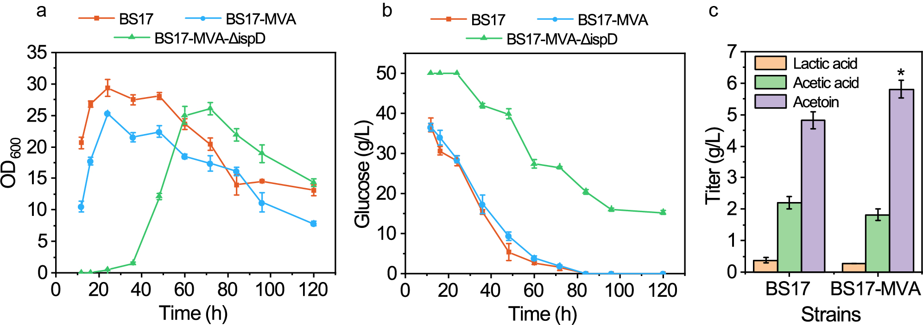
Fig. S1. The effect of introducing MVA pathway on strain growth and product synthesis. a-b The growth characteristics (a) and glucose consumption rate (b) of strain BS17, BS17-MVA and BS17-MVA-ΔispD. (c) The titer of byproduct in strain BS17 and BS17-MVA. Data displayed as mean ± s.d. (n = 3). The statistical analysis is based on Student’s t-test. All data were the average of three independent experiments with standard deviations. * indicate p < 0.05.

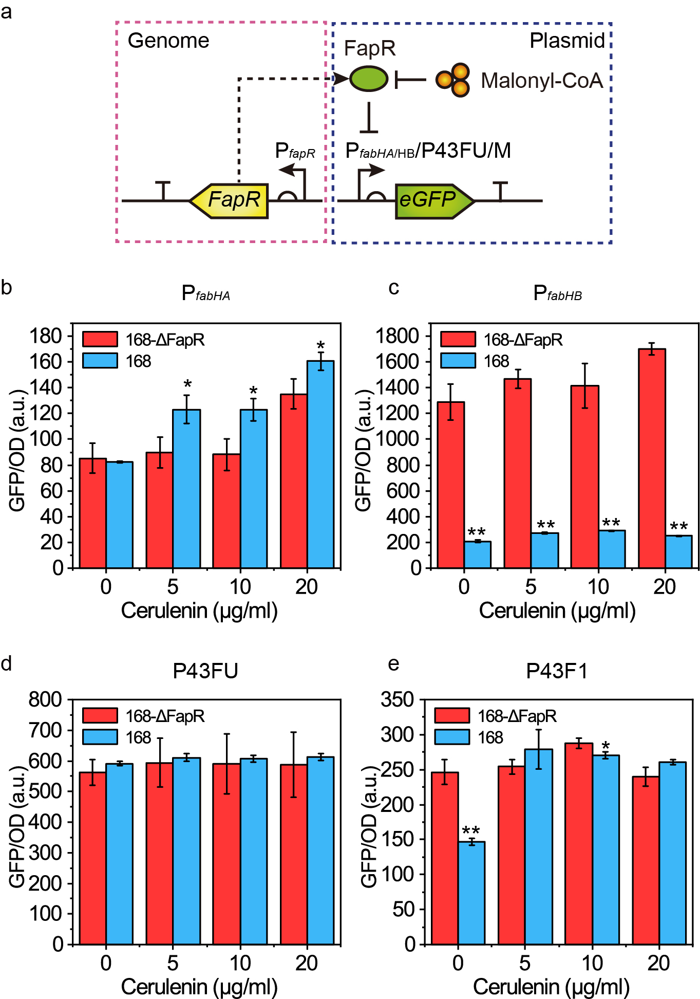
Fig. S2. Construction of FapR based malonyl-CoA-responsive genetic circuits. a Schematic diagram of the construction of malonyl-CoA-responsive genetic circuits. Malonyl-CoA responsive transcription factor FapR was expressed using its native promoter on genome. P_{fabHA} and P_{fabHB}, native promoter of gene fabHA and fabHB; P43FU, the hybrid promoter that the FapR binding site was inserted into the upstream of the “-35” region of promoter P43; P43F1, the hybrid promoter that the FapR binding site was inserted into the downstream of the +1 site of promoter P43; eGFP, enhanced green fluorescence protein (reporter). b-e When adding different concentrations of cerulenin, the strength of promoters P_{fabHA} (b), P_{fabHB} (c), P43FU (d) and P43F1 (e) in the strains with or without FapR, respectively. Data displayed as mean ± s.d. (n = 3). The statistical analysis is based on Student’s t-test. All data were the average of three independent experiments with standard deviations. * and ** indicate p < 0.05 and p < 0.01, respectively.

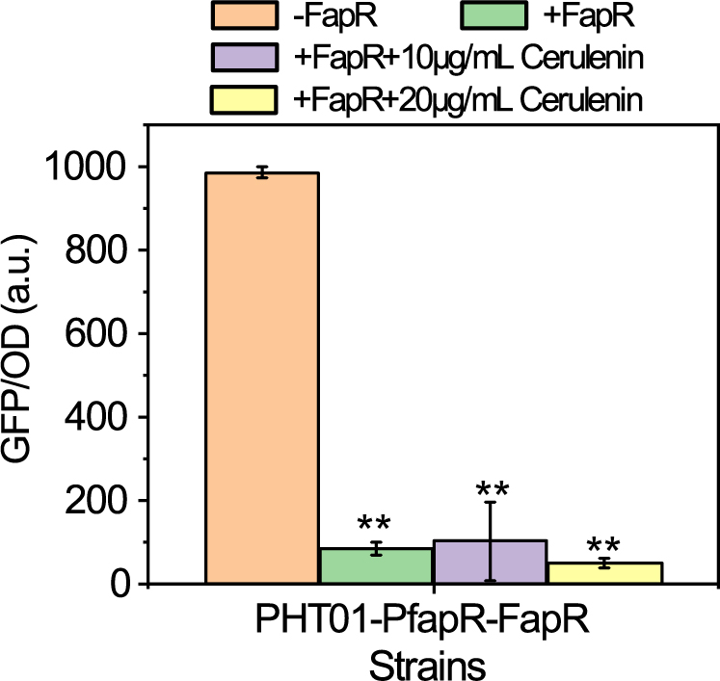
Fig. S3. The activity of P_{fabI} in different strains when FapR is expressed on the plasmid. Data displayed as mean ± s.d. (n = 3). The statistical analysis is based on Student’s t-test. All data were the average of three independent experiments with standard deviations. * and ** indicate p < 0.05 and p < 0.01, respectively.

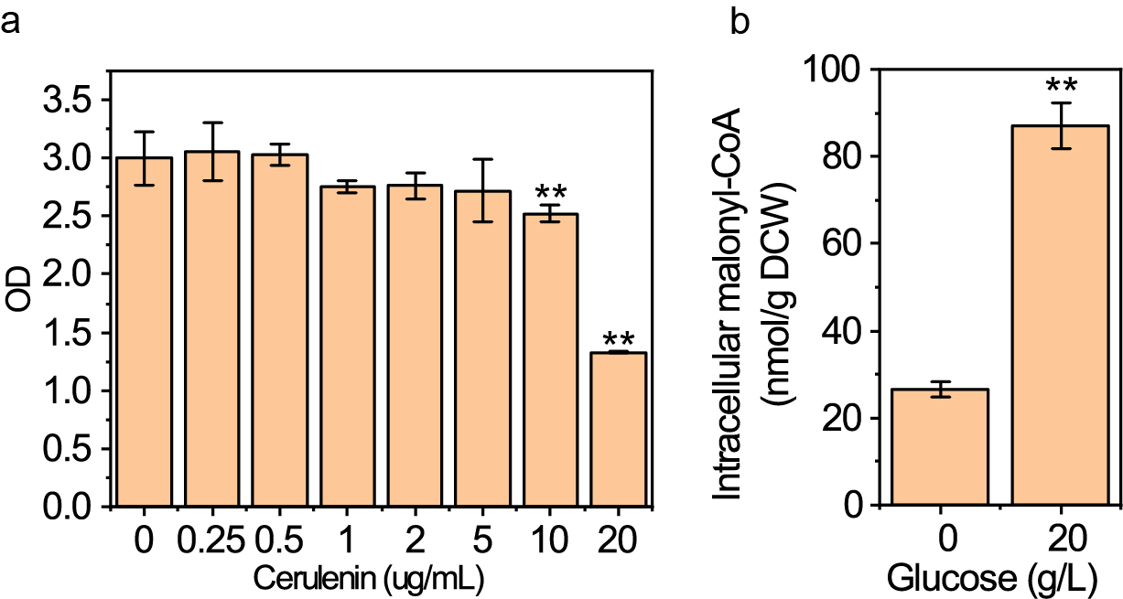
Fig. S4. The effect of different concentrations of cerulenin on cell growth (a) and the effect of adding glucose on the content of intracellular malonyl-CoA (b). Data displayed as mean ± s.d. (n = 3). The statistical analysis is based on Student’s t-test. All data were the average of three independent experiments with standard deviations. ** indicate p < 0.01.

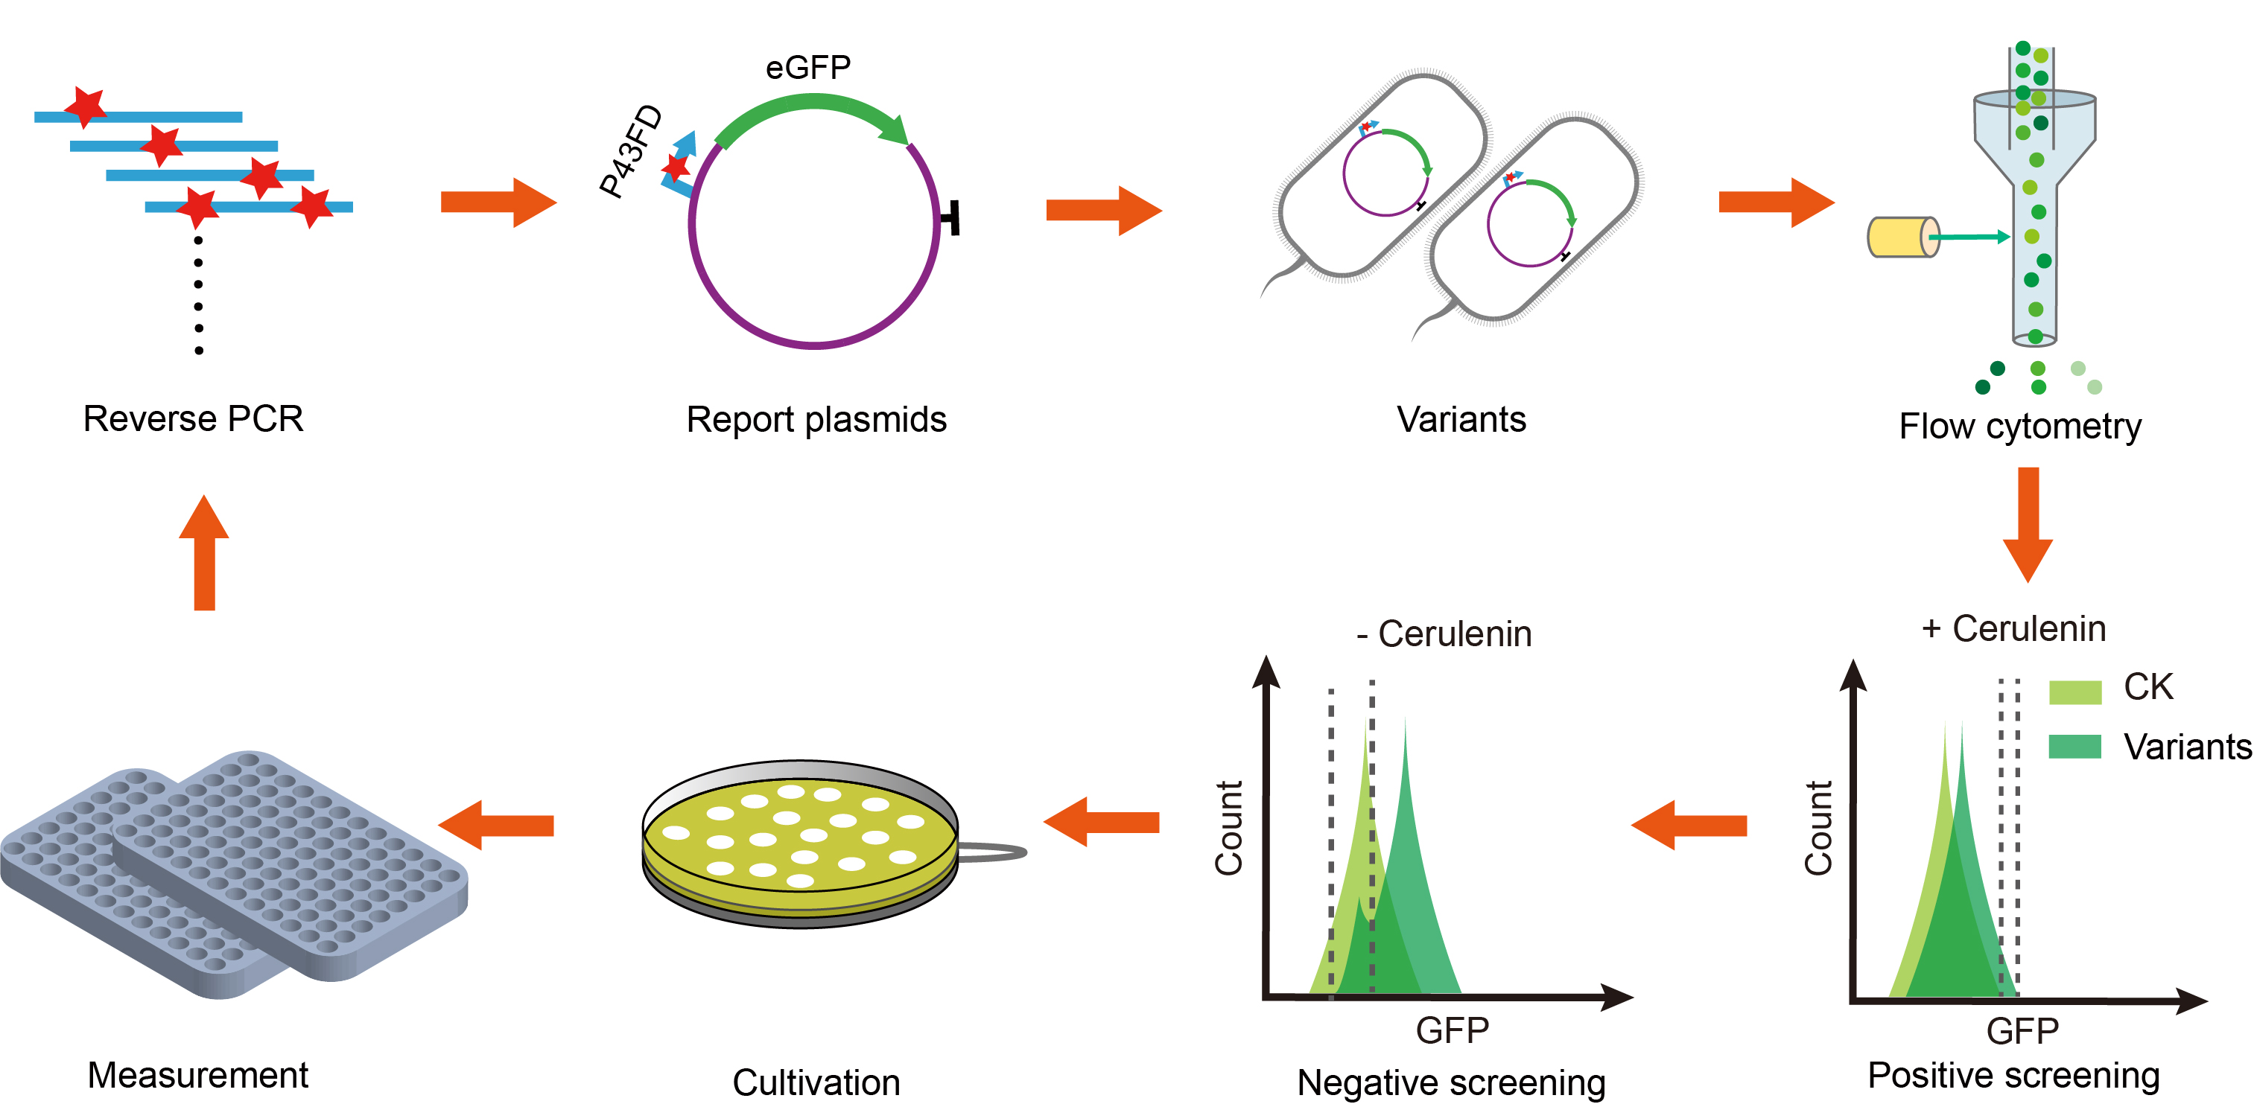
Fig. S5. Schematic diagram of selecting malonyl-CoA-responsive genetic circuit with a higher dynamic range. The variants of FapR binding sites were constructed using reverse PCR in plasmid pHT01-P43FD-GFP. Then, the variants were transformed into the E. coli and further transformed into B. subtilis 168. Next, the transformants were cultured in LB medium containing 10 μg mL-1 cerulenin, and the variants with higher relative fluorescence intensities were sorted using flow cytometry. Later, the transformants were cultured in LB medium not containing cerulenin, and the variants with lower relative fluorescence intensities were sorted. Finally, these variants were cultured in solid LB medium and then picked into 96-well fluorescent plate to detect dynamic range.

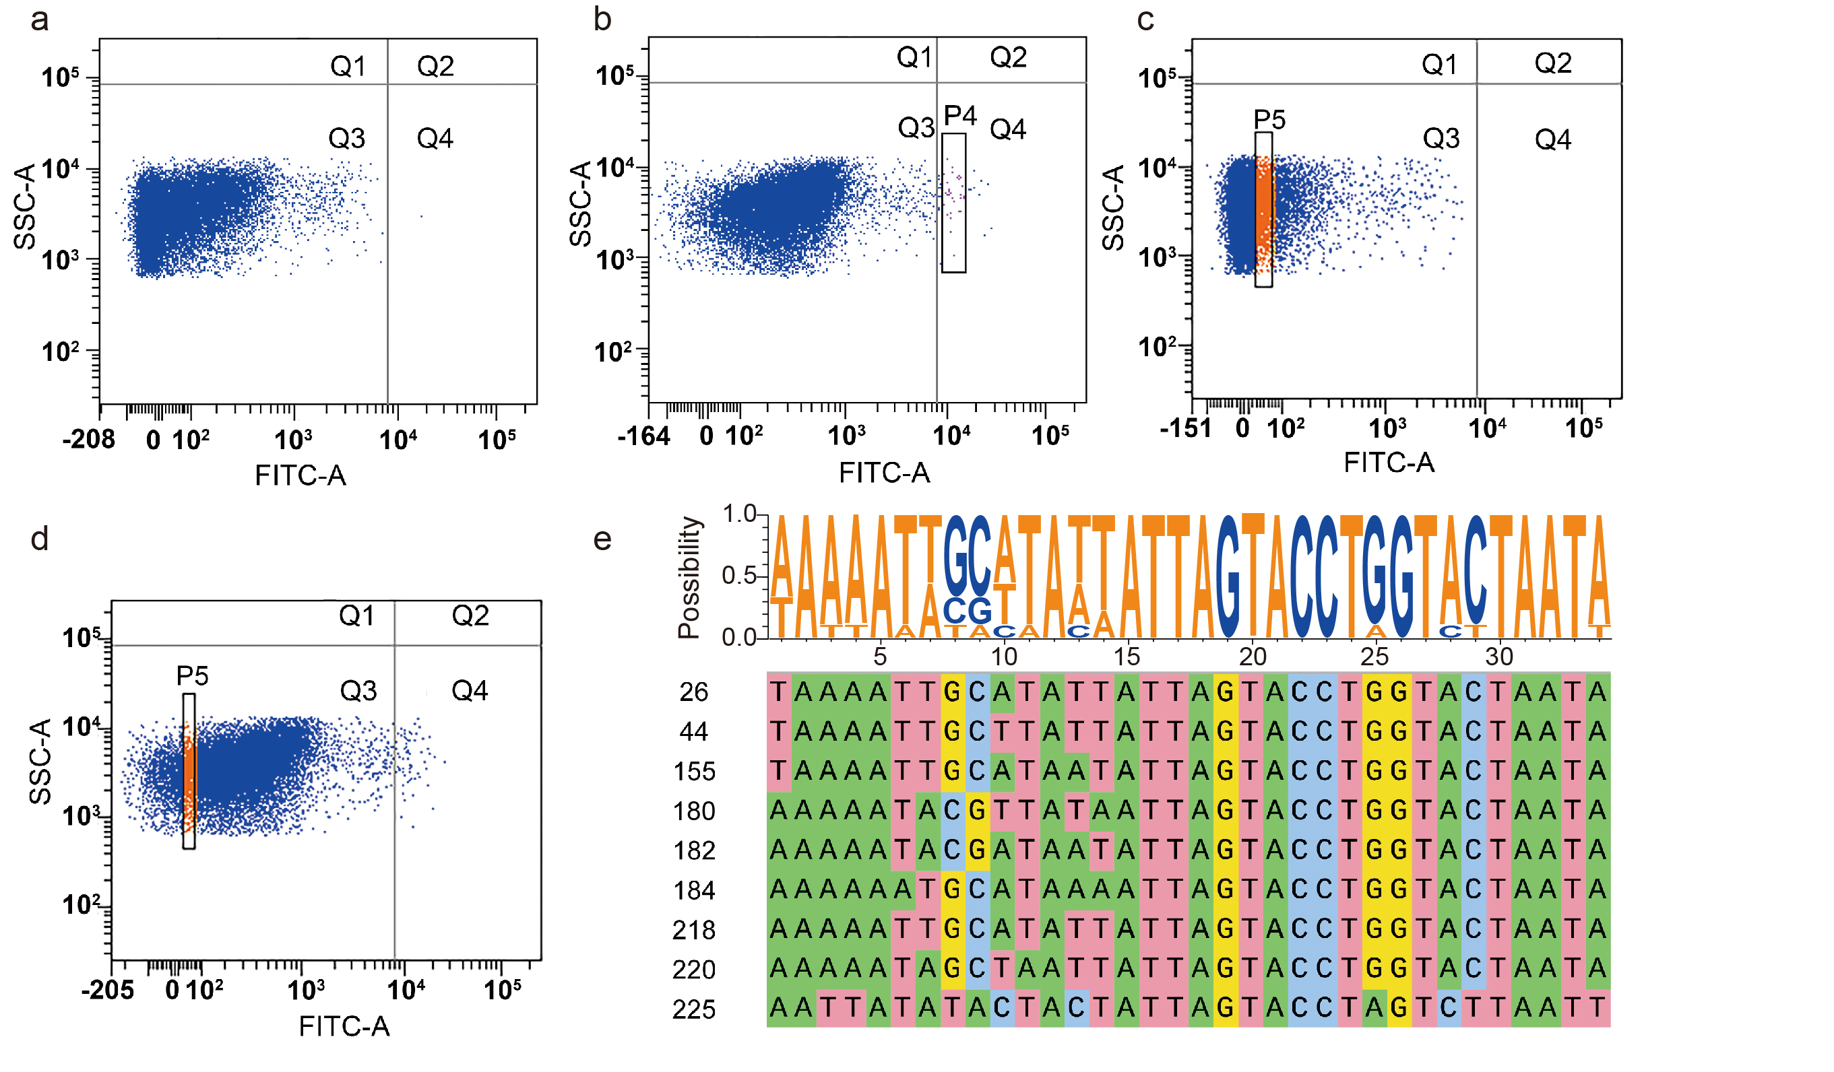
Fig. S6. Flow sorting results of malonyl-CoA response genetic circuits with different dynamic ranges. Flow cytometry scatter plots of the control strain P43FD (a) and the P43FD variants (b) during positive screening. Flow cytometry scatter plots of the control strain P43FD (c) and the P43FD variants (d) during negative screening. e Sequence conservation analysis results of P43FD variants with improved dynamic range.

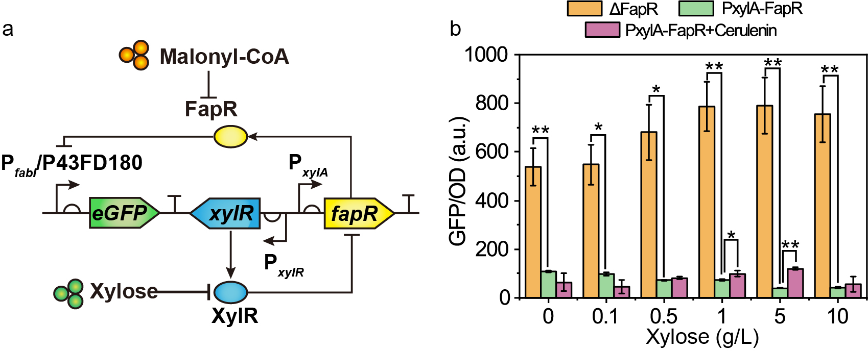
Fig. S7. Schematic diagram of the construction of plasmid pHT01-PxylA-fapR-fabI-GFP and its relative fluorescence intensity detection results. a Schematic diagram of the construction of malonyl-CoA-responsive genetic circuits pHT01-PxylA-fapR-fabI-GFP with adjustable FapR expression. The expression of FapR was under the control of xylose-inducible promoter P_{xylA}. P_{fabI}, native promoter of gene fabI; P43FD180, P43FD variant. xylR, gene encoding xylose-responsive transcription factor XylR. b When adding different concentrations of xylose, the strength of promoters P_{fabI} in the different strains, respectively. ΔFapR, 168-ΔFapR. PxylA-FapR, the FapR expression was xylose-inducible; PxylA-FapR-Cerulenin, 10 μg/mL cerulenin was added into the culture. Data displayed as mean ± s.d. (n = 3). All data were the average of three independent experiments with standard deviations. * and ** indicate p < 0.05 and p < 0.01, respectively.

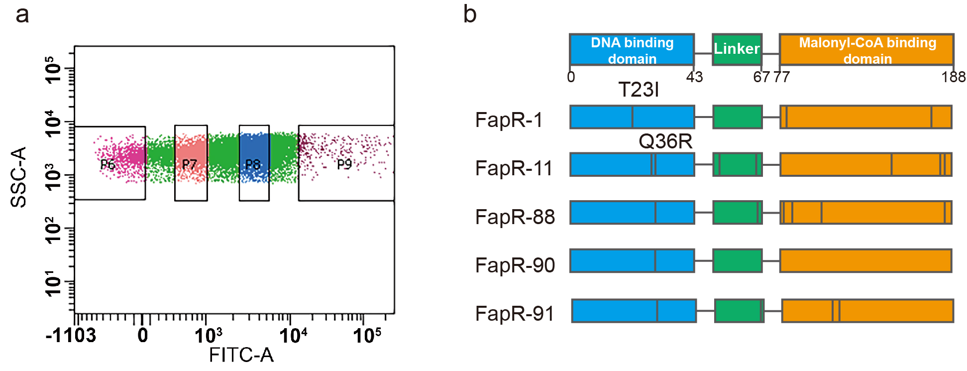
Fig. S8. Flow sorting results of transcription factor FapR variants. a Flow cytometry scatter plots of the FapR variants. b Schematic diagram of the mutation site of the variants that has lost the response ability of malonyl-CoA.

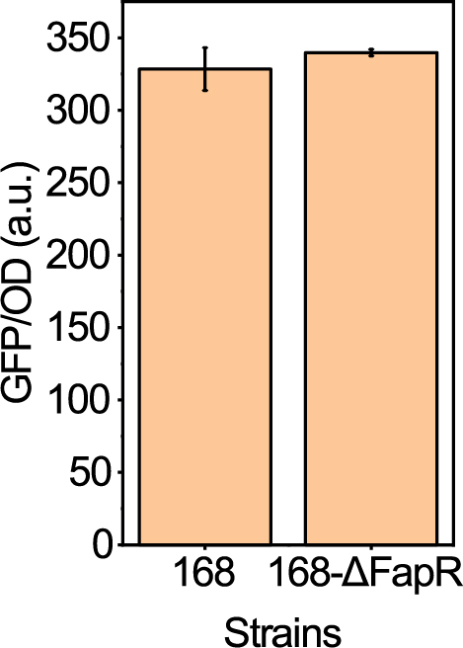
Fig. S9. The strength of P_{GAP} in strains with or without FapR, respectively. Data displayed as mean ± s.d. (n = 3).

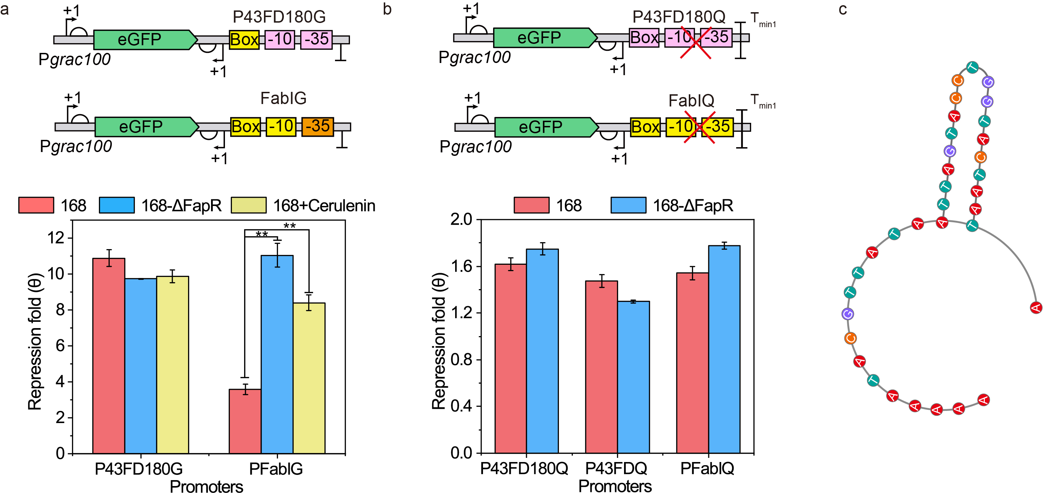
Fig. S10. Characterization and optimization of malonyl-CoA-inhibited genetic circuit a Schematic of constructing P43FD180G and FabIG and the repression fold of antisense promoters P43FD180G and FabIG in strain with or without FapR, respectively. Yellow Box, FapR binding site of PfabI; Pink -35 and -10, “-35” and “-10” region of P43FD180; Yellow -35 and -10, “-35” and “-10” region of PfabI; Orange -35, -35 region of Pgrac100. b Schematic of constructing P43FD180Q and FabIQ and the repression fold of antisense promoters P43FD180Q and FabIQ in strain with or without FapR, respectively. Pick Box, FapR binding site of P43FD180; Tmin1, Bidirectional terminator. c Secondary structure of FapR binding site.

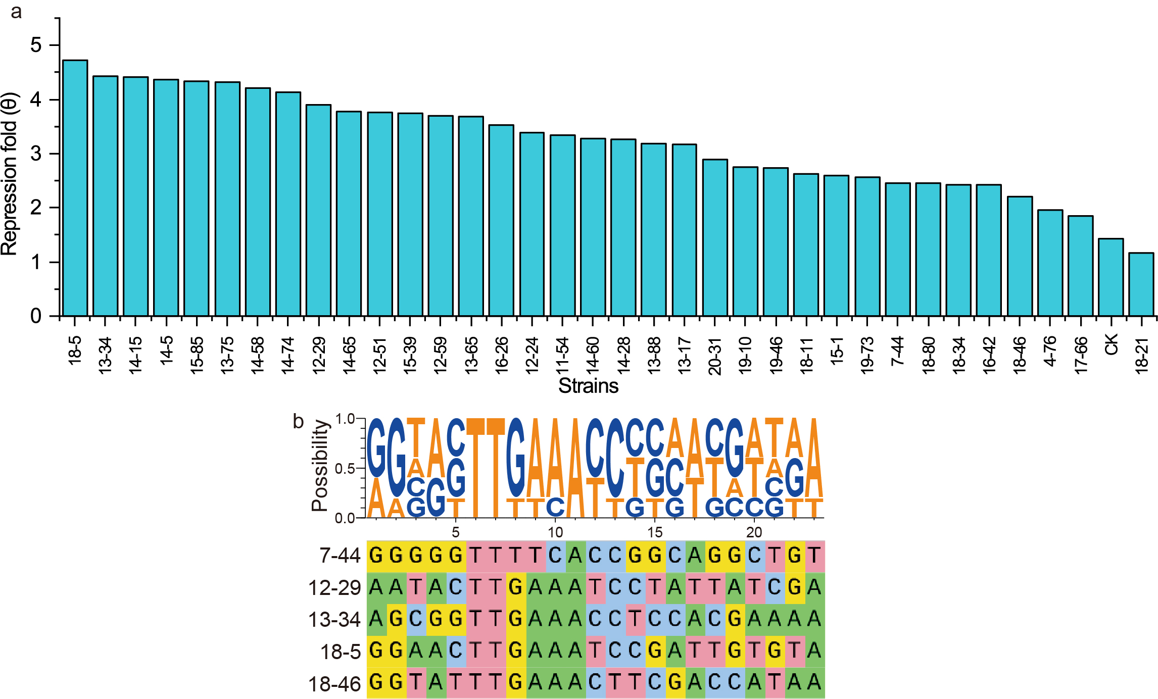
Fig. S11. Screening results of FabIG variants. a Results of the first round of screening of FabIG variants. b Sequence conservation analysis results of FabIG variants with improved dynamic range. Data displayed as mean ± s.d. (n = 3).

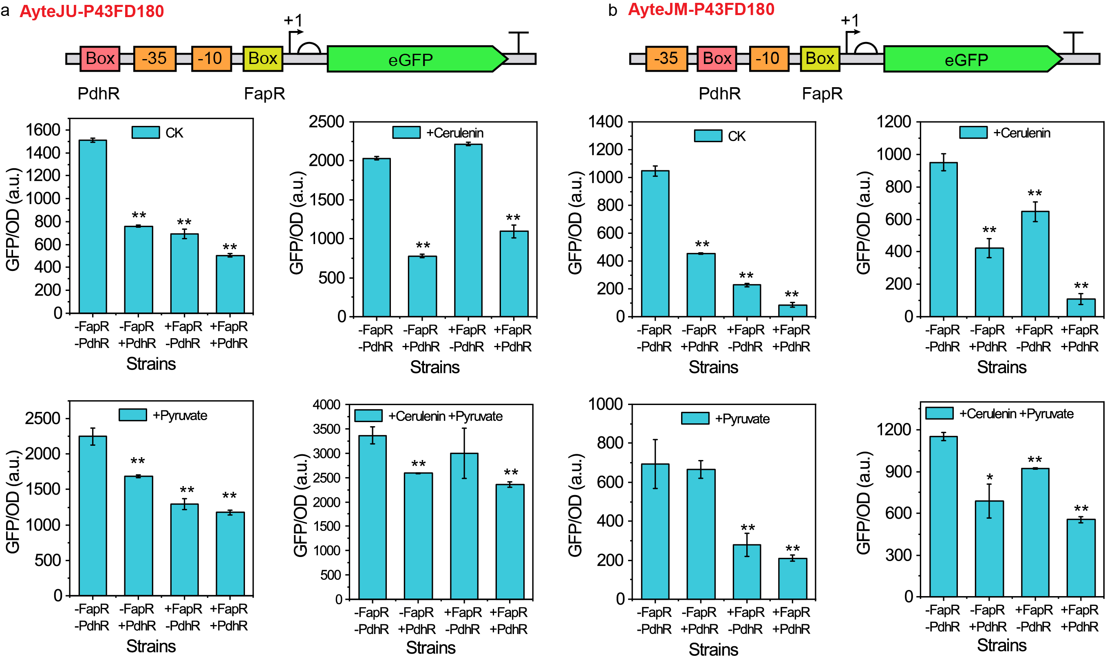
Fig. S12. Construction and characteristics of AND gate AyteJU-P43FD180 and AyteJM-P43FD180. The construction schematic diagram of And gate AyteJU-P43FD180 (a) and AyteJM-P43FD180 (b), and their relative fluorescence intensity in different culture conditions and strains. 10 g/L pyruvate or 10 μg/mL cerulenin were added into culture when required. Yellow box, FapR binding site; Pink box, PdhR binding site; Orange box, the “-35” and “-10” region of promoter P_{yteJ}. Data displayed as mean ± s.d. (n = 3). All data were the average of three independent experiments with standard deviations. * and ** indicate p < 0.05 and p < 0.01, respectively.

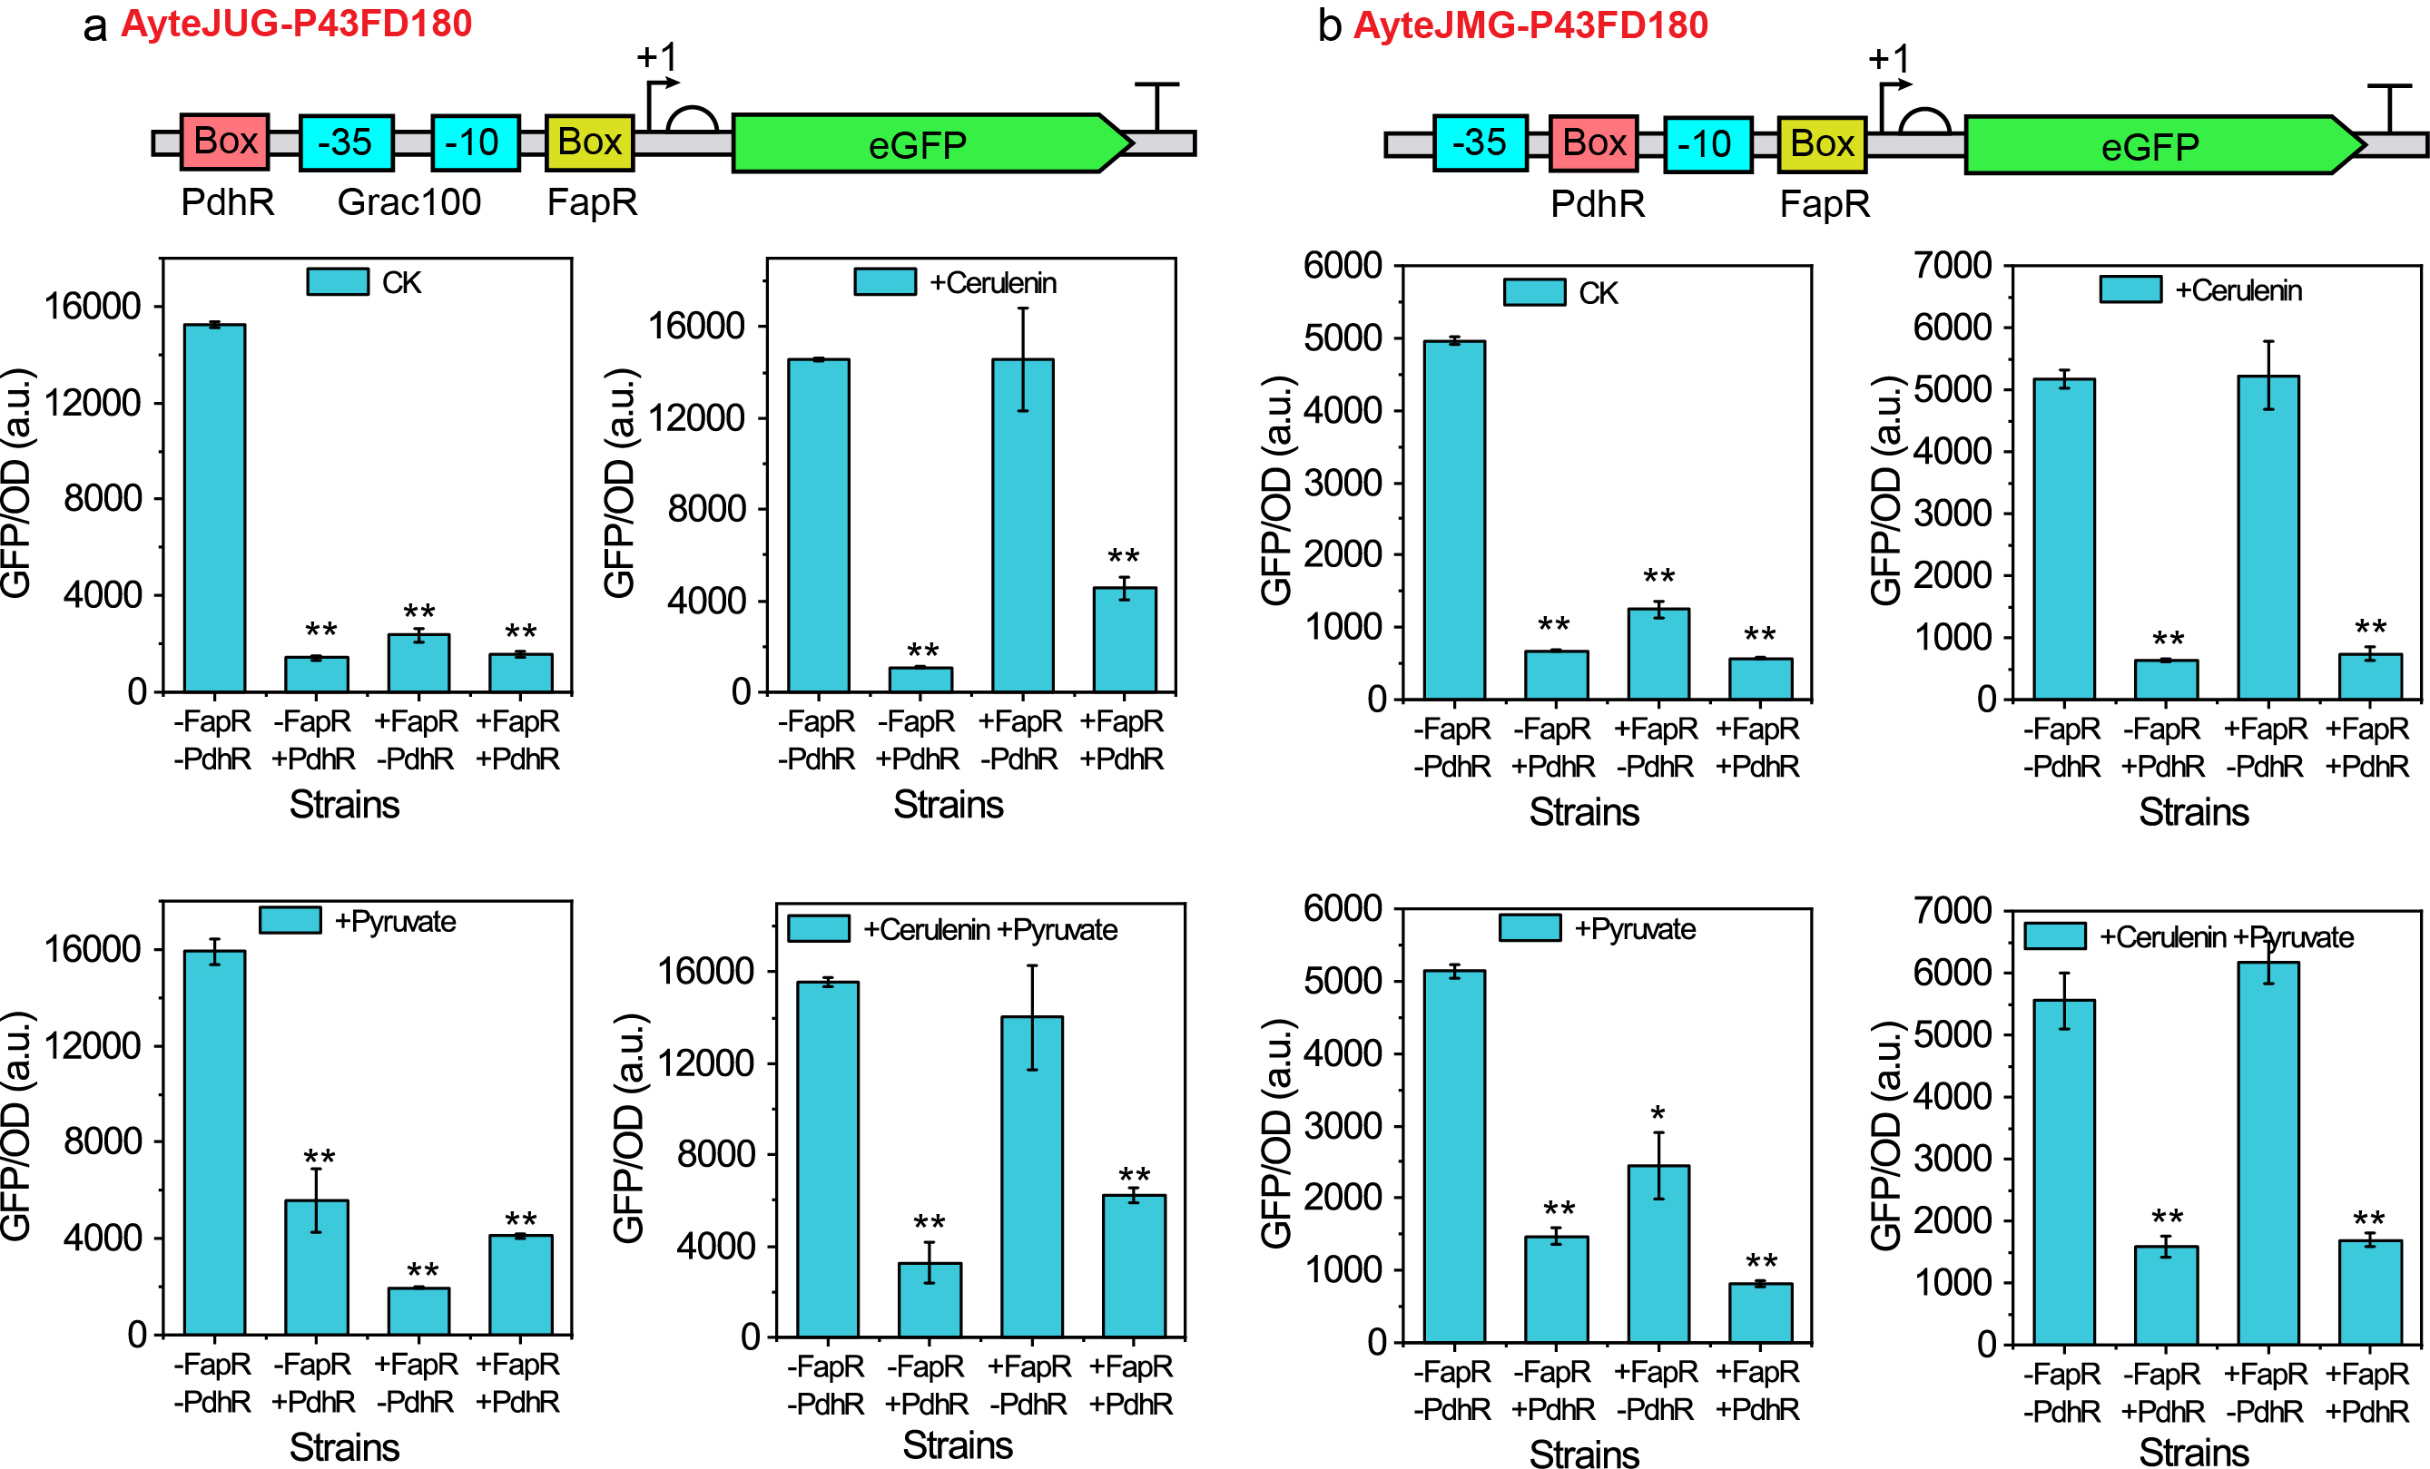
Fig. S13. Construction and characteristics of AND gate AyteJUG-P43FD180 and AyteJMG-P43FD180. The construction schematic diagram of And gate AyteJUG-P43FD180 (a) and AyteJMG-P43FD180 (b), and their relative fluorescence intensity in different culture conditions and strains. 10 g/L pyruvate or 10 μg/mL cerulenin were added into culture when required. Yellow box, FapR binding site; Pink box, PdhR binding site; Blue box, the “-35” and “-10” region of promoter Pgrac100. Data displayed as mean ± s.d. (n = 3). All data were the average of three independent experiments with standard deviations. * and ** indicate p < 0.05 and p < 0.01, respectively.

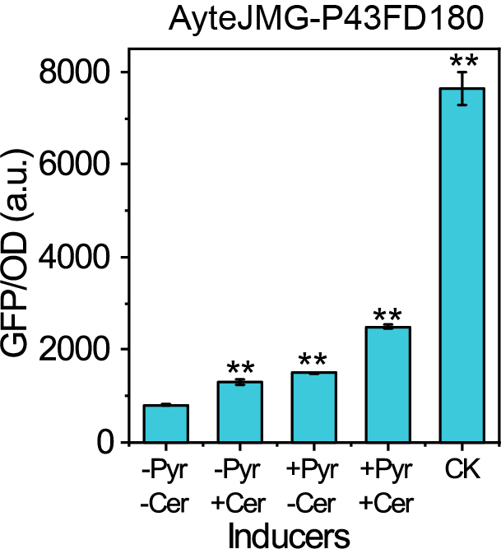
Fig. S14. The activity of AyteJMG-P43FD180 under different inducers in strain 168-PR. CK, the activity of AyteJM-P43FD180 in strain 168-ΔFapR. Data displayed as mean ± s.d. (n = 3). All data were the average of three independent experiments with standard deviations. ** indicate p < 0.01.

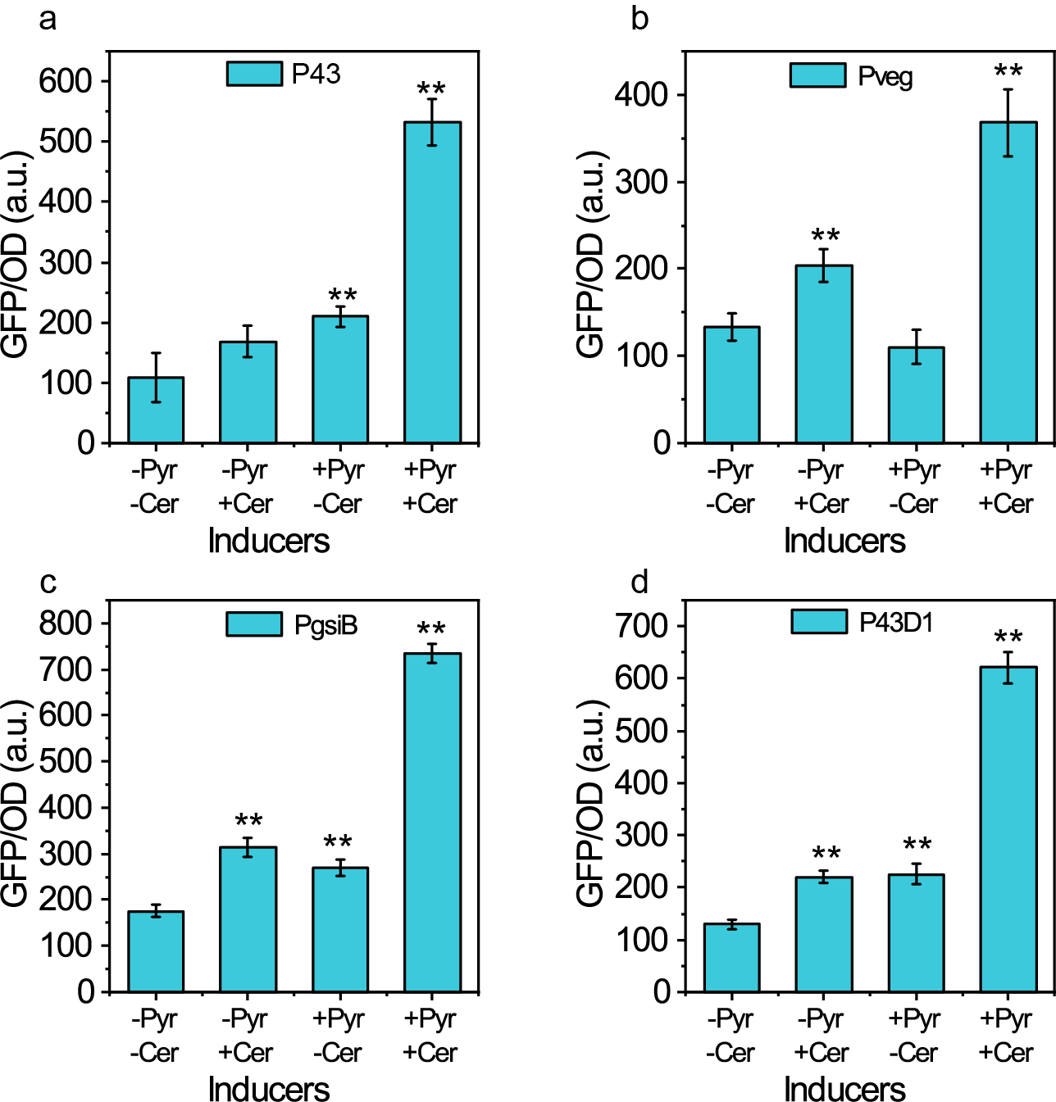
Fig. S15. Activity of AyteJU-P43FD180 in strains with different PdhR expression levels after adding different inducers. a strain PR; b strain Pveg-PR; c strain PgsiB-PR; d strain P43D1-PR; Data displayed as mean ± s.d. (n = 3). All data were the average of three independent experiments with standard deviations. ** indicate p < 0.01.

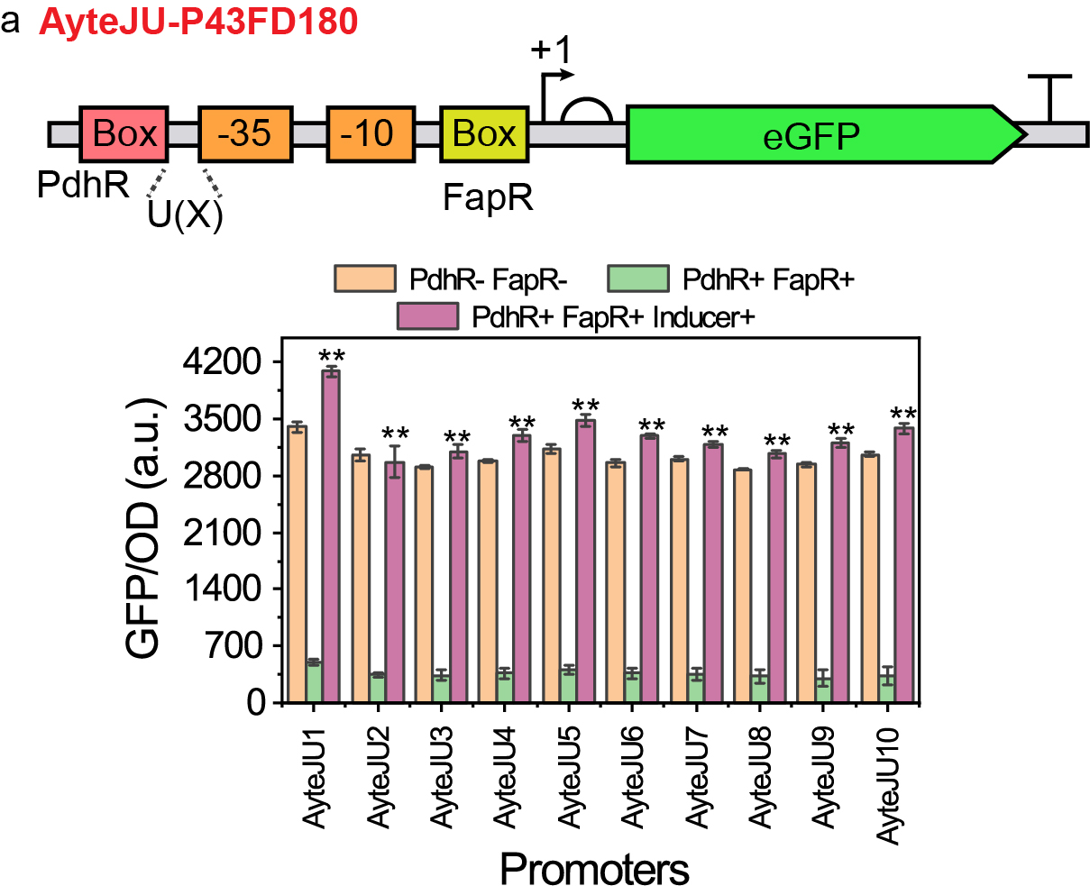
Fig. S16. Dynamic range of AND gate AyteJUG-P43FD180 with different distances between “-35” region and PdhR binding site. Data displayed as mean ± s.d. (n = 3).

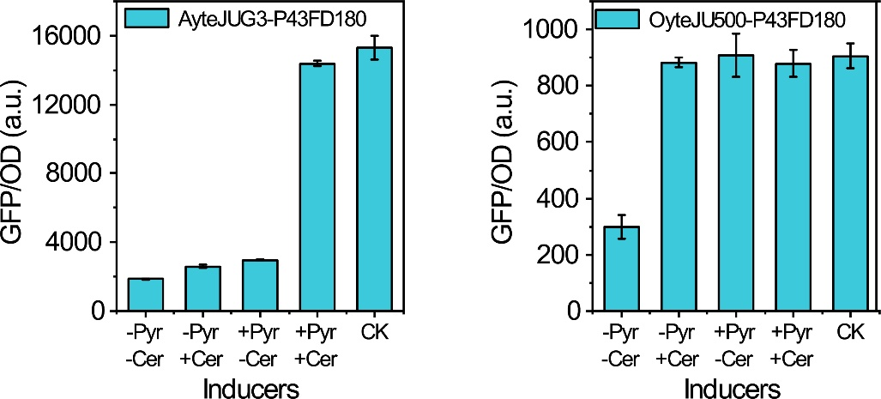
Fig. S17. The activity of AyteJUG3-P43FD180 under different inducers in strain 168-PR. CK, the activity of AyteJU-P43FD180 in strain 168-ΔFapR. Pyr, 10 g/L pyruvate; Cer, 10 μg/mL Cerulenin. Data displayed as mean ± s.d. (n = 3).

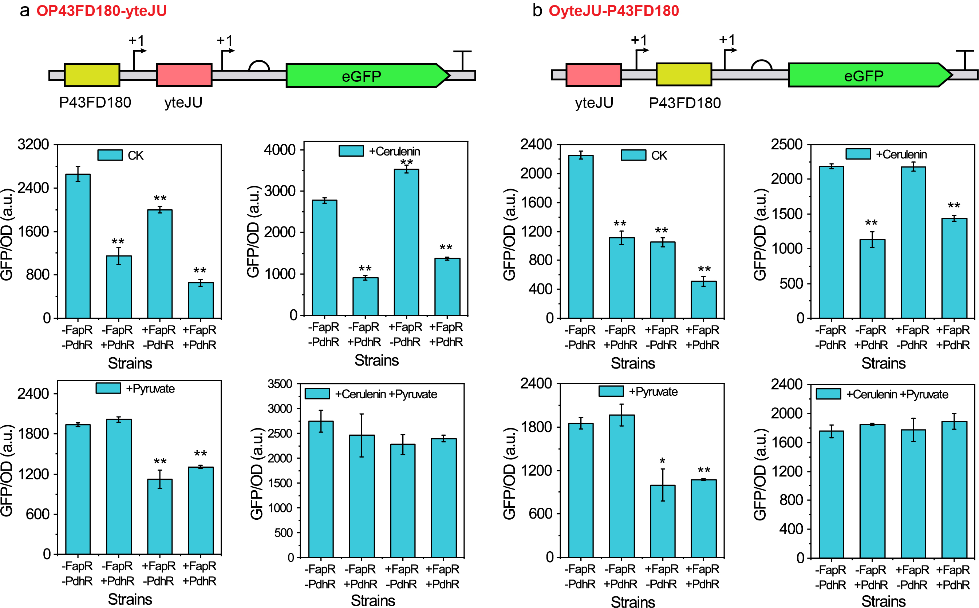
Fig. S18. Construction and characteristics of OR gate OP43FD180-yteJU and OyteJU-P43FD180. The construction schematic diagram of OR gate OP43FD180-yteJU (a) and OyteJU-P43FD180 (b), and their relative fluorescence intensity in different culture conditions and strains. 10 g/L pyruvate or 10 μg/mL cerulenin were added into culture when required. Yellow box, promoter P43FD180; Pink box, promoter yteJU. Data displayed as mean ± s.d. (n = 3). All data were the average of three independent experiments with standard deviations. * and ** indicate p < 0.05 and p < 0.01, respectively.
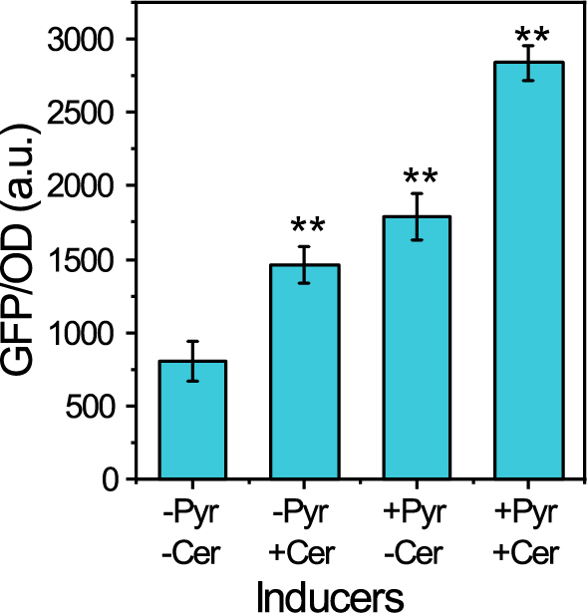
Fig. S19. Activity of OP43FD180-yteJU under different inducers in strain 168-PR. Data displayed as mean ± s.d. (n = 3). All data were the average of three independent experiments with standard deviations. ** indicate p < 0.01.

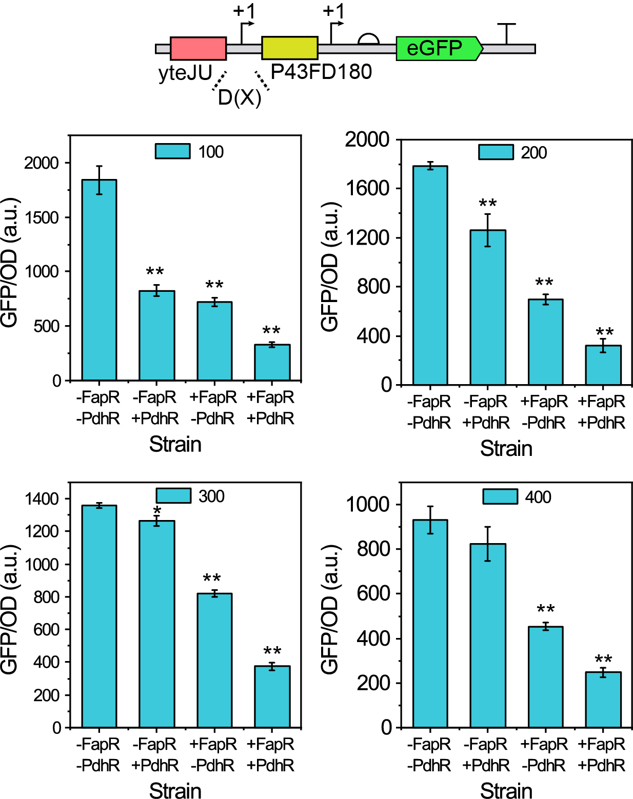
Fig. S20. The activity of OR gate in different strains when the distance between tandem promoter reached 100, 200, 300 and 400 bp. Data displayed as mean ± s.d. (n = 3). All data were the average of three independent experiments with standard deviations. * and ** indicate p < 0.05 and p < 0.01, respectively.

Fig. S21. The activity of OyteJU500-P43FD180 under different inducers in strain 168-PR. CK, the activity of AyteJU-P43FD180 in strain 168-ΔFapR. Pyr, 10 g/L pyruvate; Cer, 10 μg/mL Cerulenin. Data displayed as mean ± s.d. (n = 3).

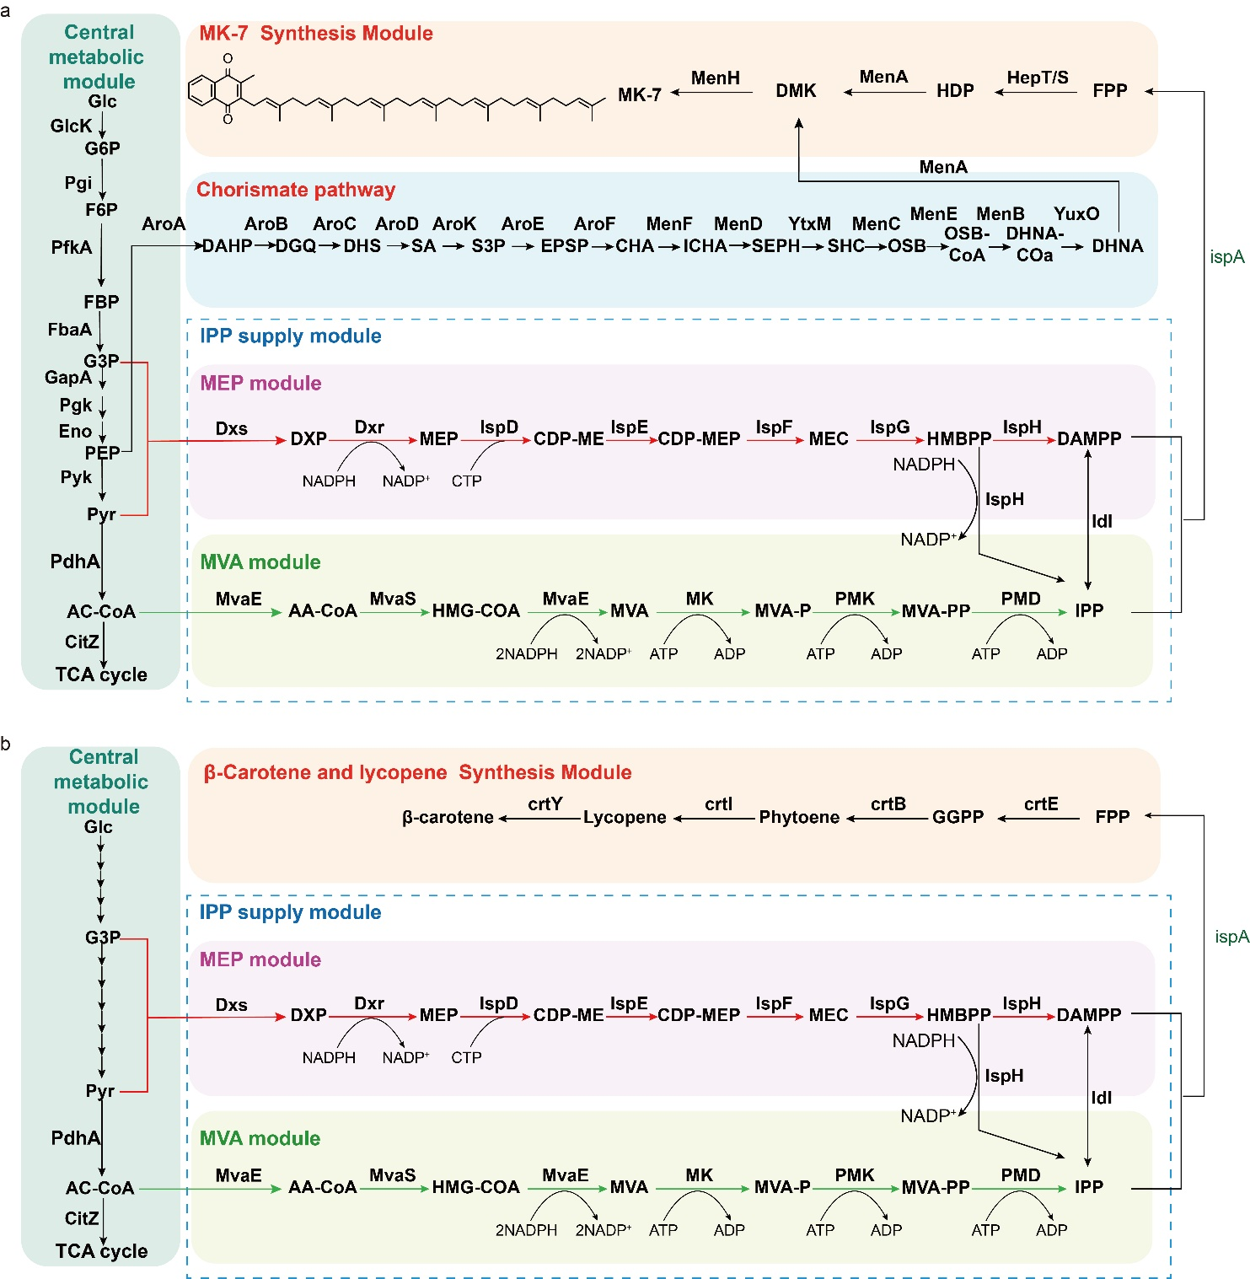
Fig. S22. Pathway of MK-7, carotene, and lycopene biosynthesis in B. subtilis. a Pathway of MK-7 biosynthesis in B. subtilis. PdhA, pyruvate dehydrogenase; CitZ, citrate synthase; Dxs, 1-deoxy-D-xylulose-5-phosphate synthase; Dxr, 1-deoxyxylulose-5-phosphate reductoisomerase; IspE, 4-diphosphocytidyl-2-C-methylerythritol kinase; IspF, 2-Cmethylerythritol-2,4-cyclodiphosphate synthase; IspG, 4-hydroxy-3-methylbut-2-enyldipho-sphate synthase; IspH, 4-hydroxy-3-methylbut-2-enyldiphosphate reductase; Idi, isopentenyl pyrophosphate isomerase; MvaE, acetoacetyl-CoA thiolase; HepT/S, heptamyl diphosphate synthase I/II; MenA, 1,4-dihydroxy-2-naphthoate heptaprenyltransferase; MenH, demethylmenaquinone methyltransf-erase; HDP, heptaprenyl diphosphate; DMK, 2-demethylmenaquinone. ispD, 2-C-methyl-D-erythritol 4-phosphocytidine transferase; MvaE, acetoacetyl-CoA thiolase; MvaS, mevalonate synthase; MK, mevalonate kinase; PMK, phosphomevalonate kinase; PMD, diphosphate mevalonate decarboxylase; MenF, isochorismate synthase; MenD, 2-succinyl-5-enolpyruvyl-6-hydroxy-3-cyclohexene-1-carboxylate synthase; YtxM, 2-succinyl-6-hydroxy-2,4-cyclohexadiene-1-carboxylate synthase; MenC, o-succinylbenzoate synthase; MenE, o-succinylbenzoic acid-CoA ligase; MenB, 1,4-dihydroxy-2-naphthoyl-CoA synthase; YuxO, 1,4-dihydroxy-2-naphthoyl-CoA hydrolase; MenA, 1,4-dihydroxy-2-naphthoate heptaprenyltransferase; MenH, demethylmenaquinone methyltransferase; PpsA, phosphoenolpyruvate synthase; AroA, chorismate mutase-isozyme 3; AroB, 3-dehydroquinate synthase; AroC, 3-dehydroquinate dehydratase; AroD, shikimate dehydrogenase; AroK, shikimate kinase; AroE, 3-phosphoshikimate 1-carboxyvinyltransferase; AroF, chorismate synthase; G3P, glyceraldehyde3-phosphate; DXP, 1-deoxy-D-xylulose 5-phosphate; MEP, 2C-methyl-D-erythritol 4-phosphate; CDP-ME, 4-diphosphocytidyl-2C-methyl-D-erythritol; MEC, 2C-methyl-D-erythritol-2,4-cyclo-diphosphate; CDP-MEP, 4-diphosphocytidyl-2C-methyl-D-erythritol-2-phosphate; HMBPP, 4-hydroxy-3-methyl-2-(E)-butenyl-4-diphosphate; Ac-CoA, acetyl-CoA; 3-hydroxy-3-methylglutaryl-CoA; AA-CoA, acetoacetyl-CoA; MVA-P, mevalonate5-phosphate; HMG-CoA, MVA-PP, mevalonate5-diphosphate. G-6P, glucose-6-phosphate; F6P, fructose-6-phosphate; FBP, fructose-1,6-bisphosphate; G3P, glyceraldehyde-3-phosphate; PEP, phosphoenolpyruvate; DAHP, 3-deoxy-arabino-heptulonate 7-phosphate; DHQ, 3-dehydroquinate; DHS, 3-dehydroshikimate; SA, shikimate; S3P, shikimate 3-phosphate; EPSP, 5-O-(1-carboxyvinyl)-3-phosphoshikimate; CHA, Chorismite; HDP, heptaprenyl diphosphate; ICHA, isochorismate; SEPH, 2-succinyl-5-enolpyruvyl-6-hydroxy-3-cyclohexene-1-carboxylate; SHC, 2-succinyl-6-hydroxy-2,4-cyclohexadiene-1-carboxylate; OSB, 2-succinylbenzoate; OSB-CoA, 2-succinyl benzoyl-CoA; DHNA-CoA, 1,4-dihydroxy-2-naphthoyl-CoA; DHNA, 1,4-dihydroxy-2-naphthoate; DMK, 2-demethylmenaquinone;b Pathway of carotene, and lycopene biosynthesis in B. subtilis. crtE, geranylgeranyl diphosphate synthase; crtB, phytoene synthase; crtI, phytoene desaturase; crtB, lycopene beta-cyclase.

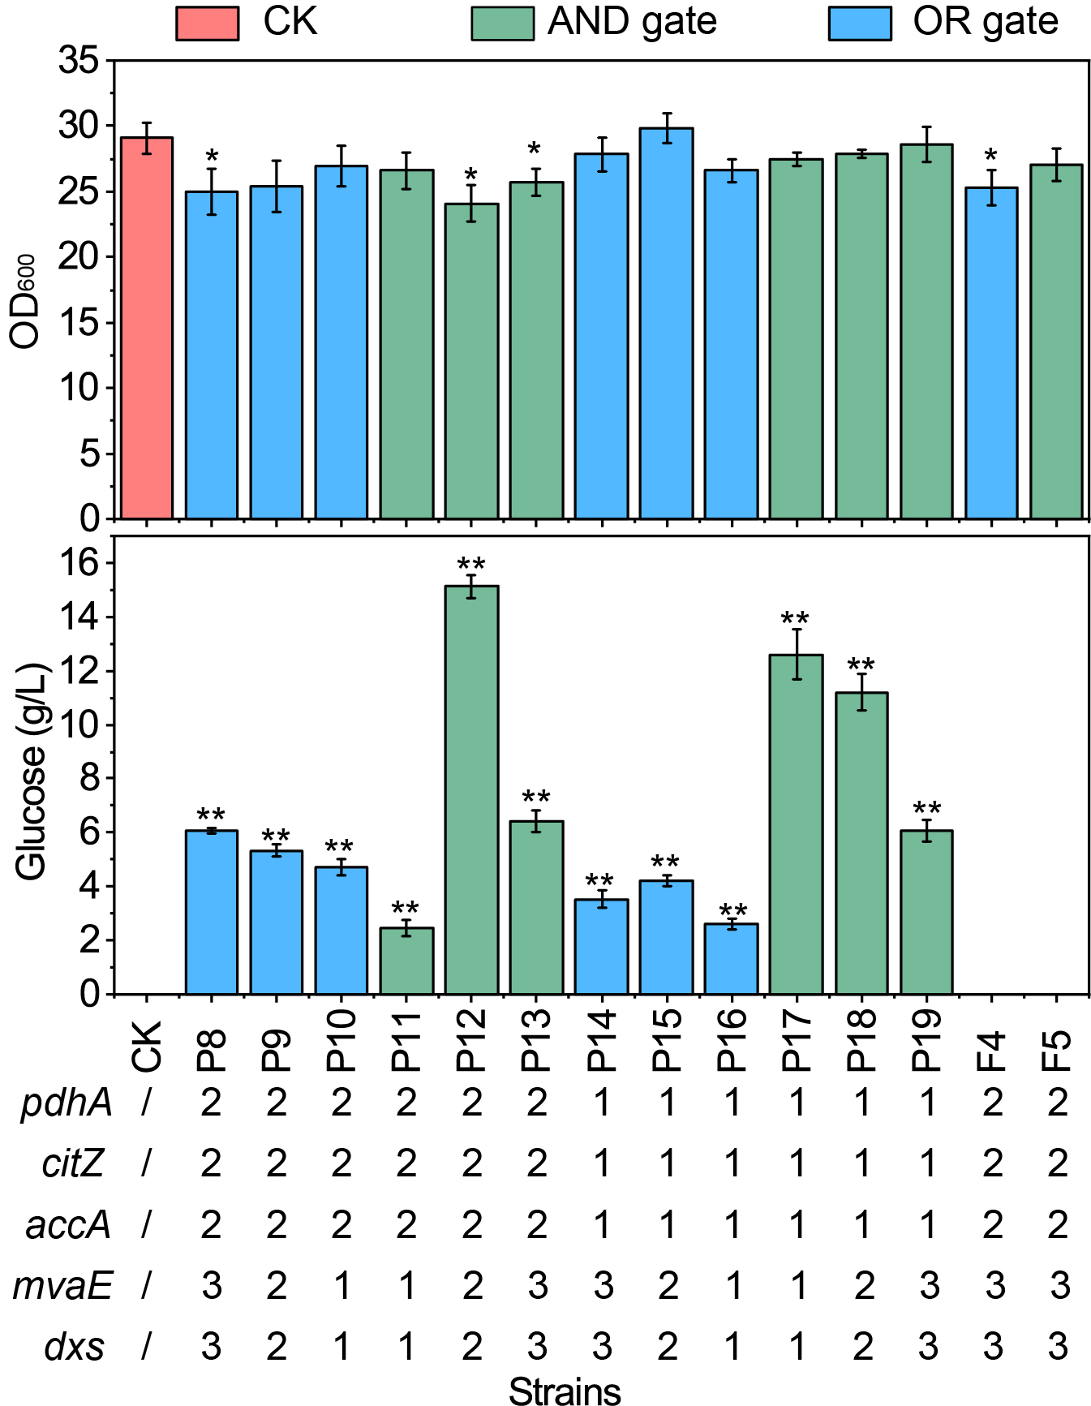
Fig. S23. The effects of dynamically regulation of the central metabolic module and IPP supply module/MK-7 synthesis module on the cell growth and glucose consumption rate. The concentration of glucose was detected at 84h, when glucose was just completely consumed in the control strain. CK, strain BS17-MVA; P8-19, dynamically regulated strains; F4-5, Statically regulated strains. 1, 2, 3 indicates that the intensity of the regulation is stepwise enhanced. Data displayed as mean ± s.d. (n = 3). All data were the average of three independent experiments with standard deviations. * and ** indicate p < 0.05 and p < 0.01, respectively.

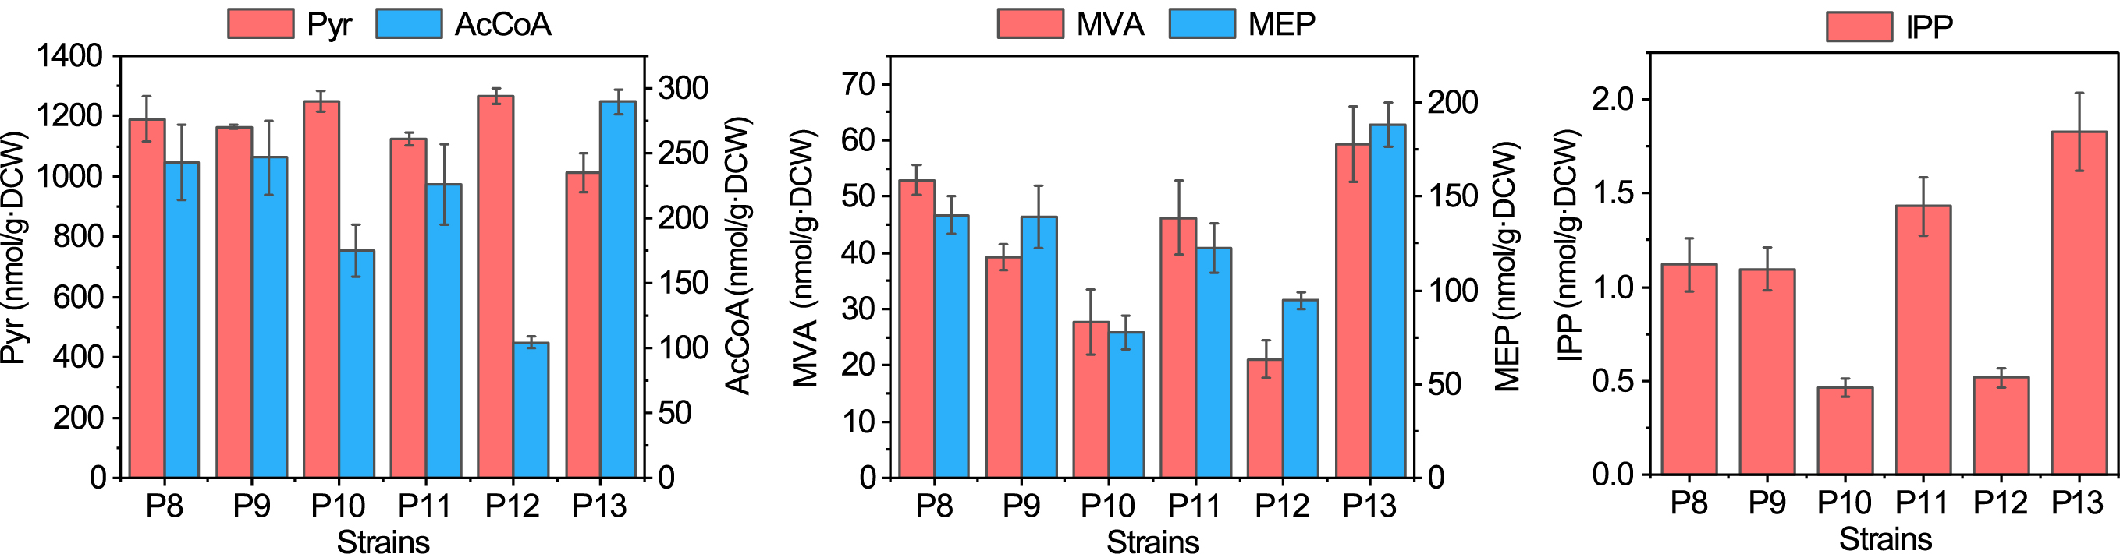
Fig. S24. The intracellular concertation of pyruvate, Ac-CoA, MVA, MEP and IPP in the strains P8, P9, P10, P11, P12 and P13. Data displayed as mean ± s.d. (n = 3).

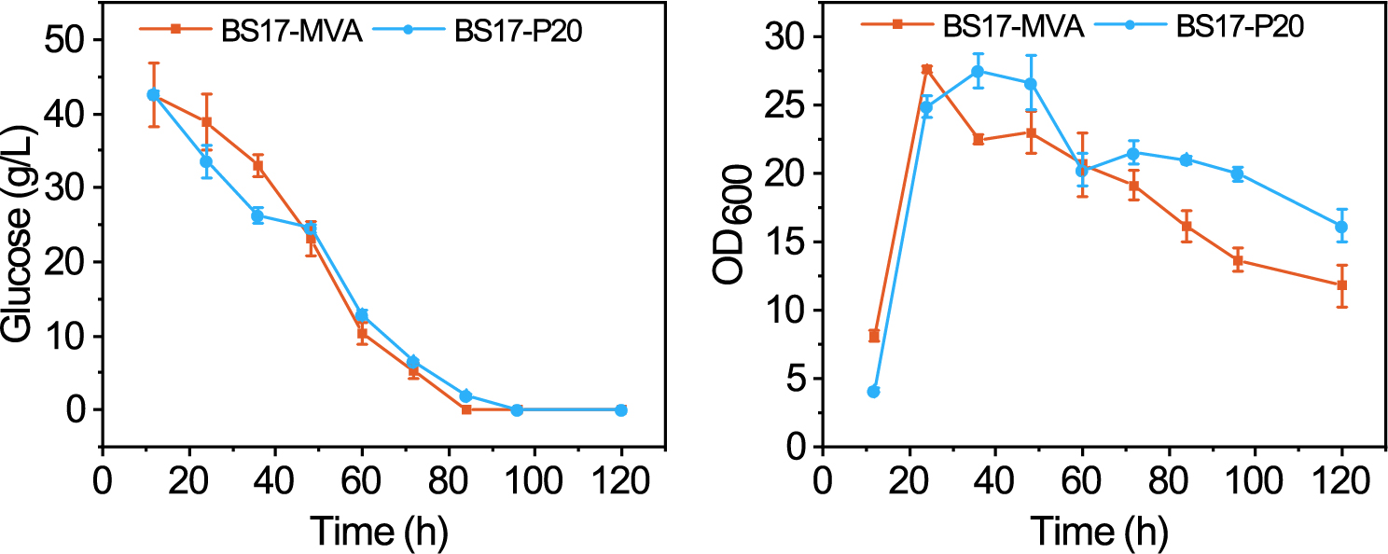
Fig. S25. The cell growth and glucose consumption rate of strain BS17-MVA and BS17-P20. Data displayed as mean ± s.d. (n = 3).

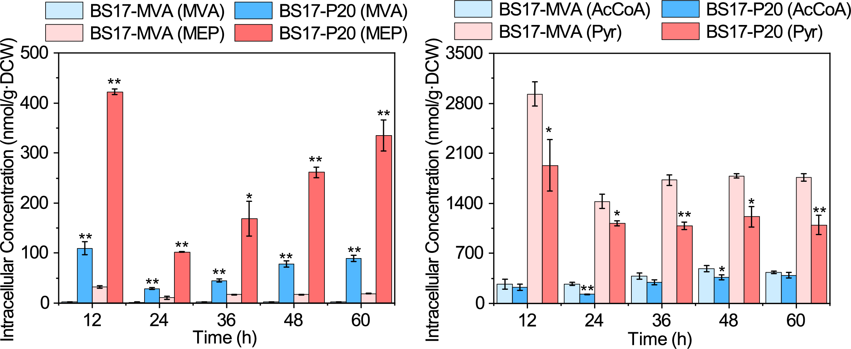
Fig. S26. Intracellular pyruvate and acetyl-CoA profile in strain BS17-MVA and BS17-P20. Data displayed as mean ± s.d. (n = 3). All data were the average of three independent experiments with standard deviations. * and ** indicate p < 0.05 and p < 0.01, respectively.

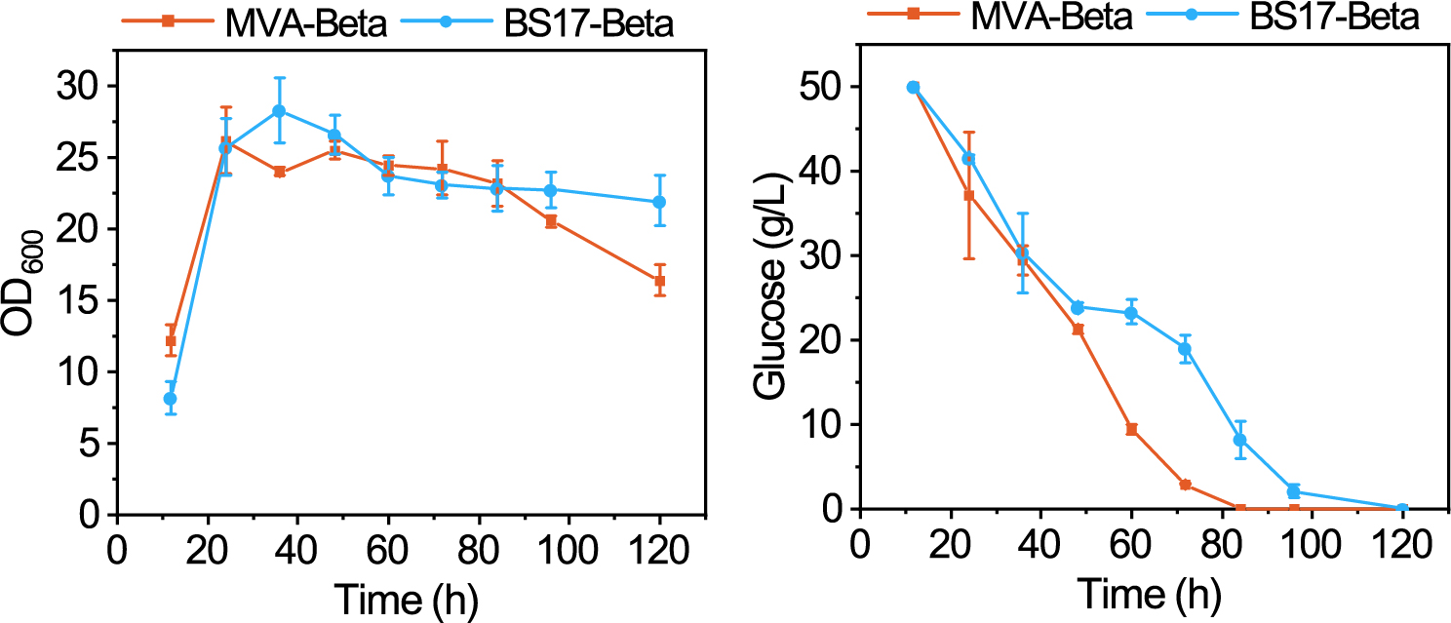
Fig. S27. The cell growth and glucose consumption rate of the strains MVA-Beta and BS17-Beta. Data displayed as mean ± s.d. (n = 3).

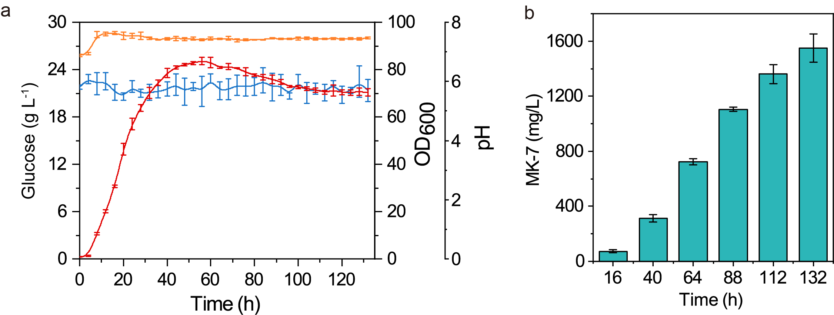
Fig. S28. The glucose consumption rate, cell growth, pH and MK-7 production of strain BS17-P20 in 50-L bioreactor.

