Supplementary file for
Therapeutic Characterization of ¹³¹I-Labeled Humanized Anti-B7-H3 Antibodies for Radioimmunotherapy for Glioblastoma
Fengqing Fu ^{a,b,#}, Meng Zheng ^{c,e,#}, Shandong Zhao ^{c,e,#}, Yan Wang ^{b,c,e}, Minzhou Huang ^{c,e}, Hanqing Chen ^{f}, Ziyi Huang ^{a,b}, Kaijie Zhang ^{c,e}, Liyan Miao ^{c,e,}*, Xueguang Zhang ^{a,b,d,}*
ª Jiangsu Institute of Clinical Immunology, the First Affiliated Hospital of Soochow University, Suzhou 215000, China
^{b} State Key Laboratory of Radiation Medicine and Protection, Soochow University, Suzhou 215123, China
^{c} Department of Clinical Pharmacology, the First Affiliated Hospital of Soochow University, Suzhou 215006, China
^{d} Suzhou Bright Scistar Antibody Biotech. Co., LTD., Suzhou 215152, China
^{e} Institute for Interdisciplinary Drug Research and Translational Sciences, College of Pharmaceutical Sciences, Soochow University, Suzhou 215123, China
^{f} Department of Hematology, the First Affiliated Hospital of Soochow University, Suzhou 215000, China

*Corresponding authors.
E-mail addresses: xueguangzh@126.com (X. Zhang), miaolysuzhou@163.com (L. Miao)

# These authors contributed equally to this work.

1. Materials and methods

1.1. Reagents
p-SCN-deferoxamine (DFO) was purchased from Macrocyclics (USA), Inc. Dimethyl sulfoxide (DMSO) was purchased from Acros Organics. Na₂CO₃ and 2‐[4‐(2‐hydroxyethyl) piperazin‐1‐yl] ethane sulfonic acid (HEPES) solution was purchased from Sigma‐Aldrich (USA). A PD-10 column was obtained from Cytiva (USA). ⁸⁹Zr-oxalate was obtained from Dongcheng AMS Pharmaceutical Co., Ltd. (China).

1.2. Cell culture and experimental animals
The human glioblastoma cell line U87 (kindly provided by Suzhou Bright Scistar Biotechnology Co., Ltd., China). The Bioware® Brite Cell Line GL261 Red-FLuc was purchased and overexpressed human B7-H3 by lentivirus using a standard protocol. Human B7-H3 expression levels in GL261 Red-FLuc cells were confirmed by western blot (Appendix A Fig. S1). U87 and GL261 Red-FLuc-B7-H3 was cultured in high-glucose Dulbecco’s modified Eagle’s medium (Gibco, USA) supplemented with 10% fetal bovine serum (Gibco, USA) and 100 U/mL penicillin/streptomycin (Beyotime, China) at 37°C in a 5% CO₂ humidified cell incubator (Thermo, Germany). Eighty male BALB/c nu/nu mice and forty C57 mice (four- to six-week-old, 18-22 g) were obtained from Shanghai Lingchang Biotechnology Co., Ltd. Animals were maintained on a 12 h light-dark cycle with food and water provided ad libitum at a temperature of 20-23°C with 40-60% humidity. All procedures involving mice and experimental protocols were approved by Soochow University Institutional Animal Care.

1.3. Tumor models
For PK and biodistribution studies with ⁸⁹Zr-labeled antibodies, tumor cells (U87, 2 × 10⁶ cells) suspended in 100 µL of PBS were injected subcutaneously into the left and right flanks of twenty-four male BALB/c nu/nu mice (U87-xenografted mice). Micro PET imaging and biodistribution were performed when the tumors grew to a diameter of 100~300 mm³
U87 subcutaneous mouse model
Fifty-six male BALB/c nu/nu mice were implanted subcutaneously with 2 × 10⁶ cells suspended in 100 µL of PBS (U87-xenografted mice) in the right flank. and PD investigation was initiated when the tumor size reached ~100 mm³.
GL261 Red-FLuc-B7-H3 situ glioma tumor mouse model
A day of fasting was followed by the studies on C57BL/6 mice. They were subsequently secured in a stereotactic device after receiving an intraperitoneal injection of 10% chloral hydrate (3 mL/kg; Sigma, USA) to anesthetize them. The scalp's skin was then cut with surgical scissors along the midline of the skull. Then, the cranial bone was then punctured 1 mm posteriorly to the bregma and 3mm laterally to the sagittal suture. A 30-gauge needle with a microsyringe was inserted to a depth of 7 mm from the skull surface; Eighteen male C57BL/6 mice were stereotactically injected with 1 × 10⁷ cells suspended in 10 µL of PBS. After the injection is over 10 minutes, the needle remains in place for 5 minutes at the end of the injection, then gradually draws out for over 3 minutes to prevent the solution from backflowing.

1.4. Biodistribution with ¹²⁵I and ¹³¹I-labeled antibodies
For the biodistribution with ¹²⁵I labeled antibodies study, tumor-bearing mice were dissected at 72 h post-injection after SPECT imaging, and the major organs and tissues of each mouse, such as blood, heart, liver, spleen, kidney, bone, long bone joints, muscle, stomach, intestine, gonad, reticular tissue, and tumor samples, were collected, weighted and counted using a gamma counter (n=3) (2480 WIZARD, Perkin Elmer). Biodistribution with ¹³¹I-labeled antibodies are similar to that of ¹²⁵I labeled antibodies.

1.5. Hematoxylin-eosin (H&E) and immunofluorescence (IF) staining
At the end of treatment, the tumors were collected and used for H&E and IF staining. CD31, PDGFRβ and collagen type IV expression were evaluated by IF. Briefly, the tumor tissues were fixed in 4% paraformaldehyde, dehydrated in an ethanol gradient, paraffin-embedded, and sectioned (thickness of 4 μm). The sections were then dewaxed by placing the slides in xylene, followed by progressive hydration for 5 min according to the alcohol gradient: 100%, 100%, 95%, 90%, 80%, and 70%. Each section was placed in 3% H₂O₂ in methanol to block endogenous catalase, and 5% goat serum was used to block nonspecific sites. The sections were incubated overnight with a CD31 antibody (cat. nb600-562, 1:200 dilution, Novus, USA), a PDGFRβ antibody (cat. 3169, 1:100 dilution, CST, USA) and anti-type IV collagen (cat. AB756P, 1:200 dilution, Millipore Sigma, USA) at 4 °C followed by 1 h of incubation at room temperature with donkey anti-rabbit IgG Alexa Fluor 488 (cat. ab150064, 1:200 dilution, Abcam, USA) and donkey anti-mouse IgG Alexa Fluor 594 (cat. ab150109, 1:200 dilution, Abcam, USA) and stained with DAPI (cat. ab104139, Abcam, USA). The samples were finally observed, and images were captured by a fluorescence microscope (BX53, OLYMPUS, Japan). Quantification of fluorescence intensity of immunofluorescence captured images were further analyzed by software Image pro plus 6.0.

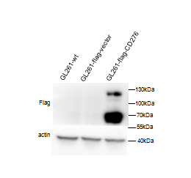
Fig. S1. The expression of human B7-H3 (CD276) in GL261 Red-FLuc cells by western blot.

Fig. S2. The binding patterns of 4G4 and 4H12 to the B7-H3 protein. (a) Binding of 4G4 and 4H12 to glioma cell lines and the B7-H3 knockout U87 cell line U87-B7-H3-mu. Binding of (b) 4G4 and (c) 4H12 to the B7 family proteins B7-H1, B7-H2, B7-H3, B7-H4, B7-H5, B7-H6, and B7-H7. The B7-H3 expression pattern in glioma cell lines was assessed. (d) Detection of whether hu4G4 and hu4H12 have the same B7-H3 protein binding epitopes. B7-H3 protein was first incubated with 4G4 at increasing concentrations and then detected by hu4G4 or hu4H12. (e, f) Kinetic analysis of antibody (4G4/4H12) binding to B7-H3 measured by Biacore.
Fig. S3. Stability evaluation of the ⁸⁹Zr-labeled antibodies in vitro at different time points. (a) Stability of the ⁸⁹Zr-labeled antibodies in acetate buffer. (b) Stability of the ⁸⁹Zr-labeled antibodies in serum.

Fig. S4. The results of time-dependent ⁸⁹Zr-labeled antibody uptake in each group in U87-xenografted mice determined by PET imaging. (a) Liver and (b) spleen uptake (%ID/g), respectively. Target-to-background ratios of the ⁸⁹Zr-DFO-antibodies (hu4G4, hu4H12, or IgG) at (c) 72 and (d) 168 h postinjection, respectively.
Fig. S5. Tumor absorbed dose of ¹³¹I-(hu4G4, hu4H12, IgG) calculated based on ¹²⁵I-(hu4G4, hu4H12, IgG) SPECT imaging data. The tumor absorbed dose in U87-xenografted mice in the Na¹²⁵I, ¹²⁵I-huIgG, ¹²⁵I-hu4G4, and ¹²⁵I-hu4H12 groups was analyzed by OLINDA/EXM (version 2.1).

Fig. S6. Stability evaluation of the ¹³¹I-labeled antibodies in vitro at different time points with radio-TLC. (a) Stability of the ¹³¹I-labeled antibodies in a solvent. (b) Stability of the ¹³¹I-labeled antibodies in serum.
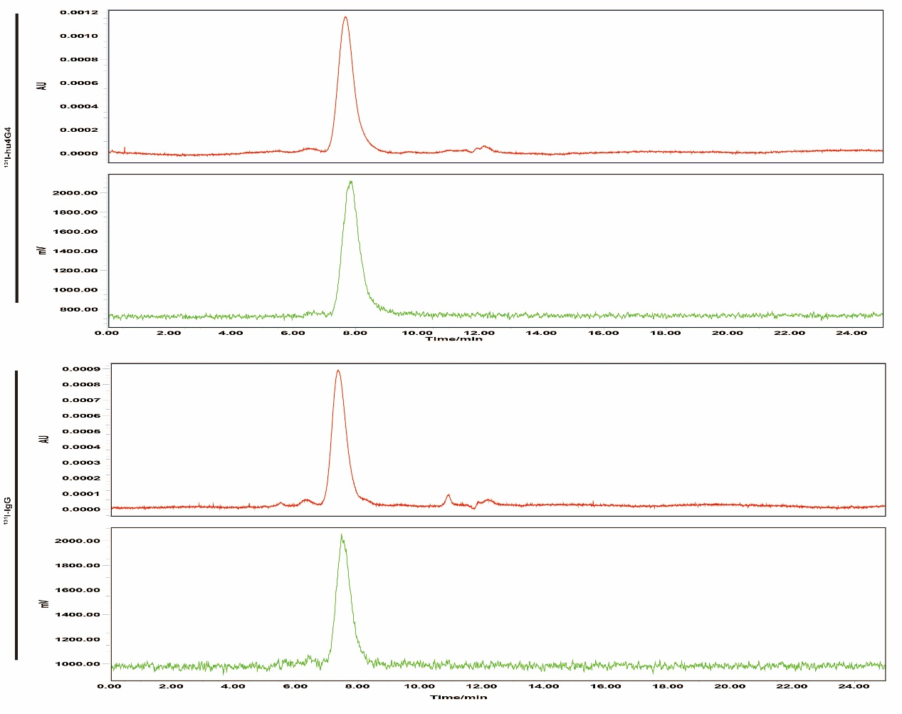
Fig. S7. The radiochemical purities of the ¹³¹I-labeled antibodies evaluated by radio-HPLC in vitro.

Table S1
The tumor inhibition rate and relative tumor growth rate after treatment for 7 and 21 days.
U87-tumors | ¹³¹I-IgG | ¹³¹I-hu4G4
D7 tumor inhibition rate（%） | 41.96 | 51.80
D7 relative tumor growth rate （%） | 66.22 | 52.37
D21 tumor inhibition rate （%） | 53.28 | 68.47
D21 relative tumor growth rate （%） | 54.67 | 36.27

Fig. S8. Evaluation of ¹³¹I-hu4G4 radiotherapy safety in U87-xenografted mice. (a) Body weight of each group during treatment. (b) Red blood cell (RBC) counts, (c) white blood cell (WBC) counts, and (d) platelet (PLT) counts of mice bearing U87 xenografts that received ¹³¹I-hu4G4 at 3, 5, and 16 d and mice that did not receive ¹³¹I-hu4G4 at 0 d. The healthy range for athymic mice is represented by the red dotted lines.

Fig. S9. Evaluation of ¹³¹I-hu4G4 therapeutic efficacy in an in situ glioma tumor model. Tumor growth was monitored based on luciferase expression using the PerkinElmer IVIS® Spectrum at several time points. The image shows (a) tumor growth from a representative mouse and (b) quantified tumor growth. (c) Survival proportion curve. (d) Body weight was monitored during treatment.

Fig. S10. Ex vivo biodistribution of ¹³¹I-radiolabeled antibodies in U87-xenografted mice. Biodistribution of ¹³¹I -radiolabeled antibodies at (a) day 7 and (b) day 21, respectively. (c) The tumor-to-liver ratio of each group at days 7 and 21. (d) The tumor-to-muscle ratio of each group at days 7 and 21.

