Supplementary data for

Initialization-Free Programmable Spin-Logic Gate in a Single Spin-Orbit Torque Device
Jie Lin^{a,#}, Shuai Zhang^{a,#}, Shihao Liª, Yan Xuª, Xin Liª, Wei Duanª, Jincheng Houª, Chenxi Zhouª, Wei Zhanª, Zhe Guo^{b,g}, Min Song^{b,g}, Xiaofei Yangª, Yufeng Tian^{c}, Xuecheng Zouª, Dan Feng^{d,e}, Long You^{a,e,f,}*

ª School of Integrated Circuits & Wuhan National Laboratory for Optoelectronics, Huazhong University of Science and Technology, Wuhan 430074, China
^{b} School of Microelectronics, Hubei University, Wuhan 430062, China
^{c} School of Physics, Shandong University, Jinan 250100, China
^{d} School of Computer Science and Technology & Wuhan National Laboratory for Optoelectronics, Huazhong University of Science and Technology, Wuhan 430074, China
^{e} Key Laboratory of Information Storage System, Ministry of Education, Huazhong University of Science and Technology, Wuhan 430074, China
^{f} Shenzhen Huazhong University of Science and Technology Research Institute, Shenzhen 518000, China
^{g} Key Laboratory of Intelligent Sensing System and Security, Ministry of Education, Hubei University, Wuhan 430062, China
# These authors contributed equally to this work.
* Corresponding author.
E-mail address: lyou@hust.edu.cn (L. You).

S1. Theoretical derivations and simulation results of bias field
We firstly derived the in-plane bias field generated by a current flowing through an Au line. According to Maxwell’s equations, the line integral of magnetic field can be expressed as:
$\oint_{l}^{ }{H∙dl = \iint_{S}{J⋅dS}}+\iint_{S}^{ }{\frac{∂D}{∂T}∙dS}$, (S1)
where H is the magnetic field vector along the integration path, J is the conduction current, S is the cross-sectional area of conductive area, and D is the electric displacement.
In general, the displacement current can be ignored, and thus, Eq. (S1) can be simplified as:
$\int_{w}^{ }{H∙dl} = \iint_{S}^{ }{J∙dS}$, (S2)
Assuming the region of integration is a rectangle, as shown in Fig. S1, due to the top line of the rectangle is in the center of Au line, the line integral on the top is 0. In our device, because the width of the rectangle is much larger than both the thickness of CoFeB layer and the distance between Au lines and CoFeB layer (more than 2 orders of magnitude), the line integral along the left and right of the rectangle can be ignored. Therefore, only the line integral of the magnetic field at the bottom of the rectangle should be considered, and Eq. (S2) can be simplified as:
$H_{x}w = \iint_{S}^{ }{J∙dS}$, (S3)
where $H_{x}$ is the line integral of the magnetic field at the bottom of the rectangle. As for the right hand of Eq. (S3), because there is no current flowing through the Al₂O₃ layer, only the surface integral of the current density in Au line should be considered:
$H_{x}w = J_{Au}w\frac{t}{2}$, (S4)
where J_{Au} is the current density in Au line, w is the width of the rectangle, t is the thickness of Au line.
Here, we substitute J_{Au} = 3.64 MA cm⁻² (corresponding to a current of I_{Au} = 200 mA) and t = 110 nm into the above equation to obtain:
$H_{x} = \frac{J_{Au}t}{2}≈ 2×{10}^{3}\frac{A}{m}≈ 25.1 Oe$, (S5)
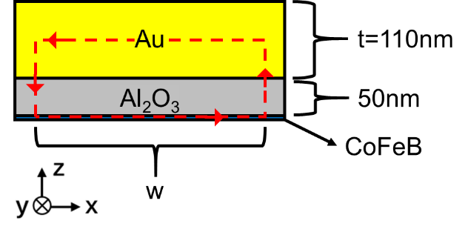
Fig. S1. Demonstration of using Maxwell’s equations to calculate the equivalent induction bias field generated by electrified Au line.

Next, we performed COMSOL simulations, and the results show that 200 mA current flowing through an Au line can generate a bias field of about 25 Oe in the FM layer, as shown in Fig. S2. The Au line has a width and a thickness of 50 μm and 110 nm, respectively. The distance between FM layer and the bottom of Au line is 50 nm. The relative magnetic permeability of the CoFeB layer is set to 1.
There is almost no discrepancies on the estimated magnetic field from different methods among the experimental measurements, theoretical calculations, and COMSOL simulations. It has also been verified in our previous work [1].
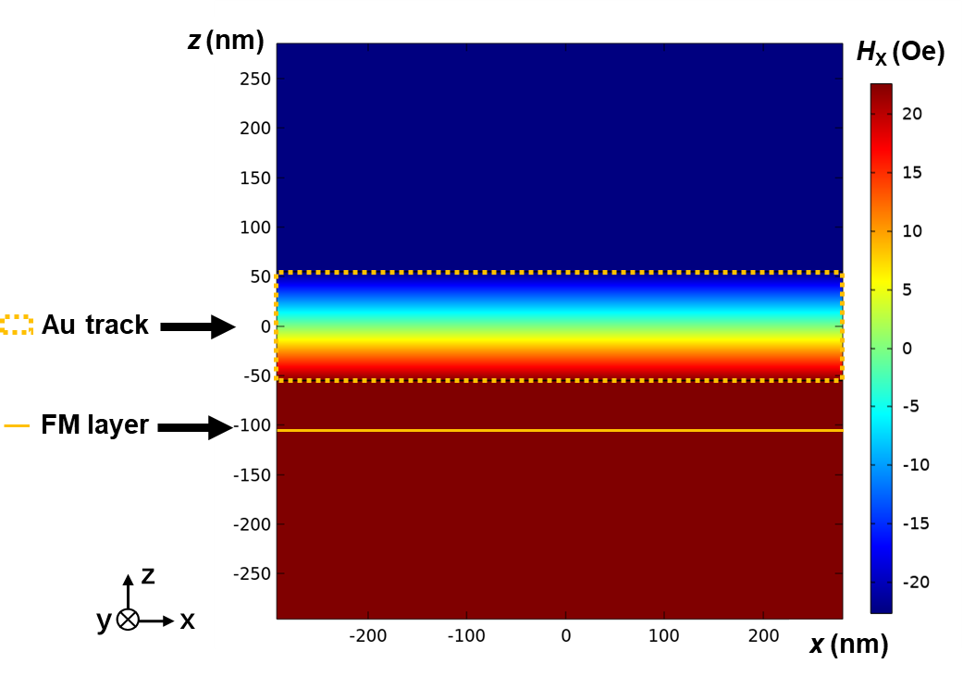
Fig. S2. Simulation verification of equivalent bias field distribution which generated by 200 mA current flowing through Au line.

S2. Complete Boolean logic functions
For R = A˄B, we set C = 1 (I_{C} = +0.2 A) and D = 1 (I_{D} = +1.8 mA). Then, if I_{A} + I_{B} ≤ 0 A, such as A = B = 0 (I_{A} + I_{B} − I_{C} = −0.6 A), A = 0 & B = 1, or A = 1 & B = 0 (I_{A} + I_{B} − I_{C} = −0.2 A), the total in-plane magnetic fields will be along −x direction, resulting in a clockwise switching polarity. Since I_{D} is positive, the magnetization will be switched to downward state and the output will be R = 0. But if A = B = 1 (I_{A} + I_{B} − I_{C} = +0.2 A), the total in-plane magnetic field will be along +x direction, causing an anti-clockwise switching polarity and R = 1.
For R = A˅B, we set C = 0 (I_{C} = −0.2 A) and D = 1 (I_{D} = +1.8 mA). Then, if I_{A} + I_{B} ≥ 0 A, such as A = B = 1 (I_{A} + I_{B} − I_{C} = +0.6 A), A = 0 & B = 1, or A = 1 & B = 0 (I_{A} + I_{B} − I_{C} = +0.2 A), the total in-plane magnetic fields will be along +x direction, resulting in an anti-clockwise switching polarity. Since I_{D} is positive, the magnetization will be switched to upward state and the output will be R = 1. But if A = B = 0 (I_{A} + I_{B} − I_{C} = −0.2 A), the total in-plane magnetic field will be along −x direction, causing a clockwise switching polarity and R = 0.
For R = ¬A˅¬B, we set C = 1 (I_{C} = +0.2 A) and D = 0 (I_{D} = −1.8 mA). Then, if I_{A} + I_{B} ≤ 0 A, such as A = B = 0 (I_{A} + I_{B} − I_{C} = −0.6 A), A = 0 & B = 1, or A = 1 & B = 0 (I_{A} + I_{B} − I_{C} = −0.2 A), the total in-plane magnetic fields will be along −x direction, resulting in a clockwise switching polarity. Since I_{D} is negative, the magnetization will be switched to upward state and the output will be R = 1. But if A = B = 1 (I_{A} + I_{B} − I_{C} = +0.2 A), the total in-plane magnetic field will be along +x direction, causing an anti-clockwise switching polarity and R = 0.
For R = ¬A˄¬B, we set C = 0 (I_{C} = −0.2 A) and D = 0 (I_{D} = −1.8 mA). Then, if I_{A} + I_{B} ≥ 0 A, such as A = B = 1 (I_{A} + I_{B} − I_{C} = +0.6 A), A = 0 & B = 1, or A = 1 & B = 0 (I_{A} + I_{B} − I_{C} = +0.2 A), the total in-plane magnetic fields will be along +x direction, resulting in an anti-clockwise switching polarity. Since I_{D} is negative, the magnetization will be switched to downward state and the output will be R = 0. But if A = B = 0 (I_{A} + I_{B} − I_{C} = −0.2 A), the total in-plane magnetic field will be along −x direction, causing a clockwise switching polarity and R = 1. The experimental implementation of the above logic operations is shown in Figure S3.
Fig. S3. Truth table and demonstration of complete Boolean logic functions, encompassing the operations of R = A˄B, R = A˅B, R = ¬A˅¬B, and R = ¬A˄¬B.

For R = ¬A˅C, we set B = 0 (I_{B} = −0.2 A) and D = 0 (I_{D} = −1.8 mA). Then, if A = C = 0 (I_{A} + I_{B} − I_{C} = −0.2 A), A = 0 & C = 1 (I_{A} + I_{B} − I_{C} = −0.6 A), A = C = 1 (I_{A} + I_{B} − I_{C} = −0.2 A), the total in-plane magnetic fields will be along −x direction, resulting in a clockwise switching polarity. Since I_{D} is negative, the magnetization will be switched to upward state and the output will be R = 1. But if A = 1 & C = 0 (I_{A} + I_{B} − I_{C} = +0.2 A), the total in-plane magnetic fields will be along +x direction, causing an anti-clockwise switching polarity and R = 0.
For R = A˄¬C, we set B = 0 (I_{B} = −0.2 A) and D = 1 (I_{D} = +1.8 mA). Then, if A = C = 0 (I_{A} + I_{B} − I_{C} = −0.2 A), A = 0 & C = 1 (I_{A} + I_{B} − I_{C} = −0.6 A), A = C = 1 (I_{A} + I_{B} − I_{C} = −0.2 A), the total in-plane magnetic fields will be along −x direction, resulting in a clockwise switching polarity. Since I_{D} is positive, the magnetization will be switched to downward state and the output will be R = 0. But if A = 1 & C = 0 (I_{A} + I_{B} − I_{C} = +0.2 A), the total in-plane magnetic fields will be along +x direction, causing an anti-clockwise switching polarity and R = 1.
For R = ¬A˄C, we set B = 1 (I_{B} = +0.2 A) and D = 0 (I_{D} = −1.8 mA). Then, if A = C = 0 (I_{A} + I_{B} − I_{C} = +0.2 A), A = 1 & C = 0 (I_{A} + I_{B} − I_{C} = +0.6 A), A = C = 1 (I_{A} + I_{B} − I_{C} = +0.2 A), the total in-plane magnetic fields will be along +x direction, resulting in an anti-clockwise switching polarity. Since I_{D} is negative, the magnetization will be switched to downward state and the output will be R = 0. But if A = 0 & C = 1 (I_{A} + I_{B} − I_{C} = −0.2 A), the total in-plane magnetic fields will be along −x direction, causing a clockwise switching polarity and R = 1.
For R = A˅¬C, we set B = 1 (I_{B} = +0.2 A) and D = 1 (I_{D} = +1.8 mA). Then, if A = C = 0 (I_{A} + I_{B} − I_{C} = +0.2 A), A = 1 & C = 0 (I_{A} + I_{B} − I_{C} = +0.6 A), A = C = 1 (I_{A} + I_{B} − I_{C} = +0.2 A), the total in-plane magnetic fields will be along +x direction, resulting in an anti-clockwise switching polarity. Since I_{D} is positive, the magnetization will be switched to upward state and the output will be R = 1. But if A = 0 & C = 1 (I_{A} + I_{B} − I_{C} = −0.2 A), the total in-plane magnetic fields will be along −x direction, causing a clockwise switching polarity and R = 0. The experimental implementation of the above logic operations is shown in Fig. S4.
Fig.S4. Truth table and demonstration of complete Boolean logic functions, encompassing the operations of R = ¬A˄C, R = A˅¬C, R = ¬A˄C and R = A˅¬C.

For R = A↔D, we set B = 0 (I_{B} = −0.2 A) and C = 0 (I_{C} = −0.2 A). When A = D = 0 (I_{A} + I_{B} − I_{C} = −0.2 A), the total in-plane magnetic fields will be along −x direction, resulting in a clockwise switching polarity and R = 1; When A = 0 & D = 1 (I_{A} + I_{B} − I_{C} = −0.2 A), the total in-plane magnetic fields will be along −x direction, resulting in a clockwise switching polarity and R = 0; When A = 1 & D = 0 (I_{A} + I_{B} − I_{C} = +0.2 A), the total in-plane magnetic fields will be along +x direction, resulting in anti-clockwise switching polarity and R = 0; When A = D = 1 (I_{A} + I_{B} − I_{C} = +0.2 A), the total in-plane magnetic fields will be along +x direction, resulting in an anti-clockwise switching polarity and R = 1.
For R = C⊕D, we set A = 0 (I _{A}= −0.2 A) and B = 1 (I_{B} = +0.2 A). When C = D = 0 (I_{A} + I_{B} − I_{C} = +0.2 A), the total in-plane magnetic fields will be along +x direction, resulting in an anti-clockwise switching polarity and R = 0; When C = 0 & D = 1 (I_{A} + I_{B} − I_{C} = +0.2 A), the total in-plane magnetic fields will be along +x direction, resulting in an anti-clockwise switching polarity and R = 1; When C = 1 & D = 0 (I_{A} + I_{B} − I_{C} = −0.2 A), the total in-plane magnetic fields will be along −x direction, resulting in a clockwise switching polarity and R = 1; When C = D = 1 (I_{A} + I_{B} − I_{C} = −0.2 A), the total in-plane magnetic fields will be along −x direction, resulting in a clockwise switching polarity and R = 0.
For R = A / B, only we set D = 1 (I_{D} = +1.8 mA). When A = 0 or B = 0 (I_{A} or I_{B} = −0.2 A), the total in-plane magnetic fields will be along −x direction, resulting in a clockwise switching polarity and R = 0. When A = 1 or B = 1 (I_{A} or I_{B} = +0.2 A), the total in-plane magnetic fields will be along +x direction, resulting in an anti-clockwise switching polarity and R = 1.
For R = ¬A / ¬B, only we set D = 0 (I_{D} = −1.8 mA). When A = 0 or B = 0 (I_{A} or I_{B} = −0.2 A), the total in-plane magnetic fields will be along −x direction, resulting in a clockwise switching polarity and R = 1. When A = 1 or B = 1 (I_{A} or I_{B} = +0.2 A), the total in-plane magnetic fields will be along +x direction, resulting in an anti-clockwise switching polarity and R = 0.
For R = 1, we set A = B = D = 1 (I_{A} = +0.2 A, I_{B} = +0.2 A, I_{D} = +1.8 mA). When C = 0 (I_{C} = −0.2 A), the total in-plane magnetic fields will be along +x direction, resulting in an anti-clockwise switching polarity and R = 1. When C = 1(I_{C} = +0.2 A), the total in-plane magnetic fields will be along +x direction, resulting in an anti-clockwise switching polarity and R = 1.
For R = 0, we set A = B = 0, D = 1 (I_{A} = −0.2 A, I_{B} = −0.2 A, I_{D} = +1.8 mA). When C = 0 (I_{C} = −0.2 A), the total in-plane magnetic fields will be along −x direction, resulting in a clockwise switching polarity and R = 0; When port C = 1 (I_{C} = +0.2 A), the total in-plane magnetic fields will be along −x direction, resulting in a clockwise switching polarity and R = 0. The experimental implementation of the above logic operations is shown in Fig. S5.
Fig. S5. Truth table and demonstration of complete Boolean logic functions, encompassing the operations of R = A↔D, R = C⊕D, R = A / B, R = ¬A / ¬B, R = 1 and R = 0.

S3. Energy/area estimation and comparison with CMOS-based logic circuits.
In this section, we calculated the power consumption required for each logic operation in our device. In our device, the current I_{D}, which flows through the HM/FM heterostructure, is 1.8 mA. The resistance of the device (R_{xx}) is measured as 4.5 kΩ, corresponding to a resistivity of ρ_{xx} = 237 μΩ·cm. Then, the power consumption of this part is calculated as 14.58 mW. For currents flowing through the Au line, |I_{A}| = |I_{B}| = |I_{C}| = 200 mA. The resistance of the Au line (R_{Au}) is measured as 8 Ω (ρ_{Au} = 7.9 μΩ·cm). The maximum power consumption produced in Au line at a single operation is 2.88 W. Therefore, the maximum total power consumption of one logic operation is approximately 2.89 W.
Furthermore, the logic device structure can be developed as a SOT-MTJ structure, with a size of 60 nm × 60 nm and a write current of 112 MA cm⁻² under a write time of 1 ns [2]. In this case, the size of HM layer can be scaled down to 100 nm (length) × 60 nm (width) × 5 nm (thickness). Under such a size, the resistance in the HM layer of the MTJ is approximately 790 Ω assuming the resistivity is unchanged (237 μΩ·cm for our Hall-bar device), and I_{D} = 336 μA (corresponding to 112 MA cm⁻²). The power consumption of this part is 89.2 μW. Meanwhile, to ensure a sufficiently bias field, the Au line can be scaled down to 100 nm (length) × 60 nm (width) × 30 nm (thickness). The current flowing through the Au line (I_{Au}) is considered as 5 × 10⁻⁴ A (corresponding to a current density of 27.78 MA cm⁻²), with which a bias field of 30 Oe can be generated, as shown in Fig. S6. Under such a size, the resistance in the Au line is approximately 4.39 Ω, and the maximum power consumption of this part is 9.88 μW. To sum up, the total power consumption of one logic operation is approximately 99.1 μW. Moreover, under the write time of 1 ns, the logic energy can reach 99.1 fJ.
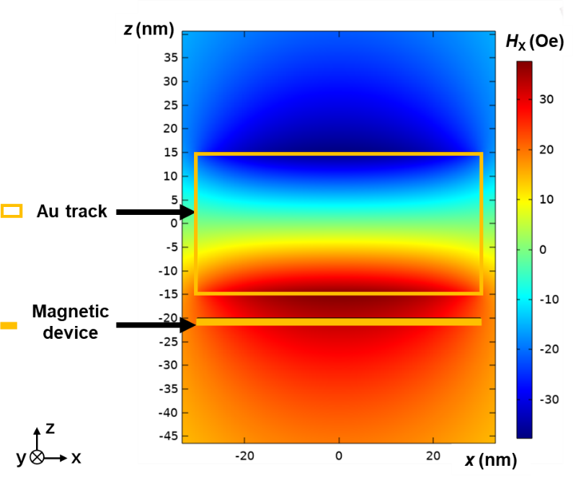
Fig. S6. Simulation of bias field distribution generated by an Au line with a current of 5 × 10⁻⁴ A, the width and thickness of Au line are 60 nm and 30 nm, respectively.

Table S1 compares the logic performance between our expected optimized device with scaled dimension and logics based on STT-MTJ, giant spin Hall effect (GSHE), two-dimensional memristor (2D-MEM) and memristors-as-drivers gate (MAD). Our expected optimized gate can achieve complete 16 Boolean logic functions in a single device, which based on a SOT-MTJ unit with bias field Au line. Moreover, it has a faster logic speed and lower energy consumption than the logic gate based on STT-MTJ [3]. Compared with the simulation model based on GSHE [4], the experimental work based on 2D-memristor [5] and the MAD gates using driver circuitry [6], our expected device in optimized case has more diverse programmable logic functions, results in higher programmability and reconfigurable performance. Due to initialization-free that realizing the synchronization clock operation, our device shows significant improvement in terms of logic unit, power consumption, logic density, and so on.

Table S1
Comparison of logic performance with other works.
NAND/NOR Operation | This work |  |  | STT-MTJ [3] |  | GSHE [4] | 2D-MEM [5] | MAD [6]
NAND/NOR Operation | (reality) |  | (optimization)
Number of logic units | 1 Hall bar | 1 MTJ |  | 1 MTJ +  1 MOS |  | 1 GSHE | 1 MEM | 8 MEM +  9 RES
Per logic time | 0.2 s | 1 ns |  |  | 4.8 ns | 8 ns | 50 ns | 400 ps
Power consumption | 2.89 W | 99.1 μW |  |  | 542 μW | 0.56 μW | 2.0 μW | 82.5 μW
Power delay product | 0.432 J | 99.1 fJ |  |  | 2.6 pJ | 4.46 fJ | 100 fJ | 33 fJ
Initialization-free | √ |  |  |  | × | × | × | ×
Core size | 1μm | 60 nm |  |  | 50 nm | 14 nm | 20 nm | -
Boolean logic | 16 |  |  |  | 16 | 6 | 3 | 6

S4. Cascading scheme
Cascadability is a key point to be considered for the logic implementation. Here, we propose a cascading scheme between programmable logic gates, as illustrated in Fig. S7(a). We define different ports as programming control ports, to implement different logics. If the output voltage of previous device is higher than reference voltage, the 2:1 gated switch (SW₁~SW₁₂) will input the positive current (I_{Au,H} or I_{D,H}) to the next logic gate; otherwise, if the voltage is less than the reference voltage, the SW will connect the negative current (I_{Au,L} or I_{D,L}) to the next logic gate. The I_{D,L} or I_{D,H} represents the negative or positive current flowing through the HM layer, respectively, while the I _{Au,L} or I _{Au,H} represents the negative or positive current flowing through the Au line, respectively. As shown in the illustration, the first and second gates perform XNOR logic operations on X, Y and C_{in} to get V_{S}, and then performs three AND logic operations to get XY, XC_{in} and YC_{in}, finally performs two OR logic operations to get V_{Cout}, and decoding V_{Cout} and V_{S} to get the result of the above logic expressions. To sum up, we only use six of our logic units, with adding some gated switch circuits to realize the complex function of 1-bit Full-Adder.
In this way, the cascadability of logic units is realized with the assistance of the switch circuits, it can develop to large-scale integration and complex logic functions in the future. At the same time, a more efficient cascade scheme will be the next optimization direction of this work. Two schematic diagrams with different perspectives of the logic gate by replacing Hall Bar for SOT-MTJ, to provide a larger output signal, are demonstrated, and the currents through the Au line above and beneath MTJ is designed to adjust the in-plane bias fields, as illustrated in Figs. S7(b) and (c), respectively. An ideal current source is used for providing the reading signal. By replacing current with voltage for input, or taking output voltage directly as input signal of the next logic unit, can effectively reduce the hardware overhead of the circuit.
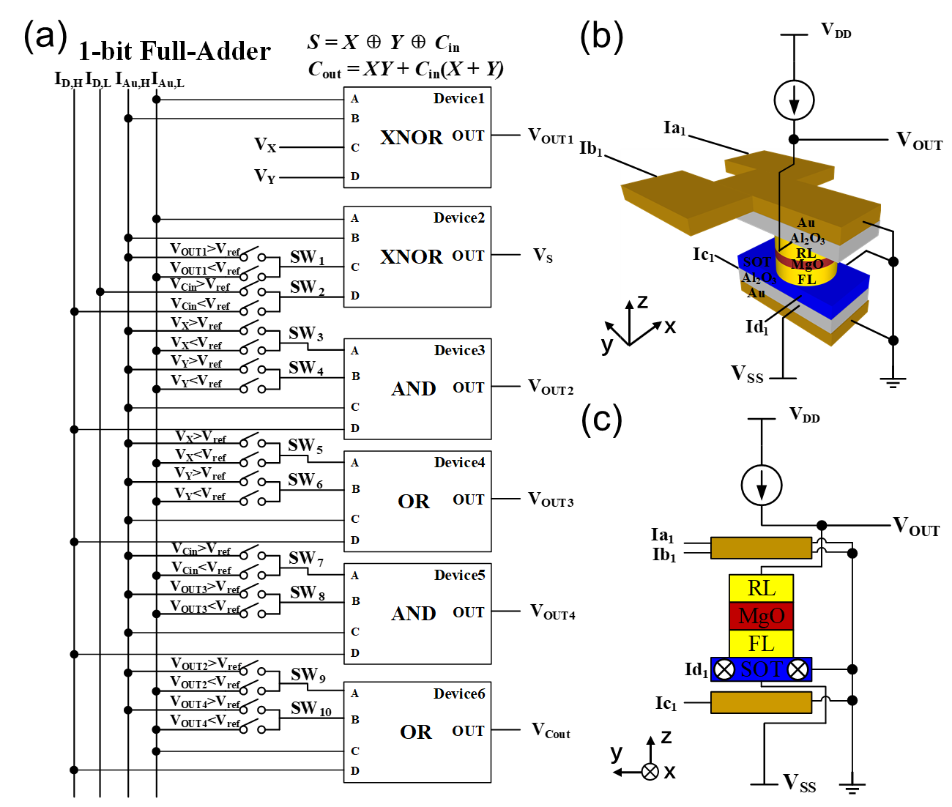
Fig. S7. Cascade scheme between spin logic gates; (a) Adding gated switches to realize circuits encoding for cascading; (b)(c) schematic diagrams of logic gate by replacing Hall Bar for SOT-MTJ.

S5. Method to increase logical density
Logic density is a key factor should be considered in the practical application of programmable logic chip; it is related to whether a logic gate can be applied for large-scale integration. We design a method based on SOT-MTJ for multiple gates interconnection to improve array integration and logical density, as illustrated in Fig. S8. Since ports C and D are selected as the programming control ports, interconnects ports C and D of four logic gates is considered. The logic gates are connected through a U-shaped structure in a symmetrical way to achieve different logic operation functions. When the forward current flows through port C or D of one logic gate, the equivalent reverse current flows through port C or D of the mirror gate. In general, ports C and D are chosen as programming control ports, which can implement AND, OR, NAND and NOR logic functions. Therefore, through sharing the programming control ports, a low-power consumption, high-logic density and low-redundancy logic gate array can be achieved.
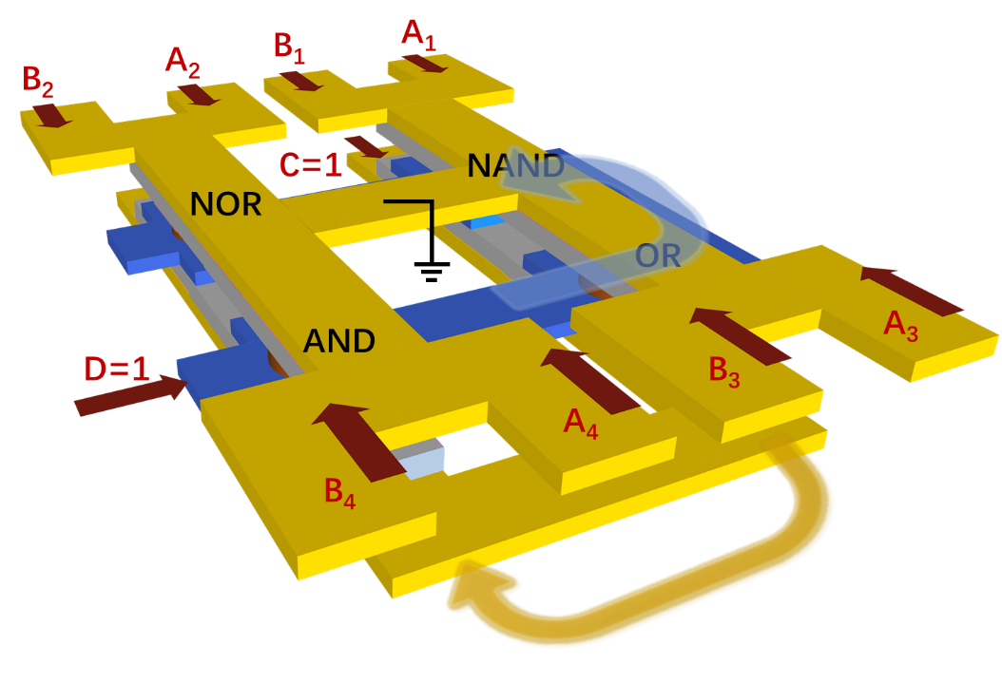
Fig. S8. Schematic of a logic gate array composed of four different logic functions, which includes NAND, OR, NOR, AND gates.

References
[1] Li R, Song M, Guo Z, Li S, Duan W, Zhang S, et al. In‐Memory Mathematical Operations with Spin‐Orbit Torque Device. Adv Sci 2022;9(25):2202478.
[2] Garello K, Yasin F, Kar GS. Spin-Orbit Torque MRAM for ultrafast embedded memories: from fundamentals to large scale technology integration. IEEE Int Memory Workshop 2019;1-4, doi: 10.1109/IMW.2019.8739466.
[3] Huang Y, Cao K, Zhang K, Wang J, Shi K, Hao Z, et al. Implementation of 16 Boolean logic operations based on one basic cell of spin-transfer-torque magnetic random access memory. Sci China Inf Sci 2023;66(6):162402.
[4] Rangarajan N, Parthasarathy A, Kani N, Rakheja S. Energy-efficient computing with probabilistic magnetic bits-Performance modeling and comparison against probabilistic CMOS logic. IEEE T Magn 2017;53(11):1-10.
[5] Liu L, Li Y, Huang X, Chen J, Yang Z, Xue K, et al. Low‐Power Memristive Logic Device Enabled by Controllable Oxidation of 2D HfSe2 for In‐Memory Computing. Adv Sci 2021;8(15):2005038.
[6] Guckert L, Swartzlander EE. MAD gates-Memristor logic design using driver circuitry. IEEE Trans Circuits Syst. II Express Briefs, 2016;64(2):171-5.

