Supplementary Data for
High-Efficiency Circularly-Polarized Phased Array Based on 5 μm-Thick Nematic Liquid Crystals: Design, OTA Calibration, and Experimental Validation
Xin Yu Wu ª, Fengshuo Wan ª, Hong Yuan Feng ª, Shichao Jin ^{b}, Chong Guo ^{a,c}, Yu Wei ª, Dunge Liu ^{b}, Yuqian Yang ^{b}, Longzhu Cai ^{a,c}, Zhi Hao Jiang ^{a,c,*}, Wei Hong ^{a,c}
ª State Key Laboratory of Millimeter Waves, School of Information Science and Engineering, Southeast University, Nanjing 210096, China
^{b} State Key Laboratory of Space–Ground Integrated Information Technology, Beijing Institute of satellite Information Engineering, Beijing 100095, China
^{c} Research Institute of Millimeter-Wave and Terahertz Technology (RIMMATT), Nanjing 211111, China

* Corresponding author.
E-mail address: zhihao.jiang@seu.edu.cn (Z. H. Jiang).

S1. Parametric study on LCPS performance
To further analyze the influence of the LC layer thickness on the performance of the LCPS, a parametric study on the LC layer thickness is carried out by varying the thickness from 3.5 to 6.5 μm. The simulated results are illustrated in Fig. S1. It can be observed that the variation of the insertion loss and range of phase shift, caused by the ±10% LC layer thickness variation, are less than 0.6 dB and 80 deg, respectively. The amount of phase shift is still good enough for beamforming. As shown in Fig. S2, the actual measured variation of phase shift of the 16 channels of LCPA is less than 50 deg, which is also in line with the numerical results shown in Fig. S1(b). This indicates that the LC layer thickness variation is less than 10%, i.e., around 5% to 7%, which is acceptable and almost will not deteriorate the performance of the final LCPA. Therefore, from the results shown in Fig. 8(a) in the main text, it can be seen that more consistent responses of the LCPA channels can be obtained by improving the fabrication accuracy.
Fig. S1. Simulated (a) insertion loss and (b) phase shifting ranges of the LCPS with different LC layer thickness at 25.5 GHz.

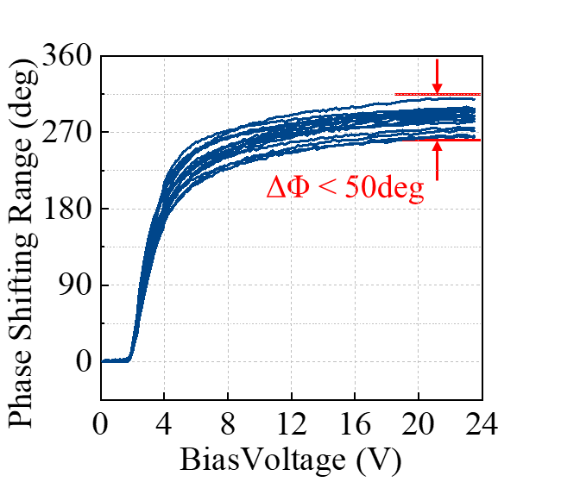
Fig. S2. Comparison of the measured phase shifting ranges of all 16 channels of the LCPA at 25.5 GHz.

In addition to the LC thickness, the effect of another variable, i.e. the number of the LCPS units, was also investigated, as shown in Fig. S3. The LC thickness is changed from 4 to 6 μm while the number of LCPS units varies from 34 to 50. Accordingly, the electrical length of the LCPS lies within the range from 2.04λ₀ to 3.66λ₀. For these cases, the simulated phase shifting range, averaged insertion loss, and figure-of-merit (FoM) are illustrated in Figs. S3(a)–(c), respectively. It can be observed that, by reducing the thickness of LC layer, the LCPS can possess a larger phase shifting range, a smaller length, a faster response time, and a higher insertion loss. When designing the LCPSs, a thinner LC layer and higher FoM should be targeted for reaching a phase shifting range of 360 deg and manufacturable by the fabrication process.
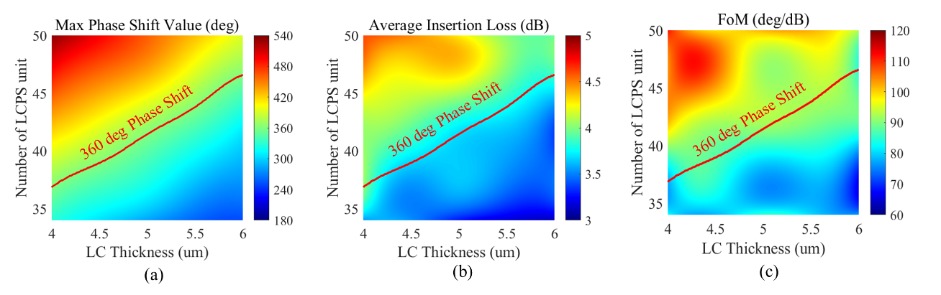
Fig. S3. Simulated (a) phase shift range, (b) averaged insertion loss, and (c) FoM of LCPSs with different LC thicknesses and numbers of LCPS units.

S2. Robustness test of the LCPA
In order to illustrate the robustness of the fabricated LCPS, we conducted two experiments by repeatedly switching between two different bias voltages and observing the stability of the phase shift properties. In the first experiment, the bias voltage was switched between 0 V and 6 V repeatedly. In the second experiment, the bias voltage was switched between 0 V and 20 V repeatedly. In these experiments, the period of switch was set to be 0.5 s. The measured phase response curves are plotted in Fig. S4. The averaged value and standard deviation of the measured results are listed in Table S1. It can be observed that the LCPSs of the phased array can still maintain a stable phase shift even after 1000 times of switching cycles.
Fig. S4. Measured phase response of the radiating beam of the LCPA after several switching cycles.

Table S1
Averaged value and standard deviation of the phase response of the LCPA with different bias voltages after certain numbers of switching cycles.
Number of Switch Cycles | 1st Experiment |  | 2nd Experiment
Number of Switch Cycles | V_{bias} = 0 V | V_{bias} = 6 V | V_{bias} = 0 V | V_{bias} = 20 V
10 | 16.76° ± 1.22° | -175.60° ± 2.88° | 17.14° ± 2.02° | -226.62° ± 3.13°
50 | 17.36° ± 0.67° | -179.20° ± 4.25° | 17.53° ± 0.94° | -228.04° ± 2.59°
100 | 17.39°± 0.52° | -178.76° ± 3.89° | 17.59° ± 0.73° | -230.52° ± 3.42°
1000 | 17.45°± 0.47° | -178.86° ± 3.44° | 17.57° ± 0.66° | -230.81° ± 3.76°

S3. Detailed information of the LCPA radiation performance
The simulated and measured radiation pattern as well as the gain and axial ratio curves are illustrated in Fig. 10 and Fig. 11 in the main manuscript. In order to provide the accurate values of gain and axial ratio of the scanned beams at different frequencies, the specific gain values of the beams scanning from −40° to +40° at different frequencies are provided in added in Table S2. It can be seen that the measured and simulated gain values match well with each other, with an averaged deviation of only 0.99 dB, 0.56 dB, and 0.86 dB at 25.5 GHz, 25.75 GHz, and 26 GHz, respectively. The measured gain fluctuation of the beams scanning from −40° to +40° is less than 1.76 dB, 1.62 dB, and 1.66 dB at three measured frequency points.
The specific AR values in the half-power beamwidth of the beams scanning from −40° to +40° at different frequencies are provided in added in Table S3. It can be seen that the AR values within the half-power beamwidth are still less than 3 dB for majority of the scanned beams. However, it should be noted that in practical applications, such as radars and wireless communications, the critical parameter regarding the polarization purity of a CP beam is the AR value in the maximum radiation direction, since that is where the receiver locates. From another perspective, for the few cases where the AR values of the beam deteriorates at the edge of the half-power beamwidth, such as θ_{scan}+Δθ, the beam direction of the proposed LCPA could be readily adjusted from θ_{scan} to θ_{scan}+Δθ in practical application to always ensure a good AR. This is one of the advantages of the beam steering phase arrays over the static passive antenna arrays.

Table S2
Specific gain of LCPA of different scanning beams (Units: dBic)
θ_{scan} | 25.5 GHz |  | 25.75 GHz |  | 26 GHz
θ_{scan} | Simu. | Meas. | Simu. | Meas. | Simu. | Meas.
−40° | 11.59 | 10.46 | 11.38 | 10.86 | 11.40 | 10.76
−30° | 12.48 | 12.22 | 12.43 | 12.48 | 12.42 | 11.78
−20° | 12.66 | 12.02 | 12.47 | 11.92 | 12.52 | 11.28
−10° | 12.78 | 11.39 | 12.60 | 12.02 | 12.78 | 12.42
0° | 12.79 | 11.94 | 12.45 | 11.39 | 12.85 | 10.92
+10° | 12.99 | 11.85 | 12.67 | 12.03 | 12.79 | 11.65
+20° | 12.41 | 11.07 | 12.33 | 11.81 | 12.39 | 12.08
+30° | 12.43 | 10.93 | 12.24 | 11.58 | 12.19 | 11.57
+40° | 12.00 | 11.33 | 11.83 | 11.37 | 11.69 | 10.86

Table S3
Maximum AR in the half-power beamwidth (−60° ≤ θ_{scan} ≤ +60°, Units: dB)
θ_{scan} | 25.5 GHz |  | 25.75 GHz |  | 26 GHz
θ_{scan} | Simu. | Meas. | Simu. | Meas. | Simu. | Meas.
−40° | 2.45 | 4.24 | 3.36 | 2.25 | 4.93 | 2.38
−30° | 1.24 | 2.24 | 2.05 | 1.41 | 3.45 | 2.82
−20° | 1.49 | 3.04 | 1.17 | 1.89 | 2.29 | 2.05
−10° | 1.56 | 3.15 | 1.52 | 2.45 | 2.94 | 2.97
0° | 1.71 | 7.02 | 1.63 | 4.34 | 3.04 | 4.64
+10° | 1.49 | 3.16 | 1.49 | 1.87 | 3.00 | 2.12
+20° | 1.56 | 3.79 | 0.97 | 3.43 | 2.28 | 2.83
+30° | 1.67 | 2.08 | 1.27 | 1.12 | 2.70 | 1.33
+40° | 2.63 | 2.85 | 3.91 | 2.55 | 5.36 | 3.74

