Supplementary data for

AUH, A New Technology for Ocean Exploration
Jing Zhou ª, Haocai Huang ª, S.H. Huang ª, Yulin Si ª, Kai Shi ^{c}, Xiangqian Quan ^{d}, Chunlei Guo ^{c}, Chen-Wei Chen ª, Zhikun Wang ª, Yingqiang Wang ª, Zhanglin Wang ª, Chengye Cai ª, Ruoyu Hu ª, Zhenwei Rong ª, Jiazhong He ª, Ming Liu ª, Ying Chen ^{a,b}
ª Zhejiang University, Hangzhou 310027, China
^{b} State Key Laboratory of Fluid Power & Mechatronic Systems, Zhejiang University, Hangzhou 310027, China
^{c} State Key Laboratory of Robotics, Shenyang Institute of Automation, Chinese Academy of Sciences, Shenyang 110169, China
^{d} Institute of Deep-sea Science and Engineering, Chinese Academy of Sciences, Sanya 572000, China

MethodsX details

1. Acoustic and optical navigation scheme
The navigation module of the AUH consists of an piUSBL system, an inertial measurement unit (IMU) and a depth sensor (Fig. S1). The piUSBL is a recently proposed system for underwater acoustic positioning, featuring low energy consumption [1]. Normally, the beacon of a USBL is placed on an underwater vehicle, and multiple receiving unit arrays are placed on the ship/shore base station. After receiving signals sent from the underwater vehicle, the ship/shore base station calculates the location and attitude information. Acoustic communication is necessary for an underwater vehicle to acquire its own position. This paper presents an piUSBL system in which a six-element hydrophone on the AUH and one beacon on the base station are used. The advantage of piUSBL positioning system mainly lie in the following three aspects [2-5]: (i)The piUSBL system features low-cost, low-power, and lightweight; (ii) the underwater vehicle is able to get instantaneous acoustic measurements, without waiting for the topside measurements through acoustic communication equipment as in the conventional USBL; (iii) the omnidirectional positioning pulses from the beacon enable passive receivers on multiple vehicles to self-locate and navigate concurrently, which is of great significance to multi-vehicle applications.
Acoustic navigation is usually utilized when the AUH cruises within a 3 km range of the helipad. The motion control panel perceives data from sensors, and outputs motion commands after position calculation. The inertial measurement unit (IMU) measures the three-axis attitude angle and acceleration rate of the AUH. The piUSBL system is used to determine the exact position of the AUH according to the delay difference in the acoustic signals sent to and received from the vehicle. A depth sensor measures the depth of the AUH. Having received data from the positioning system, the motion control panel then calculates the actual position of the AUH and compares it with the target position and determines the amount of thrust accordingly.
In the far end, the AUH determines its position with an acoustic transducer and navigates towards the helipad. Upon approaching the helipad, the AUH gradually adjusts its posture to align with the target orientation. In the near end, the AUH tracks the navigation lights with a machine vision algorithm to adjust its position and posture precisely and dock with the helipad successfully.
When the distance between the AUH and helipad is within a given value (usually < 15 m), the AUH switches to optical navigation mode. The camera will first detect whether the light source is within the camera view. If the light source is not found, the AUH will keep moving to obtain a larger field of view for a second detection. If the second detection fails, the AUH determines that the helipad is still outside the specified distance and will switch back to acoustic navigation mode until the light source is finally detected. Once the light source is detected, a program will call the camera to capture an image frame. Image pre-processing is conducted afterwards, including de-interference, noise reduction, sharpening, de-distortion and binarization. According to the image processing algorithm, the features of the image are extracted and analyzed to obtain the relative deviation angle and pixel distance between the AUH and the helipad. These processing results are sent to the MCU through a serial port. The propellers are modulated according to the calculated deviation angle and distance through closed-loop PID control. Once the docking conditions are met, the propellers push the vehicle downwards into the helipad.
It is worth noting that the maximum depth feasible for optical depends on the penetration distance of light in seawater, which is usually 10–20 meters (as the surface seawater can be affected by pollution and biological activities, the clarity of the seawater increases with the increase of water depth). On the other hand, the transition point between acoustic and optical navigation is also relevant to the terminal acoustic positioning accuracy. When the AUH is too close to the helipad ( < 10 meters), the positioning accuracy is greatly reduced, which is not enough to guide AUH dock into the helipad.

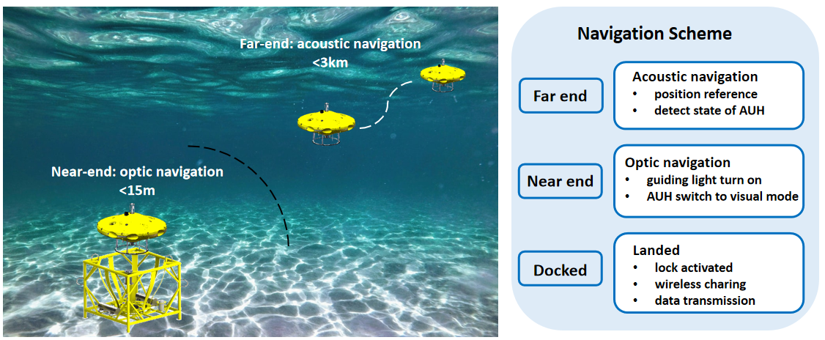
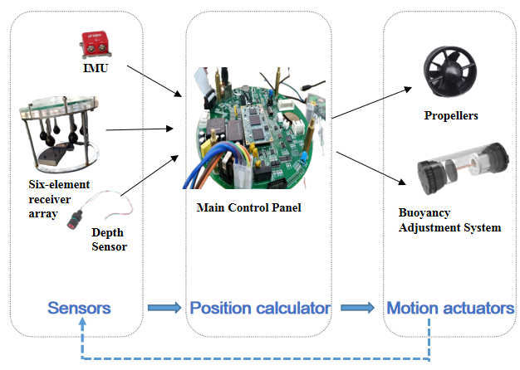
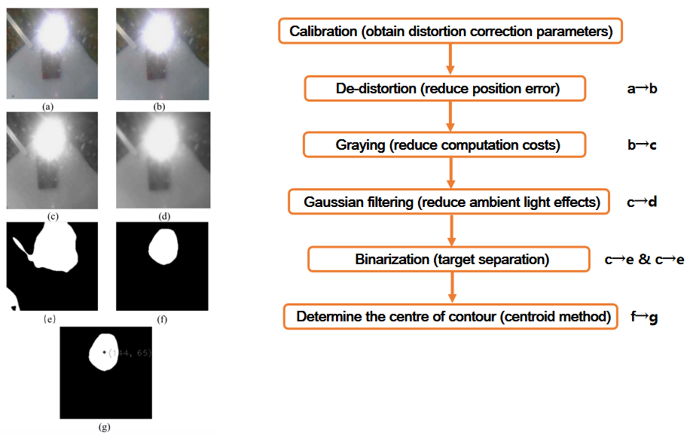
Fig. S1. Acoustic-optical navigation scheme(Top). Sensors and actuators(Middle). Image-processing procedure (Bottom).

2. Operation principle of acoustic positioning system
The uniqueness of the acoustic positioning system of the AUH, piUSBL, is further illustrated in Fig. 8 in the manuscript. A conventional USBL positioning system consists of a transceiver mounted under a mother ship and a responder on the subsea target. The transceiver, which transmits acoustic pulses to trigger the responder to get an echo responding, determines the relative slant range and angle from itself to the responder [6]. For our piUSBL, a single acoustic beacon is placed on a mother ship or a subsea station as a reference point, periodically broadcasting a predefined positioning signal. A passive receiving array, which is time-synchronized to the beacon, is mounted on the moving AUH rather than on the topside surface ship like the conventional USBL transceiver, explaining the so-called inverted mode. The relative range and angle between the beacon and the receiving array are determined by one-way travel-time acoustic measurements on the AUH, using the synchronized clocks on both sides [2–5].
There are three distinct advantages of our piUSBL positioning system [2–5]: firstly, the passive nature of the acoustic receiver helps AUVs outfitted with piUSBL receivers become low-cost, low-power, and lightweight; secondly, the inverted mode of mounting the receiver on the AUV makes it possible for the AUV to get instantaneous acoustic measurements, without waiting for the topside measurements through acoustic communication equipment as in the conventional USBL; thirdly, the omnidirectional positioning pulses from the beacon enable passive receivers on multiple AUVs to self-locate and navigate concurrently, which is of great significance to multi-AUV applications.

3. Design and verification of sea trial scheme
The objective of the sea trial was to test the operation performance of the AUH, such as mobility and navigation capability. The AUH is required to complete mobility tests, such as moving straight forward, circular steering, fixed-point hovering, floating and sinking, landing on and taking off from the helipad and under piUSBL and acoustic-optic combined navigation. A series of sea trial tests were designed and performed as follows:
3.1. Basic sailing performance test
The basic sailing performance includes the motions of diving and floating up, all-round steering, fixed altitude sailing, etc. The experiments were designed to test and verify the basic navigation capabilities and performance indicators of the AUH, including diving and ascent speeds, steering and orientation performance, and fixed-altitude orientation performance. The variation of navigation data with time is shown in Figs. S2–S4.
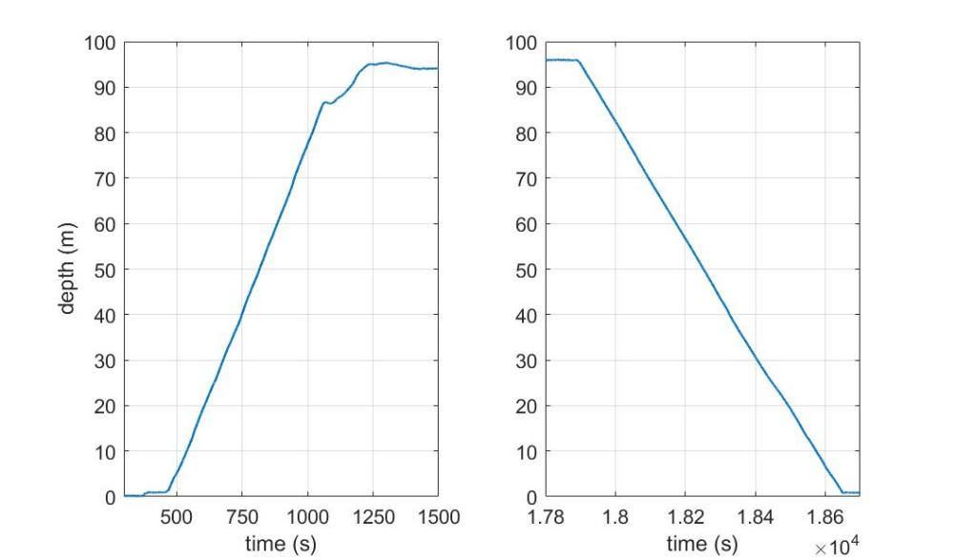
Fig. S2. Diving(left) and floating up(right).
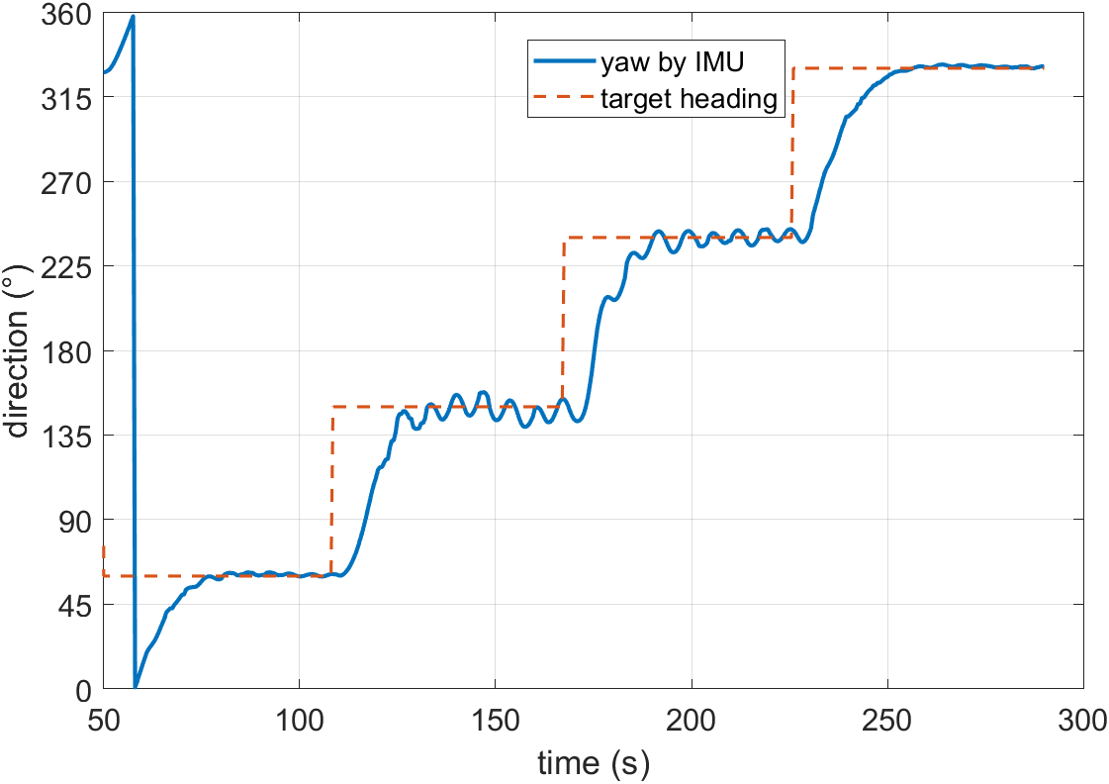
Fig. S3. All-round steering.
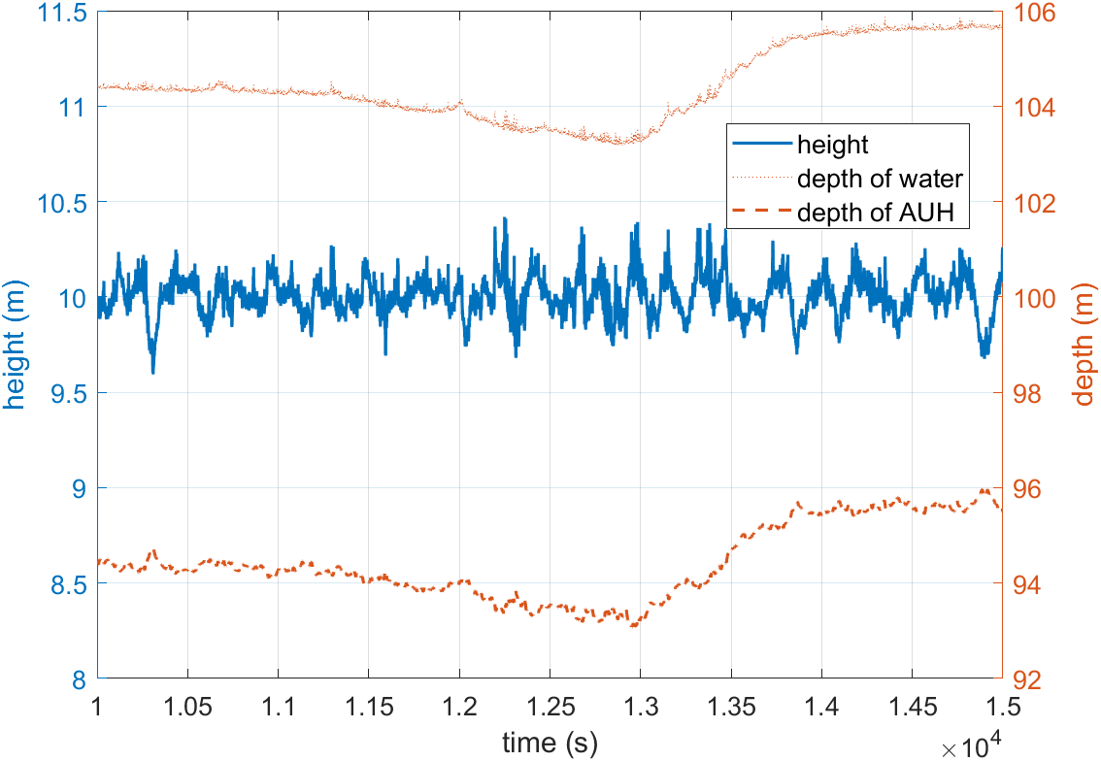
Fig. S4. Fixed altitude sailing.

As shown in Fig. S2, the AUH could dive and float up in a normal manner. The diving speed was about 0.15 m/s, and the floating speed was about 0.13m/s. After diving to the target depth, AUH could maintain at the target depth immediately. The all-round steering test is shown in Fig. S3, the AUH was set to face at 60°, 150°, 240°, and 330° (0° for north) respectively and kept for a few seconds. It can be seen that the AUH can turn 360° freely in situ. The turning speed is about 5° per second, and the AUH could stably maintain at the target angle after turning. The result of fixed altitude sailing is shown in Fig. S4, the height of the AUH (distance between the AUH and seabed) was maintained within 10 ± 0.5 m, regardless of the depth of water and depth of the AUH.
3.2 Comprehensive performance sailing test
The AUH's comprehensive performance sailing test includes AUH long-distance sailing test and AUH base station docking test. Through these tests, the maximum endurance time, sailing speed, fixed-point hovering ability and docking ability of AUH were verified. The working pattern of AUH is described as follows: After deployment from the mother ship, the AUH dived to the target altitude, then sailed for a certain distance in a fixed direction, and returned helipad under the guidance of piUSBL navigation system.
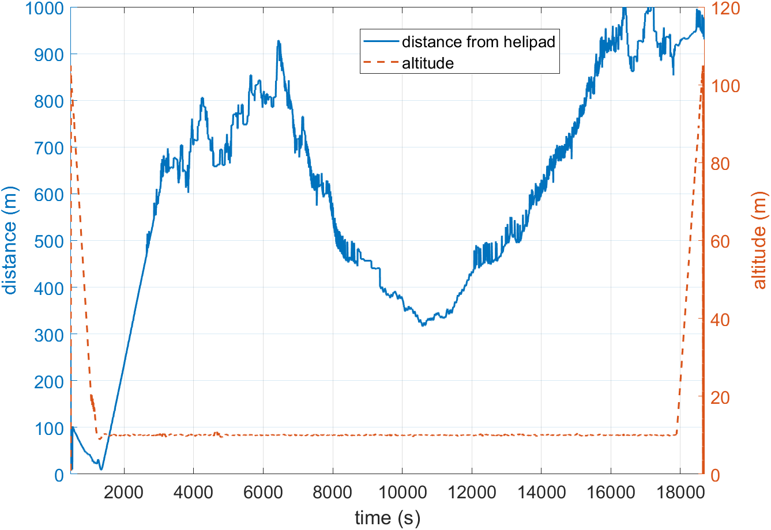
Fig. S5. Long-distance sailing test.

In our sea trial, the docking test was performed at 100 m depth. As shown in Fig. S5, the AUH sailed at a fixed altitude of 10 m, and the whole cruising process was stable. The total endurance time was more than 3 hours, and the sailing speed was maintained around 0.35 m/s.
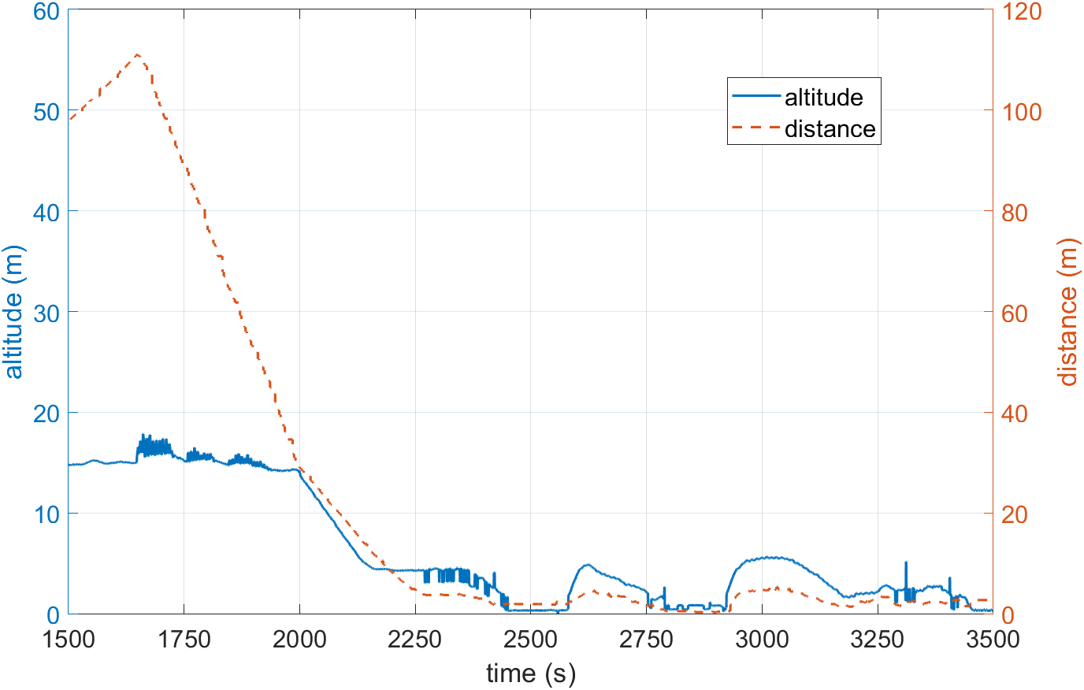
Fig. S6. Docking test.
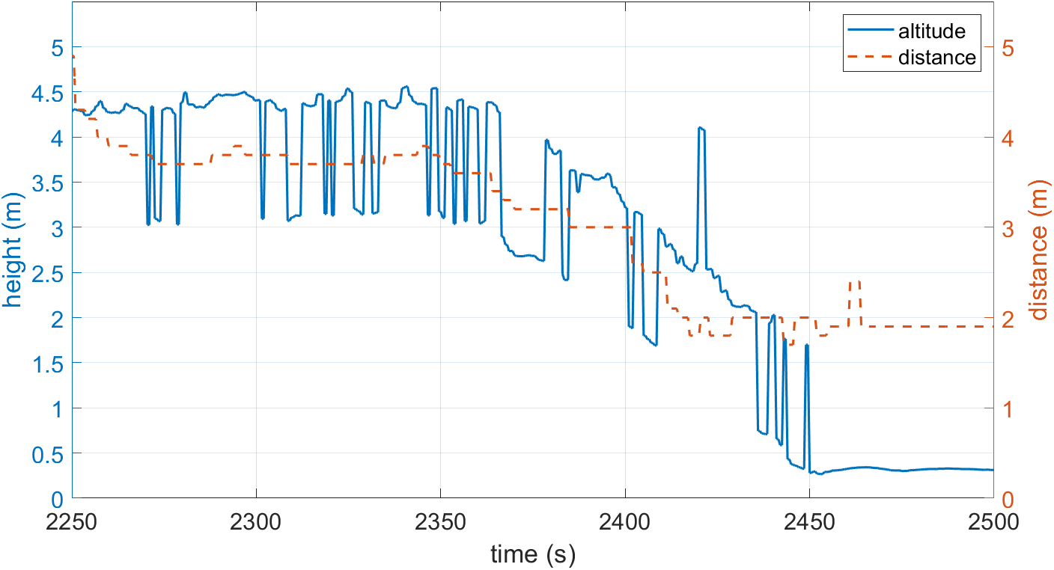
Fig. S7. Fixed point hovering.

As shown in the Figs. S6 and S7, the AUH completed the docking test with the helipad. In the experiment, after completing the previous experimental procedure, the AUH approached the helipad under guidance of piUSBL system. AUH reached above the helipad at about 2250 s, and hovered at fixed-point for more the 100s (Fig. S6). Fig. S6 shows that there was a jump of about 1.5 m in the altitude measurement because AUH was above helipad at that time, and the height of helipad is about 1.5 m. Ignoring the jump caused by the helipad, it can be found that within 100 s from 2250 s to 2350 s, AUH maintained a fixed-point hover with an altitude variation within 0.3m and a distance variation within 0.2 m.
After fixed-point hovering, the AUH successfully docked into the helipad under optic navigation twice and conducted wireless charging with the helipad. As shown in Fig. S7, after AUH docked into the helipad, both height and distance data became constant, which validated that the helipad is an important platform for an AUH on the seafloor and guarantees the safe housing and reliable operation of the AUH.

4. Hydrodynamic analysis and optimization
Fine hydrodynamic shape plays an extremely important role in maintaining motion stability and reducing running resistance of the AUH. The hydrodynamic analysis and optimization is described in this section.
4.1. Hydrodynamic simulation
The model of AUH prototype is established and hydrodynamic simulation is carried out in ANSYS FLUENT (Fig. S8). The finite element result is compared with ITTC1957 empirical model, and the consistency between the two methods proves the effectiveness of the simulation result. Hydrodynamic analysis of flow field is carried out when the AUH is moving in both horizontal and vertical direction, it can be concluded that the AUH is moving in horizontal direction, secondary flow area appears at the tail, which incurs the fluctuations in hydrodynamic resistance, and results in the motion instability of the AUH. Correspondingly, one of the functions of vertical propellers is to maintain the stability of horizontal movement.
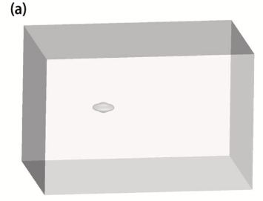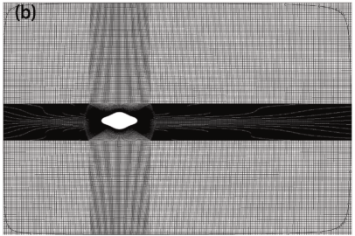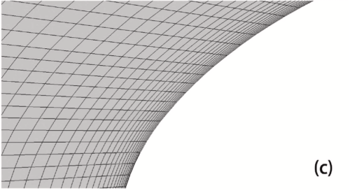
Fig. S8. Hydrodynamic modeling and mesh generation
4.2. Scaling test results
The scaling model hydrodynamic test is shown in Fig. S9, and the rectangular section of the tank is 600 mm × 500 mm, the test water depth is 250 mm, and the AUH model is installed in the middle of the tank 120 mm above the bottom. ADV current meter is installed at 600 mm away from the AUH head to measure the incoming flow velocity. The AUH model is fixed in the water tank through the airfoil rod, and a triaxial force sensor is installed between the other end of the airfoil rod and the frame (accuracy 0.01 N).
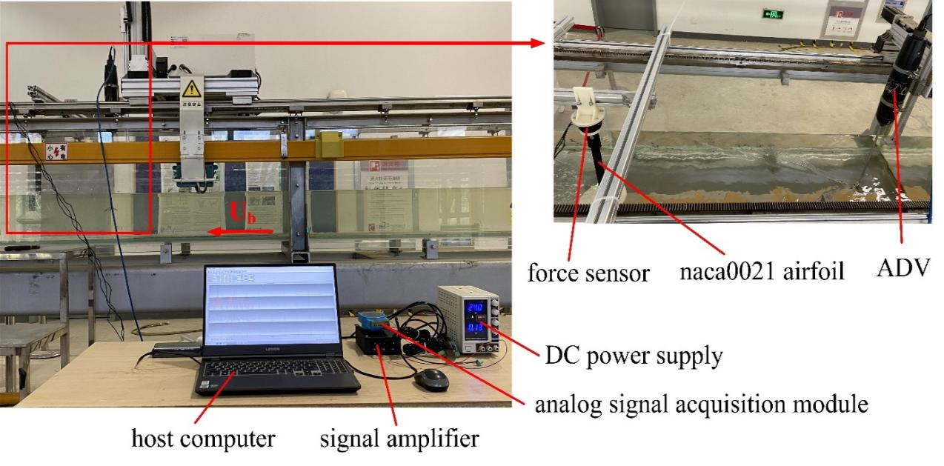
Fig. S9. Scaling model test setup.
Research was carried out on drag, lift, overturning moment and lift drag ratio when the angle of attack of HG1 and HG3 changes from 0 to 30 degrees. Fig. S10(a) shows that the upstream area of AUH will increase with the increase of the angle of attack, so its resistance will go up with the increase of the angle of attack (Fig. S10). At the same time, an angle of attack less than 15 degrees is conducive to the low resistance navigation of HG3.
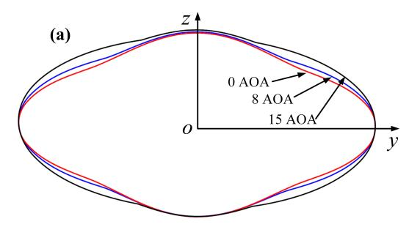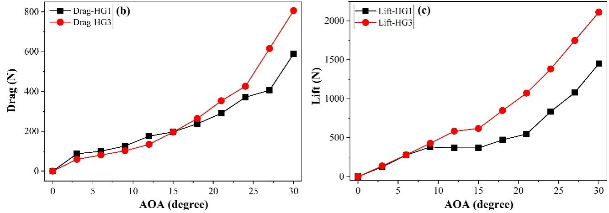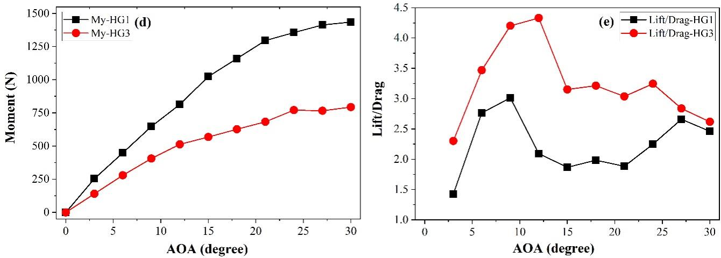
Fig. S10. Drag/lift analysis of different AUH contours

With the increase of flow velocity, the resistance of AUH model increases. At the same speed, the resistance of HG1 is greater than that of HG3, and the resistance of the loaded model has increased significantly compared with the basic model. The experimental results are in good agreement with the simulation conclusions (Fig. S11).
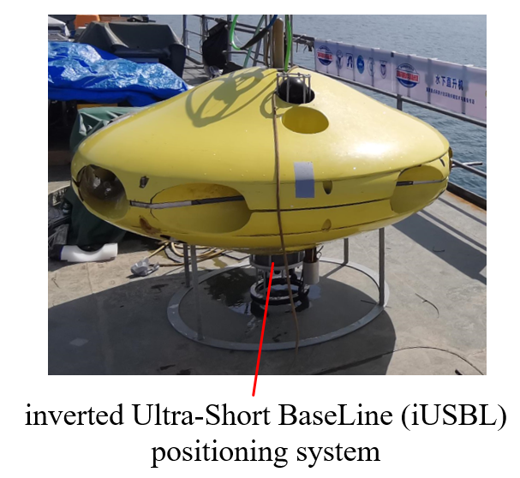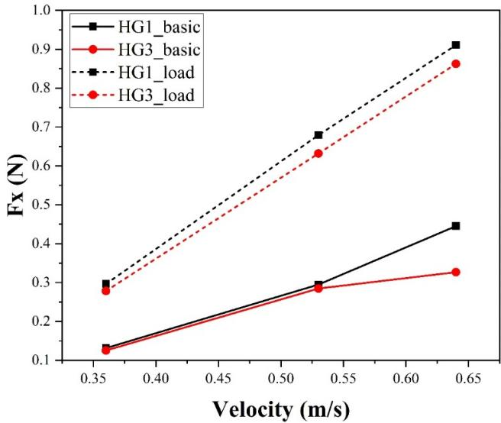
Fig. S11. Experimental and simulation resistance of AUH
4.3. Sea trial results
In the sea trial, with 3 kWh electricity and 150 N propulsion force, the AUH achieved the maximum cruising speed of 1.2 knots and the endurance of 6km.
To compare with the resistance of AUV of similar weight, we calculated the cruising resistance of the traditional torpedo-shaped AUV according to empirical equations:
For streamlined underwater vehicle, the shaft power can be calculated as:
In which, ρ-water density，kg/m³
v-speed, m/s
C_{x}- frontal drag coefficient
η- propulsion efficiency of propeller system
S-cross-sectional area of vehicle，m²
Take REMUS 600 as an example, its diameter is 0.7 m and the length is 4.3 m. C_{x} for AUV is determined as 0.1, and the propulsion efficiency is determined to be 0.35. When the cruising speed is 1.2 knots, the shaft power is calculated as 0.012 kW, and the drag force is roughly 20 N. With 3 kWh electricity storage, the AUV has an operation endurance of 250 h.

5. Design and development of various AUH prototypes
The mini-AUH is the first-generation conceptual prototype, with four horizontal propellers and an optical positioning system, and it verifies the basic motions of a disc-shaped AUH. Based on the concept of the mini-AUH, we developed an S-AUH, with a simple acoustic positioning system, that is 1 m in diameter to further investigate the hydrodynamic characteristics and hovering performance. Under the sponsorship of the National Key R&D Research Project, we designed and developed a G-AUH with more comprehensive functions, such as acoustic positioning, buoyancy regulation, wireless charging, docking with the helipad under acoustic/optic guidance, etc. The G-AUH was designed to withstand a 1000 m depth under the sea and has been tested in Qiandaohu lake and in South China Sea. In 2019, we started the customized development of AUHs for different application scenarios. The ICE-AUH was designed for the observation of algae under Arctic ice. Equipped with an acoustic positioning system, the ICE-AUH was able to complete polar coordinate positioning with a beacon as the centre. The CORAL-AUH was designed for ecological observation of coral reefs, equipped with an HD camera, as well as a variety of sensors, such as a chlorophyll meter, a salinity meter, a pH meter, a turbidity meter, and a dissolved oxygen concentration meter. The OT-AUH is an engineering prototype developed in cooperation with Zhejiang OceanTech Company, it was designed as a standard product for various industrial applications. Various AUH prototypes are compared in terms of size, weight, propeller layout, sensor asset and functions. Details can be found in Table S1.

Table S1
Comparison of various AUH prototypes.
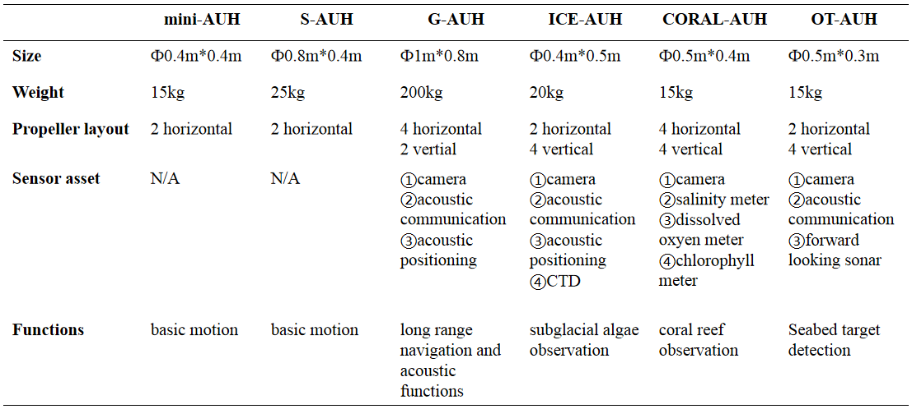
5.1. CORAL-AUH
The function and reliability of CORAL-AUH were tested in a field test in the waters of Luhuitou and Yazhou Bay in Sanya City. Coral reef ecological restoration areas located in the Nanhaisuo National Coral Conservation Area and the Dongluo Island Coral Restoration Area were selected as test sites (shown in Fig. S12). In the field test, CORAL-AUH successfully cruised to the desired site with a preset route. The photos taken by CORAL-AUH are shown in Figs. S13 and S14, and the water quality data collected by the sensor group are shown in Tables S2 and S3.
Fig. S12. Coral-AUH in field test.
Fig. S13. National Coral Conservation Area in Luhuitou.
Fig. S14. Picture taken under the sea of Dongluo Island.
Table 2
Water quality data of National Coral Conservation Area.
Position |  | pH | Electric Conductivity (uS/cm) | Dissolved Oxygen Concentration (mg/L) | Turbidity (FTU) | Chlorophyll (ug/L)
Eastern Longitude | Northern Latitude
18°12’42’’ | 109°28’21” | 8.08 | 47.8 | 6.32 | 21.05 | 3.02
18°12’45’’ | 109°28’25’’ | 8.13 | 46.35 | 6.17 | 19.83 | 3
18°12’46’’ | 109°28’34” | 8.11 | 47.48 | 5.93 | 23.42 | 2.72
18°12’47” | 109°28’38” | 8.13 | 52.64 | 5.89 | 16.8 | 3.39

Table 3
Water quality data of Dongluo Island.
Position |  | pH | Electric Conductivity (uS/cm) | Dissolved Oxygen Concentration (mg/L) | Turbidity (FTU) | Chlorophyll (ug/L)
Eastern Longitude | Northern Latitude
18°19’32’’ | 108°59’30’’ | 8.06 | 47.8 | 5.99 | 20.21 | 3.2
18°19’28’’ | 108°59’20’’ | 8.15 | 46.35 | 6.03 | 35.02 | 4.81
18°19’42’’ | 108°59’18’’ | 8.2 | 47.48 | 6.01 | 15.98 | 2.91
18°19’44’’ | 108°59’19’’ | 8.25 | 52.64 | 5.91 | 16.13 | 3.23

The field test lasted 2 hours each time. The maximum depth reached was 30 m. It can be seen from the test results that the Coral-AUH successfully cruised to the coral reef site and hovered there to take photographs; meanwhile, it could detect environmental data such as pH, conductivity, dissolved oxygen, turbidity and chlorophyll in real time. The test results show that the system can improve the accuracy and timeliness of coral monitoring and can meet the long-term stereoscopic observation requirements for coral reefs in a complex seabed ecological environment.
5.2. ICE-AUH
ICE-AUH is a small polar underwater helicopter with underwater positioning capability, which is utilized for observation algae under arctic ice. Researchers used to study the algae under ice in a traditional way, in which they attached a camera at the end of a rod, and stick the rod under ice through a whole, in order to capture images of the algae. With ICE-AUH, they only need to dig a ϕ40cm hole in the ice, and put ICE-AUH into it. In polar navigation mode, ICE-AUH makes a circular motion around the hole and capture image along the way.
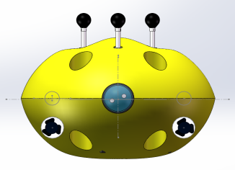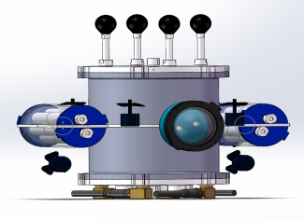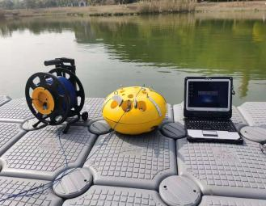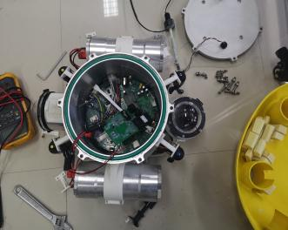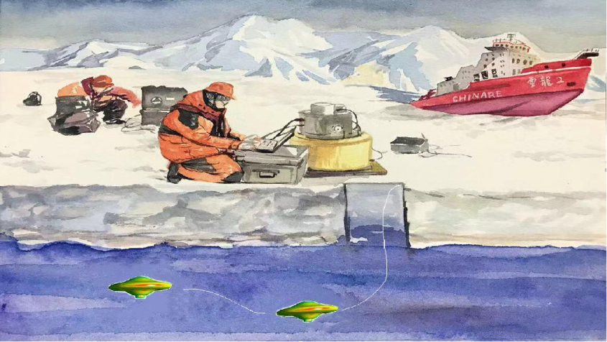
Fig. S15. ICE-AUH. (Left) Structure and prototype of ICE-AUH. (Right) Application scenario of ICE-AUH.

5.3. OT-AUH
OT-AUH is an industrialization attempt for AUH series prototype, it adopts modular design and can be equipped with forward looking sonar, camera, and acoustic communication device, to perform observations in ocean ranch, inspection on offshore wind power infrastructure and submarine cables etc.

References
[1] X. Liu, Z. Wang, Y. Guo, Y. Wu, G. Wu, H. Huang, Y. Chen, The Design of Control System based on Autonomous Underwater Helicopter. OCEANS-MTS, 22-25 Oct. 2018, Charleston, USA
[2] N. R. Rypkema and H. Schmidt, "Passive Inverted Ultra-Short Baseline (piUSBL) Localization: An Experimental Evaluation of Accuracy," in 2019 IEEE/RSJ International Conference on Intelligent Robots and Systems (IROS), 3-8 Nov. 2019, pp. 7197-7204, doi: 10.1109/IROS40897.2019.8967800.
[3] L. Paull, S. Saeedi, M. Seto, and H. Li, "AUV Navigation and Localization: A Review," (in English), IEEE. J. Ocean. Eng., Article vol. 39, no. 1, pp. 131-149, Jan 2014, doi: 10.1109/joe.2013.2278891.
[4] Y. Wang, S. H. Huang, Z. Wang, R. Hu, M. Feng, P. Du, W. Yang, Y. Chen, “Design and experimental results of passive iUSBL for small AUV navigation,” Ocean Engineering, vol. 248, p. 110812, 2022, doi: 10.1016/j.oceaneng.2022.110812.
[5] Y. Wang, R. Hu, S. H. Huang, Z. Wang, P. Du, W. Yang, Y. Chen, “Passive Inverted Ultra-Short Baseline Positioning for a Disc-Shaped Autonomous Underwater Vehicle: Design and Field Experiments,” IEEE Robotics and Automation Letters, vol. 7, no. 3, pp. 6942-6949, July 2022, doi: 10.1109/LRA.2022.3178494.
[6] N. R. Rypkema and H. Schmidt, "Passive Inverted Ultra-Short Baseline (piUSBL) Localization: An Experimental Evaluation of Accuracy," in 2019 IEEE/RSJ International Conference on Intelligent Robots and Systems (IROS), 3-8 Nov. 2019, pp. 7197-7204, doi: 10.1109/IROS40897.2019.8967800.

