Supplementary Information for

Short-Term Synchronous and Asynchronous Ambient Noise Tomography in Urban Areas: Application to Karst Investigation
Ya Liu ª, Jianghai Xia ^{a,}*, Bo Guan ª, Chaoqiang Xi ^{b}, Ling Ning ^{c}, Hao Zhang ^{d}
ª Key Laboratory of Geoscience Big Data and Deep Resource of Zhejiang Province, School of Earth Sciences, Zhejiang University, Hangzhou 310027, China
^{b} State Key Laboratory of Mining Response and Disaster Prevention and Control in Deep Coal Mines, School of Earth and Environment, Anhui University of Science and Technology, Huainan 232001, China
^{c} Key Laboratory of Poyang Lake Wetland and Watershed Research Ministry of Education, Jiangxi Normal University, Nanchang 330022, China
^{d} GBA Branch of Aerospace Information Research Institute, Chinese Academy of Sciences, Guangzhou 510700, China

* Corresponding author.
E-mail address: jhxia@zju.edu.cn (J. Xia).

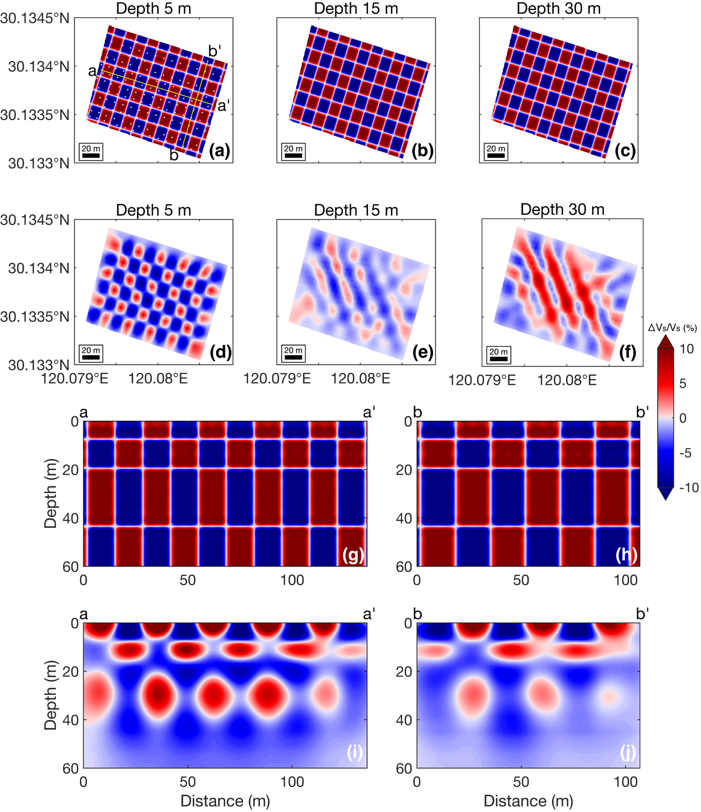
Fig. S1. Checkerboard tests for a fine anomaly size of approximately $14×17$ m in the horizontal direction. Note that only half of the cross-correlation pairs are used for the tests. The anomaly sizes in the depth direction are 9, 12, 24, and 59 m from shallow to deep. The letters a, a′ and b, b′ represent the locations of the cross-sections aa′ and bb′, respectively. The term $∆V_{S}/V_{S}$ indicates the perturbation of the shear wave velocity relative to the average shear wave velocity at the corresponding depth. (a-f) Horizontal slices of (a-c) the true model and (d-f) the recovered model at depths of 5, 15, and 30 m. (g-j) Velocity profiles of aa′ and bb′ for (g-h) the true model and (i-j) the recovered model. Note that we limit the maximum depth to 60 m in the plot. The locations of velocity profiles are indicated by the yellow lines in (a), where stations used for the test are denoted as white dots.

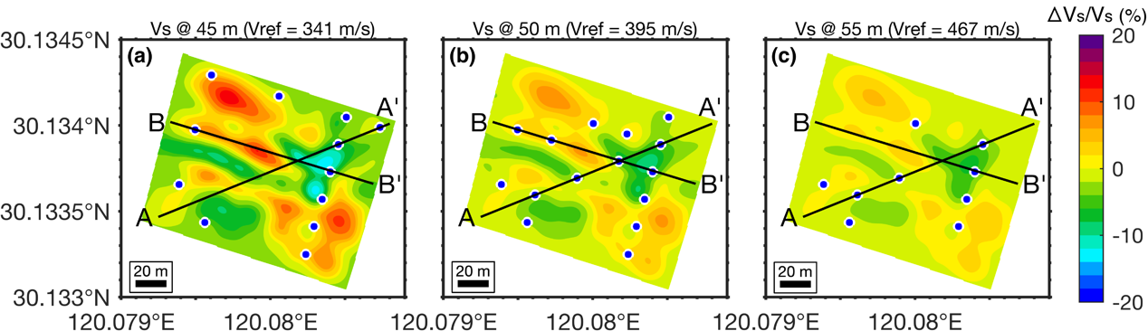
Fig. S2. Horizontal slices of the inverted S-wave velocity model at depths of (a) 45, (b) 50, and (c) 55 m in the parking lot area. Note that only half of the cross-correlation pairs are used for the inversion. $V_{ref}$ denotes the average shear wave velocity at that depth. The black lines AA′and BB′indicate the locations of two velocity profiles analyzed later. Blue points denote the karst caves at different depths found in well logs.

