Supplementary data for

Record-Breaking Frequency of 44 GHz Based on the Higher Order Mode of Surface Acoustic Waves with LiNbO₃/SiO₂/SiC Heterostructures
Jian Zhou ª, Dinghong Zhang ª, Yanghui Liu ª, Fengling Zhuo ª, Lirong Qian ^{b,}*, Honglang Li ^{c}, Yong-Qing Fu ^{d}, Huigao Duan ^{a,}*

ª College of Mechanical and Vehicle Engineering, Hunan University, Changsha 410082, China
^{b} Tianjin Key Laboratory of Film Electronic and Communication Devices, School of Integrated Circuit Science and Engineering, Tianjin University of Technology, Tianjin 30084, China
^{c} CAS Center for Excellence in Nanoscience, National Center for Nanoscience and Technology, Beijing 100190, China
^{d} Faculty of Engineering and Environment, Northumbria University, Newcastle upon Tyne, NE1 8ST, UK

* Corresponding authors.
E-mail addresses: duanhg@hnu.edu.cn (H. Duan), lirongqian83@email.tjut.edu.cn (L. Qian).

1. Fabrication processes of LN single crystal film on a slow-on-fast substrate
The manufacture processes of the LN/SiO₂/SiC multilayered substrate have four major steps. The first step is ion implantation, where He ions with certain energy values (90–120 KeV) were injected into X cut-34°Y LN single crystal substrate. The second step is the bonding of SiO₂/SiC. Before this step, a SiO₂ oxide layer was deposited onto a SiC substrate using plasma enhanced chemical vapor deposition (PECVD). This SiO₂ thin layer was used to assist the bonding process and reduce the defects during the bonding process. After that, the LiNbO₃ was bonded with the SiO₂/SiC substrate. The third step is annealing and transferring. In this process, the bonded LN/SiO₂/SiC layered material was annealed (250–400 °C) to generate cracks in the damaged layer introduced by ion implantation, and part of the LiNbO₃ material was removed. The last step is polishing of the sample surface. Mechanical chemical polishing (CMP) was used to remove the ion-implanted layer on the surface of LN, thus forming a smooth structure of LN/SiO₂/SiC multilayer.
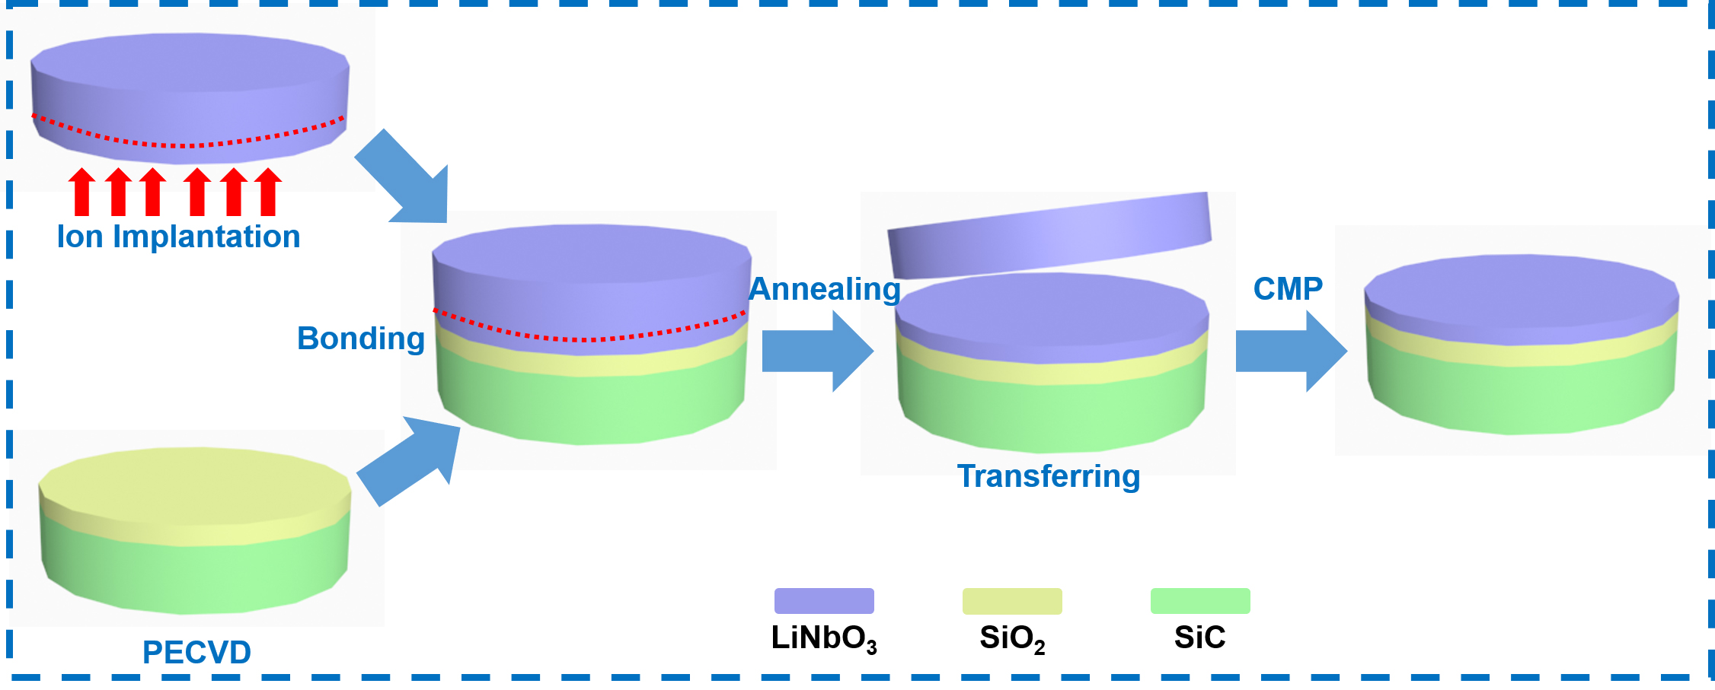
Fig. S1. The fabrication processes of LN single crystal film on a slow-on-fast substrate.

2. Process flow using the EBL and lift-off processes for patterning the nanoscale interdigital transducers (IDTs)
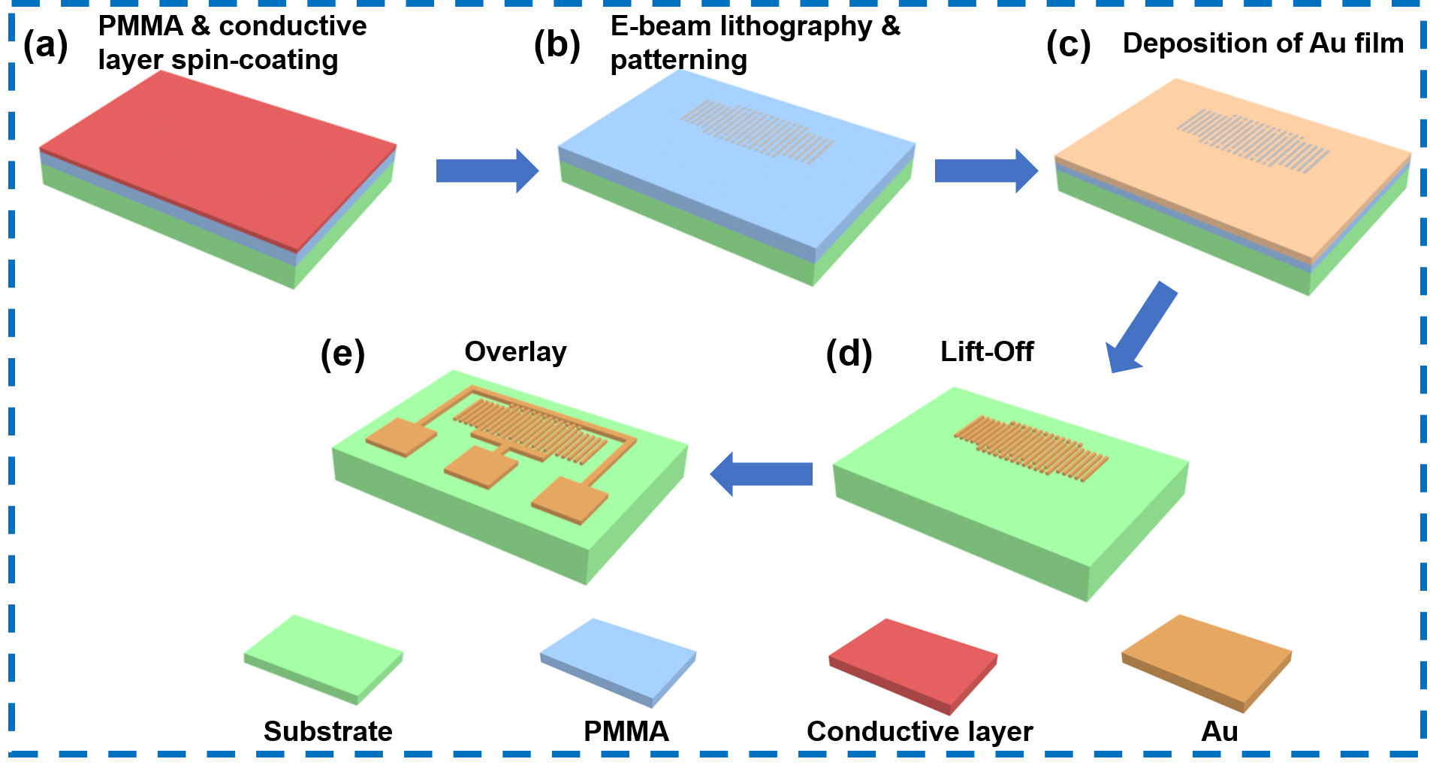
Fig. S2. Schematic illustrations of the fabrication processes for SAW devices. (a) Spin-coating of photoresist (PMMA) and conductive layer (ESPACER); (b) electron beam lithography and development; (c) deposition of Au film; (d) lift-off; (e) layout of the bus bar and contact pads.

3. Geometrical parameters of SAW devices with different IDT wavelengths
Table S1
Geometrical parameters of several devices with different structures.
Wavelength (nm) | Aperture (nm) | IDT pairs | Reflectors numbers | Electrode width  (nm) | Pitch (nm) | Distance between IDTs and reflectors  (nm)
800 | 16000 | 50 | 50 | 200 | 200 | 200
600 | 12000 | 50 | 50 | 150 | 150 | 150
400 | 8000 | 50 | 50 | 100 | 100 | 100
320 | 6400 | 50 | 50 | 70 | 90 | 90
200 | 4000 | 50 | 50 | 45 | 55 | 55
160 | 3200 | 50 | 50 | 35 | 45 | 45

4. SEM image of SAW device with an Au line-width of ~35 nm
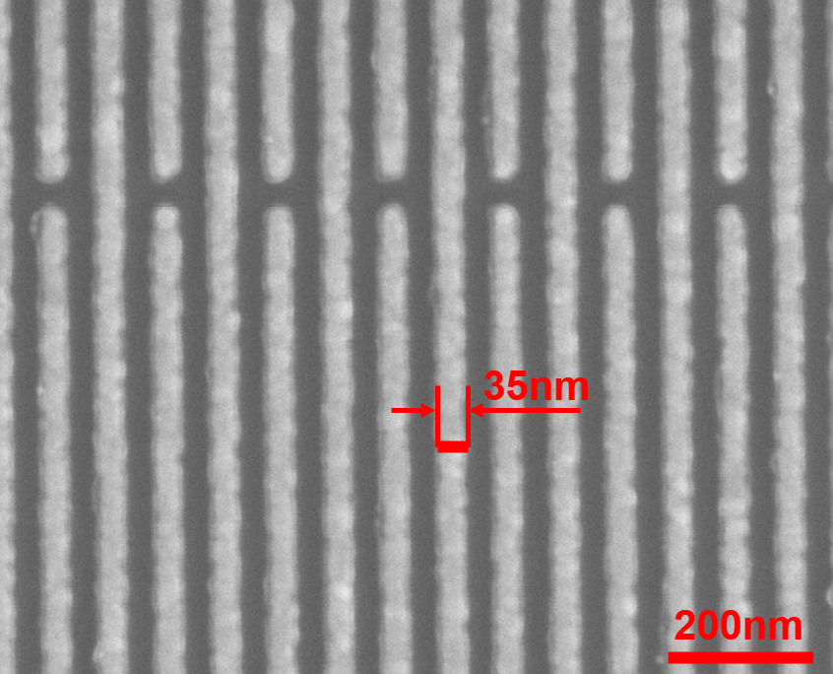
Fig. S3. The SEM image of a SAW device with a Au line-width of ~35 nm.

5. Reflectance (S₁₁) signals of the SAW devices with different IDT wavelengths and an IDT thickness of 25 nm
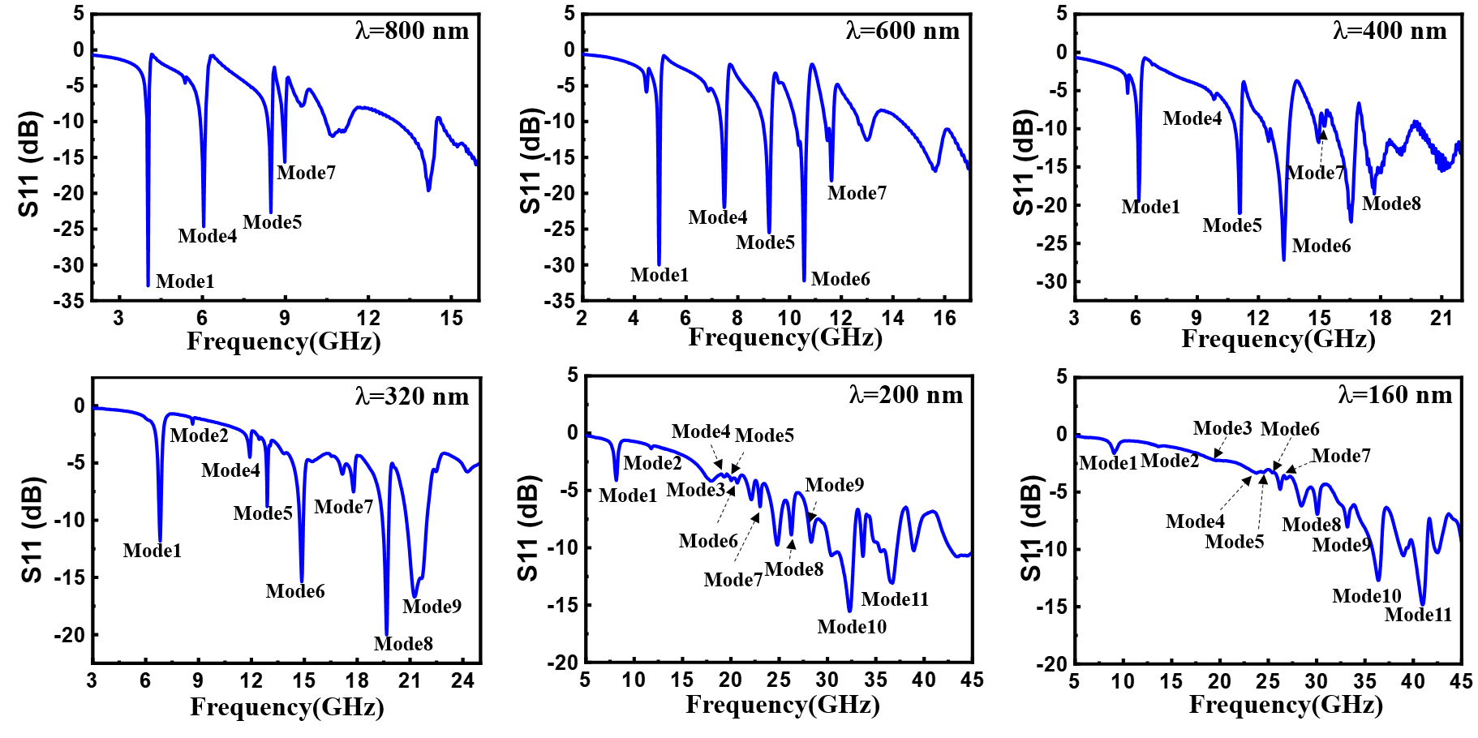
Fig. S4. Reflectance (S₁₁) signals of the SAW devices with different IDT wavelengths of 800, 600, 400, 320, 200 and 160 nm, and an IDT thickness of 25 nm.

6. Reflection spectra of SAW devices with IDT wavelength of 160 nm
To verify if the obtained frequency of ~41.5 GHz is truly excited by the SAWs, but not due to the noise/parasitic responses, we have fabricated four SAW devices with the same IDT wavelength of 160 nm, and the results of reflection spectra are shown in Figure S5. It is clear that all these devices display similar results, and clearly show the Mode 1, Mode 10 and Mode 11, and the resonant frequencies and amplitudes of those modes only show subtle differences. The resonant frequencies of the M1, M10, and M11 for these devices are ∼9.0 GHz, ∼36.2 GHz, and ∼41.5 GHz, respectively. All the results have verified that the obtained frequency of ~41.5 GHz is truly excited by the SAWs but not due to the noise/parasitic waves.
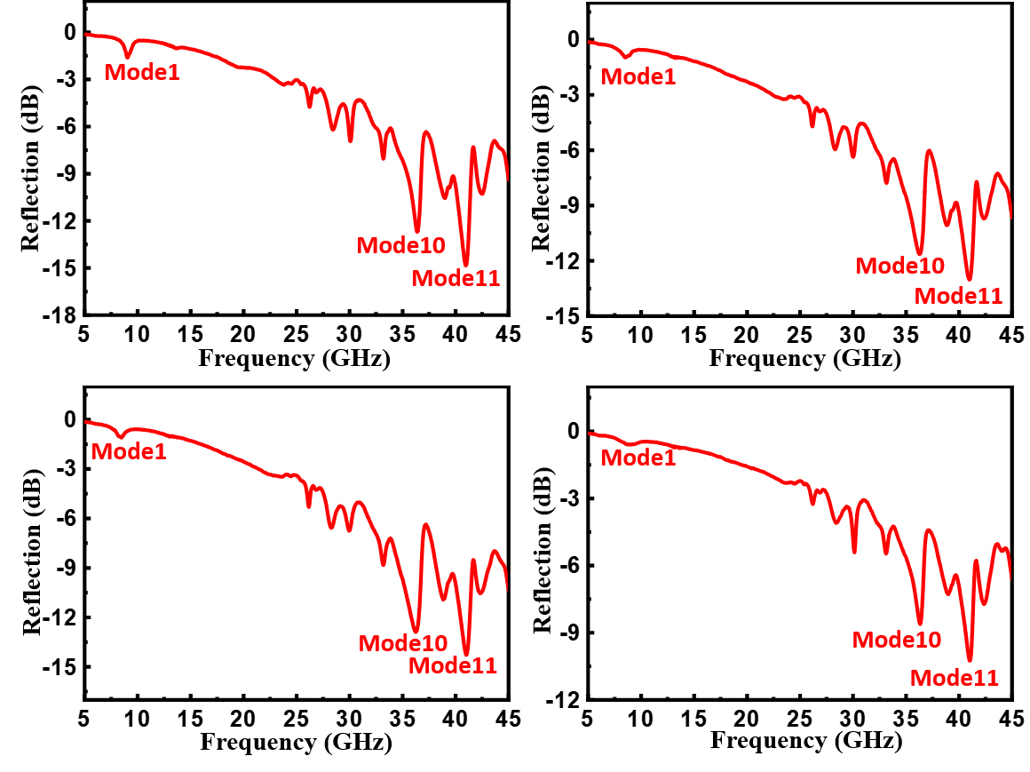
Fig. S5. Reflection spectra of the fabricated four SAW resonators with an IDT wavelength of 160 nm.

7. Simulation and experimental results of the frequency responses for the different modes of SAW devices
Fig. 2 (in the main text) presents the obtained simulation and experimental results of the frequency responses, which clearly show that the simulated frequency signals of samples have good agreements with the experimental ones at different wavelengths. In the case of the device with a wavelength of 800 nm (Fig. 2a), the simulated frequencies of Mode 1, Mode 4, Mode 5 and Mode 7 are 4.2, 6.3, 7.3 and 8.3 GHz, whereas the experimental results are 3.9, 5.9, 7.3 and 8.2 GHz, respectively. For the device with a wavelength of 600 nm, the simulated frequencies of Mode 1, Mode 4, Mode 5, Mode 6 and Mode 7 are 5.1, 7.6, 8.2, 10.3 and 10.8 GHz, whereas the experimental results are 4.6, 7.1, 8.3, 10.1 and 11.9 GHz, respectively. These results clearly demonstrate that the simulated frequency values are consistent with the experimentally obtained ones for different wave modes. In addition, For the Mode 1 (e.g., the SH wave), the simulated frequencies are 4.2, 5.1, 6.4, 7.1, 8.3 and 8.8 GHz, for the wavelengths of 800, 600, 400, 240, 200, and 160 nm, whereas the experimental frequencies are 3.9, 4.6, 5.6, 6.7, 7.8 and 9.0 GHz, respectively. These results show that for the specific mode, the simulated frequencies are also consistent with the experimental results for the devices with different wavelengths. These comparisons indicate that the simulated frequency signals of samples with different wavelengths have shown good agreements with the experimental results.

8. Particle vibration patterns and detailed discussions of the SH mode
We used a 2.5D model to further simulate the different wave modes. We chose the device with a wavelength of 800 nm as an example. The obtained particle displacement results are shown in Fig. S6a. It is clear that particle displacements of this mode are mainly along the direction of horizontal aperture, demonstrating that it is indeed an SH Mode.
We have summarized the obtained K² and Q values of this SH mode as a function of the normalized thickness kH (2πh/λ) for all the wavelengths of SAW devices. The obtained results are shown in Fig. S6b. With the increase of SAW wavelengths, the Q values of the SH mode are increased. The decreased Q values for the smaller wavelengths of the SAW devices can be explained by the larger impedance values of the SAW devices with extremely narrow IDT fingers, higher acoustic loss, and also the non-uniformity of IDT widths produced by the nanoscale fabrication. For the wavelength of the SAW device of 600 nm, the value of K² has the highest value of nearly 20% (Fig. S6b), showing the large electromechanical coupling efficiency. This indicates that this mode has a good potential for sensing and communication applications.
Figure. S6c exhibits the phase velocities of the SH mode as a function of the normalized thickness, indicating that the phase velocities increase with the decrease of the normalized thickness. It has a value of 3300 m/s at the wavelength of 800 nm.
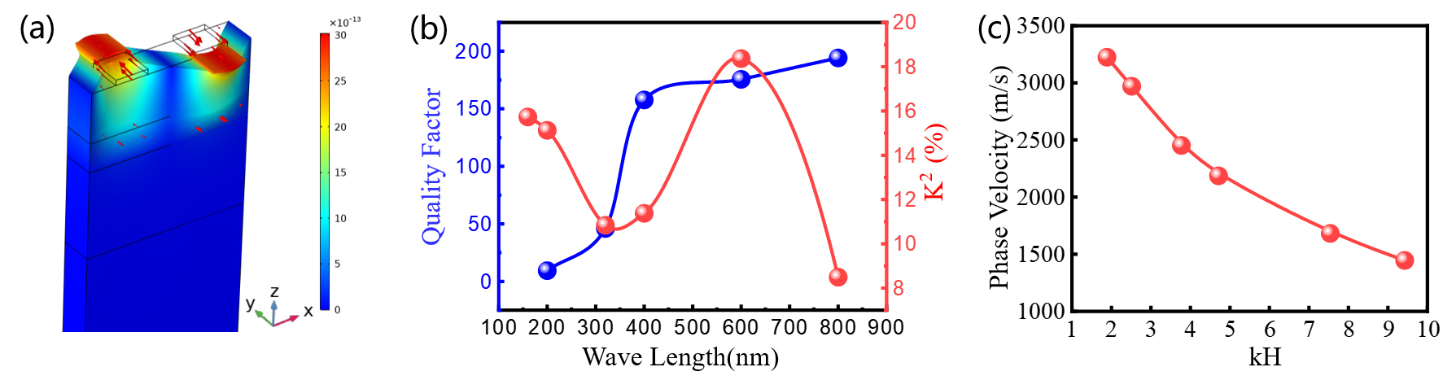
Fig. S6. (a) Particle displacement of the SH mode for the SAW with wavelength of 800 nm; (b) Q values and K² values vs. wavelengths for SAW with the wavelength from 800 to 160 nm; (c) Phase velocity vs. the normalized piezoelectric film thickness on the LN/SiO₂/SiC structure (kH) SAW.

9. The measured Bode-Q values of SAW devices with different IDT wavelengths
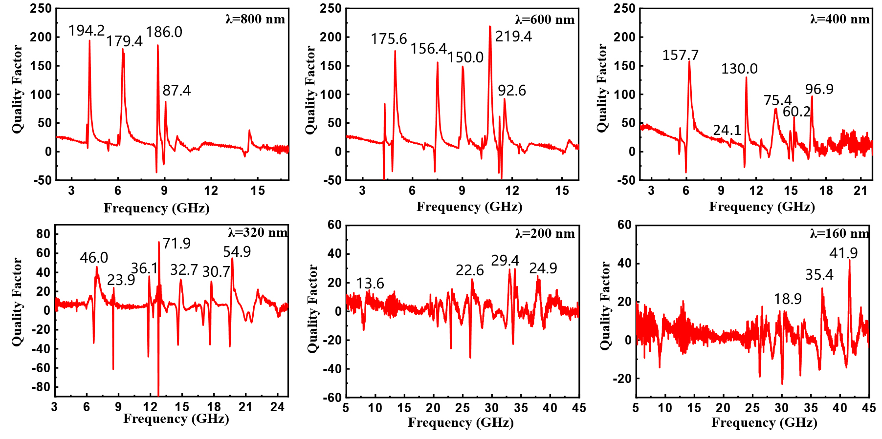
Fig. S7. The measured Bode-Q values of devices with different wavelengths and modes.

Table S2
Results of the measured Q values of devices with different wavelengths and modes.
Wavelength (nm) | Mode1 | Mode2 | Mode4 | Mode5 | Mode6 | Mode7 | Mode8 | Mode10 | Mode11
800 | 194.2 |  | 179.4 | 186.0 |  | 87.4
600 | 175.6 |  | 156.4 | 150.0 | 219.4 | 92.6
400 | 157.7 |  | 24.1 | 130.0 | 75.4 | 60.2 | 96.9
320 | 46.0 | 23.9 | 36.1 | 71.9 | 32.7 | 30.7 | 54.9
200 | 13.6 |  |  |  |  |  | 22.6 | 29.4 | 24.9
160 |  |  |  |  |  |  | 18.9 | 35.4 | 41.9

10. The detail information for the measured and simulated values of k²_{eff}
Table S3
Results of the measured and simulated k²_{eff} values (%) of devices with different wavelengths and modes.
 | Wavelength (nm) | Mode1 | Mode2 | Mode4 | Mode5 | Mode6 | Mode7 | Mode8 | Mode9 | Mode10 | Mode11
Measured results | 800 | 8.493 |  | 10.780 | 6.835 |  | 4.073
Measured results | 600 | 18.369 |  | 7.947 | 6.389 | 6.117 | 2.032
Measured results | 400 | 11.378 |  |  | 8.026 | 7.303 | 3.044 | 6.842
Measured results | 320 | 10.836 | 1.775 | 2.345 | 1.139 | 5.787 | 2.733 | 5.655
Measured results | 200 | 15.126 | 3.487 |  |  | 5.462 | 2.839 | 3.164 | 5.710 | 10.450 | 7.040
Measured results | 160 | 15.733 |  |  |  |  |  | 3.332 | 3.286 | 8.229 | 7.333
Simulated results | 800 | 10.724 |  | 15.517 | 12.179 |  | 1.477
Simulated results | 600 | 12.866 |  | 6.168 | 9.700 | 7.849 | 5.458
Simulated results | 400 | 16.545 |  |  | 4.446 | 9.831 | 2.395
Simulated results | 320 | 15.219 |  | 2.006 | 3.724 | 6.450 | 2.689 | 3.054
Simulated results | 200 | 12.063 |  |  |  |  | 3.659 | 2.315 | 6.241 | 5.012 | 3.358
Simulated results | 160 | 10.277 |  |  |  |  | 3.228 | 2.459 | 2.699 | 4.215 | 5.861

11. Mass sensing results obtained using the SAW device with an IDT wavelength of 200 nm
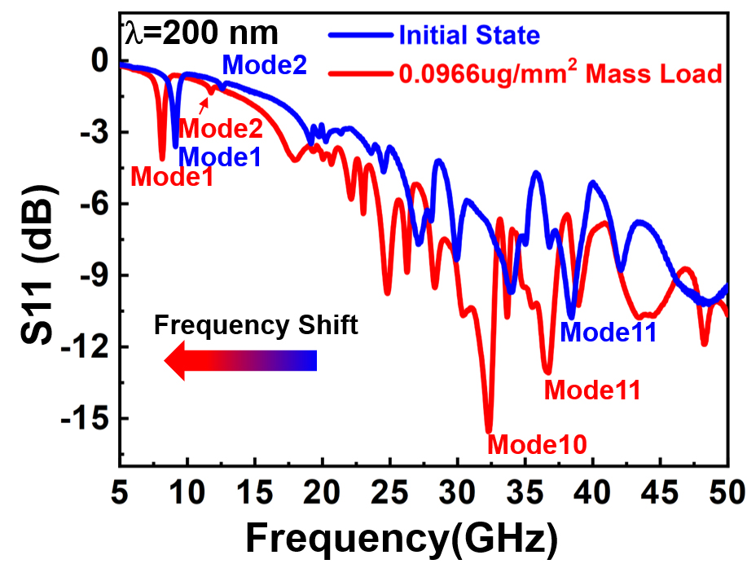
Fig S8. Frequency responses of mass sensing for the fabricated SAW with the wavelength of 200 nm.

12. The detail information for the calculated sensitivity values.
Table S4
Results of the calculated sensitivity values (MHz×mm²/$μg$) of devices with different wavelengths and modes.
 | Mode1 | Mode2 | Mode3 | Mode4 | Mode5 | Mode6 | Mode7 | Mode8 | Mode9 | Mode10 | Mode11
320 | 6717.1 | 3033.5 |  | 3466.9 | 4333.6 | 11050.7 | 14734.2 | 16250.9
200 | 10183.9 | 7800.5 |  | 4333.7 | 5633.7 | 15384.1 | 15167.6 | 17984.9 | 15528.5 | 16684.4 | 17551.0
160 | 15817.5 | 13650.8 |  |  |  |  |  | 18351.1 | 13267.3 | 29465.3 | 33151.9

13. Shifts of resonant frequency of a SAW device with a wavelength of 200 nm as a function of temperature
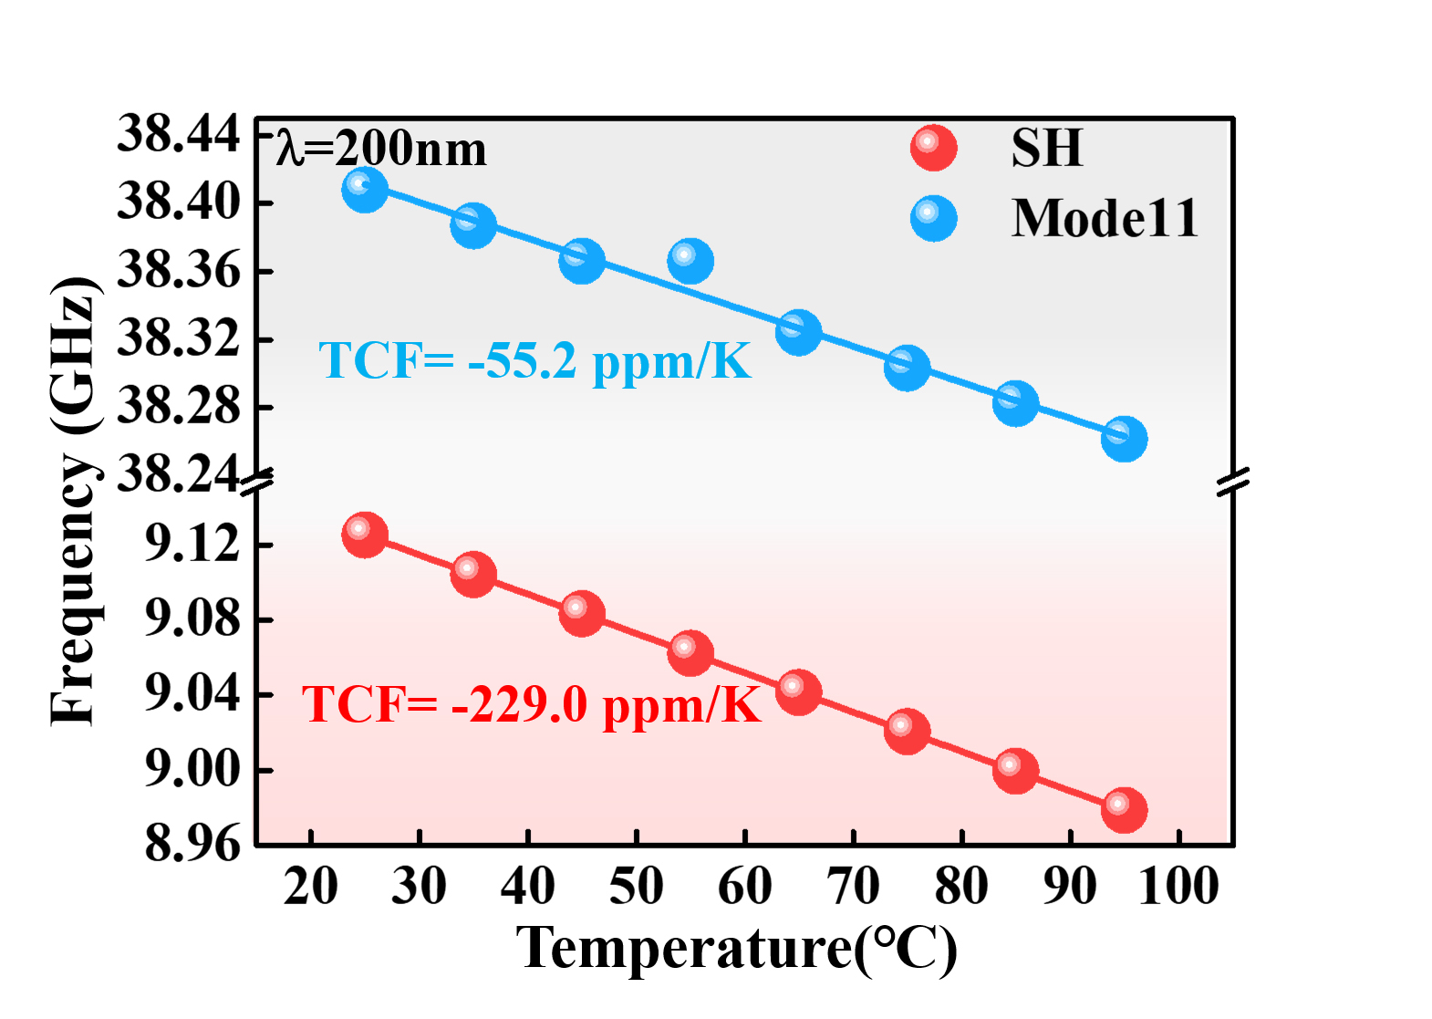
Fig. S9. Resonant frequency shifts of a device with wavelength of 200 nm as a function of temperature for the SH-SAW and wave Mode 11.

14. The simulated TCF results of LiNbO₃/SiO₂/SiC based SAW device with an IDT wavelength of 160 nm
In order to verify the correctness of measured TCF values, we simulated the temperature effects of the SAW devices with an IDT wavelength of 160 nm, and the obtained results are shown in Figure S10. At 25 °C, the frequency is ~10.366 GHz, and when the temperature is increased to 35 °C, the frequency is decreased to 10.350 GHz. This shows the TCF value is ~154.4 ppm/K, which is close to the experimentally obtained result (165.8 ppm/k).
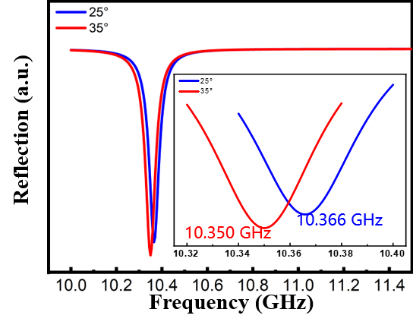
Fig. S10. The simulated frequency shifts at two different temperatures for the LiNbO₃/SiO₂/SiC based SAW device with an IDT wavelength of 160 nm

