Supplementary data for

Toward Sustainable Agriculture: The Design of Environmentally Friendly, Economical, and Modular Vertical Farming Systems
Junye Wu ^{a,b,c}, Yoke Wang Cheng ^{b,d}, Guiying Lin ^{b,c}, Dequan Xu ^{a,b,c}, Yiying Wang ^{b,c}, Clive Chong ^{e}, Yanjun Dai ^{a,b}, Chi-Hwa Wang ^{b,c,*}, Tianshu Ge ^{a,b,*}
ª Research Center of Solar Power and Refrigeration, Institute of Refrigeration and Cryogenics, Shanghai Jiao Tong University, Shanghai 200240, China
^{b} Energy and Environmental Sustainability Solutions for Megacities (E2S2), Campus for Research Excellence and Technological Enterprise (CREATE), Singapore 138602, Singapore
^{c} Department of Chemical and Biomolecular Engineering, National University of Singapore, Singapore 117585, Singapore
^{d} NUS Environmental Research Institute, National University of Singapore, Singapore 138602, Singapore
^{c} Paradise Eco Tourism Pte Ltd., Singapore 049909, Singapore
* Corresponding authors.
E-mail address: chewch@nus.edu.sg (C.-H. Wang), baby_wo@sjtu.edu.cn (T. Ge)

Note S1. The energy consumption of direct air capture rotary adsorber
Direct air capture (DAC) of CO₂ is achieved through temperature swing: CO₂ is captured at ambient temperature using CO₂ selective solid adsorbents, and then it is released under heating conditions. Therefore, the majority of the energy consumed to drive the DAC process of rotary adsorber is thermal energy, with a smaller amount being electrical energy. The thermal energy consumption EC_{thermal} (kWh/kg_{CO2}) and electrical energy consumption EC_{electric} (kWh/kg_{CO2}) are calculated using the following equations derived from our previous research[1]:
The meanings of the symbol used for calculation of energy consumption are illustrated below. For a detailed derivation of these equations, readers are referred to our previously published paper.[1]
Symbol | Unit | Meaning of the symbol
ρ_{air} | kg/m³ | density of air
c_{p,air} | J/°C/kg | specific heat capacity of air
μ_{air} | Pa s | viscosity of air
M_{CO2} | kg/mol | molecular weight of CO₂
t | h | operation time of rotary adsorber
T_{ambient} | °C | ambient temperature
T_{in,reg} | °C | inlet temperature in the regeneration flow path
T_{out,reg} | °C | outlet temperature in the regeneration flow path
Q_{reg} | m³/h | air flow rate in the regeneration flow path
Q_{pro} | m³/h | air flow rate in the process flow path
ƞ_{recovery} | % | efficiency of heat recovery
C_{out,reg} | mol/m³ | CO₂ concentration in the outlet of the regeneration flow path
C_{in,reg} | mol/m³ | CO₂ concentration in the inlet of the regeneration flow path
v_{pro} | m/s | air velocity in the process section
L | m | the length of the gas flow channel
R_{channel} | m | channel equivalent diameter
Δp_{main} | Pa | the pressure drop in the main regeneration air flow path
Δp_{hr} | Pa | the pressure drop in the heat exchanger for heat recovery
n_{rot} | rpm | wheel rotation speed
T_{q} | N m | load torque of motor

Note S2. An exemplified design
Based on literature research and planting experience, a cultivation chamber measuring 12 m×12 m×3 m is designed to be the minimized module (Figure S8). The frame of the chamber is made of galvanized steel, the floor is made of wood with polyvinyl chloride cover, and the sidewalls and ceiling are made of aluminum alloy plates. Additionally, a layer of foam plastic board is applied to the surface of the sidewalls and ceiling to enhance the thermal insulation. Pak choi is considered for the demonstration calculation in this section. Inside this chamber, there are ten hangers, each hosting five rows of planters on both sides, which is determined based on the planting space requirements of leafy vegetables. The planters are filled with the potting substrate (i.e., the mixture of soil and biochar) where the vegetables are grown. Water pipes and LED lights are suspended above the planters, used for irrigation and illumination, respectively. During irrigation, the excess water flows into the trough beneath the planters, where it is collected and pumped back into the water tank for recycling. CO₂ is introduced into the cultivation chamber through gas pipes to create an elevated indoor CO₂ concentration. The amount of CO₂ to be added is determined based on the photosynthesis rate of vegetables, as well as the requirement of indoor ventilation, which in turn determines the carbon capture capacity of the DAC unit. According to the standard T/SZFAA 03-2019, the ventilation rate is determined based on the volume of the chamber, ensuring that the replacement time is no more than 1.2 hours. This corresponds to a minimum air exchange rate of 0.83 times per hour. The ventilation and temperature regulation are achieved using the heating, ventilation, and air-conditioning (HVAC) unit. Temperature and humidity control is achieved through the air conditioners. According to the standard T/SZFAA 03-2019, we select air conditioner with energy efficiency rates of no less than 3. The agricultural sensors are installed to monitor the indoor environmental conditions.
For general considerations, we assume that six minimized modules are stacked together to form a medium-sized vertical farming cultivation chamber (Figure S9). The medium-sized chamber is designed with two layers, which is done with a priority on expanding in the horizontal direction to maximize the utilization of sunlight.[2] Based on the above structure, the economic and environmental performance of the systems were evaluated using the techno-economic analysis and life cycle assessment methodologies respectively. The vertical farm system is assumed to cultivate pak choi and to be constructed around urban areas in Shanghai with subtropical monsoon climate. The basic information as the input for calculation is listed in Table S6. Note that this study serves as a demonstration, the design and evaluation of vertical farms in other scenarios (for different sizes and locations) can be carried out using a similar manner.

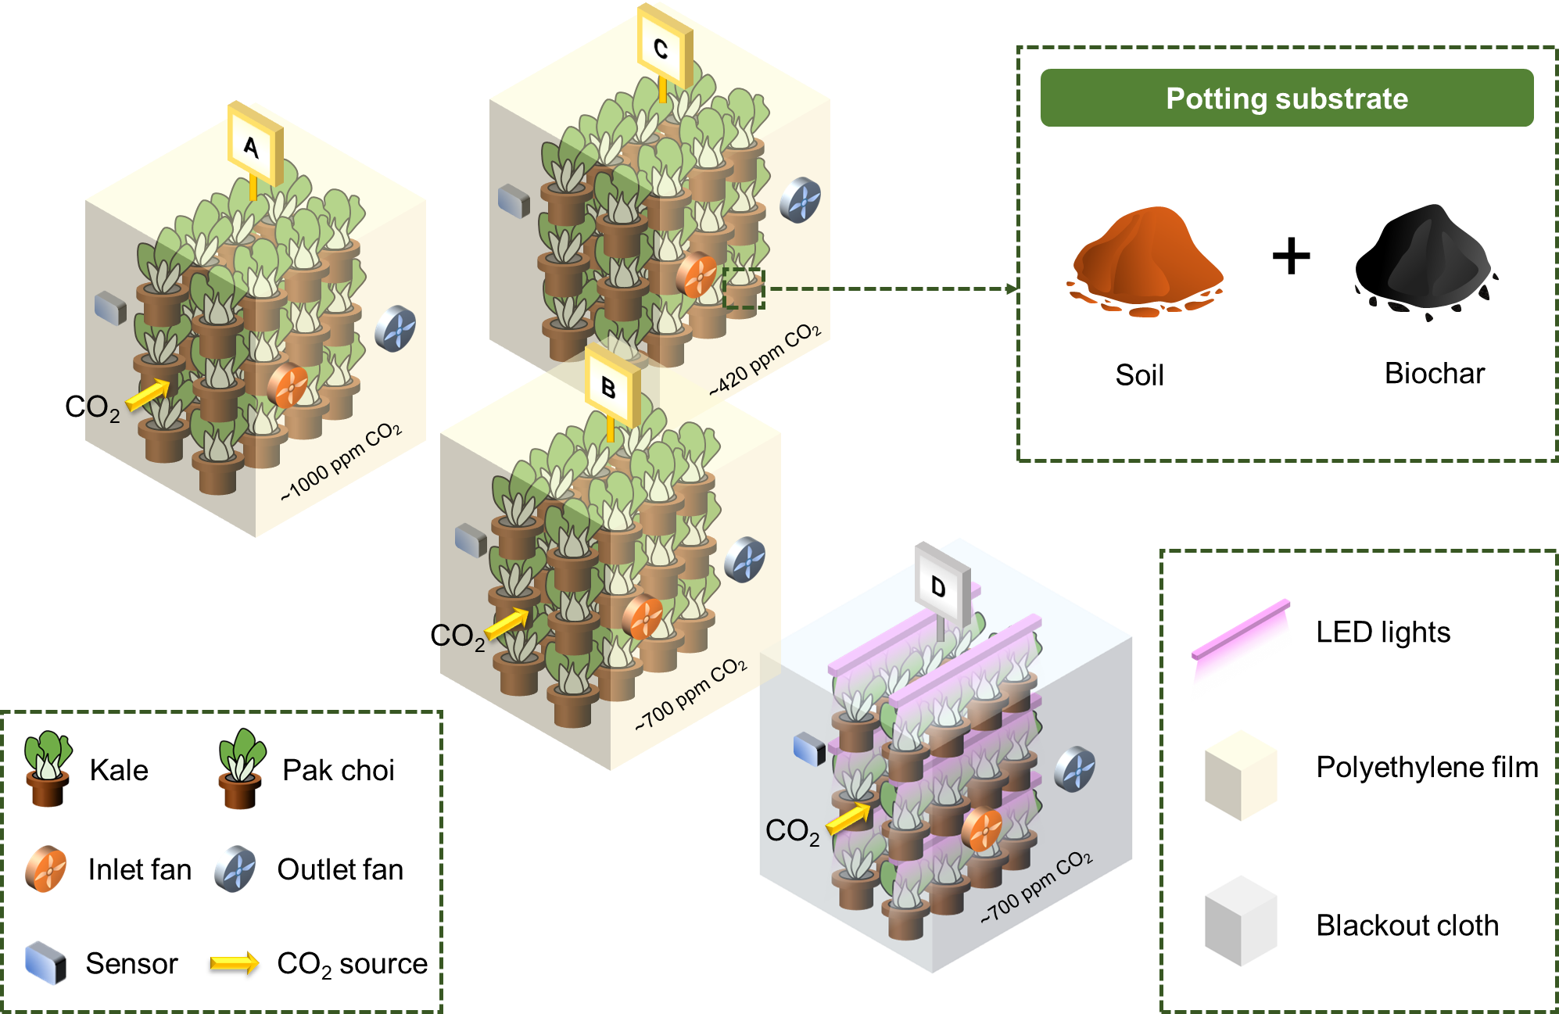

Figure S1. The overall layout of the experimental set-up. Tests were performed to investigate the effects of lighting condition, CO₂ concentration, biochar application, and vegetable species.

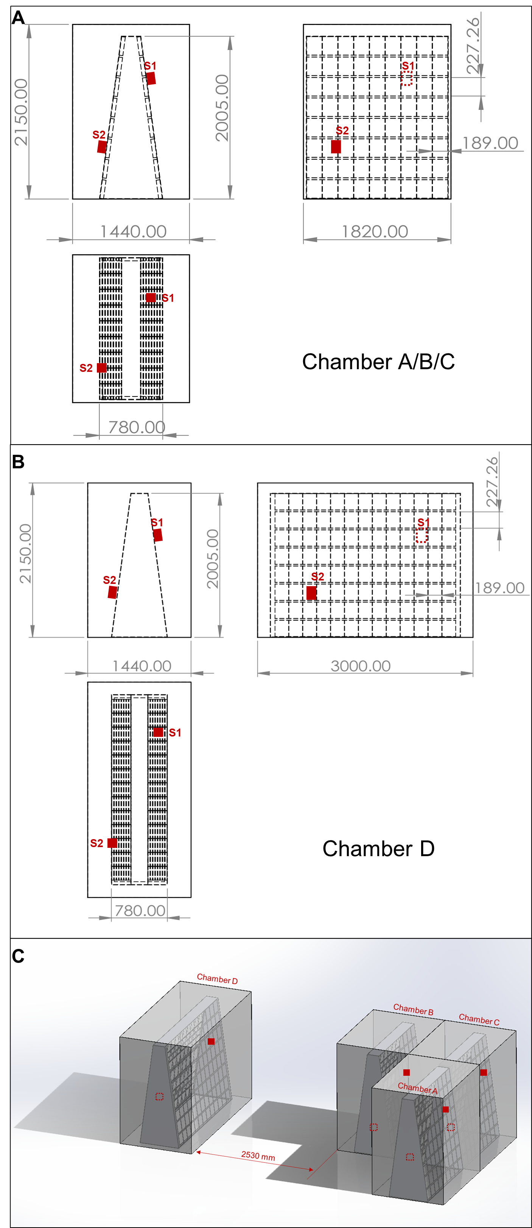

Figure S2. Schematic of cultivation chambers. (A) Dimensions of Chamber A/B/C. (B) Dimensions of Chamber D. (C) The deployment of chambers. Chamber D was designed with a longer frame length to accommodate the installation of LED lights. Two agricultural sensors (S1 and S2) are installed in each chamber, and their positions are indicated in the figures. The readings of the two sensors are very close, so we selected the data from one of them for analysis.

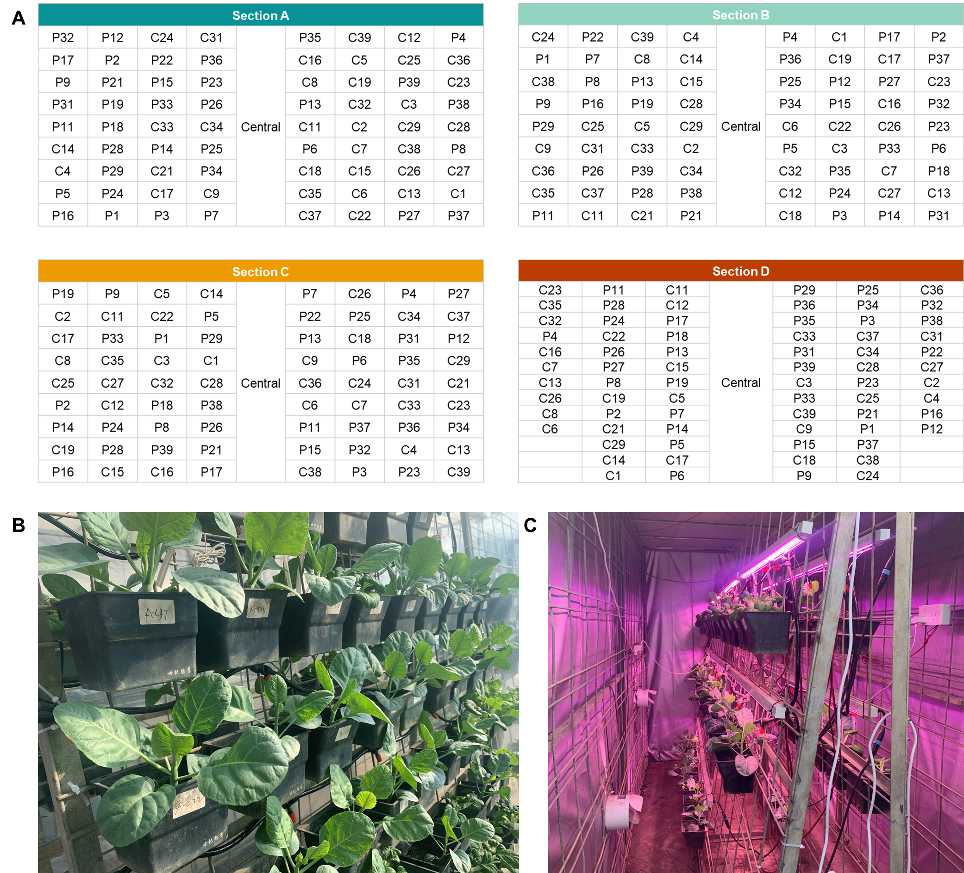

Figure S3. The cultivation chamber arrangement. (A) The label and position of vegetable pots. “P” denotes pak choi and “C” denotes kale. The vegetable pots were placed at random. The numbers 1–39 denote pots with different soil and biochar weight percentages, as shown in Table S2. (B−C) The photographs of chambers with natural sun lights and LED lights, respectively. In Chamber D, the lights were positioned approximately 20 cm above the soil surface when installed. Each light had the capacity to illuminate 4 to 5 potted plants, ensuring adequate lighting coverage within the chamber.

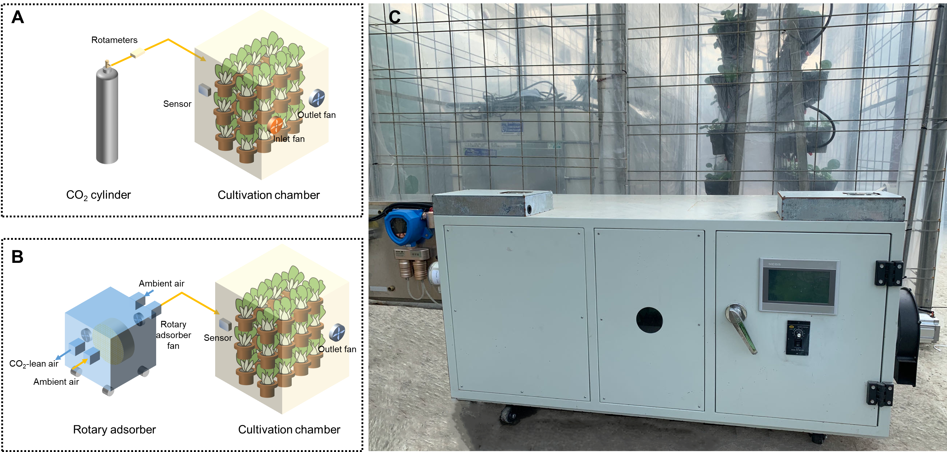

Figure S4. The CO₂ enrichment approach in the experiments. The schematic diagram of CO₂ enrichment using (A) the cylinder and (B) the rotary adsorber. (C) The photograph of rotary adsorber prototype.
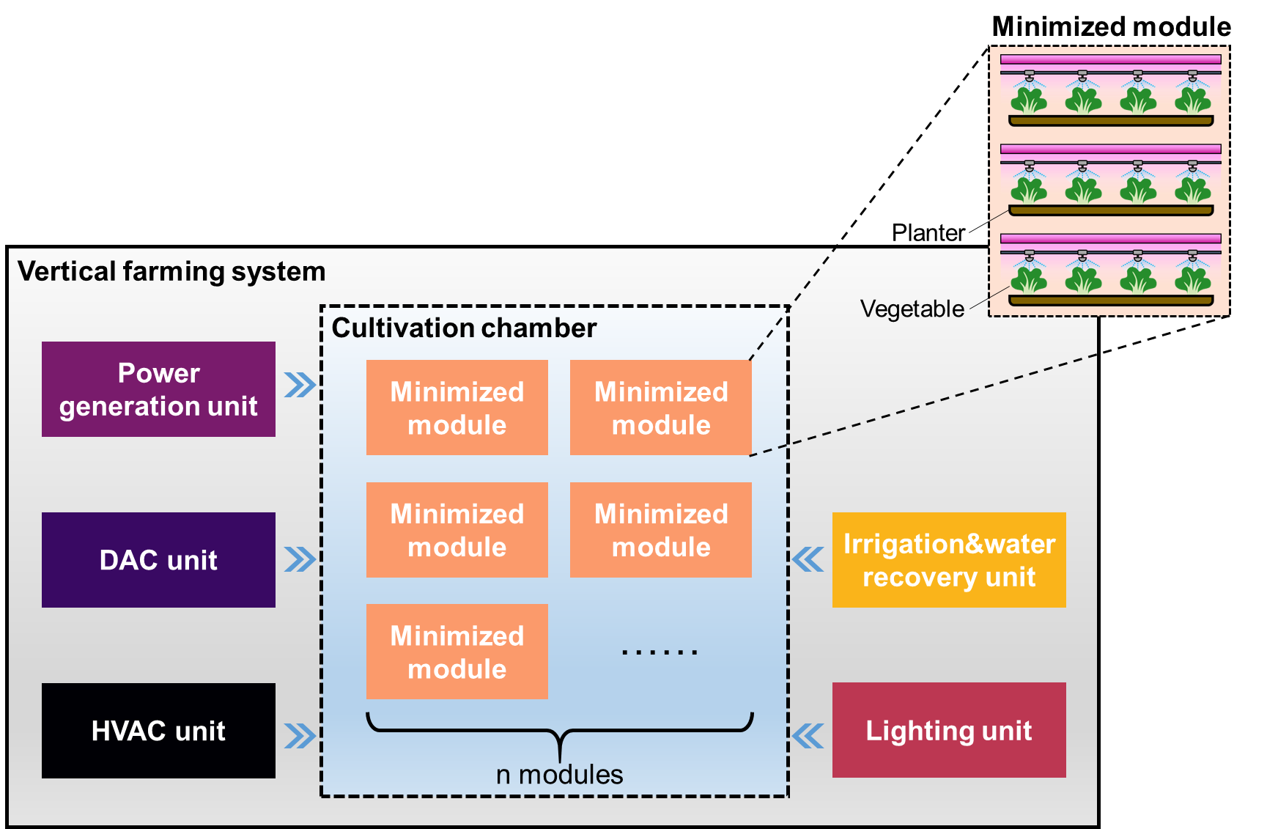

Figure S5. The vertical farming model. The core of the model is the minimized cultivation module, within which multiple planters are vertically stacked. When several minimized modules are combined and connected with auxiliary facilities (power generation unit, HVAC unit, DAC unit, etc.), they form a vertical farming system.

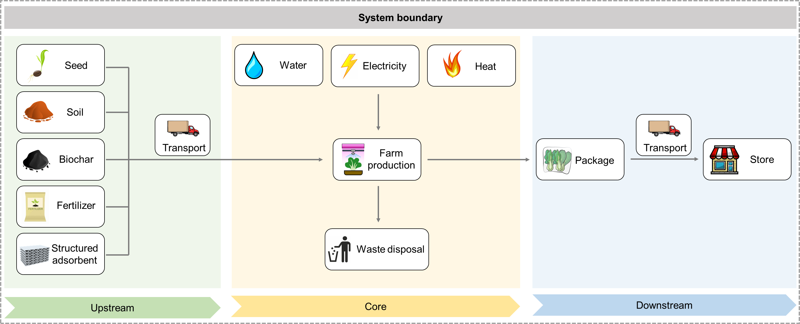

Figure S6. The system boundary for LCA of the vertical farming systems.

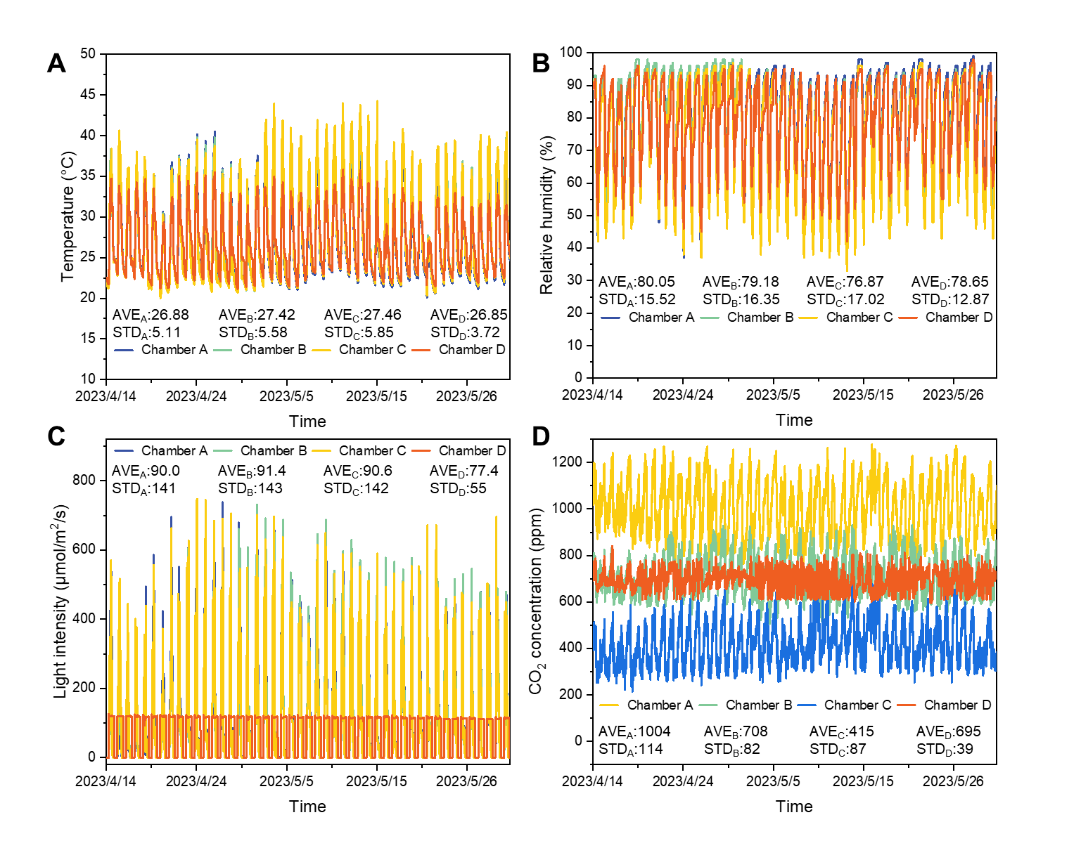

Figure S7. The environmental data in the four chambers. (A) The temperature, (B) relative humidity, (C) light intensity, and (D) CO₂ concentration. The data was measured by the four-in-one agricultural loggers. In figures A-C, the data for chamber A-C had very similar trends, and therefore they mostly overlapped. The average (AVE) and standard deviation (STD) of the data throughout the period are presented in each figure. Due to Singapore’s hot and humid climate, the temperature and humidity inside the chambers remained at relatively high levels, with daytime temperature exceeding 35°C and nighttime relative humidity exceeding 90%. The CO₂ concentration in the control group (Chamber C) was approximately 420 ppm, while the CO₂ concentration in Chamber A, Chamber B, and Chamber C maintained close to the set values of 700, 1000, and 700 ppm respectively. The fluctuations of CO₂ concentration throughout the day and night were observed, which might be caused by the photosynthesis and respiration processes of vegetables. The original data measured by the sensor is in units of lux. Based on the spectral distribution of sunlight and LED light, the unit has been converted to μmol/m²/s to more accurately reflect the effective radiation supplied to plants. The light intensities inside Chambers A, B, and C were higher than that in Chamber D. The light intensity inside Chambers A, B, and C varied unevenly over time because of daily weather changes, while light intensity in Chamber D exhibited a very regular pattern due to the artificial control of LED lights.

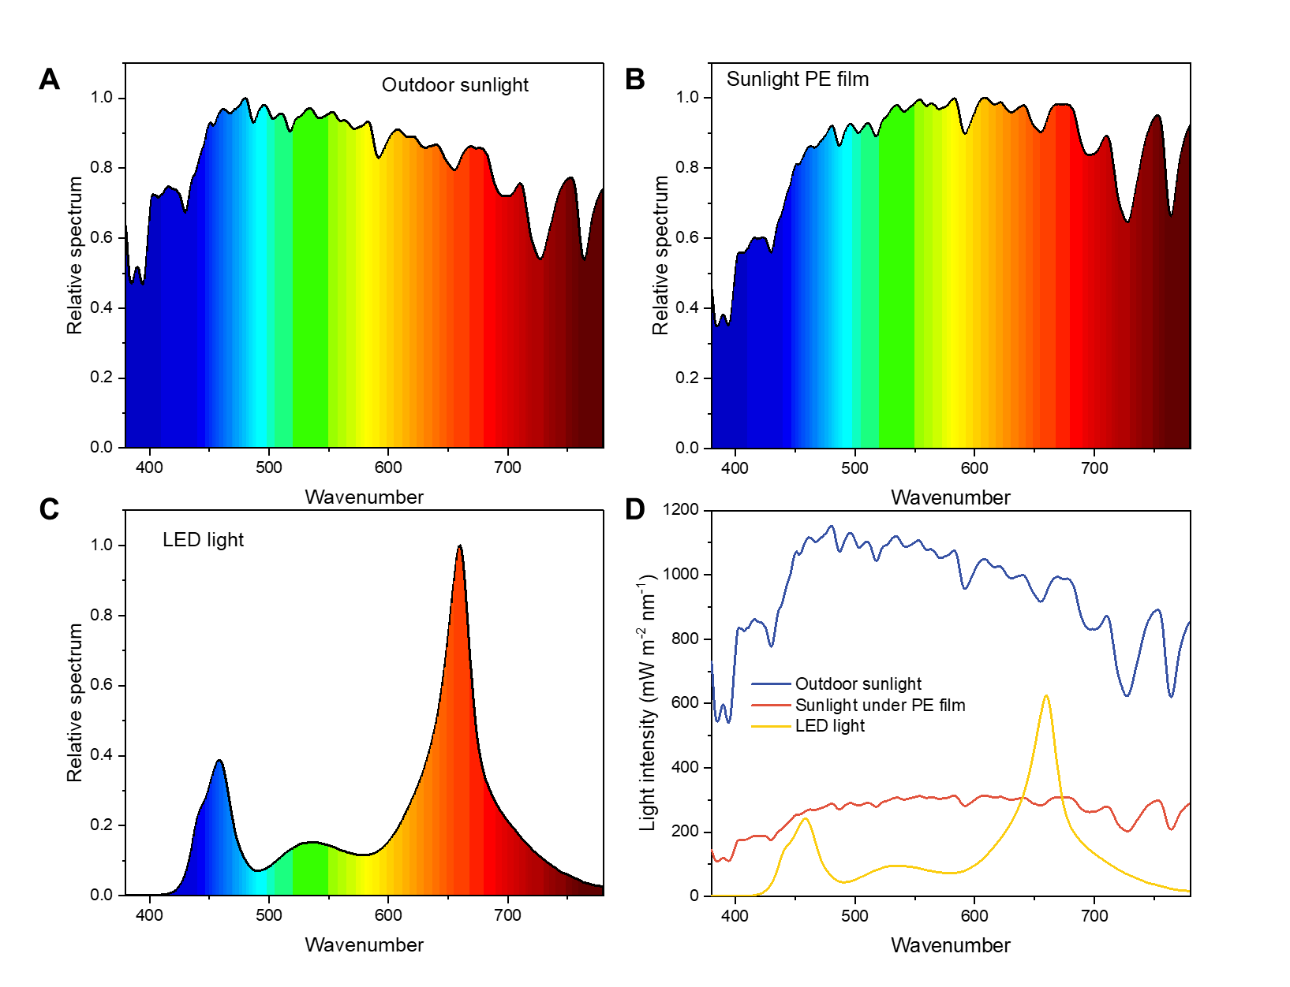

Figure S8. The lighting conditions during the experiments. (A–C) The light spectrum of outdoor sunlight, sunlight under PE film, and LED light. (D) The light intensity of outdoor sunlight, sunlight under polyethylene (PE) film, and LED light. The data was measured by the portable spectrometer on 22nd May (Day 39). Figure A−B shows that compared to outdoor sunlight, sunlight under PE film had slightly reduced blue light proportion, while its overall peak position did not change significantly. Figure C shows that the light from the LED was mainly concentrated in the red and blue light regions. Figure D shows that the light intensity was reduced inside the chamber covered with PE film compared to natural outdoor light, but the spectral distribution remained mostly unaltered. Comparing Chamber B (Sunlight under PE film) and Chamber D (LED light) in terms of lighting conditions, it was revealed that the overall LED light intensity was lower than natural light under the PE film, except in the red-light spectral region.

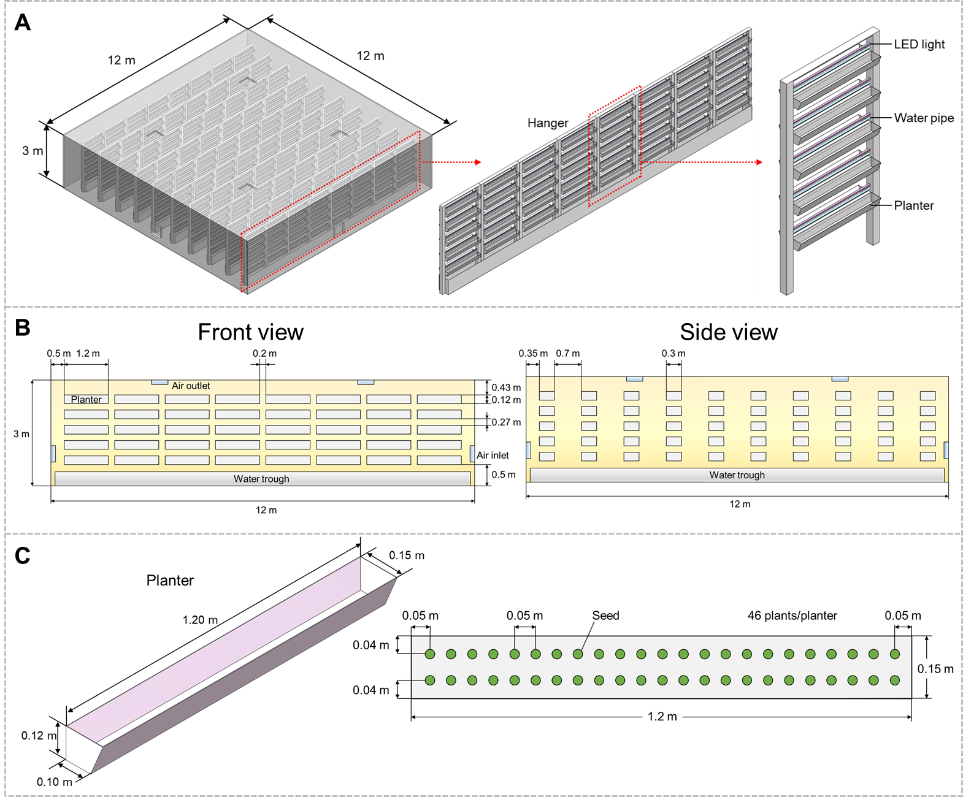

Figure S9. The minimized vertical farming module. (A) The three-dimensional scheme of the minimized module. (B) The front view and side view of the minimized module. (C) The three-dimensional scheme of a single planter and the layout of vegetable planting.

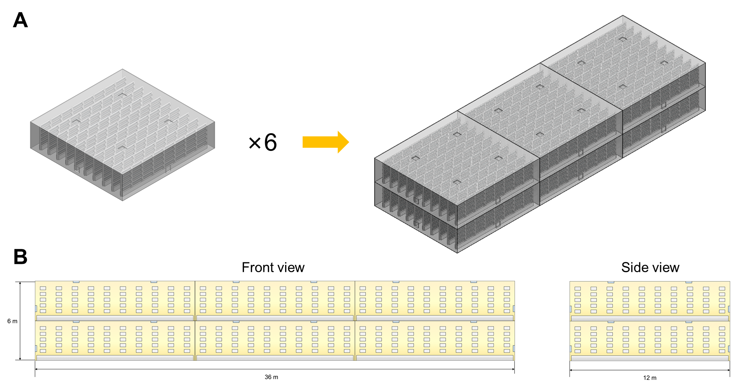

Figure S10. The medium-sized vertical farming cultivation chamber. (A) The three-dimensional view of the vertical farming cultivation chamber. (B) The front view and side view of the vertical farming cultivation chamber. The medium-sized vertical farming cultivation chamber is composed of six minimized modules.

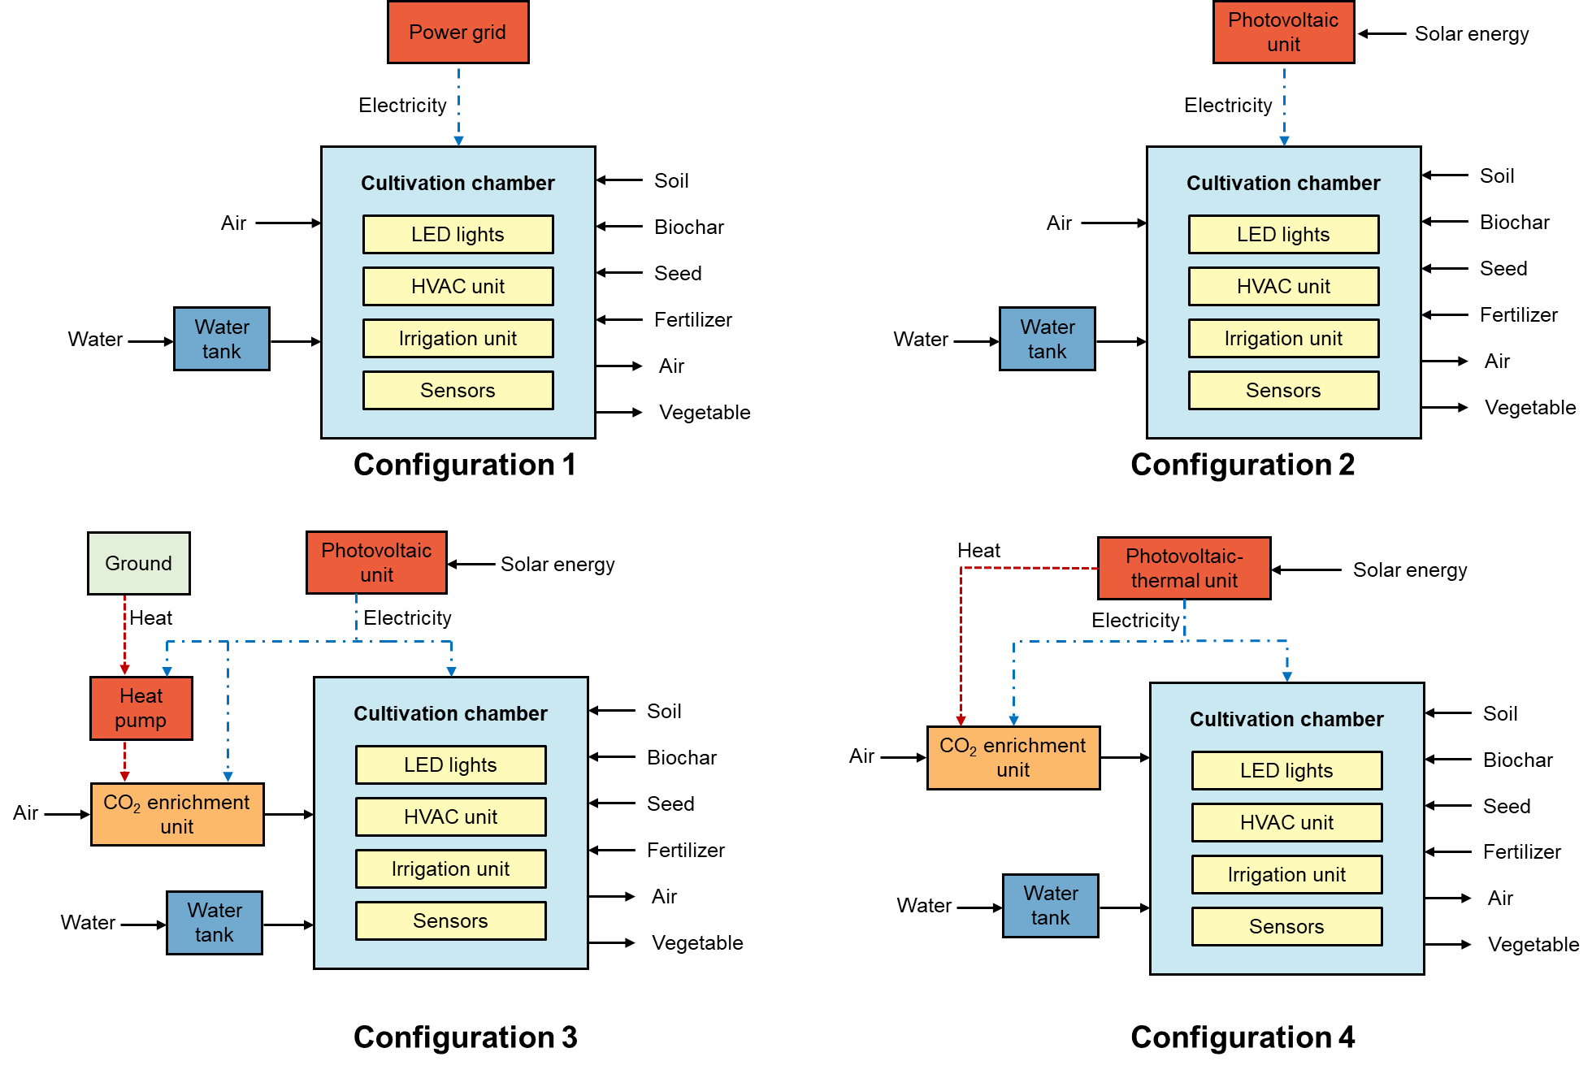

Figure S11. The schematic diagrams of systems with different configurations.
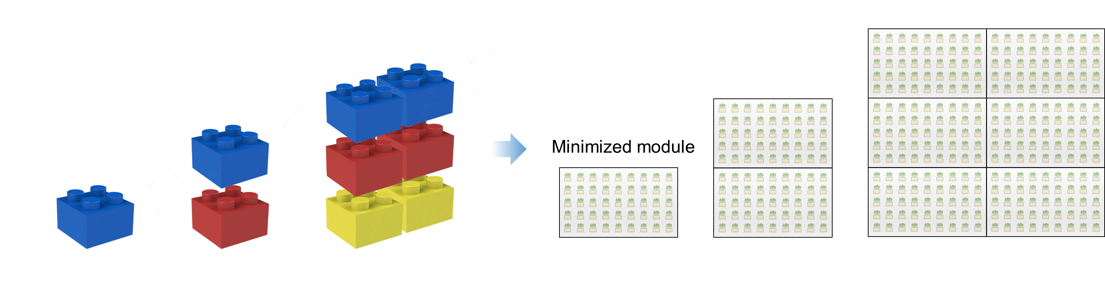

Figure S12. The combination of minimized modules. Similar to a manner of building with blocks, the minimized modules are stacked together to form the system with specific geometric structure.

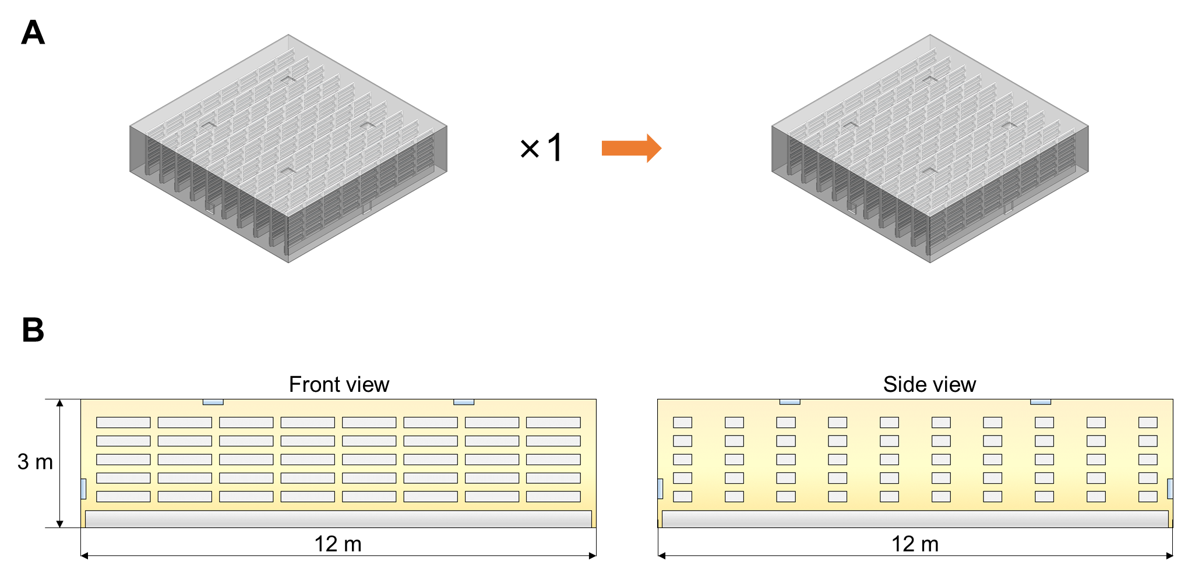

Figure S13. The small-sized vertical farming cultivation chamber. (A) The three-dimensional view of the vertical farming cultivation chamber. (B) The front view and side view of the vertical farming cultivation chamber. The small-sized vertical farming cultivation chamber is composed of only one minimized module.

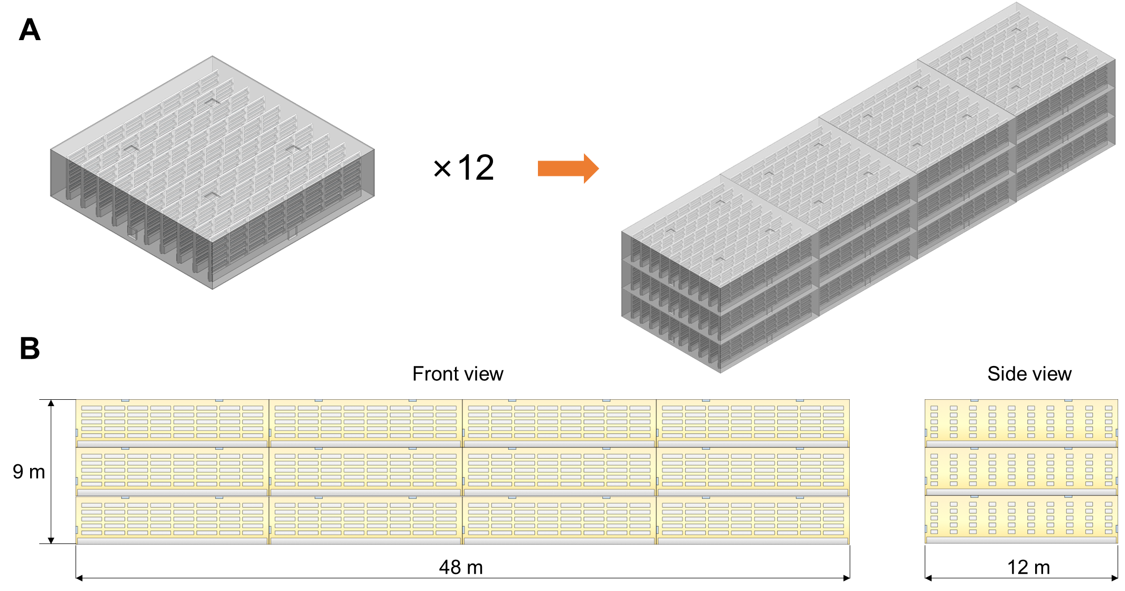

Figure S14. The large-sized vertical farming cultivation chamber. (A) The three-dimensional view of the vertical farming cultivation chamber. (B) The front view and side view of the vertical farming cultivation chamber. The large-sized vertical farming cultivation chamber is composed of twelve minimized modules.

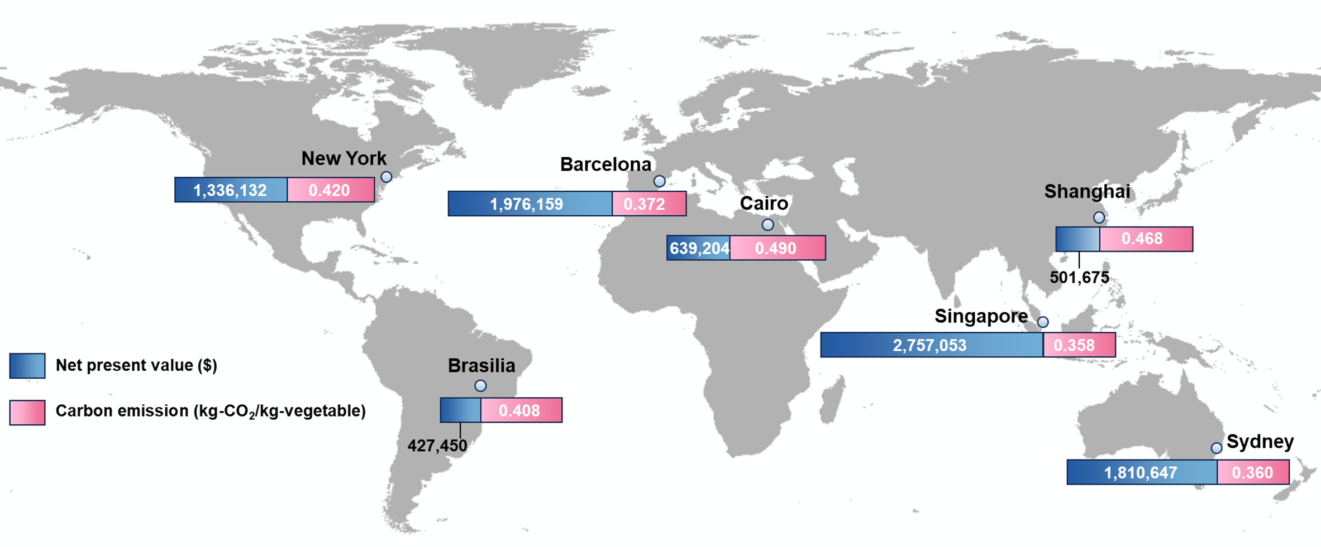

Figure S15. The economic and environmental performance of the system when deployed in different cities.

Table S1. The soil and biochar weight percentage of samples.
Number | Soil weight (g) | Biochar weight (g) | Total weight (g) | Biochar weight percentage (%)*
#1–9 | 950 | 0 | 950 | 0
#11–19 | 922 | 28 | 950 | 3
#21–29 | 898 | 52 | 950 | 6
#31–39 | 870 | 80 | 950 | 9
*Biochar weight percentage (wt%) is calculated by biochar weight/(biochar weight + soil weight).

Table S2. The environmental conditions in the four chambers.
Chamber | Conditions
A | Natural sunlight, wrapped with polyethylene membrane, ~1000 ppm CO₂
B | Natural sunlight, wrapped with polyethylene membrane, ~700 ppm CO₂
C | Natural sunlight, wrapped with polyethylene membrane, ~420 ppm CO₂
D | LED light, wrapped with blackout cloth, ~700 ppm CO₂

Table S3. Timeline and activities of vegetable cultivation.
Time | Date | Activity
Day 1 | 2023-04-14 | Sowing
Day 5 | 2023-04-18 | Gemination
Day 9 | 2023-04-22 | Fertilization applying
Day 16 | 2023-04-29 | Leaf number counting
Day 16 | 2023-04-29 | Leaf area measuring
Day 24 | 2023-05-07 | Leaf number counting
Day 25 | 2023-05-08 | Water content measuring
Day 26 | 2023-05-09 | Leaf area measuring
Day 26 | 2023-05-09 | Fertilization applying
Day 31 | 2023-05-14 | Leaf area measuring
Day 36 | 2023-05-19 | Leaf number counting
Day 36 | 2023-05-19 | Leaf area measuring
Day 39 | 2023-05-22 | Fertilization applying
Day 47 | 2023-05-30 | Vegetable harvesting
Day 47 | 2023-05-30 | Fresh weight measuring
Day 47 | 2023-05-30 | Leaf number counting
Day 47 | 2023-05-30 | Leaf area measuring
Day 47 | 2023-05-30 | Stem length measuring

Table S4. The operating conditions of the rotary adsorber in different cases.
Case | Operating conditions
1 | Process air flow rate 310 m³ h⁻¹, process air temperature ~30°C, regeneration air flow rate 100 m³ h⁻¹, regeneration temperature 70°C, wheel rotation speed 7 rph
2 | Process air flow rate 310 m³ h⁻¹, process air temperature ~30°C, regeneration air flow rate 100 m³ h⁻¹, regeneration temperature 80°C, wheel rotation speed 7 rph
3 | Process air flow rate 310 m³ h⁻¹, process air temperature ~30°C, regeneration air flow rate 100 m³ h⁻¹, regeneration temperature 90°C, wheel rotation speed 7 rph
4 | Process air flow rate 310 m³ h⁻¹, process air temperature ~30°C, regeneration air flow rate 80 m³ h⁻¹, regeneration temperature 70°C, wheel rotation speed 7 rph
5 | Process air flow rate 310 m³ h⁻¹, process air temperature ~30°C, regeneration air flow rate 120 m³ h⁻¹, regeneration temperature 70°C, wheel rotation speed 7 rph
6 | Process air flow rate 310 m³ h⁻¹, process air temperature ~30°C, regeneration air flow rate 140 m³ h⁻¹, regeneration temperature 70°C, wheel rotation speed 7 rph
Day 40 | Process air flow rate 310 m³ h⁻¹, process air temperature ~30°C, regeneration air flow rate 100 m³ h⁻¹, regeneration temperature 70°C, wheel rotation speed 7 rph (same as Case 1)

Table S5. The basic information of the exemplified vertical farming systems.
Parameter | Unit | Amount | Comment
Cultivation location: Shanghai, China
Vegetable cultivation
Vegetable plant per planter | plant/planter | 46
Cultivation period | day/cycle | 30 | Cultivation period of 30 days can be achieved for pak choi when the cultivation temperature is regulated.[3]
Cultivation day per year | day/year | 360
Cultivation cycle per year | cycle/year | 12
Vertical farming system lifespan | year | 20 | The lifespan of vertical farming system is assumed to be 20 years based on data referenced from existing literature.[4-7]
Discount rate | % | 10 | [8]
Capital recovery factor | - | 0.117 | Calculated using the system lifespan and discount rate.[9]
Cultivation chamber
Cultivation chamber layer | - | 2
Module per layer | - | 3
Total module | - | 6
Cultivation chamber length | m | 36
Cultivation chamber width | m | 12
Cultivation chamber height | m | 6
Steel structure
Steel rebar total length | m | 336 | Determined by farming building size.
Steel rebar cross-sectional area | m² | 4.52×10⁻⁴ | Tubular cross-section, outer diameter 30 mm, wall thickness 2 mm.
Steel rebar density | kg/m² | 7850 | [10]
Steel structure total weight | kg | 1193
Envelope
Floor | m² | 864 | Material: wood (28 mm) with polyvinyl chloride cover (2 mm).
Sidewalls and roof | m² | 1440 | Material: aluminum alloy (4 mm).
Insulation | m² | 1440 | Material: polyethylene foams (40 mm), covering the sidewalls and roof.
Hanger
Hanger per module | - | 10
Total hanger | - | 60
Steel rebar total length | m | 2206 | Determined by hanger size.
Steel rebar cross-sectional area | m² | 1.13×10⁻⁴ | Tubular cross-section, outer diameter 20 mm, wall thickness 2 mm.
Steel rebar density | kg/m³ | 7850 | [10]
Hanger total weight | kg | 1958
Planter
Planter length | m | 1.2
Planter upper width | m | 0.15
Planter lower width | m | 0.1
Planter depth | m | 0.12
Planter per hanger | - | 80 | 8 planters per row, 5 rows per side, 2 sides per hanger.
Total planter | - | 4800
Irrigation unit
Water pipe length | m | 3300 | Determined by the planter arrangement.
Irrigation length per irrigation pump | m | 45
Irrigation pump quantity | - | 74
Irrigation pump operating duration | h/day | 0.5
Water recovery unit
Water recovery gutter length | m | 660 | Determined by the planter arrangement.
Recovery length per recovery pump | m | 45
Recovery pump quantity | - | 15
Recovery pump operating duration | h/day | 1.2
Water tank volume | m³ | 10
Lighting unit
LED light length | m | 2880 | Determined by the planter arrangement.
LED light operating duration | h/day | 12
HVAC unit (Configuration 1&2)
Inlet fan quantity | - | 6
Inlet fan air flow rate | m³/h | 717
Inlet total air flow rate | m³/h | 4303
Inlet fan operating duration | h/day | 24
Outlet fan quantity | - | 6
Outlet fan air flow rate | m³/h | 717
Outlet total air flow rate | m³/h | 4303
Outlet fan operating duration | h/day | 24
Air conditioner quantity | - | 30
Cooling operating duration | h/day | 12
Cooling period | day/year | 123 | From May to August.
Heating operating duration | h/day | 12
Heating period | day/year | 120 | From November to February.
HVAC unit (Configuration 3&4)
Inlet fan quantity | - | 6
Inlet fan air flow rate | m³/h | 717
Inlet total air flow rate | m³/h | 4303
Inlet fan operating duration | h/day | 12
Outlet fan quantity | - | 6
Outlet fan air flow rate | m³/h | 717
Outlet total air flow rate | m³/h | 4303
Outlet fan operating duration | h/day | 24
Air conditioner quantity | - | 30
Cooling operating duration | h/day | 12
Cooling period | day/year | 123 | From May to August.
Heating operating duration | h/day | 12
Heating period | day/year | 120 | From November to February.
Agricultural sensor
Agricultural sensor quantity | - | 6
Agricultural sensor operating duration | h/day | 24
Seed usage
Seed per planter | seed/planter | 46
Seed germination rate | % | 80 | [11]
Seed usage per cycle | seed/cycle | 276000
Seed weight | kg/seed | 2.8×10⁻⁶ | [12]
Seed usage per year | kg/year | 9.27
Substrate handling
Potting substrate depth | m | 0.09
Potting substrate volume per planter | m³/planter | 0.0128
Soil density | kg/m³ | 635 | Experimental data.
Potting substrate density | kg/m³ | 613 | Experimental data.
Potting substrate weight per planter | kg/planter | 7.86
Potting substrate usage per cycle | kg/cycle | 37736
Potting substrate usage per year | kg/year | 452835
Biochar weight ratio | % | 6
Soil weight ratio | % | 94
Biochar usage per year | kg/year | 27170
Soil usage per year | kg/year | 425665
Biochar transportation distance (Trip 1) | km | 50 | Distance from the biochar production site to the use site.
Biochar transportation distance (Trip 2) | km | 50 | Distance from the use site to the sequestration site.
Biochar transportation load | tkm/year | 2717
Soil transportation distance (Trip 1) | km | 50 | Distance from the soil excavation site to the use site.
Soil transportation distance (Trip 2) | km | 50 | Distance from the use site to the sequestration site.
Soil transportation load | tkm/year | 42567
Fertilizer usage
Fertilizer application rate | kg/m² | 0.0165 | [13]
Fertilizer usage per cycle | kg/cycle | 14.26
Fertilizer usage per year | kg/year | 171
Rotary adsorber (Configuration 3&4)
Wheel-shaped CO₂ adsorbent diameter | mm | 2400
Wheel-shaped CO₂ adsorbent thickness | mm | 400
Wheel-shaped CO₂ adsorbent weight | kg | 570
Wheel-shaped CO₂ adsorbent regeneration temperature | °C | 90
Adsorption section air flow rate | m³/h | 17576
Regeneration section air flow rate | m³/h | 3565
Target indoor CO₂ concentration | ppm | 1000
Rotary adsorber operating duration | h/day | 12
Rotary adsorber carbon capture capacity | kg_{CO2}/year | 31320
Heat pump (Configuration 3)
Heating power | kW | 15
Coefficient of performance | - | 3 | [14]
Heat pump operating duration | h/day | 12
Heat generation | kWh/year | 64800
PV module (Configuration 2)
PV panel area | m² | 1560
PV electricity generation rate | kWh/m²/year | 232 | [15]
PV electricity generation | kWh/year | 361920
PV module (Configuration 3)
PV panel area | m² | 1680
PV electricity generation rate | kWh/m²/year | 232 | [15]
PV electricity generation | kWh/year | 389760
PVT module (Configuration 4)
PVT panel area | m² | 1635
PVT electricity generation rate | kWh/m²/year | 224 | [16]
PVT electricity generation | kWh/year | 366240
PVT heat generation rate | kWh/m²/year | 357 | [16]
PVT heat generation | kWh/year | 583695
System product (Configuration 1&2)
Fresh weight yield per vegetable plant | kg/plant | 0.024
Fresh weight yield per planter | kg/planter | 1.104
Fresh weight yield per cycle | kg/cycle | 5299.2
Fresh weight yield per year | kg/year | 63590
System product (Configuration 3&4)
Fresh weight yield per vegetable plant | kg/plant | 0.037
Fresh weight yield per planter | kg/planter | 1.702
Fresh weight yield per cycle | kg/cycle | 8169.6
Fresh weight yield per year | kg/year | 98035
Package film usage (Configuration 1&2)
Package film weight | kg/year | 382 | 0.006 kg package film (polyethylene material) is consumed per kg vegetable[17, 18]
Package film usage (Configuration 3&4)
Package film weight | kg/year | 588 | 0.006 kg package film (polyethylene material) is consumed per kg vegetable[17, 18]

Table S6. The capital costs of the exemplified vertical farming systems.
Parameter | Unit | Amount | Comment
Steel structure
Steel rebar unit cost | $/kg | 2.195 | [19]
Steel structure cost | $ | 2619
Envelope
Floor unit cost | $/m² | 4.29 | [20]
Sidewalls and roof unit cost | $/m² | 18.7 | [21]
Insulation unit cost | $/m² | 0.5 | [22]
Envelope cost | $ | 31383
Hanger
Hanger unit cost | $/kg | 2.195 | [19]
Hanger cost | $ | 4298
Planter
Planter unit cost | $/planter | 2.772 | [23]
Planter cost | $ | 13306
Irrigation unit
Water pipe unit cost | $/m | 0.03 | [24]
Water pipe cost | $ | 99
Irrigation pump unit cost | $ | 8.5 | [25]
Irrigation pump cost | $ | 629
Cost of irrigation unit | $ | 728
Water recovery unit
Water recovery gutter unit cost | $/m | 2.62 | [23]
Water recovery gutter cost | $ | 1729
Water recovery pump unit cost | $ | 8.5 | [25]
Water recovery pump cost | $ | 128
Water tank unit cost | $/m³ | 110 | [26]
Water tank cost | $ | 1100
Cost of water recovery unit | $ | 2957
Lighting unit
LED light unit cost | $/m | 10 | [27]
Cost of lighting unit | $ | 28800
HVAC unit
Inlet fan unit cost | $ | 15 | [28]
Inlet fan cost | $ | 90
Outlet fan unit cost | $ | 15 | [28]
Outlet fan cost | $ | 90
Air conditioner unit cost | $ | 150 | [29]
Air conditioner cost | $ | 4500
Cost of HVAC unit | $ | 4680
Agricultural sensor
Agricultural sensor unit cost | $ | 106.8 | [30]
Agricultural sensor cost | $ | 641
Rotary adsorber (Configuration 3&4)
Rotary adsorber cost | $ | 47413
Heat pump (Configuration 3)
Heat pump cost | $ | 15800 | [14]
PV unit (Configuration 2)
PV device unit cost | $/m² | 96 | [31]
Cost of PV unit | $ | 149760
PV unit (Configuration 3)
PV device unit cost | $/m² | 96 | [31]
Cost of PV unit | $ | 161280
PVT unit (Configuration 4)
PVT device unit cost | $/m² | 101 | [16]
Cost of PVT unit | $ | 165135
Others (Configuration 1)
Installation | $ | 22353 | Approximately 25% of equipment cost[32]
Land acquisition | $ | 4471 | Approximately 5% of equipment cost[32]
Working capital | $ | 20351 | Approximately 15% of capital costs[32]
Others (Configuration 2)
Installation | $ | 59793 | Approximately 25% of equipment cost[32]
Land acquisition | $ | 11959 | Approximately 5% of equipment cost[32]
Working capital | $ | 54369 | Approximately 15% of capital costs[32]
Others (Configuration 3)
Installation | $ | 78476 | Approximately 25% of equipment cost[32]
Land acquisition | $ | 15695 | Approximately 5% of equipment cost[32]
Working capital | $ | 71661 | Approximately 15% of capital costs[32]
Others (Configuration 4)
Installation | $ | 75490 | Approximately 25% of equipment cost[32]
Land acquisition | $ | 15098 | Approximately 5% of equipment cost[32]
Working capital | $ | 69439 | Approximately 15% of capital costs[32]

Table S7. The operating costs of the exemplified vertical farming systems.
Parameter | Unit | Amount | Comment
Irrigation unit
Irrigation pump unit power | kW | 0.05 | [33]
Irrigation pump total power | kW | 3.7
Irrigation pump electricity consumption | kWh/year | 666
Water recovery unit
Water recovery pump unit power | kW | 0.05 | [33]
Water recovery pump total power | kW | 0.75
Water recovery pump electricity consumption | kWh/year | 333
Lighting unit
LED light unit power | kW/m | 0.017 | [27]
LED light total power | kW | 48.96
LED light electricity consumption | kWh/year | 211507
HVAC unit (Configuration 1&2)
Inlet fan unit power | kW | 0.05 | [28]
Inlet fan total power | kW | 0.3
Outlet fan unit power | kW | 0.05 | [28]
Outlet fan total power | kW | 0.3
Ventilation electricity consumption | kWh/year | 5184
Cooling unit power | kW | 1.65 | [29]
Cooling total power | kW | 49.5
Cooling electricity consumption | kWh/year | 73062
Heating unit power | kW | 1.6 | [29]
Heating total power | kW | 48
Heating electricity consumption | kWh/year | 69120
HVAC unit electricity consumption | kWh/year | 147366
HVAC unit (Configuration 3&4)
Inlet fan unit power | kW | 0.05 | [28]
Inlet fan total power | kW | 0.3
Outlet fan unit power | kW | 0.05 | [28]
Outlet fan total power | kW | 0.3
Ventilation electricity consumption | kWh/year | 3888
Cooling unit power | kW | 1.65 | [29]
Cooling total power | kW | 49.5
Cooling electricity consumption | kWh/year | 73062
Heating unit power | kW | 1.6 | [29]
Heating total power | kW | 48
Heating electricity consumption | kWh/year | 69120
HVAC unit electricity consumption | kWh/year | 146070
Agricultural sensor
Agricultural sensor unit power | kW | 0.001 | [30]
Agricultural sensor total power | kW | 0.006
Agricultural sensor electricity consumption | kWh/year | 52
Rotary adsorber (Configuration 3&4)
Rotary adsorber electricity consumption | kWh/kg_{CO2} | 0.27
Rotary adsorber electricity consumption | kWh/year | 7517
Rotary adsorber heat consumption | kWh/kg_{CO2} | 1.98
Rotary adsorber heat consumption | kWh/year | 62014
Heat pump (Configuration 3)
Heat pump electrical power | kW | 5.0 | [14]
Heat pump electricity consumption | kWh/year | 21600
Electricity consumption (Configuration 1)
Total electricity consumption | kWh/year | 359924
Electricity consumption unit cost | $/kWh | 0.1 | [34]
Electricity consumption cost | $/year | 35992
Electricity consumption (Configuration 2)
Total electricity consumption | kWh/year | 359924
Electricity consumption cost | $/year | 0 | Electricity is supplied by the PV unit.
Electricity consumption (Configuration 3)
Total electricity consumption | kWh/year | 387745
Electricity consumption cost | $/year | 0 | Electricity is supplied by the PT unit.
Electricity consumption (Configuration 4)
Total electricity consumption | kWh/year | 366145
Electricity consumption cost | $/year | 0 | Electricity is supplied by the PVT unit.
Heat consumption (Configuration 3)
Total heat consumption | kWh/year | 62014
Heat consumption cost | $ | 0 | Heat is supplied by the heat pump.
Heat consumption (Configuration 4)
Total heat consumption | kWh/year | 62014
Heat consumption cost | $ | 0 | Heat is supplied by the PVT unit.
Water usage
Irrigation pump unit flow rate | L/min | 4.3 | [33]
Irrigation pump total flow rate | m³/h | 19.09
Water recovery pump unit flow rate | L/min | 4.3 | [33]
Water recovery pump total flow rate | m³/h | 3.87
Water consumption | m³/year | 1765
Tap water unit cost | $/m³ | 0.389 | [35]
Water consumption cost | $/year | 686
Seed usage
Seed unit cost | $/kg | 97.5 | [12]
Seed cost | $/year | 904
Substrate handling
Biochar transportation unit cost | $/tkm | 0.1 | [36]
Biochar transportation cost | $/year | 271.70
Soil excavation unit cost | $/m³ | 3.272 | [37]
Soil excavation cost | $/year | 2193.35
Soil transportation unit cost | $/tkm | 0.1 | [36]
Soil transportation cost | $/year | 4256.65
Substrate handling cost | $/year | 6722
Fertilizer usage
Fertilizer unit cost | $/kg | 0.629 | [38]
Fertilizer cost | $/year | 108
Structured adsorbent usage (Configuration 3&4)
Structured adsorbent unit cost | $/kg | 5.76
Structured adsorbent lifespan | year | 1.5
Structured adsorbent cost | US$/year | 2189
Package film usage (Configuration 1&2)
Package film unit cost | $/kg | 1.92 | [39]
Package film cost | $/year | 733
Package film usage (Configuration 3&4)
Package film unit cost | $/kg | 1.92 | [39]
Package film cost | $/year | 1129
Others (Configuration 1)
Maintenance and repairs | $/year | 2682 | Approximately 3% of equipment cost.[32]
Operating labor | $/year | 4946 | Calculated by 0.067 man hour/kg-product × 1.161 $/(man hour).[40]
Others (Configuration 2)
Maintenance and repairs | $/year | 7175 | Approximately 3% of equipment cost.[32]
Operating labor | $/year | 4946 | Calculated by 0.067 man hour/kg-product × 1.161 $/(man hour).[40]
Others (Configuration 3)
Maintenance and repairs | $/year | 9417 | Approximately 3% of equipment cost.[32]
Operating labor | $/year | 7626 | Calculated by 0.067 man hour/kg-product × 1.161 $/(man hour).[40]
Others (Configuration 4)
Maintenance and repairs | $/year | 9059 | Approximately 3% of equipment cost.[32]
Operating labor | $/year | 7626 | Calculated by 0.067 man hour/kg-product × 1.161 $/(man hour).[40]

Table S8. The revenues of the exemplified vertical farming systems.
Parameter | Unit | Amount | Comment
Configuration 1&2
Fresh weight yield per vegetable plant | kg/plant | 0.024
Fresh weight yield per planter | kg/planter | 1.104
Fresh weight yield per cycle | kg/cycle | 5299
Fresh weight yield per year | kg/year | 63590
Pak choi selling price | $/kg | 1.44 | [41]
Annual revenue | $/year | 91570
Configuration 3&4
Fresh weight yield per vegetable plant | kg/plant | 0.037
Fresh weight yield per planter | kg/planter | 1.702
Fresh weight yield per cycle | kg/cycle | 8170
Fresh weight yield per year | kg/year | 98035
Pak choi selling price | $/kg | 1.44 | [41]
Annual revenue | $/year | 141171

Table S9. The economic performance of the exemplified vertical farming systems.
Parameter | Configuration 1 | Configuration 2 | Configuration 3 | Configuration 4
Capital costs ($) | 136587 | 365293 | 479738 | 461988
Operating costs ($/year) | 52774 | 21275 | 28781 | 28422
Annual profit* ($/year) | 39695 | 71485 | 111516 | 112262
Net present value** ($) | 195004 | 235522 | 480862 | 501675
Discounted payback period (year) | 4.6 | 7.7 | 5.9 | 5.6
*The income obtained from selling vegetable is assumed to be tax-exempt.
** Net present value at the end of system lifespan.

Table S10. The life cycle inventory for materials.
Input | Data | Amount | Unit | Comment
Seed 1 kg
Seed | Cabbages, start material, at seed production (NL) Economic, S | 1 | kg
Transport | Transport, freight, lorry 3.5-7.5 metric ton, EURO5 (RoW)| market for transport, freight, lorry 3.5-7.5 metric ton, EURO5 | Cut-off, S | 100 | kgkm | Distance of 100 km from the seed purchase site to the use site.
Soil 1 kg
Soil | Input from nature, Soil | 1 | kg
Excavation | Diesel (RoW)| market for diesel | Cut-off, S | 6.945×10⁻⁴ | kg | Evaluate the environmental impacts of excavation by calculating the diesel fuel consumed.[42, 43]
Transport | Transport, freight, lorry >32 metric ton, EURO5 (RoW)| market for transport, freight, lorry >32 metric ton, EURO5 | Cut-off, S | 50 | kgkm | Distance of 50 km for soil transport from the excavation site to the use site.
Biochar 1 kg
Water hyacinth harvest | Diesel (RoW)| market for diesel | Cut-off, S | 4.598×10⁻² | kg | 2 kg water hyacinth feedstock to produce 0.4 kg water hyacinth biochar, 0.01 hour spent for harvesting, evaluate the environmental impact of harvesting by calculated the diesel fuel consumed.[44]
Woodchips harvest | Diesel (RoW)| market for diesel | Cut-off, S | 5.898×10⁻² | kg | 3 kg woodchips feedstock to produce 0.6 kg woodchips biochar, 0.015 hour spent for harvesting, evaluate the environmental impact of harvesting by calculated the diesel fuel consumed.[44]
Feed stock transport | Transport, freight, lorry 16-32 metric ton, EURO5 (RoW)| market for transport, freight, lorry 16-32 metric ton, EURO5 | Cut-off, S | 500 | kgkm | Distance of 500 km for feedstock transport.
Grinding | Diesel (RoW)| market for diesel | Cut-off, S | 3.956×10⁻² | kg | Evaluate the environmental impact of grinding by calculated the diesel fuel consumed.[45]
Waste treatment | Inert waste, for final disposal (RoW)| treatment of inert waste, inert material landfill | Cut-off, S | 0.1 | kg | [46]
Transport | Transport, freight, lorry 16-32 metric ton, EURO5 (RoW)| market for transport, freight, lorry 16-32 metric ton, EURO5 | Cut-off, S | 50 | kgkm | Distance of 50 km for biochar transport from the production site to the use site.
Fertilizer 1 kg
Fertilizer | NPK (15-15-15) fertiliser (RoW)| market for NPK (15-15-15) fertiliser | Cut-off, S | 1 | kg
Transport | Transport, freight, lorry 3.5-7.5 metric ton, EURO5 (RoW)| market for transport, freight, lorry 3.5-7.5 metric ton, EURO5 | Cut-off, S | 50 | kgkm | Distance of 50 km from the fertilizer purchase site to the use site.
Polyethyleneimine 1 kg
Monoethanolamine | Monoethanolamine (GLO)| market for monoethanolamine | Cut-off, S | 1.42 | kg | [47]
Sulfuric acid | Sodium sulfate, anhydrite (RoW)| market for sodium sulfate, anhydrite | Cut-off, S | 2.28 | kg | [47]
Sodium hydroxide | Sodium hydroxide, without water, in 50% solution state (GLO)| market for sodium hydroxide, without water, in 50% solution state | Cut-off, S | 1.86 | kg | [47]
Hydrochloric acid | Hydrochloric acid, without water, in 30% solution state (RoW)| market for hydrochloric acid, without water, in 30% solution state | Cut-off, S | 0.16 | kg | [47]
Sodium hydroxide | Sodium sulfate, anhydrite (RoW)| market for sodium sulfate, anhydrite | Cut-off, S | 0.16 | kg | [47]
Ethanol | Ethanol, without water, in 99.7% solution state, from ethylene (RoW)| market for ethanol, without water, in 99.7% solution state, from ethylene | Cut-off, S | 2.84 | kg | [47]
Diethyl ether | Ethylene (RoW)| market for ethylene | Cut-off, S | 33.9 | kg | [47]
Water | Water, deionised (RoW)| market for water, deionised | Cut-off, S | 11.99 | kg | [47]
Electricity | Electricity, low voltage (GLO)| market group for electricity, low voltage | Cut-off, S | 0.42 | kWh | [47]
Heat | Heat, district or industrial, natural gas (GLO)| market group for heat, district or industrial, natural gas | Cut-off, S | 2.35 | MJ | [47]
Unreacted solvent treatment | Spent solvent mixture (RoW)| market for spent solvent mixture | Cut-off, S | 0.37 | kg | [47]
Structured adsorbent 1 kg
Polyethyleneimine | Polyethyleneimine | 0.16 | kg | [48]
Silica | Silica fume, densified (GLO)| market for silica fume, densified | Cut-off, S | 0.24 | kg | [48]
Glass fiber substrate | Glass fibre (GLO)| market for glass fibre | Cut-off, S | 0.6 | kg | [48]
Heat | Heat, district, or industrial, natural gas (RoW)| market for heat, district or industrial, natural gas | Cut-off, S | 12.96 | MJ | [48]
Transport | Transport, freight, lorry 3.5-7.5 metric ton, EURO5 (RoW)| market for transport, freight, lorry 3.5-7.5 metric ton, EURO5 | Cut-off, S | 100 | kgkm | Distance of 100 km from the adsorbent production site to the use site.
Package 1 kg
Package film | Packaging film, low density polyethylene (GLO)| market for packaging film, low density polyethylene | Cut-off, S | 1 | kg
Transport | Transport, freight, lorry 3.5-7.5 metric ton, EURO5 (RoW)| market for transport, freight, lorry 3.5-7.5 metric ton, EURO5 | Cut-off, S | 50 | kgkm | Distance of 50 km from the package production site to the use site.

Table S11. The life cycle inventory for vegetable production in the exemplified vertical farming systems. The material and energy flows were converted into annual quantities.
Input | Data | Amount | Unit | Comment
Vegetable product (Configuration 1) 63590 kg
Seed | Seed | 9.27 | kg
Soil | Soil | 425665 | kg
Biochar | Biochar | 27170 | kg
Fertilizer | Fertilizer | 171 | kg
Package | Package | 382 | kg
Irrigation water | Tap water (RoW)| market for tap water | Cut-off, S | 1764720 | kg
Electricity | Electricity, low voltage (CN)| market group for electricity, low voltage | Cut-off, S | 359924 | kWh
Vegetable transport | Transport, freight, lorry 7.5-16 metric ton, EURO5 (RoW)| market for transport, freight, lorry 7.5-16 metric ton, EURO5 | Cut-off, S | 3180 | tkm | Distance of 50 km from the vegetable production site to the store.
Soil transport | Transport, freight, lorry >32 metric ton, EURO5 (RoW)| market for transport, freight, lorry >32 metric ton, EURO5 | Cut-off, S | 21283 | tkm | Distance of 50 km for soil transport from the use site to the sequestration site.
Biochar transport | Transport, freight, lorry >32 metric ton, EURO5 (RoW)| market for transport, freight, lorry >32 metric ton, EURO5 | Cut-off, S | 1359 | tkm | Distance of 50 km for biochar transport from the use site to the sequestration site.
Substrate treatment | Biowaste (RoW)| treatment of biowaste, industrial composting | Cut-off, S | 14853 | kg | Waste treatment for the used substrate.[49]
Biochar sequestration | Emission to air, carbon dioxide | –13077 | kg | The negative emission effect of biochar as a soil amendment (–0.4813 kg CO₂ emission per kg biochar sequestrated).[50]
Vegetable product (Configuration 2) 63590 kg
Seed | Seed | 9.27 | kg
Soil | Soil | 425665 | kg
Biochar | Biochar | 27170 | kg
Fertilizer | Fertilizer | 171 | kg
Package | Package | 382 | kg
Irrigation water | Tap water (RoW)| market for tap water | Cut-off, S | 1764720 | kg
Electricity | Electricity, low voltage (CN-SH)| electricity production, photovoltaic, 570kWp open ground installation, multi-Si | Cut-off, S | 359924 | kWh
Vegetable transport | Transport, freight, lorry 7.5-16 metric ton, EURO5 (RoW)| market for transport, freight, lorry 7.5-16 metric ton, EURO5 | Cut-off, S | 3180 | tkm | Distance of 50 km from the vegetable production site to the store.
Soil transport | Transport, freight, lorry >32 metric ton, EURO5 (RoW)| market for transport, freight, lorry >32 metric ton, EURO5 | Cut-off, S | 21283 | tkm | Distance of 50 km for soil transport from the use site to the sequestration site.
Biochar transport | Transport, freight, lorry >32 metric ton, EURO5 (RoW)| market for transport, freight, lorry >32 metric ton, EURO5 | Cut-off, S | 1359 | tkm | Distance of 50 km for biochar transport from the use site to the sequestration site.
Substrate treatment | Biowaste (RoW)| treatment of biowaste, industrial composting | Cut-off, S | 14853 | kg | Waste treatment for the used substrate.[49]
Biochar sequestration | Emission to air, carbon dioxide | –13077 | kg | The negative emission effect of biochar as a soil amendment (–0.4813 kg CO₂ emission per kg biochar sequestrated).[50]
Vegetable product (Configuration 3) 98035 kg
Seed | Seed | 9.27 | kg
Soil | Soil | 425665 | kg
Biochar | Biochar | 27170 | kg
Fertilizer | Fertilizer | 171 | kg
Package | Package | 588 | kg
Structured adsorbent | Structured adsorbent | 570 | kg
Irrigation water | Tap water (RoW)| market for tap water | Cut-off, S | 1764720 | kg
Electricity | Electricity, low voltage (CN-SH)| electricity production, photovoltaic, 570kWp open ground installation, multi-Si | Cut-off, S | 387745 | kWh
Heat | Heat, central or small-scale, other than natural gas (RoW)| heat production, at heat pump 30kW, allocation exergy | Cut-off, S | 62014 | kWh
Vegetable transport | Transport, freight, lorry 7.5-16 metric ton, EURO5 (RoW)| market for transport, freight, lorry 7.5-16 metric ton, EURO5 | Cut-off, S | 4902 | tkm | Distance of 50 km from the vegetable production site to the store.
Soil transport | Transport, freight, lorry >32 metric ton, EURO5 (RoW)| market for transport, freight, lorry >32 metric ton, EURO5 | Cut-off, S | 21283 | tkm | Distance of 50 km for soil transport from the use site to the sequestration site.
Biochar transport | Transport, freight, lorry >32 metric ton, EURO5 (RoW)| market for transport, freight, lorry >32 metric ton, EURO5 | Cut-off, S | 1359 | tkm | Distance of 50 km for biochar transport from the use site to the sequestration site.
Substrate treatment | Biowaste (RoW)| treatment of biowaste, industrial composting | Cut-off, S | 22898 | kg | Waste treatment for the used substrate.[49]
Biochar sequestration | Emission to air, carbon dioxide | –13077 | kg | The negative emission effect of biochar as a soil amendment (–0.4813 kg CO₂ emission per kg biochar sequestrated).[50]
Vegetable product (Configuration 4) 98035 kg
Seed | Seed | 9.27 | kg
Soil | Soil | 425665 | kg
Biochar | Biochar | 27170 | kg
Fertilizer | Fertilizer | 171 | kg
Package | Package | 588 | kg
Structured adsorbent | Structured adsorbent | 570 | kg
Irrigation water | Tap water (RoW)| market for tap water | Cut-off, S | 1764720 | kg
Electricity | Electricity, low voltage (CN-SH)| electricity production, photovoltaic, 570kWp open ground installation, multi-Si | Cut-off, S | 366145 | kWh
Heat | Heat, central or small-scale, other than natural gas (RoW)| operation, solar collector system, Cu flat plate collector, multiple dwelling, for hot water | Cut-off, S | 62104 | kWh
Vegetable transport | Transport, freight, lorry 7.5-16 metric ton, EURO5 (RoW)| market for transport, freight, lorry 7.5-16 metric ton, EURO5 | Cut-off, S | 4902 | tkm | Distance of 50 km from the vegetable production site to the store.
Soil transport | Transport, freight, lorry >32 metric ton, EURO5 (RoW)| market for transport, freight, lorry >32 metric ton, EURO5 | Cut-off, S | 21283 | tkm | Distance of 50 km for soil transport from the use site to the sequestration site.
Biochar transport | Transport, freight, lorry >32 metric ton, EURO5 (RoW)| market for transport, freight, lorry >32 metric ton, EURO5 | Cut-off, S | 1359 | tkm | Distance of 50 km for biochar transport from the use site to the sequestration site.
Substrate treatment | Biowaste (RoW)| treatment of biowaste, industrial composting | Cut-off, S | 22898 | kg | Waste treatment for the used substrate.[49]
Biochar sequestration | Emission to air, carbon dioxide | –13077 | kg | The negative emission effect of biochar as a soil amendment (–0.4813 kg CO₂ emission per kg biochar sequestrated).[50]

Table S12. The results of analysis of variance conducted on experimental groups with more than three levels. A significance level p-value less than 0.05 indicates a significant difference, while the opposite means it is not significant.
Kale, Chamber A, B, C (fresh weight), sample size n=36 in each group
 | Sum of squares | df | Mean square | F | Sig. (p)
Between groups | 1513.322 | 2 | 756.661 | 73.544 | 0.000
Within groups | 1080.302 | 105 | 10.289
Total | 2593.624 | 107
Kale, Chamber A, B, C (dry weight), sample size n=24 in each group
 | Sum of squares | df | Mean square | F | Sig. (p)
Between groups | 10.707 | 2 | 5.353 | 30.828 | 0.000
Within groups | 11.982 | 69 | 0.174
Total | 22.689 | 71
Kale, biochar ratio (leaf area Day 47), sample size n=12 in each group
 | Sum of squares | df | Mean square | F | Sig. (p)
Between groups | 72336.229 | 3 | 24112.076 | 20.908 | 0.000
Within groups | 50741.750 | 44 | 1153.222
Total | 123077.979 | 47
Kale, biochar ratio (fresh weight), sample size n=36 in each group
 | Sum of squares | df | Mean square | F | Sig. (p)
Between groups | 53.140 | 3 | 17.713 | 0.855 | 0.466
Within groups | 2899.164 | 140 | 20.708
Total | 2952.304 | 143
Kale, biochar ratio (dry weight), sample size n=24 in each group
 | Sum of squares | df | Mean square | F | Sig. (p)
Between groups | 0.084 | 3 | 0.028 | 0.096 | 0.962
Within groups | 26.557 | 92 | 0.289
Total | 26.641 | 95
Pak choi, Chamber A, B, C (fresh weight), sample size n=36 in each group
 | Sum of squares | df | Mean square | F | Sig. (p)
Between groups | 2986.829 | 2 | 1493.414 | 82.516 | 0.000
Within groups | 1900.351 | 105 | 18.099
Total | 4887.180 | 107
Pak choi, Chamber A, B, C (dry weight), sample size n=24 in each group
 | Sum of squares | df | Mean square | F | Sig. (p)
Between groups | 5.440 | 2 | 2.720 | 18.162 | 0.000
Within groups | 10.333 | 69 | 0.150
Total | 15.773 | 71
Pak choi, biochar ratio (leaf area Day 47), sample size n=12 in each group
 | Sum of squares | df | Mean square | F | Sig. (p)
Between groups | 62714.896 | 3 | 20904.965 | 16.943 | 0.000
Within groups | 54289.583 | 44 | 1233.854
Total | 117004.479 | 47
Pak choi, biochar ratio (fresh weight), sample size n=36 in each group
 | Sum of squares | df | Mean square | F | Sig. (p)
Between groups | 56.299 | 3 | 18.766 | 0.493 | 0.688
Within groups | 5326.757 | 140 | 38.048
Total | 5383.056 | 143
Pak choi, biochar ratio (dry weight), sample size n=24 in each group
 | Sum of squares | df | Mean square | F | Sig. (p)
Between groups | 0.486 | 3 | 0.162 | 0.778 | 0.509
Within groups | 19.161 | 92 | 0.208
Total | 19.647 | 95

Table S13. The results of significance analysis for experimental data. The calculation was implemented using t-tests with confidence level α=0.05.
Group | Group compared | p value | Significant
Kale, Chamber A, B, C (fresh weight), sample size n=36 in each group
Chamber A | Chamber B | 1.704E-07 | Yes
 | Chamber C | 1.150E-21 | Yes
Chamber B | Chamber C | 2.596E-09 | Yes
Pak choi, Chamber A, B, C (fresh weight), sample size n=36 in each group
Chamber A | Chamber B | 6.475E-10 | Yes
 | Chamber C | 2.983E-23 | Yes
Chamber B | Chamber C | 2.421E-08 | Yes
Kale, Chamber B, D (fresh weight), sample size n=36 in each group
Chamber B | Chamber D | 3.513E-01 | No
Pak choi, Chamber B, D (fresh weight), sample size n=36 in each group
Chamber B | Chamber D | 9.403E-02 | No
Kale, Chamber A, B, C (dry weight), sample size n=24 in each group
Chamber A | Chamber B | 2.554E-02 | Yes
 | Chamber C | 8.807E-11 | Yes
Chamber B | Chamber C | 1.020E-06 | Yes
Pak choi, Chamber A, B, C (dry weight), sample size n=24 in each group
Chamber A | Chamber B | 1.144E-04 | Yes
 | Chamber C | 1.333E-07 | Yes
Chamber B | Chamber C | 7.840E-02 | Yes
Kale, Chamber B, D (dry weight), sample size n=24 in each group
Chamber B | Chamber D | 7.293E-01 | No
Pak choi, Chamber B, D (dry weight), sample size n=24 in each group
Chamber B | Chamber D | 8.365E-01 | No
Kale, biochar ratio (leaf area Day 47), sample size n=12 in each group
0 wt% | 3 wt% | 9.608E-06 | Yes
 | 6 wt% | 1.732E-09 | Yes
 | 9 wt% | 8.449E-07 | Yes
3 wt% | 6 wt% | 1.396E-02 | Yes
 | 9 wt% | 4.709E-01 | No
6 wt% | 9 wt% | 7.353E-02 | No
Pak choi, biochar ratio (leaf area Day 47), sample size n=12 in each group
0 wt% | 3 wt% | 3.690E-04 | Yes
 | 6 wt% | 8.286E-09 | Yes
 | 9 wt% | 1.558E-04 | Yes
3 wt% | 6 wt% | 2.300E-03 | Yes
 | 9 wt% | 7.816E-01 | No
6 wt% | 9 wt% | 4.968E-03 | Yes
Kale, biochar ratio (fresh weight), sample size n=36 in each group
0 wt% | 3 wt% | 6.866E-01 | No
 | 6 wt% | 1.926E-01 | No
 | 9 wt% | 8.851E-01 | No
3 wt% | 6 wt% | 3.671E-01 | No
 | 9 wt% | 5.839E-01 | No
6 wt% | 9 wt% | 1.482E-01 | No
Pak choi, biochar ratio (fresh weight), sample size n=36 in each group
0 wt% | 3 wt% | 5.921E-01 | No
 | 6 wt% | 2.292E-01 | No
 | 9 wt% | 5.920E-01 | No
3 wt% | 6 wt% | 5.036E-01 | No
 | 9 wt% | 9.998E-01 | No
6 wt% | 9 wt% | 5.037E-01 | No
Kale, biochar ratio (dry weight), sample size n=24 in each group
0 wt% | 3 wt% | 4.789E-01 | No
 | 6 wt% | 4.432E-01 | No
 | 9 wt% | 5.933E-01 | No
3 wt% | 6 wt% | 9.529E-01 | No
 | 9 wt% | 8.614E-01 | No
6 wt% | 9 wt% | 8.153E-01 | No
Pak choi, biochar ratio (dry weight), sample size n=24 in each group
0 wt% | 3 wt% | 7.240E-01 | No
 | 6 wt% | 4.425E-01 | No
 | 9 wt% | 5.322E-01 | No
3 wt% | 6 wt% | 6.777E-01 | No
 | 9 wt% | 7.857E-01 | No
6 wt% | 9 wt% | 8.856E-01 | No

Table S14. The environmental impacts of the exemplified vertical farming systems calculated using the Endpoint method. The environmental impacts were quantified using weighted points (Pt) per functional unit (FU).
Damage category | Human health (Pt/FU) | Ecosystems (Pt/FU) | Resources (Pt/FU) | Total (Pt/FU)
Configuration 1 | 0.214501 | 0.006799 | 0.001386 | 0.222686
Configuration 2 | 0.035024 | 0.001356 | 0.000675 | 0.037055
Configuration 3 | 0.031841 | 0.001171 | 0.000657 | 0.033668
Configuration 4 | 0.026904 | 0.001015 | 0.000617 | 0.028537

Table S15. The environmental impacts of the exemplified vertical farming systems calculated using the Midpoint method. The environmental impacts were converted into amount per functional unit (FU).
 | Unit | SDU | BU | SU | FU | PK | AU | IR | TS | EC | HC | WT
Configuration 1
(1) | kgCO_{2eq}/FU | 6.96E-04 | -1.01E-01 | 7.61E-02 | 4.14E-03 | 1.95E-02 | – | 3.53E-02 | 5.07E-02 | 5.67E+00 | – | 1.58E-02
(2) | kgSO_{2eq}/FU | 7.36E-06 | 3.00E-04 | 1.67E-04 | 1.52E-05 | 5.48E-05 | – | 1.21E-04 | 1.06E-04 | 2.00E-02 | – | 3.38E-04
(3) | kgP_{eq}/FU | 7.37E-07 | 7.73E-06 | 6.47E-06 | 9.11E-07 | 5.47E-06 | – | 1.35E-05 | 4.36E-06 | 1.11E-03 | – | 1.83E-06
(4) | kgN_{eq}/FU | 3.61E-06 | 5.76E-06 | 2.06E-06 | 1.31E-07 | 6.03E-07 | – | 1.34E-06 | 1.19E-06 | 7.12E-05 | – | 3.25E-07
(5) | kg1,4-DCB/FU | 5.28E-03 | 8.94E-01 | 1.38E+00 | 1.95E-02 | 4.34E-02 | – | 9.52E-02 | 8.89E-01 | 1.24E+01 | – | 2.44E-02
(6) | kg1,4-DCB/FU | 1.22E-04 | 1.75E-03 | 1.70E-03 | 1.78E-04 | 4.84E-04 | – | 1.27E-03 | 1.16E-03 | 2.36E-01 | – | 2.43E-04
(7) | kg1,4-DCB/FU | 3.28E-05 | 2.92E-03 | 3.01E-03 | 2.35E-04 | 6.46E-04 | – | 1.73E-03 | 2.02E-03 | 3.00E-01 | – | 3.25E-04
(8) | kg1,4-DCB/FU | 6.35E-06 | 4.54E-03 | 3.62E-03 | 1.99E-04 | 7.94E-04 | – | 1.44E-02 | 2.43E-03 | 1.83E-01 | – | 1.16E-03
(9) | kg1,4-DCB/FU | 8.32E-03 | 5.55E-02 | 5.73E-02 | 3.26E-03 | 1.18E-02 | – | 3.01E-02 | 3.87E-02 | 3.89E+00 | – | 4.38E-03
(10) | m²a crop_{eq}/FU | 8.62E-04 | 3.42E-03 | 4.92E-03 | 9.62E-05 | 5.81E-04 | – | 5.77E-04 | 2.98E-03 | 7.15E-02 | – | 7.92E-04
(11) | kg oil_{eq}/FU | 6.85E-05 | 9.05E-02 | 2.91E-02 | 9.02E-04 | 1.14E-02 | – | 8.47E-03 | 1.64E-02 | 1.12E+00 | – | 1.94E-03
(12) | m³/FU | 5.37E-06 | 2.41E-04 | 1.72E-04 | 3.97E-05 | 1.61E-04 | – | 2.64E-02 | 1.08E-04 | 1.54E-02 | – | -5.00E-05
Configuration 2
(1) | kgCO_{2eq}/FU | 6.96E-04 | -1.01E-01 | 7.61E-02 | 4.14E-03 | 1.95E-02 | – | 3.53E-02 | 5.07E-02 | 4.58E-01 | – | 1.58E-02
(2) | kgSO_{2eq}/FU | 7.36E-06 | 3.00E-04 | 1.67E-04 | 1.52E-05 | 5.48E-05 | – | 1.21E-04 | 1.06E-04 | 1.97E-03 | – | 3.38E-04
(3) | kgP_{eq}/FU | 7.37E-07 | 7.73E-06 | 6.47E-06 | 9.11E-07 | 5.47E-06 | – | 1.35E-05 | 4.36E-06 | 2.45E-04 | – | 1.83E-06
(4) | kgN_{eq}/FU | 3.61E-06 | 5.76E-06 | 2.06E-06 | 1.31E-07 | 6.03E-07 | – | 1.34E-06 | 1.19E-06 | 2.22E-05 | – | 3.25E-07
(5) | kg1,4-DCB/FU | 5.28E-03 | 8.94E-01 | 1.38E+00 | 1.95E-02 | 4.34E-02 | – | 9.52E-02 | 8.89E-01 | 1.11E+01 | – | 2.44E-02
(6) | kg1,4-DCB/FU | 1.22E-04 | 1.75E-03 | 1.70E-03 | 1.78E-04 | 4.84E-04 | – | 1.27E-03 | 1.16E-03 | 9.64E-02 | – | 2.43E-04
(7) | kg1,4-DCB/FU | 3.28E-05 | 2.92E-03 | 3.01E-03 | 2.35E-04 | 6.46E-04 | – | 1.73E-03 | 2.02E-03 | 1.27E-01 | – | 3.25E-04
(8) | kg1,4-DCB/FU | 6.35E-06 | 4.54E-03 | 3.62E-03 | 1.99E-04 | 7.94E-04 | – | 1.44E-02 | 2.43E-03 | 7.71E-02 | – | 1.16E-03
(9) | kg1,4-DCB/FU | 8.32E-03 | 5.55E-02 | 5.73E-02 | 3.26E-03 | 1.18E-02 | – | 3.01E-02 | 3.87E-02 | 1.14E+00 | – | 4.38E-03
(10) | m²a crop_{eq}/FU | 8.62E-04 | 3.42E-03 | 4.92E-03 | 9.62E-05 | 5.81E-04 | – | 5.77E-04 | 2.98E-03 | 1.61E-01 | – | 7.92E-04
(11) | kg oil_{eq}/FU | 6.85E-05 | 9.05E-02 | 2.91E-02 | 9.02E-04 | 1.14E-02 | – | 8.47E-03 | 1.64E-02 | 1.14E-01 | – | 1.94E-03
(12) | m³/FU | 5.37E-06 | 2.41E-04 | 1.72E-04 | 3.97E-05 | 1.61E-04 | – | 2.64E-02 | 1.08E-04 | 1.53E-02 | – | -5.00E-05
Configuration 3
(1) | kgCO_{2eq}/FU | 4.51E-04 | -6.52E-02 | 4.94E-02 | 2.68E-03 | 1.95E-02 | 7.41E-02 | 2.29E-02 | 3.72E-02 | 3.20E-01 | 1.15E-01 | 1.58E-02
(2) | kgSO_{2eq}/FU | 4.77E-06 | 1.94E-04 | 1.08E-04 | 9.87E-06 | 5.47E-05 | 1.97E-04 | 7.84E-05 | 7.75E-05 | 1.38E-03 | 3.87E-04 | 3.38E-04
(3) | kgP_{eq}/FU | 4.78E-07 | 5.01E-06 | 4.19E-06 | 5.91E-07 | 5.46E-06 | 9.20E-06 | 8.73E-06 | 3.20E-06 | 1.71E-04 | 4.88E-05 | 1.83E-06
(4) | kgN_{eq}/FU | 2.34E-06 | 3.74E-06 | 1.34E-06 | 8.51E-08 | 6.02E-07 | 4.31E-06 | 8.70E-07 | 8.72E-07 | 1.55E-05 | 3.21E-06 | 3.25E-07
(5) | kg1,4-DCB/FU | 3.43E-03 | 5.80E-01 | 8.96E-01 | 1.26E-02 | 4.33E-02 | 1.45E-01 | 6.17E-02 | 6.33E-01 | 7.78E+00 | 3.27E-01 | 2.44E-02
(6) | kg1,4-DCB/FU | 7.93E-05 | 1.14E-03 | 1.10E-03 | 1.16E-04 | 4.83E-04 | 1.26E-03 | 8.26E-04 | 8.48E-04 | 6.73E-02 | 6.46E-03 | 2.43E-04
(7) | kg1,4-DCB/FU | 2.13E-05 | 1.89E-03 | 1.95E-03 | 1.53E-04 | 6.45E-04 | 1.69E-03 | 1.12E-03 | 1.47E-03 | 8.86E-02 | 8.24E-03 | 3.25E-04
(8) | kg1,4-DCB/FU | 4.12E-06 | 2.94E-03 | 2.35E-03 | 1.29E-04 | 7.93E-04 | 1.89E-03 | 9.34E-03 | 1.78E-03 | 5.39E-02 | 4.73E-03 | 1.16E-03
(9) | kg1,4-DCB/FU | 5.40E-03 | 3.60E-02 | 3.72E-02 | 2.11E-03 | 1.18E-02 | 3.67E-02 | 1.95E-02 | 2.82E-02 | 7.95E-01 | 1.10E-01 | 4.38E-03
(10) | m²a crop_{eq}/FU | 5.59E-04 | 2.22E-03 | 3.19E-03 | 6.24E-05 | 5.80E-04 | 5.04E-04 | 3.74E-04 | 2.08E-03 | 1.13E-01 | 1.83E-03 | 7.92E-04
(11) | kg oil_{eq}/FU | 4.44E-05 | 5.87E-02 | 1.89E-02 | 5.85E-04 | 1.14E-02 | 5.45E-02 | 5.50E-03 | 1.20E-02 | 7.99E-02 | 2.73E-02 | 1.94E-03
(12) | m³/FU | 3.48E-06 | 1.56E-04 | 1.11E-04 | 2.57E-05 | 1.61E-04 | 5.93E-04 | 1.71E-02 | 7.80E-05 | 1.07E-02 | 6.50E-04 | -5.00E-05
Configuration 4
(1) | kgCO_{2eq}/FU | 4.51E-04 | -6.52E-02 | 4.94E-02 | 2.68E-03 | 1.95E-02 | 7.41E-02 | 2.29E-02 | 3.72E-02 | 3.02E-01 | 8.91E-03 | 1.58E-02
(2) | kgSO_{2eq}/FU | 4.77E-06 | 1.94E-04 | 1.08E-04 | 9.87E-06 | 5.47E-05 | 1.97E-04 | 7.84E-05 | 7.75E-05 | 1.30E-03 | 9.49E-05 | 3.38E-04
(3) | kgP_{eq}/FU | 4.78E-07 | 5.01E-06 | 4.19E-06 | 5.91E-07 | 5.46E-06 | 9.20E-06 | 8.73E-06 | 3.20E-06 | 1.62E-04 | 1.40E-05 | 1.83E-06
(4) | kgN_{eq}/FU | 2.34E-06 | 3.74E-06 | 1.34E-06 | 8.51E-08 | 6.02E-07 | 4.31E-06 | 8.70E-07 | 8.72E-07 | 1.46E-05 | 4.23E-07 | 3.25E-07
(5) | kg1,4-DCB/FU | 3.43E-03 | 5.80E-01 | 8.96E-01 | 1.26E-02 | 4.33E-02 | 1.45E-01 | 6.17E-02 | 6.33E-01 | 7.35E+00 | 5.69E-01 | 2.44E-02
(6) | kg1,4-DCB/FU | 7.93E-05 | 1.14E-03 | 1.10E-03 | 1.16E-04 | 4.83E-04 | 1.26E-03 | 8.26E-04 | 8.48E-04 | 6.36E-02 | 6.21E-03 | 2.43E-04
(7) | kg1,4-DCB/FU | 2.13E-05 | 1.89E-03 | 1.95E-03 | 1.53E-04 | 6.45E-04 | 1.69E-03 | 1.12E-03 | 1.47E-03 | 8.37E-02 | 7.96E-03 | 3.25E-04
(8) | kg1,4-DCB/FU | 4.12E-06 | 2.94E-03 | 2.35E-03 | 1.29E-04 | 7.93E-04 | 1.89E-03 | 9.34E-03 | 1.78E-03 | 5.09E-02 | 3.21E-03 | 1.16E-03
(9) | kg1,4-DCB/FU | 5.40E-03 | 3.60E-02 | 3.72E-02 | 2.11E-03 | 1.18E-02 | 3.67E-02 | 1.95E-02 | 2.82E-02 | 7.51E-01 | 9.33E-02 | 4.38E-03
(10) | m²a crop_{eq}/FU | 5.59E-04 | 2.22E-03 | 3.19E-03 | 6.24E-05 | 5.80E-04 | 5.04E-04 | 3.74E-04 | 2.08E-03 | 1.06E-01 | 4.62E-04 | 7.92E-04
(11) | kg oil_{eq}/FU | 4.44E-05 | 5.87E-02 | 1.89E-02 | 5.85E-04 | 1.14E-02 | 5.45E-02 | 5.50E-03 | 1.20E-02 | 7.54E-02 | 2.19E-03 | 1.94E-03
(12) | m³/FU | 3.48E-06 | 1.56E-04 | 1.11E-04 | 2.57E-05 | 1.61E-04 | 5.93E-04 | 1.71E-02 | 7.80E-05 | 1.01E-02 | 9.23E-05 | -5.00E-05
(1) Global warming, (2) Terrestrial acidification, (3) Freshwater eutrophication, (4) Marine eutrophication, (5) Terrestrial ecotoxicity, (6) Freshwater ecotoxicity, (7) Marine ecotoxicity, (8) Human carcinogenic toxicity, (9) Human non-carcinogenic toxicity, (10) Land use, (11) Fossil resource scarcity, (12) Water consumption. SDU: Seed usage, BU: Biochar usage, SU: Soil usage, FU: Fertilizer usage, PK: Packaging, AU: Adsorbent usage, IR: Irrigation, TS: Transportation, EC: Electricity consumption, HC: Heat consumption, WT: Waste treatment.

Table S16. The economic performance of vertical farming systems with different sizes.
Parameter | Small-sized | Medium-sized | Large-sized
Capital costs ($) | 102556 | 461988 | 814078
Operating costs ($/year) | 5317 | 28422 | 57827
Annual profit ($/year) | 18385 | 112262 | 225882
Net present value* ($) | 53095 | 501675 | 1104848
Discounted payback period (year) | 8.7 | 5.6 | 4.7
* Net present value at the end of system lifespan.

Table S17. The environmental impacts of systems with different sizes calculated using the Midpoint method. The environmental impacts were converted into amount per functional unit (FU).
 | Unit | SDU | BU | SU | FU | PK | AU | IR | TS | EC | HC | WT
Small-sized
(1) | kgCO_{2eq}/FU | 4.53E-04 | 4.94E-02 | -6.52E-02 | 2.73E-03 | 1.17E-01 | 7.33E-02 | 2.09E-02 | 3.72E-02 | 3.02E-01 | 8.95E-03 | 1.58E-02
(2) | kgSO_{2eq}/FU | 4.79E-06 | 1.08E-04 | 1.94E-04 | 1.00E-05 | 3.28E-04 | 1.95E-04 | 7.17E-05 | 7.75E-05 | 1.30E-03 | 9.54E-05 | 3.38E-04
(3) | kgP_{eq}/FU | 4.79E-07 | 4.19E-06 | 5.01E-06 | 6.01E-07 | 3.27E-05 | 9.10E-06 | 7.98E-06 | 3.20E-06 | 1.62E-04 | 1.40E-05 | 1.83E-06
(4) | kgN_{eq}/FU | 2.35E-06 | 1.34E-06 | 3.74E-06 | 8.66E-08 | 3.61E-06 | 4.26E-06 | 7.95E-07 | 8.72E-07 | 1.46E-05 | 4.25E-07 | 3.25E-07
(5) | kg1,4-DCB/FU | 3.44E-03 | 8.96E-01 | 5.80E-01 | 1.28E-02 | 2.60E-01 | 1.44E-01 | 5.65E-02 | 6.33E-01 | 7.35E+00 | 5.72E-01 | 2.44E-02
(6) | kg1,4-DCB/FU | 7.96E-05 | 1.10E-03 | 1.14E-03 | 1.18E-04 | 2.90E-03 | 1.25E-03 | 7.56E-04 | 8.48E-04 | 6.36E-02 | 6.24E-03 | 2.43E-04
(7) | kg1,4-DCB/FU | 2.14E-05 | 1.95E-03 | 1.89E-03 | 1.55E-04 | 3.87E-03 | 1.67E-03 | 1.03E-03 | 1.47E-03 | 8.37E-02 | 8.00E-03 | 3.25E-04
(8) | kg1,4-DCB/FU | 4.13E-06 | 2.35E-03 | 2.94E-03 | 1.32E-04 | 4.76E-03 | 1.87E-03 | 8.54E-03 | 1.78E-03 | 5.09E-02 | 3.23E-03 | 1.16E-03
(9) | kg1,4-DCB/FU | 5.41E-03 | 3.72E-02 | 3.60E-02 | 2.15E-03 | 7.07E-02 | 3.63E-02 | 1.79E-02 | 2.82E-02 | 7.51E-01 | 9.37E-02 | 4.38E-03
(10) | m²a crop_{eq}/FU | 5.61E-04 | 3.19E-03 | 2.22E-03 | 6.35E-05 | 3.48E-03 | 4.98E-04 | 3.42E-04 | 2.08E-03 | 1.06E-01 | 4.64E-04 | 7.91E-04
(11) | kg oil_{eq}/FU | 4.46E-05 | 1.89E-02 | 5.87E-02 | 5.95E-04 | 6.86E-02 | 5.39E-02 | 5.03E-03 | 1.20E-02 | 7.54E-02 | 2.20E-03 | 1.94E-03
(12) | m³/FU | 3.50E-06 | 1.11E-04 | 1.56E-04 | 2.62E-05 | 9.66E-04 | 5.87E-04 | 1.57E-02 | 7.80E-05 | 1.01E-02 | 9.27E-05 | -5.00E-05
Medium-sized
(1) | kgCO_{2eq}/FU | 4.51E-04 | -6.52E-02 | 4.94E-02 | 2.68E-03 | 1.95E-02 | 7.41E-02 | 2.29E-02 | 3.72E-02 | 3.02E-01 | 8.91E-03 | 1.58E-02
(2) | kgSO_{2eq}/FU | 4.77E-06 | 1.94E-04 | 1.08E-04 | 9.87E-06 | 5.47E-05 | 1.97E-04 | 7.84E-05 | 7.75E-05 | 1.30E-03 | 9.49E-05 | 3.38E-04
(3) | kgP_{eq}/FU | 4.78E-07 | 5.01E-06 | 4.19E-06 | 5.91E-07 | 5.46E-06 | 9.20E-06 | 8.73E-06 | 3.20E-06 | 1.62E-04 | 1.40E-05 | 1.83E-06
(4) | kgN_{eq}/FU | 2.34E-06 | 3.74E-06 | 1.34E-06 | 8.51E-08 | 6.02E-07 | 4.31E-06 | 8.70E-07 | 8.72E-07 | 1.46E-05 | 4.23E-07 | 3.25E-07
(5) | kg1,4-DCB/FU | 3.43E-03 | 5.80E-01 | 8.96E-01 | 1.26E-02 | 4.33E-02 | 1.45E-01 | 6.17E-02 | 6.33E-01 | 7.35E+00 | 5.69E-01 | 2.44E-02
(6) | kg1,4-DCB/FU | 7.93E-05 | 1.14E-03 | 1.10E-03 | 1.16E-04 | 4.83E-04 | 1.26E-03 | 8.26E-04 | 8.48E-04 | 6.36E-02 | 6.21E-03 | 2.43E-04
(7) | kg1,4-DCB/FU | 2.13E-05 | 1.89E-03 | 1.95E-03 | 1.53E-04 | 6.45E-04 | 1.69E-03 | 1.12E-03 | 1.47E-03 | 8.37E-02 | 7.96E-03 | 3.25E-04
(8) | kg1,4-DCB/FU | 4.12E-06 | 2.94E-03 | 2.35E-03 | 1.29E-04 | 7.93E-04 | 1.89E-03 | 9.34E-03 | 1.78E-03 | 5.09E-02 | 3.21E-03 | 1.16E-03
(9) | kg1,4-DCB/FU | 5.40E-03 | 3.60E-02 | 3.72E-02 | 2.11E-03 | 1.18E-02 | 3.67E-02 | 1.95E-02 | 2.82E-02 | 7.51E-01 | 9.33E-02 | 4.38E-03
(10) | m²a crop_{eq}/FU | 5.59E-04 | 2.22E-03 | 3.19E-03 | 6.24E-05 | 5.80E-04 | 5.04E-04 | 3.74E-04 | 2.08E-03 | 1.06E-01 | 4.62E-04 | 7.92E-04
(11) | kg oil_{eq}/FU | 4.44E-05 | 5.87E-02 | 1.89E-02 | 5.85E-04 | 1.14E-02 | 5.45E-02 | 5.50E-03 | 1.20E-02 | 7.54E-02 | 2.19E-03 | 1.94E-03
(12) | m³/FU | 3.48E-06 | 1.56E-04 | 1.11E-04 | 2.57E-05 | 1.61E-04 | 5.93E-04 | 1.71E-02 | 7.80E-05 | 1.01E-02 | 9.23E-05 | -5.00E-05
Large-sized
(1) | kgCO_{2eq}/FU | 4.52E-04 | 4.94E-02 | -6.52E-02 | 2.68E-03 | 1.95E-02 | 6.33E-02 | 2.26E-02 | 3.72E-02 | 3.01E-01 | 7.74E-03 | 1.58E-02
(2) | kgSO_{2eq}/FU | 4.77E-06 | 1.08E-04 | 1.94E-04 | 9.87E-06 | 5.47E-05 | 1.69E-04 | 7.73E-05 | 7.75E-05 | 1.30E-03 | 8.25E-05 | 3.38E-04
(3) | kgP_{eq}/FU | 4.78E-07 | 4.19E-06 | 5.01E-06 | 5.91E-07 | 5.46E-06 | 7.86E-06 | 8.61E-06 | 3.20E-06 | 1.61E-04 | 1.21E-05 | 1.83E-06
(4) | kgN_{eq}/FU | 2.34E-06 | 1.34E-06 | 3.74E-06 | 8.51E-08 | 6.02E-07 | 3.68E-06 | 8.58E-07 | 8.72E-07 | 1.46E-05 | 3.68E-07 | 3.25E-07
(5) | kg1,4-DCB/FU | 3.43E-03 | 8.96E-01 | 5.80E-01 | 1.26E-02 | 4.33E-02 | 1.24E-01 | 6.09E-02 | 6.33E-01 | 7.33E+00 | 4.94E-01 | 2.44E-02
(6) | kg1,4-DCB/FU | 7.94E-05 | 1.10E-03 | 1.14E-03 | 1.16E-04 | 4.83E-04 | 1.08E-03 | 8.16E-04 | 8.48E-04 | 6.34E-02 | 5.39E-03 | 2.43E-04
(7) | kg1,4-DCB/FU | 2.13E-05 | 1.95E-03 | 1.89E-03 | 1.53E-04 | 6.45E-04 | 1.44E-03 | 1.11E-03 | 1.47E-03 | 8.34E-02 | 6.92E-03 | 3.25E-04
(8) | kg1,4-DCB/FU | 4.12E-06 | 2.35E-03 | 2.94E-03 | 1.29E-04 | 7.93E-04 | 1.61E-03 | 9.21E-03 | 1.78E-03 | 5.07E-02 | 2.79E-03 | 1.16E-03
(9) | kg1,4-DCB/FU | 5.40E-03 | 3.72E-02 | 3.60E-02 | 2.11E-03 | 1.18E-02 | 3.13E-02 | 1.93E-02 | 2.82E-02 | 7.48E-01 | 8.10E-02 | 4.38E-03
(10) | m²a crop_{eq}/FU | 5.60E-04 | 3.19E-03 | 2.22E-03 | 6.24E-05 | 5.80E-04 | 4.30E-04 | 3.69E-04 | 2.08E-03 | 1.06E-01 | 4.01E-04 | 7.92E-04
(11) | kg oil_{eq}/FU | 4.45E-05 | 1.89E-02 | 5.87E-02 | 5.85E-04 | 1.14E-02 | 4.66E-02 | 5.42E-03 | 1.20E-02 | 7.52E-02 | 1.91E-03 | 1.94E-03
(12) | m³/FU | 3.49E-06 | 1.11E-04 | 1.56E-04 | 2.57E-05 | 1.61E-04 | 5.07E-04 | 1.69E-02 | 7.80E-05 | 1.01E-02 | 8.02E-05 | -5.00E-05
(1) Global warming, (2) Terrestrial acidification, (3) Freshwater eutrophication, (4) Marine eutrophication, (5) Terrestrial ecotoxicity, (6) Freshwater ecotoxicity, (7) Marine ecotoxicity, (8) Human carcinogenic toxicity, (9) Human non-carcinogenic toxicity, (10) Land use, (11) Fossil resource scarcity, (12) Water consumption. SDU: Seed usage, BU: Biochar usage, SU: Soil usage, FU: Fertilizer usage, PK: Packaging, AU: Adsorbent usage, IR: Irrigation, TS: Transportation, EC: Electricity consumption, HC: Heat consumption, WT: Waste treatment.

Table S18. The economic performance of the vertical farming systems cultivating different vegetables.
Parameter | Lettuce | Pak choi | Kale | Tomato
Capital costs ($) | 461988 | 461988 | 461988 | 431241
Operating costs ($/year) | 34941 | 28422 | 25675 | 14226
Annual profit ($/year) | 124740 | 112262 | 53061 | 79903
Net present value* ($) | 608325 | 501675 | 31017 | 244711
Discounted payback period (year) | 4.9 | 5.6 | 17.0 | 8.3
* Net present value at the end of system lifespan.

Table S19. The environmental impacts of the vertical farming systems that cultivate different vegetables calculated using the Midpoint method. The environmental impacts were converted into amount per functional unit (FU).
 | Unit | SDU | BU | SU | FU | PK | AU | IR | TS | EC | HC | WT
Lettuce
(1) | kgCO_{2eq}/FU | 2.57E-04 | 2.81E-02 | -3.71E-02 | 1.53E-03 | 1.95E-02 | 4.22E-02 | 1.30E-02 | 2.12E-02 | 1.72E-01 | 5.07E-03 | 1.58E-02
(2) | kgSO_{2eq}/FU | 2.72E-06 | 6.15E-05 | 1.11E-04 | 5.62E-06 | 5.47E-05 | 1.12E-04 | 4.46E-05 | 4.41E-05 | 7.39E-04 | 5.40E-05 | 3.39E-04
(3) | kgP_{eq}/FU | 2.72E-07 | 2.39E-06 | 2.85E-06 | 3.36E-07 | 5.46E-06 | 5.24E-06 | 4.97E-06 | 1.82E-06 | 9.20E-05 | 7.95E-06 | 1.84E-06
(4) | kgN_{eq}/FU | 1.33E-06 | 7.61E-07 | 2.13E-06 | 4.84E-08 | 6.02E-07 | 2.45E-06 | 4.95E-07 | 4.96E-07 | 8.33E-06 | 2.41E-07 | 3.26E-07
(5) | kg1,4-DCB/FU | 1.95E-03 | 5.10E-01 | 3.30E-01 | 7.19E-03 | 4.33E-02 | 8.28E-02 | 3.51E-02 | 3.60E-01 | 4.18E+00 | 3.24E-01 | 2.44E-02
(6) | kg1,4-DCB/FU | 4.52E-05 | 6.28E-04 | 6.47E-04 | 6.59E-05 | 4.83E-04 | 7.18E-04 | 4.70E-04 | 4.82E-04 | 3.62E-02 | 3.53E-03 | 2.43E-04
(7) | kg1,4-DCB/FU | 1.21E-05 | 1.11E-03 | 1.08E-03 | 8.68E-05 | 6.45E-04 | 9.62E-04 | 6.39E-04 | 8.35E-04 | 4.76E-02 | 4.53E-03 | 3.25E-04
(8) | kg1,4-DCB/FU | 2.35E-06 | 1.33E-03 | 1.68E-03 | 7.36E-05 | 7.93E-04 | 1.07E-03 | 5.31E-03 | 1.01E-03 | 2.90E-02 | 1.83E-03 | 1.16E-03
(9) | kg1,4-DCB/FU | 3.07E-03 | 2.12E-02 | 2.05E-02 | 1.20E-03 | 1.18E-02 | 2.09E-02 | 1.11E-02 | 1.60E-02 | 4.27E-01 | 5.31E-02 | 4.39E-03
(10) | m²a crop_{eq}/FU | 3.18E-04 | 1.81E-03 | 1.26E-03 | 3.55E-05 | 5.80E-04 | 2.87E-04 | 2.13E-04 | 1.19E-03 | 6.05E-02 | 2.63E-04 | 7.93E-04
(11) | kg oil_{eq}/FU | 2.53E-05 | 1.08E-02 | 3.34E-02 | 3.33E-04 | 1.14E-02 | 3.10E-02 | 3.13E-03 | 6.81E-03 | 4.29E-02 | 1.25E-03 | 1.94E-03
(12) | m³/FU | 1.98E-06 | 6.33E-05 | 8.90E-05 | 1.46E-05 | 1.61E-04 | 3.38E-04 | 9.76E-03 | 4.44E-05 | 5.76E-03 | 5.25E-05 | -5.01E-05
Pak choi
(1) | kgCO_{2eq}/FU | 4.51E-04 | -6.52E-02 | 4.94E-02 | 2.68E-03 | 1.95E-02 | 7.41E-02 | 2.29E-02 | 3.72E-02 | 3.02E-01 | 8.91E-03 | 1.58E-02
(2) | kgSO_{2eq}/FU | 4.77E-06 | 1.94E-04 | 1.08E-04 | 9.87E-06 | 5.47E-05 | 1.97E-04 | 7.84E-05 | 7.75E-05 | 1.30E-03 | 9.49E-05 | 3.38E-04
(3) | kgP_{eq}/FU | 4.78E-07 | 5.01E-06 | 4.19E-06 | 5.91E-07 | 5.46E-06 | 9.20E-06 | 8.73E-06 | 3.20E-06 | 1.62E-04 | 1.40E-05 | 1.83E-06
(4) | kgN_{eq}/FU | 2.34E-06 | 3.74E-06 | 1.34E-06 | 8.51E-08 | 6.02E-07 | 4.31E-06 | 8.70E-07 | 8.72E-07 | 1.46E-05 | 4.23E-07 | 3.25E-07
(5) | kg1,4-DCB/FU | 3.43E-03 | 5.80E-01 | 8.96E-01 | 1.26E-02 | 4.33E-02 | 1.45E-01 | 6.17E-02 | 6.33E-01 | 7.35E+00 | 5.69E-01 | 2.44E-02
(6) | kg1,4-DCB/FU | 7.93E-05 | 1.14E-03 | 1.10E-03 | 1.16E-04 | 4.83E-04 | 1.26E-03 | 8.26E-04 | 8.48E-04 | 6.36E-02 | 6.21E-03 | 2.43E-04
(7) | kg1,4-DCB/FU | 2.13E-05 | 1.89E-03 | 1.95E-03 | 1.53E-04 | 6.45E-04 | 1.69E-03 | 1.12E-03 | 1.47E-03 | 8.37E-02 | 7.96E-03 | 3.25E-04
(8) | kg1,4-DCB/FU | 4.12E-06 | 2.94E-03 | 2.35E-03 | 1.29E-04 | 7.93E-04 | 1.89E-03 | 9.34E-03 | 1.78E-03 | 5.09E-02 | 3.21E-03 | 1.16E-03
(9) | kg1,4-DCB/FU | 5.40E-03 | 3.60E-02 | 3.72E-02 | 2.11E-03 | 1.18E-02 | 3.67E-02 | 1.95E-02 | 2.82E-02 | 7.51E-01 | 9.33E-02 | 4.38E-03
(10) | m²a crop_{eq}/FU | 5.59E-04 | 2.22E-03 | 3.19E-03 | 6.24E-05 | 5.80E-04 | 5.04E-04 | 3.74E-04 | 2.08E-03 | 1.06E-01 | 4.62E-04 | 7.92E-04
(11) | kg oil_{eq}/FU | 4.44E-05 | 5.87E-02 | 1.89E-02 | 5.85E-04 | 1.14E-02 | 5.45E-02 | 5.50E-03 | 1.20E-02 | 7.54E-02 | 2.19E-03 | 1.94E-03
(12) | m³/FU | 3.48E-06 | 1.56E-04 | 1.11E-04 | 2.57E-05 | 1.61E-04 | 5.93E-04 | 1.71E-02 | 7.80E-05 | 1.01E-02 | 9.23E-05 | -5.00E-05
Kale
(1) | kgCO_{2eq}/FU | 6.42E-04 | 7.03E-02 | -9.28E-02 | 3.82E-03 | 1.94E-02 | 1.05E-01 | 3.25E-02 | 5.30E-02 | 4.30E-01 | 1.27E-02 | 1.58E-02
(2) | kgSO_{2eq}/FU | 6.79E-06 | 1.54E-04 | 2.77E-04 | 1.41E-05 | 5.47E-05 | 2.81E-04 | 1.12E-04 | 1.10E-04 | 1.85E-03 | 1.35E-04 | 3.39E-04
(3) | kgP_{eq}/FU | 6.80E-07 | 5.97E-06 | 7.13E-06 | 8.41E-07 | 5.46E-06 | 1.31E-05 | 1.24E-05 | 4.56E-06 | 2.30E-04 | 1.99E-05 | 1.84E-06
(4) | kgN_{eq}/FU | 3.33E-06 | 1.90E-06 | 5.32E-06 | 1.21E-07 | 6.02E-07 | 6.13E-06 | 1.24E-06 | 1.24E-06 | 2.08E-05 | 6.02E-07 | 3.26E-07
(5) | kg1,4-DCB/FU | 4.88E-03 | 1.28E+00 | 8.25E-01 | 1.80E-02 | 4.33E-02 | 2.07E-01 | 8.79E-02 | 9.00E-01 | 1.05E+01 | 8.09E-01 | 2.44E-02
(6) | kg1,4-DCB/FU | 1.13E-04 | 1.57E-03 | 1.62E-03 | 1.65E-04 | 4.83E-04 | 1.80E-03 | 1.18E-03 | 1.21E-03 | 9.05E-02 | 8.83E-03 | 2.43E-04
(7) | kg1,4-DCB/FU | 3.03E-05 | 2.78E-03 | 2.70E-03 | 2.17E-04 | 6.45E-04 | 2.40E-03 | 1.60E-03 | 2.09E-03 | 1.19E-01 | 1.13E-02 | 3.25E-04
(8) | kg1,4-DCB/FU | 5.86E-06 | 3.34E-03 | 4.19E-03 | 1.84E-04 | 7.92E-04 | 2.68E-03 | 1.33E-02 | 2.54E-03 | 7.24E-02 | 4.57E-03 | 1.16E-03
(9) | kg1,4-DCB/FU | 7.68E-03 | 5.29E-02 | 5.12E-02 | 3.01E-03 | 1.18E-02 | 5.22E-02 | 2.78E-02 | 4.01E-02 | 1.07E+00 | 1.33E-01 | 4.39E-03
(10) | m²a crop_{eq}/FU | 7.96E-04 | 4.54E-03 | 3.16E-03 | 8.88E-05 | 5.80E-04 | 7.17E-04 | 5.33E-04 | 2.96E-03 | 1.51E-01 | 6.57E-04 | 7.93E-04
(11) | kg oil_{eq}/FU | 6.32E-05 | 2.69E-02 | 8.35E-02 | 8.33E-04 | 1.14E-02 | 7.76E-02 | 7.82E-03 | 1.70E-02 | 1.07E-01 | 3.12E-03 | 1.94E-03
(12) | m³/FU | 4.96E-06 | 1.58E-04 | 2.23E-04 | 3.66E-05 | 1.61E-04 | 8.44E-04 | 2.44E-02 | 1.11E-04 | 1.44E-02 | 1.31E-04 | -5.01E-05
Tomato
(1) | kgCO_{2eq}/FU | 7.17E-02 | 7.00E-03 | -9.27E-03 | 3.81E-04 | 1.95E-02 | 2.34E-01 | 6.15E-02 | 1.94E-02 | 6.99E-01 | 2.81E-02 | 1.58E-02
(2) | kgSO_{2eq}/FU | 1.70E-05 | 1.53E-05 | 2.76E-05 | 1.40E-06 | 5.49E-05 | 6.22E-04 | 2.11E-04 | 4.00E-05 | 3.01E-03 | 2.99E-04 | 3.39E-04
(3) | kgP_{eq}/FU | 1.61E-06 | 5.95E-07 | 7.11E-07 | 8.39E-08 | 5.47E-06 | 2.90E-05 | 2.35E-05 | 1.67E-06 | 3.74E-04 | 4.40E-05 | 1.84E-06
(4) | kgN_{eq}/FU | 1.45E-07 | 1.90E-07 | 5.30E-07 | 1.21E-08 | 6.03E-07 | 1.36E-05 | 2.34E-06 | 4.48E-07 | 3.39E-05 | 1.33E-06 | 3.26E-07
(5) | kg1,4-DCB/FU | 3.78E-02 | 1.27E-01 | 8.23E-02 | 1.79E-03 | 4.34E-02 | 4.58E-01 | 1.66E-01 | 2.93E-01 | 1.70E+01 | 1.79E+00 | 2.44E-02
(6) | kg1,4-DCB/FU | 2.62E-04 | 1.57E-04 | 1.61E-04 | 1.64E-05 | 4.84E-04 | 3.98E-03 | 2.22E-03 | 4.36E-04 | 1.47E-01 | 1.96E-02 | 2.43E-04
(7) | kg1,4-DCB/FU | 3.50E-04 | 2.77E-04 | 2.69E-04 | 2.16E-05 | 6.47E-04 | 5.33E-03 | 3.02E-03 | 7.39E-04 | 1.94E-01 | 2.51E-02 | 3.25E-04
(8) | kg1,4-DCB/FU | 2.82E-04 | 3.33E-04 | 4.18E-04 | 1.84E-05 | 7.95E-04 | 5.95E-03 | 2.51E-02 | 9.26E-04 | 1.18E-01 | 1.01E-02 | 1.16E-03
(9) | kg1,4-DCB/FU | 4.56E-03 | 5.27E-03 | 5.11E-03 | 3.00E-04 | 1.18E-02 | 1.16E-01 | 5.25E-02 | 1.43E-02 | 1.74E+00 | 2.94E-01 | 4.39E-03
(10) | m²a crop_{eq}/FU | 1.61E-02 | 4.52E-04 | 3.15E-04 | 8.86E-06 | 5.81E-04 | 1.59E-03 | 1.01E-03 | 8.94E-04 | 2.46E-01 | 1.46E-03 | 7.93E-04
(11) | kg oil_{eq}/FU | 1.95E-02 | 2.68E-03 | 8.32E-03 | 8.30E-05 | 1.15E-02 | 1.72E-01 | 1.48E-02 | 6.15E-03 | 1.74E-01 | 6.91E-03 | 1.94E-03
(12) | m³/FU | 1.68E-03 | 1.58E-05 | 2.22E-05 | 3.65E-06 | 1.61E-04 | 1.87E-03 | 4.61E-02 | 3.82E-05 | 2.34E-02 | 2.91E-04 | -5.01E-05
(1) Global warming, (2) Terrestrial acidification, (3) Freshwater eutrophication, (4) Marine eutrophication, (5) Terrestrial ecotoxicity, (6) Freshwater ecotoxicity, (7) Marine ecotoxicity, (8) Human carcinogenic toxicity, (9) Human non-carcinogenic toxicity, (10) Land use, (11) Fossil resource scarcity, (12) Water consumption. SDU: Seed usage, BU: Biochar usage, SU: Soil usage, FU: Fertilizer usage, PK: Packaging, AU: Adsorbent usage, IR: Irrigation, TS: Transportation, EC: Electricity consumption, HC: Heat consumption, WT: Waste treatment.

Table S20. The economic performance of the soil-based system and the hydroponic system.
Parameter | Soil-based cultivation | Hydroponic cultivation
Capital costs ($) | 461988 | 492624
Operating costs ($/year) | 28422 | 26291
Annual profit ($/year) | 112262 | 122511
Net present value* ($) | 501675 | 554475
Discounted payback period (year) | 5.6 | 5.4
* Net present value at the end of system lifespan.

Table S21. The environmental impacts of the soil-based system and the hydroponic system calculated using the Midpoint method. The environmental impacts were converted into amount per functional unit (FU).
Soil-based cultivation
 | Unit |  | SDU |  | BU |  | SU |  | FU |  | PK |  | AU |  | IR |  | TS |  | EC |  | HC |  | WT
(1) | kgCO_{2eq}/FU |  | 2.57E-04 |  | 2.81E-02 |  | -3.71E-02 |  | 1.53E-03 |  | 1.95E-02 |  | 4.22E-02 |  | 1.30E-02 |  | 2.12E-02 |  | 1.72E-01 |  | 5.07E-03 |  | 1.58E-02
(2) | kgSO_{2eq}/FU |  | 2.72E-06 |  | 6.15E-05 |  | 1.11E-04 |  | 5.62E-06 |  | 5.47E-05 |  | 1.12E-04 |  | 4.46E-05 |  | 4.41E-05 |  | 7.39E-04 |  | 5.40E-05 |  | 3.39E-04
(3) | kgP_{eq}/FU |  | 2.72E-07 |  | 2.39E-06 |  | 2.85E-06 |  | 3.36E-07 |  | 5.46E-06 |  | 5.24E-06 |  | 4.97E-06 |  | 1.82E-06 |  | 9.20E-05 |  | 7.95E-06 |  | 1.84E-06
(4) | kgN_{eq}/FU |  | 1.33E-06 |  | 7.61E-07 |  | 2.13E-06 |  | 4.84E-08 |  | 6.02E-07 |  | 2.45E-06 |  | 4.95E-07 |  | 4.96E-07 |  | 8.33E-06 |  | 2.41E-07 |  | 3.26E-07
(5) | kg1,4-DCB/FU |  | 1.95E-03 |  | 5.10E-01 |  | 3.30E-01 |  | 7.19E-03 |  | 4.33E-02 |  | 8.28E-02 |  | 3.51E-02 |  | 3.60E-01 |  | 4.18E+00 |  | 3.24E-01 |  | 2.44E-02
(6) | kg1,4-DCB/FU |  | 4.52E-05 |  | 6.28E-04 |  | 6.47E-04 |  | 6.59E-05 |  | 4.83E-04 |  | 7.18E-04 |  | 4.70E-04 |  | 4.82E-04 |  | 3.62E-02 |  | 3.53E-03 |  | 2.43E-04
(7) | kg1,4-DCB/FU |  | 1.21E-05 |  | 1.11E-03 |  | 1.08E-03 |  | 8.68E-05 |  | 6.45E-04 |  | 9.62E-04 |  | 6.39E-04 |  | 8.35E-04 |  | 4.76E-02 |  | 4.53E-03 |  | 3.25E-04
(8) | kg1,4-DCB/FU |  | 2.35E-06 |  | 1.33E-03 |  | 1.68E-03 |  | 7.36E-05 |  | 7.93E-04 |  | 1.07E-03 |  | 5.31E-03 |  | 1.01E-03 |  | 2.90E-02 |  | 1.83E-03 |  | 1.16E-03
(9) | kg1,4-DCB/FU |  | 3.07E-03 |  | 2.12E-02 |  | 2.05E-02 |  | 1.20E-03 |  | 1.18E-02 |  | 2.09E-02 |  | 1.11E-02 |  | 1.60E-02 |  | 4.27E-01 |  | 5.31E-02 |  | 4.39E-03
(10) | m²a crop_{eq}/FU |  | 3.18E-04 |  | 1.81E-03 |  | 1.26E-03 |  | 3.55E-05 |  | 5.80E-04 |  | 2.87E-04 |  | 2.13E-04 |  | 1.19E-03 |  | 6.05E-02 |  | 2.63E-04 |  | 7.93E-04
(11) | kg oil_{eq}/FU |  | 2.53E-05 |  | 1.08E-02 |  | 3.34E-02 |  | 3.33E-04 |  | 1.14E-02 |  | 3.10E-02 |  | 3.13E-03 |  | 6.81E-03 |  | 4.29E-02 |  | 1.25E-03 |  | 1.94E-03
(12) | m³/FU |  | 1.98E-06 |  | 6.33E-05 |  | 8.90E-05 |  | 1.46E-05 |  | 1.61E-04 |  | 3.38E-04 |  | 9.76E-03 |  | 4.44E-05 |  | 5.76E-03 |  | 5.25E-05 |  | -5.01E-05
Hydroponic cultivation
 |  | Unit |  | SDU |  | PK |  | GWU |  | TS |  | AU |  | NSP |  | FER |  | EC |  | HC |  | WWP
(1) |  | kgCO_{2eq}/FU |  | 4.28E-04 |  | 1.95E-02 |  | 1.02E-02 |  | 1.31E-02 |  | 7.03E-02 |  | 2.48E-02 |  | 1.66E-02 |  | 3.16E-01 |  | 8.45E-03 |  | 2.04E-03
(2) |  | kgSO_{2eq}/FU |  | 4.53E-06 |  | 5.47E-05 |  | 3.49E-05 |  | 2.66E-05 |  | 1.87E-04 |  | 1.14E-04 |  | 4.64E-05 |  | 1.36E-03 |  | 9.01E-05 |  | 5.93E-06
(3) |  | kgP_{eq}/FU |  | 4.53E-07 |  | 5.46E-06 |  | 3.89E-06 |  | 1.12E-06 |  | 8.73E-06 |  | 2.19E-04 |  | 1.72E-05 |  | 1.69E-04 |  | 1.32E-05 |  | 4.53E-05
(4) |  | kgN_{eq}/FU |  | 2.22E-06 |  | 6.02E-07 |  | 3.88E-07 |  | 2.96E-07 |  | 4.09E-06 |  | 5.89E-06 |  | 3.70E-06 |  | 1.53E-05 |  | 4.01E-07 |  | 1.62E-05
(5) |  | kg1,4-DCB/FU |  | 3.25E-03 |  | 4.34E-02 |  | 2.75E-02 |  | 1.68E-01 |  | 1.38E-01 |  | 1.28E-01 |  | 1.14E-01 |  | 7.70E+00 |  | 5.40E-01 |  | 8.63E-03
(6) |  | kg1,4-DCB/FU |  | 7.53E-05 |  | 4.83E-04 |  | 3.68E-04 |  | 2.90E-04 |  | 1.20E-03 |  | 1.26E-03 |  | 1.55E-03 |  | 6.66E-02 |  | 5.89E-03 |  | 2.79E-04
(7) |  | kg1,4-DCB/FU |  | 2.02E-05 |  | 6.45E-04 |  | 5.01E-04 |  | 4.76E-04 |  | 1.60E-03 |  | 1.65E-03 |  | 2.08E-03 |  | 8.76E-02 |  | 7.55E-03 |  | 3.79E-04
(8) |  | kg1,4-DCB/FU |  | 3.91E-06 |  | 7.93E-04 |  | 4.16E-03 |  | 6.21E-04 |  | 1.79E-03 |  | 1.24E-03 |  | 1.47E-03 |  | 5.33E-02 |  | 3.05E-03 |  | 3.51E-04
(9) |  | kg1,4-DCB/FU |  | 5.12E-03 |  | 1.18E-02 |  | 8.71E-03 |  | 9.34E-03 |  | 3.48E-02 |  | 2.25E-02 |  | 3.43E-02 |  | 7.86E-01 |  | 8.85E-02 |  | 1.57E-02
(10) |  | m²a crop_{eq}/FU |  | 5.31E-04 |  | 5.80E-04 |  | 1.67E-04 |  | 4.49E-04 |  | 4.78E-04 |  | 4.94E-04 |  | 5.17E-04 |  | 1.11E-01 |  | 4.38E-04 |  | 4.10E-05
(11) |  | kg oil_{eq}/FU |  | 4.22E-05 |  | 1.14E-02 |  | 2.45E-03 |  | 4.07E-03 |  | 5.17E-02 |  | 4.51E-03 |  | 3.93E-03 |  | 7.89E-02 |  | 2.08E-03 |  | 4.13E-04
(12) |  | m³/FU |  | 3.31E-06 |  | 1.61E-04 |  | 7.64E-03 |  | 2.37E-05 |  | 5.63E-04 |  | 2.43E-04 |  | 6.60E-05 |  | 1.06E-02 |  | 8.76E-05 |  | -1.35E-02
(1) Global warming, (2) Terrestrial acidification, (3) Freshwater eutrophication, (4) Marine eutrophication, (5) Terrestrial ecotoxicity, (6) Freshwater ecotoxicity, (7) Marine ecotoxicity, (8) Human carcinogenic toxicity, (9) Human non-carcinogenic toxicity, (10) Land use, (11) Fossil resource scarcity, (12) Water consumption. For soil-based cultivation, SDU: Seed usage, BU: Biochar usage, SU: Soil usage, FU: Fertilizer usage, PK: Packaging, AU: Adsorbent usage, IR: Irrigation, TS: Transportation, EC: Electricity consumption, HC: Heat consumption, WT: Waste treatment. For hydroponic cultivation, SDU: Seedling usage, PK: Package, GWU: Growing media water usage, TS: Transportation, AU: Adsorbent usage, NSP: Nutrition solution preparation, FER: Filter element replacement, EC: Electricity consumption, HC: Heat consumption, WWP: Waste water processing.

Table S22. The economic performance of the vertical farming systems deployed in different locations.
Parameter | Shanghai | Singapore | Barcelona | Cairo | Brasilia | New York | Sydney
Capital costs ($) | 461988 | 408277 | 351189 | 337645 | 296274 | 369650 | 338925
Operating costs ($/year) | 28422 | 30976 | 30611 | 26666 | 28237 | 30314 | 31139
Annual profit ($/year) | 112262 | 369988 | 278200 | 120387 | 91366 | 204970 | 257084
Net present value* ($) | 501675 | 2754013 | 2026588 | 691303 | 484632 | 1382230 | 1858374
Discounted payback period (year) | 5.6 | 1.2 | 1.4 | 3.5 | 4.1 | 2.1 | 1.5
* Net present value at the end of system lifespan.

Table S23. The environmental impacts of the vertical farming systems deployed in different locations calculated using the Midpoint method. The environmental impacts were converted into amount per functional unit (FU).
 | Unit | SDU | BU | SU | FU | PK | AU | IR | TS | EC | HC | WT
Shanghai
(1) | kgCO_{2eq}/FU | 4.51E-04 | -6.52E-02 | 4.94E-02 | 2.68E-03 | 1.95E-02 | 7.41E-02 | 2.29E-02 | 3.72E-02 | 3.02E-01 | 8.91E-03 | 1.58E-02
(2) | kgSO_{2eq}/FU | 4.77E-06 | 1.94E-04 | 1.08E-04 | 9.87E-06 | 5.47E-05 | 1.97E-04 | 7.84E-05 | 7.75E-05 | 1.30E-03 | 9.49E-05 | 3.38E-04
(3) | kgP_{eq}/FU | 4.78E-07 | 5.01E-06 | 4.19E-06 | 5.91E-07 | 5.46E-06 | 9.20E-06 | 8.73E-06 | 3.20E-06 | 1.62E-04 | 1.40E-05 | 1.83E-06
(4) | kgN_{eq}/FU | 2.34E-06 | 3.74E-06 | 1.34E-06 | 8.51E-08 | 6.02E-07 | 4.31E-06 | 8.70E-07 | 8.72E-07 | 1.46E-05 | 4.23E-07 | 3.25E-07
(5) | kg1,4-DCB/FU | 3.43E-03 | 5.80E-01 | 8.96E-01 | 1.26E-02 | 4.33E-02 | 1.45E-01 | 6.17E-02 | 6.33E-01 | 7.35E+00 | 5.69E-01 | 2.44E-02
(6) | kg1,4-DCB/FU | 7.93E-05 | 1.14E-03 | 1.10E-03 | 1.16E-04 | 4.83E-04 | 1.26E-03 | 8.26E-04 | 8.48E-04 | 6.36E-02 | 6.21E-03 | 2.43E-04
(7) | kg1,4-DCB/FU | 2.13E-05 | 1.89E-03 | 1.95E-03 | 1.53E-04 | 6.45E-04 | 1.69E-03 | 1.12E-03 | 1.47E-03 | 8.37E-02 | 7.96E-03 | 3.25E-04
(8) | kg1,4-DCB/FU | 4.12E-06 | 2.94E-03 | 2.35E-03 | 1.29E-04 | 7.93E-04 | 1.89E-03 | 9.34E-03 | 1.78E-03 | 5.09E-02 | 3.21E-03 | 1.16E-03
(9) | kg1,4-DCB/FU | 5.40E-03 | 3.60E-02 | 3.72E-02 | 2.11E-03 | 1.18E-02 | 3.67E-02 | 1.95E-02 | 2.82E-02 | 7.51E-01 | 9.33E-02 | 4.38E-03
(10) | m²a crop_{eq}/FU | 5.59E-04 | 2.22E-03 | 3.19E-03 | 6.24E-05 | 5.80E-04 | 5.04E-04 | 3.74E-04 | 2.08E-03 | 1.06E-01 | 4.62E-04 | 7.92E-04
(11) | kg oil_{eq}/FU | 4.44E-05 | 5.87E-02 | 1.89E-02 | 5.85E-04 | 1.14E-02 | 5.45E-02 | 5.50E-03 | 1.20E-02 | 7.54E-02 | 2.19E-03 | 1.94E-03
(12) | m³/FU | 3.48E-06 | 1.56E-04 | 1.11E-04 | 2.57E-05 | 1.61E-04 | 5.93E-04 | 1.71E-02 | 7.80E-05 | 1.01E-02 | 9.23E-05 | -5.00E-05
Singapore
(1) | kgCO_{2eq}/FU | 4.51E-04 | -6.52E-02 | 4.94E-02 | 2.68E-03 | 1.95E-02 | 7.70E-02 | 2.29E-02 | 3.72E-02 | 2.01E-01 | 7.11E-02 | 1.58E-02
(2) | kgSO_{2eq}/FU | 4.77E-06 | 1.94E-04 | 1.08E-04 | 9.87E-06 | 5.47E-05 | 2.05E-04 | 7.84E-05 | 7.75E-05 | 8.67E-04 | 7.57E-04 | 3.38E-04
(3) | kgP_{eq}/FU | 4.78E-07 | 5.01E-06 | 4.19E-06 | 5.91E-07 | 5.46E-06 | 9.55E-06 | 8.73E-06 | 3.20E-06 | 1.08E-04 | 1.11E-04 | 1.83E-06
(4) | kgN_{eq}/FU | 2.34E-06 | 3.74E-06 | 1.34E-06 | 8.51E-08 | 6.02E-07 | 4.47E-06 | 8.70E-07 | 8.72E-07 | 9.76E-06 | 3.38E-06 | 3.25E-07
(5) | kg1,4-DCB/FU | 3.43E-03 | 5.80E-01 | 8.96E-01 | 1.26E-02 | 4.33E-02 | 1.51E-01 | 6.17E-02 | 6.33E-01 | 4.90E+00 | 4.54E+00 | 2.44E-02
(6) | kg1,4-DCB/FU | 7.93E-05 | 1.14E-03 | 1.10E-03 | 1.16E-04 | 4.83E-04 | 1.31E-03 | 8.26E-04 | 8.48E-04 | 4.24E-02 | 4.95E-02 | 2.43E-04
(7) | kg1,4-DCB/FU | 2.13E-05 | 1.89E-03 | 1.95E-03 | 1.53E-04 | 6.45E-04 | 1.76E-03 | 1.12E-03 | 1.47E-03 | 5.58E-02 | 6.35E-02 | 3.25E-04
(8) | kg1,4-DCB/FU | 4.12E-06 | 2.94E-03 | 2.35E-03 | 1.29E-04 | 7.93E-04 | 1.96E-03 | 9.34E-03 | 1.78E-03 | 3.39E-02 | 2.56E-02 | 1.16E-03
(9) | kg1,4-DCB/FU | 5.40E-03 | 3.60E-02 | 3.72E-02 | 2.11E-03 | 1.18E-02 | 3.81E-02 | 1.95E-02 | 2.82E-02 | 5.01E-01 | 7.44E-01 | 4.38E-03
(10) | m²a crop_{eq}/FU | 5.59E-04 | 2.22E-03 | 3.19E-03 | 6.24E-05 | 5.80E-04 | 5.23E-04 | 3.74E-04 | 2.08E-03 | 7.09E-02 | 3.68E-03 | 7.92E-04
(11) | kg oil_{eq}/FU | 4.44E-05 | 5.87E-02 | 1.89E-02 | 5.85E-04 | 1.14E-02 | 5.66E-02 | 5.50E-03 | 1.20E-02 | 5.03E-02 | 1.75E-02 | 1.94E-03
(12) | m³/FU | 3.48E-06 | 1.56E-04 | 1.11E-04 | 2.57E-05 | 1.61E-04 | 6.16E-04 | 1.71E-02 | 7.80E-05 | 6.76E-03 | 7.36E-04 | -5.00E-05
Barcelona
(1) | kgCO_{2eq}/FU | 4.51E-04 | -6.52E-02 | 4.94E-02 | 2.68E-03 | 1.95E-02 | 7.70E-02 | 5.66E-03 | 3.65E-02 | 2.32E-01 | 7.11E-02 | 1.58E-02
(2) | kgSO_{2eq}/FU | 4.77E-06 | 1.94E-04 | 1.08E-04 | 9.87E-06 | 5.47E-05 | 2.05E-04 | 2.05E-05 | 6.91E-05 | 9.97E-04 | 7.57E-04 | 3.38E-04
(3) | kgP_{eq}/FU | 4.78E-07 | 5.01E-06 | 4.19E-06 | 5.91E-07 | 5.46E-06 | 9.55E-06 | 3.77E-06 | 2.74E-06 | 1.24E-04 | 1.11E-04 | 1.83E-06
(4) | kgN_{eq}/FU | 2.34E-06 | 3.74E-06 | 1.34E-06 | 8.51E-08 | 6.02E-07 | 4.47E-06 | 3.67E-07 | 9.86E-07 | 1.12E-05 | 3.38E-06 | 3.25E-07
(5) | kg1,4-DCB/FU | 3.43E-03 | 5.80E-01 | 8.96E-01 | 1.26E-02 | 4.33E-02 | 1.51E-01 | 1.97E-02 | 6.31E-01 | 5.64E+00 | 4.54E+00 | 2.44E-02
(6) | kg1,4-DCB/FU | 7.93E-05 | 1.14E-03 | 1.10E-03 | 1.16E-04 | 4.83E-04 | 1.31E-03 | 2.93E-04 | 8.24E-04 | 4.88E-02 | 4.95E-02 | 2.43E-04
(7) | kg1,4-DCB/FU | 2.13E-05 | 1.89E-03 | 1.95E-03 | 1.53E-04 | 6.45E-04 | 1.76E-03 | 4.02E-04 | 1.44E-03 | 6.42E-02 | 6.35E-02 | 3.25E-04
(8) | kg1,4-DCB/FU | 4.12E-06 | 2.94E-03 | 2.35E-03 | 1.29E-04 | 7.93E-04 | 1.96E-03 | 4.68E-03 | 1.74E-03 | 3.91E-02 | 2.56E-02 | 1.16E-03
(9) | kg1,4-DCB/FU | 5.40E-03 | 3.60E-02 | 3.72E-02 | 2.11E-03 | 1.18E-02 | 3.81E-02 | 6.78E-03 | 2.72E-02 | 5.76E-01 | 7.44E-01 | 4.38E-03
(10) | m²a crop_{eq}/FU | 5.59E-04 | 2.22E-03 | 3.19E-03 | 6.24E-05 | 5.80E-04 | 5.23E-04 | 1.54E-04 | 2.06E-03 | 8.17E-02 | 3.68E-03 | 7.92E-04
(11) | kg oil_{eq}/FU | 4.44E-05 | 5.87E-02 | 1.89E-02 | 5.85E-04 | 1.14E-02 | 5.66E-02 | 1.48E-03 | 1.17E-02 | 5.79E-02 | 1.75E-02 | 1.94E-03
(12) | m³/FU | 3.48E-06 | 1.56E-04 | 1.11E-04 | 2.57E-05 | 1.61E-04 | 6.16E-04 | 1.77E-02 | 7.89E-05 | 7.78E-03 | 7.36E-04 | -5.00E-05
Cairo
(1) | kgCO_{2eq}/FU | 4.51E-04 | -6.52E-02 | 4.94E-02 | 2.68E-03 | 1.95E-02 | 7.70E-02 | 2.29E-02 | 3.72E-02 | 3.33E-01 | 7.11E-02 | 1.58E-02
(2) | kgSO_{2eq}/FU | 4.77E-06 | 1.94E-04 | 1.08E-04 | 9.87E-06 | 5.47E-05 | 2.05E-04 | 7.84E-05 | 7.75E-05 | 1.43E-03 | 7.57E-04 | 3.38E-04
(3) | kgP_{eq}/FU | 4.78E-07 | 5.01E-06 | 4.19E-06 | 5.91E-07 | 5.46E-06 | 9.55E-06 | 8.73E-06 | 3.20E-06 | 1.78E-04 | 1.11E-04 | 1.83E-06
(4) | kgN_{eq}/FU | 2.34E-06 | 3.74E-06 | 1.34E-06 | 8.51E-08 | 6.02E-07 | 4.47E-06 | 8.70E-07 | 8.72E-07 | 1.61E-05 | 3.38E-06 | 3.25E-07
(5) | kg1,4-DCB/FU | 3.43E-03 | 5.80E-01 | 8.96E-01 | 1.26E-02 | 4.33E-02 | 1.51E-01 | 6.17E-02 | 6.33E-01 | 8.10E+00 | 4.54E+00 | 2.44E-02
(6) | kg1,4-DCB/FU | 7.93E-05 | 1.14E-03 | 1.10E-03 | 1.16E-04 | 4.83E-04 | 1.31E-03 | 8.26E-04 | 8.48E-04 | 7.01E-02 | 4.95E-02 | 2.43E-04
(7) | kg1,4-DCB/FU | 2.13E-05 | 1.89E-03 | 1.95E-03 | 1.53E-04 | 6.45E-04 | 1.76E-03 | 1.12E-03 | 1.47E-03 | 9.22E-02 | 6.35E-02 | 3.25E-04
(8) | kg1,4-DCB/FU | 4.12E-06 | 2.94E-03 | 2.35E-03 | 1.29E-04 | 7.93E-04 | 1.96E-03 | 9.34E-03 | 1.78E-03 | 5.61E-02 | 2.56E-02 | 1.16E-03
(9) | kg1,4-DCB/FU | 5.40E-03 | 3.60E-02 | 3.72E-02 | 2.11E-03 | 1.18E-02 | 3.81E-02 | 1.95E-02 | 2.82E-02 | 8.27E-01 | 7.44E-01 | 4.38E-03
(10) | m²a crop_{eq}/FU | 5.59E-04 | 2.22E-03 | 3.19E-03 | 6.24E-05 | 5.80E-04 | 5.23E-04 | 3.74E-04 | 2.08E-03 | 1.17E-01 | 3.68E-03 | 7.92E-04
(11) | kg oil_{eq}/FU | 4.44E-05 | 5.87E-02 | 1.89E-02 | 5.85E-04 | 1.14E-02 | 5.66E-02 | 5.50E-03 | 1.20E-02 | 8.31E-02 | 1.75E-02 | 1.94E-03
(12) | m³/FU | 3.48E-06 | 1.56E-04 | 1.11E-04 | 2.57E-05 | 1.61E-04 | 6.16E-04 | 1.71E-02 | 7.80E-05 | 1.12E-02 | 7.36E-04 | -5.00E-05
Brasilia
(1) | kgCO_{2eq}/FU | 4.51E-04 | -6.52E-02 | 4.94E-02 | 2.68E-03 | 1.95E-02 | 7.70E-02 | 1.13E-02 | 2.78E-02 | 2.72E-01 | 7.11E-02 | 1.58E-02
(2) | kgSO_{2eq}/FU | 4.77E-06 | 1.94E-04 | 1.08E-04 | 9.87E-06 | 5.47E-05 | 2.05E-04 | 6.38E-05 | 5.53E-05 | 1.17E-03 | 7.57E-04 | 3.38E-04
(3) | kgP_{eq}/FU | 4.78E-07 | 5.01E-06 | 4.19E-06 | 5.91E-07 | 5.46E-06 | 9.55E-06 | 4.77E-06 | 2.34E-06 | 1.46E-04 | 1.11E-04 | 1.83E-06
(4) | kgN_{eq}/FU | 2.34E-06 | 3.74E-06 | 1.34E-06 | 8.51E-08 | 6.02E-07 | 4.47E-06 | 5.84E-07 | 3.51E-06 | 1.32E-05 | 3.38E-06 | 3.25E-07
(5) | kg1,4-DCB/FU | 3.43E-03 | 5.80E-01 | 8.96E-01 | 1.26E-02 | 4.33E-02 | 1.51E-01 | 1.55E-01 | 6.20E-01 | 6.63E+00 | 4.54E+00 | 2.44E-02
(6) | kg1,4-DCB/FU | 7.93E-05 | 1.14E-03 | 1.10E-03 | 1.16E-04 | 4.83E-04 | 1.31E-03 | 1.63E-03 | 1.38E-03 | 5.73E-02 | 4.95E-02 | 2.43E-04
(7) | kg1,4-DCB/FU | 2.13E-05 | 1.89E-03 | 1.95E-03 | 1.53E-04 | 6.45E-04 | 1.76E-03 | 2.16E-03 | 1.52E-03 | 7.54E-02 | 6.35E-02 | 3.25E-04
(8) | kg1,4-DCB/FU | 4.12E-06 | 2.94E-03 | 2.35E-03 | 1.29E-04 | 7.93E-04 | 1.96E-03 | 1.05E-02 | 1.39E-03 | 4.59E-02 | 2.56E-02 | 1.16E-03
(9) | kg1,4-DCB/FU | 5.40E-03 | 3.60E-02 | 3.72E-02 | 2.11E-03 | 1.18E-02 | 3.81E-02 | 2.90E-02 | 2.49E-02 | 6.77E-01 | 7.44E-01 | 4.38E-03
(10) | m²a crop_{eq}/FU | 5.59E-04 | 2.22E-03 | 3.19E-03 | 6.24E-05 | 5.80E-04 | 5.23E-04 | 8.89E-04 | 2.90E-03 | 9.59E-02 | 3.68E-03 | 7.92E-04
(11) | kg oil_{eq}/FU | 4.44E-05 | 5.87E-02 | 1.89E-02 | 5.85E-04 | 1.14E-02 | 5.66E-02 | 2.59E-03 | 8.87E-03 | 6.80E-02 | 1.75E-02 | 1.94E-03
(12) | m³/FU | 3.48E-06 | 1.56E-04 | 1.11E-04 | 2.57E-05 | 1.61E-04 | 6.16E-04 | 1.72E-02 | 4.91E-04 | 9.13E-03 | 7.36E-04 | -5.00E-05
New York
(1) | kgCO_{2eq}/FU | 4.51E-04 | -6.52E-02 | 4.94E-02 | 2.68E-03 | 1.95E-02 | 7.70E-02 | 2.29E-02 | 3.72E-02 | 2.62E-01 | 7.11E-02 | 1.58E-02
(2) | kgSO_{2eq}/FU | 4.77E-06 | 1.94E-04 | 1.08E-04 | 9.87E-06 | 5.47E-05 | 2.05E-04 | 7.84E-05 | 7.75E-05 | 1.13E-03 | 7.57E-04 | 3.38E-04
(3) | kgP_{eq}/FU | 4.78E-07 | 5.01E-06 | 4.19E-06 | 5.91E-07 | 5.46E-06 | 9.55E-06 | 8.73E-06 | 3.20E-06 | 1.40E-04 | 1.11E-04 | 1.83E-06
(4) | kgN_{eq}/FU | 2.34E-06 | 3.74E-06 | 1.34E-06 | 8.51E-08 | 6.02E-07 | 4.47E-06 | 8.70E-07 | 8.72E-07 | 1.27E-05 | 3.38E-06 | 3.25E-07
(5) | kg1,4-DCB/FU | 3.43E-03 | 5.80E-01 | 8.96E-01 | 1.26E-02 | 4.33E-02 | 1.51E-01 | 6.17E-02 | 6.33E-01 | 6.38E+00 | 4.54E+00 | 2.44E-02
(6) | kg1,4-DCB/FU | 7.93E-05 | 1.14E-03 | 1.10E-03 | 1.16E-04 | 4.83E-04 | 1.31E-03 | 8.26E-04 | 8.48E-04 | 5.52E-02 | 4.95E-02 | 2.43E-04
(7) | kg1,4-DCB/FU | 2.13E-05 | 1.89E-03 | 1.95E-03 | 1.53E-04 | 6.45E-04 | 1.76E-03 | 1.12E-03 | 1.47E-03 | 7.26E-02 | 6.35E-02 | 3.25E-04
(8) | kg1,4-DCB/FU | 4.12E-06 | 2.94E-03 | 2.35E-03 | 1.29E-04 | 7.93E-04 | 1.96E-03 | 9.34E-03 | 1.78E-03 | 4.42E-02 | 2.56E-02 | 1.16E-03
(9) | kg1,4-DCB/FU | 5.40E-03 | 3.60E-02 | 3.72E-02 | 2.11E-03 | 1.18E-02 | 3.81E-02 | 1.95E-02 | 2.82E-02 | 6.52E-01 | 7.44E-01 | 4.38E-03
(10) | m²a crop_{eq}/FU | 5.59E-04 | 2.22E-03 | 3.19E-03 | 6.24E-05 | 5.80E-04 | 5.23E-04 | 3.74E-04 | 2.08E-03 | 9.23E-02 | 3.68E-03 | 7.92E-04
(11) | kg oil_{eq}/FU | 4.44E-05 | 5.87E-02 | 1.89E-02 | 5.85E-04 | 1.14E-02 | 5.66E-02 | 5.50E-03 | 1.20E-02 | 6.55E-02 | 1.75E-02 | 1.94E-03
(12) | m³/FU | 3.48E-06 | 1.56E-04 | 1.11E-04 | 2.57E-05 | 1.61E-04 | 6.16E-04 | 1.71E-02 | 7.80E-05 | 8.79E-03 | 7.36E-04 | -5.00E-05
Sydney
(1) | kgCO_{2eq}/FU | 4.51E-04 | -6.52E-02 | 4.94E-02 | 2.68E-03 | 1.95E-02 | 7.70E-02 | 2.29E-02 | 3.72E-02 | 2.01E-01 | 7.11E-02 | 1.58E-02
(2) | kgSO_{2eq}/FU | 4.77E-06 | 1.94E-04 | 1.08E-04 | 9.87E-06 | 5.47E-05 | 2.05E-04 | 7.84E-05 | 7.75E-05 | 8.64E-04 | 7.57E-04 | 3.38E-04
(3) | kgP_{eq}/FU | 4.78E-07 | 5.01E-06 | 4.19E-06 | 5.91E-07 | 5.46E-06 | 9.55E-06 | 8.73E-06 | 3.20E-06 | 1.07E-04 | 1.11E-04 | 1.83E-06
(4) | kgN_{eq}/FU | 2.34E-06 | 3.74E-06 | 1.34E-06 | 8.51E-08 | 6.02E-07 | 4.47E-06 | 8.70E-07 | 8.72E-07 | 9.73E-06 | 3.38E-06 | 3.25E-07
(5) | kg1,4-DCB/FU | 3.43E-03 | 5.80E-01 | 8.96E-01 | 1.26E-02 | 4.33E-02 | 1.51E-01 | 6.17E-02 | 6.33E-01 | 4.89E+00 | 4.54E+00 | 2.44E-02
(6) | kg1,4-DCB/FU | 7.93E-05 | 1.14E-03 | 1.10E-03 | 1.16E-04 | 4.83E-04 | 1.31E-03 | 8.26E-04 | 8.48E-04 | 4.23E-02 | 4.95E-02 | 2.43E-04
(7) | kg1,4-DCB/FU | 2.13E-05 | 1.89E-03 | 1.95E-03 | 1.53E-04 | 6.45E-04 | 1.76E-03 | 1.12E-03 | 1.47E-03 | 5.56E-02 | 6.35E-02 | 3.25E-04
(8) | kg1,4-DCB/FU | 4.12E-06 | 2.94E-03 | 2.35E-03 | 1.29E-04 | 7.93E-04 | 1.96E-03 | 9.34E-03 | 1.78E-03 | 3.38E-02 | 2.56E-02 | 1.16E-03
(9) | kg1,4-DCB/FU | 5.40E-03 | 3.60E-02 | 3.72E-02 | 2.11E-03 | 1.18E-02 | 3.81E-02 | 1.95E-02 | 2.82E-02 | 4.99E-01 | 7.44E-01 | 4.38E-03
(10) | m²a crop_{eq}/FU | 5.59E-04 | 2.22E-03 | 3.19E-03 | 6.24E-05 | 5.80E-04 | 5.23E-04 | 3.74E-04 | 2.08E-03 | 7.07E-02 | 3.68E-03 | 7.92E-04
(11) | kg oil_{eq}/FU | 4.44E-05 | 5.87E-02 | 1.89E-02 | 5.85E-04 | 1.14E-02 | 5.66E-02 | 5.50E-03 | 1.20E-02 | 5.01E-02 | 1.75E-02 | 1.94E-03
(12) | m³/FU | 3.48E-06 | 1.56E-04 | 1.11E-04 | 2.57E-05 | 1.61E-04 | 6.16E-04 | 1.71E-02 | 7.80E-05 | 6.74E-03 | 7.36E-04 | -5.00E-05
(1) Global warming, (2) Terrestrial acidification, (3) Freshwater eutrophication, (4) Marine eutrophication, (5) Terrestrial ecotoxicity, (6) Freshwater ecotoxicity, (7) Marine ecotoxicity, (8) Human carcinogenic toxicity, (9) Human non-carcinogenic toxicity, (10) Land use, (11) Fossil resource scarcity, (12) Water consumption. SDU: Seed usage, BU: Biochar usage, SU: Soil usage, FU: Fertilizer usage, PK: Packaging, AU: Adsorbent usage, IR: Irrigation, TS: Transportation, EC: Electricity consumption, HC: Heat consumption, WT: Waste treatment.

Table S24. The system boundaries and assumptions of economic and environmental analysis in current studies.
Ref. | System boundaries | Main assumptions | Production cost  (US$/kg-vegetable) | Electricity consumption  (kWh/kg-vegetable) | Carbon emission  (kg-CO₂eq/kg-vegetable)
Agri. Wat. Manag., 2018, 206, 48 | - consider raw materials, production consumption, machinery and labor, calculations performed for a whole year | - two cycles are implemented for soil-based system per year  - 3700 m³/ha/year of water is consumed for irrigation  - diesel was used by machinery in its operations, machinery works totally 73 h/ha  - labour works totally 1024 h/ha  - the investment and the variable costs in this study are provided by the farmer’s own funds and hence there is no financial funding  - a life period of 20 years | 0.533–0.589 | − | −
Eur. Rev. Agri. Eco., 2023, 50, 1547 | - cradle-to-gate perspective  - tracking raw resources or materials, energy by type, water, and emissions to air, water and land by specific substance | - minimal differences in costs and environmental outcomes for the different production systems after wholesale delivery  - using a nutrient film technique growing system  - using glass glazing material and LED lights  - located in New York metro area or a peri-urban location close to New York  - choosing a location very close to the major wholesale market | 4.680−8.760 | 7.706−9.883 | 1.51−1.93
Sus. Cities Soc., 2022, 83, 103923 | - including computation of input costs, market prices and expected future cash flows | - annual interest rate of 10%  - lettuce sold at 0.75$ per head  - harvesting takes place between the 5−8th week after transplanting  - production loss of 30%  - salvage value not included  - sundry costs of 10% of total investment amount  - zero cost land | 3.000−3.830 | − | −
J. Agri. Studies, 2014, 2, 40 | - the capital expenditure for constructing a vertical farming (building plus equipment) and the annual variable costs  - different cost scenarios are identified | - a vertical farm with a total of 37 floors, results to a total building height of 167.5 meters, with a length (and width) of 44 meters.  - with agricultural, aquacultural, food processing, and waste management sub-system.  - The building and equipment costs amortized over 30 years  - the interest rate of 3% | 3.815−4.360 | 10 | −
Appl. Them. Eng., 2024, 239, 122129 | - cost accounting only for energy consumption in the growing chamber | - a one-dimensional transient heat transfer equation  - a reference yield of 6.25 kg/m²  - a proportionality factor taking into account the dependency of productivity on lighting level and air temperature  - using the electrical efficiency of the national grid of the city considered | 0.927−1.908 | − | −
Int. J. Life Cycle Assess., 2015, 20, 350 | - cradle to gate perspective (except for the greenhouse structure analyzed from a cradle to grave perspective) | - a crop yield of 25 kg/m²  - the electricity mix in 2013 for Spain assumed for electricity consumption  - no product losses occur within the local supply chain  - transportation costs calculated according to the “Observatory of road freight transport costs in Catalonia” | 0.863−1.086 | − | 3.218−3.668
Clean Tech. Environ. Policy, 2023, 25, 1837 | - cost of production including labor cost, energy cost, rent cost, water cost  - considering profit margin appeal of location | - any established farming continuing its work for a year in a single location  - producing approximately 90,000 kg of lettuce per year  - both vertical and traditional farming practices operating under industrial energy rates  - traditional farming practice needing fertile land to grow while vertical farming operating on non-fertile land | 1.485 | 5.75 | −
J. Cleaner Prod., 2022, 377, 134443 | - cradle-to-gate perspective | - evaluate the soil-based greenhouse and hydroponic greenhouse  - natural gas is burnt for heating and steaming  - the transportation of the crop inputs to greenhouse facilities varies between 55 and 200 km  - for both the transportation of the crops and the crop inputs, diesel lorry transportation between 3.5 and 7.5 t was selected | − | 0.13–1.37 | 1.078–1.324
Int. J. Life Cycle Assess., 2009, 14, 381 | - cradle to gate perspective, including all farm operations (soil management, fertilizer use, planting, pest and disease management, irrigation, harvesting and post-harvest cooling) | - same downstream stages regardless of the origin of the product  - lettuce sold loose and no packaging production  - no distinction made on the basis of lettuce variety or nutritional content | − | 10.742 | 0.52−2.62
J. Cleaner Prod., 2021, 288, 125668 | - cradle to gate perspective | - steel racks holding the hanging bags with lifetime of 30 years.  - “packaging and delivery” stage including wooden crates and the transport to deliver products to the distribution center, Rungis, 38 km away  - the system’s coproduct replacing the alternative product, resulting in negative (or avoided) production of the alternative product and negative environmental impacts  - in alternative scenarios, an economic-based allocation done to distribute 7−10% of the impacts from wheat grain production | − | 13.144 | 2.99−3.18
J. Cleaner Prod., 2022, 369, 133214 | - cradle to gate perspective | - six different electricity sources investigated, including three renewable and three grid electricity sources  - different supply scenario assumed including field supply chains involving regional, continental or inter-continental transport  - assumed that CEA systems (hydroponic containers) always located in close proximity to final consumers  - 6 g of low-density polyethylene plastic required as packaging per kg of lettuce produced | − | 15 | 0.48−17.8
Sci. Total Environ., 2022, 807, 150621 | - cradle to gate perspective | - system lifespan of 10 years  - the lettuce distributed immediately once produced by local farms or received by the local wholesalers  - the yield of greenhouse vertical farming of 70% of that of indoor farming when the same setup  - LED lamps accounted for 60% of the total electricity consumption | − | − | 0.4–6.6
J. Cleaner Prod., 2018, 186, 703 | - cradle to gate perspective | - same consumption of produced vegetables in all cases  - system lifetimes of 15 years  - same average products of the plant factory as lettuce grown in conventional horticulture  - bagasse-derived unused heat from a sugar mill assumed as the source of unused heat during the period of sugar production from December to April in Japanese mills | − | − | 1.485−5.667
J. Cleaner Prod., 2017, 147, 589 | - cradle to gate perspective | - greenhouse assumed to correspond to the most common characteristics of conventional greenhouses in Portugal  - the controlled-environment farms assumed to be using the hydroponic Nutrient Film Technique and to be equipped with water pumps and supplemental artificial lighting  - Coefficient of Performance of 3.1 for heating and of 3.93 for cooling | − | − | 0.352−1.319
This work | - cradle to gate perspective | - system lifespan of 20 years.  - a mixture of soil and biochar is used as a substrate to cultivate the vegetable  - vegetable packaged with polyethylene film and then transported to the store 50 km away  - the maintenance cost of 3% of the equipment cost  - interest rate of 10%.  - tax-exempt income obtained from selling vegetable  - permanently sequestered biochar after its use  - waste disposal estimated by accounting for bio-waste treatments | 0.71–1.06 | 2.35–3.95 | 0.358–0.562

Supplementary References
1. Wu, J., et al., A direct air capture rotary adsorber for CO2 enrichment in greenhouses. Device, 2024. 2: p. 100510.
2. Bao, Y., et al., Integrating vertical farm into low-carbon high-rise building in high-density context: A design case study in Hong Kong. Journal of Building Engineering, 2024. 96.
3. Zou, H., et al., Eliminating greenhouse heat stress with transparent radiative cooling film. Cell Reports Physical Science, 2023. 4(8).
4. Li, L., et al., A decision support framework for the design and operation of sustainable urban farming systems. Journal of Cleaner Production, 2020. 268.
5. Sanjuan-Delmás, D., et al., Environmental assessment of an integrated rooftop greenhouse for food production in cities. Journal of Cleaner Production, 2018. 177: p. 326-337.
6. Kikuchi, Y., et al., Environmental and resource use analysis of plant factories with energy technology options: A case study in Japan. Journal of Cleaner Production, 2018. 186: p. 703-717.
7. Bartzas, G., D. Zaharaki, and K. Komnitsas, Life cycle assessment of open field and greenhouse cultivation of lettuce and barley. Information Processing in Agriculture, 2015. 2(3): p. 191-207.
8. Gumisiriza, M.S., et al., Building sustainable societies through vertical soilless farming: A cost-effectiveness analysis on a small-scale non-greenhouse hydroponic system. Sustainable Cities and Society, 2022. 83: p. 103923.
9. Ahmed, A., et al., Environmental life cycle assessment and techno-economic analysis of triboelectric nanogenerators. Energy & Environmental Science, 2017. 10(3): p. 653-671.
10. Density Of Metals. online]; Available from: https://www.theworldmaterial.com/density-of-metals/.
11. Choi, S., et al., Viability of sprout seeds as affected by treatment with aqueous chlorine dioxide and dry heat, and reduction of Escherichia coli O157:H7 and Salmonella enterica on pak choi seeds by sequential treatment with chlorine dioxide, drying, and dry heat. Food Microbiology, 2016. 54: p. 127-132.
12. Pak Choi Seed. online]; Available from: https://kitazawaseed.com/collections/pak-choi-bok-choi/products/cabbage-seeds-pak-choi-tall-white-stem-hybrid?variant=42229261435114.
13. Gourevitch, J.D., B.L. Keeler, and T.H. Ricketts, Determining socially optimal rates of nitrogen fertilizer application. Agriculture, Ecosystems & Environment, 2018. 254: p. 292-299.
14. Geothermal Heat Pump. online]; Available from: https://mangoheatpump.en.made-in-china.com/product/xKQEbBsjZpUd/China-Mango-Heat-Pump-China-Warmepumpe-Wasser-Zu-Wasser-120-Kw-Geothermal-Heat-Pump.html.
15. Murat Ates, A. and H. Singh, Rooftop solar Photovoltaic (PV) plant – One year measured performance and simulations. Journal of King Saud University - Science, 2021. 33(3): p. 101361.
16. Widyolar, B., et al., Experimental performance of an ultra-low-cost solar photovoltaic-thermal (PVT) collector using aluminum minichannels and nonimaging optics. Applied Energy, 2020. 268: p. 114894.
17. Saha, N.C., M. Garg, and S.D. Sadhu, Packaging Techniques for Fresh Fruits and Vegetables, in Food Packaging: Materials,Techniques and Environmental Issues, N.C. Saha, et al., Editors. 2022, Springer Nature Singapore: Singapore. p. 165-191.
18. Casey, L., et al., Comparative environmental footprints of lettuce supplied by hydroponic controlled-environment agriculture and field-based supply chains. Journal of Cleaner Production, 2022. 369.
19. Daily metal prices. online]; Available from: https://www.dailymetalprice.com/.
20. WPC Decking Floor Hardwood Flooring. 2025; Available from: https://barefootwpc.en.made-in-china.com/product/gFwAubsLfRtC/China-Wood-Plastic-Composite-Decking-Waterproof-Easy-Install-WPC-Decking-Floor-Hardwood-Flooring.html.
21. Price of Aluminum Alloy Plate. 2025; Available from: https://wxtz818.en.made-in-china.com/product/fdntobpvZiks/China-Carbon-Stainless-Galvanized-Aluminum-Copper-Prepainted-Zinc-Coated-Corrugated-Roofing-Sheet-Hot-Cold-Rolled-Iron-Alloy-Dx51d-6061-304-Stainless-Steel-Plate.html.
22. Polyethylene Foam Building Roof Insulation. 2025; Available from: https://hnszhongzheng.en.made-in-china.com/product/PmbrVfIMuuYa/China-Reflective-Aluminum-Foil-EPE-Polyethylene-Foam-Building-Roof-Insulation.html?pv_id=1ii0rn7e4841&faw_id=1ii0rrpm3588.
23. PVC Gutter. online]; Available from: https://www.alibaba.com/product-detail/Large-Industrial-Pluvial-Roof-House-Canaleta_1600788575610.html?spm=a2700.shop_pl.41413.162.5c4524bdHyYjgb.
24. Irrigation PE Pipe. online]; Available from: https://dfsgg520.en.made-in-china.com/product/qCynSJrlfdkH/China-Agricultural-Farm-1-Hectare-Drip-Irrigation-PE-Pipe-Price.html.
25. Agriculture Battery Sprayer Pump. online]; Available from: https://fuanmotor.en.made-in-china.com/product/cBexFjSPpORN/China-Lifesrc-Best-Price-4-Lpm-Misting-Agriculture-Battery-Sprayer-Pump.html.
26. Water Storage Tank. online]; Available from: https://dzaike.en.made-in-china.com/product/PywxqNmACKhT/China-Manufacturer-of-Sectional-SMC-GRP-FRP-Fiberglass-Flexible-Panel-Drinking-Water-Storage-Tank-Price-for-Fire-and-Water-Treatment-in-China-with-Certificate.html.
27. Red and Blue LED Full Spectrum LED Light. online]; Available from: https://teclion.en.made-in-china.com/product/lOafAJYzuyUp/China-Red-and-Blue-LED-Full-Spectrum-LED-Light-Tube-Fruit-and-Vegetable-Plant-Grow-Light.html.
28. Ventilation Fan. online]; Available from: https://xingchaung.en.made-in-china.com/product/gQHpSIzchekb/China-Best-Price-380V-220V-Axial-Fan-Manufacturers-Industrial-Ventilation-Fan.html.
29. Air Conditioner. online]; Available from: https://haiser.en.made-in-china.com/product/IZMEAmiGaDcv/China-T1-T3-0-75ton-1ton-1-5ton-2ton-Rotary-Inverter-Cooling-Split-AC-Air-Conditioner-with-WiFi-R32-R410A-Heat-Pump-Manufacturer-Good-Quality-China-OEM-Factory-Price.html.
30. CO2, Temperature, and Humidity Sensor. online]; Available from: https://www.alibaba.com/product-detail/CWT-SAQ-X-CH-RS485-Air_1600498378073.html?spm=a2700.picsearch.normal_offer.d_image.17125f93hsgzGJ.
31. PV Systems. online]; Available from: https://solarpv.en.made-in-china.com/product/dZLfWwOFPVRI/China-off-Grid-5kw-to-15kw-Home-House-Used-Power-Supply-Solar-Energy-Storage-Panel-Generator-PV-Systems-Price-for-Air-Conditioner-with-Inverter.html.
32. Peters, M.S. and K.D. Timmerhaus, Plant design and economics for chemical engineers. 4th ed. McGraw-Hill chemical engineering series. 1991, New York.
33. Sprayer Pump. online]; Available from: https://fuanmotor.en.made-in-china.com/product/cBexFjSPpORN/China-Lifesrc-Best-Price-4-Lpm-Misting-Agriculture-Battery-Sprayer-Pump.html.
34. Electricity prices. online]; Available from: https://www.globalpetrolprices.com/electricity_prices/.
35. The Water Price Index. online]; Available from: https://www.holidu.com/magazine/water-price-index-intl.
36. Sahin, B., et al., An approach for analysing transportation costs and a case study. European Journal of Operational Research, 2009. 193(1): p. 1-11.
37. Excavation cost. online]; Available from: https://homeguide.com/costs/excavation-cost.
38. NPK Fertilizers online]; Available from: https://klcxgm.en.made-in-china.com/product/HmhpOXjrgQUl/China-Suitable-for-Vegetables-Planting-Incomplete-NPK-Fertilizers-Fully-Soluble-NPK-Fertilizers-Prices.html.
39. Polyethylene Stretching Plastic Film. online]; Available from: https://www.alibaba.com/product-detail/LLDPE-Shrinking-Film-Polyethylene-Stretching-plastic_1600974147277.html?spm=a2700.galleryofferlist.normal_offer.d_title.35a45dd1rEPzJt.
40. Moghimi, F. and B. Asiabanpour, Economics of vertical farming in the competitive market. Clean Technologies and Environmental Policy, 2023. 25(6): p. 1837-1855.
41. Bok choy Prices. online]; Available from: https://www.selinawamucii.com/insights/prices/china/bok-choy/?utm_source=united-states-of-america+bok-choy&utm_medium=button&utm_campaign=price_finder_tool#google_vignette.
42. Morera, S., et al., Evaluation of different practices to estimate construction inventories for life cycle assessment of small to medium wastewater treatment plants. Journal of Cleaner Production, 2020. 245: p. 118768.
43. Devi, L.P. and S. Palaniappan, A study on energy use for excavation and transport of soil during building construction. Journal of Cleaner Production, 2017. 164: p. 543-556.
44. Su, W., et al., The Resource Utilization of Water Hyacinth (Eichhornia crassipes [Mart.] Solms) and Its Challenges. Resources, 2018. 7(3).
45. NETL Life Cycle Inventory Data: 1 kg of Ground Biomass. online]; Available from: https://www.netl.doe.gov/projects/files/DF_Stage3_O_Biomass_Grinding_2011-01.pdf.
46. Ouedraogo, A.S., R.S. Frazier, and A. Kumar, Comparative Life Cycle Assessment of Gasification and Landfilling for Disposal of Municipal Solid Wastes. Energies, 2021. 14(21).
47. Deutz, S. and A. Bardow, Life-cycle assessment of an industrial direct air capture process based on temperature–vacuum swing adsorption. Nature Energy, 2021. 6(2): p. 203-213.
48. Wu, J., et al., Easily-synthesized and low-cost amine-functionalized silica sol-coated structured adsorbents for CO2 capture. Chemical Engineering Journal, 2021. 425.
49. Martin, M., M. Elnour, and A.C. Siñol, Environmental life cycle assessment of a large-scale commercial vertical farm. Sustainable Production and Consumption, 2023. 40: p. 182-193.
50. He, X., et al., Integrated applications of water hyacinth biochar: A circular economy case study. Journal of Cleaner Production, 2022. 378.

