Supplementary Data for

Enhancing the Efficiency of Enterprise Shutdowns for Environmental Protection: An Agent-Based Modeling Approach with High Spatial–Temporal Resolution Data
Qi Zhou ^{a,b}, Shen Qu ^{a,b,}*, Miaomiao Liu ^{c}, Jianxun Yang ^{c}, Jia Zhou ^{d,e}, Yunlei She ^{a,b}, Zhouyi Liu ^{a,b}, Jun Bi ^{c}
a. School of Management and Economics, Beijing Institute of Technology, Beijing, China
b. Center for Energy & Environmental Policy Research, Beijing Institute of Technology, Beijing, China
c. State Key Laboratory of Pollution Control and Resource Reuse, School of the Environment, Nanjing University, Nanjing, China
d. The Center of Enterprise Green Governance, Chinese Academy of Environmental Planning, Beijing, China
e. State Environmental Protection Key Laboratory of Environmental Planning and Policy Simulation, Chinese Academy of Environmental Planning, Beijing, China
* Corresponding author
E-mail address: squ@bit.edu.cn (S. Qu).

1 text
3 figures
4 tables
17 pages

Supplementary Texts

Text S1. Detailed information on the agent-based supply chain model
The model is an agent-based model for simulating the evolution of an input-output system which can either be monetary or physical, single- or multi-regional. The model can be used to model the supply chain impacts of external shocks and the modeled scenarios can unfold at relatively fine temporal scales (such as days).
Given enough data and computing power, this agent-based model can be applied to any input-output system with many producers, consumers, and transporters. Below we assume, as in multi-regional input-output (MRIO) models, there are $r = 1, ⋯, R$ regions and $s = 1, ⋯, S$ sectors in each region. Each region-sector is represented by a production agent $〈P〉\left(r,s\right)$. The final consumption in each region is represented by a consumption agent $〈C〉\left(r\right)$. The transportation agent from production agents $〈P〉\left(r_{1},s_{1}\right)$ to $〈P〉\left(r_{2},s_{2}\right)$ is ${〈T〉}^{→〈P〉}\left(r_{1},s_{1},r_{2},s_{2}\right)$, shipping the relevant intermediate product, and the transportation agent from the production agent $〈P〉\left(r_{1},s_{1}\right)$ to the consumption agent $〈C〉\left(r_{2}\right)$ is ${〈T〉}^{→〈C〉}\left(r_{1},s_{1},r_{2}\right)$, shipping the final product to consumers in region $r_{2}$. The following sections explain the behaviors of these agents.

Production agent $〈P〉\left(r,s\right)$ carries out the production and sends products and orders to other connected agents in the supply network in each simulation step. If external shocks (such as shortage of raw materials and/or loss of production capacity) occur, they can show certain adaptive behaviors, such as replenishing inventory, adjusting the order shares of upstream suppliers, using idle production capacity, adjusting production technology, post-disaster reconstruction, etc. Below we detail each type of behavior of this agent $〈P〉\left(r,s\right)$ in one simulation step (e.g., one day).

(1) Producing goods using the Leontief production function
The production is based on the Leontief production function and is limited by the total order, production capacity, and raw material supply:
$$X^{a}=min\left\{O^{tot}, X^{cap}, min\left\{X^{s^{'}}\right\}, min\left\{X^{r^{'}, s^{'}}\right\}\right\} \left(1\right)$$
where $X^{a}$ is the actual production; $O^{tot}$ denotes the total order; $X^{cap}$ is production capacity; $X^{s^{'}}$ is the production constraint due to the inventory of intermediate product $s^{'}$ (if $s^{'}$ is a homogeneous product such as rice), and $X^{r^{'},s^{'}}$ is the production constraint due to the inventory of intermediate product $s^{'}$ from region $r^{'}$ (if $s^{'}$is specific such as a particular type of machine component). Note that if an intermediate product $s^{'}$ is specific, the products $s^{'}$ from different regions are assumed to be different. These limitation variables are defined in equations (2) to (5) below, respectively.
Total order. The total order received by this production agent is
$$O^{tot}=∑O^{←〈P〉}\left(r^{'},s^{'}\right)+∑O^{←〈C〉}\left(r^{'}\right)+O^{E} \left(2\right)$$
where$O^{←〈\text{P}〉}$ denotes the order of other production agents; $O^{←〈C〉}$ denotes the order from the consumer;${\text{O}}^{\text{E}}$ denotes export orders (for open economies).
Production capacity. The production capacity of this agent is
$$X^{cap}=α×\left(1-θ\right)×\overline{X} \left(3\right)$$
where$α$ is overproduction capacity (the value is 1 by default); $θ$ is the reduction in production capacity relative to pre-event level (the value is 0 by default); $\overline{X}$ is the production capacity at the pre-event level.
Production constraint. The production constraint due to the inventory of intermediate product is
$$\left\{\begin{aligned}I^{\text{R}}\left(s^{'}\right)=n\left(s^{'}\right)×X_{t-1}^{a}×a\left(s^{'}\right) \\ X^{s^{'}}=\frac{I\left(s^{'}\right)}{a\left(s^{'}\right)}×min\left\{1,\frac{I\left(s^{'}\right)}{ψI^{R}\left(s^{'}\right)}\right\}\end{aligned} if s^{'} is a homogeneous product \right. \left(4\right)$$
$$\left\{\begin{aligned}I^{R}\left({r^{'}, s}^{'}\right)=n\left(s^{'}\right)×X_{t-1}^{a}×a\left({r^{'}, s}^{'}\right) \\ X^{{r^{'}, s}^{'}}=\frac{I\left({r^{'}, s}^{'}\right)}{a\left({r^{'}, s}^{'}\right)}×min\left\{1,\frac{I\left({r^{'}, s}^{'}\right)}{\text{Ψ}I^{R}\left({r^{'}, s}^{'}\right)}\right\}\end{aligned} if s^{'} is a specific product\right. \left(5\right)$$
where $I^{R}$ is the required inventory level, $n$ is the target usage days for different products; $X^{a}$ is the actual production; $a$ is the input requirement of raw materials for unitary production; $X^{s^{'}}$ or $X^{{r^{'}, s}^{'}}$ is possible production levels constrained by inventories of different products; $I$ is the current inventory level; $Ψ$ is the ratio of the required inventory level below which the production agent would use only part of the inventory in order to smooth production between simulation steps (the value of $Ψ$ is 0 by default).

(2) Sending out products onto transportation chains to other agents
The distribution of products is based on received orders and observed patterns of product distribution. When the actual production is equal to the total order, products are allocated according to the orders as described in equation (6). When the actual production is less than the total order, products are allocated according to the share of various orders as described in equation (7).
$$\left\{\begin{aligned}Z^{→〈P〉}\left({r^{'}, s}^{'}\right)=O^{←〈P〉}\left({r^{'}, s}^{'}\right) \\ Z^{→〈C〉}\left(r^{'}\right)=O^{←〈C〉}\left(r^{'}\right) \\ Z^{→E}=O^{E} \end{aligned}\right. \text{if} \begin{matrix}X^{a}=O^{tot} & \left(6\right)\end{matrix}$$
$$\left\{\begin{aligned}Z^{→〈P〉}\left({r^{'}, s}^{'}\right)=X^{a}×\frac{O^{←〈P〉}\left({r^{'}, s}^{'}\right)}{O^{tot}} \\ Z^{→〈C〉}\left(r^{'}\right)=X^{a}×\frac{O^{←〈C〉}\left(r^{'}\right)}{O^{tot}} \\ Z^{→E}=X^{a}×\frac{O^{E}}{O^{tot}} \end{aligned}\right. \text{if}\begin{matrix}{ X}^{a}<O^{tot} & \left(7\right)\end{matrix}$$
where $Z^{→〈\text{P}〉}\text{, }Z^{→〈\text{C}〉}\text{, }$and $Z^{→E}$ denote products sent toward different production agents, consumption agents, and export (which is only for the open economy).

(3) Sending orders to replenish intermediate product inventories
The evolution of inventory of an intermediate product $s^{'}$ is
$$I_{t}\left(s^{'}\right)=I_{t-1}\left(s^{'}\right)-X_{t-1}^{a}×a_{t-1}\left(s^{'}\right)+∑Z^{←〈P〉}\left({r^{'}, s}^{'}\right) \left(8\right)$$
where$I_{t}\left(s^{'}\right)$ is the inventory of $s^{'}$ for the production agent in period t$; I_{t-1}\left(s^{'}\right)$ is the inventory of $s^{'}$ for the production agent in period t-1$; X_{t-1}^{a}$ is the actual production in t-1$; a_{t-1}\left(s^{'}\right)$ is the input requirement of $s^{'}$ for unit production in t-1; $Z^{←〈P〉}$ denotes the product inflows from production agents in different regions.
When the target inventory, defined in equation (9), is greater than the current inventory, the agent will increase the order so that the inventory level would gradually grow to the target level, as in equation (10).
$$I^{T}\left(s^{'}\right)=n\left(s^{'}\right)×min\left\{O^{tot},X^{cap}\right\}×a\left(s^{'}\right) \left(9\right)$$
$$O^{→〈P〉}\left(s^{'}\right)=a\left(s^{'}\right)×X^{a}+\left(I^{T}\left(s^{'}\right)-I\left(s^{'}\right)\right)×\frac{Δt}{τ_{I}} \left(10\right)$$
where $I^{T}\left(s^{'}\right)$ is the target inventory; $O^{→〈P〉}$ is orders sent toward different production agents;$Δt$ is the time length of each simulation step (e.g., one day); $τ_{I}$ is the timescale for adjusting to targeted inventory levels.

(4) Adjusting upstream suppliers to alleviate the shortage of intermediate products
The order shares of a homogeneous intermediate product $s^{'}$ given to connected suppliers in different regions can be adjusted in each period, according to the difference between the share of product $s^{'}$ sent by a particular supplier in the total product $s^{'}$ sent by all suppliers and the previous order share of this supplier. Intuitively, if a supplier provided fewer raw materials than the order given to it in the previous period, the order share given to it in this period will decrease.
$$o_{t}^{→〈P〉}\left(r^{'},s^{'}\right)=o_{t-1}^{→〈P〉}\left(r^{'},s^{'}\right)+\left(\frac{Z^{→〈P〉}\left(r,s|〈P〉\left(r^{'},s^{'}\right)\right)}{\sum_{r^{'}}{Z^{→〈P〉}\left(r,s|〈P〉\left(r^{'},s^{'}\right)\right)}}-\frac{O_{t-1}^{→〈P〉}\left(r^{'},s^{'}\right)}{O_{t-1}^{→〈P〉}\left(s^{'}\right)}\right)×\frac{∆t}{τ_{O}} \left(11\right)$$
where $Z^{→〈P〉}\left(r,s|〈P〉\left(r^{'},s^{'}\right)\right)$ denotes the product sent (toward the production agent $〈P〉\left(r,s\right)$ in consideration) by production agent $〈P〉\left(r^{'},s^{'}\right)$;$o_{t}^{→〈P〉}\left(r^{'},s^{'}\right)$ denotes the share of order for intermediate product $s^{'}$ sent toward the supplier in region $r^{'}$ in the current time period $t$; $τ_{O}$ denotes the timescale for adjusting to the target order distribution.
Therefore, the order to the supplier in the region $r^{'}$ is
$$O^{→〈P〉}\left(r^{'},s^{'}\right)=O^{→〈P〉}\left(s^{'}\right)×o^{→〈P〉}\left(r^{'},s^{'}\right) \left(12\right)$$
where $O^{→〈P〉}\left(s^{'}\right)$ is the total order for the intermediate product $s^{'}$ determined in equation (10).

(5) Using overproduction capacity to ensure product supply
If the actual production level is smaller than the total order received, i.e., ${\text{X}}^{\text{ a}}<{\text{O}}^{\text{tot}}$, there is a scarcity. In this case, the production agent will gradually utilize idle production capacities (i.e., overproduction capacity) to increase supply. If $X^{a}=O^{tot}$, there is no scarcity. The production agent will gradually reduce the overproduction capacity parameter $α$ toward 1.
$$α_{t+1}=\left\{\begin{aligned}α_{t}+\left(α^{max}-α_{t}\right)×\frac{O^{tot}-X^{a}}{O^{tot}}×\frac{Δt}{τ_{α} } if X^{a}<O^{tot} \\ α_{t}-\left(α_{t}-1\right)×\frac{Δt}{τ_{α} } if X^{a}=O^{tot}\end{aligned}\right. \left(13\right)$$
where $α^{max}$ denotes the maximum possible overproduction capacity (with the default value of 1.2); $τ_{α}$ is the timescale for adjusting to maximum production capacity.

(6) Adjusting production technology to meet the shortage of intermediate products
Case of scarcity. Faced with a shortage of an intermediate product, the production agent will gradually reduce the requirement for it to a certain degree. For the intermediate product $s^{'}$, if equation (14) is satisfied, the production agent detects a shortage. Thus, the production agent sees a shortage if the total amount of $s^{'}$ sent by all the connected suppliers falls short of the previous total order. In this case, it will update intermediate requirements for unitary production (i.e., adjusting production technology) as described in equation (15).
$${O_{t-1}}^{→〈P〉}\left(s^{'}\right)>Z^{→〈P〉}\left(r,s|〈P〉\left(s^{'}\right)\right) \left(14\right)$$
$$a_{t}\left(s^{'}\right)=a_{t-1}\left(s^{'}\right)-\frac{O_{t-1}^{→〈P〉}\left(s^{'}\right)-Z^{→〈P〉}\left(r,s|〈P〉\left(s^{'}\right)\right)}{O_{t-1}^{→〈P〉}\left(s^{'}\right)}×a_{t-1}\left(s^{'}\right)×\frac{∆t}{τ_{A}^{↓}} \left(15\right)$$
where $Z^{→〈P〉}\left(r,s|〈P〉\left(s^{'}\right)\right)$ denotes the product sent (toward the production agent $〈P〉\left(r,s\right)$ in consideration) by all connected suppliers and ${O_{t-1}}^{→〈P〉}\left(s^{'}\right)$ is the total order for $s^{'}$ sent in the previous simulation period; $a_{t}\left(s^{'}\right)$ denotes the intermediate requirement of $s^{'}$ for unitary production and $τ_{A}^{↓}$ is the timescale parameter of this adjustment.
Case of no scarcity. If equation (16) is satisfied, there is no scarcity of intermediate product $s^{'}$. This means the total amount of $s^{'}$ sent by all the connected suppliers satisfies the previous total order. Then the requirement of $s^{'}$ for unitary production will shift back towards the original value in the steady state as described in equation (17).
$${O_{t-1}}^{→〈\text{P}〉}\left(s^{'}\right)=Z^{→〈\text{P}〉}\left(r,s|〈P〉\left(s^{'}\right)\right) \left(16\right)$$
$$a_{t}\left(s^{'}\right)\text{= }a_{t-1}\left(s^{'}\right)+\frac{\overline{a}\left(s^{'}\right)-a_{t-1}\left(s^{'}\right)}{\overline{a}\left(s^{'}\right)}×\left(\overline{a}\left(s^{'}\right)-a_{t-1}\left(s^{'}\right)\right)×\frac{Δt}{τ_{A}^{↑}} \left(17\right)$$
where $τ_{A}^{↑}$ is the timescale for this technology adaptation and $\overline{a}\left(s^{'}\right)$ is the input requirement for unitary production in a steady state.
If the modeled input-output system is open, agents may resort to foreign supplies, and the import requirement for unitary production is:
$$i_{t}=i_{t-1}+\sum_{\text{s ' =1}}^{s}{\left(a_{t-1}\left(s^{'}\right) - a_{\text{t}}\left(s^{'}\right)\right)} \left(18\right)$$
that is, the agent may use imported goods to compensate for the decreased/increased requirements for scarce intermediate inputs.

(7) Post-disaster reconstruction (gradual restoration of production capacity)
If the production agent suffers from an external shock resulting in the reduction of production capacity (with $θ$ representing the ratio of loss), after the event, it will slowly restore the capacity through reconstruction until the $θ$becomes 0. Therefore, the production agent will gradually recover after an external shock (such as a disaster) and the speed is governed by the timescale parameter $τ_{θ}.$
$$θ_{t+1}=\left(1-\frac{Δt}{τ_{θ}}\right)×θ_{t} \left(19\right)$$
where $θ$ is the ratio of loss and $τ_{θ}$ is the timescale for reconstruction.

(8) Record key state variables
The production agent stores the relevant state variables in the current simulation period, which will be used in computations in future periods.

Consumption agent $〈C〉\left(r\right)$ consumes products $s^{'} = 1, 2, ⋯, S$ in each simulation period. To do this, it must send orders to different suppliers and adjust these orders according to the actual supply fluctuations. Specifically, the consumption agent acts in the following ways.

(1) Sending order outflows
In a simulation period, the order shares (for a homogeneous product $s^{'}$) given to producers in different regions will be adjusted according to the difference between the share of product $s^{'}$ sent by a particular supplier in the total product $s^{'}$ sent by all suppliers and the previous order share of this supplier. Intuitively, if a supplier provided fewer products than the order given to it in the previous period, the order share given to it in this period will decrease.
$$o_{t}^{→〈P〉}\left(r^{'},s^{'}\right)=o_{t-1}^{→〈P〉}\left(r^{'},s^{'}\right)+\left(\frac{Z^{→〈C〉}\left(r,s|〈P〉\left({r^{'}, s}^{'}\right)\right)}{\sum_{r^{'}}{Z^{→〈C〉}\left(r,s|〈P〉\left({r^{'}, s}^{'}\right)\right)}}-\frac{O_{t-1}^{→〈P〉}\left({r^{'}, s}^{'}\right)}{O_{t-1}^{→〈P〉}\left(s^{'}\right)}\right)×\frac{Δt}{τ_{O}} \left(20\right)$$
where $Z^{→〈C〉}\left(r,s|〈P〉\left({r^{'}, s}^{'}\right)\right)$ denotes the product sent toward the consumption agent $〈C〉\left(r\right)$ in consideration by production agent $〈P〉\left(r^{'},s^{'}\right)$;$o_{t}^{→〈P〉}\left(r^{'},s^{'}\right)$ denotes the share of order for product $s^{'}$ sent toward the connected supplier in region $r^{'}$ in the simulation period $t$; $τ_{O}$ denotes the timescale for adjusting to the target order distribution.
Therefore, the consumption agent sends orders to all connected suppliers for $s^{'}$ in different regions:
$$O^{→〈P〉}\left({r^{'}, s}^{'}\right)\text{= }O^{→〈P〉}\left(s^{'}\right)×o^{→〈P〉}\left({r^{'}, s}^{'}\right) \left(21\right)$$
where $O^{→〈P〉}\left(s^{'}\right)$ is the total order for this homogeneous product $s^{'}$, which is determined by the steady-state consumption level.

(2) Record key state variables
The consumption agent stores the relevant state variables in the current simulation period, which will be used in computations in future periods.

Transportation agent is the transportation chain connecting a pair of agents. Each transportation chain can transport one type of product. It is represented by a row vector and the length of this vector equals the number of simulation periods for transporting the product. For example, if it takes 5 days to move a certain type of product from one production/consumption agent to another and given the temporal resolution for the simulation is 1 day, the relevant transportation chain will have a length of 5. In each period, the sending agent put the product into the first grid of this transportation chain, each original element of this chain moves to the right by one grid, and the original last element of the chain is unloaded to the receiving agent. In this way, we can simulate the product transportation processes between different agents. Below we express the above image mathematically.

Transportation between production agents
(1) Transportation chain between production agents
${〈T〉}^{→〈P〉}\left(r_{1},s_{1},r_{2},s_{2}\right)$ delivers the cargo produced by the production agent in $〈P〉\left(r_{1},s_{1}\right)$ to the production agent in $〈P〉\left(r_{2},s_{2}\right)$. The length of the transportation chain is L and the cargo at each step of the transportation chain in period t is
$$Z_{t}\left(⋅|{〈T〉}^{→〈P〉}\left(r_{1},s_{1},r_{2},s_{2}\right)\right)≡\left(Z_{1,t},Z_{2,t},⋯,Z_{\text{L},t}\right) \left(22\right)$$

(2) Loading
In the period of t + 1, the cargo is loaded to the transportation agent.
$${\tilde{Z}}_{t+1}\left(⋅|{〈\text{T}〉}^{→〈P〉}\left(r_{1},s_{1},r_{2},s_{2}\right)\right)=\left({Z_{t}}^{→〈P〉}\left(r_{2},s_{2}|〈P〉(r_{1},s_{1})\right),Z_{1,t},Z_{2,t},⋯,Z_{\text{L},t}\right)$$
$$≡\left({\tilde{Z}}_{1,t+1},{\tilde{Z}}_{2,t+1},⋯,{\tilde{Z}}_{\text{L}+1,t+1}\right) \left(23\right)$$
where ${Z_{t}}^{→〈P〉}\left(r_{2},s_{2}|〈P〉(r_{1},s_{1})\right)$ represents the cargo produced by $〈P〉\left(r_{1},s_{1}\right)$ and planned to be delivered to $〈P〉\left(r_{2},s_{2}\right)$ in t.

(3) Blockage (optional, not in this study)
If this transportation agent ${〈T〉}^{→〈P〉}\left(r_{1},s_{1},r_{2},s_{2}\right)$ has $b$ units of goods $s_{1}$ blocked at step $l \left(l=1, 2, …, L\right)$, then unit $b$ of goods $s_{1}$ on step $l$ cannot be transported forward as modeled in equation (23) due to this blockage. If b > 0, the transportation chain is blocked; If b = 0, the transportation chain is not blocked. Therefore, we must adjust the flows from step $l$ to $l$+1 in the transportation chain:
$${\tilde{\tilde{Z}}}_{t+1}=\left({\tilde{Z}}_{1,t+1},⋯,{\tilde{Z}}_{l,t+1}+b,{\tilde{Z}}_{l+1,t+1}-b,⋯,{\tilde{Z}}_{\text{L}+1,t+1}\right)$$
$$≡\left({\tilde{\tilde{Z}}}_{1,t+1},⋯,{\tilde{\tilde{Z}}}_{l,t+1},{\tilde{\tilde{Z}}}_{l+1,t+1},⋯,{\tilde{\tilde{Z}}}_{\text{L}+1,t+1}\right) \left(24\right)$$

(4) Unloading
The cargo in the last step L+1 of transportation chain is unloaded to $〈P〉\left(r_{2},s_{2}\right)$ in simulation period t+1:
$$Z_{t+1}^{←〈P〉}\left(r_{1},s_{1}|〈P〉\left(r_{2},s_{2}\right)\right)={\tilde{\tilde{Z}}}_{\text{L}+1,t+1} \left(25\right)$$
where $Z_{t+1}^{←〈P〉}\left(r_{1},s_{1}|〈P〉\left(r_{2},s_{2}\right)\right)$ represents cargo inflow to $〈P〉\left(r_{2},s_{2}\right)$ in t+1 and the cargo was sent by $〈P〉\left(r_{2},s_{2}\right)$ in a previous period (by putting it onto the transportation chain).

(5) Updating
After unloading the cargo in previous step, the cargo at each step of the transportation agent in t+1 is:
$$Z_{t+1}\left(⋅|{〈T〉}^{→〈P〉}\left(r_{1},s_{1},r_{2},s_{2}\right)\right)=\left({\tilde{\tilde{Z}}}_{1,t+1},⋯,{\tilde{\tilde{Z}}}_{\text{L},t+1}\right) \left(26\right)$$
Therefore, we have completed updating the transportation chain connecting the two production agents $〈P〉\left(r_{1},s_{1}\right)$ and $〈P〉\left(r_{2},s_{2}\right)$.

Transportation between production agent and consumption agents
(1) Transportation agent between production agent and consumption agents
${〈T〉}^{→〈C〉}\left(r_{1},s_{1},r_{2}\right)$ delivers the cargo produced by the production agent in $〈P〉\left(r_{1},s_{1}\right)$ to the consumption agent in $〈C〉\left(r_{2}\right)$. The length of the transportation agent is L, and the cargo at each step of the transportation agent in t is:
$$Z_{t}\left(⋅|{〈T〉}^{→〈C〉}\left(r_{1},s_{1},r_{2}\right)\right)≡\left(Z_{1,t},Z_{2,t},⋯,Z_{\text{L},t}\right) \left(27\right)$$

(2) Loading
In the period of t+1, the cargo is loaded to the transportation agent
$${\tilde{Z}}_{t+1}\left(⋅|{〈T〉}^{→〈C〉}\left(r_{1},s_{1},r_{2}\right)\right)=\left({Z_{t}}^{→〈C〉}\left(r_{2}|〈P〉\left(r_{1},s_{1}\right)\right),Z_{1,t},Z_{2,t},⋯,Z_{\text{L},t}\right)≡\left({\tilde{Z}}_{1,t+1},{\tilde{Z}}_{2,t+1},⋯,{\tilde{Z}}_{\text{L}+1,t+1}\right) \left(28\right)$$
where ${Z_{t}}^{→〈C〉}\left(r_{2}|〈P〉\left(r_{1},s_{1}\right)\right)$represents the cargo produced by production agent $〈P〉\left(r_{1},s_{1}\right)$ and planned to be delivered to consumption agent $〈C〉\left(r_{2}\right)$ in t.
(3) Blockage (Optional, not in this study)
If this transportation agent ${〈T〉}^{→〈C〉}\left(r_{1},s_{1},r_{2}\right)$ has $b$ units of goods $s_{1}$ blocked at step $l \left(l=1, 2, …, L\right)$, then unit $b$ of goods $s_{1}$ on step $l$ cannot be transported forward. If b > 0, the transportation chain is blocked; If b = 0, the transportation chain is not blocked. Similar to the previous case, the relevant production flows must be adjusted:
$${\tilde{\tilde{Z}}}_{t+1}=\left({\tilde{Z}}_{1,t+1},⋯,{\tilde{Z}}_{l,t+1}+b,{\tilde{Z}}_{l+1,t+1}-b,⋯,{\tilde{Z}}_{\text{L}+1,t+1}\right)$$
$$≡\left({\tilde{\tilde{Z}}}_{1,t+1},⋯,{\tilde{\tilde{Z}}}_{l,t+1},{\tilde{\tilde{Z}}}_{l+1,t+1},⋯,{\tilde{\tilde{Z}}}_{\text{L}+1,t+1}\right) \left(29\right)$$

(4) Unloading
The cargo on the last step L+1 of the transportation chain is unloaded to the target consumption agent $〈C〉\left(r_{2}\right)$ in simulation period t+1:
$$Z_{t+1}^{←〈P〉}\left(r_{1},s_{1}|〈C〉\left(r_{2}\right)\right)={\tilde{\tilde{Z}}}_{\text{L}+1,t+1} \left(30\right)$$

(5) Updating
After unloading the cargo in the previous step, the cargo at each step of the transportation chain in t+1 is:
$$Z_{t+1}\left(⋅|{〈T〉}^{→〈C〉}\left(r_{1},s_{1},r_{2}\right)\right)=\left({\tilde{\tilde{Z}}}_{1,t+1},⋯,{\tilde{\tilde{Z}}}_{\text{L},t+1}\right) \left(31\right)$$
Therefore, we have completed updating the transportation chain connecting the production agent $〈P〉\left(r_{1},s_{1}\right)$ and the consumption agent $〈C〉\left(r_{2}\right)$.

Supplementary Figures

Fig. S1. The flow chart of the data combining and data mining procedures.
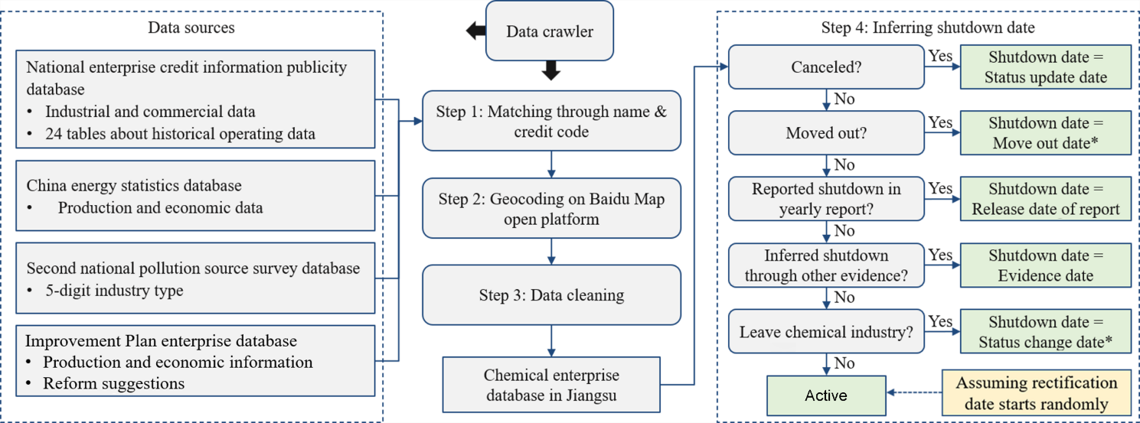
* Referring to records of changes in industrial and commercial information

Fig. S2. The simulated daily dynamics of value added in (A) China and (B) 13 cities in Jiangsu due to the Improvement Plan
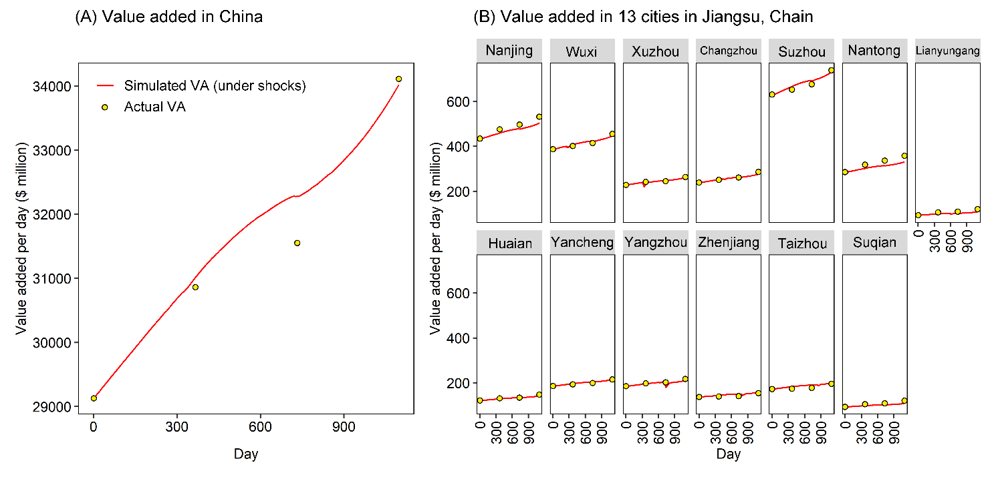

Fig. S3. The simulated daily loss due to the Improvement Plan at city level in Jiangsu.
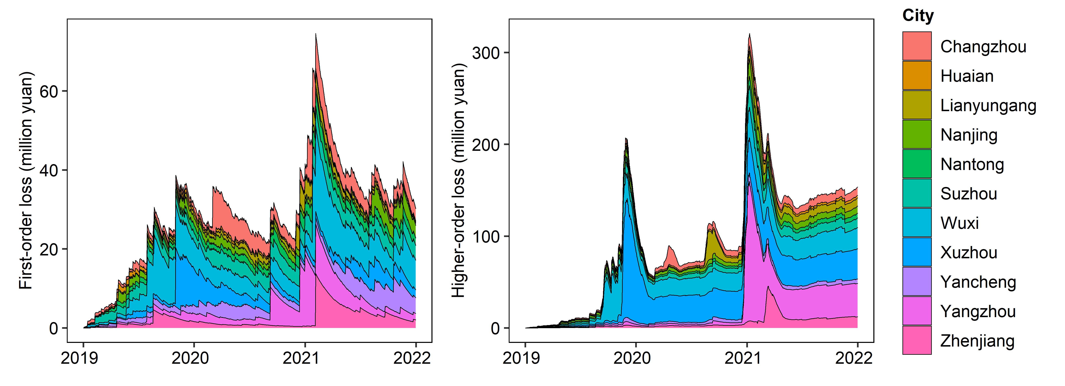

Supplementary Tables

Table S1. Model parameters are drawn from an adaptive regional input-output model of the economic impacts of Hurricane Katrina[1] and economically reasonable approximations, as listed
Parameter | Description | Value
$α$ | Overproduction capacity | 1
$α^{max}$ | Maximum possible overproduction capacity | 1.2
$Δt$ | Time length of each simulation step | 1 day
$τ_{θ}$ | Timescale for reconstruction | 180 days
$τ_{I}$ | Timescale for adjusting to targeted inventory levels | 180 days
$τ_{α}$ | Timescale for adjusting to maximum production capacity | 180 days
$τ_{O}$ | Timescale for adjusting to the target order distribution | 180 days
$τ_{A}$ | Timescale for technology adaptation | 180 days
$L$ | Length of the transportation chain, expressed as the integer of the transportation days between regions in the multi-regional input-output (MRIO) table, is estimated by dividing the distance between regions by the average speed of transport (35 km/h) and 24 hours. | 2.11 days on average, ranging from 1 to 6 days

Table S2. Example of Enterprise Environmental Penalty Records
Name | Date | Decision Document Number | Reason | Result | Authority
Jiangsu Tianyin Chemical Co., Ltd. | Sep 2, 2016 | Xihuan Penalty Decision [2016] NO.71 | Violation of the management system for air pollution prevention and control | Fined 260,000 yuan | Wuxi Environmental Protection Bureau
Lianyungang Jinchanglin Liquor Industry Co., Ltd. | Sep 13, 2021 | Lianguannan Penalty Decision [2021] NO.50 | Violation of the management system for water pollution prevention and control | Fined 300,000 yuan | Lianyungang Environmental Protection Bureau
Sinopec Jinling Petrochemical Co., Ltd. | Aug 26, 2016 | Ningqi Penalty Decision [2016] NO.52 | Solid waste pollution | Fined 37,800 yuan | Nanjing Qixia District Environmental Protection Bureau
Gaoyou Huabao Pigment Co., Ltd. | Sep 23, 2021 | Yanghuan Penalty Decision [2021] NO.02-62 | Failed to carry out emergency training for sudden environmental events as required | Fined 24,500 yuan | Yangzhou Environmental Protection Bureau

Table S3. Example of Enterprise Safety Inspection Records
Name | Date | Inspection result | Authority
Nantong Tianlong Chemical Co., Ltd. | Jan 30, 2018 | Inadequate management of hazardous waste and Incomplete diversion of rainwater and sewage | Nantong Environmental Protection Bureau
Nantong Jiahe Chemical Co., Ltd | Mar 11, 2020 | 1. The alarm function of the electrostatic grounding alarm device in the tank farm has failed, and the eye washer lacks a filter screen; 2. The anti-flow facilities in Warehouse 13 were damaged, and the barreled materials lacked safety labels; 3. There is no review of the contractor's construction plan and emergency plan. | Emergency Management Bureau of Haimen City
Suqian Siruiyi New Materials Co., Ltd | May 3, 2018 | 1. Please strengthen equipment maintenance and repair during the shutdown period of the company to ensure the normal operation of various pollutant treatment facilities after commencement. 2. Please contact the operation and maintenance company of the boiler flue gas online monitoring equipment to find the reason for the high oxygen content in the flue gas, and ensure that the oxygen content in the flue gas is normal. | Environmental Protection Branch of Chemical Industry Park
Jiangsu Jinmei Hengsheng Chemical Co., Ltd | Mar 17, 2020 | No issues found | Xuzhou Xinyi Environmental Protection Bureau

Table S4. Environmental, safety, and economic performances across industry subgroups during 2016-2018
Industry  Reform group | Refined petroleum (C251) | Basic raw material (C261) | Fertilizer (C262) | Pesticide (C263) | Paints (C264) | Synthetic materials (C265) | Special products (C266) | Explosive products (C267) | Daily products (C268)
n.
Shutdown | 74 | 360 | 59 | 44 | 368 | 93 | 468 | 1 | 6
Temporary shutdown | 15 | 131 | 17 | 25 | 105 | 39 | 110 |  | 2
Rectification | 61 | 377 | 39 | 90 | 258 | 138 | 397 |  | 5
Average production capacity (million yuan)
Shutdown | 208 | 241 | 31 | 342 | 55 | 144 | 53 | 9 | 130
Temporary shutdown | 227 | 412 | 117 | 444 | 233 | 846 | 286 |  | 125
Rectification | 3320 | 918 | 427 | 804 | 317 | 1358 | 482 |  | 671
Total environmental penalty per unit production capacity
Shutdown | 8.5E-08 | 1.2E-04 | 3.6E-04 | 1.4E-04 | 2.0E-04 | 3.8E-05 | 1.2E-04 | 0 | 0
Temporary shutdown | 0 | 1.0E-04 | 2.1E-04 | 4.5E-05 | 9.2E-05 | 1.7E-05 | 3.9E-05 |  | 2.0E-04
Rectification | 2.6E-06 | 6.0E-04 | 2.9E-05 | 2.5E-05 | 2.6E-05 | 2.1E-05 | 5.3E-03 |  | 0
Average proportion of safety violations
Shutdown | 0 | 11.8 | 0 | 22.2 | 30.4 | 35.3 | 6.7 |  | 0
Temporary shutdown | 0 | 5.5 | 0 | 16.7 | 18.2 | 0 | 21.2 |  | 0
Rectification | 12.0 | 6.5 | 0 | 11.4 | 7.5 | 7.7 | 5.0 |  | 0

References
[1] Hallegatte S. An Adaptive Regional Input-Output Model and its Application to the Assessment of the Economic Cost of Katrina. Risk Analysis 2008;28(3):779-799.

