Supplementary data for

Commercial Gel-Type Ion Exchange Resin Enables Large-Scale Production of Ultrasmall Nanoparticles for Highly Efficient Water Decontamination
Sikai Chengª, Jieshu Qian^{b}, Xiaolin Zhang^{a, c,}*, Zhenda Lu^{c, d}, Bingcai Pan^{a, c}
ª School of the Environment, Nanjing University, Nanjing 210023, China
^{b} School of Environmental and Biological Engineering, Nanjing University of Science and Technology, Xiao Ling Wei 200, Nanjing, 210094, China
^{c} Research Center for Environmental Nanotechnology (ReCENT), Nanjing University, Nanjing 210023, China
^{d} College of Engineering and Applied Science, Nanjing University, Nanjing 210023, China

* Corresponding author.
E-mail address: XLZhang@nju.edu.cn (X. Zhang)

Table S1.
The basic properties of the D201 and N201 hosts
Material | D201 | N201
Appearance | Spherical beads, ~0.8 mm in diameter
Color | White | Transparent
Skeleton | Poly (styrene-co-divinylbenzene)
Functional group | -N⁺(CH₃)₃
Porogenic agent | Isobutanol | Not used
BET surface area (m²/g) | 14.4 | 5.9
Pore volume (cm³/g) | 0.042 | 0.013
Average pore diameter (nm) | 20.6 | 4.9

Text S1. Synthetic procedure of other nanocomposites.
(1) Synthesis of cadmium sulphide nanocomposite.
20 g of N201 beads were added into the 400 ml solution containing 0.2 mol·L⁻¹ CdCl₂, 1.5 mol·L⁻¹ HCl, and 35%(w/v) ethanol. The solution was stirred at room temperature for 12 h. The beads were filtrated out and then added into 400 mL 5% Na₂S solution. After stirring at room temperature for 12 h, the beads were filtrated out and rinsed with ultrapure water for several times to reach neutral, and then dried at 50℃ for 12 h to obtain CdS@N201.
(2) Synthesis of manganese hydroxide nanocomposite.
20 g of dry N201 beads were added into 400 ml 0.2 mol·L⁻¹ KMnO₄ solution. The solution was stirred at room temperature for 12 h. The beads were filtrated out and then added into 400 mL 50% (v/v) ethanol solution. After stirring at room temperature for 12 h, the beads were filtrated out and rinsed with ultrapure water for several times, and then dried at 50℃ for 12 h to obtain HMO@N201.
(3) Synthesis of zero-valent iron nanocomposite.
20 g of N201 beads were added into 400 ml solution containing 0.8 mol·L⁻¹ FeCl₃, 1.5 mol·L⁻¹ HCl, and 35%(w/v) ethanol. The solution was stirred at room temperature for 12 h. The beads were filtrated out and then added into 400 mL 7.2% NaBH₄ solution. After ultrasonic shaking at room temperature for 15 min, the beads were filtrated out and then dried under vacuum at 50℃ for 12 h to obtain ZVI@N201.
Fig. S1. Pore size distribution of N201 and D201 based on N₂ adsorption–desorption tests (BJH model).
Fig. S2. (a) Optical pictures of D201, FeCl₄⁻–preloaded D201 and HFO@D201, (b) TEM and (c) STEM–HAADF images of HFO@D201.
Fig. S3. XRD patterns of HFO@N201 and HFO@D201
Fig. S4. (a) SEM images and (b) the elemental Fe distribution along the cross–section of HFO@N201
Fig. S5. TEM images of (a) CdS@N201, (b) ZVI@N201, and (c) HMO@N201, (d) TEM picture of the HFO@N201 obtained from kg–scale manufacture, and (e) optical photo of the HFO@N201 obtained from kg–scale production.

Fig. S6. Elemental distribution of Fe along the cross–sections of the FeCl₄⁻–preloaded D201 (a) and N201 (b) based on SEM–EDS analysis.

Fig. S7. Optical photos of the dry and swollen N201.
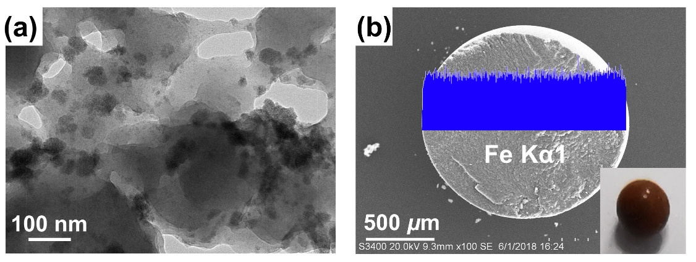
Fig. S8. (a) TEM images and (b) elemental Fe distribution along the cross–section of the HFO@D201 prepared under 10% NaOH conditions (inset is the optical photo of HFO@D201 bead).
Fig. S9. Adsorption isotherms of As(V) by the HFO@N201 prepared in kg–scale (solid dosage: 0.30 g/L, pH 7.0, T = 298 K)

Text S2. Experimental details of potentiometric titration
All titrations were conducted in a 100 mL beaker at 298 K. Prior to titration, 50 mg samples were suspended in 0.1 mol·L⁻¹ NaNO₃ solution (50 mL) and purged with N₂ gas for 1 h. The solution pH was firstly titrated to 3.0 using HNO₃ solution (0.2 mol·L⁻¹). After that, the suspension was slowly back-titrated using NaOH solution (0.030 mol·L⁻¹) until pH reached 11. Each step was allowed to stabilize until the pH drift was less than 0.005 per minute. All solutions were prepared with pre-boiled deionized water and then kept under a nitrogen atmosphere. Moreover, high-purity N₂ gas was bubbled into solutions throughout the experiments.
The net surface charge Q_{H} (mmol/g–Fe) was calculated as (Eq. S1):
$Q_{H}=\frac{{(V}_{A\left(T\right)}C_{A}-V_{B}C_{B})/V_{T}+[H^{+}]-[{OH}^{-}]}{m}V_{T}$ (S1)
where V_{A(T)} (mL) is the total volume of the HNO₃ added; V_{B} (mL) is volume of the titrated NaOH; C_{A} and C_{B} (mol/L) are the molar concentrations of the HNO₃ and NaOH added, respectively; [H⁺] and [OH⁻] (mol/L) are the activities of the aqueous H⁺and OH⁻ in the solutions; V_{T} (L) is the solution volume; and m (g) is mass of the sample titrated (in terms of the mass of Fe).
Fig. S10. Maximum adsorption capacities (Qm) of HFO and HMO inside the gel-type ion exchange resin and the macroporous ion exchange resin toward other pollutants including phosphate and nickel. (solid dosage=0.30 g/L, pH 7.0, T = 298 K).
Fig. S11. Effect of the coexisting substances on As(V) removal by HFO@N201 and HFO@D201. (a) Cl⁻, (b) HCO₃⁻, (c) SiO₃²⁻ (d) humic acid, (solid dosage=0.50 g/L, [As (V)]₀ =10 mg/L, pH 7.0, T = 298 K)
Fig. S12. The iron dissolution of HFO@N201 and HFO@D201 at different pH for 24h (solid dosage: 0.30 g/L, T = 298 K).
Fig. S13 Sphericity after attrition of N201 and HFO@N201 before and after 7 cyclic adsorption–regeneration runs
Fig. S14. (a) TEM images and (b) XRD patterns of HFO@N201 before and after 60–day storage

