Supplementary data for

Divergent Changes in Vegetation Greenness, Productivity, and Rainfall Use Efficiency Are Characteristic of Ecological Restoration Towards High-Quality Development in the Yellow River Basin, China
Yang Yu ^{a,b,}*, Ting Hua ^{c,d}, Liding Chen ^{e}, Zhiqiang Zhang ^{a,b}, Paulo Pereira ^{f}
ª Jixian National Forest Ecosystem Observation and Research Station, National Ecosystem Research Network of China (CNERN), School of Soil and Water Conservation, Beijing Forestry University, Beijing 100083, China
^{b} School of Soil and Water Conservation, Beijing Forestry University, Beijing 100083, China
^{c} State Key Laboratory of Earth Surface Processes and Resource Ecology, Faculty of Geographical Science, Beijing Normal University, Beijing 100875, China
^{d} Institute of Land Surface System and Sustainable Development, Faculty of Geographical Science, Beijing Normal University, Beijing 100875, China
^{e} State Key Laboratory of Urban and Regional Ecology, Research Center for Eco-Environmental Sciences, Chinese Academy of Sciences, Beijing 100085, China
^{f} Environmental Management Laboratory, Mykolas Romeris University, Vilnius 08303, Lithuania

* Corresponding author.
E-mail address: yangyu@bjfu.edu.cn (Y. Yu).

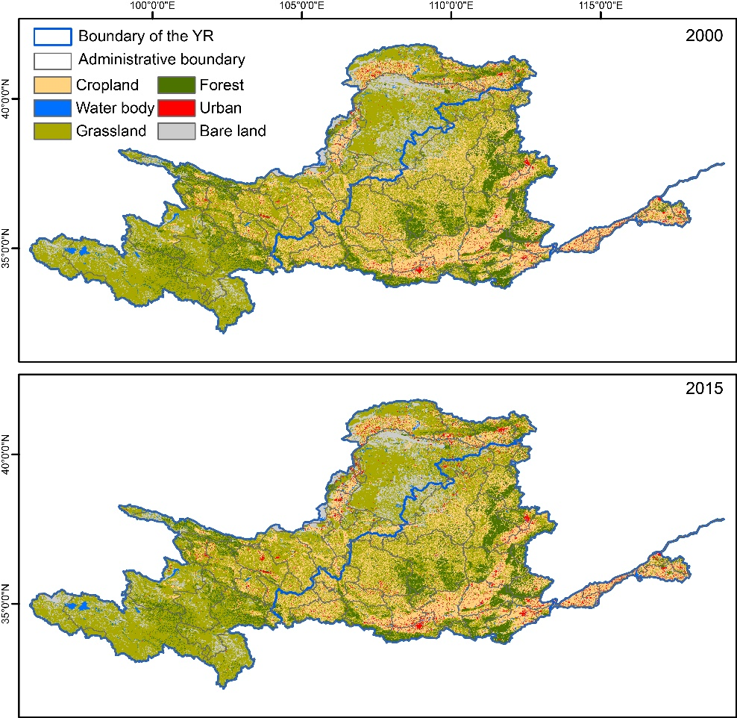
Figure S1 The land use change of the YRB

