Supplementary data for
The Correlation Between Decreased Ornithine Level and Alleviation of Rheumatoid Arthritis Patients Assessed by a Randomized, Placebo-Controlled, Double-Blind Clinical Trial of Sinomenine
Ying Shi ^{a,#}, Hu-Dan Pan ^{b,c,#}, Jian-Lin Wu ^{c}, Qing-Hua Zou ª, Xin-Yi Xie ^{c}, Hong-Gang Li ^{d}, Hua Zhou ^{c}, Xi-Qing Bian ^{c},Wen-Fei Leng ^{e}, Can-Jian Wang ^{c}, Ya-Feng Wang ^{f}, Ping Qiu ^{g}, Fei-Chi Wu ^{g}, Yong-Fei Fang ^{a,}*, Liang Liu ^{c,}*
ª Department of Rheumatology, The Southwest Hospital of Army Military Medical University, Chongqing 400038, China
^{b} Dr. Neher’s Biophysics Laboratory for Innovative Drug Discovery, Macau University of Science and Technology, Macao 999078, China
^{c} State Key Laboratory of Quality Research in Chinese Medicine & Macau Institute for Applied Research in Medicine and Health, Macau University of Science and Technology, Macao 999078, China
^{d} People’s Hospital of Changshou Chongqing, Chongqing 401220, China
^{e} Traditional Chinese Medicine Hospital Dianjiang Chongqing, Chongqing 408300, China
^{f} Medical Management Center, World Federation of Chinese Medicine Societies, Beijing 100101, China
^{g} Hunan Zheng Qing Pharmaceutical Group Co. Ltd., Huaihua 418000, China

Table S1
Baseline data of the study.
Characteristics | SIN (n = 38) | MTX (n = 39) | MTX + SIN (n = 36)
Age (SD) (years) | 54.5 (12.7) | 50.8 (12.0) | 50.4 (13.7)
Number of female (%) | 27 (71.1%) | 30 (76.9%) | 22 (61.1%)
Height (SD) (cm) | 157.5 (6.7) | 157.9 (6.5) | 160.0 (8.0)
Weight (SD) (kg) | 56.4 (8.2) | 56.7 (6.9) | 56.9 (9.3)
Disease duration (SD) (years) | 2.3 (3.7) | 2.2 (3.8) | 1.8 (3.3)
Number of previous DMARDs exposure (%) | 6 (15.8%) | 5 (12.8%) | 6 (16.7%)
Number of oral glucocorticoid used (%) | 10 (26.3%) | 15 (38.5%) | 11 (30.6%)
Number of rheumatoid factor positive (%) | 31 (81.6%) | 28 (71.8%) | 29 (80.6%)
Number of ACPA positive (%) | 25 (65.8%) | 28 (71.8%) | 28 (77.8%)
ESR (SD) (mm/h) | 29.9 (24.2) | 28.5 (23.4) | 27.5 (21.8)
CRP (SD) (mg/L) | 21.7 (32.5) | 21.3 (24.9) | 20.8 (21.8)
TJC (SD) | 4.8 (2.6) | 5.3 (2.7) | 4.9 (2.3)
SJC (SD) | 4.2 (2.9) | 4.2 (2.4) | 3.8 (2.1)
HAQ-DI (SD) | 1.2 (0.8) | 1.1 (0.7) | 0.9 (0.7)
DAS28 (SD) | 4.3 (0.9) | 4.4 (0.8) | 4.3 (0.8)
Data are presented as the mean (SD) or n (%). ACPA: anti-citrullinated protein antibody; TJC: tender joint count; SJC: swollen joint count; HAQ: health assessment questionnaire.

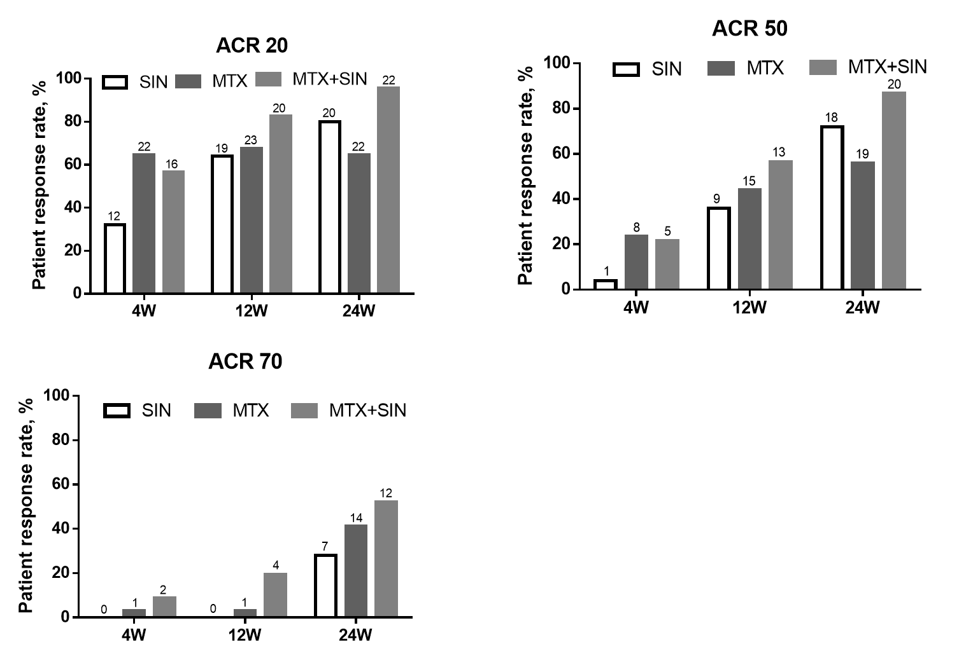
Fig. S1. The primary and secondary efficacy measures over time in PP analysis.

Table S2
Adverse events.
Adverse event | MTX + SIN | SIN | MTX
Hepatic disorder | 8 | 1 | 10
Leukopenia | 6 | 3 | 3
Leukocytosis | 0 | 0 | 1
Anemia | 1 | 0 | 0
Creatinine increased | 0 | 1 | 0
Rash | 2 | 6 | 1
Gastrointestinal disorder | 6 | 7 | 14
Anorexia | 2 | 1 | 0
Dental ulcer | 2 | 0 | 2
Rhinobyon | 1 | 0 | 1
Gomphiasis | 1 | 0 | 0
Dizziness | 1 | 1 | 2
Eyes discomfort | 1 | 0 | 1
Fatigue | 1 | 0 | 0
Pausimenia | 1 | 0 | 0
Flushing | 1 | 0 | 0
Sphagitis | 1 | 0 | 0
Thrombocytopenia | 1 | 0 | 0
Hematuria | 0 | 1 | 0
Hypertension | 0 | 2 | 0
Skin itch | 0 | 6 | 0
Puffiness of face | 0 | 0 | 1
Baldness | 0 | 0 | 1
Constipation | 0 | 1 | 0
Palpitation | 0 | 1 | 0
Vomit | 0 | 1 | 1
Lymphedema of the lower extremity | 0 | 1 | 0

Table S3
The correlation analysis between serum levels of ornithine, citrulline, arginine, and clinical phynotypes.
Measures | Total (n = 221) |  |  | SIN (n = 65) |  |  | MTX (n = 89) |  |  | MTX + SIN (n = 67)
Measures | Ornithine | Citrulline | Arginine | Ornithine | Citrulline | Arginine | Ornithine | Citrulline | Arginine | Ornithine | Citrulline | Arginine
TJC | 0.197** | 0.173* | 0.212** | 0.165 | 0.233 | 0.205 | 0.1 | 0.167 | 0.183 | 0.502** | 0.152 | 0.279*
SJC | 0.193** | 0.075 | 0.179** | 0.231 | 0.086 | 0.176 | 0.062 | 0.086 | 0.215* | 0.425** | 0.075 | 0.13
Pain | 0.283** | 0.309** | 0.404** | 0.278* | 0.427** | 0.557** | 0.167 | 0.291** | 0.274** | 0.692** | 0.297* | 0.373**
PhGADA | 0.287** | 0.076 | 0.281** | 0.377** | 0.237 | 0.390** | .287** | 0.074 | 0.143 | 0.227 | 0.02 | 0.301*
PaGADA | 0.331** | 0.142* | 0.365** | 0.341** | 0.256* | 0.497** | .301** | 0.227* | 0.299** | 0.420** | 0.012 | 0.275*
DAS28 | 0.245** | 0.202** | 0.309** | 0.242 | 0.249* | 0.288* | 0.2 | 0.263* | 0.311** | 0.366** | 0.12 | 0.318*
CDAI | 0.261** | 0.127 | 0.264** | 0.276* | 0.204 | 0.297* | 0.167 | 0.156 | 0.239* | 0.458** | 0.073 | 0.245*
Note: samples analyzed in total group (n = 221) containing those collected from the patients treated by three different treatments with at most 4 samples in each patient. * P < 0.05; ** P < 0.01.

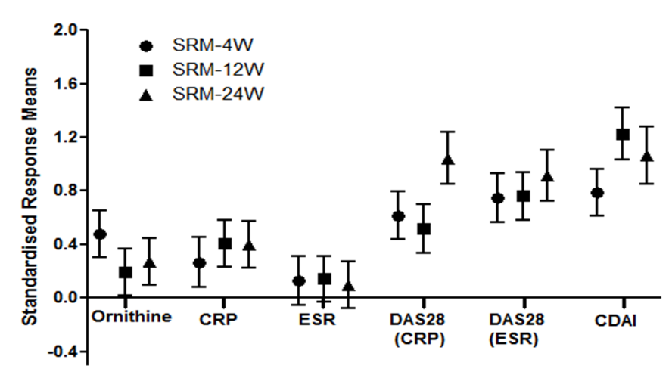
Fig. S2. SRMs for measures of inflammation and disease activity after 4, 12, and 24 weeks of treatments.

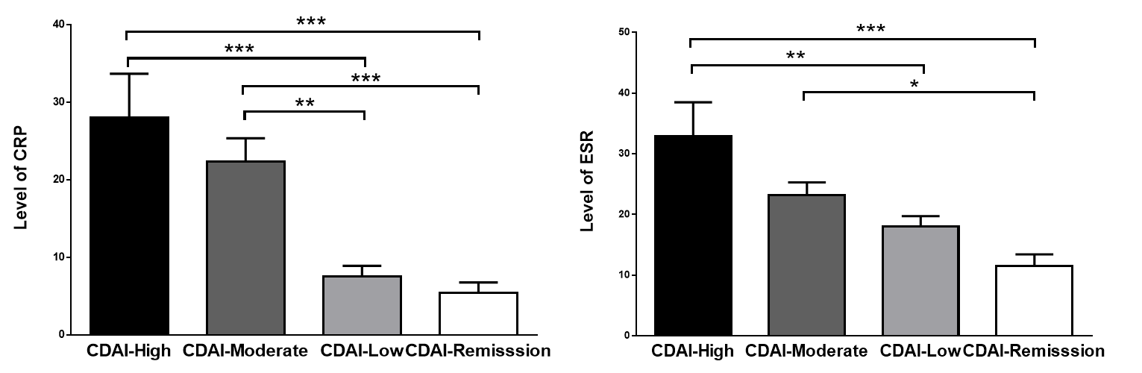
Fig. S3. Levels of CRP and ESR in patients in high, moderate, low and remission disease activity according to CDAI. * P < 0.05; ** P < 0.01, *** P < 0.001.

