Table S1
Primers for qRT-PCR.
Gene |  | Primer
M1 | iNOS | F 5′- GGGCTGTCACGGAGATCAATG-3′
M1 | iNOS | R 5′- GCCCGGTACTCATTCTGCATG-3′
M1 | CD80 | F 5′- AAAGTGGTGCTGTCTGTCATTG-3′
M1 | CD80 | R 5′- TTATGTTGGGGGTAGAGAAGTCAG-3′
M1 | CD86 | F 5′- TGACCGTTGTGTGTGTTCTGGA-3′
M1 | CD86 | R 5′- TCTCTGTCAGCGTTACTATCCCG-3′
M2 | ARG1 | F 5′- CATATCTGCCAAAGACATCGTG-3′
M2 | ARG1 | R 5′- GACATCAAAGCTCAGGTGAATC-3′
M2 | retnla | F 5′- CGTGGAGAATAAGGTCAAGGAAC-3′
M2 | retnla | R 5′- GTCAACGAGTAAGCACAGGCA-3′
M2 | YM1 | F 5′- GTCTCTACTCCTCAGAACCGTCA-3′
M2 | YM1 | R 5′- GAGTAGCAGCCTTGGAATGTCT-3′

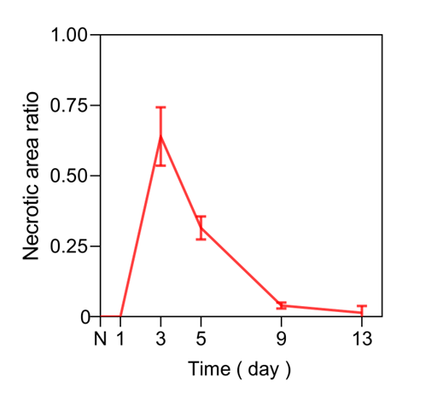
Fig. S1. Necrotic area ratio directly observed on the surface of normal skeletal muscle and injured skeletal muscle on days 1, 3, 5, 9, and 13 post-injury.
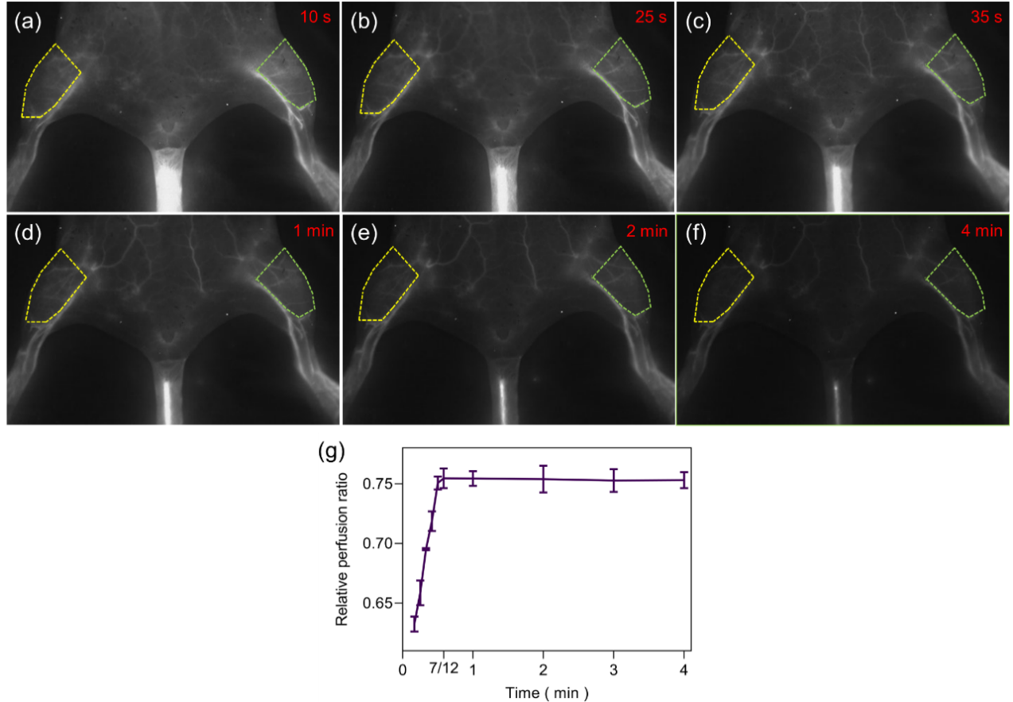
Fig. S2. SWIR fluorescence imaging of CTX-induced hind limb skeletal muscle injury in mice at (a) 10 s, (b) 25 s, (c) 35 s, (d) 1 min, (e) 2 min, and (f) 4 min after QDs injection five days post-injury. Yellow dotted line indicates ROI of CTX-induced injury area, and green dotted line indicates control area. See also Movie S1. (g) Relative perfusion ratio of CTX-induced hind limb skeletal muscle injury in (a)- (f).

Movie S1. SWIR fluorescence imaging video of mice corresponding to S3 from 10 s to 4 min and 50 s after the QDs injection (ten times the speed). Attached.

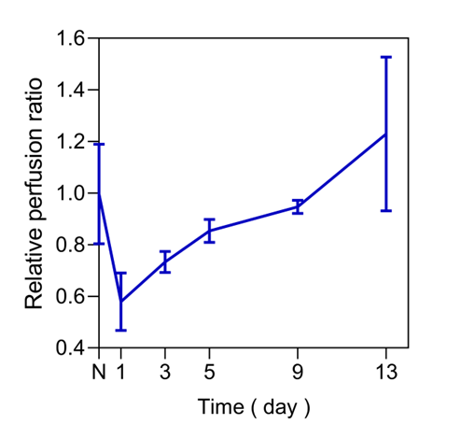
Fig. S3. Relative perfusion ratio in SWIR fluorescence imaging of normal and injured skeletal muscles on days 1, 3, 5, 9, and 13 post-injury.

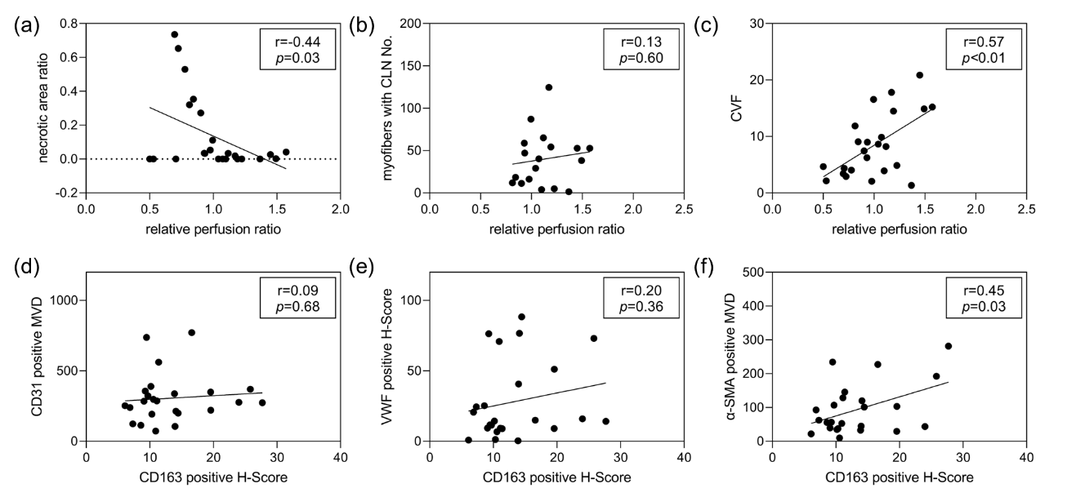
Fig. S4. Correlation among (a) necrotic area ratio, (b) myofibers with CLN No., (c) CVF, and relative perfusion ratio; and (d) CD31 positive MVD, (e) VWF positive H-Score, (f) α-SMA positive MVD and CD163 positive H-score.

