Research
Sustainable and High-Performance Structural Materials—Article
Efficient Multifunctional Modification of Commercial Carbon Fiber through Tailored Carbon Layer Structure
Chun Pei ^{a,b}, Hongtao Yu ^{a,b}, Ji-Hua Zhu ^{a,b,}*, Feng Xing ^{b,c}
ª College of Civil and Transportation Engineering, Shenzhen University, Shenzhen 518060, China
^{b} Guangdong Province Key Laboratory of Durability for Marine Civil Engineering, Shenzhen 518060, China
^{c} Jinan University, Guangzhou 518060, China

*Corresponding author.
E-mail address: zhujh@szu.edu.cn (J.-H. Zhu).

EIS testing of SCF before and after the immersing treatment. EIS was performed on a three-electrode system, in which a platinum wire and an additional Ag/AgCl (sat. KCl solution) were used as the counter and reference electrode. 10 mM K₃Fe(CN)₆/0.6 M Na₂SO₄ or 10 mM K₃Fe(CN)₆/0.9 M NaCl solution was used as the electrolyte. The amplitude of the AC voltage was 10 mV in a frequency range from 100 mHz to 100 kHz at an overpotential of 0 V vs. SCF was immersed in the electrolyte and tested at a different time.
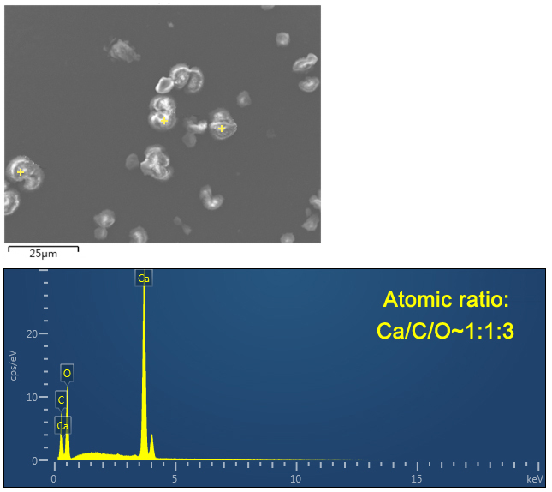
Fig. S1. EDS spectrum and atomic ratio of the formed particles in the electrolyte of SCF_{NaCl}.

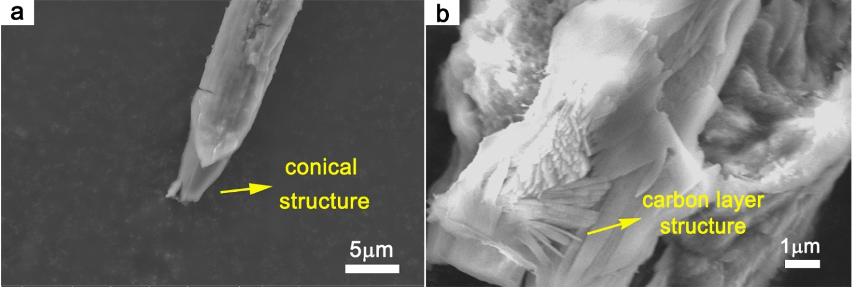
Fig. S2. SEM images of (a) SCF_{NaCl} at the slender and tapering part of the fiber marked by the red arrow in OM images and (b)${ CFB}_{{Na}_{2}{SO}_{4}}$with high magnification.

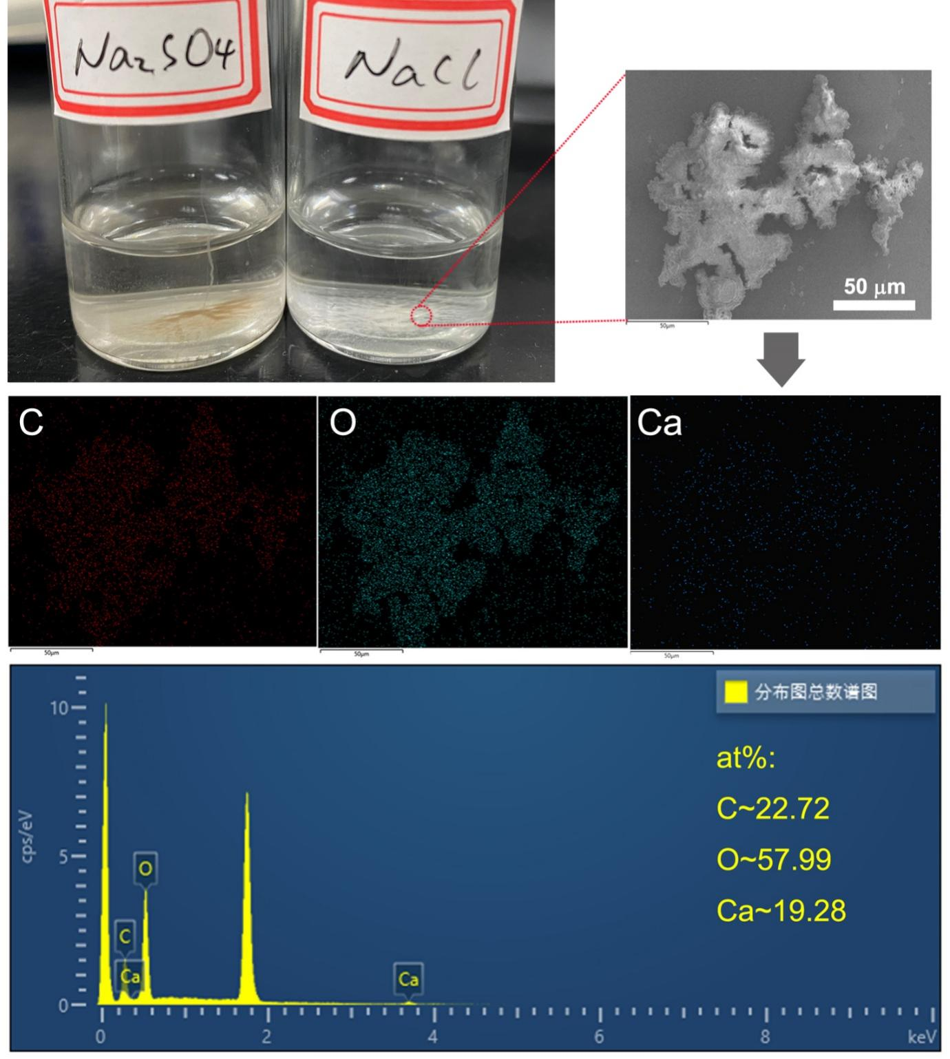
Fig. S3. Electrolytic products (brown and white precipitates) of${ CFB}_{{Na}_{2}{SO}_{4}}$and CFB_{NaCl}.

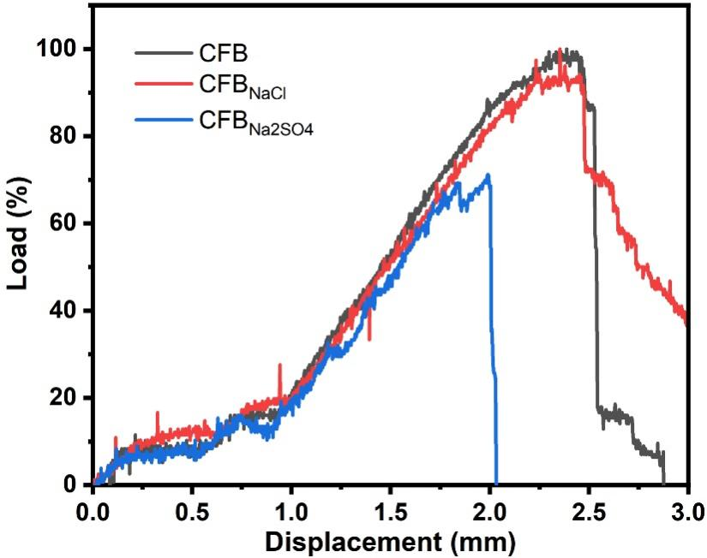
Fig. S4. Tensile stress-strain curves of the pristine and modified CFB. The maximum stress value of pristine CFB is recognized as 100. (A test frame with a maximum capacity of 50 kN was used with a controlled displacement rate of 0.2 mm·min⁻¹).

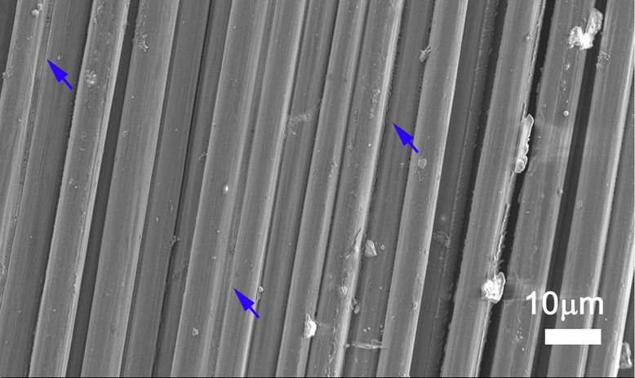
Fig. S5. SEM of ${CFB}_{{Na}_{2}{SO}_{4}}$with a low magnification. (The typically bonded carbon fibers have been marked by blue arrows).

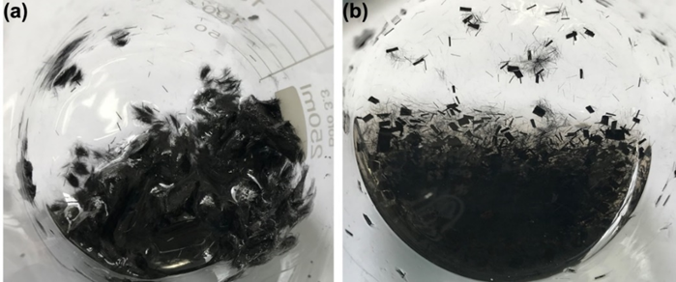
Fig. S6. Dispersibility of short carbon fibers from (a) CFB and (b) ${CFB}_{{Na}_{2}{SO}_{4} }$in aqueous solution after violent stirring for 20 mins. (These chopped carbon fibers with a length of ~3 mm were obtained by cutting the pristine CFB or${ CFB}_{{Na}_{2}{SO}_{4}}$). From these pictures, we can observe that the chopped CFB from the pristine CFB were easily separated after stirring in the aqueous solution, while most of the CFB from${ CFB}_{{Na}_{2}{SO}_{4}}$were hard to disperse, which means the adhesive strength among the CFs of ${CFB}_{{Na}_{2}{SO}_{4} }$was much higher than that of pristine.

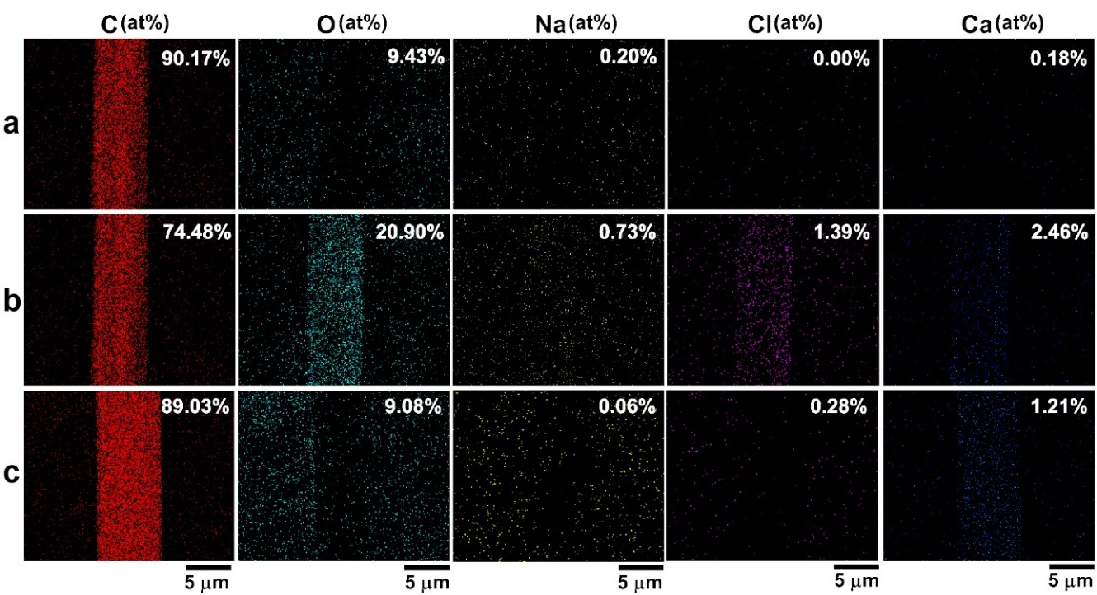
Fig. S7. Multielement EDS mapping with the corresponding atomic ratio of SCF in CFB (a), CFB_{NaCl} (b) and${ CFB}_{{Na}_{2}{SO}_{4}}$(c).

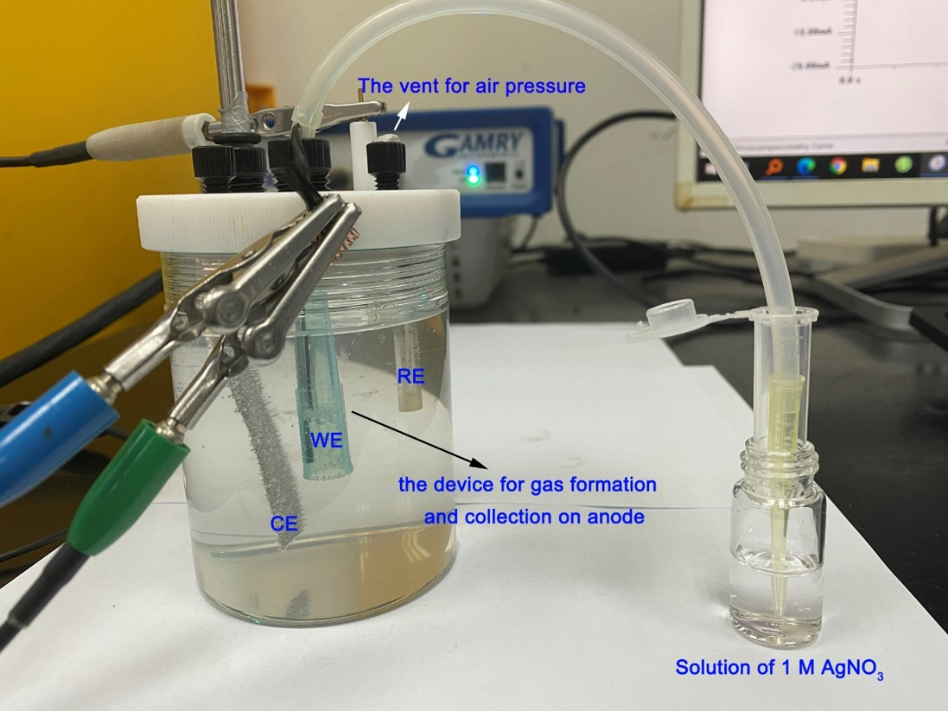
Fig. S8. This electrochemical device was used for testing chlorine gas formed during the treatment of CFB in the solution of NaCl/Ca(OH)₂. The applied potential is 3 V for 1 h. During the process, a mass of the bubble was formed and released from the surface of CFB, which leads to the dropping of the liquid level of the gas-collecting device. When the device was almost filled with gas, air pressure was applied to the liquid level of the electrolytic cell to arise the liquid level of the gas-collecting device, thus the collected gas was injected into the solution of AgNO₃. This process was repeated several times and no white precipitate formed in the AgNO₃ solution (;).

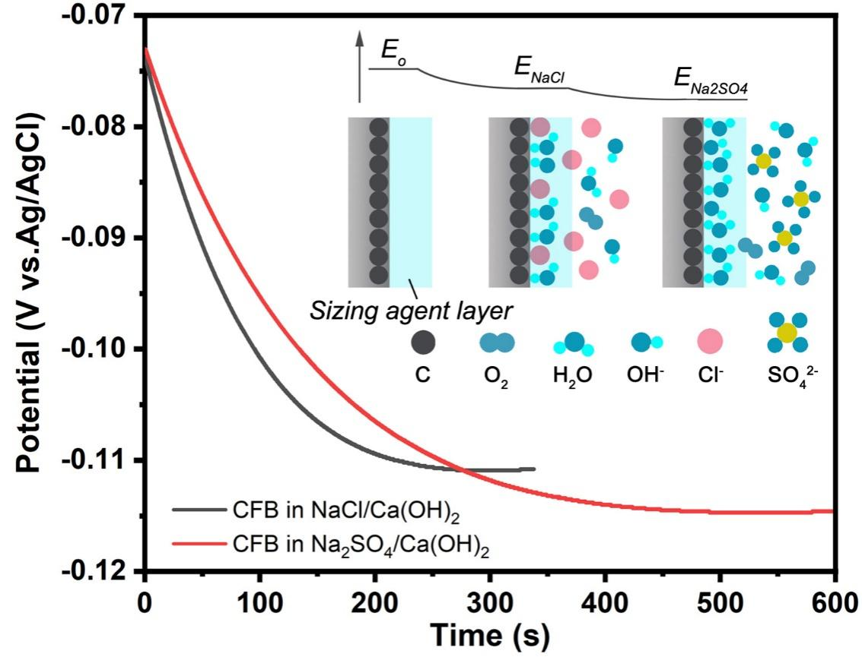
Fig. S9. OCP-time curves of CFB in the solution of NaCl/Ca(OH)₂ and Na₂SO₄/Ca(OH)₂. The equilibrium potential of CFB decreased resulting from the hydration of surface carbon. Cl⁻ possesses a higher permeability to the surface sizing agent and absorption to the surface of CFB than OH⁻ and SO₄²⁻, which can retard the decreasing of equilibrium potential.

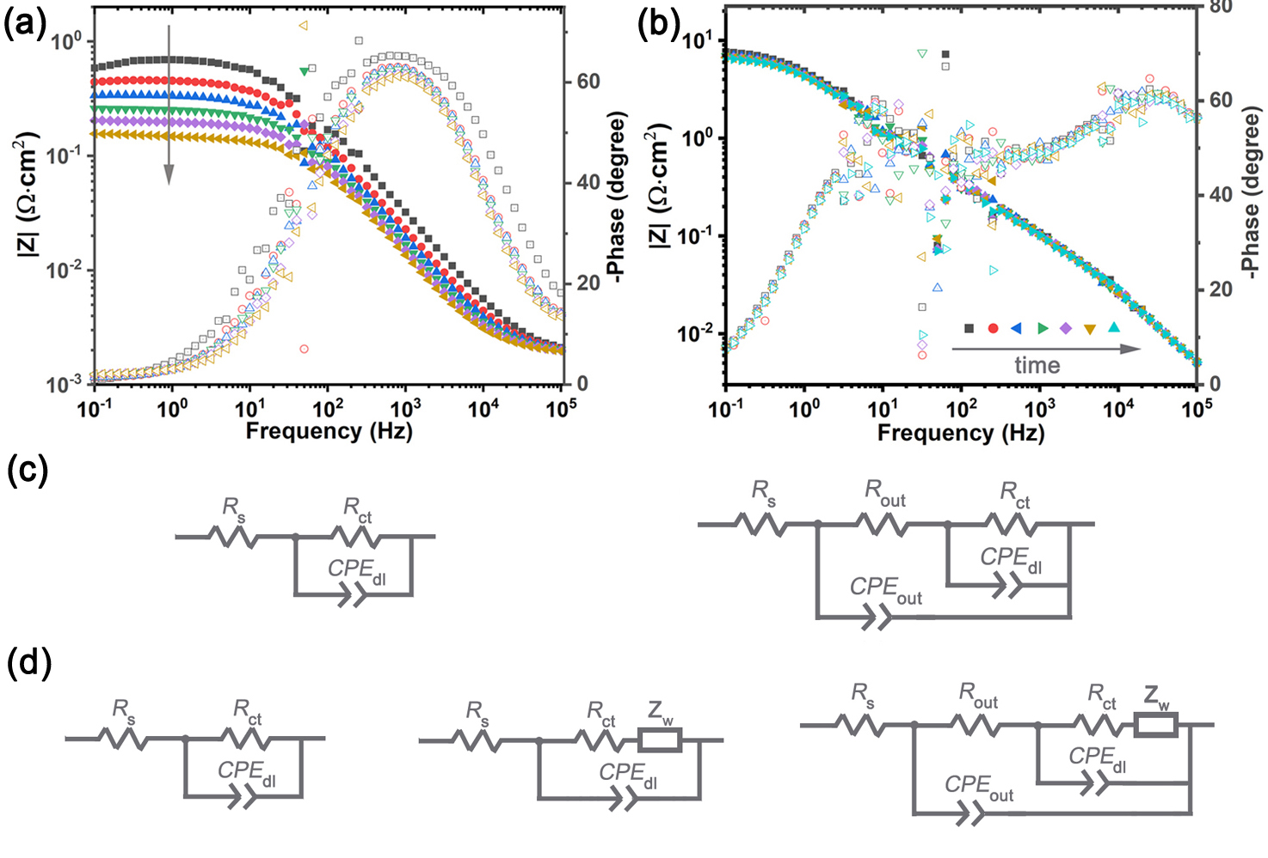
Fig. S10. (a, b) Bode plots of the SCF after immersing treatment in Na₂SO₄/K₃Fe(CN)₆ and NaCl/K₃Fe(CN)₆ solution with a different time; (c) The equivalent circuits.

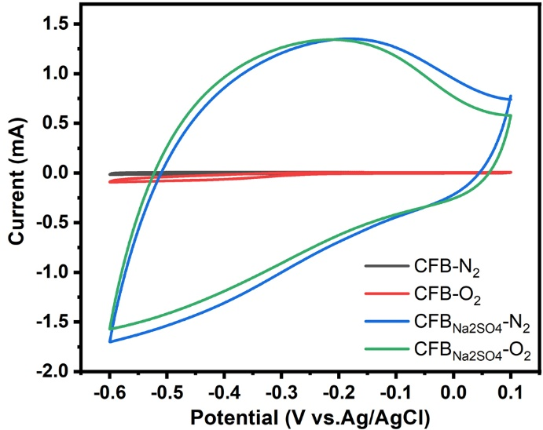
Fig. S11. CV curves of CFB/${CFB}_{{Na}_{2}{SO}_{4}}$in 0.1 M KOH solution saturated with N₂ or O₂ for the assay of ORR, scan rate: 50 mV∙s⁻¹.

Table S1 Comparison of the Specific Capacitance of Micro-sized Carbon Fiber-Based Electrodes.
Samples | Diameter | Electrolyte | Capacitance (F·g⁻¹) |  | Ref.
f-CFP | ~8 μm | H₂SO₄ | 16.8 (0.2 A g⁻¹) | 9.5 (2.0 A g⁻¹) | [1]
CFC-750-N-S | ~5 μm | Na₂SO₄ | 9.6 (1.0 A g⁻¹) | 3.3 (4.2 A g⁻¹) | [2]
activated CC | ~5 μm | H₂SO₄ | 7.1 (1.0 A g⁻¹) | 7.0 (2.0 A g⁻¹) | [3]
ACFT | ~8 μm | H₂SO₄ | 7.9 (10 mV s⁻¹) | 5.8 (1.0 V s⁻¹) | [4]
RCFs | ~6 μm | Na₂SO₄ | 52.0 (1.0 A g⁻¹) | 15.0 (8 A g⁻¹) | [5]
RCFs | ~6 μm | KOH | 11.1 (2 A g⁻¹) | 6.2 (10 A g⁻¹) | [6]
CFB_{Na2SO4} | ~7 μm | Na₂SO₄ | 57.5 (1.0 A g⁻¹) | 40.5 (16 A g⁻¹) | This work

References
[1] Phansiri Suktha, et. al., High-Performance Supercapacitor of Functionalized Carbon Fiber Paper with High Surface Ionic and Bulk Electronic Conductivity: Effect of Organic Functional Groups, Electrochimica Acta, 2015, 176, 504–513.
[2] Tian Ouyang, et. al., A general in-situ etching and synchronous heteroatom doping strategy to boost the capacitive performance of commercial carbon fiber cloth, Chemical Engineering Journal, 2018, 335, 638–646.
[3] Gongming Wang, et. al., Solid-State Supercapacitor Based on Activated Carbon Cloths Exhibits Excellent Rate Capability, Advanced Materials, 2014, 26, 2676–2682.
[4] Dingshan Yu, et. al., Transforming Pristine Carbon Fiber Tows into High Performance Solid-State Fiber Supercapacitors, Advanced Materials, 2015, 27, 4895–4901.
[5] Yanan Zhou, et. al., Reclaimed Carbon Fiber-Based 2.4 V Aqueous Symmetric Supercapacitors, ACS Sustainable Chemistry Engineering, 2019, 7, 5095–5102.
[6] Chongjun Zhao, et. al., Solar-assisting pyrolytically reclaimed carbon fiber and their hybrids of MnO₂/RCF for supercapacitor electrodes, Carbon, 2017, 114, 230e241.

