Supplementary data for

Optimal Scheduling and On-the-Fly Flexible Control of Integrated Energy Systems for Residential Buildings Considering Photovoltaic Prediction Errors
Ziqing Wei ª, Xiaoqiang Zhai ^{a,}*, Ruzhu Wang ^{a,}*
ª Institute of Refrigeration and Cryogenics, Shanghai Jiao Tong University, Shanghai 200240, China

* Corresponding authors.
E-mail addresses: xqzhai@sjtu.edu.cn (X. Zhai), rzwang@sjtu.edu.cn (R. Wang).

Section 1: CNN-LSTM structure
Table S1 outlies the CNN-LSTM model’s architecture, which is composed of 1D-CNN, LSTM, and fully connected (FC) layers. The CNN and LSTM work together to extract important features using an end-to-end approach, eliminating the need for manual feature extraction. The model is implemented through PyTorch software on hardware equipped with i7-7700HQ@3.4GHz, 24 G RAM, and GTX1060 with CUDA.
Table S1 Construction of CNN-LSTM model
Layer Number | Type | Unit | Activate function
1 | Conv1D | 64 | ReLU
2 | Conv1D | 64 | ReLU
3 | Pool | - | -
4 | Flatten | 128 | -
5 | LSTM | 128 | ELU
6 | LSTM | 128 | ELU
7 | Dense | 128 | ReLU
8 | Dense | 128 | ReLU
9 | Dense | 128 | ReLU
10 | Output | 96 | -
Section 2: Convolution Neural Network layer
Two convolutional filters are used to extract the features among different sensor data. Alongside the FC layer, the primary components of a CNN include the convolutional layer, activation function, and pooling layer. The convolutional layer and activation function are usually combined and implemented as follows,
$\begin{matrix}y_{i}=\text{Relu}\left(X_{i}*W+θ_{i}\right)=\text{Relu}\left(\sum_{j=1}^{k}{x_{i+j-1}w_{j}}+θ_{i}\right) \\ X_{i}∈Χ, \\ \begin{aligned}&X_{i}=[x_{1},x_{2},x_{3}…,x_{n}], \\ &W=[w_{1},w_{2},w_{3}…,x_{k}]\end{aligned}\end{matrix}$ (S1)
where $y_{i}$ represents the output of the i-th component from the convolution operation. $X_{i}$ denotes the i-th 1D inputs of the total dataset X, which contains n features. $W$ corresponds to the convolutional kernel that contains k elements. Symbol * represents the convolution action of dot product and summation. $θ_{i}$ signifies the bias term, and Relu() denotes the activation function.
After applying convolution, pooling is applied to reduce the dimensionality of the feature maps, thereby reducing the computational complexity and controlling overfitting,
$Z_{i}=\text{MAX}\left(y_{i},y_{i+1},...,y_{i+m-1}\right)$ (S2)
where is the i-th output of intermediate layer, MAX() is the function that takes the maximum value.
Section 3. Long Short-Term Memory layer
LSTM is a specific form of recurrent neural network (RNN), which is widely used for time series prediction. It addresses the gradient vanishing and exploding issues through gating mechanisms. The core components of an LSTM include the input gate, forget gate, cell state, and output gate.
In a sequence, the LSTM cell processes each step t by updating its hidden state h_{t} and cell state c_{t} based on the previous hidden state h_{t-1}, cell state c_{t-1}, and the current input x_{t}. An LSTM cell can be expressed as follows,
$\begin{matrix}Γ_{τ}=σ\left({\tilde{Γ}}_{τ}\right)=σ(W_{xΓ}x_{τ}+W_{ΠΓ}Π_{τ-1}+θ_{Γ}) \\ \begin{aligned}Λ_{τ}=σ\left({\tilde{Λ}}_{τ}\right)=σ(W_{xΛ}x_{τ}+W_{ΠΛ}Π_{τ-1}+θ_{i}) \\ Θ_{τ}=tanh\left({\tilde{Λ}}_{τ}\right)=tanh(W_{xΘ}x_{τ}+W_{ΠΘ}Π_{τ-1}+θ_{Θ}) \\ O_{τ}=σ\left({\tilde{O}}_{τ}\right)=σ(W_{xO}x_{τ}+W_{ΠO}Π_{τ-1}+θ_{O}) \\ Ψ_{τ}=Ψ_{τ-1}⊙Γ_{τ}+Θ_{τ}⊙Λ_{τ} \\ Π_{τ}=O_{τ}⊙tanh⁡(Ψ_{τ}) \\ y_{τ}=W_{yΠ}Π_{τ}+θ_{y}\end{aligned}\end{matrix}$ (S3)
where $Γ_{τ}$, $Λ_{τ}$, $Θ_{τ}$, $O_{τ}$, $Ψ_{τ}$, $Π_{τ}$, and $y_{τ}$ represent the outputs of the forget gate, input gate, candidate layer for input gate, output gate, update cell state, hidden state, and final output of time slot $τ$, respectively. $x_{τ}$ is input at time step t, $Π_{τ-1}$ is the hidden state at the previous time step τ-1, $Ψ_{τ-1}$ is cell state at the previous time step τ-1, $W_{xΓ}$, $W_{xΛ}$, $W_{xΘ}$, $W_{xO}$, and $W_{yΠ}$ are the weights for the gates (forget, input, candidate layer for input, output, and final output gate), θ denotes the biases for each gates, $σ()$ and $tanh()$ are the activation function of the sigmoid and hyperbolic tangent, respectively.
Section 4: Full connected layer
A full connected layer can be expressed as follows,
$Y_{i}=f(X_{i}W+θ_{i})$ (S4)
where $Y_{i}$ is the i-th output, $X_{i}$ represents the i-th input, $W$ corresponds to the weight matrix, $θ_{i}$ is the bias, and f() is the activation function.

Section 5: Entropy weight method
According to Problem 1, two weights α₁ and α₂ are determined through the entropy weight method (EWM) which is based on information theory [45] to access data uncertainty or disorder. In the context of this bi-objective optimization problem, EWM can be applied to determine the relative importance of each objective. The pseudocode for calculating weights is shown in Algorithm 1.

Algorithm 1: Weights calculation based on EWM
Inputs: Model(m), weather_array([t_{ambient}, I])
Outputs: [α₁, α₂]

Launch optimization model m
Launch [t_{ambient}, I]

# STEP 1 Set objective function
Set object function 1 obj1 = Eq. (22)
Set object function 2 obj2 = Eq. (23)

# STEP 2 Get decision matrix
Activate m.obj1, deactivate m.obj2
Initialize m, Solve m
Get minimum Z_{economic}, maximum Z_{comfort}
Activate m.obj2, deactivate m.obj1
Solve m
Get minimum Z_{comfort}, maximum Z_{economic}
obj_list = []
for in range(0, 1, 0.025):
Set objective function 3 obj = λZ_{economic} +(1-λ)Z_{comfort}
Solve m
obj_list.append([Z_{economic}, Z_{comfort}])
end for

# STEP 3 Normalization
obj1_min = np.array(obj_list).T[0].min()
obj1_max = np.array(obj_list).T[0].max()
obj2_min = np.array(obj_list).T[1].min()
obj2_max = np.array(obj_list).T[1].max()
Get the normalized data(norm_data) through Eq. (24) and Eq. (25)

# STEP 4 Probability and Entropy
m, n = norm_data.shape[0], norm_data.shape[1]
k = 1/log(m)
p = norm_data / np.sum(norm_data, axis=0)
entro_mat = -k * np.sum(p * np.log(p + np.finfo(float).eps), axis=0)

# STEP 5 Divergence and Entropy Weights
d = 1 - entro_mat
weights = d / np.sum(d)
Return weights
The first step involves establishing two single objective functions based on Eqs. (22) and Eq. (23). In the second step, a temporary weight λ ranging from 0 to 1 in increments of 0.025 is applied to form the multi-objective function. A decision matrix that contains 40 sets of [obj1, obj2] can be obtained from various λ settings. The decision matrix shown in Fig. S1 illustrates the Pareto-front formed by the two objective functions. In the third step, the decision matrix is normalized through min-max scaling, as given in Eq. (24) and Eq. (25). The fourth step involves calculating the entropy matrix, where k is a constant decided by the number of rows of the decision matrix, and p denotes the proportion for each indicator. The entropy matrix is derived using the Shannon EWM formula [45]. In the final step, the difference coefficient d and the weights can be obtained. The weights of α₁ and α₂ are 0.14 and 0.86 for the case study, respectively.
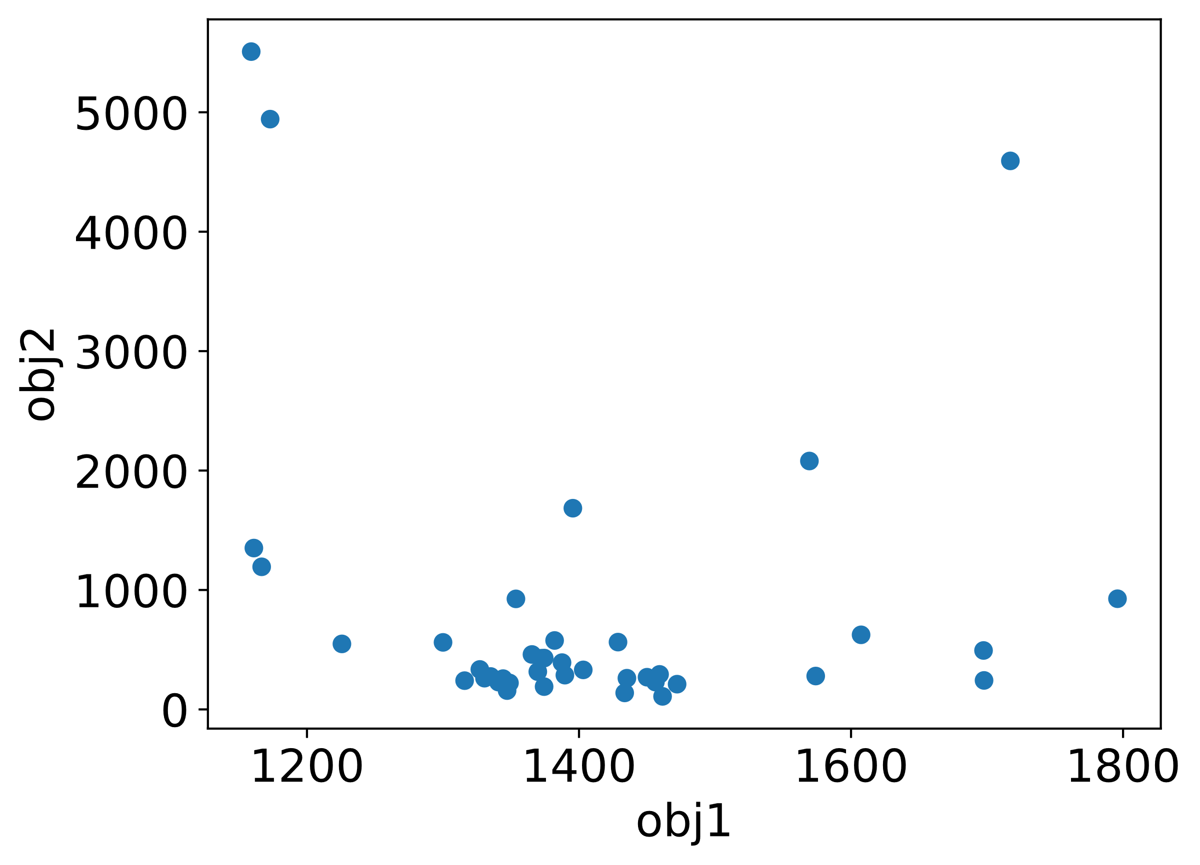
Fig. S1. Results obtained for bi-objective optimization.
References

[45] Shannon CE. A mathematical theory of communication. Bell Syst Tech J 1948;27(3):379–423.

