Supplementary data for
Novel Insight into the Etiology of Haff Disease by Mapping the N-Glycome with Orthogonal Mass Spectrometry
Si Liu ª, Yuanyuan Liu ª, Jiajing Lin ª, Bi-Feng Liu ª, Zhenyu He ^{b}, Xiaomin Wu ^{b,}*, Xin Liu ^{a,}*
ª The Key Laboratory for Biomedical Photonics of the MOE at Wuhan National Laboratory for Optoelectronics–Hubei Bioinformatics and Molecular Imaging Key Laboratory, Systems Biology Theme, Department of Biomedical Engineering, College of Life Science and Technology, Huazhong University of Science and Technology, Wuhan 430074, China
^{b} Wuhan Center for Disease Control & Prevention, Wuhan 430015, China

Fig. S1. Purification and elucidation of IgG serum from healthy controls and haff disease patients. (A, B) UV detection of IgG and IgG depleted serum protein at 280 nm via Protein G based affinity chromatography; (C) comparative analysis of absorbance between HC and HD; (D) representative desalting chromatography of isolated IgG fractions via GE Desalting Column; (E) SDS-PAGE elucidation of the purity of purified serum IgG. R1–R3 represents the three test samples.
Fig. S2. Evaluation of the reproducibility for the quantitation of serum N-glycome by MALDI-MS analysis. H: hexose; N: N-acetylglucosamine; F: fucose; S: sialic acid; SD: standard deviation; RSD: relative standard deviation. Glycan symbols were presented as follows: blue square: N-acetylglucosamine; green circle: mannose; yellow circle: galactose; purple diamond: sialic acid; red triangle: fucose.
Table S1
MALDI-MS spectra of N-glycans identified in human serum. Symbols as Fig. S2.
No. of peak | Glycan (m/z) [M + Na] |  | Chemical composition | Glycan structure
No. of peak | Calculated | Observed | Chemical composition | Glycan structure
1 | 1136.4 | 1136.6 | H3N3 | 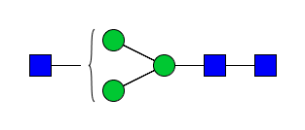
2 | 1257.4 | 1257.5 | H5N2 | 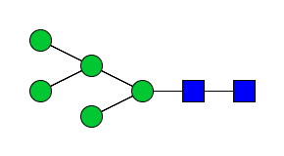
3 | 1282.5 | 1282.5 | H3N3F1 | 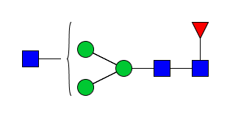
4 | 1298.5 | 1298.5 | H4N3 | 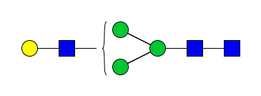
5 | 1339.5 | 1339.5 | H3N4 | 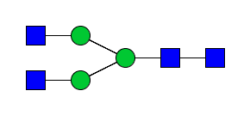
6 | 1419.5 | 1419.6 | H6N2 | 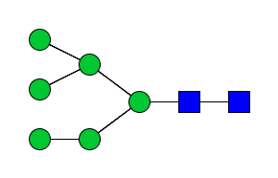
7 | 1444.5 | 1444.6 | H4N3F1 | 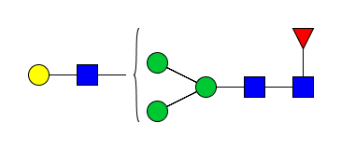
8 | 1460.5 | 1460.6 | H5N3 | 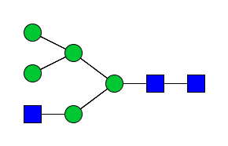
9 | 1485.5 | 1485.6 | H3N4F1 | 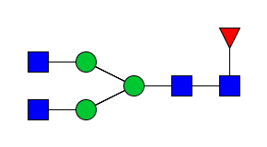
10 | 1501.5 | 1501.6 | H4N4 | 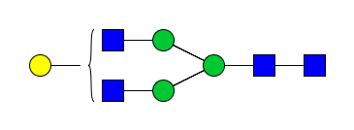
11 | 1542.6 | 1542.6 | H3N5 | 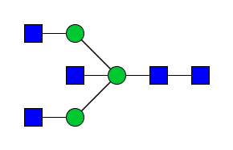
12 | 1581.5 | 1581.7 | H7N2 | 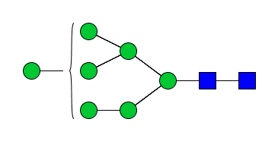
13 | 1602.6 | 1602.7 | H4N3S1 | 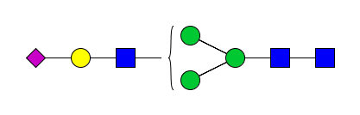
14 | 1606.5 | 1606.6 | H5N3F1 | 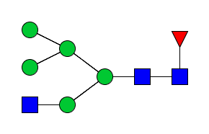
15 | 1622.6 | 1622.6 | H6N3 | 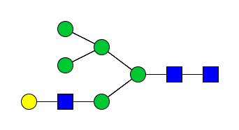
16 | 1647.6 | 1647.7 | H4N4F1 | 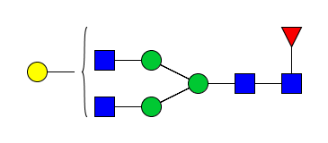
17 | 1663.6 | 1663.7 | H5N4 | 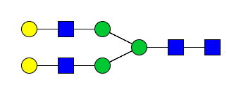
18 | 1688.6 | 1688.7 | H3N5F1 | 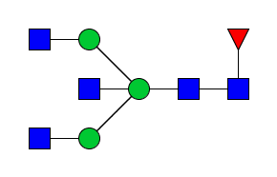
19 | 1704.6 | 1704.7 | H4N5 | 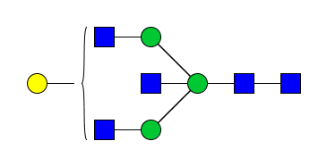
20 | 1743.6 | 1743.7 | H8N2 | 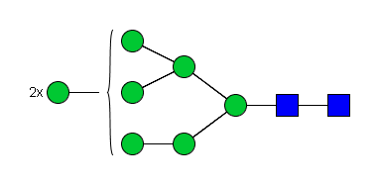
21 | 1748.6 | 1748.7 | H4N3S1F1 | 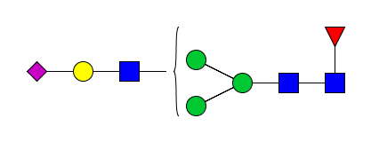
22 | 1764.6 | 1764.7 | H5N3S1 | 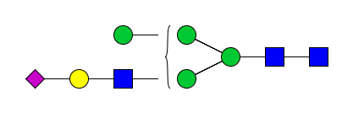
23 | 1805.6 | 1805.7 | H4N4S1 | 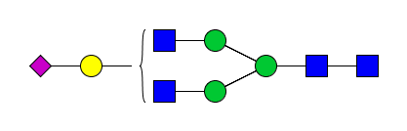
24 | 1809.7 | 1809.7 | H5N4F1 | 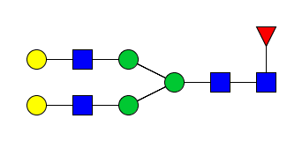
25 | 1850.7 | 1850.8 | H4N5F1 | 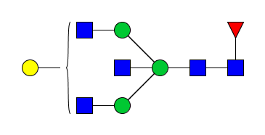
26 | 1866.7 | 1866.7 | H5N5 | 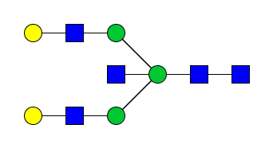
27 | 1905.6 | 1905.7 | H9N2 | 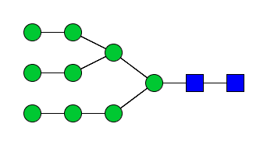
28 | 1926.7 | 1926.8 | H6N3S1 | 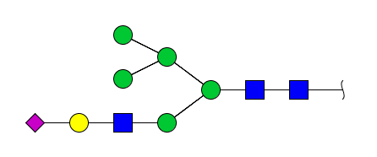
29 | 1951.7 | 1951.8 | H4N4S1F1 | 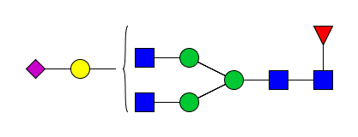
30 | 1967.7 | 1967.8 | H5N4S1 | 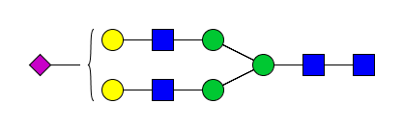
31 | 2008.7 | 2008.8 | H4N5S1 | 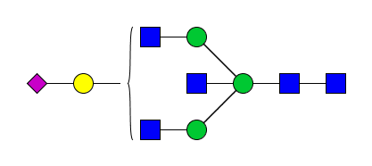
32 | 2012.7 | 2012.8 | H5N5F1 | 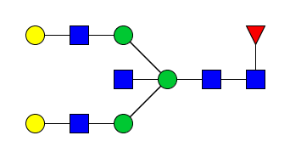
33 | 2028.7 | 2028.8 | H6N5 | 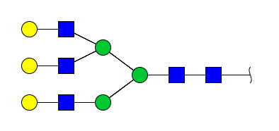
34 | 2113.8 | 2113.9 | H5N4S1F1 | 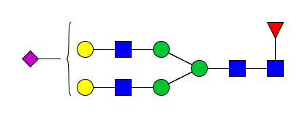
35 | 2154.8 | 2154.9 | H4N5S1F1 | 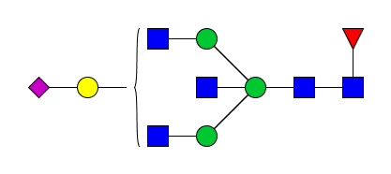
36 | 2170.8 | 2170.9 | H5N5S1 | 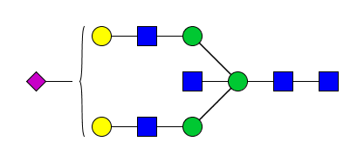
37 | 2271.8 | 2271.9 | H5N4S2 | 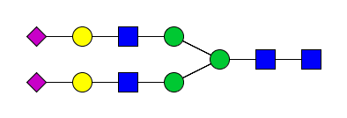
38 | 2316.8 | 2316.9 | H5N5S1F1 | 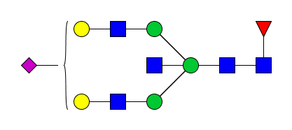
39 | 2332.8 | 2332.9 | H6N5S1 | 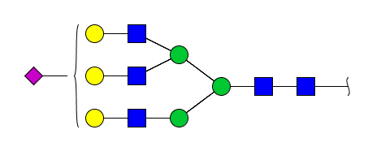
40 | 2417.8 | 2418.0 | H5N4S2F1 | 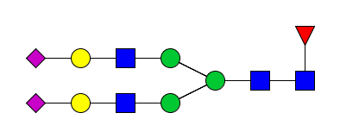
41 | 2474.9 | 2475.0 | H5N5S2 | 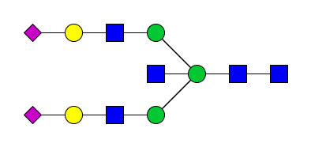
42 | 2478.9 | 2478.0 | H6N5S1F1 | 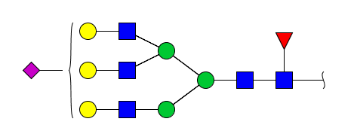
43 | 2620.9 | 2621.1 | H5N5S2F1 | 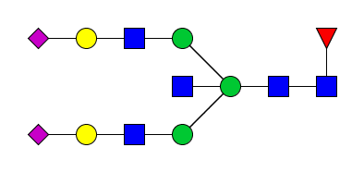
44 | 2636.9 | 2637.1 | H6N5S2 | 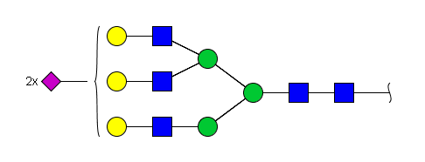
45 | 2698.0 | 2698.1 | H7N6S1 | 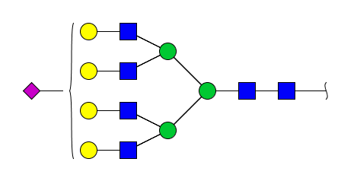
46 | 2783.0 | 2783.1 | H6N5S2F1 | 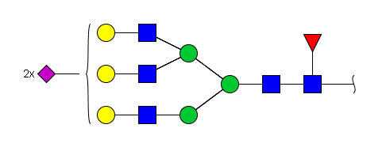
47 | 2941.0 | 2941.2 | H6N5S3 | 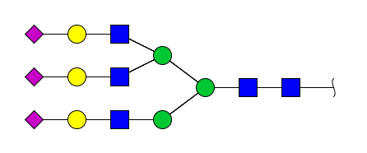
48 | 3002.1 | 3002.2 | H7N6S2 | 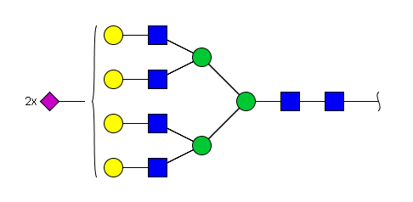
49 | 3087.1 | 3087.3 | H6N5S3F1 | 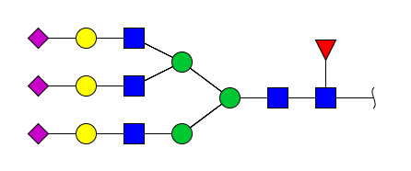
50 | 3148.1 | 3148.3 | H7N6S2F1 | 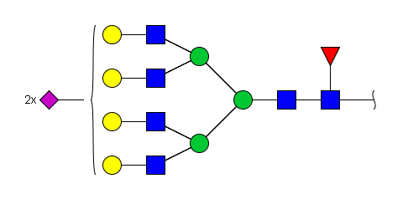
51 | 3306.1 | 3306.4 | H7N6S3 | 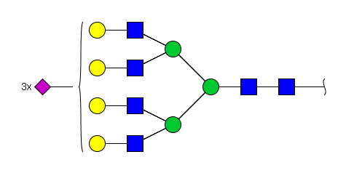
52 | 3452.2 | 3452.4 | H7N6S3F1 | 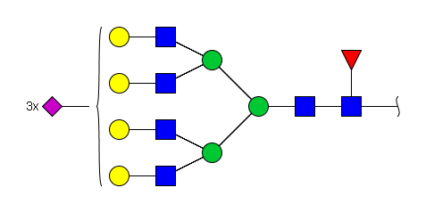
53 | 3610.2 | 3610.5 | H7N6S4 | 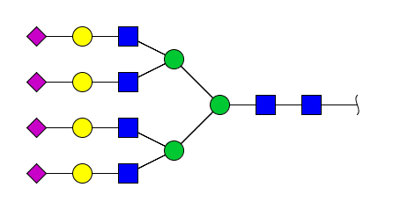
54 | 3756.3 | 3756.5 | H7N6S4F1 | 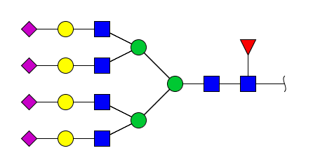

Table S2
MALDI-TOF-MS spectra of N-glycans identified in serum IgG. Symbols as Fig. S2.
No. of peak | Glycan (m/z) [M + Na] |  | Chemical composition | Glycan structure
No. of peak | Calculated | Observed | Chemical composition | Glycan structure
1 | 1257.4 | 1257.3 | H5N2
2 | 1282.5 | 1282.3 | H3N3F1
3 | 1339.5 | 1339.3 | H3N4
4 | 1485.5 | 1485.3 | H3N4F1
5 | 1501.5 | 1501.3 | H4N4
6 | 1542.6 | 1542.3 | H3N5
7 | 1647.6 | 1647.4 | H4N4F1
8 | 1663.6 | 1663.4 | H5N4
9 | 1688.6 | 1688.4 | H3N5F1
10 | 1704.6 | 1704.4 | H4N5
11 | 1748.6 | 1748.4 | H4N3S1F1
12 | 1764.6 | 1764.5 | H5N3S1
13 | 1805.6 | 1805.4 | H4N4S1
14 | 1809.7 | 1809.4 | H5N4F1
15 | 1850.7 | 1850.4 | H4N5F1
16 | 1866.7 | 1866.4 | H5N5
17 | 1951.7 | 1951.5 | H4N4S1F1
18 | 1967.7 | 1967.5 | H5N4S1
19 | 2008.7 | 2008.5 | H4N5S1
20 | 2012.7 | 2012.5 | H5N5F1
21 | 2113.8 | 2113.5 | H5N4S1F1
22 | 2154.8 | 2154.6 | H4N5S1F1
23 | 2170.8 | 2170.6 | H5N5S1
24 | 2271.8 | 2271.6 | H5N4S2
25 | 2316.8 | 2316.6 | H5N5S1F1
26 | 2417.8 | 2417.6 | H5N4S2F1
27 | 2474.9 | 2474.7 | H5N5S2
28 | 2620.9 | 2620.7 | H5N5S2F1

Table S3
Subclass-specific IgG N-glycans identified in this study. All the precursor ions shared with three charge state. Symbols as Fig. S2.
Chemical composition | Glycan structure | Glycan short name | Precursor ion (m/z) [M + 3H]³⁺
Chemical composition | Glycan structure | Glycan short name | IgG1 | IgG2 | IgG3/4
H5N4F1 |  | A2G2F | 986.7 | 976.1 | 981.4
H4N3F1 |  | A1G1FN | 865.0 | 854.4 | ND
H4N4F1 |  | A2G1F | 932.7 | 922.1 | 927.4
H3N4F1 |  | A2G0F | 878.7 | 868.0 | 873.4
H3N3F1 |  | A1G0FN | 811.0 | 800.3 | 805.7
H5N5F1 |  | A2G2FN | 1054.4 | 1043.8 | 1049.1
H4N5F1 |  | A2G1FN | 1000.4 | 989.8 | 995.1
H5N4 |  | A2G2 | 938.1 | 927.4 | ND
H3N5F1 |  | A2G0FN | 946.4 | 935.7 | 941.1
H4N4 |  | A2G1 | 884.0 | 873.4 | ND
H5N5 |  | A2G1N | 1005.8 | ND | ND
H3N4 |  | A2G0 | 830.0 | 819.3 | ND
H4N5 |  | A2G1N | 951.7 | ND | ND
H3N5 |  | A2G0N | 897.7 | ND | ND
H5N4F1S1 |  | A2G2FS1 | 1083.8 | 1073.1 | 1078.1
H5N5F1S1 |  | A2G2FNS1 | 1151.5 | 1140.8 | ND
H4N4F1S1 |  | A2G1FS1 | 1029.8 | 1019.1 | 1024.4
H4N3F1S1 |  | A1G1FNS1 | 962.1 | 951.4 | ND
H5N4S1 |  | A2G2S1 | 1035.1 | 1024.4 | ND
H5N4F1S2 |  | A2G2FS2 | 1180.8 | ND | ND
H4N4S1 |  | A2G1S1 | 981.1 | ND | ND
H4N5F1S1 |  | A2G1FNS1 | ND | 1086.8 | ND
ND: not detected.
Table S4
The individual glycoforms of serum with the same glycan features were grouped and the percentage was calculated by the formula. Glycan structures are annotated as described in Table S1.
Glycan derived trait | Description | Formula
Man | Percentage of mannosylated structures in total serum glycans | (Peak2+peak6+peak8+peak12+peak20+peak27)/(total peaks)
G0 total | Percentage of agalactosylated structures in total serum glycans | (Peak1+peak3+peak5+peak8+peak9+peak11+peak18)/(total peaks)
G1 total | Percentage of mono-galactosylated structures in total serum glycans | (Peak4+peak7+peak10+peak15+peak16+peak19+peak25)/(total peaks)
G2 total | Percentage of di-galactosylated structures in total serum glycans | (Peak17+peak24+peak26+peak32)/(total peaks)
G total | Percentage of galactosylated structures in total serum glycans | (Peak4+peak7+peak10+peak15+peak16+peak17+peak19+peak24+peak25+peak26+peak32+peak33)/(total peaks)
F neutral | Percentage of neutral fucosylated structures in total serum glycans | (Peak3+peak7+peak9+peak16+peak18+peak24+peak25+peak32)/(total peaks)
F sialo | Percentage of sialylated structures of fucosylation in total serum glycans | (Peak20+ peak29+ peak34+peak35+peak38+peak40+ peak42+peak43+peak46+peak49+peak50+peak52+peak54)/(total peaks)
F total | Percentage of structures with core-fucose in total serum glycans | (Peak3+peak7+peak9+ peak14+peak16+peak18+ peak21+peak24+peak25+peak29+peak32+peak34+peak35+peak38+peak40+peak42+peak43+peak46+peak49+peak50+peak52+peak54)/(total peaks)
B neutral | Percentage of neutral bisected structures in total serum glycans | (Peak11+peak18+peak25+peak26+peak32)/(total peaks)
B sialo | Percentage of sialyted structures with bisecting GlcNAc in total serum glycans | (Peak31+peak35+peak36+peak38+peak41+peak43/(total peaks)
B total | Percentage of bisected structures in total serum glycans | (Peak11+peak18+peak25+peak26+peak31+peak32+peak35+peak36+peak38+peak41+peak43)/(total peaks)
S1 total | Percentage of mono-sialylated structures in total serum glycans | (Peak13+peak21+peak22+peak23+peak28+peak29+peak30+peak31+peak34+peak35+peak36+peak38+peak39+peak42+peak45)/(total peaks)
S2 total | Percentage of di-sialylated structures in total serum glycans | (Peak37+peak40+peak41+peak43+peak44+peak46+peak48+peak50)/(total peaks)
S3 total | Percentage of di-sialylated structures in total serum glycans | (Peak47+peak49+peak51+peak52)/(total peaks)
S4 total | Percentage of di-sialylated structures in total serum glycans | (Peak53+peak54)/(total peaks)
S total | Percentage of sialylated structures in total serum glycans | (Peak13+peak21+peak22+peak23+peak28+peak29+peak30+peak31+peak34+peak35+peak36+peak37+peak38+peak39+peak40+peak41+peak42+peak43+peak44+peak45+peak46+peak47+peak48+peak49+peak50 +peak51+peak52+ peak53+peak54)/(total peaks)
Man: mannosylation; B: bisecting GlcNAc; F: fucosylation; G: galactosylation; S: sialylation.

Table S5
The individual glycoforms of IgG with the same glycan features were grouped and the percentage was calculated by the formula. Glycan structures are annotated as described in Table S2.
Glycan derived trait | Description | Formula
G0 total | Percentage of agalactosylated structures in total IgG glycans | (Peak2+peak3+peak4+peak6+peak8)/(total peaks)
G1 total | Percentage of mono-galactosylated structures in total IgG glycans | (Peak5 +peak9+peak14)/(total peaks)
G2 total | Percentage of di-galactosylated structures in total IgG glycans | (Peak7+peak13+peak15+peak19)/(total peaks)
G total | Percentage of galactosylated structures in total IgG glycans | (Peak5+peak7+peak9+peak13+peak15+peak19)/(total peaks)
F neutral | Percentage of neutral fucosylated structures in total IgG glycans | (Peak2+peak4+peak8+peak13+peak14+peak19)/(total peaks)
F sialo | Percentage of sialylated structures of fucosylation in total IgG glycans | (Peak10+peak16+peak20+peak21+peak24+peak25+peak27)/(total peaks)
F total | Percentage of structures with core-fucose in total IgG glycans | (Peak2+peak4+peak8+peak10+peak13+peak14+peak16+peak19+peak20+peak21+peak24+peak25+peak27)/(total peaks)
B neutral | Percentage of neutral bisected structures in total IgG glycans | (Peak6+peak8+peak9+peak14+peak15+peak19)/(total peaks)
B sialo | Percentage of sialyted structures with bisecting GlcNAc in total IgG glycans | (Peak10+peak18+peak21+peak23+peak24+peak26+peak27)/(total peaks)
B total | Percentage of bisected structures in total IgG glycans | (Peak6+peak8+peak9+peak10+peak14+peak15+peak18+peak19+peak21+peak22+peak24+peak26+peak27)/(total peaks)
S1 total | Percentage of mono-sialylated structures in total IgG glycans | (Peak11+peak12+peak13+peak17+peak18+peak19+peak21+peak22+peak23+peak25)/(total peaks)
S2 total | Percentage of di-sialylated structures in total IgG glycans | (Peak23+peak25+peak26+peak27)/(total peaks)
S total | Percentage of sialylated structures in total IgG glycans | (Peak10+peak11+peak12+peak16+peak17+peak18+peak20+peak23+peak25+peak26+peak27)/(total peaks)

Table S6
Subclass-specific IgG glycan feature calculations. Glycan structures are annotated as described in Table S3.
IgG subclass | Glycan features | Description | Formula
IgG1 | G0 | Fraction of agalactosylated glycan | A2G0F+A1G0FN+A2G0FN+A2G0+A2G0N
IgG1 | G1 | Fraction of monogalactosylated glycans | A1G1FN+A2G1F+A2G1FN+A2G1+A2G1N+A2G1FS+A1G1FNS+A2G1S
IgG1 | G2 | Fraction of digalactosylated glycans | A2G2F+A2G2FN+A2G2+A2G2N+A2G2FS+A2G2FNS+A2G2S+A2G2FS2
IgG1 | S | Fraction of sialylated glycans | A2G2FS+A2G2FNS+A2G1FS+A1G1FNS+A2G2S+A2G2FS2+A2G1S
IgG1 | B | Fraction of bisected glycans | A1G1FN+A1G0FN+A2G2FN+A2G1FN+A2G0FN+A2G2N+A2G1N+A2G0N+A2G2FNS+A1G1FNS
IgG1 | F | Fraction of fucosylated glycans | A1G1FN+A2G1F+A2G0F+A1G0FN+A2G2FN+A2G1FN+A2G0FN+A2G2FS+A2G2FNS+A2G1FS+A1G1FNS+A2G2FS2
IgG1 | A2G | Galactosylation per antenna on diantennary glycans | A2G2F+A2G2FN+A2G2+A2G2N+A2G2FS+A2G2FNS+A2G2S+A2G2FS2+(A2G1F+A2G1FN+A2G1+A2G1N+A2G1FS+A2G1S)/2
IgG1 | A2S | Sialylation per antenna on diantennary glycans | A2G2FS2+(A2G2FS+A2G2FNS+A2G2S+A2G1S)/2
IgG1 | A2GS | Sialylation per galactose on diantennary glycans | A2S/A2G
IgG2 | G0 | Fraction of agalactosylated glycan | A2G0F+A1G0FN+A2G0
IgG2 | G1 | Fraction of monogalactosylated glycans | A1G1FN+A2G1FN+A2G1F+A2G1+A2G1FNS+A2G1FS+A1G1FNS
IgG2 | G2 | Fraction of digalactosylated glycans | A2G2F+A2G2FN+A2G2FNS+A2G2FS+A2G2+A2G2S
IgG2 | S | Fraction of sialylated glycans | A2G2FNS+A2G2FS+A2G1FNS+A2G1FS+A1G1FNS+A2G2S
IgG2 | B | Fraction of bisected glycans | A2G2FN+A1G1FN+A2G1FN+A1G0FN+A2G0FN+A2G2FNS+A2G1FNS+A1G1FNS
IgG2 | F | Fraction of fucosylated glycans | A2G2F+A2G2FN+A1G1FN+A2G1FN+A2G1F+A2G0F+A1G0FN+A2G0FN+A2G2FNS+A2G2FS+A2G1FNS+A2G1FS+A1G1FNS
IgG2 | A2G | Galactosylation per antenna on diantennary glycans | A2G2F+A2G2FN+A2G2FNS+A2G2FS+A2G2+A2G2S+(A2G1FN+A2G1F+A2G1+A2G1FNS+A2G1FS)/2
IgG2 | A2S | Sialylation per antenna on diantennary glycans | (A2G2FNS+A2G2FS+A2G1FNS+A2G1FS+A2G2S)/2
IgG2 | A2GS | Sialylation per galactose on diantennary glycans | A2S/A2G
IgG3/4 | G0 | Fraction of agalactosylated glycan | A2G0F+A1G0F+A2G0FN
IgG3/4 | G1 | Fraction of monogalactosylated glycans | A2G1F+A2G1FN+A2G1FS
IgG3/4 | G2 | Fraction of digalactosylated glycans | A2G2F+A2G2FN+A2G2FS
IgG3/4 | S | Fraction of sialylated glycans | A2G2FS+A2G1FS
IgG3/4 | A2FB | GlcNAcylation of fucosylated diantennary glycans | A2G2FN+A2G1FN+A2G0FN
IgG3/4 | A2FG | Galactosylation per antenna on fucosylated diantennary glycans | A2G2F+A2G2FN+A2G2FS+(A2G1F+A2G1FN+A2G1FS)/2
IgG3/4 | A2FS | Sialylation per antenna on fucosylated diantennary glycans | (A2G2FS+A2G1FS)/2
IgG3/4 | A2FGS | Sialylation per galactose on fucosylated diantennary glycans | A2FS/A2FG

Table S7
Comparative analysis of serum glycan derived traits between healthy controls and haff disease.

Table S8.
Comparative analysis of individual serum N-glycans between HC and HD. Symbols as Fig. S2.
Fig. S3. Box plot of the relative intensity of serum N-glycans between HC and HD. Mann–Whitney U test followed by Benjamini–Hochberg multiple tests correction was performed in the comparison between HC and HD.

Fig. S4. Box plot of the relative intensity of representative glycan features of IgG in HC vs HD. Mann–Whitney U test followed by Benjamini–Hochberg multiple test correction was performed in the comparison between HC and HD.

Table S9
Comparative analysis of individual IgG N-glycans between HC and HD.

Fig. S5. Pearson correlation between subclass-specific IgG glycosylation and common serological markers for HD. Only the samples with available serological tests and glycosylation analysis were involved in this correlation analysis. r: correlation coefficient.

