Supplementary data for

Soil PAH Concentrations Decrease in China in response to the Adjustment of the Energy Structure during the Past Two Decades
Xinghui Xia ^{a,#,*}, Yanan Liu ^{a,b,#}, Zhenrui Zhang ª, Nannan Xi ª, Jiaao Bao ª, Zhifeng Yang ^{c}
ª Key Laboratory of Water and Sediment Sciences of Ministry of Education, State Key Laboratory of Water Environment Simulation, School of Environment, Beijing Normal University, Beijing 100875, China
^{b} Laboratory for Earth Surface Processes, College of Urban and Environmental Sciences, Peking University, Beijing 100871, China
^{c} Key Laboratory for City Cluster Environmental Safety and Green Development of the Ministry of Education, Institute of Environmental and Ecological Engineering, Guangdong University of Technology, Guangzhou 510006, China
* Corresponding author: Xinghui Xia xiaxh@bnu.edu.cn
# These authors contributed equally to the manuscript.

Method for sample collection: soil depth
Due to the low water solubility and high binding ability with soil organic matter, PAHs are mainly distributed in the depth range of 0–30cm¹. Regardless of whether the sampling site is in a city, paddy field or dry land, the concentration of PAHs at 0–10 cm, 10–20 cm and 20–30 cm maintained relatively high levels and the composition of PAHs did not change significantly with the sampling depth². In this study, 0–30 cm of soil is mixed to measure the total amount of PAHs in Beijing. The depth of 0–30 cm is widely used in soil sampling for PAH analyses ³⁻⁵, and this sampling depth was also adopted by the published literature collection work ⁶.

Table S1. Normal test after logarithmic transformation of ∑₁₆PAHs concentration nationwide.
Tests of Normality
 | Kolmogorov-Smirnovª |  |  | Shapiro-Wilk
 | Statistic | df | Sig. | Statistic | df | Sig.
Log ∑₁₆PAHs concentration | 0.053 | 1664 | 0.000 | 0.977 | 1664 | 0.000
a. Lilliefors Significance Correction

Table S2. Normal test after logarithmic transformation and normal score transformation of ∑₁₆PAHs concentration nationwide.
Tests of Normality
 | Kolmogorov-Smirnovª |  |  | Shapiro-Wilk
 | Statistic | df | Sig. | Statistic | df | Sig.
Normal Score of Log ∑₁₆PAHs concentration using Blom's Formula | 0.002 | 1636 | 0.200* | 1.000 | 1636 | 1.000
a. Lilliefors Significance Correction
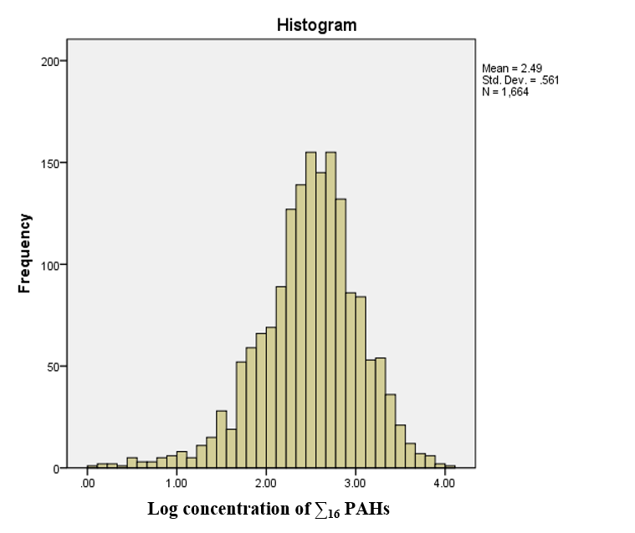
Fig. S1. Normal test after logarithmic transformation of ∑₁₆PAHs concentration nationwide.
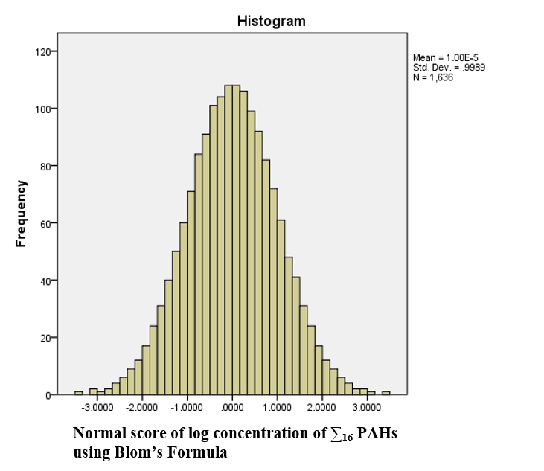
Fig. S2. Normal test after logarithmic transformation and normal score transformation of ∑₁₆PAHs concentration nationwide.
Fig. S3 Logarithmic correlations between concentration of PAHs and fossil energy consumption per unit area, gross regional product per unit area, industrial output per unit area, as well as population density. Dots represent the measured data for each province, and the mean values (dot) and SEs (error bars) of complied soil PAHs concentration during 2001 to 2019 were applied in the analysis. The red line denotes the fitted results.
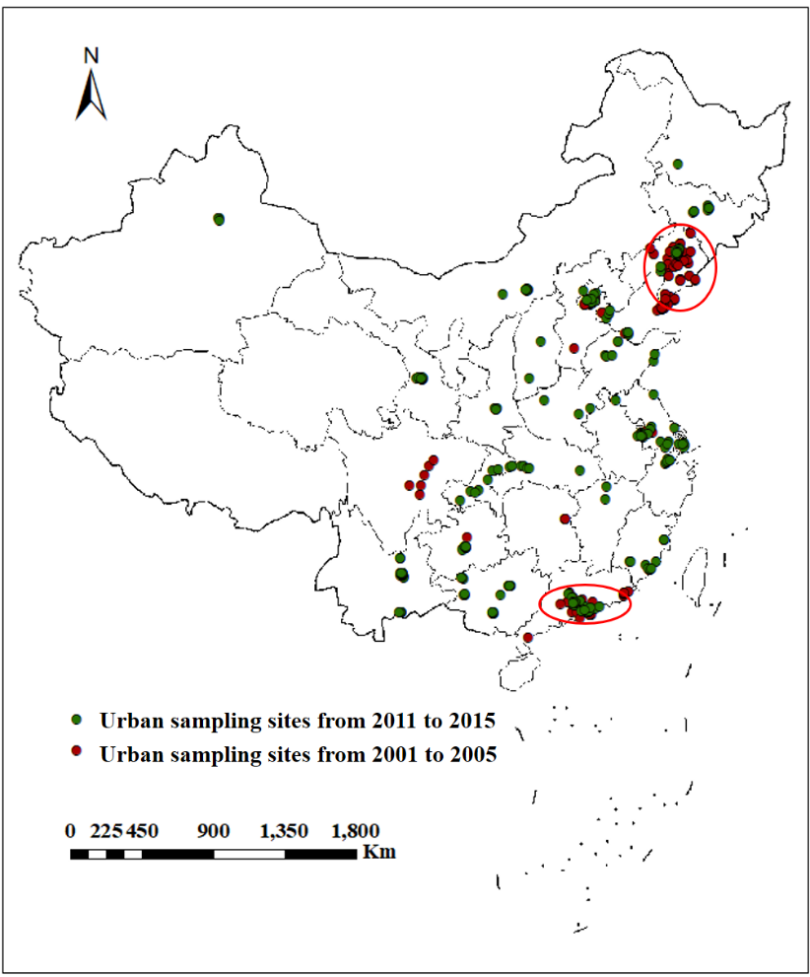

Fig. S4. The sampling sites from ‘2001–2005’ and ‘2011–2015’ periods for the urban samples in three typical regions: the Beijing–Tianjin–Hebei city cluster, the Liaoning industrial base and the Pearl River Delta city cluster.
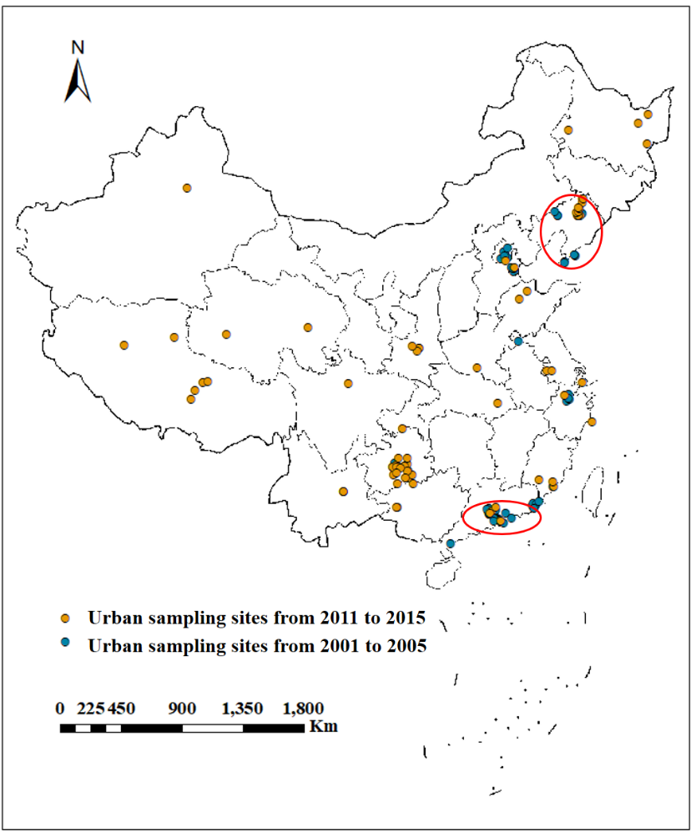
Fig. S5. The sampling sites from ‘2001–2005’ and ‘2011–2015’ periods for the suburban samples in three typical regions: the Beijing–Tianjin–Hebei city cluster, the Liaoning industrial base and the Pearl River Delta city cluster.
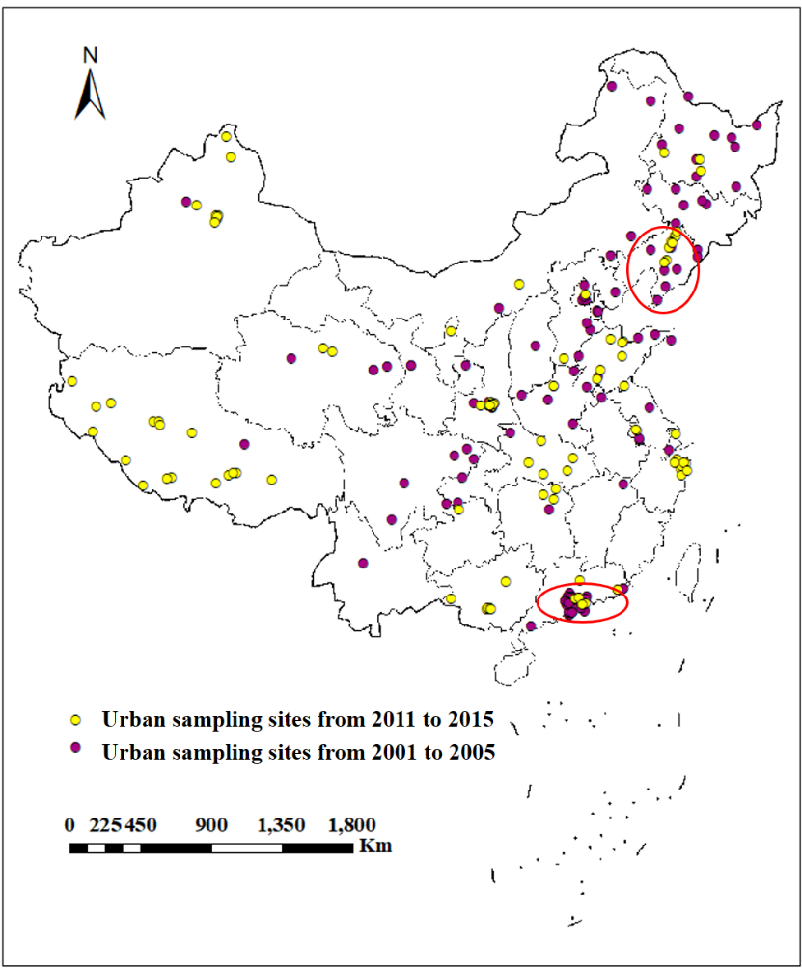
Fig. S6. The sampling sites from the ‘2001-2005’ and ‘2011-2015’ periods for the rural samples in three typical regions: the Beijing-Tianjin-Hebei city cluster, the Liaoning industrial base and the Pearl River Delta city cluster.

Fig. S7. Changes in the source composition of PAHs in China topsoil from the “2001–2005” to “2011–2015” period (left) and in Beijing from 2008 to 2019 (right).
Fig. S8 Percentages of total energy consumption (%) from coal, petroleum, natural gas, and primary electricity and other energy consumption between 2000 and 2019. The data are from the China Statistical Yearbook.

Figure S9. Daily consumption of main energy varieties in Beijing from 2002 to 2019. The data are from the Beijing Statistical Yearbook.

References:
1. Bu, Q. W.; Zhang, Z. H.; Lu, S.; He, F. P., Vertical distribution and environmental significance of PAHs in soil profiles in Beijing, China. Environmental geochemistry and health 2009, 31, (1), 119–131.
2. Lu, Y.-T.; Xiang, X.-X.; Zhang, S.-C.; Liu, M.-L.; Wang, J.; Li, S.; Yao, H.; Sun, S.-B., Vertical Distribution Characteristics of PAHs in Soils with Different Land Use Types During Rapid Urbanization. Huanjing kexue 2019, 40, (7), 3369–3377.
3. Shi, B.; Wu, Q.; Ouyang, H.; Liu, X.; Zhang, J.; Zuo, W., Distribution and source apportionment of polycyclic aromatic hydrocarbons in the surface soil of Baise, China. Environmental monitoring and assessment 2015, 187, (5), 1–14.
4. Liang, J.; Wu, H. B.; Wang, X. X., Distribution characteristics and health risk assessment of heavy metals and PAHs in the soils of green spaces in Shanghai, China. Environmental monitoring and assessment 2019, 191, (6), 1–14.
5. Monaco, D.; Riccio, A.; Chianese, E.; Adamo, P.; Di Rosa, S.; Fagnano, M., Chemical characterization and spatial distribution of PAHs and heavy hydrocarbons in rural sites of Campania Region, South Italy. Environmental science and pollution research international 2015, 22, (19), 14993–15003.
6. Zeng, S.; Ma, J.; Ren, Y.; Liu, G.-J.; Zhang, Q.; Chen, F., Assessing the spatial distribution of soil pahs and their relationship with anthropogenic activities at a national scale. International journal of environmental research and public health 2019, 16, (24), 4928.

