Supplementary Data for

Engineering DNA Materials for Sustainable Data Storage Using a DNA Movable-Type System
Zi-Yi Gong ^{a,#}, Li-Fu Song ^{a,#}, Guang-Sheng Pei ^{b}, Yu-Fei Dong ª, Bing-Zhi Li ^{a,}*, Ying-Jin Yuan ª
ª Frontiers Science Center for Synthetic Biology & Key Laboratory of Systems Bioengineering (Ministry of Education), School of Chemical Engineering and Technology, Tianjin University, Tianjin 300072, China
^{b} School of Biomedical Informatics, The University of Texas Health Science Center at Houston (UTHealth), Houston, TX 77030, USA

* Corresponding author.
E-mail address: bzli@tju.edu.cn (B.Z. Li).
# These authors contributed equally to this work.

Material and methods
The Python source codes utilized for the encoding and decoding of data

def byteToDNA(abyte):
#define the converter of four bits to DNA chars
converter = ('AT', 'AG', 'AC', 'AA', 'TA', 'TC', 'TG', 'TT', 'GG', 'GA', 'GT', 'GC', 'CC', 'CT', 'CA', 'CG')
octNum = abyte
dnastr = converter[octNum % 16]
octNum = octNum//16
dnastr = converter[octNum % 16] + dnastr
return dnastr

def bytesToDNAWithCheckBases(manyBytes, start_rule=0):
dnastr = ''
for aByte in manyBytes:
dnastr = dnastr + byteToDNA(aByte)
return addCheckBaseToDNA(dnastr, start_rule)

def dnaWithCheckBasesToBytes(dnaStr):
i = 0
nBytes=b''
while i < len(dnaStr):
nBytes = nBytes + DNAToByte(dnaStr[i:i+6])
i = i + 6
return nBytes

def DNAToByte(dnaStr):
converter = ('AT', 'AG', 'AC', 'AA', 'TA', 'TC', 'TG', 'TT', 'GG', 'GA', 'GT', 'GC', 'CC', 'CT', 'CA', 'CG')
bytesConverter = {}
i = 0
while i < 16:
j = 0
while j < 16:
fourBases = converter[i] + converter[j]
bytesConverter[fourBases] = bytes([i*16 + j])
j = j + 1
i = i + 1
return bytesConverter[dnaStr[0:2] + dnaStr[3:5]]

def addCheckBaseToDNA(dnaStr, start_rule=0):
#rules = [{'AT': 'A', 'TA': 'A', 'GG': 'A', 'CC': 'A', 'AG': 'G', 'TC': 'G', 'GA': 'G', 'CT': 'G', 'AC': 'C', 'TG': 'C',
# 'GT': 'C', 'CA': 'C', 'AA': 'T', 'TT': 'T', 'GC': 'T', 'CG': 'T'},
# {'AT': 'C', 'TA': 'C', 'GG': 'C', 'CC': 'C', 'AG': 'A', 'TC': 'A', 'GA': 'A', 'CT': 'A', 'AC': 'T', 'TG': 'T',
# 'GT': 'T', 'CA': 'T', 'AA': 'G', 'TT': 'G', 'GC': 'G', 'CG': 'G'})]
rules = []

rules = get_rules()
nDNAstr = ''
cRule = start_rule
sx = 0
while sx < len(dnaStr):
twoBases = dnaStr[sx:sx+2]
nDNAstr = nDNAstr + twoBases
nDNAstr = nDNAstr + rules[cRule][twoBases]
cRule = cRule + 1
if cRule > 23: #Switch encoding rules.
cRule = 0
sx = sx + 2;
return nDNAstr

def get_rules():
rules = []
groups = [['AA', 'TT', 'GG', 'CC'], ['AT', 'TG', 'GC', 'CA'],['AG', 'TC', 'GA', 'CT'],['AC', 'TA', 'GT', 'CG']]
base_orders = [['A', 'T', 'G', 'C'], ['A', 'T', 'C', 'G'], ['A', 'G', 'T', 'C'], ['A', 'G', 'C', 'T'], ['A', 'C', 'T', 'G'], ['A', 'C', 'G', 'T']]
#Generate rules table
for base_order in base_orders:
j = 0
while j < 4:
if j > 0:
base_order.append(base_order[0])
del base_order[0]

newRule = {}
i = 0
while i < 4:
for twoBases in groups[i]:
newRule[twoBases] = base_order[i]
i = i + 1
rules.append(newRule)
j = j + 1
return rules

def get_tri_base_rules():
rules = get_rules()
tribase_rules = {}
i = 0
while i < len(rules):
for twobase in rules[i].keys():
tribase = twobase + rules[i][twobase]
if tribase in tribase_rules.keys():
tribase_rules[tribase].append(i)
else:
tribase_rules[tribase] = [i]
i = i + 1
return tribase_rules

def get_triple2rules():
rules = get_rules()
triple_rules = {}
i = 0
while i < 24:
for twobase in rules[i].keys():
triBase = twobase + rules[i][twobase]
if triBase in triple_rules.keys():
triple_rules[triBase].append(i)
else:
triple_rules[triBase] = []
triple_rules[triBase].append(i)
i = i + 1
return triple_rules

def triBlocksOfRule(rule):
rules = []
rules = get_rules()
nBlocks = {}
for k in rules[rule].keys():
nBlocks[k + rules[rule][k]] = 1
return nBlocks

def triBlocksOfAllRules():
rules = []
rules = get_rules()
nBlocks = {}
for k in range(0,24):
nBlocks[k] = triBlocksOfRule(k)
return nBlocks

def DNA_complement(sequence):
sequence = sequence.upper()
sequence = sequence.replace('A', 't')
sequence = sequence.replace('T', 'a')
sequence = sequence.replace('C', 'g')
sequence = sequence.replace('G', 'c')
return sequence.upper()

def DNA_reverse(sequence):
sequence = sequence.upper()
return sequence[::-1]

def DNA_rev_complement(sequence):
sequence = DNA_complement(sequence)
return DNA_reverse(sequence)

def tripleKmers(str, kmer_len):
kmers = []
i = 0
if len(str) >= kmer_len:
i = 0
kmstr = ''
while i <= len(str) - kmer_len:
kmstr = str[i:i + kmer_len]
kmers.append(kmstr)
i = i + 3
return kmers

def addCheckBaseToDNAUsingRules(dnaStr, rules, start_rule=0):
nDNAstr = ''
cRule = start_rule
sx = 0
while sx < len(dnaStr):
twoBases = dnaStr[sx:sx + 2]
nDNAstr = nDNAstr + twoBases
nDNAstr = nDNAstr + rules[cRule][twoBases]
cRule = cRule + 1
if cRule > 23: # Switch encoding rules.
cRule = 0
sx = sx + 2;
return nDNAstr

Table S1
The DNA movable-types with text information.

No. | 1 | 2 | 3 | 4 | 5 | 6
Encoding region | TCGTTT | TGCAGT | TTATAA | TTCAAG | TGGCGA | TGCCAA
No. | 7 | 8 | 9 | 10 | 11 | 12
Encoding region | ACTCCG | ACGATA | TAGAAC | TTTACT | TGCGAT | TGTAAT
No. | 13 | 14 | 15 | 16 | 17 | 18
Encoding region | TGTGCG | ACTCCC | ACGATC | TATTGA | TTAACA | TGCAGG
No. | 19 | 20 | 21 | 22 | 23 | 24
Encoding region | TGGCAC | TGTGCA | TGCCCC | TGGGAC | TGCCAG | ACCCAA

Table S2
Summary of the sequencing results of the proof-concept verification with text information. This report was generated by fastp 0.23.2 (https://github.com/OpenGene/fastp).
General | Values
Sequencing | Paired end (150 cycles + 150 cycles)
Mean length before filtering | 150 bp, 150 bp
Mean length after filtering | 127 bp, 127 bp
Duplication rate | 45.046608%
Insert size peak | 216
Before filtering
Total reads | 18.658204 M
Total bases | 2.798731 G
Q20 bases | 2.562394 G (91.555575%)
Q30 bases | 2.393898 G (85.535118%)
GC content | 46.996934%
After filtering
Total reads | 18.544904 M
Rotal bases | 2.363035 G
Q20 bases | 2.249683 G (95.203121%)
Q30 bases | 2.139270 G (90.530598%)
GC content | 46.132008%
Filtering result
Reads passed filters | 18.544904 M (99.392760%)
Reads with low quality | 105.476000 K (0.565306%)
Reads with too many N | 1.394000 K (0.007471%)
Reads too short | 6.430000 K (0.034462%)

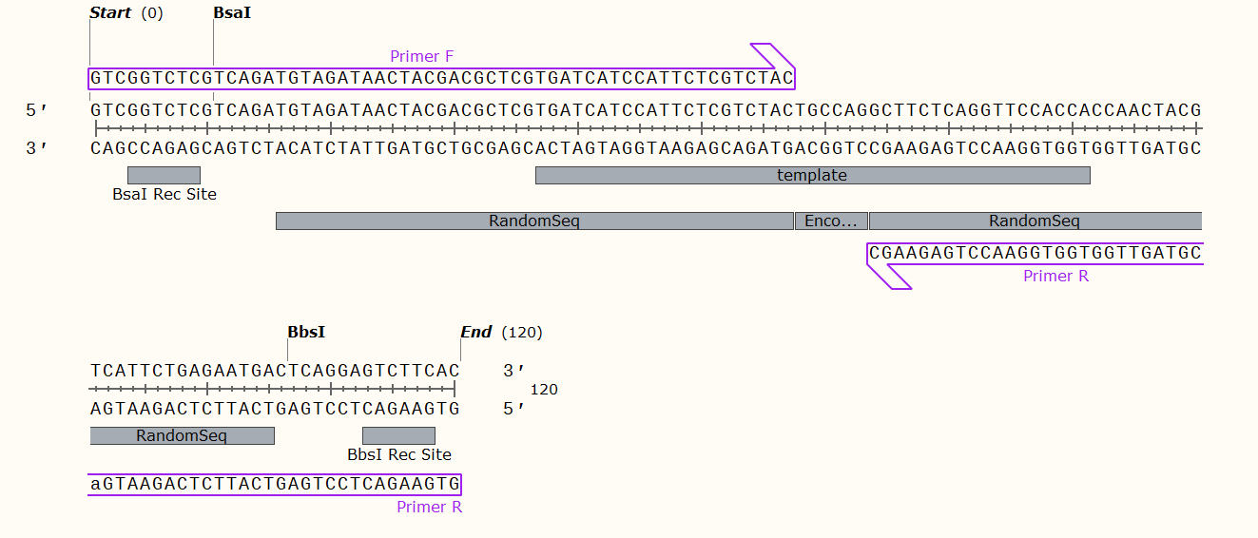
Fig. S1. Schematic view of the 120 bp DNA movable-types sequence.

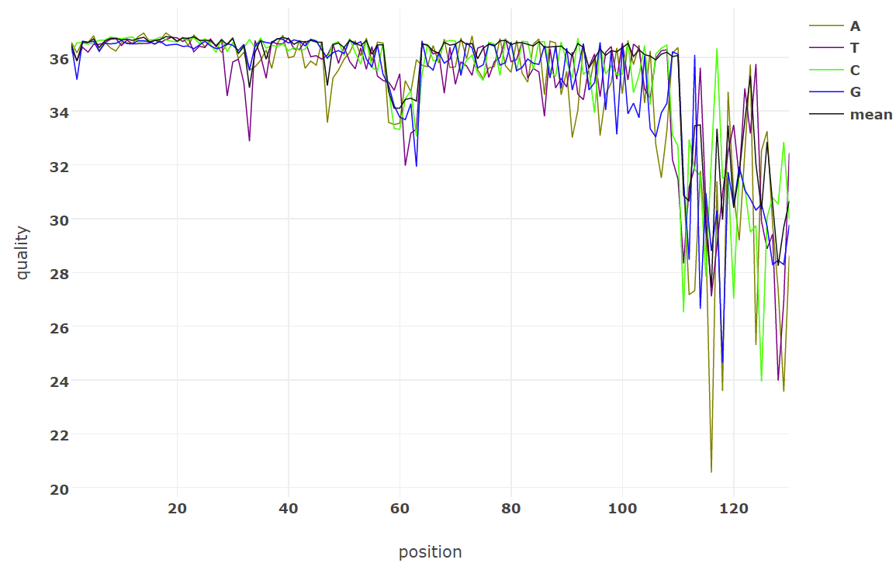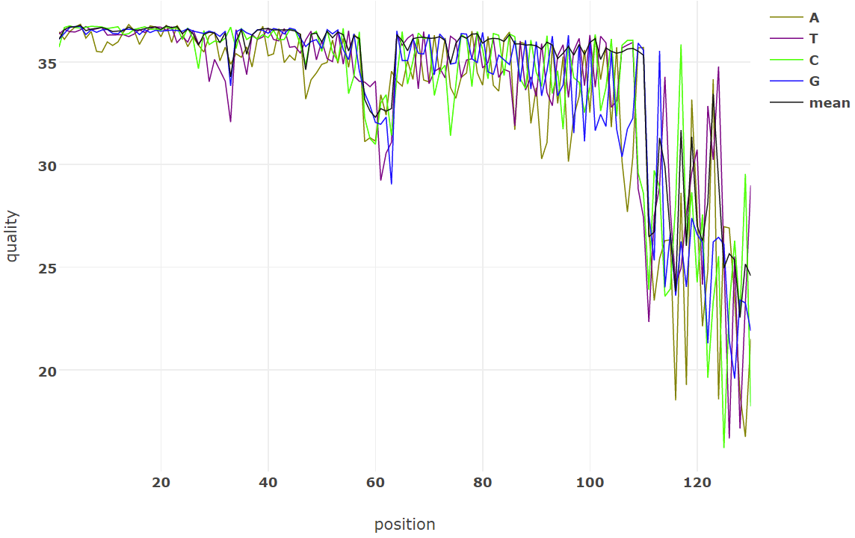
Fig. S2. The sequencing quality of the paired-end reads. The horizontal axis is the position where the base is located and the vertical axis is its mass. The sequencing approach adopted was two-end sequencing, resulting in two reads. Left: read 1; right: read 2.

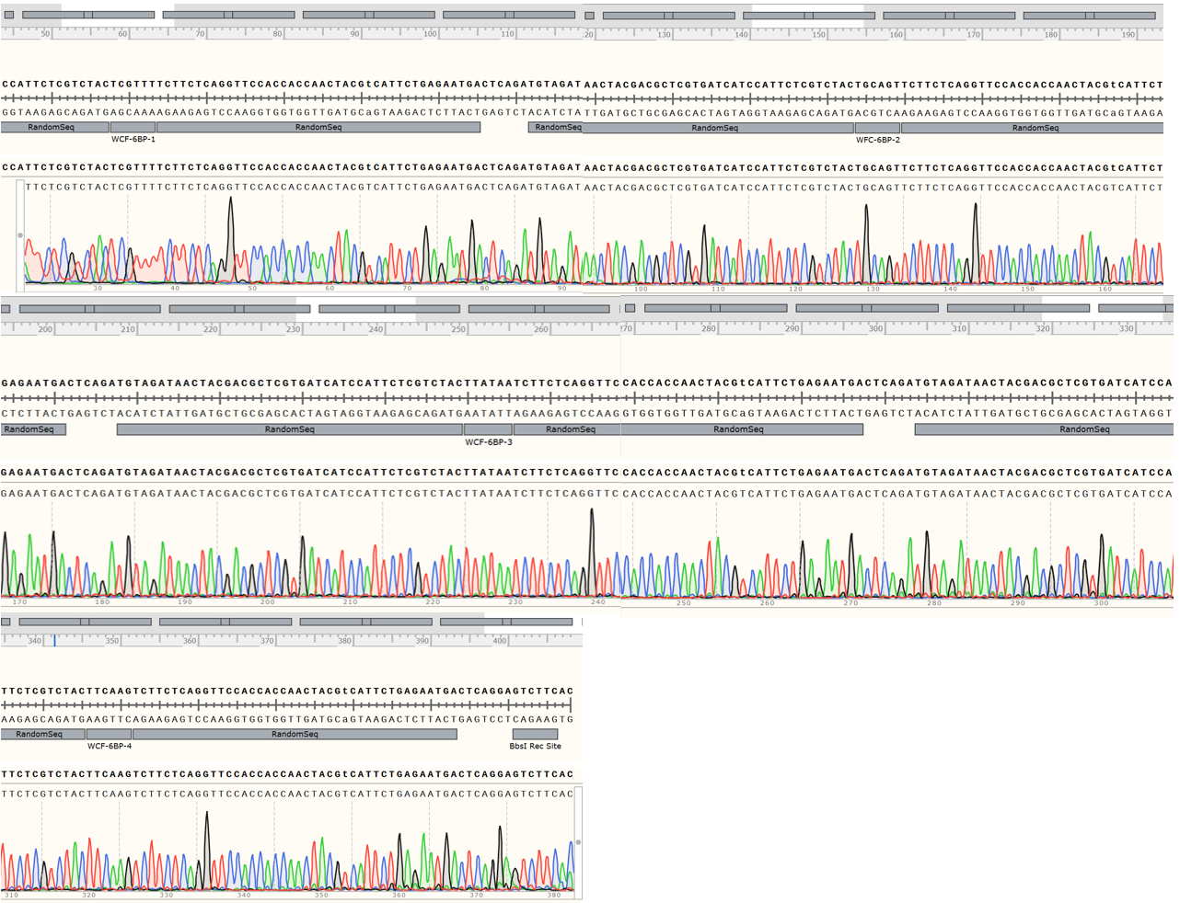
Fig. S3. Sanger sequencing results of a single storage unit. Storage unit 1: 1 + 2 + 3 + 4.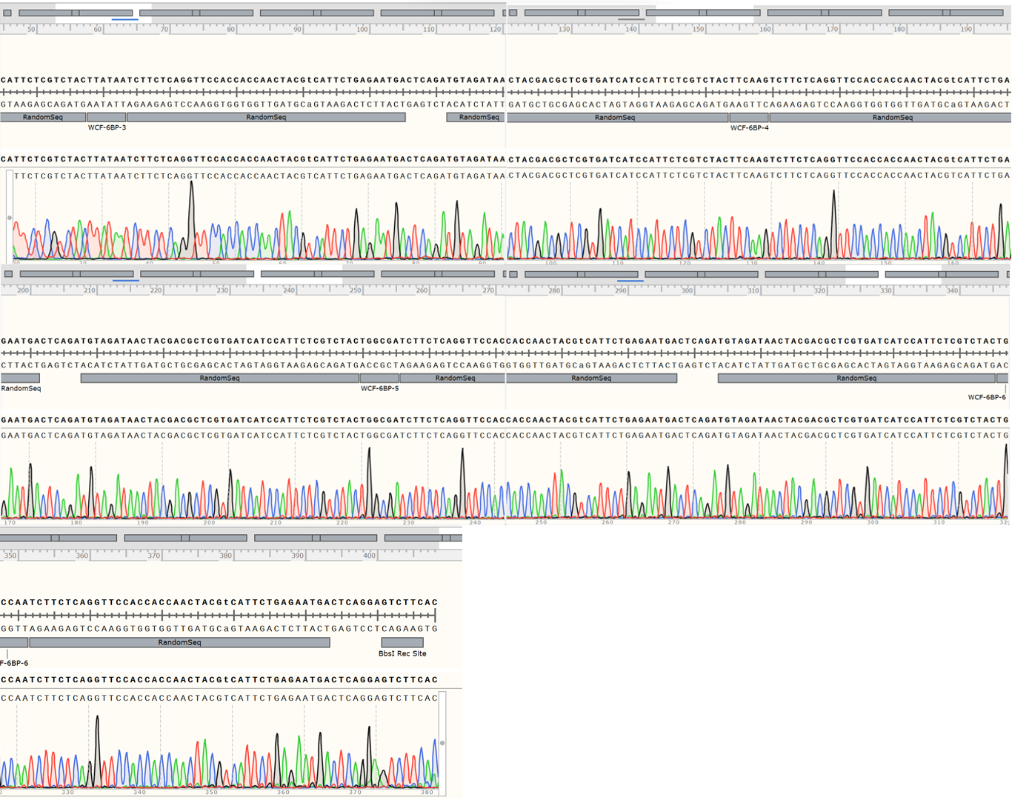
Fig. S4. Sanger sequencing results of a single storage unit. Storage unit 2: 3 + 4 + 5 + 6.

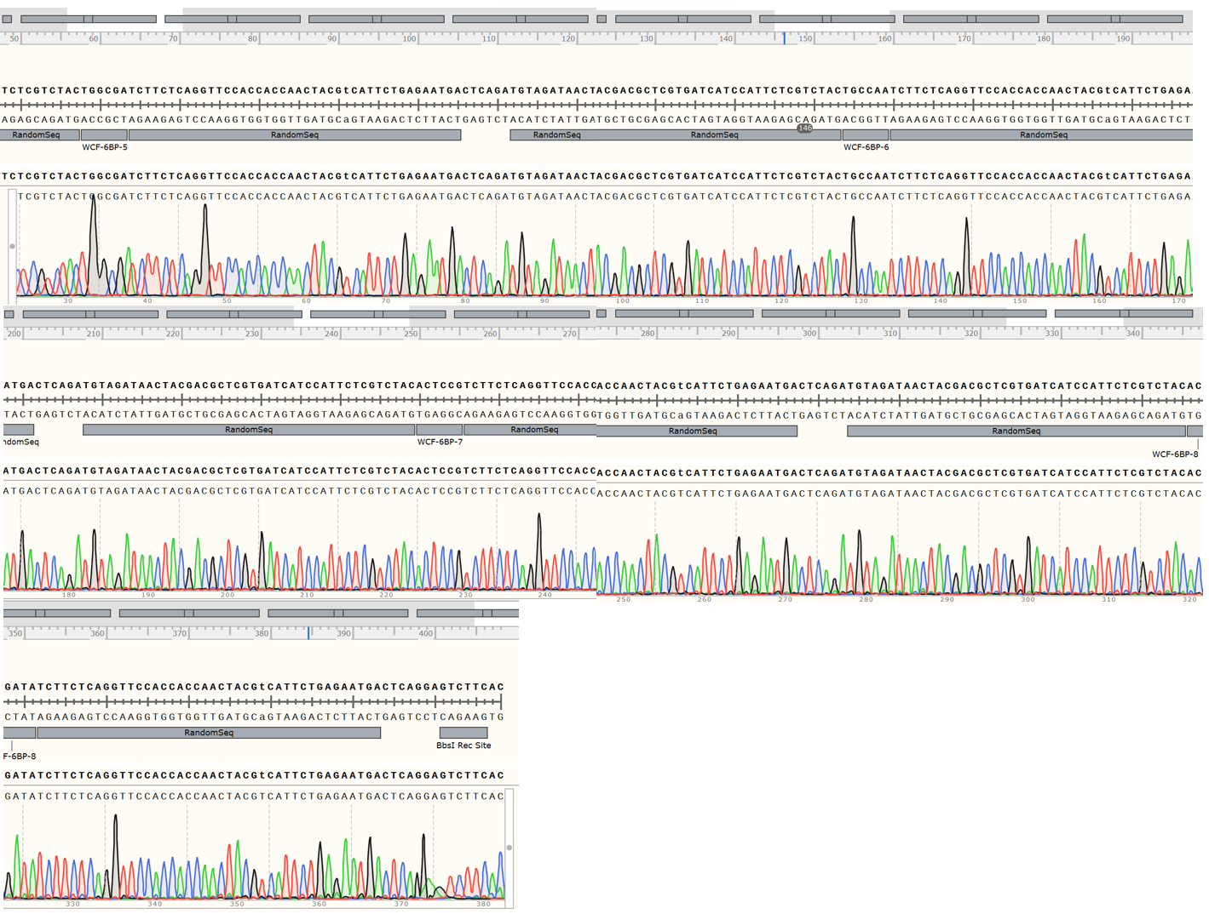
Fig. S5. Sanger sequencing results of a single storage unit. Storage unit 3: 5 + 6 + 7 + 8.

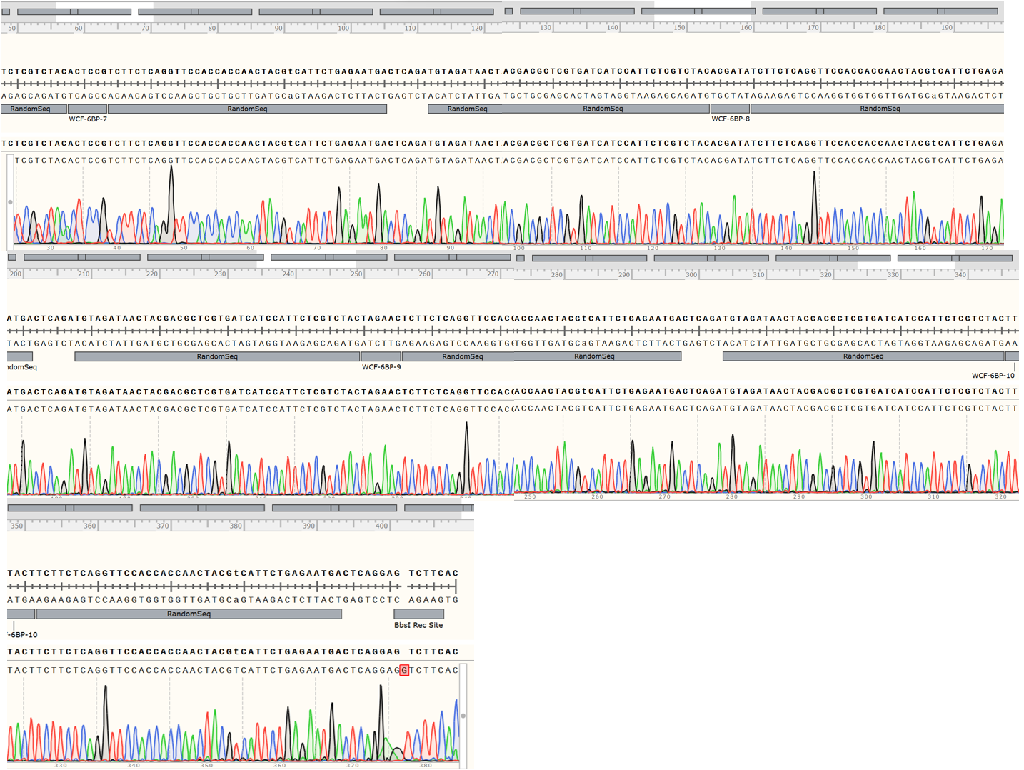
Fig. S6. Sanger sequencing results of a single storage unit. Storage unit 4: 7 + 8 + 9 + 10.

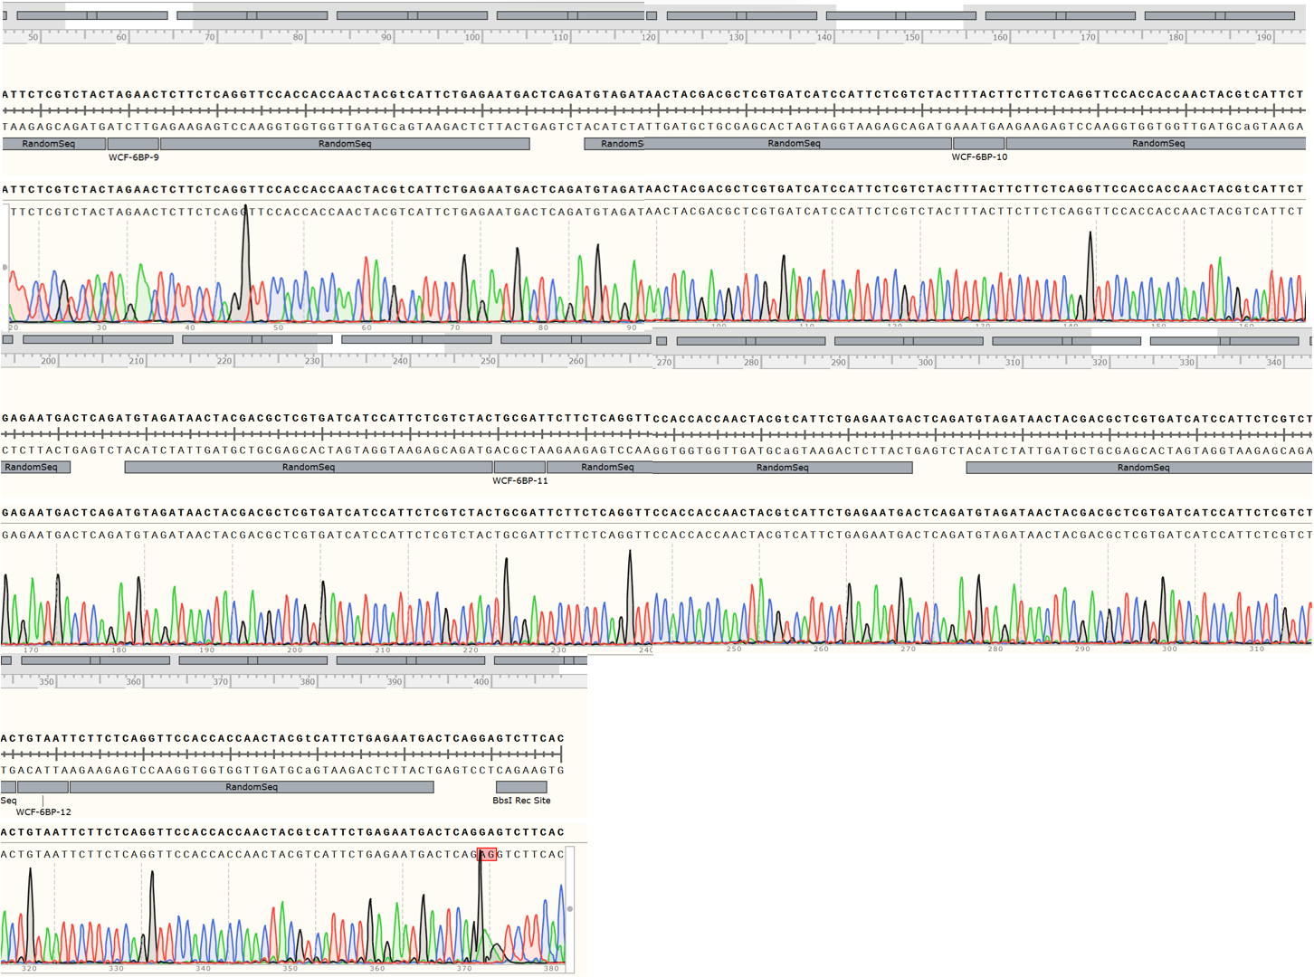
Fig. S7. Sanger sequencing results of a single storage unit. Storage unit 5: 9 + 10 + 11 + 12.

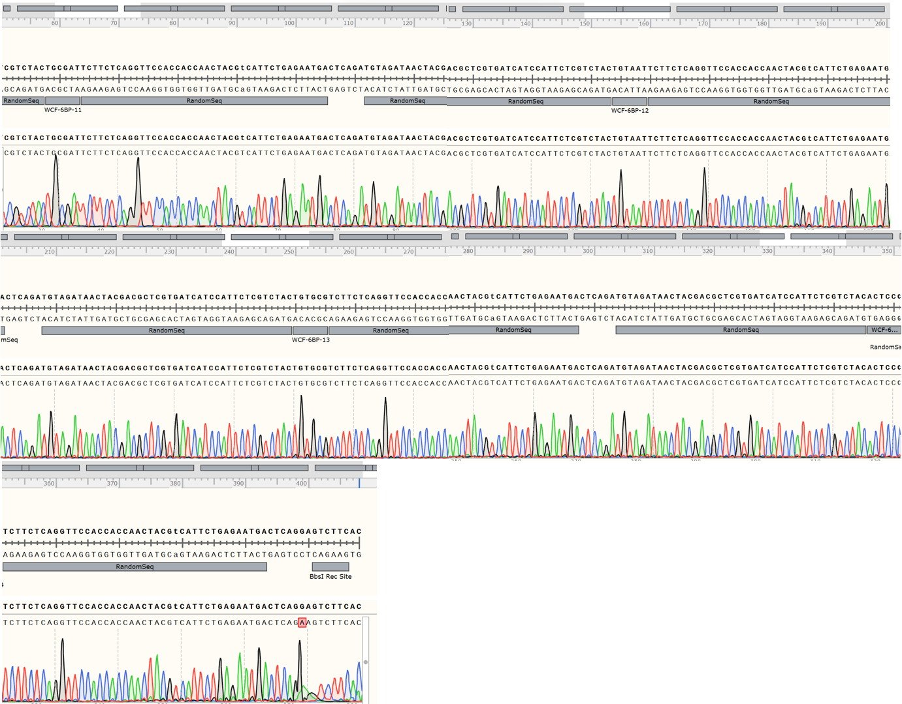
Fig. S8. Sanger sequencing results of a single storage unit. Storage unit 6: 11 + 12 + 13 + 14.

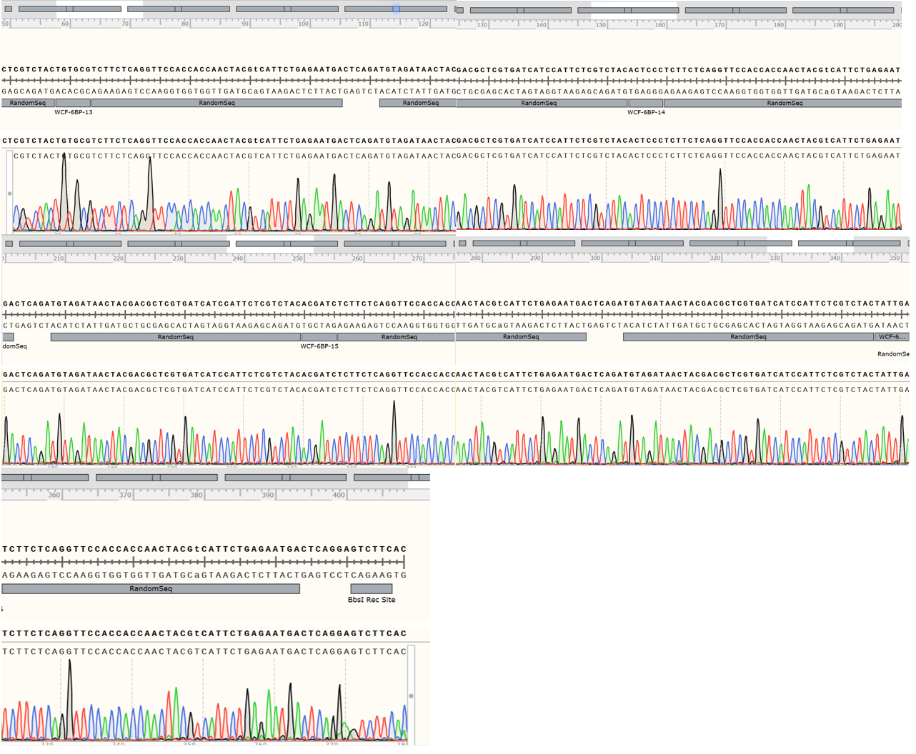
Fig. S9. Sanger sequencing results of a single storage unit. Storage unit 7: 13 + 14 + 15 + 16.
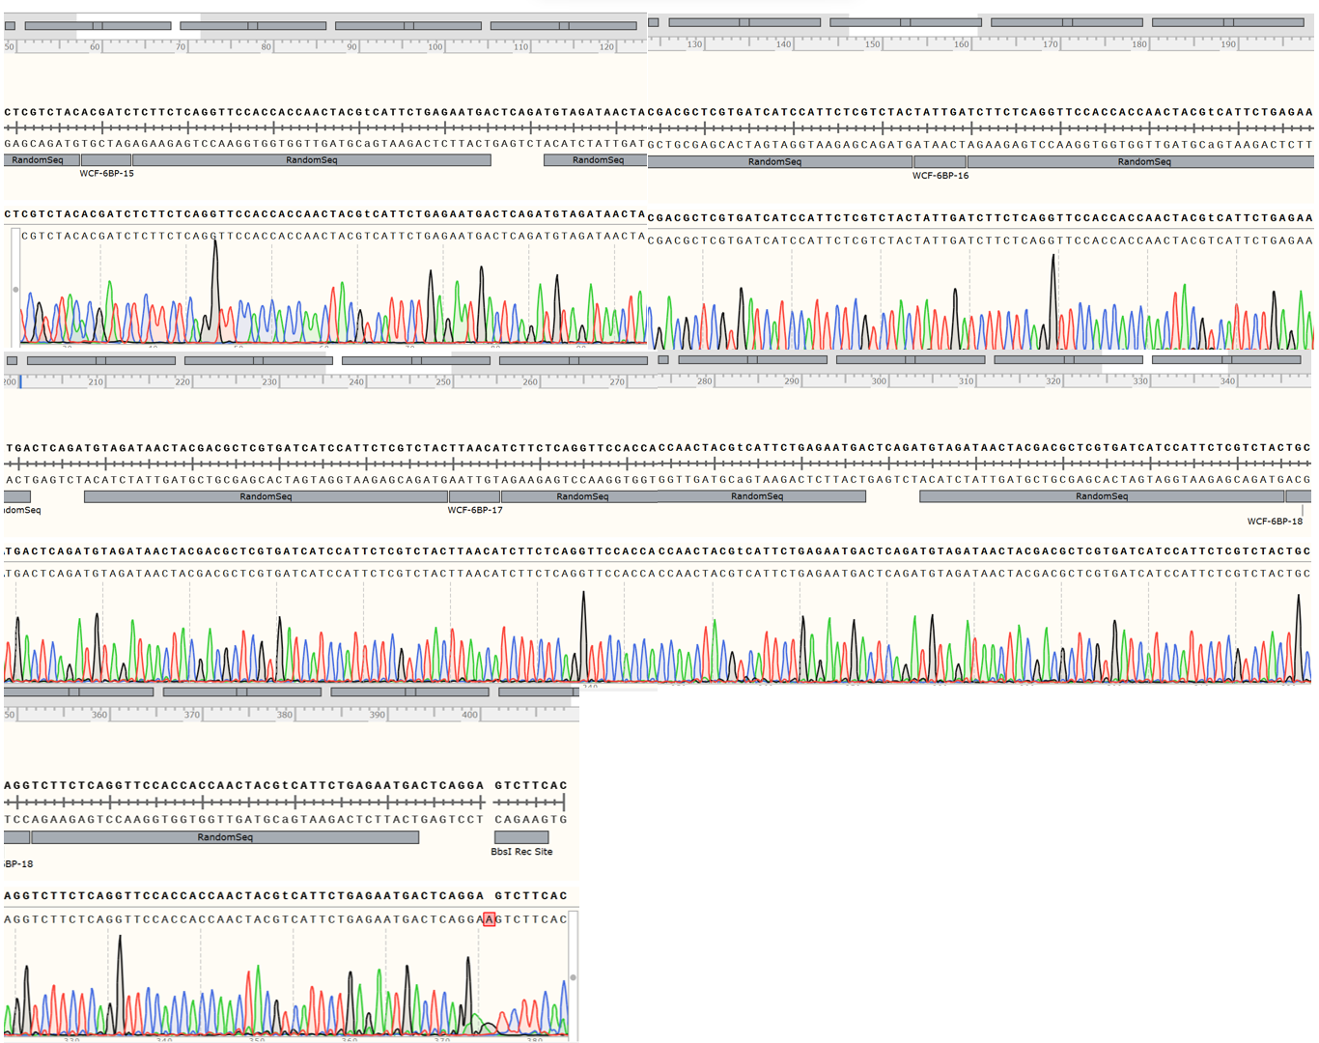
Fig. S10. Sanger sequencing results of a single storage unit. Storage unit 8: 15 + 16 + 17 + 18.

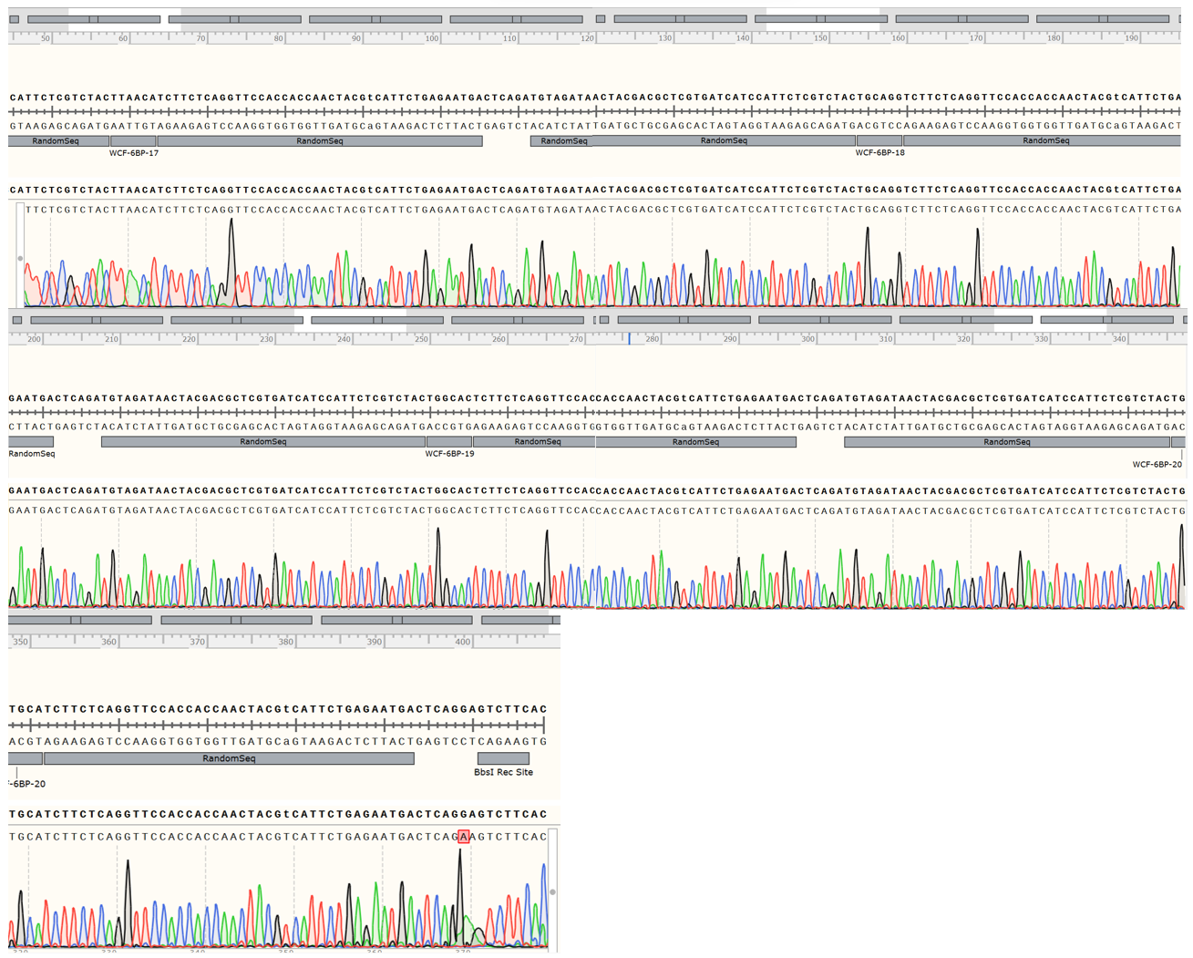
Fig. S11. Sanger sequencing results of a single storage unit. Storage unit 9: 17 + 18 + 19 +20.
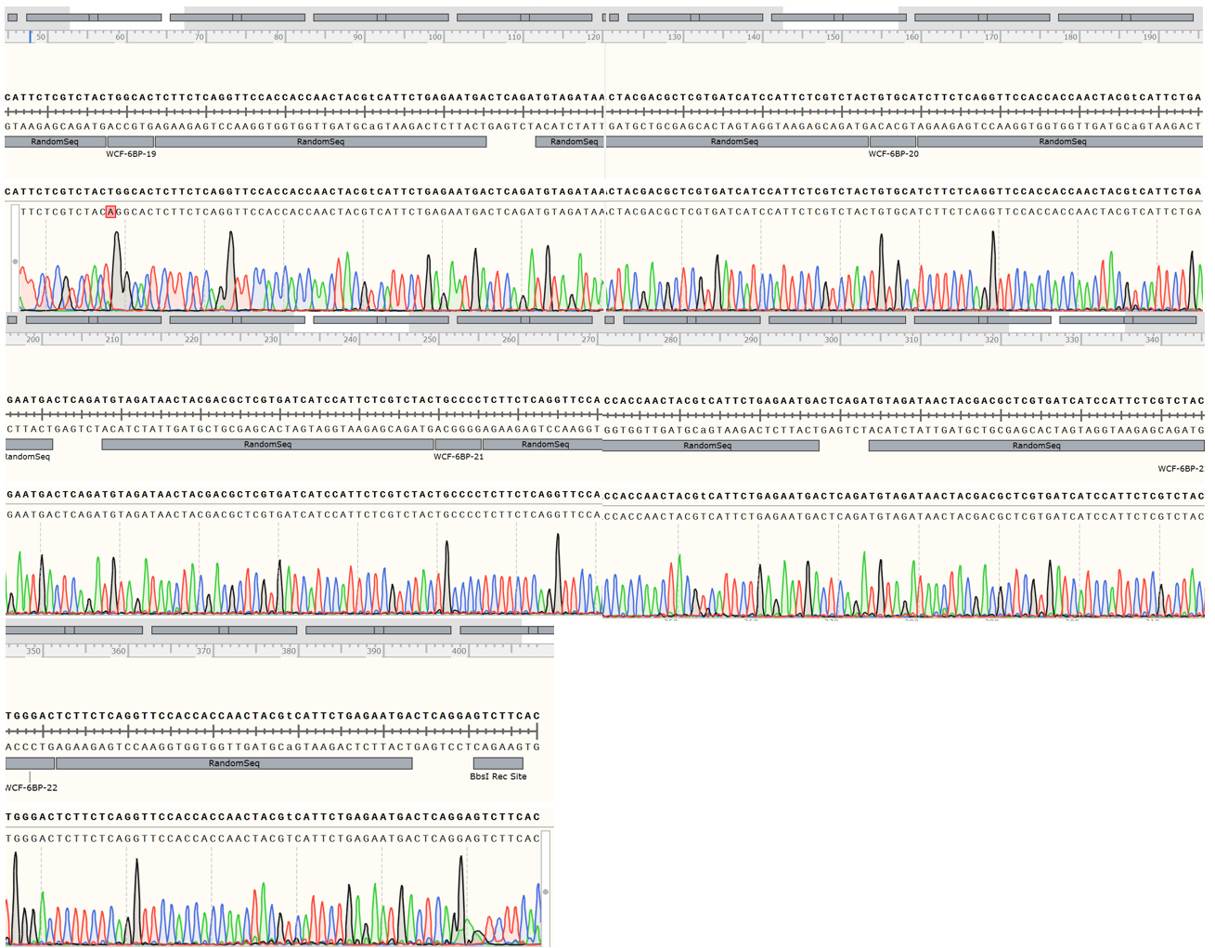
Fig. S12. Sanger sequencing results of a single storage unit. Storage unit 10: 19 + 20 + 21 + 22.

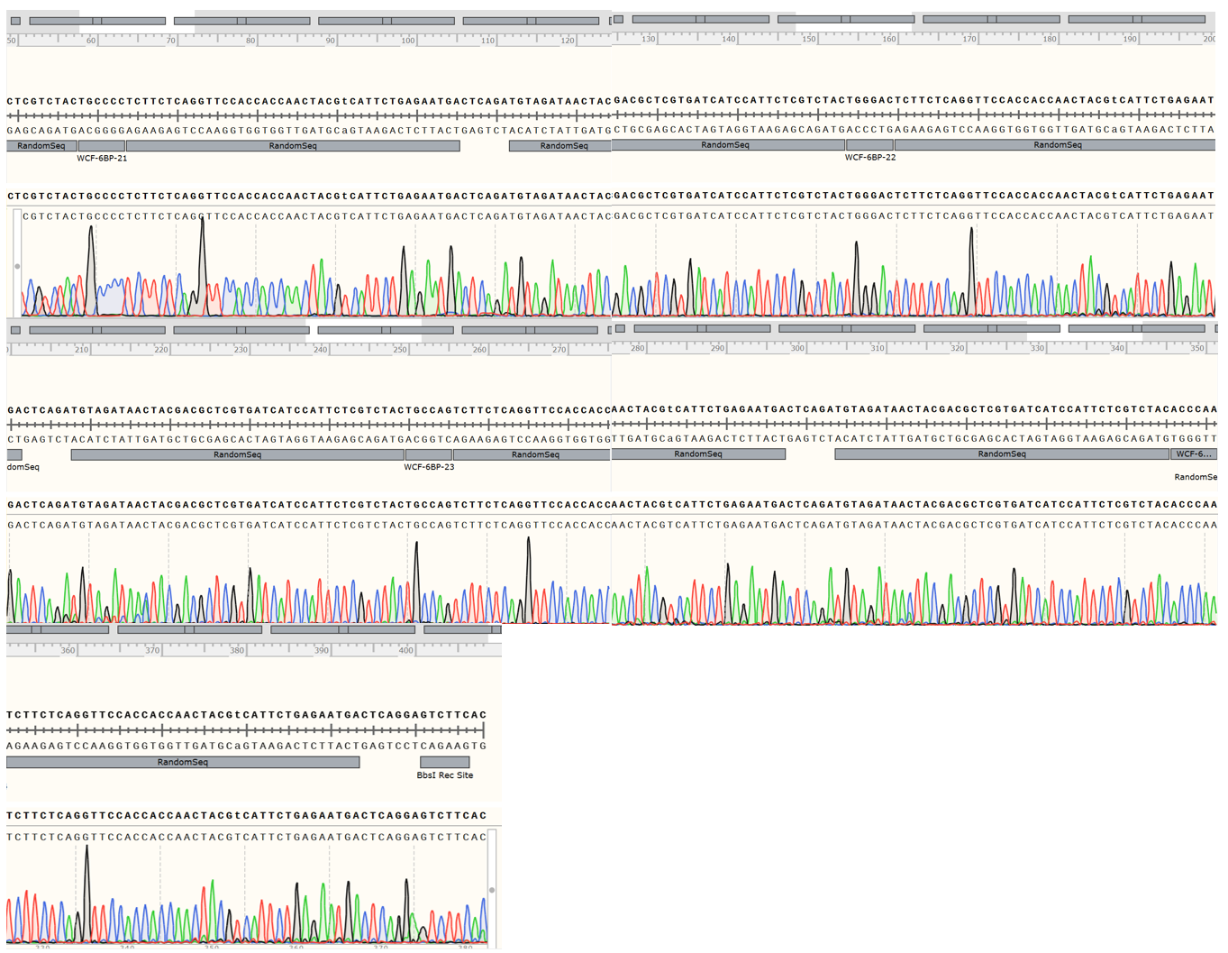
Fig. S13. Sanger sequencing results of a single storage unit. Storage unit 11: 21 + 22 + 23 + 24.

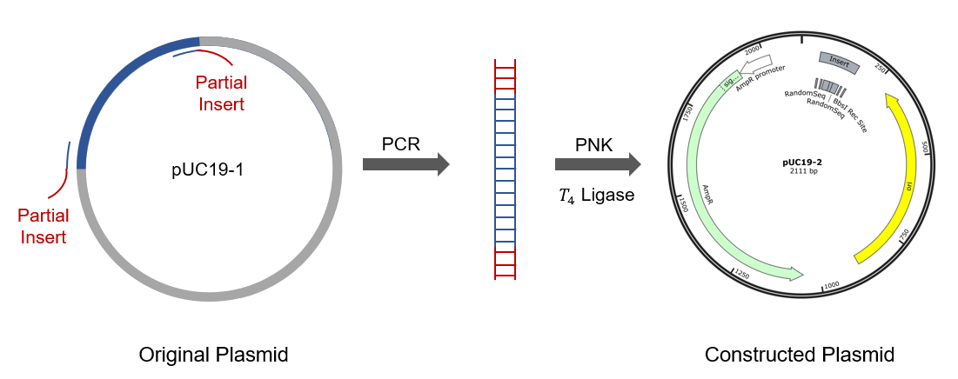
Fig. S14. The designed plasmid for the production of DNA movable-types by cell factories.

