Supplementary data for

Selective Microcrystalline Cellulose Extraction from Chinese Medicine Residues via Direct PMS Oxidation
Jinjing Huang ª, Xia Liu ^{b}, Kaixing Fu ª, Shengyun Yang ^{c}, Shiqing Zhou ^{d}, Jinming Luo ^{a,}*
ª State Environmental Protection Key Laboratory of Environmental Health Impact Assessment of Emerging Contaminants, School of Environmental Science and Engineering, Shanghai Jiao Tong University, Shanghai 200240, PR China
^{b} College of Chemistry and Chemical Engineering, Qingdao University, Qingdao 266071, PR China
^{c} Jiangxi Weiqing Environmental Engineering Co., Ltd., Nanchang, 330038, PR China
^{d} Hunan Engineering Research Center of Water Security Technology and Application, College of Civil Engineering, Hunan University, Changsha 410082, PR China
*Corresponding author.
E-mail address: jinming.luo@sjtu.edu.cn (J. Luo).

Supporting Data Content
17 Pages
4 texts
10 Figures
13 Tables

Text S1. Analysis methods and characterizations.
Fourier transform infrared spectroscopy (FT-IR) spectra were obtained on a Thermo Scientific Nicolet iS20 instrument. The resolution was set at 4 cm⁻¹, with 32 scans, covering the wavenumber range of 400 to 4000 cm⁻¹. X-ray diffraction (XRD, Japan Rigaku Miniflex 600) was conducted by scanning from 5° to 60° (2θ) with a 0.02° step interval and a scanning rate of 10° min⁻¹. To calculate the crystallinity (the fraction of the crystal phase) of the MCC from the XRD spectra, individual crystalline peaks were extracted by the peak deconvolution method from the diffraction intensity profiles. In this work, all the peaks were fitted, assuming Gaussian functions for each peak, and broad peaks at approximately 16° and 34° were attributed to the amorphous contribution [1, 2]. The AFM images were obtained via atomic force microscopy (AFM, Bruker Dimension Icon) by using cellulose suspensions (10 μL, 0.0005 wt %) deposited onto freshly cleaved mica surfaces and subsequently air-dried. The length and width frequency distributions of NCCs were analyzed using NanoScope and ImageJ software. Thermo Scientific Nicolet iS20 equipment with a universal ATR accessory was used to detect any changes in the vibrations of PMS upon contact with the RPR in water. Milli-Q water was used as a background for the ATR-FTIR scan. The spectra of the PMS solution (0.3 M) were taken on the ZnSe crystal of the ATR with 32 scans in the range of 700-2500 cm⁻¹ at a resolution of 4 cm⁻¹. After reacting with RPR, any remaining PMS was precipitated with an alcohol solution and dried at 60 °C before conducting measurements under the same conditions as those used for the original PMS solution. Thermogravimetric (TG) and derivative thermogravimetric (DTG) curves were obtained via thermogravimetric analysis (TGA). In each measurement, approximately 20 mg of lignin sample was weighed in a 70 μL alumina crucible and scanned from 30 to 600 °C at a rate of 10 °C·min⁻¹. 2D-HSQC NMR spectroscopy (Bruker AVANCE NEO 400 M spectrometer) was used to monitor the structure of the high-molecular-weight polymer in the Chinese medicine residues (the original RPR was dissolved in DMSO-d₆). The signals at δC/δH 3.63 and 60.30 represent β-O-4 linkages present in lignin, and the signals at δC/δH 3.35-3.61 and 71.78-78.75 represent the structures of xylan [3]. Solid-state NMR experiments were conducted at a spinning speed of 10 kHz, contact time of 1 ms, acquisition time of 13.5 ms and delay between pulses of 5 s for all samples. EPR spectra were obtained by using 5,5-dimethyl-1-pyrroline-N-oxide (DMPO) and 2,2,6,6-tetramethylpiperidine (TEMP) as radical trapping agents.
Text S2. Measurements of DPA degradation.
DPA oxidation was employed to assess the generation of singlet oxygen (¹O₂) within the systems. Initially, 100 μL of DPA solution (1 g/L, dissolved in DMSO) was blended with 1.8 mL of deionized water. Subsequently, 1.6 mL of the time-dependent sample solution was introduced, followed by the immediate addition of 0.8 mL of methanol as a quencher. The degradation process of DPA was monitored using a UV‒vis spectrophotometer, and the rate of DPA decomposition was determined based on the change in absorbance at 378 nm.
Text S3. PMS decomposition.
PMS concentrations were determined using the colorimetric method proposed by Liang et al. based on iodine (λ_{max} = 352 nm) production via iodide oxidation by persulfate [4].
Text S4. Techno-economic Analysis (TEA).
For the PMS treatment calculation under optimistic assumptions, the specific sample is as follows:
The assumptions made for the TEA are outlined below:
1. The electricity price is assumed to be $0.03 per kWh.
2. Approximately 0.2 g of cellulose is produced from each 1 g of CMRs.
3. The power ratings for the crusher, centrifuge, freeze dryer, water bath, oven, and ultrasonic homogenizer were 550 W, 550 W, 1150 W, 400 W, 800 W, and 1080 W, respectively.
4. The costs for the crusher, centrifuge, freeze dryer, water bath, oven and ultrasonic homogenizer are approximately $42.86, $891.43, $1400, $71.43, $385.71 and $2857, respectively.
5. The equipment depreciation rate has not been considered.
6. Operational details: The received CMRs were dried in an oven at 60 °C for 12 hours. A drying oven can dry approximately 10 kg of CMRs. The crushing device processes approximately 50 g of RPR per cycle in approximately 10 minutes. The cellulose slurry underwent multiple centrifugal washes, with each 0.6 g sample requiring approximately 1 hour of centrifugation. The freeze-drying machine processes approximately 2.4 g of cellulose per cycle over 12 hours. The water bath needs 10 hours to extract 0.4 g of cellulose. The extracted cellulose was washed with approximately 2500 mL of distilled water each time. An ultrasonic homogenizer was used to ultrasound a 0.4 g slurry for approximately 20 minutes.
The total cost of the NCC extraction process consisted of the capital cost, operating cost, and material cost.
Capital cost (including the investment in equipment):
Operating cost (including the electricity consumption of the equipment):
1. Drying:
2. Crushing:
3. Centrifuging:
4. Freeze drying:
5. Water bath:
6. Ultrasounding:
Material cost (including chemical reagents and water consumption):
1. Water:
2. Peroxymonosulfate:
The total cost:

Fig. S1. The structure of original RPR in the 2D-HSQC NMR spectra.

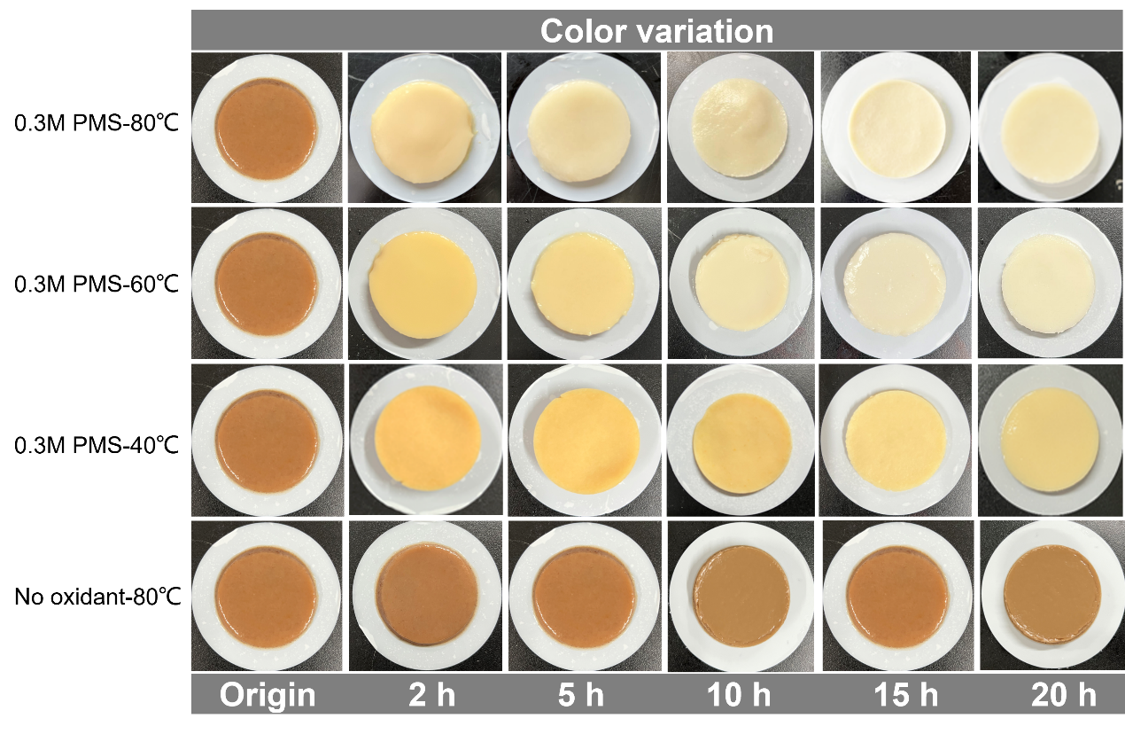
Fig. S2. Changes in color of RPR by PMS oxidation at different temperatures (40, 60 and 80 °C).

Fig. S3. The cellulose extraction efficiency under different PMS concentrations (0.2, 0.3, 0.4 M) and temperatures (80, 90 ℃).

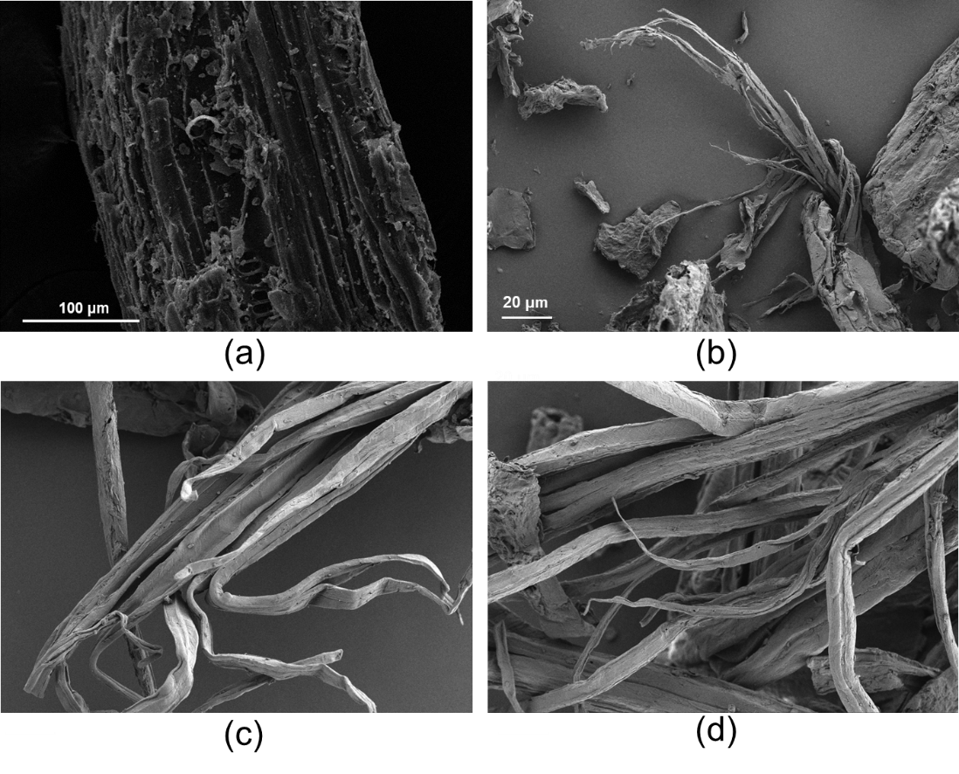
Fig. S4. SEM images depicting the one-step PMS oxidation process for cellulose extraction. (a-d) origin, 2, 5, 10 h.

Fig. S5. FTIR spectra depicting the process of cellulose extraction through one-step PMS oxidation.

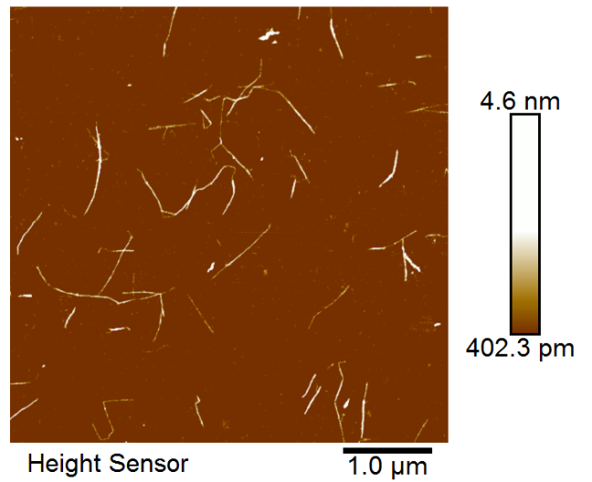
Fig. S6. The AFM images of NCC.

Fig. S7. Mechanical properties of hydrogel with or without cellulose.

Fig. S8. Effect of scavenger on cellulose extraction in the presence of MeOH and TBA. Conditions: ([PMS]₀ = 0.3 M, T = 80 °C, [CMRs]₀ = 10 g/L, [MeOH, TBA]₀ = 3 M).

Fig. S9. Effect of scavenger on cellulose extraction in the presence of L-Histidine. Conditions: ([PMS]₀ = 0.3 M, T = 80 °C, [CMRs]₀ = 10 g/L, [L-Histidine]₀ = 0.3 M).

Fig. S10. ATR-FTIR spectra of PMS and the reaction of PMS with RPR.

Table S1. The background contents for different pristine CMRs.
CMRs | Lignin (%) | Hemicellulose (%) | Cellulose (%)
Radix paeoniae rubra | 11.73 ± 0.16 | 52.42 ± 1.14 | 35.85 ± 0.02
Astragalus | 23.26 ± 1.84 | 38.72 ± 1.16 | 38.02 ± 2.49
Acorus | 9.40 ± 1.05 | 58.97 ± 0.77 | 31.62 ± 1.97
Suhuang | 24.89 ± 0.94 | 39.96 ± 0.25 | 35.15 ± 1.28
Achyranthes | 7.79 ± 0.62 | 45.62 ± 2.66 | 46.59 ± 0.58
Shaxi | 24.98 ± 1.02 | 28.54 ± 1.09 | 46.48 ± 1.58
Weisu | 28.35 ± 0.73 | 35.58 ± 0.82 | 36.06 ± 1.02

Table S2. The background contents for the different treated CMRs.
CMRs | Lignin (%) | Hemicellulose (%) | Cellulose (%)
Radix paeoniae rubra | 0.21 ± 1.15 | 5.69 ± 1.20 | 94.10 ± 3.52
Astragalus | 17.01 ± 1.52 | 17.01 ± 1.73 | 65.97 ± 1.74
Acorus | 8.95 ± 1.31 | 16.82 ± 1.07 | 74.23 ± 2.74
Suhuang | 2.37 ± 1.62 | 21.24 ± 1.42 | 76.39 ± 1.15
Achyranthes | 4.67 ± 0.74 | 2.04 ± 0.64 | 93.29 ± 1.25
Shaxi | 11.44 ± 2.31 | 9.65 ± 1.21 | 78.91 ± 2.15
Weisu | 1.19 ± 2.57 | 12.62 ± 0.63 | 86.20 ± 2.18

Table S3. The contents of lignin, hemicellulose, and cellulose were determined after 0.3 M oxidation at 40 °C.
Radix paeoniae rubra | Lignin (%) | Hemicellulose (%) | Cellulose (%)
Origin | 11.73 ± 0.16 | 52.42 ± 1.14 | 35.85 ± 0.02
PMS | 0.66 ± 0.55 | 62.56 ± 2.17 | 36.78 ± 2.20
NaClO | 17.93 ± 1.87 | 25.28 ± 0.67 | 56.79 ± 3.11
APS | 42.60 ± 3.28 | 29.79 ± 1.36 | 27.61 ± 1.42
NaClO₂ | 26.11 ± 2.11 | 53.26 ± 1.19 | 20.64 ± 3.00
PAA | 4.44 ± 0.97 | 69.20 ± 0.92 | 27.64 ± 1.91
H₂O₂ | 22.11 ± 1.34 | 50.26 ± 1.06 | 26.36 ± 2.82

Table S4. The contents of lignin, hemicellulose, and cellulose were determined after 0.3 M oxidation at 60 °C.
Radix paeoniae rubra | Lignin (%) | Hemicellulose (%) | Cellulose (%)
Origin | 11.73 ± 0.16 | 52.42 ± 1.14 | 35.85 ± 0.02
PMS | 0.65 ± 0.91 | 24.16 ± 0.13 | 75.19 ± 1.75
NaClO | 1.17 ± 3.01 | 44.14 ± 0.96 | 54.69 ± 3.73
APS | 35.54 ± 1.05 | 21.80 ± 2.22 | 42.66 ± 1.26
NaClO₂ | 8.93 ± 0.61 | 25.28 ± 0.66 | 65.79 ± 4.57
PAA | 6.13 ± 1.17 | 43.91 ± 1.74 | 49.95 ± 1.60
H₂O₂ | 8.89 ± 2.33 | 65.30 ± 0.89 | 25.81 ± 2.10

Table S5. The contents of lignin, hemicellulose, and cellulose were determined after 0.3 M oxidation at 80 °C.
Radix paeoniae rubra | Lignin (%) | Hemicellulose (%) | Cellulose (%)
Origin | 11.73 ± 0.16 | 52.42 ± 1.14 | 35.85 ± 0.02
PMS | 0.21 ± 1.15 | 5.69 ± 1.20 | 94.10 ± 3.52
NaClO | 32.96 ± 0.88 | 22.09 ± 1.54 | 44.96 ± 3.54
APS | 21.10 ± 1.64 | 20.64 ± 1.76 | 58.26 ± 3.21
NaClO₂ | 6.93 ± 3.08 | 21.26 ± 1.21 | 71.83 ± 1.10
PAA | 2.49 ± 2.16 | 19.73 ± 0.69 | 77.79 ± 0.67
H₂O₂ | 9.75 ± 0.78 | 66.66 ± 0.83 | 23.59 ± 1.50

Table S6. Characteristic peaks of lignin, hemicellulose and cellulose in the FTIR spectra.
Characteristics peak (cm⁻¹) | Functional groups
1730 | Hemicellulose (C=O stretching in acetyl group and carboxylic acid)
1660 | Lignin (C=O stretching)
1460 | Lignin (C-H bending in CH₂ and CH₃)
1380 | Hemicellulose (COO⁻ stretching)
1240 | Hemicellulose (C-O stretching in carboxylic acid)
1226 | Lignin (C-C, C-O, C=O stretching)
1030 | Cellulose (C-OH stretching dominant) or Lignin (C-O stretching)
860 | Lignin (C-H out of plane bending)
808 | Hemicellulose (In-phase ring stretching of mannosyl residues)

Table S7. The crystallinity of the cellulose generated by one-step PMS oxidation.
time | CRI
2 h | 43.09%
5 h | 74.92%
10 h | 85.36%

Table S8. HOMO and LUMO of 2-phenoxy-1-phenylethanol, xylobiose and cellobiose.
 | HOMO (eV) | LUMO (eV)
2-phenoxy-1-phenylethanol | -5.0197 | -1.2080
xylobiose | -5.7933 | -0.3143
cellobiose | -5.8943 | -0.4857

Table S9. Natural population analysis (NPA) charge distributions and condensed Fukui index (f-) of the lignin model compound.
Atom | q (N) | q (N-1) | f-
C1 | -0.0374 | -0.0294 | 0.008
C2 | -0.0375 | -0.0325 | 0.005
C3 | -0.0424 | -0.0454 | -0.003
C4 | 0.0018 | -0.0132 | -0.015
C5 | -0.0407 | -0.0457 | -0.005
C6 | -0.0367 | -0.0317 | 0.005
C7 | 0.0588 | 0.0568 | -0.002
C8 | 0.0244 | -0.0346 | -0.059
O9 | -0.1224 | 0.0066 | 0.129
C10 | 0.073 | 0.117 | 0.044
C11 | -0.0539 | 0.0061 | 0.06
C12 | -0.0382 | -0.0202 | 0.018
C13 | -0.0544 | 0.0206 | 0.075
C14 | -0.0402 | -0.0112 | 0.029
C15 | -0.0649 | -0.0109 | 0.054
O16 | -0.2223 | -0.2213 | 0.001

Table S10. Natural population analysis (NPA) charge distributions and condensed Fukui index (f-) of the hemicellulose model compound.
Atom | q (N) | q (N-1) | f-
C1 | 0.0156 | -0.0044 | -0.02
C2 | 0.0487 | 0.0457 | -0.003
C3 | 0.0495 | 0.0435 | -0.006
C4 | 0.0481 | 0.0361 | -0.012
C5 | 0.1087 | 0.0887 | -0.02
O6 | -0.1639 | -0.1349 | 0.029
C7 | 0.0178 | -0.0032 | -0.021
C8 | 0.0499 | 0.0339 | -0.016
C9 | 0.0378 | 0.0158 | -0.022
C10 | 0.045 | 0.033 | -0.012
C11 | 0.115 | 0.096 | -0.019
O12 | -0.1582 | -0.0532 | 0.105
O13 | -0.1494 | -0.0454 | 0.104
O14 | -0.2352 | -0.1172 | 0.118
O15 | -0.2168 | -0.1598 | 0.057
O16 | -0.232 | -0.145 | 0.087
O17 | -0.2064 | -0.1984 | 0.008
O18 | -0.202 | -0.214 | -0.012
O19 | -0.2228 | -0.2168 | 0.006

Table S11. Natural population analysis (NPA) charge distributions and condensed Fukui index (f-) of cellulose model compounds.
Atom | q (N) | q (N-1) | f-
C1 | 0.0438 | 0.0188 | -0.025
C2 | 0.0515 | 0.0465 | -0.005
C3 | 0.0399 | 0.0279 | -0.012
C4 | 0.1138 | 0.1058 | -0.008
O5 | -0.1657 | -0.0787 | 0.087
C6 | 0.1118 | 0.0968 | -0.015
O7 | -0.1383 | -0.1203 | 0.018
C8 | -0.0069 | -0.0309 | -0.024
O9 | -0.2382 | -0.0782 | 0.16
O10 | -0.1848 | -0.1618 | 0.023
O11 | -0.2369 | -0.1249 | 0.112
O12 | -0.1502 | -0.1202 | 0.03
C13 | 0.0529 | 0.0289 | -0.024
C14 | 0.0469 | 0.0449 | -0.002
O15 | -0.1471 | -0.1311 | 0.016
C16 | 0.1154 | 0.1104 | -0.005
C17 | 0.0353 | 0.0333 | -0.002
C18 | 0.0511 | 0.0411 | -0.01
O19 | -0.185 | -0.178 | 0.007
O20 | -0.224 | -0.205 | 0.019
O21 | -0.2323 | -0.2233 | 0.009
C22 | 0.0195 | 0.0165 | -0.003
O23 | -0.2304 | -0.1814 | 0.049

Table S12. The residual sulfate in this contest was removed via multiple washes.
Washing water volume (mL) | the residual sulfate (mg/L)
0 | 812250
1000 | 10751
2000 | 2391.6
4000 | 331.4
6000 | 55.2

Table S13. The cellulose content of the pristine and treated cellulose-based materials.
 | pristine (%) | treated (%)
tobacco | 49.25 ± 2.15 | 78.65 ± 2.15
jute | 57.78 ± 1.19 | 75.32 ± 1.28
straw | 54.03 ± 1.54 | 86.85 ± 1.94

References
[1] Garvey CJ, Parker IH, Simon GP. On the Interpretation of X-Ray Diffraction Powder Patterns in Terms of the Nanostructure of Cellulose I Fibres. Macromol Chem Phys 2005; 206: 1568-1575.
[2] Hult E, Iversen T, Sugiyama J. Characterization of the supermolecular structure of cellulose in wood pulp fibres. Cellulose 2003; 10: 103-110.
[3] Dabral S, Wotruba H, Hernández JG, Bolm C. Mechanochemical Oxidation and Cleavage of Lignin β-O-4 Model Compounds and Lignin. Acs Sustain Chem Eng 2018; 6: 3242-3254.
[4] Liang C, Huang C, Mohanty N, Kurakalva RM. A rapid spectrophotometric determination of persulfate anion in ISCO. Chemosphere 2008; 73: 1540-1543.

