Supplementary data for

Trends, Drivers, and Mitigation of CO₂ Emissions in the Guangdong–Hong Kong–Macao Greater Bay Area
Ya Zhou^{a,*}, Kejun Li ª, Sheng Liang ª, Xuelan Zeng ª, Yanpeng Cai ª, Jing Meng ^{b}, Yuli Shan ^{c}, Dabo Guan ^{d}, Zhifeng Yang ª
ª Key Laboratory of City Cluster Environmental Safety and Green Development, Ministry of Education, School of Ecology, Environment and Resources, Guangdong University of Technology, Guangzhou 510006, China
^{b} The Bartlett School of Construction and Project Management, University College London, London, WC1E 7HB, UK
^{c} Integrated Research for Energy, Environment and Society (IREES), Energy and Sustainability Research Institute Groningen, University of Groningen, Groningen, 9747 AG, Netherlands
^{d} Department of Earth System Sciences, Tsinghua University, Beijing 100080, China

* Corresponding address:
E-mail address: yazhou@gdut.edu.cn (Y. Zhou)

Table S1 17 types of fossil fuel included in this study.
No. ($i$) | Fossil fuel types | Category | NCV_{i} | EF_{i}
1 | Raw coal | Coal | 0.21 | 96.51
2 | Cleaned coal | Coal | 0.26 | 96.51
3 | Other washed coal | Coal | 0.15 | 96.51
4 | Briquettes | Coal | 0.18 | 96.51
5 | Coke | Coal | 0.28 | 115.07
6 | Coke oven gas | Coal | 1.61 | 78.8
7 | Other gas | Coal | 0.83 | 78.8
8 | Other coking products | Coal | 0.28 | 100.64
9 | Crude oil | Oil | 0.43 | 73.63
10 | Gasoline | Oil | 0.44 | 69.3
11 | Kerosene | Oil | 0.44 | 71.87
12 | Diesel oil | Oil | 0.43 | 74.07
13 | Fuel oil | Oil | 0.43 | 77.37
14 | Liquefied petroleum gas (LPG) | Oil | 0.51 | 63.07
15 | Refinery gas | Oil | 0.47 | 73.33
16 | Other petroleum products | Oil | 0.43 | 74.07
17 | Natural gas | Gas | 3.89 | 56.17
Table S2 47 socioeconomic sectors included in this study
No. ($j$) | Socioeconomic sectors | Category
1 | Coal Mining and Dressing | Energy production
2 | Petroleum and Natural Gas Extraction | Energy production
3 | Petroleum Processing and Coking | Energy production
4 | Production and Supply of Electric Power, Steam and Hot Water | Energy production
5 | Production and Supply of Gas | Energy production
6 | Ferrous Metals Mining and Dressing | Heavy manufacturing
7 | Nonferrous Metals Mining and Dressing | Heavy manufacturing
8 | Non-metal Minerals Mining and Dressing | Heavy manufacturing
9 | Other Minerals Mining and Dressing | Heavy manufacturing
10 | Raw Chemical Materials and Chemical Products | Heavy manufacturing
11 | Medical and Pharmaceutical Products | Heavy manufacturing
12 | Chemical Fibre | Heavy manufacturing
13 | Rubber Products | Heavy manufacturing
14 | Plastic Products | Heavy manufacturing
15 | Non-metal Mineral Products | Heavy manufacturing
16 | Smelting and Pressing of Ferrous Metals | Heavy manufacturing
17 | Smelting and Pressing of Nonferrous Metals | Heavy manufacturing
18 | Metal Products | Heavy manufacturing
19 | Ordinary Machinery | Heavy manufacturing
20 | Equipment for Special Purposes | Heavy manufacturing
21 | Transportation Equipment manufacturing | Heavy manufacturing
22 | Production and Supply of Tap Water | Heavy manufacturing
23 | Food Processing | Light manufacturing
24 | Food Production | Light manufacturing
25 | Beverage Production | Light manufacturing
26 | Tobacco Processing | Light manufacturing
27 | Textile Industry | Light manufacturing
28 | Garments and Other Fibre Products | Light manufacturing
29 | Leather, Furs, Down, and Related Products | Light manufacturing
30 | Timber Processing, Bamboo, Cane, Palm Fibre & Straw Products | Light manufacturing
31 | Furniture Manufacturing | Light manufacturing
32 | Papermaking and Paper Products | Light manufacturing
33 | Printing and Record Medium Reproduction | Light manufacturing
34 | Cultural, Educational and Sports Articles | Light manufacturing
35 | Food Processing | Light manufacturing
36 | Electric Equipment and Machinery | High-tech industry
37 | Electronic and Telecommunications Equipment | High-tech industry
38 | Instruments, Meters, Cultural and Office Machinery | High-tech industry
39 | Other Manufacturing Industry | High-tech industry
40 | Scrap and waste | High-tech industry
41 | Transportation, Storage, Post and Telecommunication Services | Services sectors
42 | Wholesale, Retail Trade and Catering Services | Services sectors
43 | Other service sectors | Services sectors
44 | Farming, Forestry, Animal Husbandry, Fishery and Water Conservancy | Others
45 | Construction | Others
46 | Urban | Others
47 | Rural | Others
Table S3 7 industrial processes included in this study.
No. ($t$) | Fossil fuel types | Emission factors (tonne CO₂/tonne)
1 | Ammonia production | 1.5000
2 | Soda Ash production | 0.4150
3 | Cement production | 0.2906
4 | Lime production | 0.6830
5 | Ferrochromium production | 1.3000
6 | Silicon metal production | 4.3000
7 | Ferro-unclassified production | 4.0000
Table S4 Contributions of various drives of cities in the GBA to CO₂ emissions from 2016 to 2019 (Mt).
Cities | Fuel quality | Energy structure | Energy intensity | Industrial structure | Economic growth | Population growth
Guangzhou | -6.6 | 4.7 | -0.5 | -6.8 | 9.5 | 7.9
Hong Kong | -6.4 | 4.7 | -2.7 | -4.1 | 6.3 | 1.0
Shenzhen | -0.9 | 2.2 | 0.4 | -0.2 | 4.2 | 4.8
Dongguan | -0.6 | -0.1 | 30 | -18 | 10.2 | 1.2
Foshan | 7.4 | 1.8 | -11 | -4.8 | 4.4 | 3.1
Zhuhai | -0.2 | 0.3 | -5.3 | -2.2 | 4.6 | 3.3
Huizhou | -4.3 | -0.1 | -1.5 | 2.0 | 3.2 | 0.4
Zhaoqing | 2.8 | 0.1 | 0.9 | -1.5 | 1.2 | 0.5
Jiangmen | -0.2 | -0.1 | -9.8 | 3.2 | 5.5 | 0.4
Zhongshan | -0.1 | -0.1 | -5.3 | 3.9 | 0.1 | 1.0

Table S5 Share of value added by sector in GBA cities in 2019 (%).
 | Energy production | Heavy manufacturing | Light manufacturing | High-technology industry | Services sectors | Others
Guangzhou | 29.6 | 27.4 | 25.3 | 6.4 | 24.0 | 15.3
Hong Kong | 12.9 | 0.5 | 2.3 | 0.7 | 33.0 | 23.9
Shenzhen | 14.0 | 14.4 | 13.4 | 46.8 | 20.8 | 12.7
Dongguan | 7.4 | 24.9 | 21.2 | 14.2 | 6.4 | 6.6
Foshan | 5.4 | 10.8 | 14.8 | 13.6 | 5.2 | 16.1
Zhuhai | 6.1 | 2.5 | 2.3 | 4.2 | 2.3 | 3.5
Huizhou | 12.6 | 5.0 | 3.3 | 7.3 | 2.5 | 5.5
Zhongshan | 3.9 | 5.4 | 6.9 | 4.4 | 2.4 | 2.4
Zhaoqing | 2.7 | 4.9 | 3.7 | 1.0 | 1.5 | 8.4
Jiangmen | 5.4 | 4.2 | 6.8 | 1.5 | 2.0 | 5.7

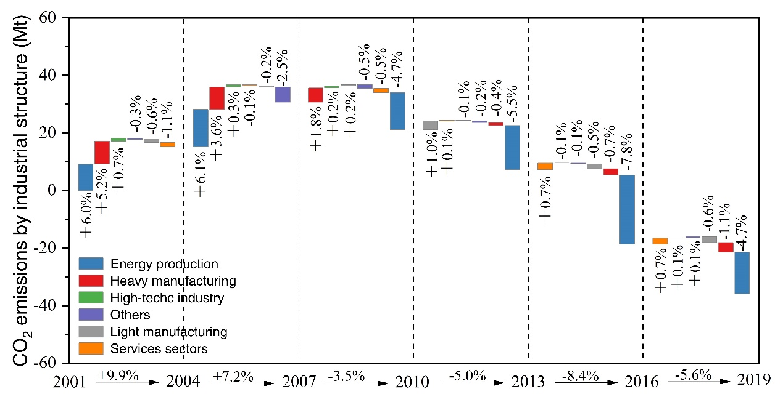
Figure S1 Contributions of industrial structure to CO₂ emissions in the GBA from 2000 to 2019.

