Supplementary file for
Stock Volatility Increases the Mortality Risk of Major Adverse Cardiovascular Events and Suicide: A Case-Crossover Study of 12 Million Deaths
Ya Gao ^{a,#}, Peng Yin ^{b,#}, Haidong Kan ^{a,c}, Renjie Chen ^{a,c,}*, Maigeng Zhou ^{b,}*
ª School of Public Health & Key Lab of Public Health Safety of the Ministry of Education & National Health Commission (NHC) Key Lab of Health Technology Assessment, Fudan University, Shanghai 200032, China
^{b} National Center for Chronic Noncommunicable Disease Control and Prevention, Chinese Center for Disease Control and Prevention, Beijing 100050, China
^{c} Integrated Research on Disaster Risk (IRDR) International Center of Excellence on Risk Interconnectivity and Governance on Weather/Climate Extremes Impact and Public Health, Fudan University, Shanghai 200438, China

# These authors contributed equally to this work.

* Corresponding authors.
E-mail addresses: zhoumaigeng@ncncd.chinacdc.cn (M. Zhou); chenrenjie@fudan.edu.cn (R. Chen)

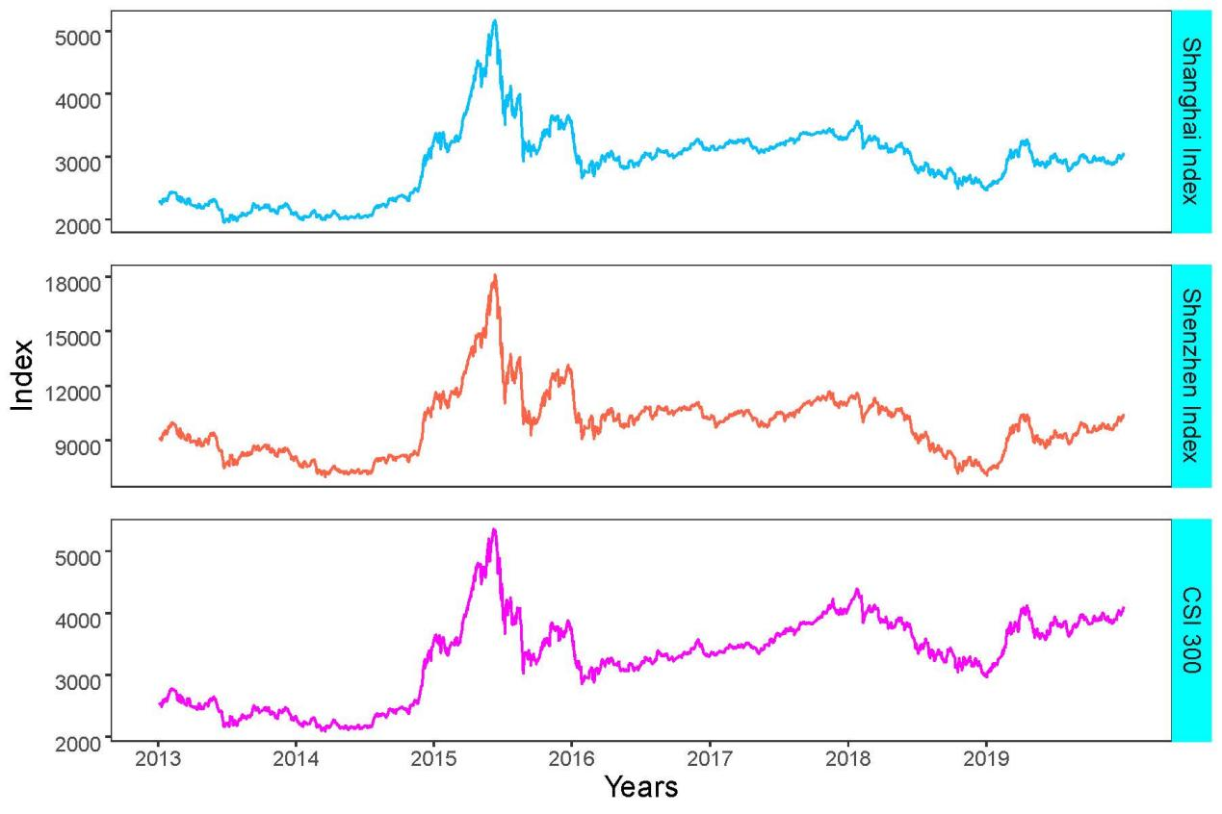
Fig. S1. Daily closing value of Shanghai Index, Shenzhen Index, and CSI 300 for the study period from 2013 to 2019.

Table S1
The summary statistics of the stock and environmental variables used in this study from 2013 to 2019.
Indices | Mean | SD | Min | P (25) | Median | P (75) | Max
Shanghai Indices
Daily stock returns (%) | 0.0 | 1.4 | –8.5 | –0.5 | 0.1 | 0.6 | 5.8
Intra-daily stock oscillations (%) | 1.6 | 1.2 | 0.3 | 0.8 | 1.2 | 1.8 | 10.9
Daily stock opening value | 2893.7 | 568.3 | 1935.5 | 2373.3 | 2969.1 | 3216.0 | 5174.4
ShenzhenIndices
Daily stock returns (%) | 0.0 | 1.7 | –8.2 | –0.7 | 0.0 | 0.8 | 6.5
Intra-daily stock oscillations (%) | 1.9 | 1.3 | 0.3 | 1.0 | 1.5 | 2.2 | 12.3
Daily stock opening value | 9855.3 | 1788.0 | 6973.1 | 8464.1 | 9850.0 | 10722.4 | 18182.6
CSI 300
Daily stock returns (%) | 0.0 | 1.5 | –8.7 | –0.6 | 0.0 | 0.7 | 6.7
Intra-daily stock oscillations (%) | 1.7 | 1.2 | 0.3 | 0.9 | 1.3 | 2.0 | 11.0
Daily stock opening value | 3285.6 | 671.1 | 2079.9 | 2607.5 | 3363.5 | 3794.9 | 5379.5
Air pollutions and weather conditions*
Temperature (°C) | 12.7 | 11.9 | –41.5 | 5.2 | 14.6 | 22.1 | 42.3
Relative humidity (%) | 66.2 | 19.6 | 0.0 | 53.0 | 70.0 | 81.0 | 100.0
PM_{2.5} (μg∙m^{–3}) | 48.5 | 43.5 | 1.0 | 22.3 | 36.8 | 60.2 | 1676.2
PM_{2.5}: particulate matter with aerodynamic diameter ≤ 2.5 μm; SD: standard deviation; P (25): 25th percentile; P (75): 75th percentile.
* Air pollution and weather conditions were matched to the nearest monitoring station based on the residential address of the deceased.

Table S2
The percentage changes in cause-specific mortality risk associated with a 1% increase in daily stock returns for the Shanghai Index, Shenzhen Index, and CSI 300 at lag 0 d, lag 1 d, and lag 2 d.
Index | Lag | AMI (%) |  | Hemorrhagic stroke (%) |  | Ischemic stroke (%) |  | Suicide (%)
Index | Lag | Negative | Positive | Negative | Positive | Negative | Positive | Negative | Positive
Shanghai Index | lag 0 d | 0.63 (0.43, 0.84) | 0.52 (0.33, 0.71) | 0.92 (0.70, 1.13) | 0.81 (0.62, 1.01) | 0.57 (0.31, 0.84) | 0.69 (0.46, 0.91) | 1.45 (0.75, 2.17) | 0.78 (0.10, 1.47)
Shanghai Index | lag 1 d | 0.41 (0.20, 0.63) | 0.43 (0.24, 0.63) | 0.45 (0.21, 0.69) | 0.63 (0.44, 0.83) | 0.59 (0.31, 0.87) | 0.89 (0.66, 1.11) | 0.58 (–0.10, 1.27) | 0.47 (–0.15, 1.09)
Shanghai Index | lag 2 d | 0.23 (0.03, 0.43) | –0.13 (–0.33, 0.07) | 0.16 (–0.05, 0.37) | 0.06 (–0.19, 0.31) | 0.10 (–0.14, 0.33) | –0.11 (–0.35, 0.13) | 0.84 (0.15, 1.54) | 0.46 (–0.23, 1.16)
Shenzhen Index | lag 0 d | 0.25 (0.04, 0.45) | 0.40 (0.25, 0.55) | 0.34 (0.13, 0.56) | 0.59 (0.44, 0.75) | 0.19 (–0.09, 0.47) | 0.49 (0.31, 0.67) | 0.70 (0.15, 1.25) | 0.40 (–0.14, 0.95)
Shenzhen Index | lag 1 d | 0.88 (0.70, 1.05) | 0.75 (0.61, 0.90) | 0.94 (0.75, 1.12) | 0.86 (0.71, 1.02) | 0.85 (0.63, 1.06) | 0.90 (0.73, 1.07) | 0.84 (0.31, 1.37) | 0.59 (0.10, 1.08)
Shenzhen Index | lag 2 d | 0.20 (0.04, 0.37) | 0.05 (–0.16, 0.27) | 0.16 (–0.06, 0.37) | 0.28 (0.11, 0.44) | 0.13 (–0.09, 0.34) | 0.14 (–0.05, 0.32) | 0.29 (–0.24, 0.82) | 0.13 (–0.45, 0.72)
CSI 300 | lag 0 d | 0.80 (0.60, 0.99) | 0.57 (0.41, 0.74) | 1.04 (0.83, 1.25) | 0.85 (0.68, 1.02) | 0.74 (0.49, 0.99) | 0.75 (0.56, 0.95) | 1.77 (1.08, 2.46) | 0.92 (0.29, 1.56)
CSI 300 | lag 1 d | 0.28 (0.07, 0.50) | 0.32 (0.15, 0.49) | 0.35 (0.11, 0.59) | 0.56 (0.38, 0.73) | 0.43 (0.15, 0.71) | 0.67 (0.47, 0.87) | 0.56 (–0.09, 1.22) | 0.36 (–0.26, 0.98)
CSI 300 | lag 2 d | 0.18 (–0.01, 0.38) | 0.02 (–0.35, 0.39) | 0.13 (–0.10, 0.36) | 0.19 (0.01, 0.37) | 0.07 (–0.16, 0.30) | –0.03 (–0.24, 0.18) | 0.82 (0.16, 1.49) | 0.46 (–0.18, 1.10)

Table S3
The percentage changes in cause-specific mortality risk associated with a 1% increase in intra-daily stock oscillations for the Shanghai Index, Shenzhen Index, and CSI 300 at lag 0 d, lag 1 d, and lag 2 d.
Index | Lag | AMI (%) | Hemorrhagic stroke (%) | Ischemic stroke (%) | Suicide (%)
Shanghai Index | lag 0 d | 0.86 (0.64, 1.08) | 0.74 (0.52, 0.97) | 0.83 (0.57, 1.09) | 0.85 (0.13, 1.57)
Shanghai Index | lag 1 d | 0.57 (0.35, 0.79) | 0.19 (–0.03, 0.42) | 0.32 (0.06, 0.58) | –0.02 (–0.75, 0.70)
Shanghai Index | lag 2 d | –0.12 (–0.34, 0.10) | –0.57 (–0.80, –0.34) | –0.09 (–0.35, 0.17) | –0.65 (–1.37, 0.08)
Shenzhen Index | lag 0 d | 0.41 (0.22, 0.60) | 0.29 (0.09, 0.48) | 0.39 (0.17, 0.61) | 0.60 (–0.02, 1.23)
Shenzhen Index | lag 1 d | 0.36 (0.17, 0.55) | 0.10 (–0.10, 0.29) | 0.28 (0.05, 0.50) | –0.16 (–0.78, 0.47)
Shenzhen Index | lag 2 d | –0.18 (–0.37, 0.01) | –0.40 (–0.60, –0.21) | –0.03 (–0.25, 0.19) | –0.52 (–1.15, 0.11)
CSI 300 | lag 0 d | 0.77 (0.56, 0.98) | 0.67 (0.46, 0.89) | 0.69 (0.44, 0.93) | 1.09 (0.40, 1.78)
CSI 300 | lag 1 d | 0.61 (0.39 ,0.82) | 0.29 (0.07, 0.51) | 0.31 (0.06, 0.56) | 0.33 (–0.36, 1.04)
CSI 300 | lag 2 d | –0.09 (–0.31, 0.12) | –0.46 (–0.67, –0.24) | 0.01 (–0.24, 0.26) | –0.32 (–1.02, 0.38)

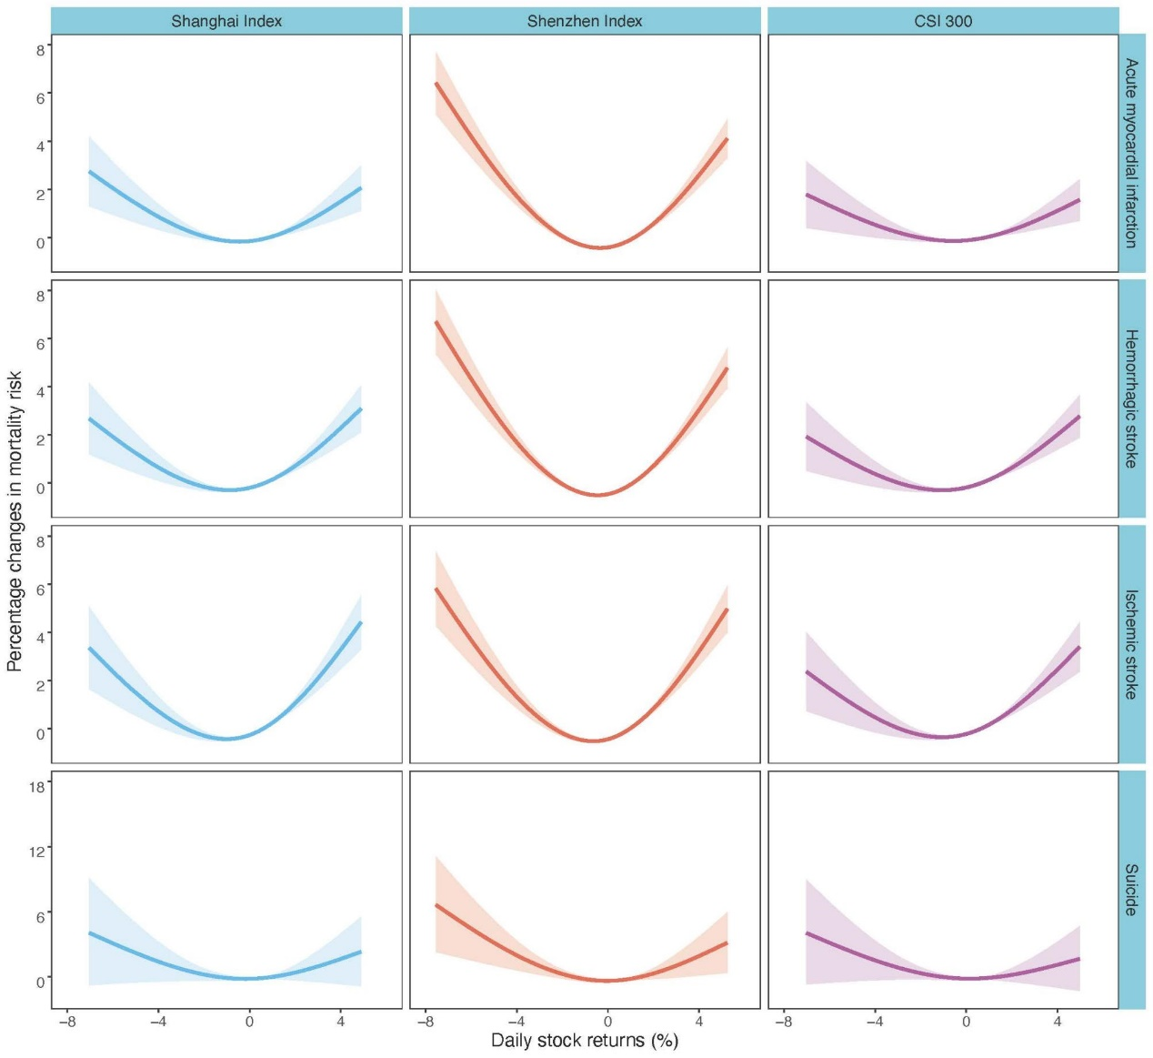
Fig. S2. Exposure-response curves for the association between daily stock returns (%) and mortality from MACEs and suicide at lag 1 d.
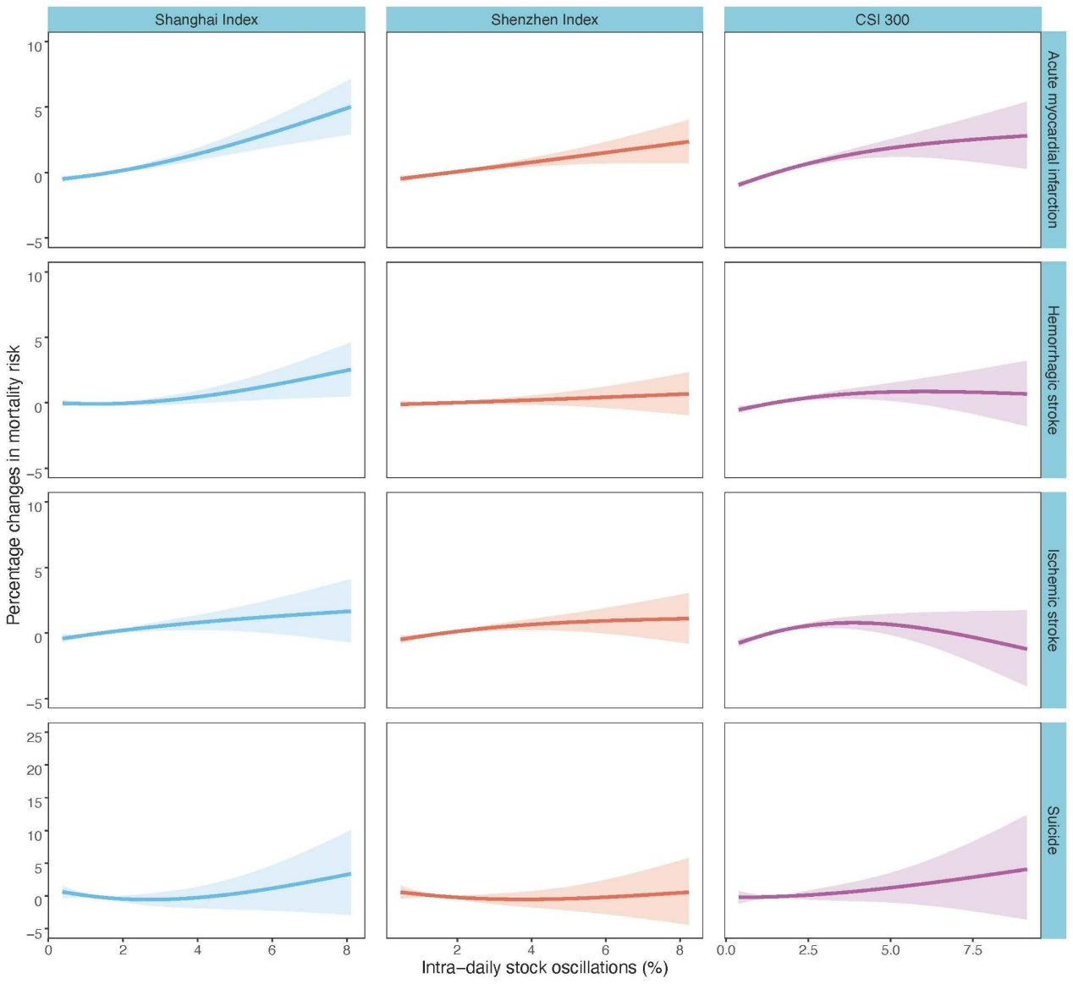
Fig. S3. Exposure-response curves for the association between intra-daily stock oscillations (%) and mortality from MACEs and suicide at lag 1 d.
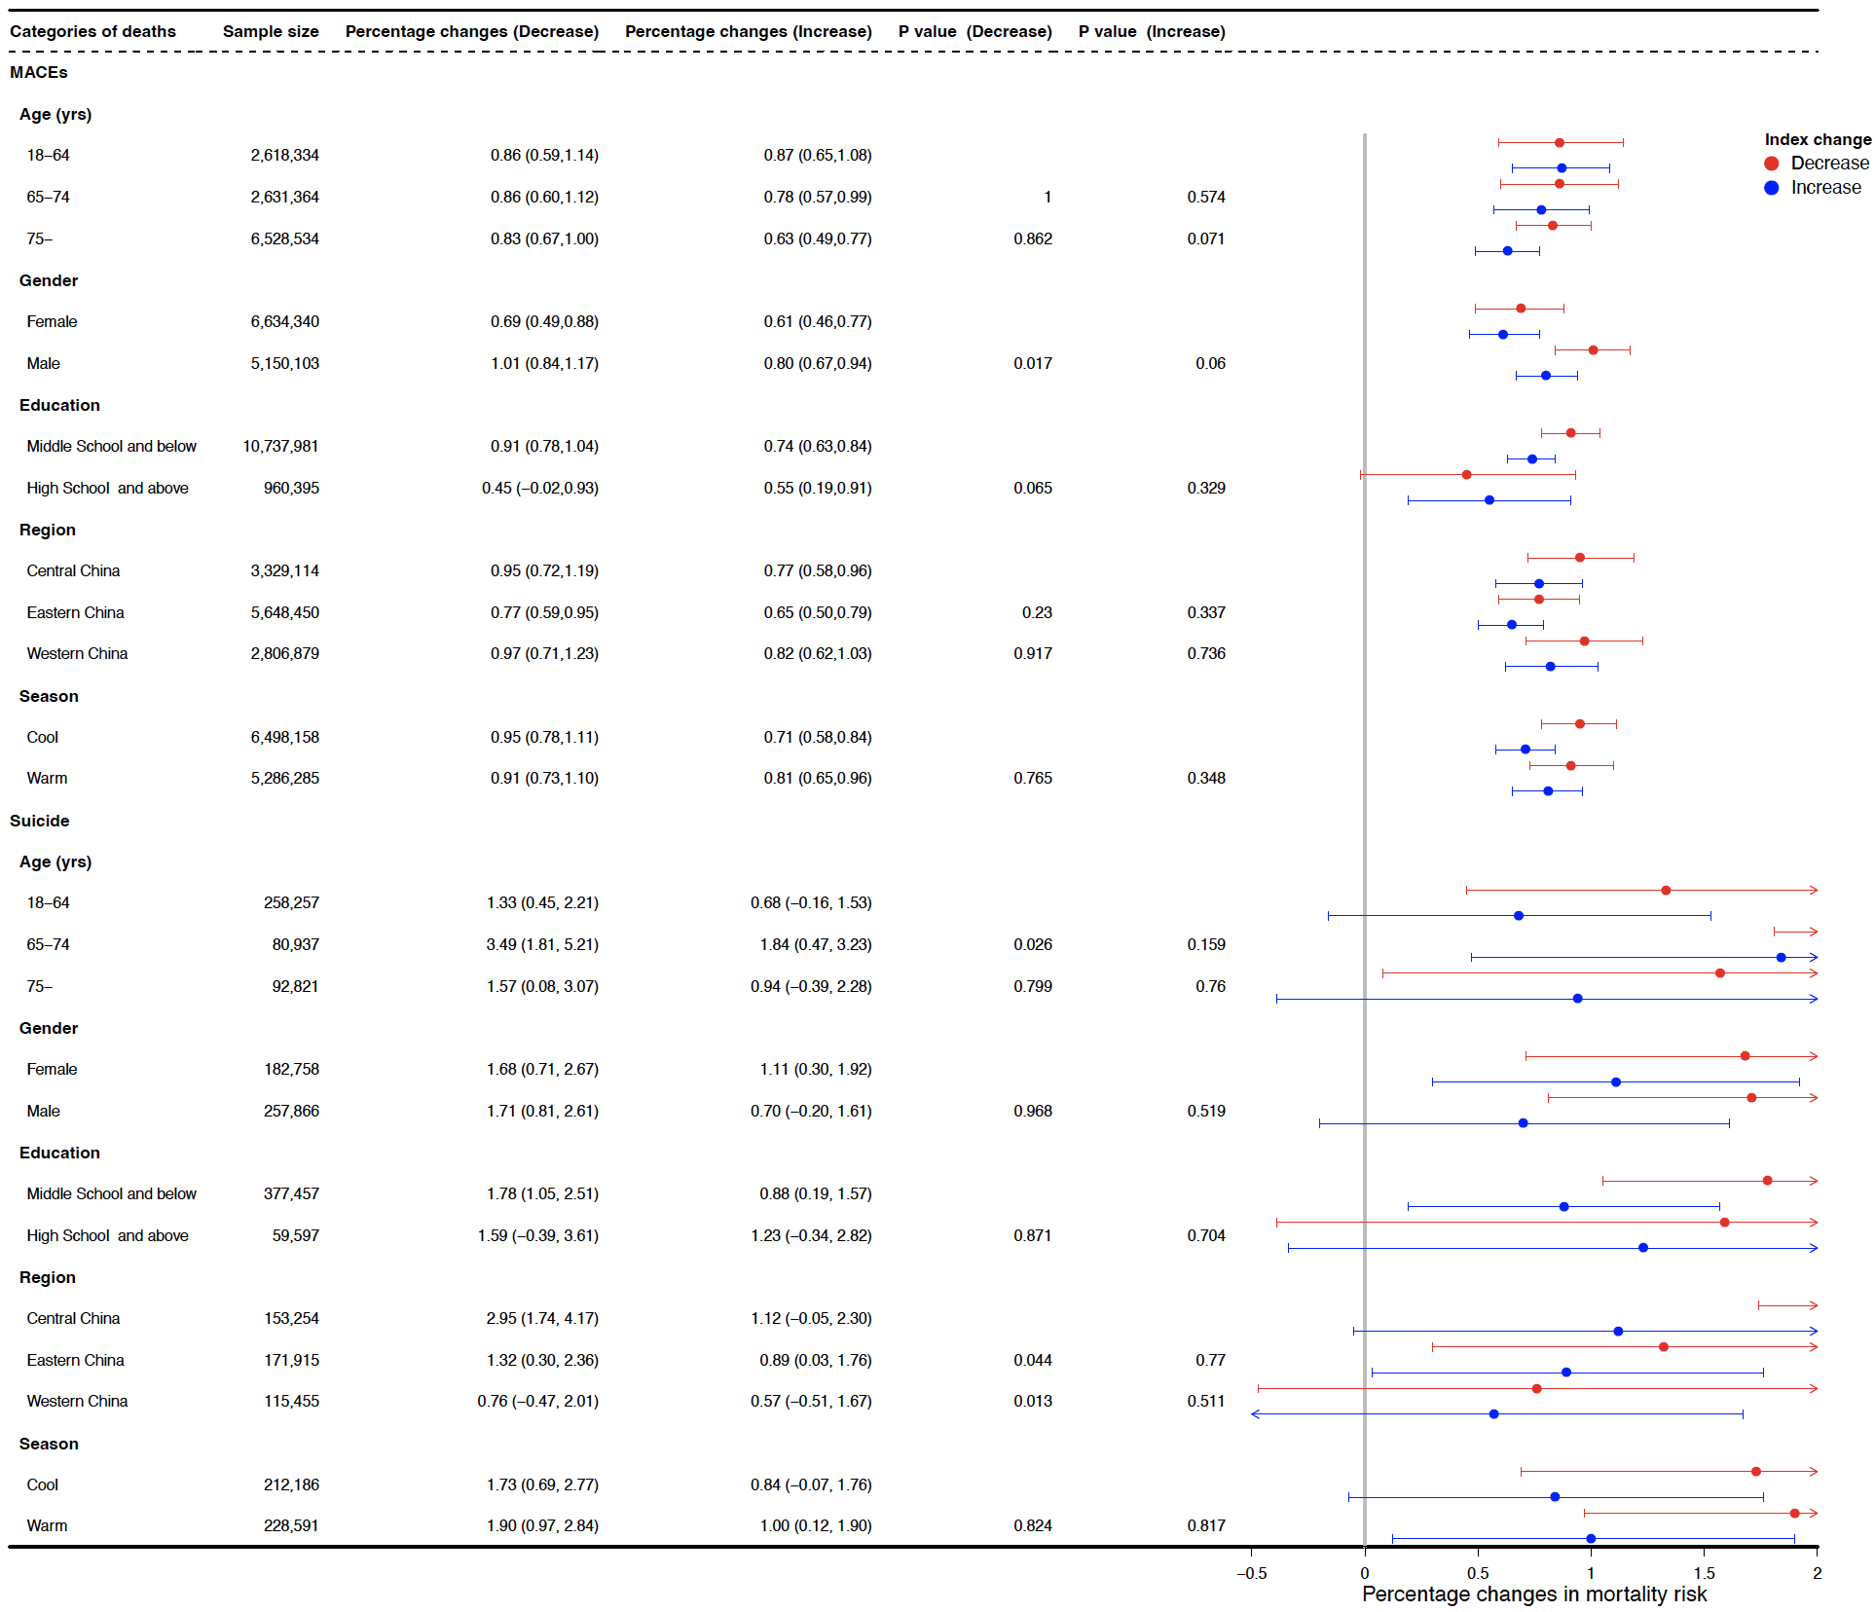
Fig. S4. The percentage changes in mortality risk of MACEs and suicide per 1% increase or decrease in daily stock returns of the CSI 300 at lag 0 d, stratified by age, gender, education level, region, and season.
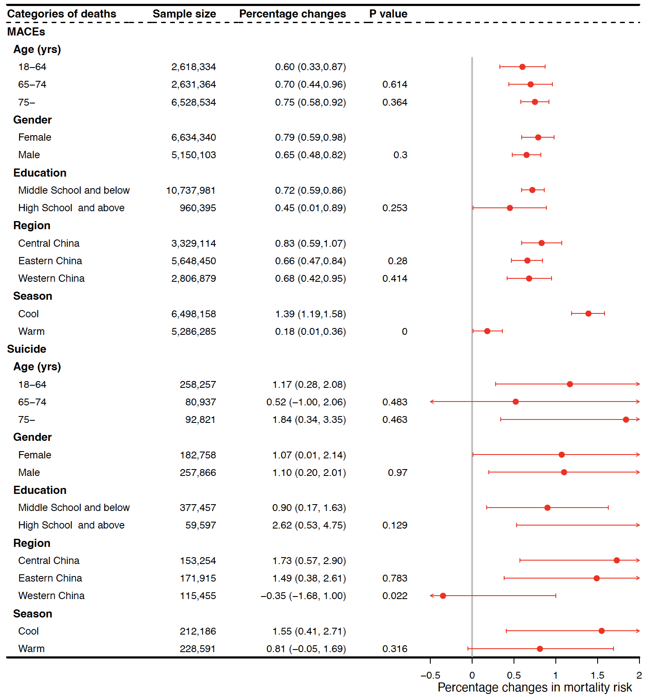
Fig. S5. The percentage changes in mortality risk of MACEs and suicide per 1% increase or decrease in intra-daily stock oscillations of the CSI 300 at lag 0 d, stratified by age, gender, education level, region, and season.

Table S4
The percentage changes in cause-specific mortality risk associated with a 1% increase or decrease in daily stock returns for the Shanghai Index, Shenzhen Index, and CSI 300 at lag 0 d and lag 1 d, adjusting for daily mean PM_{2.5}, temperature, and relative humidity in the model.
Index at lag days | AMI |  | Hemorrhagic stroke |  | Ischemic stroke |  | Suicide
Index at lag days | Negative | Positive | Negative | Positive | Negative | Positive | Negative | Positive
Shanghai Index at lag 0 d | 0.71 (0.49, 0.93) | 0.61 (0.40, 0.81) | 0.88 (0.64, 1.11) | 0.74 (0.53, 0.96) | 0.52 (0.23, 0.81) | 0.66 (0.41, 0.90) | 1.38 (0.65,2.12) | 0.62 (–0.14,1.38)
Shanghai Index at lag 1 d | 0.43 (0.19, 0.67) | 0.54 (0.33, 0.75) | 0.50 (0.24, 0.76) | 0.73 (0.51, 0.95) | 0.73 (0.44, 1.03) | 1.02 (0.78, 1.26) | 0.61 (–0.10,1.32) | 0.27 (–0.51,1.05)
Shenzhen Index at lag 0 d | 0.33 (0.12, 0.53) | 0.44 (0.27, 0.60) | 0.31 (0.09, 0.53) | 0.47 (0.30, 0.64) | 0.15 (–0.15, 0.45) | 0.38 (0.18, 0.58) | 0.62 (0.05,1.18) | 0.25 (–0.38,0.90)
Shenzhen Index at lag 1 d | 0.92 (0.73, 1.11) | 0.83 (0.67, 0.99) | 1.00 (0.80, 1.20) | 0.97 (0.81, 1.13) | 0.99 (0.76, 1.23) | 1.01 (0.82, 1.19) | 0.96 (0.37,1.54) | 0.48 (–0.12,1.09)
CSI 300 at lag 0 d | 0.89 (0.68, 1.10) | 0.63 (0.44, 0.81) | 1.06 (0.83, 1.28) | 0.78 (0.59, 0.97) | 0.71 (0.44, 0.98) | 0.71 (0.50, 0.93) | 1.62 (0.91,2.34) | 0.72 (0.01,1.44)
CSI 300 at lag 1 d | 0.33 (0.09, 0.57) | 0.45 (0.25, 0.64) | 0.45 (0.18, 0.71) | 0.71 (0.52, 0.91) | 0.62 (0.33, 0.91) | 0.83 (0.61, 1.05) | 0.60 (–0.08,1.28) | 0.20 (–0.60,1.01)

Table S5
The percentage changes in cause-specific mortality risk associated with a 1% increase in intra-daily stock oscillations for the Shanghai Index, Shenzhen Index, and CSI 300 at lag 0 d and lag 1 d, with adjusting for daily mean PM_{2.5}, temperature, and relative humidity in the model.
Index at lag days | AMI | Hemorrhagic stroke | Ischemic stroke | Suicide
Shanghai Index at lag 0 d | 0.63 (0.39, 0.88) | 0.55 (0.30, 0.80) | 0.57 (0.29, 0.86) | 0.87 (0.11, 1.63)
Shanghai Index at lag 1 d | 0.51 (0.26, 0.75) | 0.17 (–0.08, 0.42) | 0.11 (–0.17, 0.40) | 0.05 (–0.71, 0.82)
Shenzhen Index at lag 0 d | 0.26 (0.05, 0.47) | 0.19 (–0.02, 0.41) | 0.23 (–0.02, 0.47) | 0.68 (0.03, 1.35)
Shenzhen Index at lag 1 d | 0.33 (0.12, 0.54) | 0.14 (–0.07, 0.35) | 0.15 (–0.10, 0.39) | –0.19 (–0.84, 0.47)
CSI 300 at lag 0 d | 0.60 (0.37, 0.84) | 0.53 (0.29, 0.77) | 0.52 (0.24, 0.79) | 1.12 (0.39, 1.85)
CSI 300 at lag 1 d | 0.57 (0.34, 0.81) | 0.29 (0.05, 0.53) | 0.12 (–0.15, 0.40) | 0.49 (–0.25, 1.23)

Table S6
The percentage changes in risk of death due to suicide and undetermined intent associated with a 1% increase in intra-daily stock oscillations for the Shanghai Index, Shenzhen Index, and CSI 300 at lag 0 d and lag 1 d.
Index at lag days | Daily stock returns |  | Intra-daily stock oscillations
Index at lag days | Negative | Positive | Intra-daily stock oscillations
Shanghai Index at lag 0 d | 1.43 (0.77, 2.10) | 0.70 (0.04, 1.37) | 0.72 (0.04, 1.40)
Shanghai Index at lag 1 d | 0.50 (–0.19, 1.20) | 0.57 (–0.01, 1.16) | 0.04 (–0.65, 0.73)
Shenzhen Index at lag 0 d | 0.71 (0.19, 1.23) | 0.36 (–0.17, 0.90) | 0.50 (–0.09, 1.10)
Shenzhen Index at lag 1 d | 0.75 (0.23, 1.27) | 0.62 (0.16, 1.09) | –0.10 (–0.68, 0.49)
CSI 300 at lag 0 d | 1.70 (1.05, 2.35) | 0.81 (0.19, 1.43) | 0.94 (0.29, 1.59)
CSI 300 at lag 1 d | 0.44 (–0.20, 1.08) | 0.43 (–0.11, 0.98) | 0.32 (–0.34, 0.98)
This sensitivity analysis considers death cases classified under the ICD10 codes X60–X84, Y10–Y34, and Y87.0.

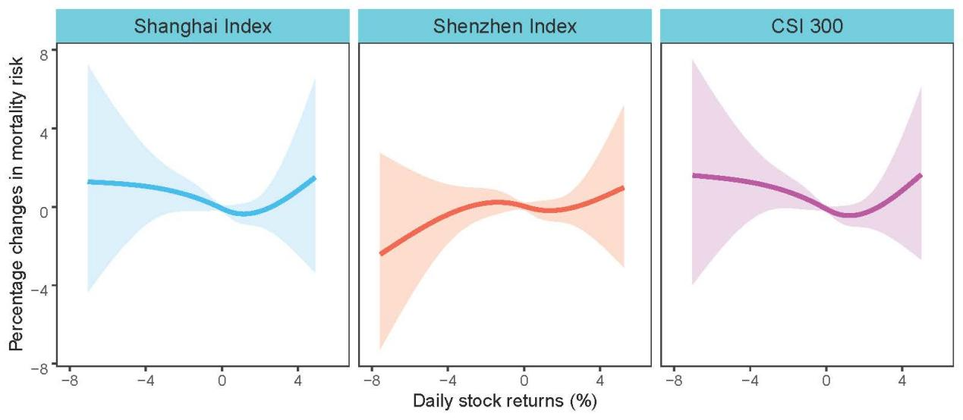
Fig. S6. Exposure-response curves for the association between daily stock returns (%) and mortality from myocardial disease and rheumatic heart disease at lag 0 d. This analysis was used as a negative control.
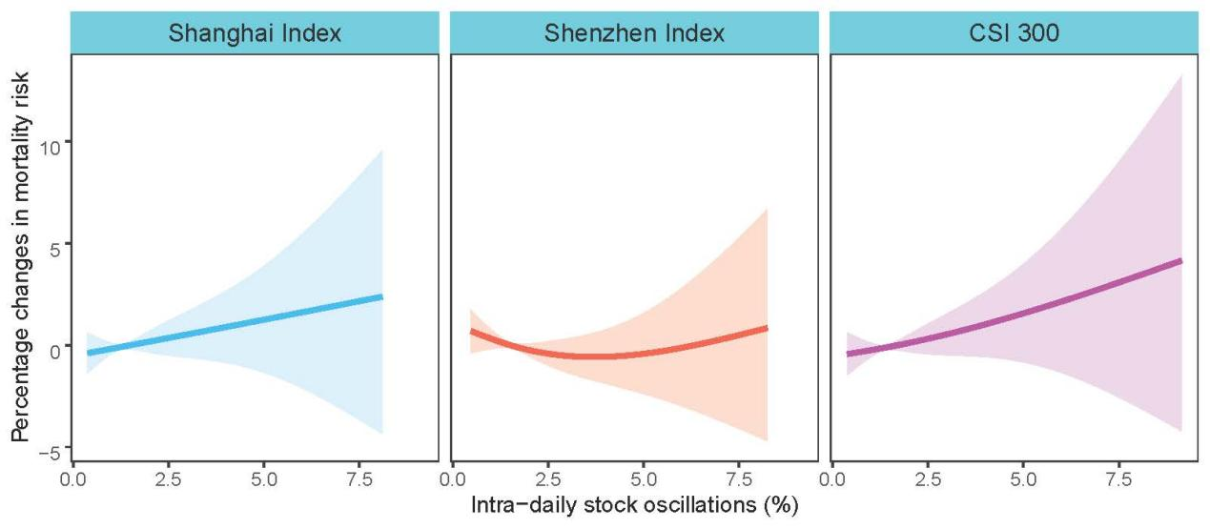
Fig. S7. Exposure-response curves for the association between intra-daily stock oscillations (%) and mortality from myocardial disease and rheumatic heart disease at lag 0 d. This analysis was used as a negative control.

