Supplementary data for

EEG Opto-Processor: Epileptic Seizure Detection Using Diffractive Photonic Computing Units
Tao Yan ^{a,c}, Maoqi Zhang ^{b,d}, Hang Chen ^{b}, Sen Wan ^{a,c,e}, Kaifeng Shang ^{a,c}, Haiou Zhang ^{b}, Xun Cao ^{d}, Xing Lin ^{b,c,e,}*, Qionghai Dai ^{a,c,e,}*

ª Department of Automation, Tsinghua University, Beijing 100084, China
^{b} Department of Electronic Engineering, Tsinghua University, Beijing 100084, China
^{c} Institute for Brain and Cognitive Sciences, Tsinghua University, Beijing 100084, China
^{d} School of Electronic Science and Engineering, Nanjing University, Nanjing 210023, China
^{e} Beijing National Research Center for Information Science and Technology, Tsinghua University, Beijing 100084, China

* Corresponding authors.
E-mail addresses: lin-x@tsinghua.edu.cn (X. Lin), daiqh@tsinghua.edu.cn (Q. Dai).

- The free-space propagation operator
Following the angular spectrum approach, the free-space propagation operator $P_{d}$ can be formulated as:
$$\begin{aligned}u\left(x,y,d\right)=P_{d}\left\{u\left(x,y,0\right)\right\}=F^{-1}\left\{F\left\{u\left(x,y,0\right)\right\}∙H\left(f_{x},f_{y},d\right)\right\},\#\left(S1\right)\end{aligned}$$
where $u\left(x,y,d\right)$ represents the optical field at the distance of $d$, $F$ and $F^{-1}$ are Fourier transform and the inverse Fourier transform, and $H\left(f_{x},f_{y},d\right)$ is the transfer function:
$$\begin{aligned}H\left(f_{x},f_{y},d\right)=\left\{\begin{aligned}exp\left\{jkd\sqrt{1-{\left(λf_{x}\right)}^{2}-{\left(λf_{y}\right)}^{2}}\right\}, f_{x}^{2}+f_{y}^{2}<\frac{1}{λ^{2}} \\ 0, f_{x}^{2}+f_{y}^{2}≥\frac{1}{λ^{2}}\end{aligned}\right.,\#\left(S2\right)\end{aligned}$$
where $λ$ is the wavelength and $k=\frac{2π}{λ}$. $f_{x}$ and $f_{y}$ are the spatial frequencies.

- The evaluation metrics
Some definitions are as follows: (1) True positive (TP): Sick people correctly identified as sick; (2) False positive (FP): Healthy people incorrectly identified as sick; (3) True negative (TN): Healthy people correctly identified as healthy; (4) False negative (FN): Sick people incorrectly identified as healthy. The accuracy, sensitivity, specificity, and $F_{β}$ score are defined as follows:
$$Accuracy=\frac{TP+TN}{TP+TN+FP+FN},$$
$$Sensitivity=Recall=\frac{TP}{TP+FN},$$
$$Specificity=\frac{TN}{TN+FP},$$
$$F_{β} Score=\left(1+β^{2}\right)\frac{Precision∙Recall}{β^{2}∙Precision+Recall}, with Precision=\frac{TP}{TP+FP}.$$
The accuracy of a classifier is the total number of correct predictions divided by the total number of predictions. This may be good enough for a well-balanced classification but not ideal for the imbalanced classification problem. For example, if 99 non-seizures and 1 seizure are tested and all of them are classified as non-seizures, the accuracy is 99% but the seizure is not detected. Sensitivity is the true positive rate and specificity is the true negative rate. Specifically, if the sensitivity is high then any person who has the disease, such as epileptic seizures, is likely to be classified as positive. On the other hand, if the specificity is high, any person who does not have the disease, such as epileptic non-seizures, is likely to be classified as negative. $F_{β}$ score is a weighted harmonic mean of the precision and recall that is more useful than accuracy, especially when the dataset is imbalanced. We adopt the F2 score, i.e., β=2, to allow the recall to have a larger weight, i.e., focusing more on the identification of epileptic seizures. All of the accuracy, sensitivity, specificity, and $F_{β}$ score are used to evaluate the performance of epileptic seizure detection more comprehensively.
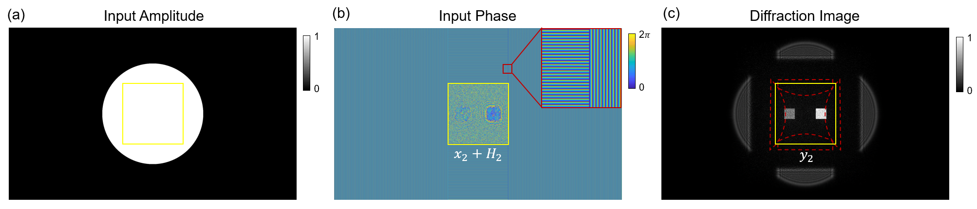
Fig. S1. The blazed grating patterns diffract the incident light outside the region of interest (ROI) away from the optical axis. (a) The circular incident light illuminating the SLM. The yellow box indicates the ROI for diffractive computing. (b) The blazed grating patterns are loaded to the SLM to make the incident light outside the ROI propagate in four oblique directions. The subgraph illustrates the details of the grating patterns in the red box. (c) The light outside the ROI diffracts away from the optical axis and has no interference with the diffraction of the ROI. The area surrounded by the red dotted line indicates the unexpected diffractive orders in the experiments due to the discrete and reflective pixel pads of the SLM.
Fig. S2. Modulation of optical field using diffractive meta-atoms. (a) Schematic of a metaline containing diffractive meta-atoms, an array of 1D rectangular silica slot etched on silicon-on-insulator (SOI) substrate. The thickness of the silicon membrane of SOI is 220 nm, the height of the meta-atom is fixed to 400 nm, and the slot period is 300 nm. (b) The phase and amplitude modulation coefficients of a diffractive meta-atom with respect to the slot width. The results are calculated from a periodic array by FDTD simulations.

Fig. S3. Evaluation of the analytical model accuracy compared with the FDTD simulations. (a) The analytical optical field propagation details of the integrated DPU in Fig. 6(a). (b) Comparisons of the optical field intensity at the position of L1 and L2 between the analytical model and FDTD simulations. (c) The phase modulation coefficients of the metaline (the part in the red box of (a)) obtained by the FDTD simulations (blue plot) with comparisons to the analytical model (orange plot). The analytical model sufficiently matches the FDTD simulation.

Fig. S4. Statistical evaluations for epileptic seizure detection with D²NNs constructed by the free-space DPU under different layer numbers. (a) Performance of 1-channel EEG signals. The average accuracy, sensitivity, specificity, and F2 score are 97.89%, 91.92%, 98.13%, and 0.8553, respectively, for the 2-layer D²NN, and 97.84%, 92.62%, 98.05%, and 0.8561 respectively for the 3-layer model. (b) Performance of 1-channel iEEG signals. The average accuracy, sensitivity, specificity, and F2 score are 90.93%, 92.50%, 90.38%, and 0.9132, respectively, for the 2-layer D²NN, and 91.69%, 93.94%, 90.55%, and 0.9254, respectively, for the 3-layer model. The results demonstrate the sufficient performance of using the 2-layer model.
Fig. S5. Supplementary numerical evaluations of epileptic seizure detection with the free-space DPU on EEG signals under different channel numbers. (a) The box diagrams of the sensitivity metric. Rand-D²NN, RF-D²NN, and RF-RF denote selecting channels randomly and classifying with a D²NN, selecting channels with a random forest and classifying with a D²NN, and selecting channels and classifying simultaneously with a random forest, respectively. (b) The box diagrams of the specificity metric. The average sensitivity and specificity of 1-channel RF-D²NN are 91.92% and 98.13%, respectively. Notice that the full-channel RF-D²NN has a sensitivity of 94.32% and a specificity of 99.14%. The full-channel RF-RF has a sensitivity of 97.45% and a specificity of 98.93%.

Fig. S6. Generalization abilities of epileptic seizure detection based on the free-space DPU using 1-channel EEG and iEEG signals. (a) Training with the first 4 patients and testing on another 4 patients from the CHB-MIT dataset. The average accuracy, sensitivity, specificity, and F2 score are 96.36%, 93.98%, 96.46%, and 0.8185, respectively, for the known patients and 92.41%, 87.96%, 92.59%, and 0.6618, respectively, for the new patients. (b) Training with the first 3 patients and testing on another 3 patients from the Epilepsy-iEEG-Multicenter-Dataset. The average accuracy, sensitivity, specificity, and F2 score are 83.97%, 86.65%, 87.58%, and 0.8647, respectively, for the known patients, and 86.09%, 84.36%, 88.86%, and 0.8528, respectively, for the new patients.

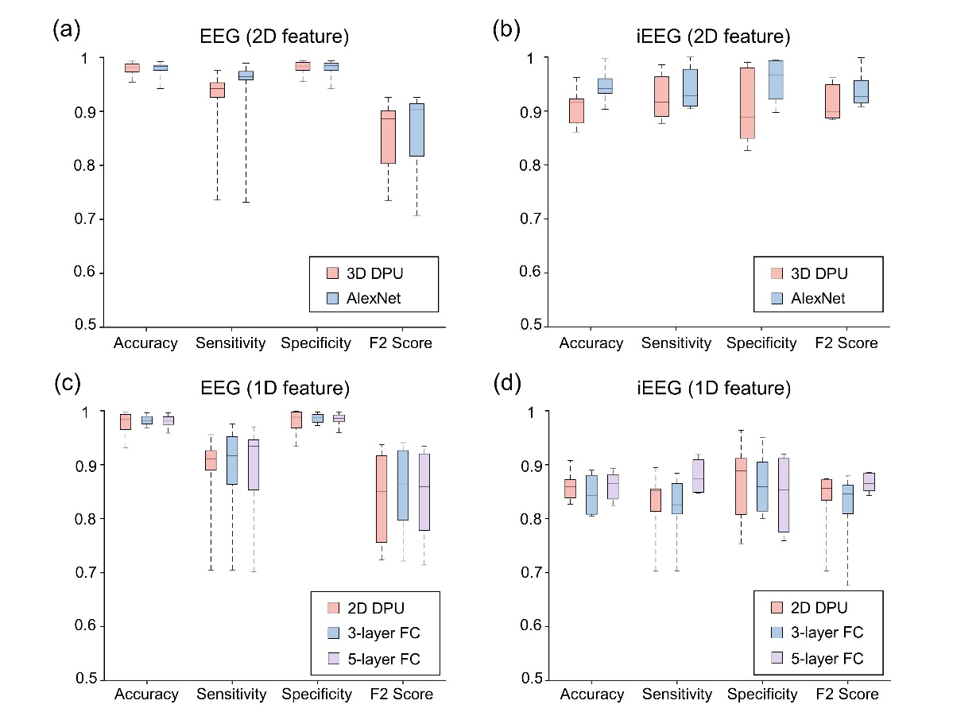
Fig. S7. Performance comparisons between DPU and SOTA electronic neural networks for epileptic seizure detection. (a) and (b), Performance of the 2-layer D2NN constructed with the 3D free-space DPU and the SOTA convolutional neural network AlexNet [1] using 2D features of single-channel EEG and iEEG signals. (c) and (d), Performance of the 2D integrated DPU and the 3-layer and 5-layer fully connected neural networks (3-layer FC, 5-layer FC) using 1D features of single-channel EEG and iEEG signals. The 3-layer FC contains 64 and 16 neurons in the two hidden layers. The 5-layer FC contains 64, 128, 64, and 16 neurons in the four hidden layers. Both of them have 2 output neurons and ReLU activation functions.

Table S1
Supplementary information about the patients selected from the CHB-MIT dataset and Epilepsy-iEEG-Multicenter-Dataset.
Dataset | Patient | Gender | Age | Seizure Number | Total Seizure Time (s) | Sampling Frequency (Hz) |  | Total Channel Number
CHB-MIT | chb01 | F | 11 | 7 | 442 |  | 256 | 23
CHB-MIT | chb03 | F | 14 | 7 | 402 |  | 256 | 23
CHB-MIT | chb05 | F | 7 | 5 | 558 |  | 256 | 23
CHB-MIT | chb08 | M | 3.5 | 5 | 919 |  | 256 | 23
CHB-MIT | chb10 | M | 3 | 7 | 447 |  | 256 | 23
CHB-MIT | chb11 | F | 12 | 3 | 806 |  | 256 | 23
CHB-MIT | chb23 | F | 6 | 7 | 424 |  | 256 | 23
CHB-MIT | chb24 | Unknown | Unknown | 16 | 511 |  | 256 | 23
Epilepsy-iEEG-Multicenter-Dataset | jh101 | Unknown | Unknown | 4 | 273 |  | 1000 | 135
Epilepsy-iEEG-Multicenter-Dataset | jh102 | Unknown | Unknown | 5 | 626 |  | 1000 | 123
Epilepsy-iEEG-Multicenter-Dataset | ummc002 | M | 4 | 3 | 437 |  | 500 | 129
Epilepsy-iEEG-Multicenter-Dataset | ummc003 | M | Unknown | 3 | 332 |  | 250 | 129
Epilepsy-iEEG-Multicenter-Dataset | ummc004 | M | 30 | 3 | 368 |  | 250 | 129
Epilepsy-iEEG-Multicenter-Dataset | ummc007 | M | Unknown | 3 | 543 |  | 1000 | 129

Table S2.
Epileptic seizure detection results of the 2-layer D²NN constructed with the free-space DPU using the single-channel EEG and iEEG signals.
Dataset | Patient |  | Simulation Results |  |  |  | Experiment Results
Dataset |  |  | Accuracy | Sensitivity | Specificity | F2 score | Accuracy | Sensitivity | Specificity | F2 score
CHB-MIT |  | chb01 | 0.9903 | 0.9463 | 0.9919 | 0.9131 | 0.9919 | 0.9339 | 0.9939 | 0.9135
 |  | chb03 | 0.9931 | 0.9554 | 0.9941 | 0.9261 | 0.9890 | 0.9554 | 0.9900 | 0.9010
 |  | chb05 | 0.9846 | 0.9380 | 0.9864 | 0.8845 | 0.9624 | 0.9574 | 0.9626 | 0.8035
 |  | chb08 | 0.9716 | 0.9145 | 0.9755 | 0.8682 | 0.9590 | 0.9679 | 0.9584 | 0.8691
 |  | chb10 | 0.9814 | 0.9757 | 0.9816 | 0.8873 | 0.9443 | 0.9393 | 0.9444 | 0.7209
 |  | chb11 | 0.9750 | 0.9507 | 0.9764 | 0.8894 | 0.9678 | 0.9483 | 0.9690 | 0.8671
 |  | chb23 | 0.9543 | 0.9375 | 0.9548 | 0.7384 | 0.9355 | 0.9241 | 0.9359 | 0.6669
 |  | chb24 | 0.9807 | 0.7356 | 0.9599 | 0.7351 | 0.9731 | 0.7318 | 0.9822 | 0.7027
Epilepsy-iEEG-Multicenter-Dataset |  | jh101 | 0.8778 | 0.9640 | 0.8496 | 0.8872 | 0.8148 | 0.9369 | 0.7759 | 0.8307
 |  | jh102 | 0.9108 | 0.8907 | 0.9229 | 0.8873 | 0.8888 | 0.8167 | 0.9314 | 0.8279
 |  | ummc002 | 0.9212 | 0.8904 | 0.9902 | 0.9095 | 0.9182 | 0.8947 | 0.9706 | 0.9115
 |  | ummc003 | 0.9622 | 0.9422 | 0.9797 | 0.9488 | 0.9229 | 0.9191 | 0.9261 | 0.9180
 |  | ummc004 | 0.9225 | 0.9856 | 0.8534 | 0.9617 | 0.8837 | 0.9522 | 0.8103 | 0.9282
 |  | ummc007 | 0.8612 | 0.8772 | 0.8269 | 0.8847 | 0.8224 | 0.8204 | 0.8269 | 0.8369

Table S3
Epileptic seizure detection results of the integrated DPU using single-channel EEG/iEEG signals and comparisons with fully connected neural networks (FC).
Dataset | Patient | DPU w/ bias |  |  |  | DPU w/o bias
Dataset | Patient | Accuracy | Sensitivity | Specificity | F2 score | Accuracy | Sensitivity | Specificity | F2 score
CHB-MIT | chb01 | 0.9952 | 0.9215 | 0.9977 | 0.9238 | 0.7990 | 0.7149 | 0.8019 | 0.3422
CHB-MIT | chb03 | 0.9971 | 0.9307 | 0.9990 | 0.9372 | 0.8878 | 0.8960 | 0.8876 | 0.5096
CHB-MIT | chb05 | 0.9912 | 0.9147 | 0.9941 | 0.9015 | 0.9283 | 0.8566 | 0.9310 | 0.6391
CHB-MIT | chb08 | 0.9320 | 0.9060 | 0.9338 | 0.7729 | 0.9176 | 0.8013 | 0.9256 | 0.6821
CHB-MIT | chb10 | 0.9745 | 0.8826 | 0.9777 | 0.8002 | 0.9626 | 0.8300 | 0.9673 | 0.7208
CHB-MIT | chb11 | 0.9806 | 0.9557 | 0.9821 | 0.9091 | 0.8878 | 0.8960 | 0.8876 | 0.5096
CHB-MIT | chb23 | 0.9565 | 0.8973 | 0.9584 | 0.7241 | 0.8016 | 0.6741 | 0.8057 | 0.3137
CHB-MIT | chb24 | 0.9871 | 0.7050 | 0.9977 | 0.7395 | 0.9443 | 0.4598 | 0.9624 | 0.4211
Epilepsy-iEEG-Multicenter-Dataset | jh101 | 0.8562 | 0.7027 | 0.9052 | 0.7027 | 0.7146 | 0.6486 | 0.7356 | 0.5921
Epilepsy-iEEG-Multicenter-Dataset | jh102 | 0.9079 | 0.8135 | 0.9638 | 0.8344 | 0.8050 | 0.7460 | 0.8400 | 0.7436
Epilepsy-iEEG-Multicenter-Dataset | ummc002 | 0.8727 | 0.8553 | 0.9118 | 0.8737 | 0.8667 | 0.8421 | 0.9216 | 0.8633
Epilepsy-iEEG-Multicenter-Dataset | ummc003 | 0.8617 | 0.8497 | 0.8719 | 0.8497 | 0.8883 | 0.8671 | 0.9064 | 0.8711
Epilepsy-iEEG-Multicenter-Dataset | ummc004 | 0.8267 | 0.8947 | 0.7538 | 0.8730 | 0.8020 | 0.7560 | 0.8513 | 0.7722
Epilepsy-iEEG-Multicenter-Dataset | ummc007 | 0.8388 | 0.8533 | 0.8077 | 0.8631 | 0.7592 | 0.7275 | 0.8269 | 0.7565
Dataset | Patient | 3-layer FC |  |  |  | 5-layer FC
Dataset | Patient | Accuracy | Sensitivity | Specificity | F2 score | Accuracy | Sensitivity | Specificity | F2 score
CHB-MIT | chb01 | 0.9924 | 0.9545 | 0.9937 | 0.9292 | 0.9914 | 0.9545 | 0.9927 | 0.9240
CHB-MIT | chb03 | 0.9962 | 0.9455 | 0.9977 | 0.9409 | 0.9963 | 0.9356 | 0.9980 | 0.9347
CHB-MIT | chb05 | 0.9867 | 0.9496 | 0.9881 | 0.9014 | 0.9864 | 0.9380 | 0.9883 | 0.8930
CHB-MIT | chb08 | 0.9687 | 0.8611 | 0.9761 | 0.8272 | 0.9701 | 0.8526 | 0.9782 | 0.8251
CHB-MIT | chb10 | 0.9814 | 0.8664 | 0.9854 | 0.8205 | 0.9794 | 0.8543 | 0.9839 | 0.8041
CHB-MIT | chb11 | 0.9813 | 0.9754 | 0.9816 | 0.9231 | 0.9802 | 0.9704 | 0.9807 | 0.9167
CHB-MIT | chb23 | 0.9701 | 0.8884 | 0.9727 | 0.7737 | 0.9587 | 0.9330 | 0.9596 | 0.7529
CHB-MIT | chb24 | 0.9828 | 0.7050 | 0.9932 | 0.7216 | 0.9816 | 0.7011 | 0.9922 | 0.7143
Epilepsy-iEEG-Multicenter-Dataset | jh101 | 0.8083 | 0.7027 | 0.8420 | 0.6759 | 0.8518 | 0.9189 | 0.8304 | 0.8430
Epilepsy-iEEG-Multicenter-Dataset | jh102 | 0.8900 | 0.8650 | 0.9048 | 0.8605 | 0.8935 | 0.8489 | 0.9200 | 0.8516
Epilepsy-iEEG-Multicenter-Dataset | ummc002 | 0.8727 | 0.8377 | 0.9510 | 0.8619 | 0.8818 | 0.8684 | 0.9118 | 0.8847
Epilepsy-iEEG-Multicenter-Dataset | ummc003 | 0.8803 | 0.8844 | 0.8768 | 0.8793 | 0.8777 | 0.8786 | 0.8768 | 0.8746
Epilepsy-iEEG-Multicenter-Dataset | ummc004 | 0.8044 | 0.8086 | 0.8000 | 0.8094 | 0.8366 | 0.9091 | 0.7590 | 0.8854
Epilepsy-iEEG-Multicenter-Dataset | ummc007 | 0.8143 | 0.8144 | 0.8141 | 0.8308 | 0.8245 | 0.8473 | 0.7756 | 0.8555

Table S4
Computing speed and energy efficiency of the proposed DPU and the comparison with GPU processor.
Methods | Computing Speed | Power Consumption | Energy Efficiency
3D DPU | 1.38 TOPS  (maximum 264.06 TOPS) | 83.15 W | 0.02 TOPS/W  (maximum 3.17 TOPS/W)
2D DPU | 1.92 TOPS | 290 mW | 6.62 TOPS/W
GPU Tesla V100 ª | 125 TOPS | 300 W | - TOPS/W
ª https://www.nvidia.com/en-gb/data-center/tesla-v100/

