Supplementary data for
Characterization of the Gastric Mucosal Microbiota in Patients with Liver Cirrhosis and Its Associations with Gastrointestinal Symptoms
Yanfei Chen ª, Jing Guo ª, Chunlei Chen ª, Ding Shi ª, Daiqiong Fang ª, Feng Ji ^{b,}*, Lanjuan Li ^{a,}*
ª State Key Laboratory for Diagnosis and Treatment of Infectious Disease, Collaborative Innovation Center for Diagnosis and Treatment of Infectious Diseases, National Clinical Research Center for Infectious Disease, The First Affiliated Hospital, Zhejiang University, Hangzhou 310003, China
^{b} Department of Gastroenterology, The First Affiliated Hospital, Zhejiang University, Hangzhou 310003, China

Table S1
Clinical and endoscopic findings of patients with liver cirrhosis.
Patient ID | Cluster | PAGI-SYM score | Gender | Age | Child class | Previous bleeding | Propanolol use | EV | GV | Previous endoscopic treatment | Portal hypertensive gastropathy | Erosive gastritis | Atrophy gastritis | Gastric ulcer | Duodenum ulcer
G_1 | C1 | 9 | M | 60 | A | Y | Y | 1 | 2 | Tissue adhesive
G_12 | C1 | 4 | M | 49 | A | Y | N | 3 | 2 | EVL | 1
G_16 | C1 | 7 | M | 47 | B | Y | N | 1 | 0
G_28 | C1 | 14 | M | 50 | A | Y | N | 3 | 3 |  | 1
G_30 | C1 | 10 | M | 60 | A | N | Y | 0 | 1 | Tissue adhesive |  |  | 1
G_38 | C1 | 1 | M | 37 | A | N | N | 0 | 1 |  | 1
G_68 | C1 | 2 | F | 50 | A | N | N | 3 | 0
G_7 | C1 | 3 | M | 43 | A | Y | N | 2 | 0 | EVL | 1
G_11 | C2 | 3 | M | 41 | A | Y | N | 1 | 0 | EVL |  |  |  | 1
G_15 | C2 | 13 | M | 54 | A | Y | N | 3 | 3 |  | 1
G_17 | C2 | 9 | M | 56 | A | Y | N | 0 | 3 |  |  | 1 |  |  | 1
G_20 | C2 | 5 | M | 47 | A | Y | N | 2 | 0 | EVL | 1
G_21 | C2 | 6 | F | 54 | A | Y | Y | 2 | 0 | EVL | 1
G_23 | C2 | 17 | F | 49 | A | N | Y | 1 | 0 | EVL
G_27 | C2 | 11 | M | 40 | A | N | N | 3 | 0 |  | 1
G_44 | C2 | 16 | M | 41 | A | Y | N | 2 | 0 | EVL
G_2 | C3 | 0 | M | 59 | A | N | Y | 1 | 0 | EVL |  |  | 1
G_5 | C3 | 9 | F | 54 | B | Y | N | 2 | 0 |  |  | 1
G_6 | C3 | 4 | M | 40 | B | Y | Y | 1 | 0 |  | 1
G_18 | C4 | 0 | M | 39 | A | Y | N | 3 | 0 |  | 1
G_19 | C4 | 3 | M | 43 | A | Y | N | 3 | 0 |  | 1
G_22 | C4 | 7 | M | 50 | C | Y | N | 3 | 0 |  | 1
G_43 | C4 | 10 | M | 53 | A | N | Y | 1 | 0 |  | 1 | 1
G_45 | C4 | 2 | F | 51 | A | Y | Y | 1 | 0 | EVL |  | 1
G_47 | C4 | 9 | F | 58 | A | Y | N | 1 | 2
G_57 | C4 | 12 | M | 39 | A | N | Y | 1 | 0 |  | 1
G_67 | C4 | 2 | F | 51 | A | Y | N | 2 | 0 |  |  |  |  | 1
G_37 | Hp positive | 4.0 | M | 32 | A | N | N | 2 | 2 |  | 1
G_50 | Hp positive | 3.0 | M | 60 | A | N | N | 1 | 0
EVL: endoscopic variceal ligation; GV: grade of gastric varices; EV: grade of esophageal varices.

Table S2
Reads ratio of Helicobacter genus.
Sample ID | Ratio of Helicobacter reads (%) | Histologically H. pylori test
G_1 | 0 | Negative
G_10 | 99.4 | Positive
G_11 | 0.2 | Negative
G_12 | 0 | Negative
G_13 | 7.9 | Negative
G_14 | 99.9 | Positive
G_15 | 0.1 | Negative
G_16 | 0.1 | Negative
G_17 | 0.1 | Negative
G_18 | 0 | Negative
G_19 | 0.1 | Negative
G_2 | 0 | Negative
G_20 | 0.9 | Negative
G_21 | 0.6 | Negative
G_22 | 0.1 | Negative
G_23 | 1.0 | Negative
G_25 | 0 | Negative
G_27 | 0.1 | Negative
G_28 | 5.3 | Negative
G_29 | 0 | Negative
G_3 | 99.4 | Positive
G_30 | 0 | Negative
G_31 | 0 | Negative
G_33 | 5.1 | Negative
G_34 | 98.3 | Positive
G_35 | 0 | Negative
G_37 | 95.4 | Positive
G_38 | 0 | Negative
G_40 | 90.1 | Positive
G_41 | 98.2 | Positive
G_42 | 0 | Negative
G_43 | 0.1 | Negative
G_44 | 0 | Negative
G_45 | 0 | Negative
G_46 | 0 | Negative
G_47 | 0.1 | Negative
G_49 | 0 | Negative
G_5 | 0.1 | Negative
G_50 | 92.8 | Positive
G_51 | 0 | Negative
G_52 | 0 | Negative
G_53 | 0 | Negative
G_54 | 0 | Negative
G_55 | 0 | Negative
G_56 | 0 | Negative
G_57 | 0 | Negative
G_58 | 94.7 | Positive
G_59 | 0.1 | Negative
G_6 | 5.8 | Negative
G_60 | 99.4 | Positive
G_61 | 0 | Negative
G_62 | 8.5 | Negative
G_63 | 0 | Negative
G_64 | 0 | Negative
G_65 | 97.7 | Positive
G_66 | 0 | Negative
G_67 | 0 | Negative
G_68 | 0 | Negative
G_7 | 0.3 | Negative
G_9 | 99.8 | Positive

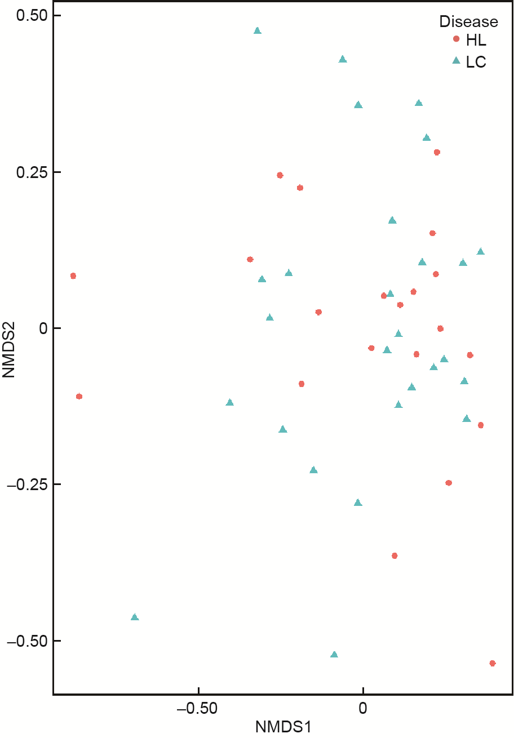
Fig. S1. Non-metric multidimensional scaling (NMDS) analysis of the gastric mucosal microbiota of H. pylori negative subjects did not show a clear separation between healthy controls (HC) and liver cirrhosis (LC).

