Supplementary file for
Lung-Targeted Transgene Expression of Nanocomplexed Ad5 Enhances Immune Response in the Presence of Preexisting Immunity
Yilong Yang #, Shipo Wu #, Yudong Wang, Fangze Shao, Peng Lv, Ruihua Li, Xiaofan Zhao, Jun Zhang, Xiaopeng Zhang, Jianmin Li, Lihua Hou *, Junjie Xu *, Wei Chen *
Beijing Institute of Biotechnology, Beijing 100071, China

Fig. S1. Characterization of (+)HSAnp. Elution profiles of purified (+)HSAnp-4 and native HSA on HPLC.
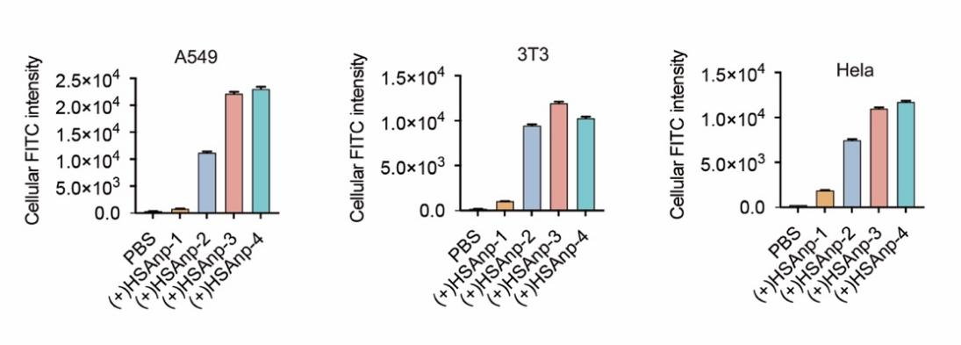
Fig. S2. Cellular delivery of (+)HSAnp. Quantitative analysis of the cellular uptake of FITC-labeled (+)HSAnp in A549, 3T3, and Hela cells. Data are presented as means ± SEM.
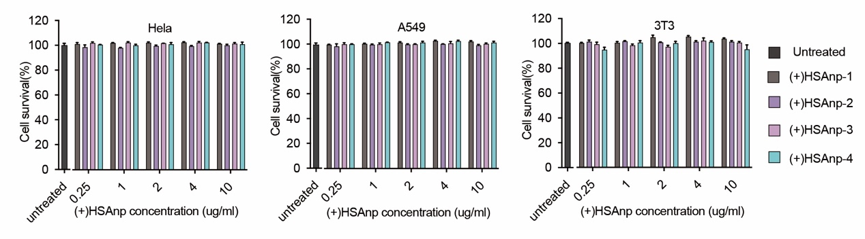
Fig. S3. Cell viability test of (+)HSAnp. Hela, A549, and 3T3 cells were treated with varying concentrations of (+)HSAnp ranging from 0.25 to 10.00 μg·mL^{–1} for 24 h. Cell viability was measured via CCK-8 assay (n = 3). Data are presented as means ± SEM.
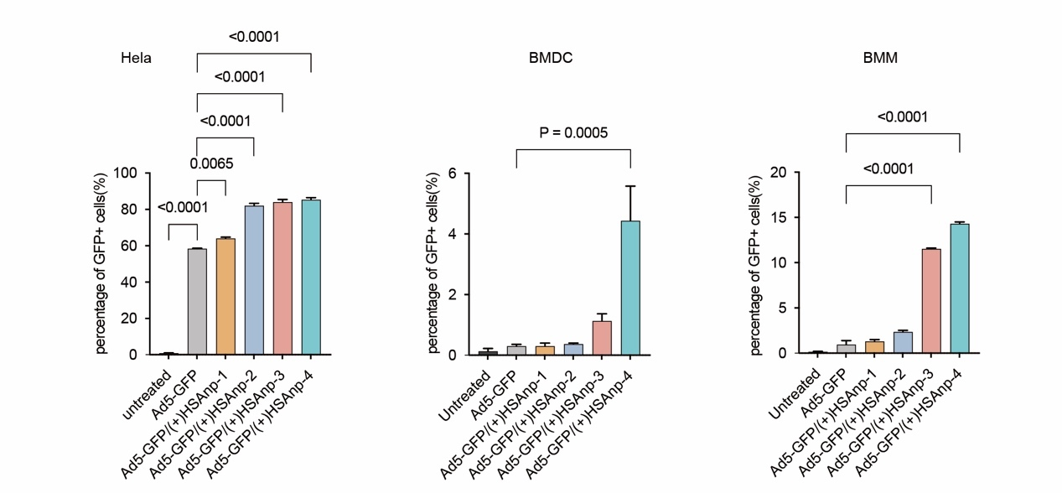
Fig. S4. Enhanced transgene expression of Ad5-GFP in complex with (+)HSAnp. Quantitative analyses of the percentage of GFP-positive cells were measured by means of fluorescence-activated cell sorting (FACS) in Hela cells, BMDCs, and BMMs (n = 3). Cell experiments were performed at a MOI of 10. Data are presented as means ± SEM. Statistical differences were determined using ANOVA with Dunn’s multiple comparison test.
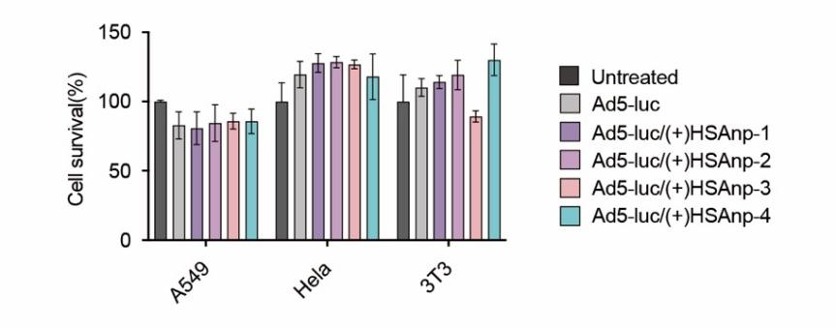
Fig. S5. Cell viability test of Ad5/(+)HSAnp. A549, Hela, and 3T3 cells were treated with Ad5/(+)HSAnp for 24 h. Cell experiments were performed at an MOI of 10. Cell viability was measured via CCK-8 assay (n = 3). Data are presented as means ± SEM.
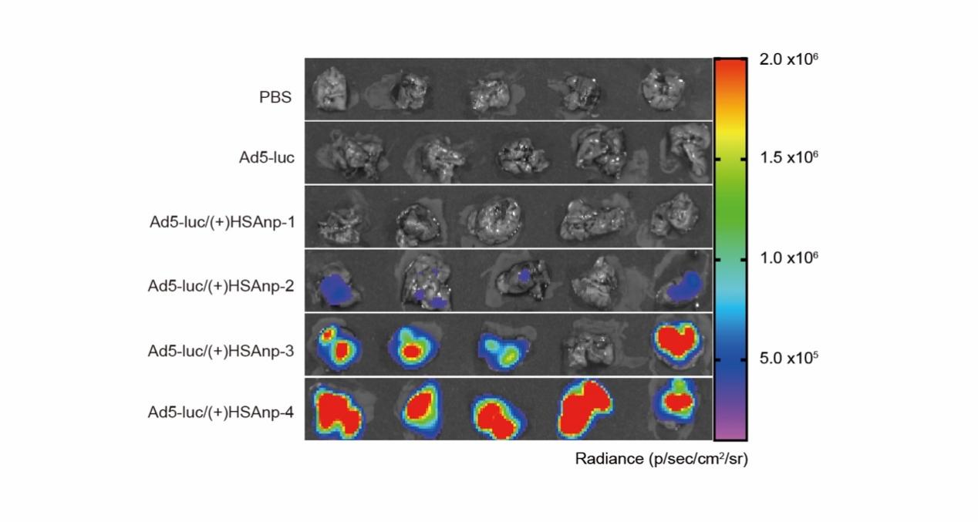
Fig. S6. Bioluminescence images showing charge-dependent enhancement of the transgene expression of Ad5-luc/(+)HSAnp. BALB/c mice (n = 5) were intranasally administrated 20 μL samples containing PBS, 5 × 10⁶ IFU of Ad5-luc alone, or Ad5-luc complexed with 1 μg of (+)HSAnp. Lung tissues were examined with BLI at 10 days post administration.
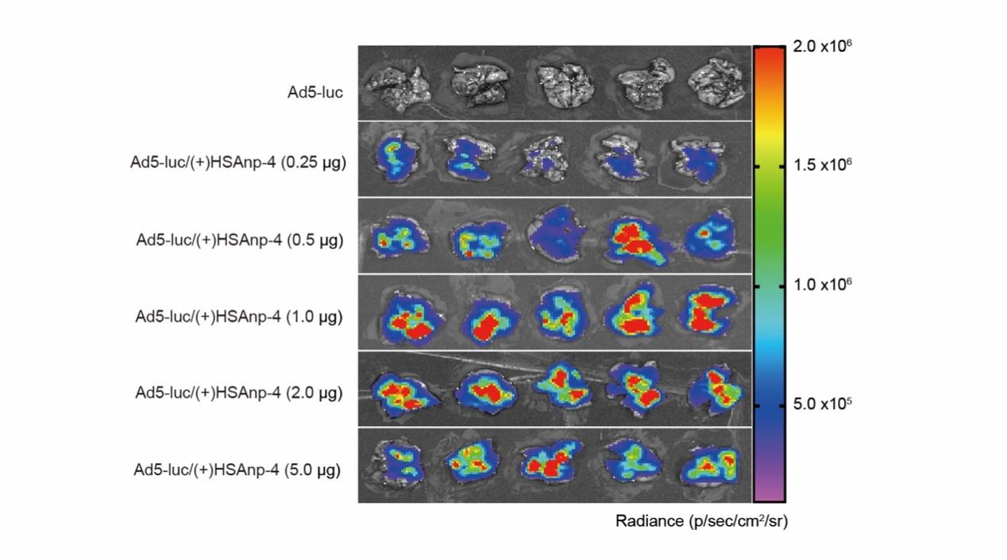
Fig. S7. Bioluminescence images showing dose-dependent enhancement of the transgene expression of Ad5-luc/(+)HSAnp. BALB/c mice (n = 5) were intranasally administrated 20 μL samples containing 5 × 10⁶ of IFU Ad5-luc alone or Ad5-luc complexed with 0.25–5.0 μg of (+)HSAnps. Lung tissues were examined with BLI at 10 days post administration.
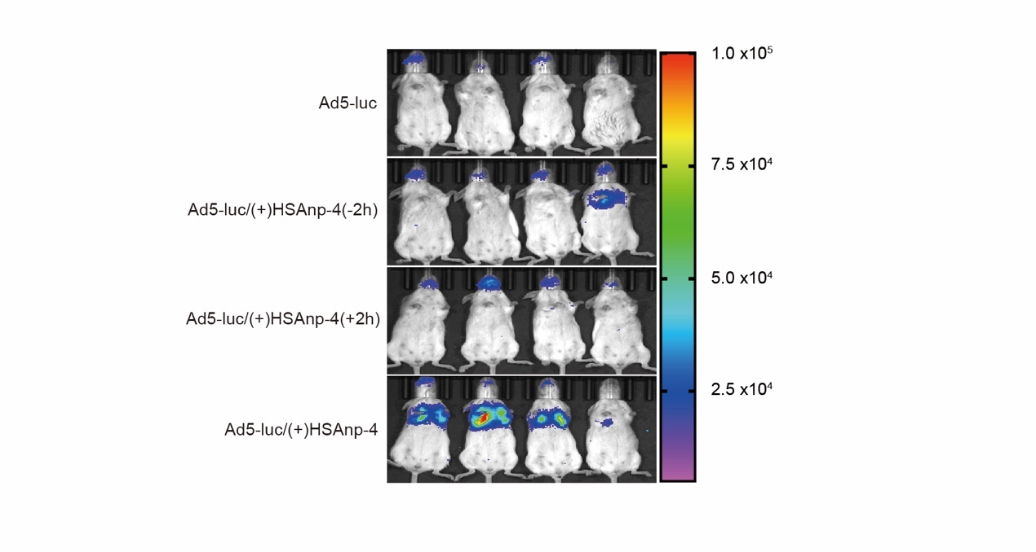
Fig. S8. In vivo bioluminescence of Ad5-luc administered simultaneously or separately with (+)HSAnp-4. BALB/c mice (n = 4) were intranasally administered 20 μL samples containing 5 × 10⁶ IFU of Ad5-luc administrated 2 h before, 2h after, or complexed with (+)HSAnp-4 (n = 4). In vivo BLI was performed at 10 days post intranasal administration.
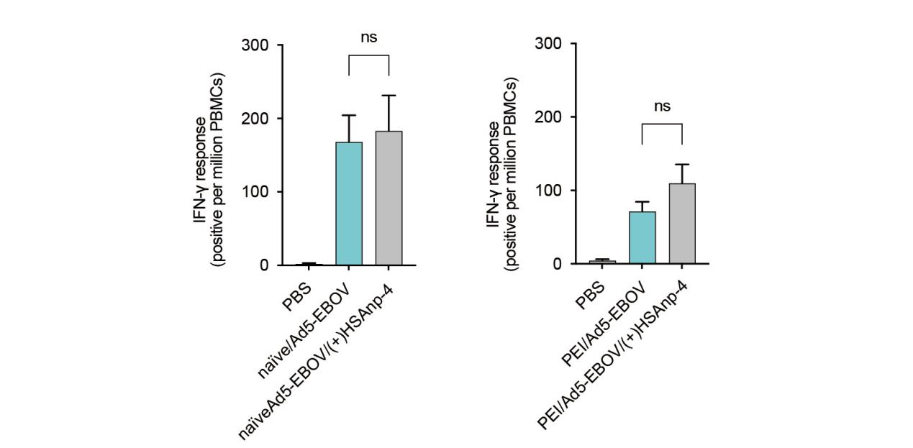
Fig. S9. The adaptive cellular immunity of nanoformulated Ad5-based vaccines. In the absence (naïve, n = 5) or presence (PEI, n = 10) of preexisting immunity, BALB/c mice were intranasally administered a single dose of 5 × 10⁶ IFU of Ad5-EBOV and Ad5-EBOV/(+)HSAnp-4. IFNγ-ELISpot assays were performed at 2 weeks and 14 weeks post administration, respectively. Data are presented as means ± SEM. Statistical differences were determined using ANOVA with Dunn’s multiple comparison test.

