Supplementary data for

The Low-Carbon Transition of Energy Systems: A Bibliometric Review from an Engineering Management Perspective
Peng Zhou ª*, Yue Lv ª, Wen Wen ª*
ª School of Economics and Management, China University of Petroleum, Qingdao 266580, China

* Corresponding authors.
E-mail address: pzhou@upc.edu.cn (P. Zhou), wenwen@upc.edu.cn (W. Wen)

Section S1. Detailed descriptions of data and methodology
The systematic review approach used in this study is claimed as an objective and efficient methodology for obtaining knowledge images and landscapes of a specific research field by identifying and analyzing existing publications [1]. It is characterized by its replicable, transparent and comprehensive research process, which emphasizes broad coverage of relevant research on an identified research field and scientific quantitative and qualitative methods for minimizing subjective bias [2]. Compared to a traditional narrative review, a systematic review builds a more comprehensive literature sample, provides a more replicable research process, and obtains more objective and authoritative analytical results. Generally, the process of a systematic review consists of seven phases: identifying a research question, building a review protocol, searching related literature, screening for inclusions or exclusions, assessing literature quality, extracting and analyzing data, and reporting the findings [1]. In terms of data analysis, bibliometric analysis is proposed for systematic reviews to explore the research structure and evolution of topics in specific research fields through quantitative analytical techniques, which provides strong support for building knowledge landscapes [3]. It is an important part of a systematic review that highly improves the objectivity and quality of the analytical results. This study follows the major process of a systematic literature review, which includes defining searching protocol, formulating screening criteria, conducting bibliometric analysis, building research landscapes, and discussing future directions [4, 5].

Section S1.1 Searching protocol
The searching protocol of this study is developed through a two-step procedure consisting of defining conceptual system boundaries and formulating searching strategies. The system boundaries are defined around our focusing topic (i.e., the low-carbon transition of energy systems) based on existing studies and conceptualizations, and the searching strategies are designed according to our boundary definitions and the searching tools provided by the WOS database.
(1) Boundary definitions
The term “energy system” has been used and defined differently in various disciplines (such as physics, chemistry, biology, engineering, and management). In this study, we stand on the shoulders of engineering management scholars. With this regard, Pfenninger et al. [6] define an “energy system” as the process chain (or a subset of it) from the extraction of primary energy to the end use of energy for services and goods. Yalew et al. [7] argue that the “energy system” includes primary energy supply, the conversion of primary energy to secondary energy, and energy demand in different sectors (such as the building, transport, and industry sectors). Grubler et al. [8] indicate that the “energy system transition” is not only a change in individual energy technology or fuel source but also in the state of an energy system.
In order to cover a broad range of related literature, this study takes a general definition of “energy systems”, which contain the processes of energy circulation (such as exploitation, production, storage, transmission, final usage, and end-of-pipe disposal) for all types of energy (including primary energy like fossil fuels and renewables, and secondary energy like electricity and heat) to achieve energy-related functions in human society. In addition, the “low-carbon transition of energy systems” is defined as the change in the state of energy systems triggered by carbon emissions reduction targets, which mainly includes the transformation of energy structure (e.g., through replacing fossil fuels with renewables), decarbonization of fossil fuel utilization (e.g., through applying low-carbon technologies such as carbon capture and storage), and improvement of energy efficiency (e.g., through enhancing operational efficiency during the whole process of energy utilization). All published studies relating to this topic from a management perspective will serve as potential subjects in this review study.
(2) Searching strategies
Firstly, we choose the SCIE and SSCI Core Collection in the WOS database as our data searching pool, with the purpose of capturing mainstream research trends published in well-established peer-reviewed academic journals. This database has been frequently used in systematic bibliometric reviews (e.g., Fahimnia et al. [3] and Xu et al. [4]). Besides, a reasonable number (over 5000) of publications have been finalized with this database; thus, we do not extend the searching pool further.
Secondly, we carefully construct a list of searching strings, trying to capture all possible topics within our boundary definition for the “low-carbon transition of energy systems”. To achieve this goal, we first look into the searching strings used in previous review studies on relevant topics related to “low-carbon transition” or “energy system” (as summarized in Table S1). Then we recognize two streams of searching string construction rules: 1) using a broad term representing “energy transition”, and 2) using a combination of two phrases representing “low-carbon transition” and “energy system” respectively. With the first rule, we develop searching strings such as “energy transformation”, “energy revolution”, and “energy decarbonization”. With the second rule, we develop searching strings such as “power system”, “heat system”, and “cooling system” to represent different types of energy systems, and words such as “low-carbon”, “zero-carbon”, and “decarbonization” to indicate the low-carbon transition. The developed searching strings are incorporated into the Boolean searching tool provided by the WOS online system, generating the searching formula as (“energy transition*” OR “energy transformation*” OR “energy revolution*” OR “energy decarbonization”) OR ((“energy system*” OR “power system*” OR “electricit* system*” OR “heat* system*” OR “thermal system*” OR “cooling system*”) AND (“low-carbon” OR “zero-carbon” OR “decarboni*” OR “emission reduction” OR “net-zero emission*” OR “carbon neutral*” OR “clean” OR “CO2 mitigation*” OR “CO2 capture”)).

Table S1 Searching strings used in the existing review studies of relevant topics.
Keywords | Authors | Searching String | Topic
Low-carbon transition | Wang et al. [9] | “low carbon” OR “low fossil fuel” OR “decarbonized” NOT “steel*” NOT “alloy*” | Low carbon development transformation
Low-carbon transition | Zhang et al. [10] | “clean energy” | Clean energy transition
Low-carbon transition | Wang et al. [11] | “low carbon economy” OR “low-carbon economy” | Low-carbon economy
Low-carbon transition | Vatananan-Thesenvitz et al. [12] | (“sustainable development” OR “sustainable growth”) AND (innovat*) | Sustainable development
Energy system | Meng et al. [13] | (“low carbon” OR “low-carbon” OR “carbon neutral” OR “carbon emission”) AND (“energy system” OR “power system” OR “electricity” OR “electric power”) | Power system
Energy system | Jin et al. [14] | (“methanol combust*” OR “ethanol combust*” OR “low* carbon alcohol* combust*” OR “primary alcohol* com- bust*” OR “short chain alcohol* combust*” OR “methyl alcohol* combust*” or “ethyl alcohol* combust*” OR “c1 alcohol* combust*” or “c2 alcohol* combust*”) AND (“internal combust* engine*” or “compress* ignit* engine*” or “spark ignit* engine*” or “IC engine*” or “CI engine*” or “SI engine*”) | Road transport system
Energy system | Omrany et al. [15] | (“net zero energy” OR “zero energy” OR “net zero carbon” OR “zero carbon” OR “NZEB” OR “ZEB” OR “ZCB” OR “zero emission” OR “zero net energy” OR “ZNE”) AND (“build*” OR “hous*” OR “construction*” OR “home*”) | Net-zero energy building system
Energy system | Dominkovic et al. [16] | (“energy system*”) AND (simul* OR model* OR “plan” OR “plans” OR “planning” OR optimi* OR analy* OR assess* OR evaluat*) | Energy system analysis

Thirdly, we set the publication time span to be from January 2012 to December 2021. A primary reason for choosing this period is that early studies on energy transition that are not aiming to reduce carbon emissions could appear in the searching results due to our broad set of searching strings. According to the Kyoto Protocol and Copenhagen Accord, developing countries began to take obligations to reduce carbon emissions in 2012, which was a significant milestone in global climate governance [17]. Related studies on the low-carbon transition of energy systems have also started to burst since then [18]. As such, we choose to look deeper into the research trends during the recent decade. In addition, to ensure consistency, we only keep articles in English (review papers and publications in other languages are excluded). The searching process was finalized by February 2022, with 9208 publications returned as our initial sample.

Section S1.2 Screening criteria
After obtaining the initial literature sample, we move forward to calibrate our sample for further review and analysis. A set of screening criteria are applied to improve the relevance and quality of the selected publications. Most of the screening processes are implemented manually (or with subjective judgment) due to the limitation of machinery recognition. A summary of the screening procedure is illustrated in Fig. S1.
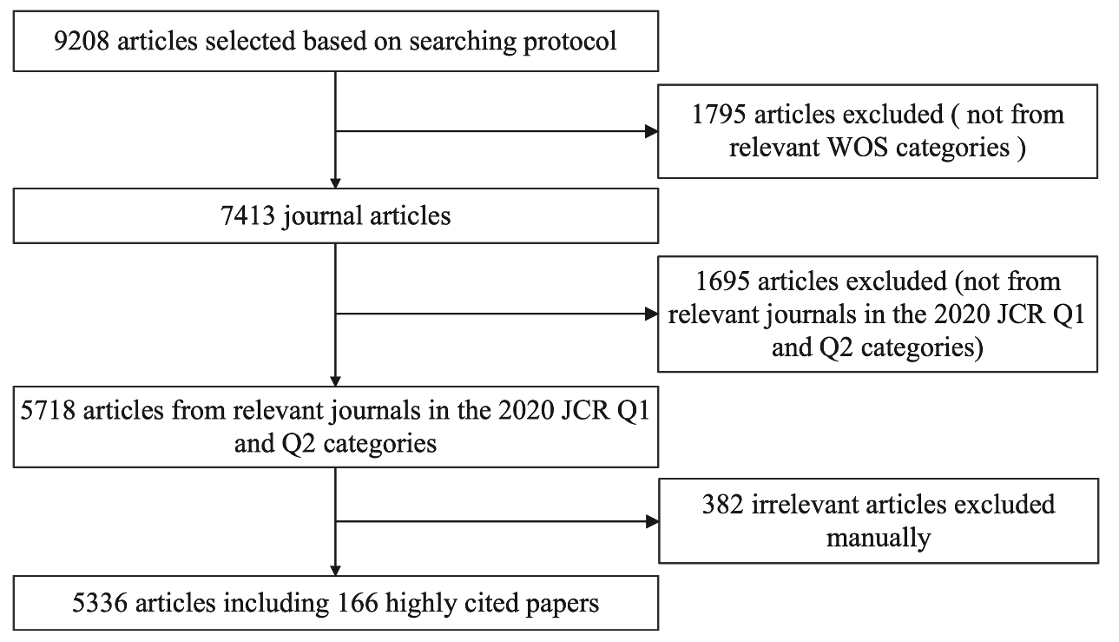
Fig. S1. Selection procedure of the literature sample
To keep the sample’s relevance to our focusing topic, we first exclude publications in the WOS categories that do not match (e.g., from disciplines of biology, physics, and chemistry). Then we exclude publications from irrelevant journals (e.g., Journal of Physics Energy, Earth Surface Dynamics). As the remaining sample is still sufficiently large (i.e., over 7000 publications), we choose to exclude publications in journals ranking in the third Quartile (Q3) and the fourth Quartile (Q4) as in the 2020 Journal Citation Report (JCR). In other words, only publications in the 2020 JCR reported first Quartile (Q1) and second Quartile (Q2) journals remained in our final sample. By doing so, we narrow our sample pool to the top 50% ranked journals and further improve the quality and consistency of selected publications. Lastly, we go through the titles and abstracts of the remaining sample publications to exclude those falling out of our boundary definition of the “low-carbon transition of energy systems” and those not addressing management issues (e.g., studies focusing purely on natural science or technological problems). For example, Serra et al. [19] designed a method to produce hydrogen by water electrolysis at low temperatures, and Cai et al. [20] proposed a host-guest semibiological photosynthesis system to facilitate energy transformation. Although these two papers include the keywords “energy system”, “decarbonization”, or “energy transformation”, they focus purely on technological problems without studying managerial problems. Hence, these two publications are excluded. After all the screening procedures, 5336 papers remained in the final sample (with 166 ESI highly cited papers) for our subsequent bibliometric analysis.

Section S1.3 Bibliometric analysis
The bibliometric method was proposed in the 1950s for quantitative analysis of existing literature [21] and was firstly named by Pritchard in 1969 [22]. With increasing data accessibility and enriching analytical tools, bibliometric analysis has gained great popularity in recent years. Broadly speaking, bibliometric analysis can be divided into two major steps: descriptive and exploratory data analysis [3, 4]. In descriptive data analysis, the numbers of publications and citations are the most used metrics to evaluate academic performance, which can be categorized by regions/countries, organizations, journals, and authors. In exploratory data analysis, co-occurrence and co-citation frequencies are often used as metrics for co-authorship analysis, co-citation analysis, and co-word analysis based on network and clustering techniques [23, 24]. The keywords analysis is the most popular approach in bibliometric reviews for revealing thematic features of specific research fields. It identifies the relations among keywords by calculating their co-occurrence frequency matrix and clusters them through algorithms [24]. The most frequently used clustering algorithms are principal component analysis, hierarchical clustering analysis, multidimensional scaling analysis, and community finding algorithms (e.g., the Louvain method and the Islands algorithm).
Currently, several kinds of software (such as Pajek, VOSviewer, Gephi, and bibliometrix R) have been developed as bibliometric tools for scholars’ ease of use. Most of these software tools are equipped with network analysis, clustering analysis, and visualization functions, while they vary in capabilities and limitations. For example, Pajek can present satisfactory bibliometric results of small samples containing no more than 100 publications [3, 25]. VOSviewer functions well with large samples to construct and visualize knowledge landscapes, which is able to avoid label overlap through labeling algorithms with zoom functionality but cannot merge different forms of the same words [23, 25]. Gephi and bibliometrix R, as emerging tools, can provide more complex bibliometric analysis, but they only work with processed data by other tools such as BibExcle and VOSviewer [4, 26]. Given the research purpose and large dataset (over 5000) of this study, VOSviewer is chosen as our software tool for conducting bibliometric analysis.
Specifically, we first display the scientometric features of sample publications, including publication quantities, co-authorship networks by countries, and co-citation networks by academic journals. It should be mentioned that we have also conducted the co-occurrence and co-citation network analysis at the organizational level and the personal level. However, the results are too trivial to be reported due to the interdisciplinary feature of our focusing research area. Secondly, we analyze the emergence, clusters, and evolution of hot topics in our focusing research field with the assistance of clustering and visualization tools provided by VOSviewer. Deep content analysis is then conducted to better understand each algorithmic clustered research category. Through the bibliometric analysis process, the landscape for management studies on the low-carbon transition of energy systems is gradually revealed and summarized with the authors’ viewpoints embedded.

Section S2. Supplementary information for the scientometric analysis
Section S2.1 Distribution of the number of authors per article
According to our sample, the distribution of the number of authors per article ranges from 1 to 46 with a right-skewed distribution (as shown in Fig. S2). Articles contributed by three authors take the most proportion (22.6%), followed by articles with two authors (20.9%) and four authors (19.1%). Around 9.4% of the sample publications are marked with a single author, and about 1.7% have more than ten authors.

Fig. S2. Distribution of the number of authors per article
Section S2.2 Top 10 highly cited papers
As of the ending date of our searching procedure (February 2022), the top 10 highly cited papers within our sample pool, as recorded in the WOS database, are summarized in Table S2.

Table S2 Top 10 highly cited papers from 2012 to 2021.
Author | Year | Title | Journal | Citations
Gielen et al. [27] | 2019 | The role of renewable energy in the global energy transformation | Energy Strategy Reviews | 620
Schmidt et al. [28] | 2017 | Future cost and performance of water electrolysis: An expert elicitation study | International Journal of Hydrogen Energy | 541
Bridge et al. [29] | 2013 | Geographies of energy transition: Space, place and the low-carbon economy | Energy Policy | 536
Rogelj et al. [30] | 2015 | Energy system transformations for limiting end-of-century warming to below 1.5 degrees C | Nature Climate Change | 488
Williams et al. [31] | 2012 | The technology path to deep greenhouse gas emissions cuts by 2050: The pivotal role of electricity | Science | 448
Connolly et al. [32] | 2014 | Heat Roadmap Europe: Combining district heating with heat savings to decarbonise the EU energy system | Energy Policy | 437
Kivimaa et al. [33] | 2016 | Creative destruction or mere niche support? Innovation policy mixes for sustainability transitions | Research Policy | 360
Sovacool [34] | 2016 | How long will it take? Conceptualizing the temporal dynamics of energy transitions | Energy Research & Social Science | 354
Rogge [35] | 2016 | Policy mixes for sustainability transitions: An extended concept and framework for analysis | Research Policy | 353
Grubler et al. [36] | 2018 | A low energy demand scenario for meeting the 1.5 degrees C target and sustainable development goals without negative emission technologies | Nature Energy | 329

Section S2.3 Journal co-citation networks
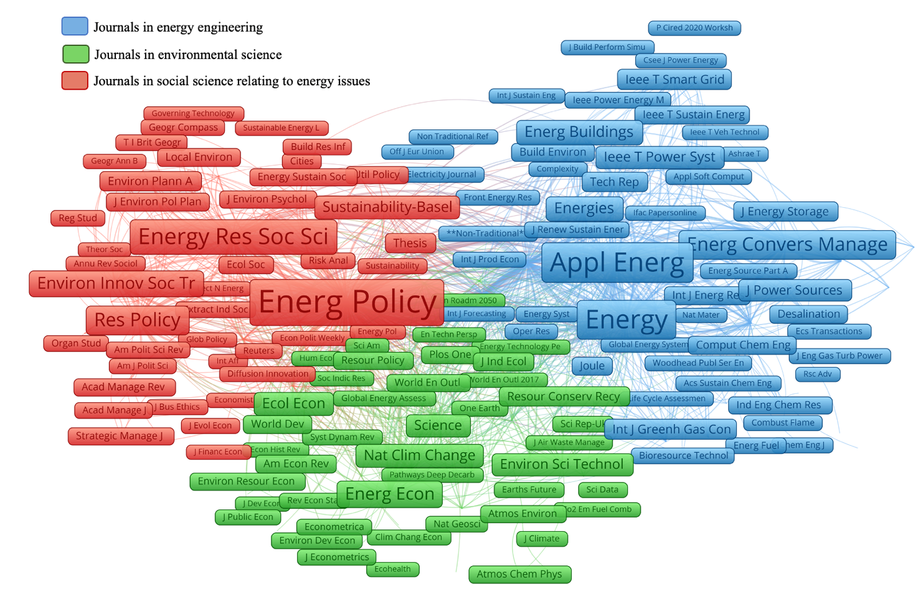
Fig. S3. Co-citation networks of journals

References for the supplementary materials
[1] Tranfield D, Denyer D, Smart P. Towards a methodology for developing evidence-informed management knowledge by means of systematic review. Brit J Manage 2003;14(3):207–22. https://doi.org/10.1111/1467-8551.00375
[2] Siddaway AP, Wood AM, Hedges LV. How to do a systematic review: A best practice guide for conducting and reporting narrative reviews, meta-analyses, and meta-syntheses. Annu Rev Psychol 2019;70(1):747–70. https://doi.org/10.1146/annurev-psych-010418-102803
[3] Fahimnia B, Sarkis J, Davarzani H. Green supply chain management: A review and bibliometric analysis. Int J Prod Econ 2015;162:101–14. https://doi.org/10.1016/j.ijpe.2015.01.003
[4] Xu XH, Chen XF, Jia F, Brown S, Gong Y, Xu YF. Supply chain finance: A systematic literature review and bibliometric analysis. Int J Prod Econ 2018;204:160–73. https://doi.org/10.1016/j.ijpe.2018.08.003
[5] Wang BC, Tao F, Fang XD, Liu C, Liu YF, Freiheit T. Smart manufacturing and intelligent manufacturing: A comparative review. Engineering 2021;7(6):738–57. https://doi.org/10.1016/j.eng.2020.07.017
[6] Pfenninger S, Hawkes A, Keirstead J. Energy systems modeling for twenty-first century energy challenges. Renew Sustain Energy Rev 2014;33:74–86. https://doi.org/10.1016/j.rser.2014.02.003
[7] Yalew SG, Van Vliet MTH, Gernaat DEHJ, Ludwig F, Miara A, Park C, et al. Impacts of climate change on energy systems in global and regional scenarios. Nat Energy 2020;5:794–802. https://doi.org/10.1038/s41560-020-0664-z
[8] Grubler A, Wilson C, Nemet G. Apples, oranges, and consistent comparisons of the temporal dynamics of energy transitions. Energy Res Soc Sci 2016;22:18–25. https://doi.org/10.1016/j.erss.2016.08.015
[9] Wang LY, Zhao L, Mao GZ, Zuo J, Du H. (2017). Way to accomplish low carbon development transformation: A bibliometric analysis during 1995–2014. Renew Sustain Energy Rev 2017;68:57–69. https://doi.org/10.1016/j.rser.2016.08.021
[10] Zhang W, Li B, Xue R, Wang C, Cao W. A systematic bibliometric review of clean energy transition: Implications for low-carbon development. PLoS One 2021;16(12):e0261091. https://doi.org/10.1371/journal.pone.0261091
[11] Wang JT, Zhou Y, Cooke FL. Low-carbon economy and policy implications: A systematic review and bibliometric analysis. Environ Sci Pollut Res 2022;29(43):65432–51. https://doi.org/10.1007/s11356-022-20381-0
[12] Vatananan-Thesenvitz R, Schaller AA, Shannon R. A bibliometric review of the knowledge base for innovation in sustainable development. Sustainability 2019;11(20):5783. https://doi.org/10.3390/su11205783
[13] Meng XC, Seong YH, Lee MK. Research characteristics and development trend of global low-carbon power—based on bibliometric analysis of 1983–2021. Energies 2021;14(16):4983. https://doi.org/10.3390/en14164983
[14] Jin C, Ampah JD, Afrane S, Yin ZH, Liu X. Low-carbon alcohol fuels for decarbonizing the road transportation industry: A bibliometric analysis 2000–2021. Environ Sci Pollut Res 2021;29(4):5577–604. https://doi.org/10.1007/s11356-021-15539-1
[15] Omrany H, Chang RD, Soebarto V, Zhang YQ, Ghaffarianhoseini A, Zuo J. A bibliometric review of net zero energy building research 1995-2022. Energy Build 2022;262:111996. https://doi.org/10.1016/j.enbuild.2022.111996
[16] Dominkovic DF, Weinand JM, Scheller F, D'Andrea M, McKenna R. Reviewing two decades of energy system analysis with bibliometrics. Renew Sustain Energy Rev 2021;153:111749. https://doi.org/10.1016/j.rser.2021.111749
[17] Lau LC, Lee KT, Mohamed AR. Global warming mitigation and renewable energy policy development from the Kyoto Protocol to the Copenhagen Accord—A comment. Renew Sustain Energy Rev 2012;16(7):5280–84. https://doi.org/10.1016/j.rser.2012.04.006
[18] Dominkovic DF, Weinand JM, Scheller F, D'Andrea M, McKenna R. Reviewing two decades of energy system analysis with bibliometrics. Renew Sustain Energy Rev 2022;153:111749. https://doi.org/10.1016/j.rser.2021.111749
[19] Serra JM, Borras-Morell JF, Garcia-Banos B, Balaguer M, Plaza-Gonzalez P, Santos-Blasco J. Hydrogen production via microwave-induced water splitting at low temperature. Nat Energy 2020;5(11):910–9. https://doi.org/10.1038/s41560-020-00720-6
[20] Cai JK, Zhao L, He C, Li YA, Duan CY. A host–guest semibiological photosynthesis system coupling artificial and natural enzymes for solar alcohol splitting. Nat Commun 2021;12(1):5092. https://doi.org/10.1038/s41467-021-25362-4
[21] Ho MT, Mantello P, Nguyen HKT, Vuong QH. Affective computing scholarship and the rise of China: a view from 25 years of bibliometric data. Humanit Soc Sci Commun 2021;8:282. https://doi.org/10.1057/s41599-021-00959-8
[22] Khalil GM, Crawford CAG. A bibliometric analysis of U.S.-Based research on the behavioral risk factor surveillance system. Am J Prev Med 2015;48(1):50–57. https://doi.org/10.1016/j.amepre.2014.08.021
[23] Donthu N, Kumar S, Mukherjee D, Pandey N, Lim WM. How to conduct a bibliometric analysis: An overview and guidelines. J Bus Res 2021;133:285–96. https://doi.org/10.1016/j.jbusres.2021.04.070
[24] Zupic I, Cater T. Bibliometric methods in management and organization. Organ Res Methods 2015;18(3):429–72. https://doi.org/10.1177/1094428114562629
[25] Van Eck NJ, Waltman L. Software survey: VOSviewer, a computer program for bibliometric mapping. Scientometrics 2010;84(2):523–38. https://doi.org/10.1007/s11192-009-0146-3
[26] Aria M, Cuccurullo C. Bibliometrix: An R-tool for comprehensive science mapping analysis. J Informetr 2017;11:959–75. https://doi.org/10.1016/j.joi.2017.08.007
[27] Gielen D, Boshell F, Saygin D, Bazilian MD, Wagner N, Gorini R. The role of renewable energy in the global energy transformation. Energy Strateg Rev 2019;24:38–50. https://doi.org/10.1016/j.esr.2019.01.006
[28] Schmidt O, Gambhir A, Staffell I, Hawkes A, Nelson J, Few S. Future cost and performance of water electrolysis: An expert elicitation study. Int J Hydrog Energy 2017;42(52):30470–92. https://doi.org/10.1016/j.ijhydene.2017.10.045
[29] Bridge G, Bouzarovski S, Bradshaw M, Eyre N. Geographies of energy transition: Space, place and the low-carbon economy. Energy Policy 2013;53:331–40. https://doi.org/10.1016/j.enpol.2012.10.066
[30] Rogelj J, Luderer G, Pietzcker RC, Kriegler E, Schaeffer M, Krey V, et al. Energy system transformations for limiting end-of-century warming to below 1.5 degrees C. Nat Clim Chang 2015;5(6):519+. https://doi.org/10.1038/nclimate2572
[31] Williams JH, DeBenedictis A, Ghanadan R, Mahone A, Moore J, Morrow WR, et al. The technology path to deep greenhouse gas emissions cuts by 2050: The pivotal role of electricity. Science 2012;335(6064):53–9. https://doi.org/10.1126/science.1208365
[32] Connolly D, Lund H, Mathiese BV, Werner S, Moller B, Persson U, et al. Heat Roadmap Europe: Combining district heating with heat savings to decarbonise the EU energy system. Energy Policy 2014;65:475–89.https://doi.org/10.1016/j.enpol.2013.10.035
[33] Kivimaa P, Kern F. Creative destruction or mere niche support? Innovation policy mixes for sustainability transitions. Res Policy 2016;45(1):205–17. https://doi.org/10.1016/j.respol.2015.09.008
[34] Sovacool BK. How long will it take? Conceptualizing the temporal dynamics of energy transitions. Energy Res Soc Sci 2016;13:202–15. https://doi.org/10.1016/j.erss.2015.12.020
[35] Rogge KS, Reichardt K. Policy mixes for sustainability transitions: An extended concept and framework for analysis. Res Policy 2016;45(8):132–47. https://doi.org/10.1016/j.respol.2016.04.004
[36] Grubler A, Wilson C, Bento N, Boza-Kiss B, Krey V, McCollum DL, et al. A low energy demand scenario for meeting the 1.5 degrees C target and sustainable development goals without negative emission technologies. Nat Energy 2018;3(6):515–27. https://doi.org/10.1038/s41560-018-0172-6

