Supplementary data for

CPAL, as a New Mediator of Cardiomyocyte Metabolic Alterations and Pyroptosis, Regulates Myocardial Infarction Injury in Mice
Jiamin Li ^{a,c,d,#}, Hongru Xue ^{a,#}, Ning Xu ^{a,#}, Liling Gong ª, Ming Li ª, Sijia Li ª, Di Huang ª, Qingwei Zhang ª, Pengyu Li ª, Qingsui Li ª, Hang Yu ª, Yining Liu ^{a,b}, Yadong Xue ª, Haixin Chen ª, Jiali Liu ª, Wanyu Zhang ª, Mingbin Liu ª, Siyu Chang ª, Xianzhi Lang ª, Xingmiao Zhao ª, Weijie Du ^{a,c,d}, Benzhi Cai ^{b,c,d}, Ning Wang ^{a,c,d,}*, Baofeng Yang ^{a,c,d,}*

ª State-Province Key Laboratories of Biomedicine-Pharmaceutics of China & Key Laboratory of Cardiovascular Medicine Research (Ministry of Education of the People's Republic of China), Department of Pharmacology, College of Pharmacy, Harbin Medical University, Harbin 150081, China
^{b} Institute of Clinical Pharmacy, The University Key Laboratory of Drug Research, Heilongjiang Higher Education Institutions, Department of Pharmacy, the Second Affiliated Hospital of Harbin Medical University, Harbin, China
^{c} Research Unit of Noninfectious Chronic Diseases in Frigid Zones (2019RU070), Chinese Academy of Medical Sciences, Harbin 150081, China
^{d} Northern Translational Medicine Research and Cooperation Center, Heilongjiang Academy of Medical Sciences, Harbin Medical University, Harbin 150081, China

* Corresponding authors.
E-mails: wangning@ems.hrbmu.edu.cn (N. Wang), yangbf@ems.hrbmu.edu.cn (B. Yang)

# These authors contributed equally to this work.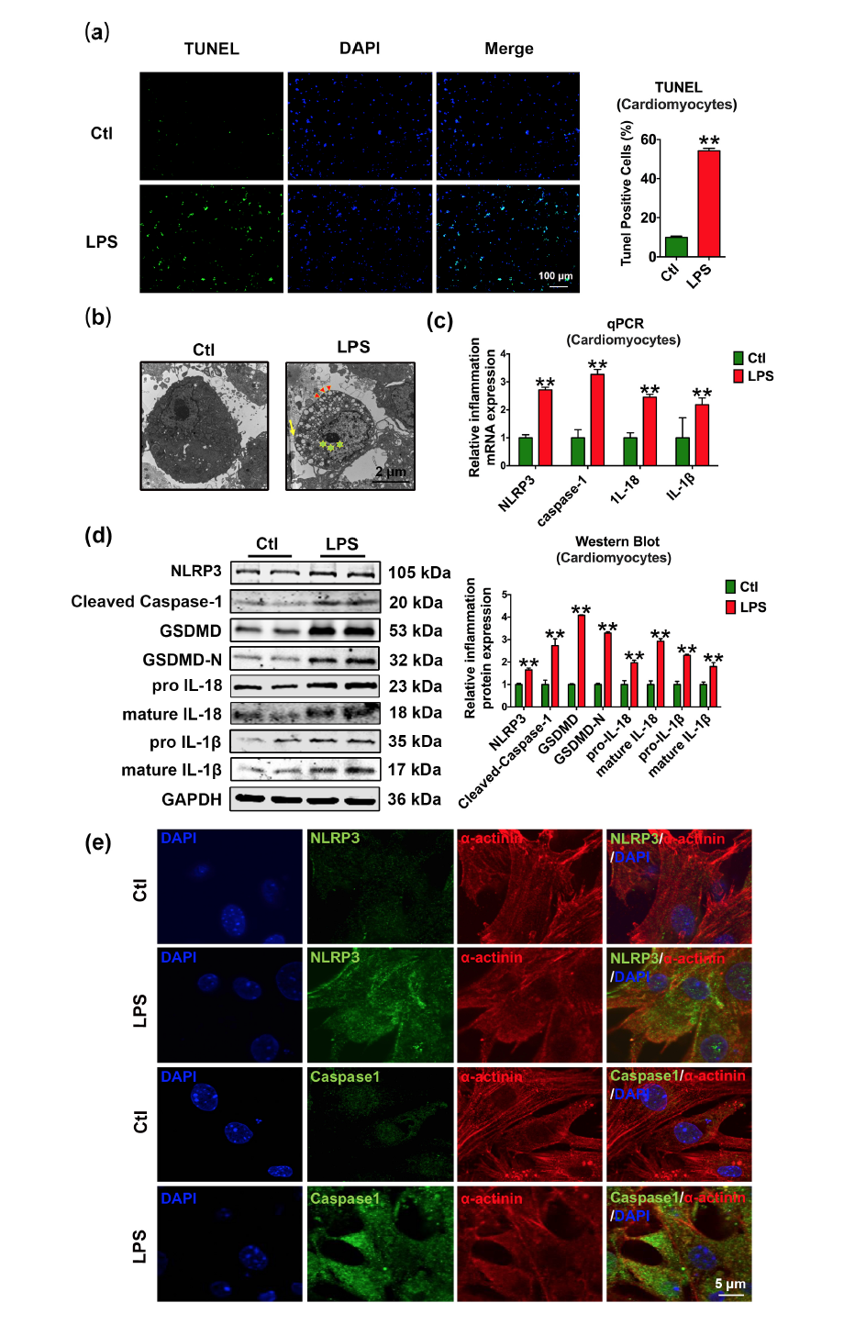

Fig. S1. LPS induces neonatal mouse cardiomyocyte pyroptosis. (a) Representative images stained by TUNEL and a percentage analysis of TUNEL-positive cardiomyocytes in the control and LPS groups (blue: nuclear staining (DAPI); green: TUNEL-positive cells; scale bar: 100 μm; **P<0.01, compared with the control group; n=3–5; mean ± SEM). (b) TEM micrograph showing the control and LPS group cardiomyocytes (green stars indicate karyopyknosis, red triangles indicate the mitochondrial vacuole, and the yellow arrow represents membranolysis; scale bar: 2 μm; n=3). (c) Relative mRNA levels of genes in the control and LPS groups (n=3-6; **P<0.01, compared with the control; mean ± SEM). (d) Protein levels of NLRP3, cleaved caspase-1, GSDMD, GSDMD-N, pro-IL-18, mature IL-18, pro-IL-1β, and mature IL-1β in LPS treatment cells or untreated (**P<0.01, compared with control; n=3–9). (e) Immunofluorescence staining for NLRP3/caspase-1-α-actinin in cardiomyocytes with LPS treatment or untreated (green: NLRP3/caspase-1, red: α-actinin, blue: DAPI; scale bar: 5 μm; n=3)

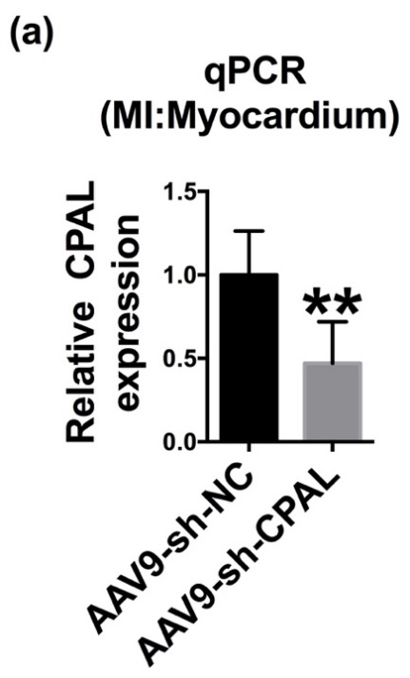
Fig. S2. Tail vein injection of AAV9-sh-CPAL in normal mice. (a) Expression of CPAL at the mRNA level in mouse hearts injected with AAV9-sh-NC/AAV9-sh-CPAL for 4 weeks (**P<0.05, compared with NC group; n=3).

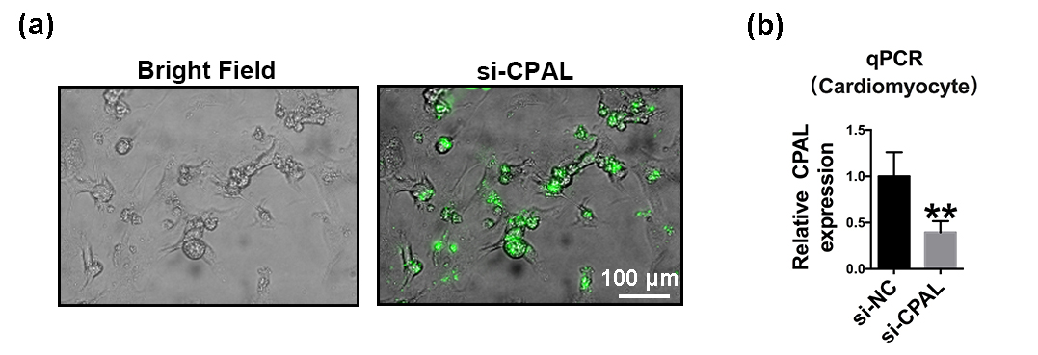
Fig. S3. si-CPAL transfection efficiency and knockdown of CPAL expression in neonatal cardiomyocytes. (a) Epifluorescence images of the transfection efficiency in cardiomyocytes (scale bar: 100 μm). (b) CPAL mRNA expression levels in neonatal cardiomyocytes transfected with si-NC/si-CPAL (*P<0.05, compared with NC; n=3; mean ± SEM).

Table S1 Sequences of qRT-PCR primers.
Gene name | Forward primer (5'–3') | Reverse primer (5'–3')
NLRP3 | GTTTGACCCCGATGATGAGC | CTTGTGGATGGGTGGGTTTG
NFκB | CAGCTCTTCTCAAAGCAGCA | TCCAGGTCATAGAGAGGCTCA
Caspase-1 | ACACGTCTTGCCCTCATTATCT | ATAACCTTGGGCTTGTCTTTCA
IL-18 | GACTCTTGCGTCAACTTCAAGG | CAGGCTGTCTTTTGTCAACGA
Il-1β | CCCTGCAGCTGGAGAGTGTGG | TGTGCTCTGCTTGAGAGGTGCT
CPAL | GCCACTAATCGTTTGCCTCG | GCCAGACTCCAAGCAAGC
HK1 | AACGGCCTCCGTCAAGATG | GCCGAGATCCAGTGCAATG
CD36 | ATGGGCTGTGATCGGAACTG | TTTGCCACGTCATCTGGGTTT
GAPDH | GCTTCGGCAGCACATATACTAAAAT | GCAACGGAGACGGCAAACC

