Supplementary file for
Biosynthesis and Immunological Evaluation of a Dual-Antigen Nanoconjugate Vaccine against Brucella melitensis
Jing Huang ^{a,b,c,#}, Yufei Wang ^{d,#}, Kangfeng Wang ^{a,e}, Shulei Li ^{a,d}, Peng Sun ª, Yan Guo ª, Jiankai Liu ^{b}, Ruifu Yang ^{c}, Ming Zeng ^{b,}*, Chao Pan ^{a,}*, Hengliang Wang ^{a,}*, Li Zhu ^{a,}*
ª State Key Laboratory of Pathogen and Biosecurity, Beijing Institute of Biotechnology, Beijing 100071, China
^{b} Beijing Minhai Biotechnology Co., Ltd., Beijing 102600, China
^{c} State Key Laboratory of Pathogen and Biosecurity, Beijing Institute of Microbiology and Epidemiology, Beijing 100071, China
^{d} The Third Medical Center, PLA General Hospital, Beijing 100039, China
^{e} College of Life Science, Hebei University, Baoding 071002, China

# These authors contributed equally to this work.
* Corresponding authors.
E-mail addresses: jewly54@bmi.ac.cn(L. Zhu ); wanghl@bmi.ac.cn (H. Wang); panchaosunny@163.com (C. Pan); zengming@263.net (M. Zeng)

Table S1
Primers used in plasmids construction.
Primers | Primer sequences(5ʹ→3ʹ) | Introduction
Omp19-F | CATGCCATGGGAAAGAAAATTTGGCTGGCCTTAGCC  GGCCTGGTTCTGGCATTCAGCGCCAGCGCACAGTCT  TCTCGTCTGGGTAA | Amplifying the Omp19
Omp19-R | CCGCTCGAGGCGGGACAGCGTTACTGC | Amplifying the Omp19
SCOG-F1 | CGAGCTCTGCATAATTCGTGTCGCTCAA | Amplifying the Tac promptor-DsbA from pET-pglL-CTB^{4573C}
SCOG-R1 | ACCAGGTCTCATGCGCTGGCGCTGAATGCCAGAACC | Amplifying the Tac promptor-DsbA from pET-pglL-CTB^{4573C}
SCOG-F2 | ACCAGGTCTCACGCAGGCGCCATGGTTGATACCTTA  TCA | Amplifying the SC from pET-pglL-SC^{4573C}
SCOG-R2 | ACCAGGTCTCAACCAGAACCGCCAATATGAGCGTC  ACCTTTAGTTGCTTT | Amplifying the SC from pET-pglL-SC^{4573C}
SCOG-F3 | ACCAGGTCTCATGGTCAAAGTAGTCGTTTGGGCAAT  CTGG | Amplifying the Omp19-4573 from pET-pglL-CTB^{4573C}
SCOG-R3 | CCGCTCGAGCTTGATCTCACTGCTTGT | Amplifying the Omp19-4573 from pET-pglL-CTB^{4573C}
SO-F | TGCTCTAGAAATAATTTTGTTTAACTTTAAGAAGGAG  ATATAATGGGCGCCATGGTTGATACCTTATCAG | Amplifying the Omp19-4573 from pET-pglL-SC-Omp19^{4573C}
SO-R | CCGCTCGAGACGTGATAAGGTCACAGC | Amplifying the Omp19-4573 from pET-pglL-SC-Omp19^{4573C}

Table S2
Primers used in gene knockout.
Primers | Primer sequences(5ʹ→3ʹ) | Introduction
pTargetF-F | CCAGGTCTCAGTCCTAGGTATAATACTAGTTGAAATG  CTAAACAGTATTG GTTTTAGAGCTAGAA | Constructing the palsmid pTarget-ΔrfaL
pTargetF-R | CCAGGTCTCAGGACTGAGCTAGCTGTCAAGGATCCA  GCATATGCGG | Constructing the palsmid pTarget-ΔrfaL
rfaL-Up-F | TCACCGAACAAGGCGAAACAGTGC | Amplifying the upstream homologous arms
rfaL-Up-R | CACCAGGTCTCAGATGTGCCCAGCGAGGAAGTCGAT | Amplifying the upstream homologous arms
rfaL-Dn-F | CACCAGGTCTCACATCGGCAGGGTATTCTGTGAC | Amplifying the upstream homologous arms
rfaL-Dn-R | ATAGGGATCTAACGCCAC | Amplifying the upstream homologous arms
Inner-F | AGTCAGGGCTGGAAACGC | Verifying the rfaL mutant strain
Inner-R | CACGGTAACAACAGACAATC | Verifying the rfaL mutant strain
Outer-F | TCACCGAACAAGGCGAAA | Verifying the rfaL mutant strain
Outer-R | ATAGGGATCTAACGCCAC | Verifying the rfaL mutant strain
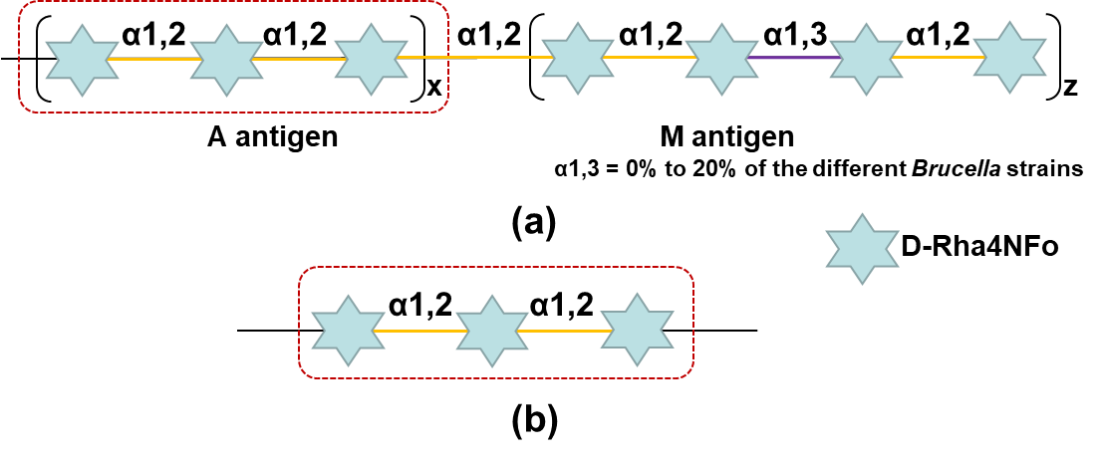
Fig. S1. The repeating OPS units in (a) Brucella and (b) the YEO:9. The red dotted box indicates the same structure in each.

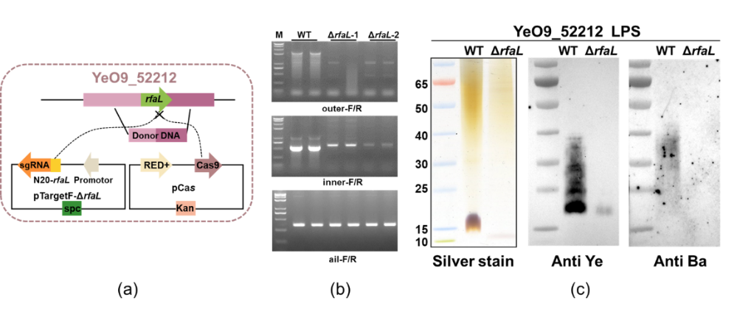
Fig. S2. Construction and verification of YeO9_52212ΔrfaL. (a) Schematic diagram of gene knockout via the CRISPR-Cas9 system. (b) PCR validation of wild strains and rfaL-deletion strains (from top to bottom: the wild-type (WT) strain and rfaL knockout strain (YeO9_52212ΔrfaL) of YeO9_52212 were verified by a rfaL external primer, internal primer, and the characteristic ail gene primer of Y. enterocolitia). (c) LPS from the WT strain and YeO9_52212ΔrfaL were analyzed by silver staining and western blotting using anti-YEO:9 and anti-B. abortus (anti-Ba) antibodies.

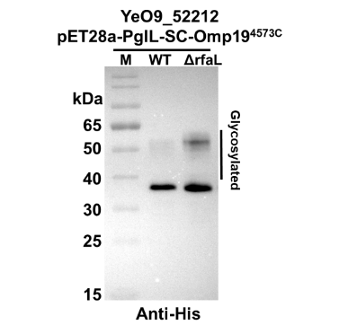
Fig. S3. YeO9_52212 and YeO9_52212ΔrfaL were transformed with pET28a-PglL-SC-Omp19^{4573C} and induced with IPTG, and then whole cell lysate samples with the same cell wet weight were analyzed by western blotting using an anti-6× His tag antibody.

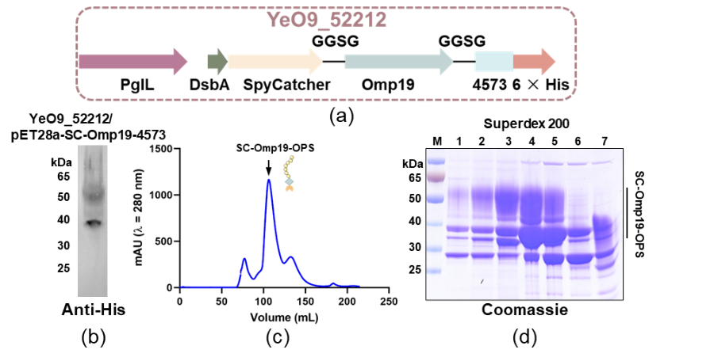
Fig. S4. Expression and purification of SC-Omp19-OPS in YeO9_52212ΔrfaL. (a) Construction of pET28a-PglL-SC-Omp19^{4573C} plasmids for expression in YeO9_52212ΔrfaL. (b) YeO9_52212ΔrfaL was transformed with pET-pglL-SC-Omp19^{4573C} and induced with IPTG, and then was analyzed by western blotting using an anti-6× His tag antibody. (c) SC-Omp19-OPS was isolated by SEC, and nine fractions were collected and analyzed by Coomassie Blue staining. (d) Coomassie blue staining of the seven collected SC-Omp19-OPS fractions.
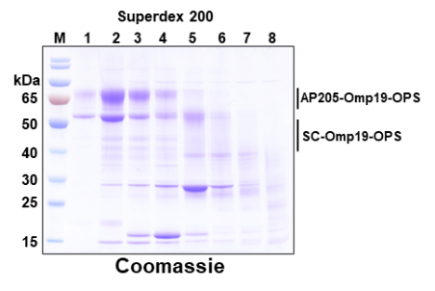
Fig. S5. ST-AP205 and SC-Omp19-OPS were combined at the optimum molar ratio and separated by SEC, and eight fractions were collected and analyzed by Coomassie blue staining.

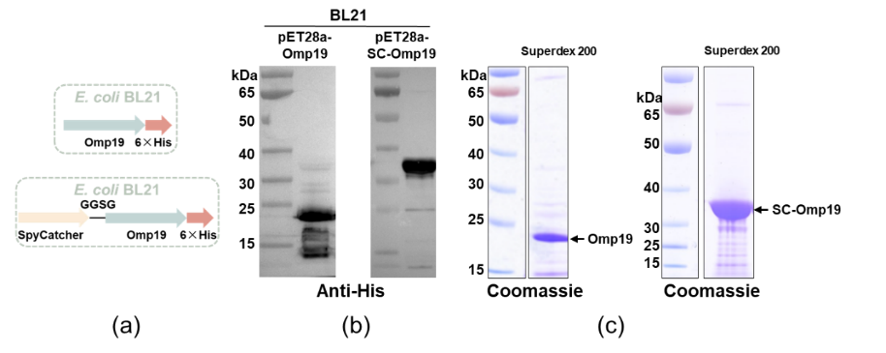
Fig. S6. Expression and purification of Omp19 and SC-Omp19 in E. coli. (a) Construction of target protein expression plasmids for E. coli BL21, vector pET28a-Omp19, which expressed antigen Omp19 followed by a 6× His tag, and vector pET28a-SC-Omp19, which expressed the fusion of SC and antigen Omp19 followed by a 6× His tag. (b) E. coli BL21 was transformed with pET28a-Omp19-4573 or pET28a-SC-Omp19 and induced with IPTG separately, then analyzed by western blotting using an anti-6× His tag antibody. (c) Coomassie blue staining of Omp19 and SC-Omp19 after purification by affinity and SEC.
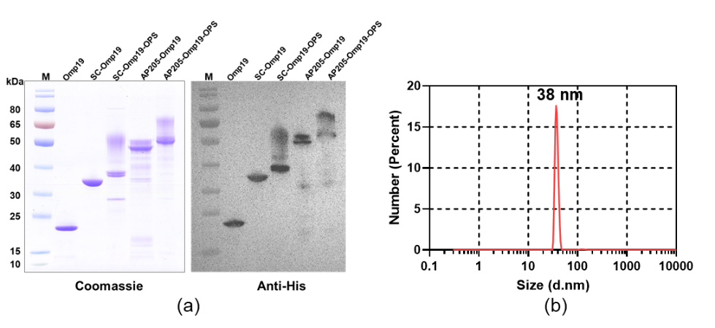
Fig. S7. AP205-Omp19 was produced in vitro by conjugation of SC-Omp19 to ST-AP205, then purified by SEC to remove the unlinked component. (a) Purified Omp19, SC-Omp19, SC-Omp19-OPS, AP205-Omp19, and AP205-Omp19-OPS were analyzed by Coomassie blue staining and western blot using an anti-6× His tag antibody. (b) DLS analysis of the AP205-Omp19 particle size.

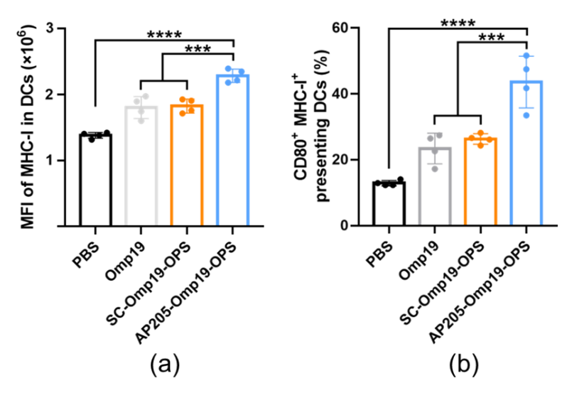
Fig. S8. Detection of MHC-I expression on DCs. Mice were immunized with different treatments, and the cells deposited in dLNs were analyzed by flow cytometry 24 h post-immunization. The mean fluorescence intensity (MFI) values of (a) MHC-I and (b) CD80⁺ MHC-I⁺ on DCs were measured (n = 4).
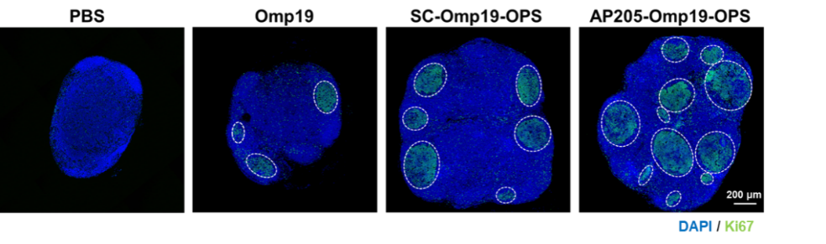
Fig. S9. Immunofluorescence staining of dLN from mice immunized with PBS, Omp19, SC-Omp19-OPS, and AP205-Omp19-OPS was performed with DAPI and anti-Ki67 antibody (blue: DAPI, green: Ki67) on day 10 post vaccination. The distribution of germinal centers is shown by white dashed lines.
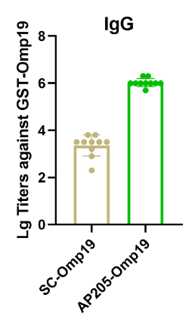
Fig. S10. The serum IgG response against GST-Omp19 after the third s.c. injection in the SC-Omp19 and AP205-Omp19 groups (n = 10).

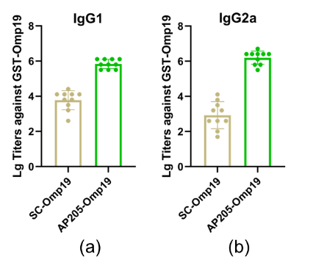
Fig. S11. The serum (a) IgG1 and (b) IgG2a responses against GST-Omp19 after the third s.c. injection in the SC-Omp19 and AP205-Omp19 groups (n = 10).

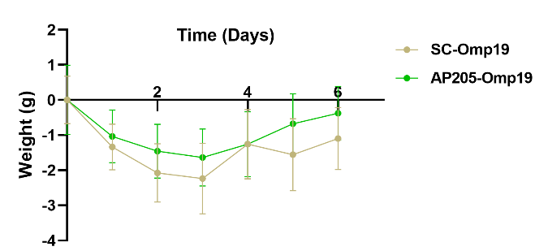
Fig. S12. Weight change of immunized mice in SC-Omp19 and AP205-Omp19 groups after infection with a non-lethal dose of B. melitensis M5 (n = 5).

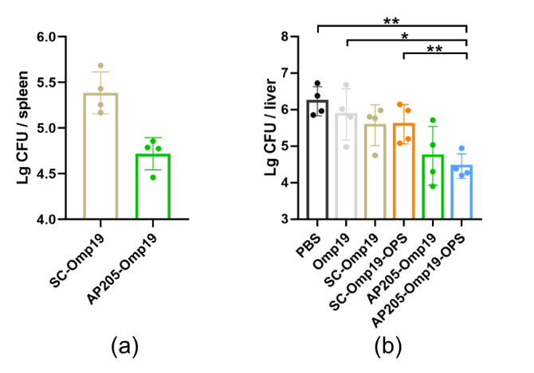
Vaccine candidates | lg(CFU) of M5 in spleen | Unit of protection | lg(CFU) of 5 in liver | Unit of rotection
PBS | 5.12 ± 0.26 | — | 6.23 ± 0.40 | —
Omp19 | 5.14 ± 0.34 | — | 5.87 ± 0.70 | 0.36
SC-Omp19 | 5.39 ± 0.23 | — | 5.58 ± 0.56 | 0.66
SC-Omp19-OPS | 4.80 ± 0.23 | 0.32 | 5.60 ± 0.54 | 0.63
AP205-Omp19 | 4.72 ± 0.18 | 0.40 | 4.74 ± 0.80 | 1.49
AP205-Omp19-OPS | 4.66 ± 0.12 | 0.46 | 4.45 ± 0.34 | 1.78
(c)
Fig. S13. Protection of mice after s.c. injection. (a) Bacterial load in spleens of mice in SC-Omp19 and AP205-Omp19 groups. (b) Bacterial load in livers of all immune groups after infection with a non-lethal dose of B. melitensis M5 (n = 4). (c) The unit of protection was calculated based on the reduction of bacterial load in spleens or livers.

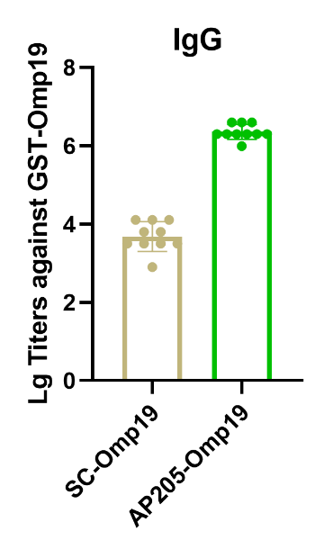
Fig. S14. The serum IgG titers against GST-Omp19 were measured in SC-Omp19 and AP205-Omp19 groups on day 10 after the third i.p. injection (n = 10).

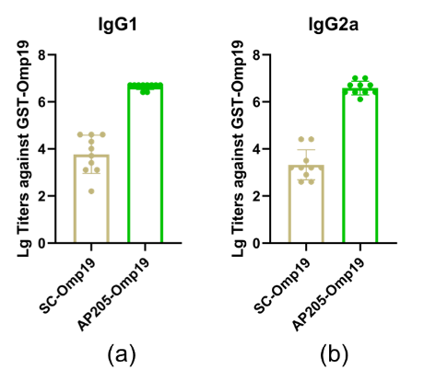
Fig. S15. (a) IgG1 and (b) IgG2a titers against GST-Omp19 were measured in the SC-Omp19 and AP205-Omp19 groups on day 10 after the third i.p. injection (n = 10).
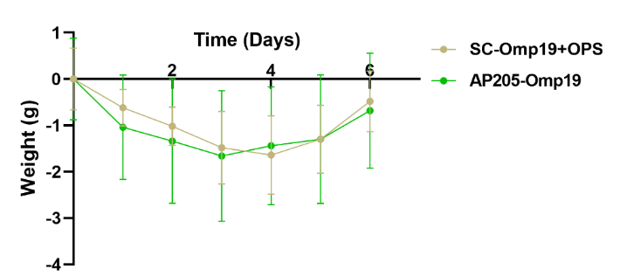
Fig. S16. Weight change of mice treated with SC-Omp19 and AP205-Omp19 after infection with M5 (n = 5).

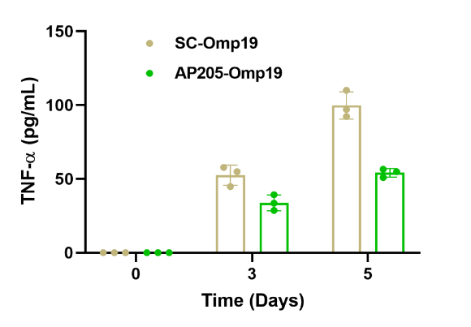
Fig. S17. TNF-α levels in the serum of SC-Omp19 and AP205-Omp19 immunized mice after infection with M5 (n = 3).

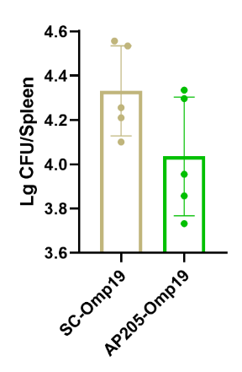
Vaccine candidates | lg(CFU) of M5 in spleen | Unit of protection
SC-Omp19 | 4.33 ± 0.20 | 0.58
AP205-Omp19 | 4.04 ± 0.27 | 0.87

Fig. S18. Quantification of bacterial colonization in spleens collected from SC-Omp19 and AP205-Omp19 immunized mice on the sixth day post challenge (n = 5). The splenic bacterial load of the mice was determined and expressed numerically in the lower table based on the data in the upper graph.
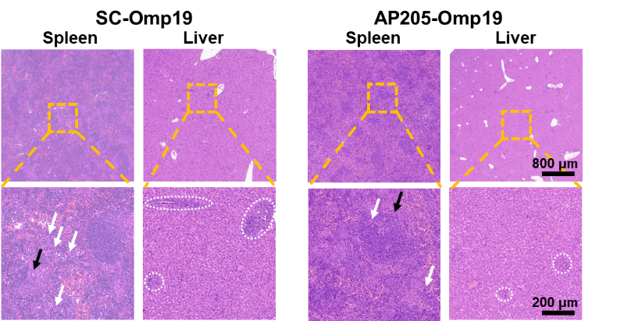
Fig. S19. Histological analysis of the spleen and liver of infected mice in SC-Omp19 and AP205-Omp19 groups. The yellow dotted boxes in the top panels represent the field of view in the corresponding figures below, and the scale bars are at the bottom of the figure. Black arrows indicate desmoplasia, white arrows indicate multinucleated giant cells, and white dotted circles indicate lymphocyte infiltration.
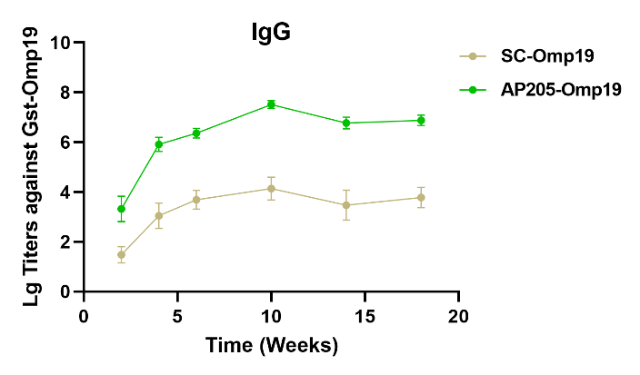
Fig. S20. Long-term IgG titers against GST-Omp19 from SC-Omp19 and AP205-Omp19 treated groups were measured over time (n = 10).

