Supplementary data for

Persulfate-Induced Three Coordinate Nitrogen (N3_{C}) Vacancies in Defective Carbon Nitride for Enhanced Photocatalytic H₂O₂ Evolution
Wei Miao^{a,b}, Yijie Wang^{a,b}, Ying Liu^{a,b}, Hehe Qin^{a,b}, Chengcheng Chu^{a,b}, Shun Mao^{a,b,}*
ª College of Environmental Science and Engineering, Biomedical Multidisciplinary Innovation Research Institute, Shanghai East Hospital, State Key Laboratory of Pollution Control and Resource Reuse, Tongji University, Shanghai 200092, China
^{b} Shanghai Institute of Pollution Control and Ecological Security, Shanghai 200092, China

* Corresponding author
E-mail address: shunmao@tongji.edu.cn (S. Mao)

Text S1. H₂O₂ detection method
2 ml of the reaction solution was taken from which the photocatalyst has been removed by filtration. Next, 1 mL of 0.4 M potassium iodide and 1 mL of 0.1 M potassium hydrogen phthalate (C₈H₅KO₄) were added to the filtrate. After standing for 30 min, the absorbance was measured at 350 nm using the ultraviolet visible spectrophotometer. The regression curve and regression equation of the standard iodimetry method are shown in Fig. S1.
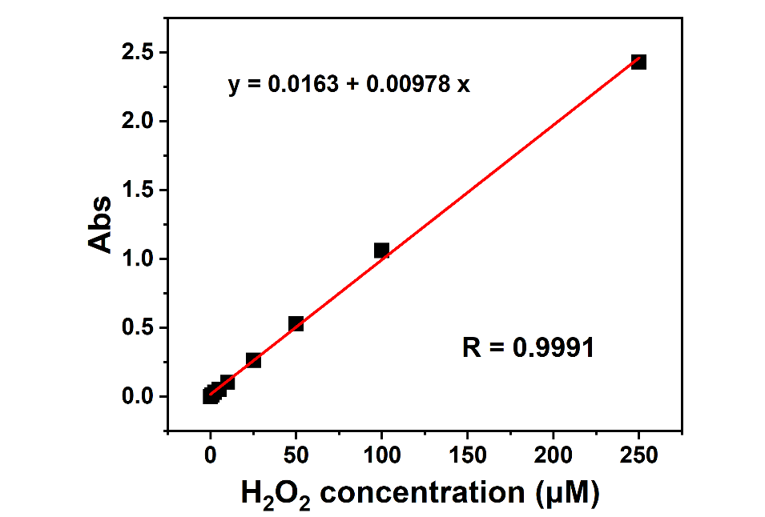
Fig. S1. The regression curve and regression equation of the standard iodimetry method.

Text S2. The Kubelk-Munk method
(αhν)^{n} = A(hν − Eg), (1)
where α is the absorption coefficient, hν is the light energy, A is a constant, Eg is the optical band gap energy and n is equal to 2 for g-C₃N₄ based materials [1].

Text S3. Electrochemical and photoelectrochemical tests
5 mg catalyst was dispersed in 500 μL mixture solution (water: isopropanol: Nafion = 250: 225: 25, v/v/v). The slurry was coated on glassy carbon electrodes or ITO substrates, used as the working electrodes. The photoelectrochemical properties were tested in a conventional three-electrode system via CHI Instruments CHI660D electrochemical workstation. Pt wire was used as the counter electrode and the SCE electrode was used as the reference electrode. 0.1 M Na₂SO₄ aqueous solution was used as the electrolyte, and the light source was a 300W Xenon lamp equipped with an ultraviolet cut-off filter (λ>420 nm).

The LSV curves were obtained via the rotating disk electrode (RDE) measurements in an O₂-saturated 0.1 m phosphate buffer solution (pH = 7). During the measurement, O₂ was kept flowing on the liquid surface of the electrolyte. The average electron transfer number (n) in the overall O₂ reduction was obtained by the slopes of Koutecky–Levich plots with the following equation:
j⁻¹ = j_{k}⁻¹ + B⁻¹Ω^{-1/2} (1)
in which
B = 0.2nFν^{-1/6} CD^{2/3} (2)
where j, j_{k}, and Ω are the tested current density, kinetic current density, and rotating speed (rpm), respectively. F and ν are the Faraday constant (96485 C mol⁻¹) and kinetic viscosity of water (0.01 cm⁻² s⁻¹), C and D are the bulk concentration of O₂ in water (1.26 × 10⁻³ mol cm⁻³) and the diffusion coefficient of O₂ (2.7 × 10⁻⁵ cm² s⁻¹) [2].
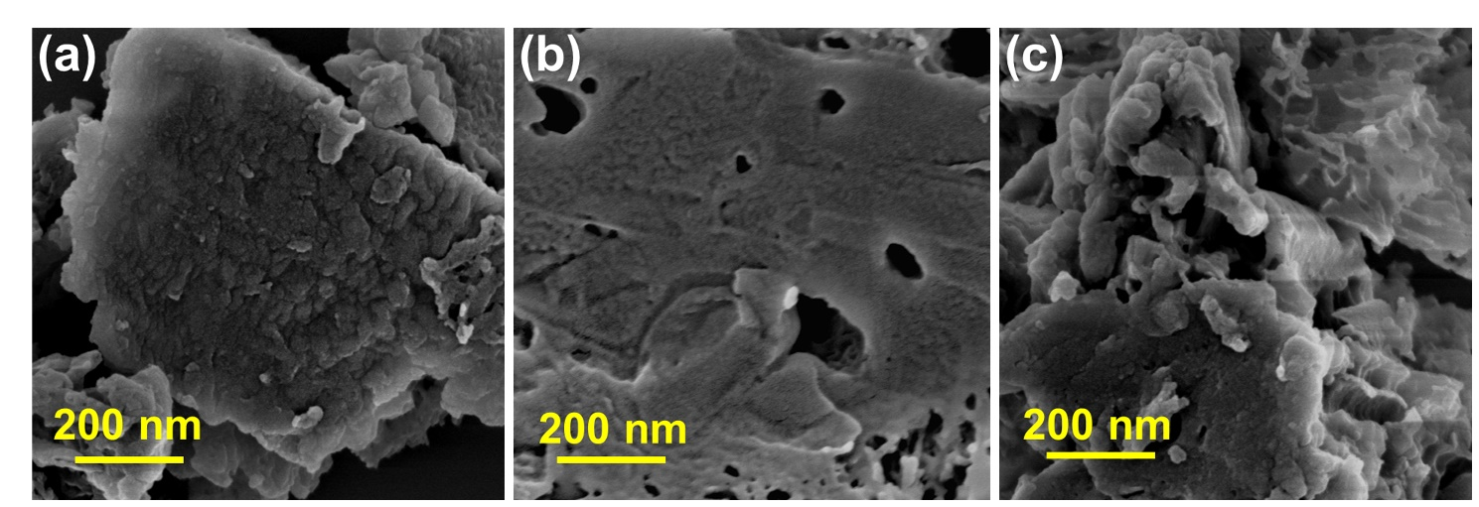
Fig. S2. SEM images of (a) CN, (b) SSCN, and (c) SPCN.
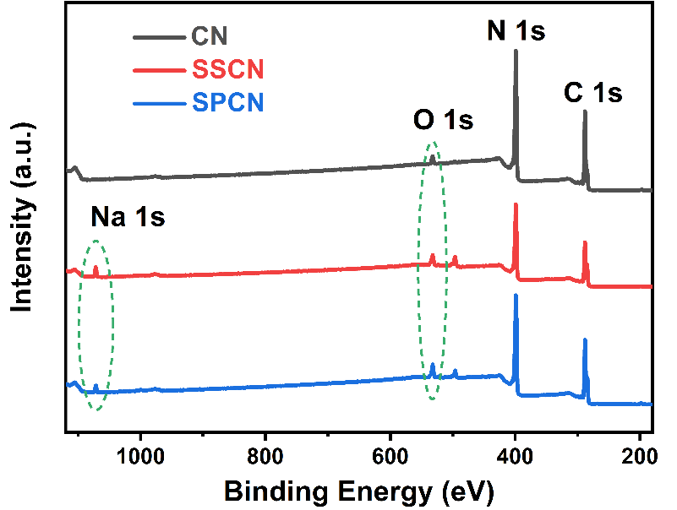
Fig. S3. XPS survey spectra of CN, SSCN, and SPCN.
Table S1
The elemental contents in the catalysts were estimated by the XPS test.
Sample | C  (at. %) | N  (at. %) | O  (at. %) | Na  (at. %) | S  (at. %) | N/C ratio | O/C  ratio
CN | 44.9 | 53.0 | 2.1 |  |  | 1.18 | 0.05
SSCN | 46.5 | 48.0 | 4.4 | 1.1 |  | 1.03 | 0.09
SPCN | 46.2 | 46.3 | 5.3 | 2.0 | 0.2 | 1.00 | 0.11
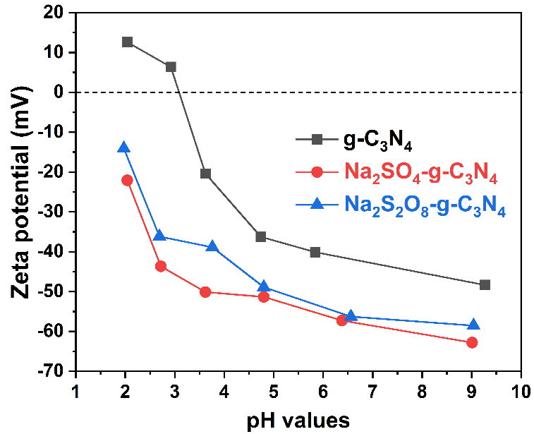
Fig. S4. Zeta-potentials of CN, SSCN, and SPCN.
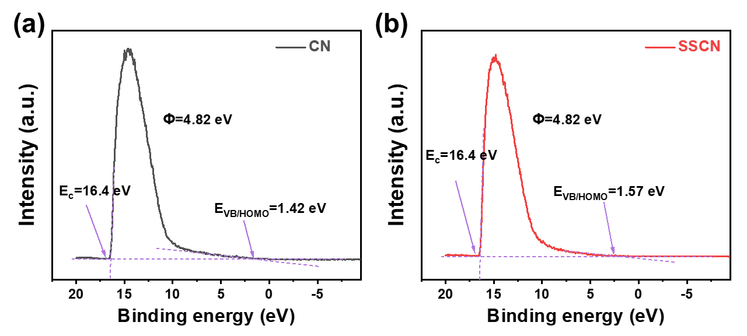
Fig. S5. The UPS spectra of (a) CN and (b) SSCN.
Table S2
Comparison of H₂O₂ generation performance of CN-based photocatalysts.
Cathode | Condition | H₂O₂ generation rate  (µmol L⁻¹ h⁻¹) | Light power (W), (source), wavelength (nm) | Ref.
g-C₃N₄ | 1 g L⁻¹ Cat., 90 Vol % Ethanol | 125 | 2000 (Xenon),  > 420 | ACS Catal. 2014, 4, 774-780
mesoporous  g-C₃N₄ | 1 g L⁻¹ Cat., 90 Vol % Ethanol | ~180 | 2000 (Xenon),  > 420 | ACS Catal. 2015, 5, 3058-3066
CoP-gC₃N₄ | 1 g L⁻¹ Cat., 10 Vol % Ethanol | 70 | 300 (Xenon),  > 420 | Eur. J. Inorg. Chem. 2017, 2017, 4797-4802.
defective g-C₃N₄ | 0.83 g L⁻¹ Cat., 10 Vol % IPA | 96.8 | AM1.5 (Sun Simulator),  > 420 | Small 2018, 14, 1703142
g-C₃N₄/CNTs | 1 g L⁻¹ Cat., 10 Vol % Ethanol | 325 | 300 (Xenon),  > 420 | Appl. Catal. B-Environ. 2018, 224, 725-732
g-C₃N₄/SiW11 | 1 g L⁻¹ Cat., 5 Vol % Ethanol | 178 | AM1.5 (Sun Simulator),  > 420 | Catal. Sci. Technol. 2018, 8, 1686-1695
Ti₃C₂/porous g-C₃N₄ | 1 g L⁻¹ Cat., 10 Vol % IPA | 131.7 | 300 (Xenon),  > 420 | Appl. Catal. B-Environ. 2019, 258, 117956
HDMP₄ grafted g-C₃N₄ | 1 g L⁻¹ Cat., 10 Vol % IPA | 174 | 300 (Xenon),  > 420 | Appl. Catal. B-Environ. 2020, 272, 118970
CN-ND | 1 g L⁻¹ Cat., 5 Vol % Ethanol | 200 | 300 (Xenon),  > 420 | ACS Sustain. Chem. Eng. 2021, 9, 4520-4530
SPCN | 0.5 g L⁻¹ Cat., 10 Vol % IPA | 323 | 300 (LED),  > 420 | This work
IPA: isopropanol
HDMP₄: 2-hydroxy-4,6-dimethylpyrimidine
SiW11: polyoxometalate (POM) cluster [SiW₁₁O₃₉]⁸⁻
CN-ND: nitrogen-deficient g-C₃N₄

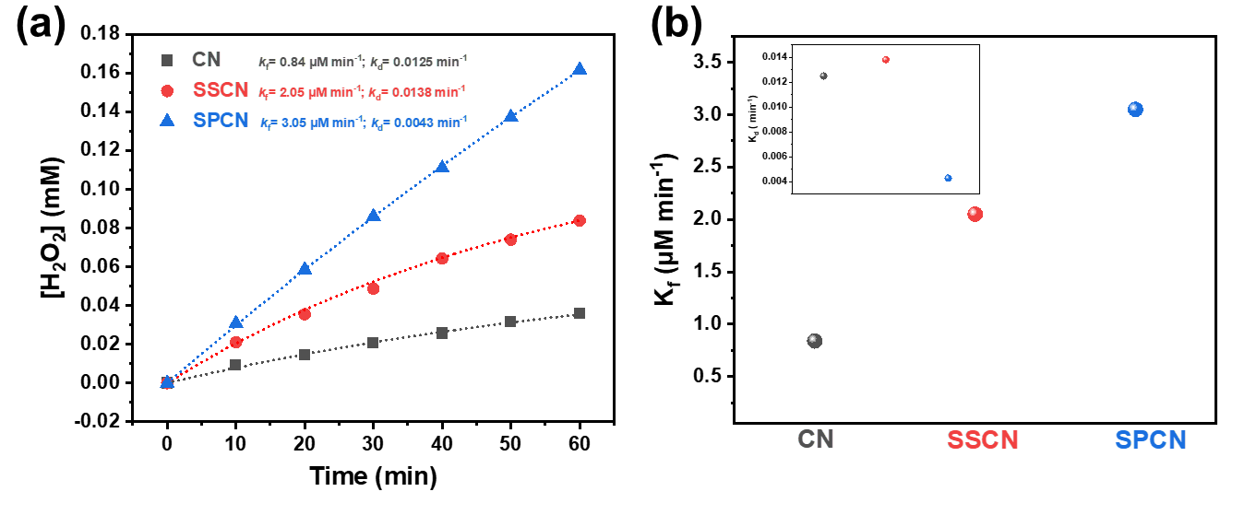
Fig. S6. (a) The kinetic models and (b) H₂O₂ formation rate constant (k_{f}) of the catalysts. The insert in (b) shows the H₂O₂ decomposition rate constant (k_{d}) of the catalysts.

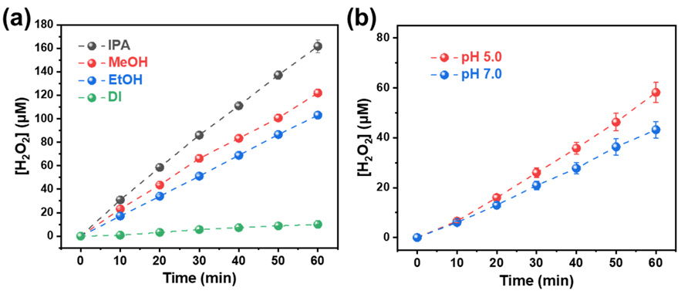
Fig. S7. Photocatalytic H₂O₂ production with SPCN (a) in the presence of IPA, MeOH, EtOH, and DI water, and (b) at pH 5.0 and 7.0.

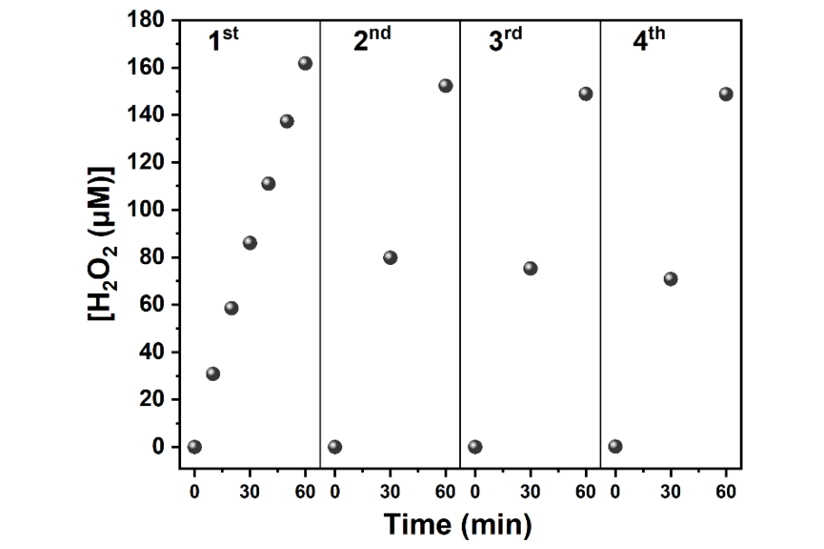
Fig. S8. Cycle test of photocatalytic H₂O₂ generation on SPCN (pH = 3, with 10 vol% IPA).
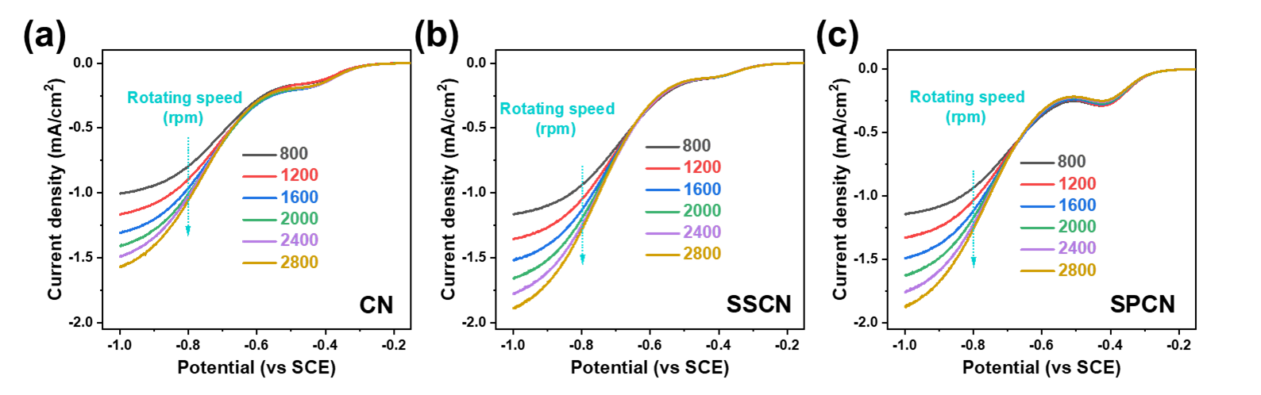
Fig. S9. LSV curves of (a) CN, (b) SSCN, and (c) SPCN were measured on RDE at different rotating speeds. Test condition: The measurements were carried out in 0.1 M Na₂SO₄ solution (pH 6.6) with a scan rate of 5 mV s^{–1}.

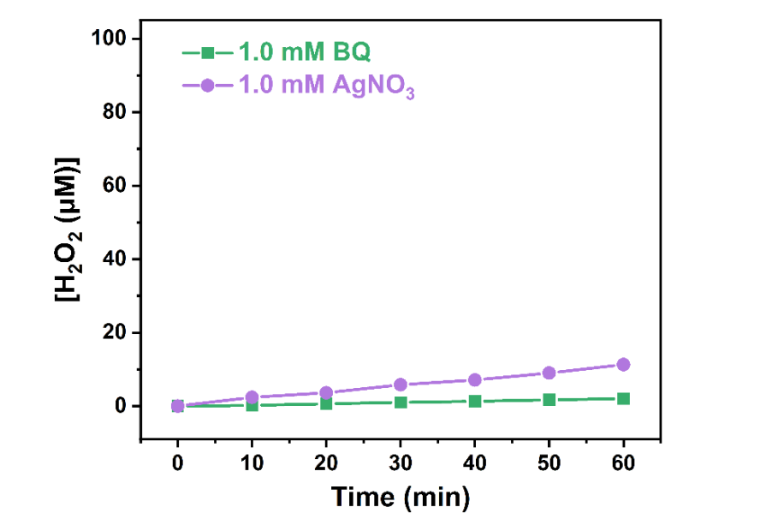
Fig. S10. The photocatalytic H₂O₂ production rates upon the addition of a sacrificial agent. For the experiment with AgNO₃ as a sacrificial agent, H₂O₂ was detected by the titanium potassium oxalate method [3].

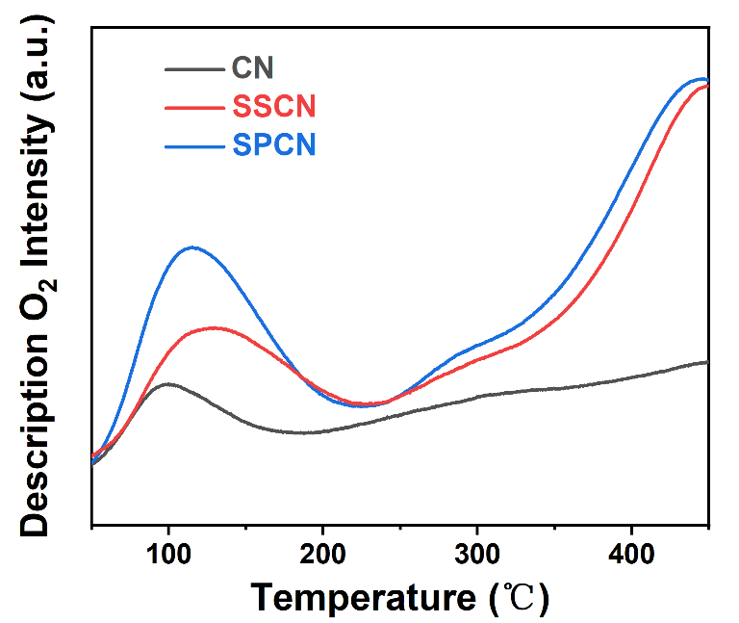
Fig. S11. The TPD-O₂ spectra of CN, SSCN, and SPCN.

References
[1] Y. Deng, L. Tang, G. Zeng, Z. Zhu, M. Yan, Y. Zhou, J. Wang, Y. Liu, J. Wang, Insight into highly efficient simultaneous photocatalytic removal of Cr(VI) and 2,4-diclorophenol under visible light irradiation by phosphorus doped porous ultrathin g-C3N4 nanosheets from aqueous media: Performance and reaction mechanism, Appl. Catal. B-Environ. 203 (2017) 343-354.
[2] C. Feng, L. Tang, Y. Deng, J. Wang, J. Luo, Y. Liu, X. Ouyang, H. Yang, J. Yu, J. Wang, Synthesis of Leaf-Vein-Like g-C3N4 with Tunable Band Structures and Charge Transfer Properties for Selective Photocatalytic H2O2 Evolution, 30 (2020) 2001922.
[3] R.M. Sellers, Spectrophotometric determination of hydrogen peroxide using potassium titanium(IV) oxalate, Analyst 105 (1980) 950-954.

