Supplementary file for

Targeting IGF2BP2–CEMIP Boosts Antiangiogenic Therapy in Colorectal Cancer in Mice

Weikang Chen ^{a,b,#}, Haojie Bai ^{a,b,#}, Yani Huo ^{b,#}, Yifan Wu ^{b}, Wei Kang ^{c}, Dong Zhang ^{b}, Yongxin Zhang ^{b}, Shiyan Wang ^{b}, Lixia Xu ^{b,d}, Chi Chun Wong ^{f}, Ka Fai To ^{c}, Xiaoxing Li ^{b,}*, Jun Yu ^{b,f,}*

ª Department of Liver Surgery, Center of Hepato-Pancreato-Biliary Surgery, The First Affiliated Hospital, Sun Yat-Sen University, Guangzhou 510080, China

^{b} Institute of Precision Medicine, The First Affiliated Hospital, Sun Yat-sen University, Guangzhou 510080, China

^{c} Department of Anatomical and Cellular Pathology, State Key Laboratory of Translational Oncology, Sir Y.K. Pao Cancer Center, Prince of Wales Hospital, The Chinese University of Hong Kong, Hong Kong 999077, China

^{d} Department of Oncology, The First Affiliated Hospital, Sun Yat-sen University, Guangzhou 510080, China

^{e} Department of Medicine and Therapeutics, Institute of Digestive Disease, State Key Laboratory of Digestive Disease, The Chinese University of Hong Kong, Hong Kong 999077, China

# These authors contributed equally.
*Corresponding authors.

E-mail addresses: lixiaox23@mail.sysu.edu.cn (X. Li), junyu@cuhk.edu.hk (J. Yu).

S1. Methods

S1.1. scRNA-seq data processing and analysis
The raw scRNA-seq fastq data were preprocessed by Cell Ranger pipelines for demultiplexing cellular barcodes, read alignment and generation of the gene-cell matrix (10× Genomics, v5.0.1, GRCh38). To identify malignant cells, we applied inferCNV (https://github.com/broadinstitute/inferCNV, RRID: SCR_021140) to infer the large- scale somatic copy number variations (CNVs) from scRNA-seq data. The following gene set scores were calculated for each cell using UCell 2 package [1]: angiogenesis signature is defined as the average expression of 36 genes obtained from Hallmark angiogenesis (MSigDB) to assess the association with angiogenesis in IGF2BP2⁺ tumor cells compared with IGF2BP2-tumor cells [2].

S1.2. In vitro vascular permeability assay
Transwell inserts (0.4 μm pore size, Corning, USA) were pre-coated with Matrigel for 30 min at 37 °C. HUVEC (1 × 10⁵) were seeded on the insert and cultured with endothelial cell medium mixed with indicated conditional medium (1:1) for 3 d at 37 °C, 5% CO₂, until they reached the appropriate confluence, and then FITC-70 kDa dextran (25 mg∙mL^{–1}; MedChemExpress, China) was added to the insert. The medium in the bottom well was collected 30 min later and fluorescent content of the samples was measured at 492/520 nm absorption/emission wavelengths.

S1.3. Microfluidic system and culture
Chips (identX 3) were purchased from AIM Biotech Pte. Ltd. (Singapore). Channel cross-sectional dimensions of gel channel are 1.30 mm (width) by 0.25 mm (height). Collagen type I (A1048301; Gibco, USA) solution (2.0 mg∙mL^{–1}) with phosphate-buffered saline (PBS; Gibco) and NaOH is injected into the gel regions of the device using a 10 mL pipette and incubated for 30 min to form a hydrogel. When the gel is polymerized, endothelial cell medium is immediately pipetted into the channels to prevent dehydration of the gel.

S1.4. Tumor spheroid generation
DLD-1 or HCT116 were seeded in non-adherent 96-well plates pre-coated with 0.5% agarose at 100 to 200 cells per well. The spheroids were grown at 37 ˚C for up to 2 d in a humidified atmosphere with 5% CO₂. To collect spheroids, the media containing the spheroids were transferred to a 15 mL conical tube, then washed twice with PBS, and centrifuged at 600 rpm for 5 min.

S1.5. In vitro model of tumor cell intravasation assay
200 μL collagen gel solution at 2.0 mg∙mL^{–1} and pH 7.4 was prepared on ice with 140 μL type I collagen (3 mg∙mL^{–1}, A1048301, Gibco), 20 μL PBS, 10 μL NaOH (0.5 mol∙L^{–1}), and 30 mL cell suspension medium with 30–50 tumor spheroids. Spheroid-containing collagen gel solution was then pipetted into the central gel region at low pressure to avoid spillage into the side channels. Once in place, collagen gel solution was kept in a humidity box at 37 ºC for 40 min to allow gel polymerization. HUVEC cell suspension (4 × 10⁴ cells), labeled with CellTracker (C34565, Invitrogen, USA), was subsequently introduced to respective media channels. After 1–2 h, HUVECs attached to the endothelial cell growth channel and formed a semi-confluent monolayer on the coverslip bottom substrate and onto the gel surface. After 3–5 days, all cells in the device were washed with PBS and later fixed with 4% paraformaldehyde for 15 min. Cell nuclei were stained with DAPI (Invitrogen) at 1:1000 dilution. All images were obtained using a confocal microscope (Olympus FV3000).

S1.6. Tumor trans-endothelial migration assay
5 × 10⁴ HUVEC were seeded on the upper surface of a transwell insert coated with type I collagen and cultured for 48–72 h until the endothelial cells formed a monolayer. A total of 1 × 10⁵ tumor cells (DLD-1/HCT116-GFP) in EGM-basic medium were added in a volume of 200 μL to the upper chamber of a 24-well transwell plate with 8 μm pore in the insert, and the medium containing 20% FBS was added to the lower chamber. After 24 to 48 hours incubation, non-migrating cells were removed with a cotton swab. Cells that have migrated into the lower chamber were counted under a ZEISS microscope.

S1.7. RNA isolation, reverse transcription, and real-time quantitative PCR (RT-qPCR)
Total RNA of cells was extracted with Ultrapure RNA Kit (CWBIO, CW0581M) following the manufacturer’s guidelines. The quantity and quality of the RNA were detected by a Nanodrop (Thermo Fisher Scientific, USA). Complementary DNA was synthesized using PrimeScrip RT reagent kit (Takara, RR037Q). qPCR was performed using TB Green Premix Ex Taq II (Takara, RR820A) on Applied Biosystems QuantStudio 5. Each sample was tested in triplicate and 2^{–ΔΔCt} method was utilized to calculate the fold change in gene expression. The primer sequences used for qPCR are listed in Table S1.

S1.8. Immunohistochemistry (IHC) and immunofluorescence (IF) staining
Sections for IHC and IF staining were deparaffinized, rehydrated, and performed antigen retrieval. Endogenous peroxidase activity was eliminated using 3% hydrogen peroxide for IHC staining. Sections were blocked with 10% goat serum (SL038; Solarbio, China) for 30 min at room temperature. The slices were incubated with anti-IGF2BP2 (11601-1-AP, 1:1000; Proteintech, China), anti-mKi-67 (12202S, 1:1000; CST, USA), anti-hKi-67 (27309-1-AP, 1:1000; Proteintech), anti-mCD31 (77699S, 1:1000; CST), anti-hCD31 (11265-1-AP, 1:1000; Proteintech), anti-CD34 (GB15013, 1:500; Servicebio, China), anti-NG2 (ET1703-16, 1:2000; Huabio, China); anti-PV-1 (GB113141, 1:2000; Servicebio), anti-CEMIP (NBP2-50336, 1:1000; Novus, USA), anti-GRP78 (GB11098-1, 1:1000; Servicebio) antibodies respectively at 4 ℃ overnight. Sections were washed three times and stained with the appropriate secondary antibodies. As for IF staining, sections were stained with DAPI, and images were captured by an Olympus FV3000 microscope.

S1.9. Western blot
Total protein from cells was extracted with RIPA lysis buffer (PC101; EpiZyme, China) supplemented with protease inhibitor (4693159001; Roche, USA) and phosphatase inhibitor (4906837001; Roche). After SDS-PAGE with 10% polyacrylamide gels, the proteins were transferred onto polyvinylidene fluoride membrane (IPVH00010; Millipore, USA) by tank blot. The membrane was blocked with 5% skim milk and incubated with anti-IGF2BP2 (11601-1-AP, 1:2000; Proteintech), anti-CEMIP (ab308288, 1:500; Abcam, USA), anti-GRP78 (11587-1-AP, 1:2000; Proteintech), anti-β-actin (4967S, 1:1000; CST) antibodies at 4 ℃ overnight followed by HRP-linked secondary antibody incubation for 1 h at room temperature. Protein signals were detected by the Amersham Imager 600 Imaging System (GE, USA).

S1.10. Cell line and cell culture
Human colorectal cell lines HCT116 and DLD-1 were acquired from American Type Culture Collection (ATCC). All cell lines were proved free from mycoplasma contamination and identified by short tandem repeat (STR) analyses. HCT116 was cultured in McCoy's 5A supplemented with 10% fetal bovine serum (FBS; Gibco) and 1% penicillin-streptomycin. DLD-1 was cultured in RPMI1640 medium supplemented with 10% FBS and 1% Penicillin-Streptomycin. All cell lines were cultured at 37 °C in an incubator with 95% air and 5% CO₂ supply. Human umbilical vein endothelial cells (HUVEC) were purchased from the China Center for Type Culture Collection (CCTCC, China) and cultured in EGM-2 medium (ScienCell, USA). CRC patient-derived organoids were cultured as previously described [3].

S1.11. Plasmids and gene transfection
Wild-type and KH3-4 domain mutant human IGF2BP2 sequences (NM_006548.6) were PCR-amplified and cloned into the pMSCVpuro lentiviral vector (Addgene plasmid # 68469) at the Bgl II/EcoR I restriction site. The full-length 3xFlag-tagged CEMIP cDNA (NM_001293298.2) was amplified and cloned into the BamHI/EcoRI restriction site of pLV-EF1a-IRES-Blast vector (Addgene plasmid # 85133). These constructs were confirmed by DNA sequencing. IGF2BP2 and negative control (shCtrl) shRNAs were cloned into lentivirus shRNA expression plasmid GV493-GFP-puro (GeneChem, China). The shRNA target sequences were as follows: shCtrl: 5′-TTCTCCGAACGTGTCACGT-3′; shIGF2BP2#1: 5′-AGCGCAAGATCAGGGAAATTG-3′; shIGF2BP2#2: 5′-AGTGAAGCTGGAAGCGCATAT-3′. Lentivirus was produced by triple transfection of 293T cells with the pLV and GV493 vector and the packaging plasmids psPAX2 (Addgene plasmid # 12260) and pMD2.G (Addgene plasmid # 12259) at a ratio of 5:3:2. For siRNA knockdown, HUVECs were transfected with GRP78 siRNAs (Guangzhou RiboBio Co., Ltd.). The siRNA target sequences were as follows: siGRP78-1: 5′-GGAGCGCATTGATACTAGA-3′; siGRP78-2: 5′-GAGGTAAACTTTCCTCTGA-3′. siRNA was transiently transfected into HUVECs using Lipofectamine 3000 Transfection Regent (L3000015; Invitrogen).

S1.12. Cell viability and colony formation assay
Cell viability assays were conducted utilizing Cell Counting Kit-8 (CA1210; Solarbio, China) colorimetric assay according to manufacturer’s instruction. The plate colony formation assay was performed to assess the colony formation ability of CRC cells. In brief, 1000 of IGF2BP2 knockdown or overexpressed CRC cells were seeded in 6-well plate. Following two weeks incubation, the cells were fixed and stained for quantification.

S1.13. Subcutaneous xenograft mouse models
For xenograft assay, approximately 5 × 10⁶ HCT116/DLD-1 cells were subcutaneously implanted into the right flanks of 4- to 6-week-old male NOD/SCID mice. The mice were monitored for changes in body weight and tumor volume every 2 to 3 d until the study endpoint.

S1.14. In vivo metastasis assays (lung and liver metastasis)
5 × 10⁶ of HCT116 cells were administered intravenously through the tail vein of 4- to 6-week-old NOD/SCID male mice. The health status of the mice was regularly monitored, with increased frequency as they approached humane intervention thresholds. The lungs of each mouse were removed, fixed in paraffin, and evaluated for lung metastasis via H&E staining.
The mouse model of liver metastasis was established by intrasplenic injection of 1 × 10⁶ HCT116 cells into NOD/SCID male mice. The mice were euthanized 4 weeks post intrasplenic injection, and their livers were extracted and preserved for subsequent histological analysis. The liver metastasis was assessed either by the number of visible liver metastatic nodules or the proportion of tumor metastases in the mouse liver when tumor nodules were indistinguishable.

S1.15. Hematoxylin and eosin (H&E) staining
Tissues from mouse models were fixed in 4% paraformaldehyde and embedded in paraffin and cut into 4 μm sections. Sections were heated in 65 °C for 2 h before staining. Slides were deparaffinized in xylene, rehydrated in graded alcohol and then subsequently rinsed in water. The sections were stained with hematoxylin and eosin followed by dehydration in graded alcohol, clearing in xylene, and then mounting in Mounting Medium (ZSGB, ZLI-9516). Slides were scanned by KFbio scanner (KF-PRO-020).

S1.16. TUNEL staining
For TUNEL fluorescence staining, In Situ Cell Death Detection kit (11684795910; Roche) according to manufacturer’s instructions. Sections for TUNEL staining were deparaffinized, rehydrated and treated with protease K. The slices were incubated with recombinant TdT enzymes and stained with DAPI.

S1.17. RNA sequencing
Total RNA of cells was extracted with Ultrapure RNA Kit (CW0581M, CWBIO, China). RNA concentration and quality were assessed using a Nanodrop 2000 (Thermo Fisher Scientific). mRNA Purification Kit (Invitrogen) was applied to deplete rRNA and isolate poly(A)+ RNA by using oligo d(T). The isolated mRNA was fragmented using fragmentation reagents (Invitrogen). The short fragments were primed with random hexamers for first-strand cDNA synthesis, then second-strand cDNA synthesis. Next, adenine (A) nucleotide was added to the 3′ ends of the blunt fragments. During adapter ligation and amplification, indexes and adapters were added to both ends of the fragments. The libraries were sequenced on an Illumina Hiseq 4000 platform and 150-bp paired-end reads were generated. Pathway analysis was conducted by KEGG database and GSEA database.

S1.18. Enzyme-linked immunosorbent assay (ELISA)
Eight-well strips were coated with 100 μL per well of anti-CEMIP antibody (A8587; ABclonal, China) in ELISA coating buffer (pH 9.6, Solarbio). Plates were incubated at 4 ℃ overnight. After washing with PBS, 3% BSA was added and incubated for 1 h at 37 ℃. Samples and standards were added to each well and incubated for 2.5 h at room temperature. After discarding the solution and washing, 100 μL of primary mouse anti-CEMIP antibody (sc-293483; Santa Cruz, USA) was added to wells and incubated for 1 hour at 37 ℃. After discarding the solution and washing, 100 μL of secondary HRP-linked antibody (7076S; CST) diluted 1:2000 was added, and incubated for 1 hour at 37 ℃. 90 μL of TMB was added to each well and incubated for 10 min at room temperature. Then 50 μL of stop solution was added and OD 450 nm of each well was detected by Varioskan LUX (Thermo Scientific, USA).

S1.19. m⁶A methylated RNA immunoprecipitation-sequencing
m⁶A methylated RNA immunoprecipitation-sequencing (m⁶A MeRIP) was conducted according to the previously described method [4]. In brief, total RNA extracted from DLD-1 cells was fragmented and then exposed to an anti-m⁶A antibody (ABE572-I; Merck Millipore, USA) at 4 ℃ for overnight immunoprecipitation. Subsequently, both the input RNA and the m⁶A-modified RNA underwent high-throughput sequencing. The regions enriched with m⁶A were identified by MeTPeak.

S1.20. RNA immunoprecipitation
A total of 1 × 10⁷ DLD-1 cells with IGF2BP2 overexpression/mutation/control were scraped from plate and extracted with 1 mL of RIP lysis buffer (1 mL NETN (100 mmol∙L^{–1} NaCl, 20 mmol∙L^{–1} Tris-HCl, 0.5 mmol∙L^{–1} EDTA, 0.5% Nonidet P40, pH = 8.0) + 10 μL Protease inhibitor +10 μL RNaseOUT (Invitrogen) +10 μL RQ1 DNase (Promega, USA)) for 10 min at room temperature. 50 µL cell lysis was used as input. Then the remaining cell lysate was incubated with anti-IGF2BP2 antibodies and precleaned Protein A/G magnetic beads (Invitrogen) at 4 ℃ overnight. The immunoprecipitates were washed three times with cold RIP wash buffer (1× PBS, 0.1% SDS, 0.5% Nonidet P40), re-suspended with 150 μL NETN buffer containing 5 μL proteinase K and incubated at 45 ℃ for 45 min to reverse crosslinking. The total RNAs were extracted by Ultrapure RNA Kit. Samples were evaluated by reverse transcription RT-qPCR or analyzed by RNA-seq.

S1.21. RNA pulldown assays
RNA pulldown assays were performed with RNA pulldown Kit Bes5102 (BersinBio, China) following the manufacturer’s protocol. In brief, biotin-labeled RNA oligonucleotides with m⁶A modification was denatured and immobilized onto streptavidin magnetic beads. RNA-conjugated streptavidin beads were washed, resuspended in binding buffer, and incubated with cell lysis or recombinant human IGF2BP2 protein (Cat: 11116-H20B; Sino Biological, China) at 4 °C overnight. After extensive washing, RNA-protein complexes were dissolved in 1x SDS buffer and subjected to western blot analysis. The sequences of probes are listed as follows: positive control: 5'biotin-CGUCUCGG(m⁶A)CUCGG(m⁶A)CUGCU-3'; CEMIP-ss-A：5′biotin- uagacuaugacggugacucuuggcagcagaccag-3′; CEMIP-ss-m⁶A：5′biotin-uagacuaugacggug (m⁶A) cucuuggcagcag(m⁶A) ccag-3′.

S1.22. Co-immunoprecipitation (Co-IP)
CRC tumor cells were lysed with NP40 buffer supplemented with proteinase inhibitors. After sonication, cell lysates were used for immunoprecipitation with IGF2BP2 antibody or the corresponding IgG. Proteins were conjugated to Protein A/G Magnetic Beads (Thermo Fisher Scientific) by incubation at 4 ºC overnight. Beads were then washed for three times with IP washing buffer. Proteins were dissolved in 1× SDS buffer and analyzed by western blotting.

S1.23. Ribosome nascent-chain complex (RNC)-qPCR
5 × 10⁶ DLD-1 cells with IGF2BP2 knockdown or control were incubated with 100 μg∙mL^{–1} of CHX at 37 ℃ for 15 min. Cells were scraped and extracted with lysis buffer (RB buffer (20 mmol∙L^{–1} HEPES-KOH, 15 mmol∙L^{–1} MgCl₂, 200 mmol∙L^{–1} KCl, 0.1 mg∙mL^{–1} cycloheximide, and 2 mmol∙L^{–1} dithiothreitol) with 1% Triton-X100). Cell lysates were centrifuged at 16 200g for 10 min and 1/10 of supernatant was taken as an input. The rest of supernatant was transferred gently on the top of 11 mL sucrose buffer (30% sucrose in RB buffer) and centrifuged at 174 900g for 5 h at 4 ℃. Ultrapure RNA Kit was used for RNC-mRNA extraction.

S1.24. RNA stability assays
HCT116/DLD-1 cells with IGF2BP2 overexpression or knockdown or control were seeded into 12-well plates and then treated with 2.5 μmol∙L^{–1} actinomycin D (ActD) (MedChemExpress, China). Cells were harvested with TRIzol at 0, 4, 8, 12, and 16 h of ActD treatment. Finally, quantification of targeted RNA was performed through RT-qPCR.

S1.25. CEMIP protein expression and purification
The serum-free conditioned medium from DLD-1 cells overexpressing CEMIP-3xHIS was concentrated using an Amicon Ultra15 Centrifugal Filter Device (UFC901024; Merck Millipore). CEMIP-3xHIS was adsorbed using Ni-IMAC Magnetic Beads (A50591, Thermo Scientific) at 4 ℃ overnight. Subsequently, complexes were washed with buffer (50 mmol∙L^{–1} monosodium phosphate, 300 mmol∙L^{–1} sodium chloride, 20 mmol∙L^{–1} imidazole in water; pH 8.0) and eluted using Elution Buffer (50 mmol∙L^{–1} monosodium phosphate, 300 mmol∙L^{–1} sodium chloride, 500 mmol∙L^{–1} imidazole in water; pH 8.0). CEMIP-3xHIS fractions were collected analyzed by SDS-PAGE.

S1.26. Membrane protein Co-IP and mass spectrometry
Membrane proteins of HUVECs were isolated with Mem-PER Plus Membrane Protein Extraction Kit (89842; Thermo Scientific) following the guidelines provided by the manufacturer. The concentrated conditioned medium from DLD-1 cells overexpressing CEMIP was incubated with HUVEC membrane proteins at 4 ℃ overnight. Immunoprecipitation of the complex was carried out using Protein A+G Agarose (P2055; Beyotime, China) and mouse anti-Flag antibody (66008-3-Ig, Proteintech). The pulldown complex was assayed by Western blot and liquid chromatography mass spectrometry (LC-MS).

S1.27. Pull down assay
The purified recombinant CEMIP-3xFlag was co-incubated with recombinant HIS-GRP78 (ab78432; Abcam) at 4 ℃ overnight. Following this incubation, the resultant complex underwent immunoprecipitation using anti-Flag magnetic beads (P2115; Beyotime) and anti-His magnetic beads (P2135; Beyotime), respectively. The subsequent Western blot was assayed by anti-Flag antibody (66008-3-Ig; Proteintech) and anti-His-tag antibody (66005-1-Ig; Proteintech).

S1.28. Preparation of LNP-siRNA
The LNPs used in this study were prepared by Guangzhou Kelan Biotechnology (China) following standardized protocols. Their morphology, colloidal stability, and loading efficiency have been validated [5]. Briefly, a solution of siRNA (15 nmol, 25 μL) was emulsified by sonication in an ice bath for 1 min in 0.5 mL of chloroform containing 2 mg of 1,2-dioleoyl-3-trimethylammonium-propane (DOTAP) and 25 mg of mPEG-b-PLGA. This primary emulsion was further emulsified in 5 mL of DEPC water by sonication (65 W for 2 min) over an ice bath. Afterwards, chloroform was removed by rotary evaporator to obtain the LNP-siRNA formulation. The resulting LNP-siRNAs were stored at 4 °C for subsequent experiments.

S2. Tables and figures
Table S1
Primers used for RT-qPCR.
Gene | Forward (5′– 3′) | Reverse (5′– 3′)
METTL3 | CATTGCCCACTGATGCTGTG | AGGCTTTCTACCCCATCTTGA
METTL14 | GAACACAGAGCTTAAATCCCCA | TGTCAGCTAAACCTACATCCCTG
FTO | GCTGCTTATTTCGGGACCTG | AGCCTGGATTACCAATGAGGA
ALKBH5 | AGTTCCAGTTCAAGCCTATTCG | TGAGCACAGTCACGCTTCC
WTAP | ACTGGCCTAAGAGAGTCTGAAG | GTTGCTAGTCGCATTACAAGGA
YTHDF1 | ACCTGTCCAGCTATTACCCG | TGGTGAGGTATGGAATCGGAG
YTHDF2 | CCTTAGGTGGAGCCATGATTG | TCTGTGCTACCCAACTTCAGT
YTHDF3 | TCAGAGTAACAGCTATCCACCA | GGTTGTCAGATATGGCATAGGCT
YTHDC1 | GAGGGCCAAATCTCCTACGC | GTCTCATGGTCAGAGCCATATTC
YTHDC2 | AGGACATTCGCATTGATGAGG | CTCTGGTCCCCGTATCGGA
IGF2BP1 | GGCCATCGAGAATTGTTGCAG | CCAGGGATCAGGTGAGACTG
IGF2BP2 | ACTCACCTCTTCAGAACGAATTG | CCATCTTTGGAAGGTTCAGGTTG
IGF2BP3 | ACGAAATATCCCGCCTCATTTAC | GCAGTTTCCGAGTCAGTGTTCA
CEMIP | CACGGTCTATTCCATCCACATC | GGTTCGCAAAACAATCGGCT
GRP78 | CATCACGCCGTCCTATGTCG | CGTCAAAGACCGTGTTCTCG
GAPDH | GTCTCCTCTGACTTCAACAGCG | ACCACCCTGTTGCTGTAGCCAA
5'arm-CKO | GTAGGAAGCGTTCTGTCTAAGGTG | GCTCAAGGACAACTGGTAAAGTCAC
3'arm-CKO | TACATAGGGATTTCCAGGGCAG | GGAGAGATAGAAGTAAGGAGGACACAC
5'arm-CKI | ATGCCCACCAAAGTCATCAGTGTAG | AGGCGGGCCATTTACCGTAAGTTA
3'arm-CKI | TCAATCCAGCGGACCTTCCTT | TCACAGAAACCATATGGCGCTCC
WT-CKI | CAGCAAAACCTGGCTGTGGATC | ATGAGCCACCATGTGGGTGTC
Cre-mice F | GCCTTCTCCTCTAGGCTCGT
Cre-mice R1 | TATAGGGCAGAGCTGGAGGA
Cre-mice R2 | AGGCAAATTTTGGTGTACGG
PLVXEF-CEMIP-6xHis | TTTCAGGTGTCGTGAGGATCCATGGGAGCTGCTGGGAGGCA | GCGGCCGCCCTCGAGGAATTCCTAGTGATGGTGATGGTGATGACCACCACCCAACTTCTTCTTCTTCA
PLVXEF-CEMIP-3xFlag | TTTCAGGTGTCGTGAGGATCCATGGGAGCTGCTGGGAGGCA | GCGGCCGCCCTCGAGGAATTCCTACTTGTCATCGTCATCCTTGTAATCGATATCATGATCTTTATAATCACCGTCATGGTCTTTGTAGTCACCACCACCCAACTTCTTCTTCTTCA

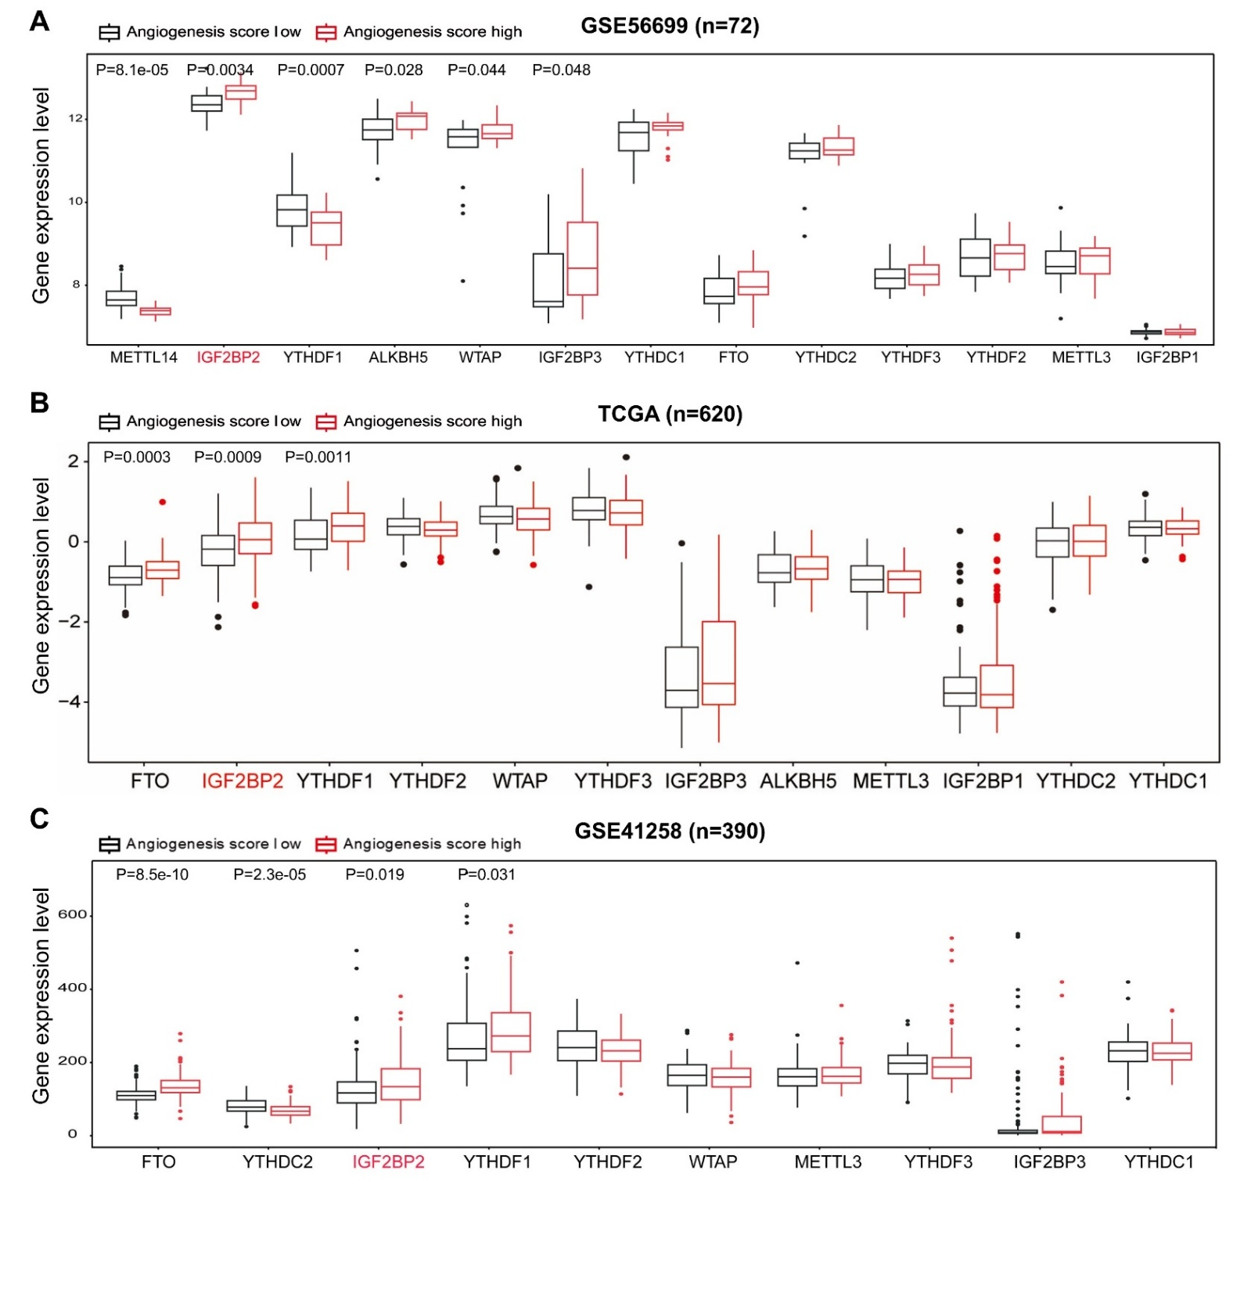
Fig. S1. Boxplots illustrating the expression levels of m⁶A-related genes in the (a, n = 72) GSE56699 dataset, (b, n = 620) TCGA, and (c, n = 390) GSE41258 dataset stratified by angiogenesis score. Two-tailed Student’s t-test was used to calculate P value.
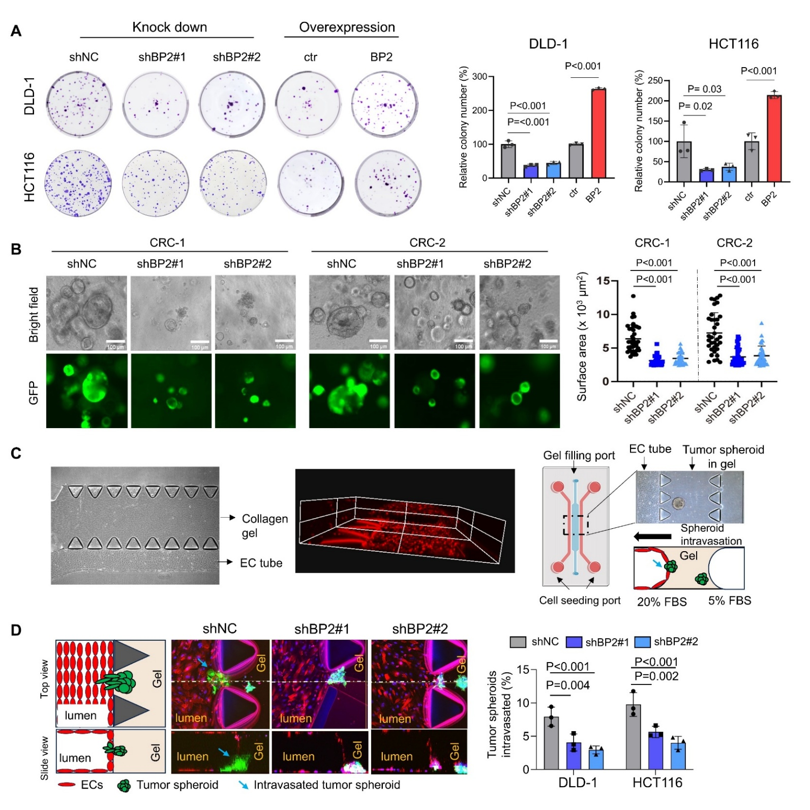
Fig. S2. (a) Representative images and quantification of colony formation in DLD-1 and HCT116 CRC cells upon IGF2BP2 knockdown or overexpression. (b) Brightfield and fluorescence images of CRC organoids with IGF2BP2 knockdown compared to control and the corresponding quantification of organoids surface area. (c) A brightfield image (left) of microfluidic vessel system with collagen gel in middle channel and endothelial cell tubes on the side. 3D reconstruction demonstrates the vascular lumen formation of endothelial cells in the tube. (d) Schematic and fluorescence images of a microfluidic vessel model for intravasation analysis. Tumor cell intravasation was quantified. (a, b, c) Analysis of variance test was used to calculate P values. All in vitro experiments were conducted three times in triplicate.
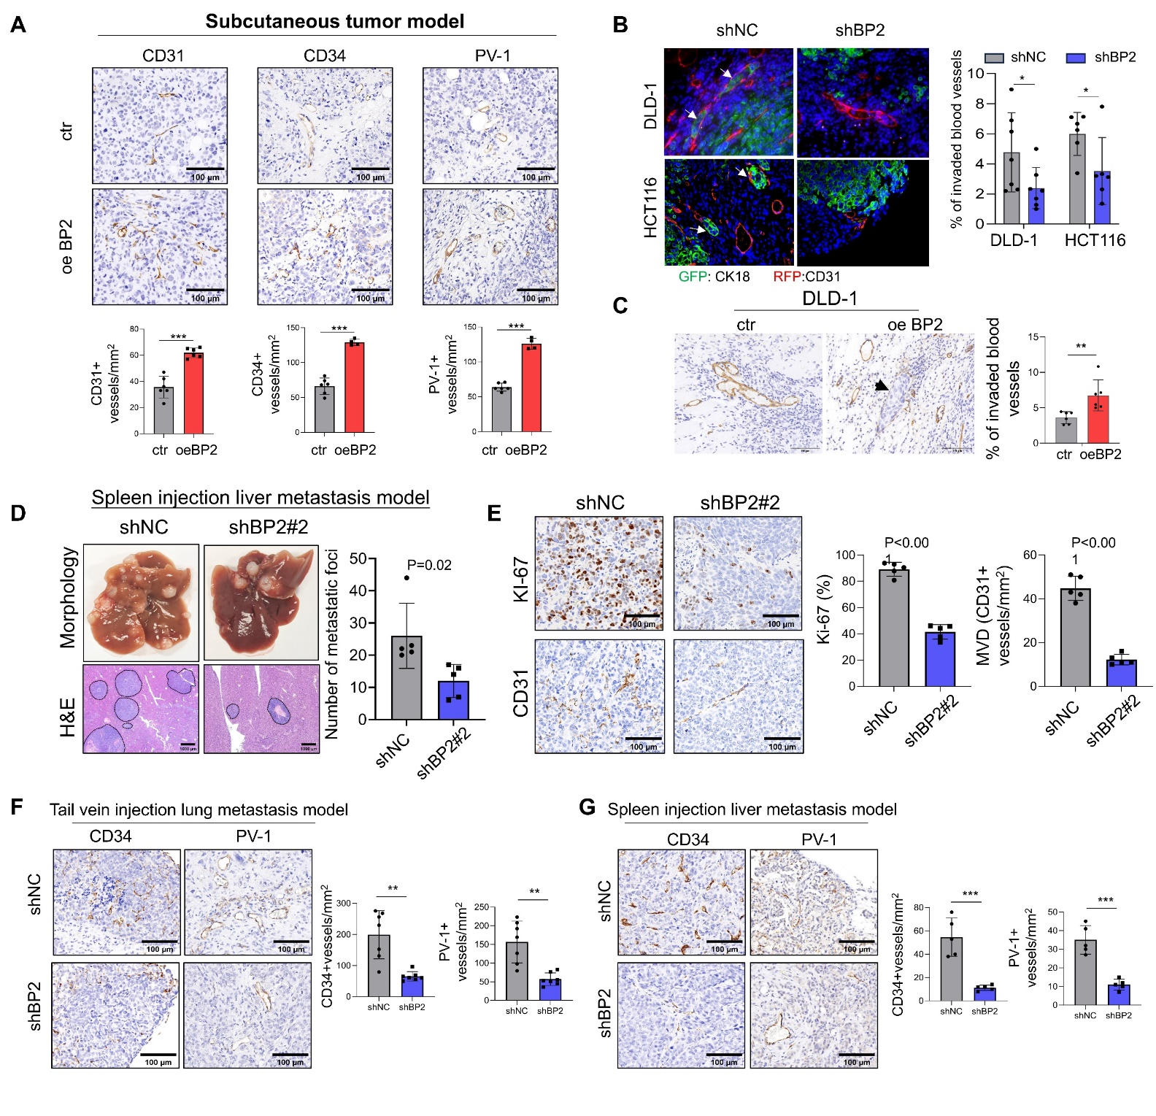 Fig. S3. (a) Representative IHC staining and quantification of CD31, CD34, and PV-1 of subcutaneous xenografts of DLD-1 cells with IGF2BP2 overexpressed or control. (b) IF images of subcutaneous xenografts of DLD-1 and HCT116 cells, showing GFP-tagged tumor cells (CK18) and RFP-tagged blood vessels (CD31) in control and IGF2BP2 knockdown groups. Quantification of the percentage of invaded blood vessels. (c) IHC images of CD31 in subcutaneous xenografts of DLD-1 cells with IGF2BP2 overexpressed or control. Tumor cells were identified by hematoxylin staining. Quantification of the percentage of invaded blood vessels. (d) Representative images and hematoxylin and eosin (H&E) staining of spleen injection liver metastasis model. (e) Ki-67 and CD31 IHC of liver metastasis model. (f) Representative IHC staining and quantification of CD34 and PV-1 of tail vein injection lung metastasis model. (g) Representative IHC staining and quantification of KI-67, CD31, CD34, and PV-1 of spleen injection liver metastasis model. Two-tailed Student’s t-test was used to calculate P value. *P < 0.05, **P < 0.01, ***P < 0.001.

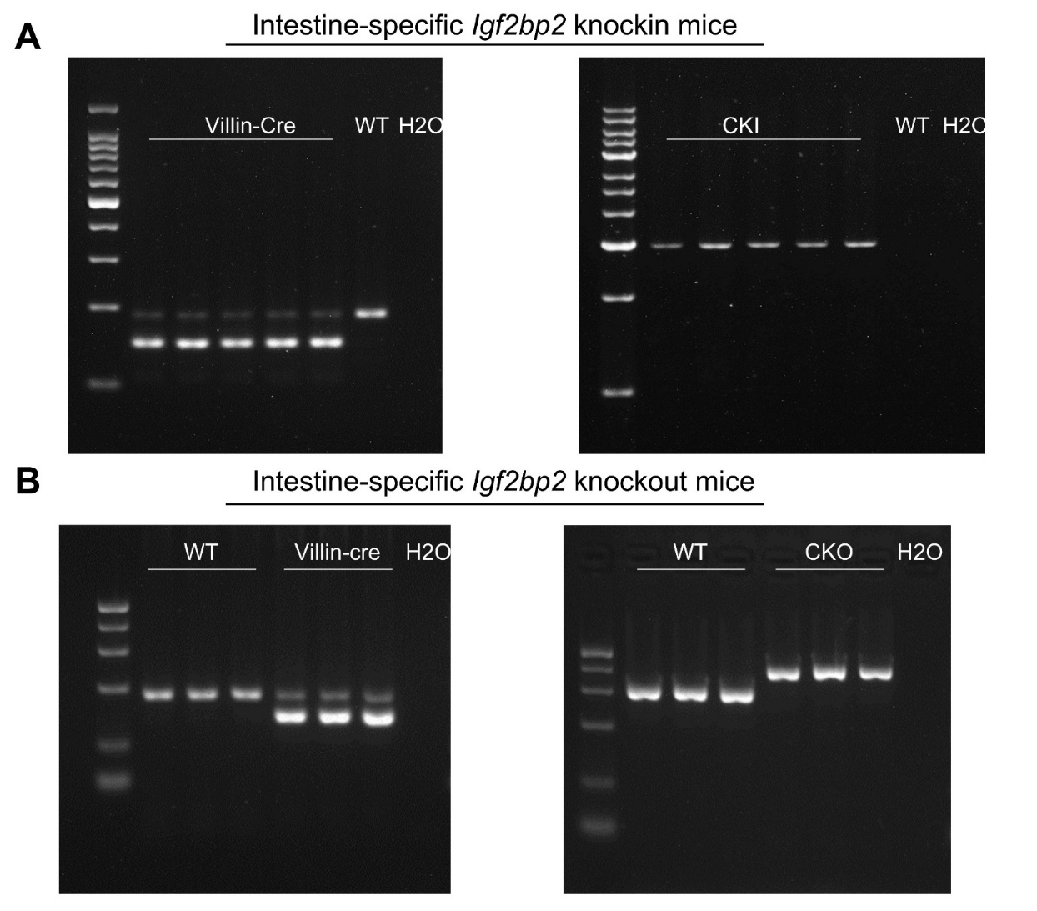
Fig. S4. Confirmation of genotype of WT, (a) CKI mice or (b) CKO mice by PCR analysis of DNA extracted from mouse tail.

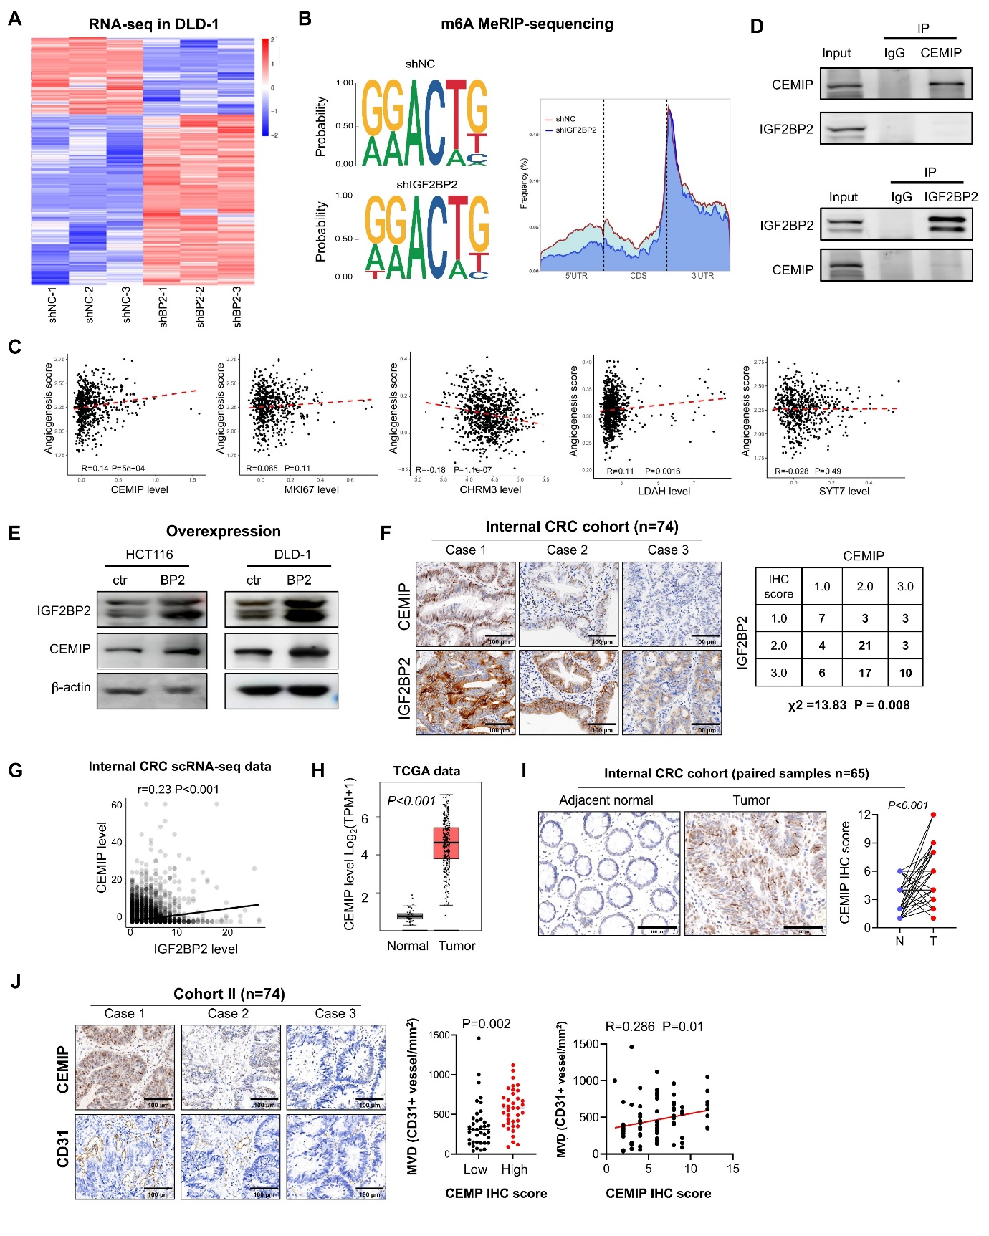
Fig. S5. (a) Heatmap of differentially expressed genes in DLD-1 cells with IGF2BP2 knockdown compared to control. (b) Sequence motifs identified as m⁶A-enriched sites. (c) Correlation analysis between the mRNA levels of IGF2BP2 potential targets and Hallmark angiogenesis signature score in TCGA cohort, dashed line indicates linear regression fit (Spearman R). (d) Western blot of CEMIP and IGF2BP2 pulled down each other by Co-IP assay. (e) Western blot of IGF2BP2 and CEMIP protein expression in CRC cells with IGF2BP2 overexpression or control. (f) Representative images and correlation analysis of IGF2BP2 and CEMIP IHC staining in CRC tissues. (g) Scatter plot of correlation between CEMIP and IGF2BP2 expression levels in scRNA-seq data from the internal CRC cohort (n = 15). Linear regression. (h) Boxplot of CEMIP mRNA levels in tumor tissues compared to normal tissues in the TCGA dataset. (i) Representative IHC images and quantitative analysis of CEMIP expression in tumor tissues compared to paired adjacent normal tissues of internal CRC cohort (n = 64). Scale bars, 100μm. (j) IHC analysis of IGF2BP2 and CD31 in CRC tissues (n = 74) to assess MVD correlation. (h, i, j) Two-tailed Student’s t-test, and (f) Pearson χ² test was used to calculate P value.

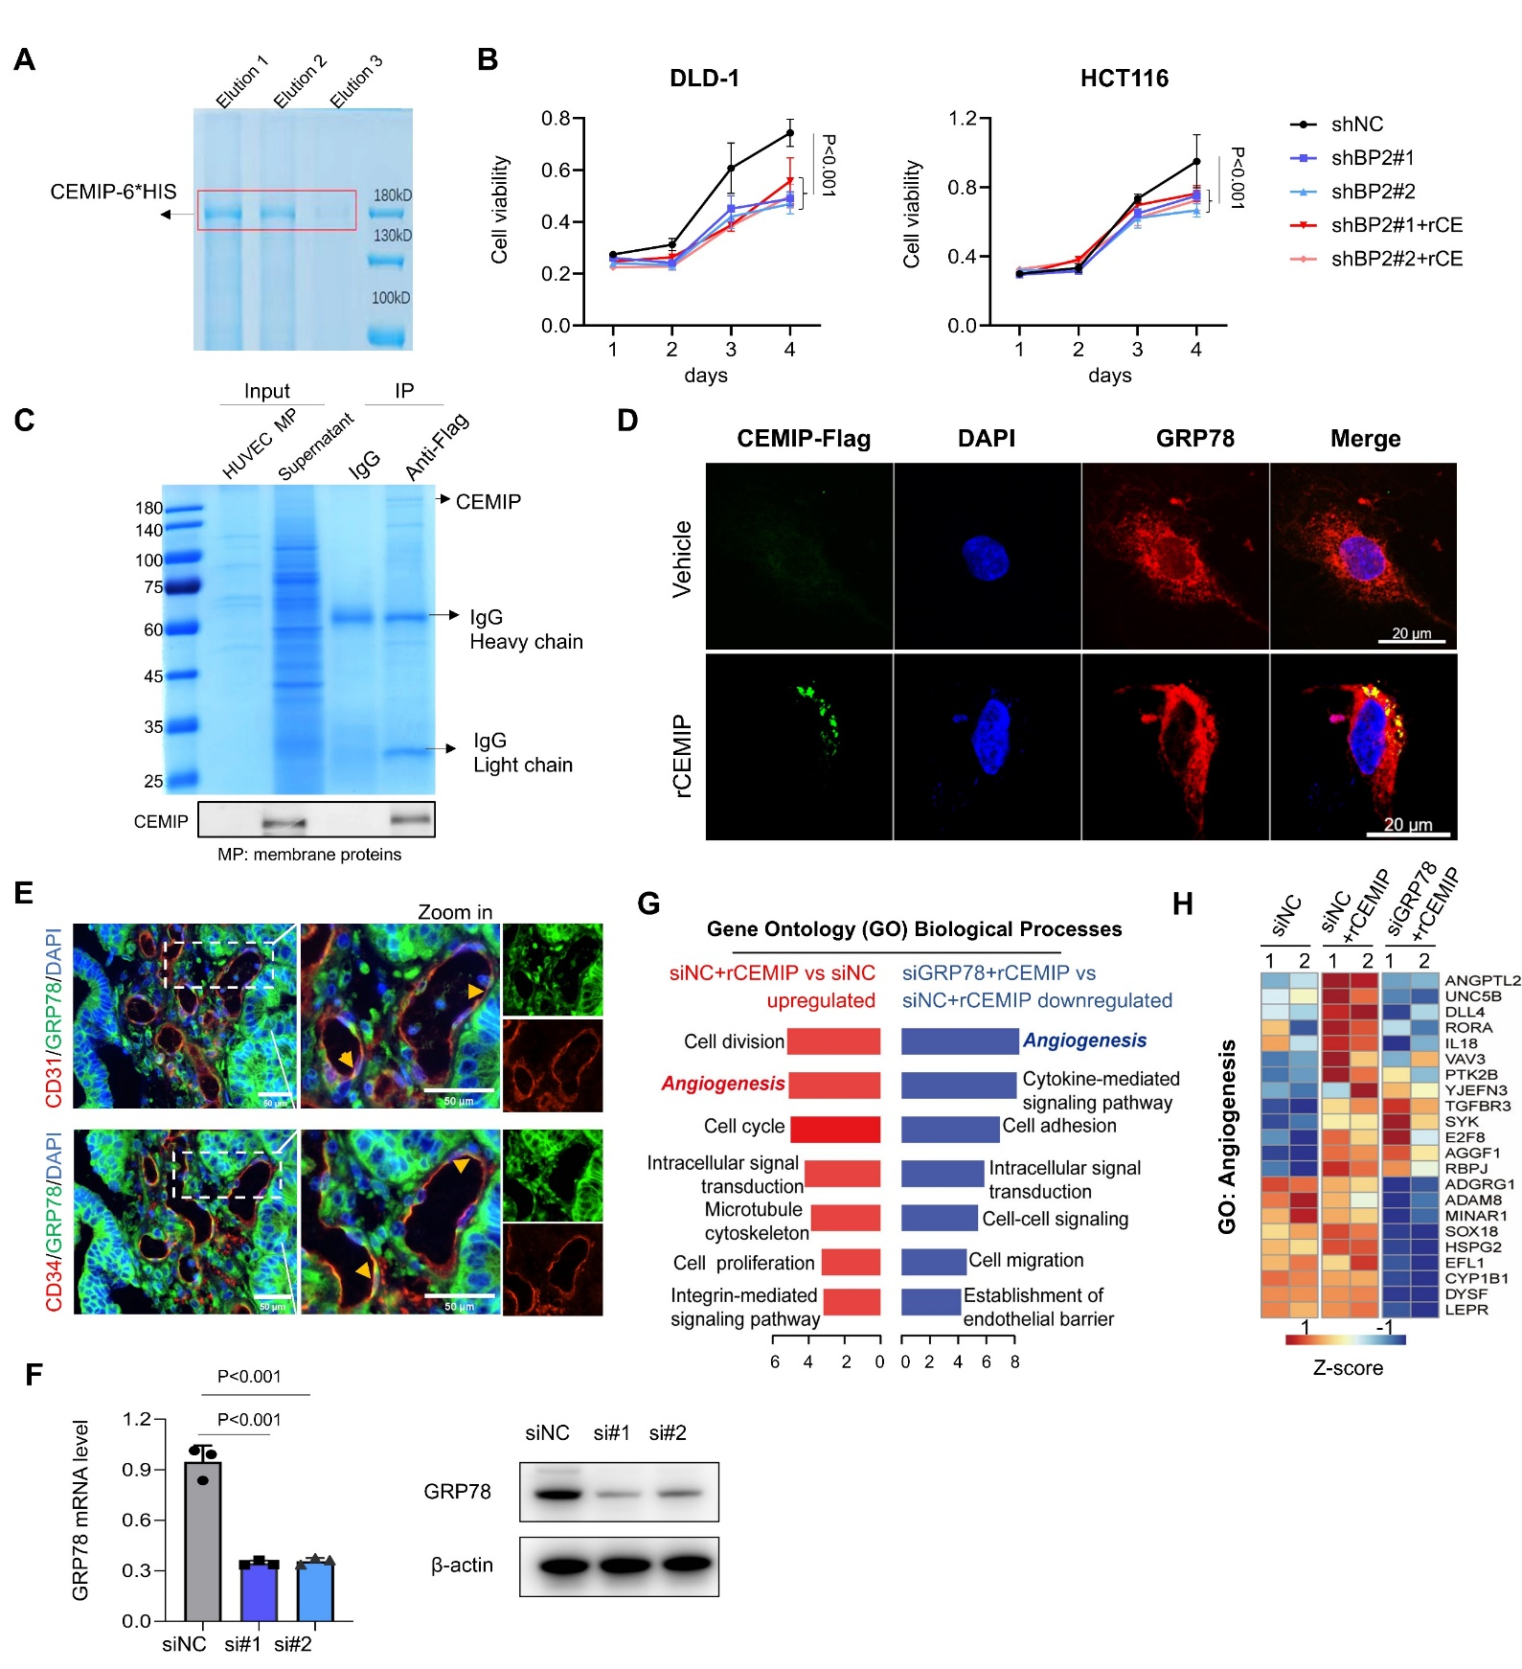
Fig. S6. (a) Coomassie brilliant blue staining of the eluted fractions from CEMIP-6× His purification. (b) Cell growth curve analysis of CRC cells with IGF2BP2 knockdown and treatment with recombinant CEMIP (rCE). (c) Coomassie brilliant blue staining and western blot of the product by Co-IP with supernatant contained CEMIP-Flag protein and HUVEC membrane protein. (d) IFA analysis confirmed the binding of Flag-rCEMIP with GRP78 on HUVEC cells. (e) Representative images of IF staining showing the co-localization of CD31 (red) or CD34 (red) with GRP78 (green) in CRC tissue sections. (f) qRT-PCR and western blot analysis confirmed the reduction of GRP78 mRNA and protein levels in HUVECs using siRNA knockdown. (g) Gene Ontology (GO) analysis of gene expression changes in HUVECs post-recombinant rCEMIP treatment. (h) RNA-seq analysis of angiogenesis-related gene expression in HUVECs with indicated treatments. (b, f) Analysis of variance test and (e) two-tailed Student’s t-test was used to calculate P value.
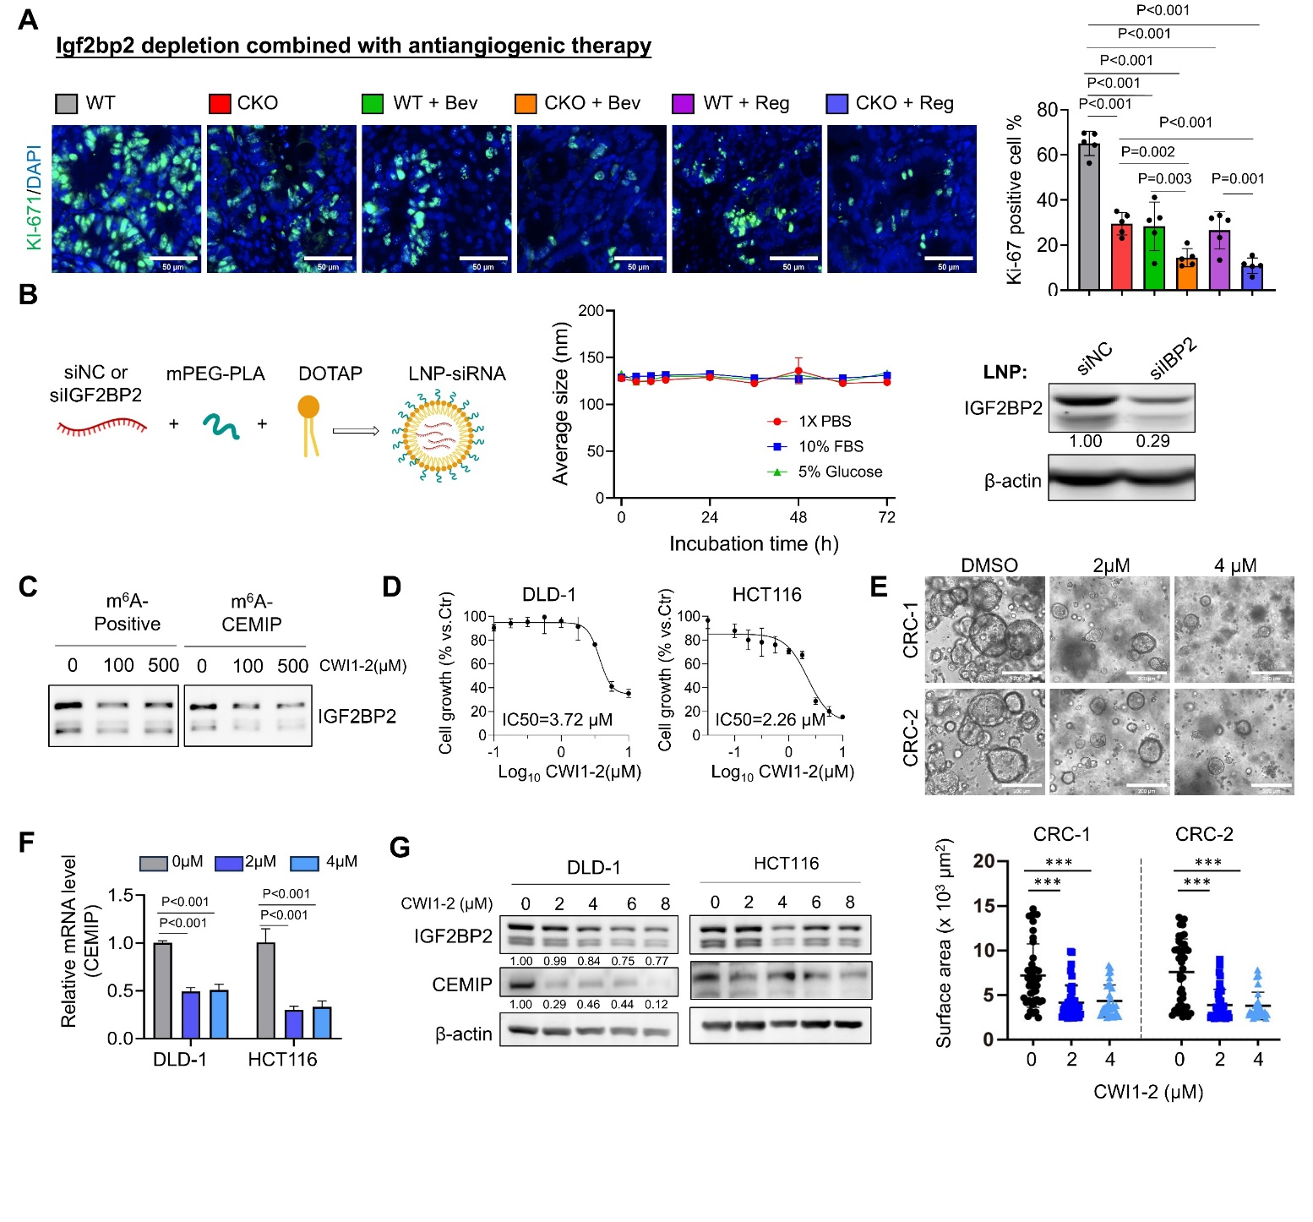
Fig. S7. (a) Representative IF staining and quantification of KI-67 of WT and intestine-specific Igf2bp2 KO mice (CKO) with bevacizumab and regorafenib treatment. (b) Schematic representation of LNP-siRNA preparation, the stability of LNP-siIGF2BP2 and western blot of efficiency detection of LNP-siRNA in vitro. (c) Western blot of IGF2BP2 of biotin RNA pull pull-down assay with different concentrations of CWI1-2. (d) Half maximal inhibitory concentration (IC50) of CRC cells treated with the CWI1-2. (e) Brightfield images of CRC organoids treated with increasing concentrations of CWI1-2 or DMSO and the corresponding quantification of organoids surface area. (f) Real time qPCR of CEMIP in CRC cells treated with CWI1-2. (g) Western blot analysis of IGF2BP2 and CEMIP in CRC cells treated with increasing concentrations of CWI1-2. (a, e) Analysis of variance test and (d) two-tailed Student’s t-test was used to calculate P value. *P < 0.05, **P < 0.01, ***P < 0.001.

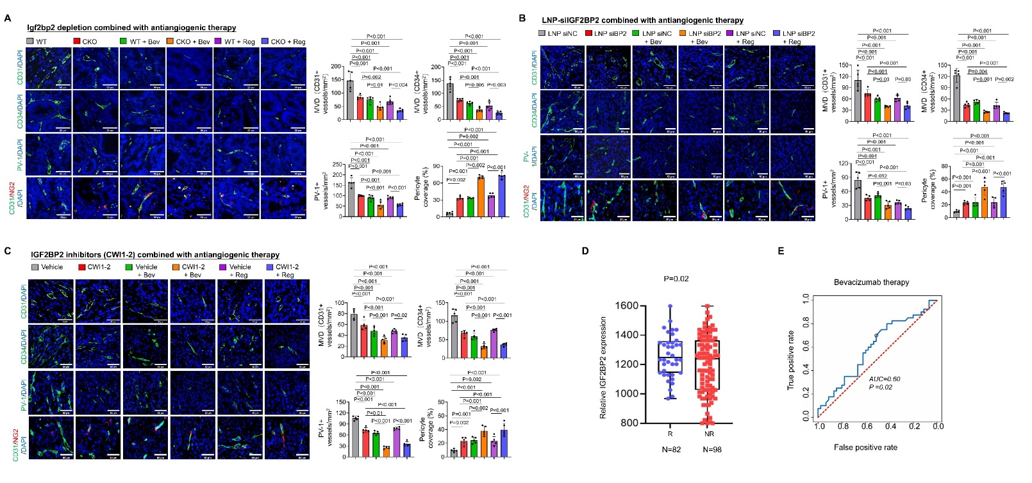
Fig. S8. (a) Representative IF staining and quantification of CD31, CD34, CD31/NG2, and PV-1 of WT and intestine-specific Igf2bp2 KO mice with bevacizumab and regorafenib treatment (n = 5 per group). (b) Representative IF staining and quantification of CD31, CD34, CD31/NG2, and PV-1 of subcutaneous xenografts treated with LNP, bevacizumab, and regorafenib in different combinations (n = 5 per group). (c) Representative IF staining and quantification of CD31, CD34, CD31/NG2, and PV-1 of subcutaneous xenografts treated with CWI1-2, bevacizumab, and regorafenib in different combinations (n = 5 per group). (d) Boxplot of relative IGF2BP2 expression levels in CRC patients who responded or did not respond to bevacizumab therapy. (e) ROC curve showing the true positive rate versus the false positive rate for IGF2BP2 expression as a predictive biomarker for bevacizumab response in CRC patients. (a–c) Analysis of variance test was used to calculate P value.
References
[1] Andreatta M, Carmona SJ. UCell: robust and scalable single-cell gene signature scoring. Comput Struct Biotechnol J 2021;19:3796–8.
[2] Bernier-Latmani J, Cisarovsky C, Mahfoud S, Ragusa S, Dupanloup I, Barras D, et al. Apelin-driven endothelial cell migration sustains intestinal progenitor cells and tumor growth. Nat Cardiovasc Res 2022;1:476–90.
[3] Sato T, Stange DE, Ferrante M, Vries RG, Van Es JH, Van den Brink S, et al. Long-term expansion of epithelial organoids from human colon, adenoma, adenocarcinoma, and Barrett's epithelium. Gastroenterology 2011;141:1762–72.
[4] Zeng Y, Wang S, Gao S, Soares F, Ahmed M, Guo H, et al. Refined RIP-seq protocol for epitranscriptome analysis with low input materials. PLoS Biol 2018;16:e2006092.
[5] Zhang Y, Zhang Z, Li S, Zhao L, Li D, Cao Z, et al. A siRNA-assisted assembly strategy to simultaneously suppress "self" and upregulate "eat-me" signals for nanoenabled chemo-immunotherapy. ACS Nano 2021;15:16030–42.

