Supplementary data for
Hybrid-Layer Data Storage with High-Orthogonality Random Meta-Channels
Dong Zhao ^{a,b,#}, Hongkun Lian^{a,#}, Xueliang Kang ^{a,c}, Kun Huang ^{a,b,}*
ª Department of Optics and Optical Engineering, University of Science and Technology of China, Hefei 230026, China
^{b} Anhui Key Laboratory of Optoelectronic Science and Technology, University of Science and Technology of China, Hefei 230026, China
^{c} School of Electrical and Information Engineering, North Minzu University, Yinchuan 750021, China
# These authors contributed equally to this work.
* Corresponding author.
E-mail address: huangk17@ustc.edu.cn (K. Huang).

S1. Fabrication of the metasurfaces
The designed metasurfaces are fabricated through a standard top-down process, as sketched in Fig. S1. The sapphire substrate is first deposited with a 300 nm-thick silicon by using atomic layer deposition (ALD), which determines the height of c-Si nanobricks. After a positive electron beam resist (AR-P 6200) coated onto the substrate, the device is patterned by using electron beam lithography (JEOL, JBX 6300FS) with an accelerating voltage of 100 kV. Then, the device is developed and deposited a 10 nm-thick chromium by using electron beam evaporation (Kurt J. Lesker, PVD75 Proline). After lift-off, all the patterns are transferred into chromium hard mask. Next, the exposed silicon film is etched sufficiently by an inductively coupled plasma (ICP) etching system (Oxford, Plasma Pro System100 ICP380). Finally, the residual chromium is removed by chromium etchant, yielding the designed metasurfaces. The fabricated samples are shown in Figs. 1(d), 1(e), and 2(e).
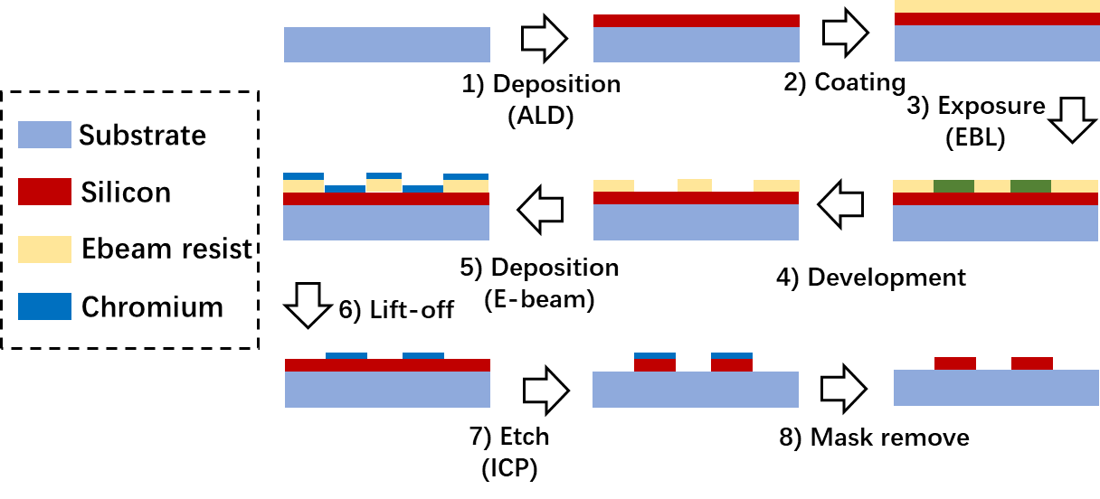
Fig. S1. Fabrication flow chart of the metasurface.

S2. Simulated holographic images in the virtual layer
To give a comparison with the measured holographic images in the virtual layers, we simulate the holographic images under the same circumstance by using Rayleigh-Sommerfeld diffraction. Fig. S2 shows the simulated holographic images, where all the images are clearly distinguishable in despite of the existence of holographic speckles. Note that, in our simulations, only the holographic phase is used as the incidence and the tilting phase is not considered because it will not influence the holographic reconstruction. Compared with the experimental images, both of them are highly consistent with each other. It also confirms the feasibility of our proposed hybrid-layer ODS.
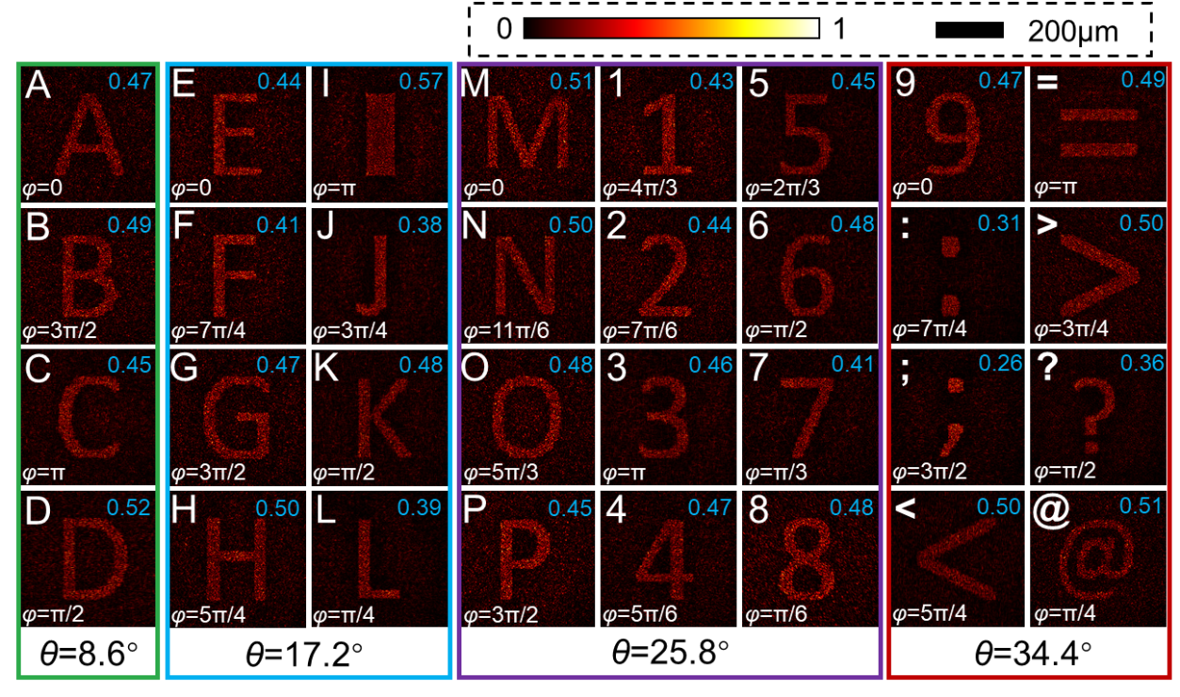
Fig. S2. Simulated holographic images with different polar angle θ and azimuthal angle φ at the distance of z =1.5 mm. The calculated RMSEs between the simulated and ideal images are shown at the upper-right corner of each image.

S3. Orthogonality of channels in our proposed hybrid-layer storage
To investigate the orthogonality of the proposed storage, we implement the simulation of diffraction fields from each channel when all the other channels are blocked. Since all the apertures of each channels have random spatial distribution, it is difficult to implement the measurement of orthogonality in experiment, so that only the simulated orthogonality is provided here. In our simulations, we use the Rayleigh-Sommerfeld theory to calculate the diffraction fields of each channel. When a light beam is incident on one channel (labelled by C_{n}), we can obtain the diffracted intensity profiles along the directions where the other channels are located. The diffracted intensities along these directions can be used to evaluate the orthogonality of this channel C_{n} at the other channels. In this work, the total power of diffracted field encircled in a square of 275 μm× 275 μm (larger than the range of each stored image) at the propagation distance of z = 1.5 mm away from the sample is employed as the data of evaluating orthogonality, which has been normalized to the maximum and shown in Fig. S3(b) by addressing the channel parameters in Fig. S3(a). One can find that each channel has the largest power at its designed direction (i.e., diagonal elements in Fig. S3(b)). In contrast, smaller power at the other directions (i.e., non-diagonal elements in Fig. S3(b)) where other channels are located refers to the crosstalk among the channels. When the angular interval is Δθ = 8.6°, the crosstalk can be observed due to the high-order diffraction caused by the pixel pitch of 2 μm (Fig. 1(e)) for each channel. It might be the reason why the experimental RMSEs are worse than the simulated ones, as shown in Fig. 4.
To decrease the crosstalk and enhance the orthogonality, we suggest one method by using different angular interval Δθ. For example, when Δθ = 12°, the calculated orthogonal matrix in Fig. S3(d) shows that the non-diagonal elements have the maximum value of 0.144, which is much smaller than 0.375 for the case of Δθ = 8.6°. It verifies the feasibility of reducing the crosstalk by choosing the suitable the angular interval Δθ. In addition, optimized arrangement of the azimuthal parameter φ and careful choice of the pixel pitch are also the possible methods to decrease the crosstalk.
Note that, in our simulations about the orthogonality of channels, we use the oblique illumination (with the incident angles opposite to the designed angles of the other channels) on each channel so that the diffracted fields can be obtained at a normal z-cut plane z = 1.5 mm, which facilities our simulations significantly.
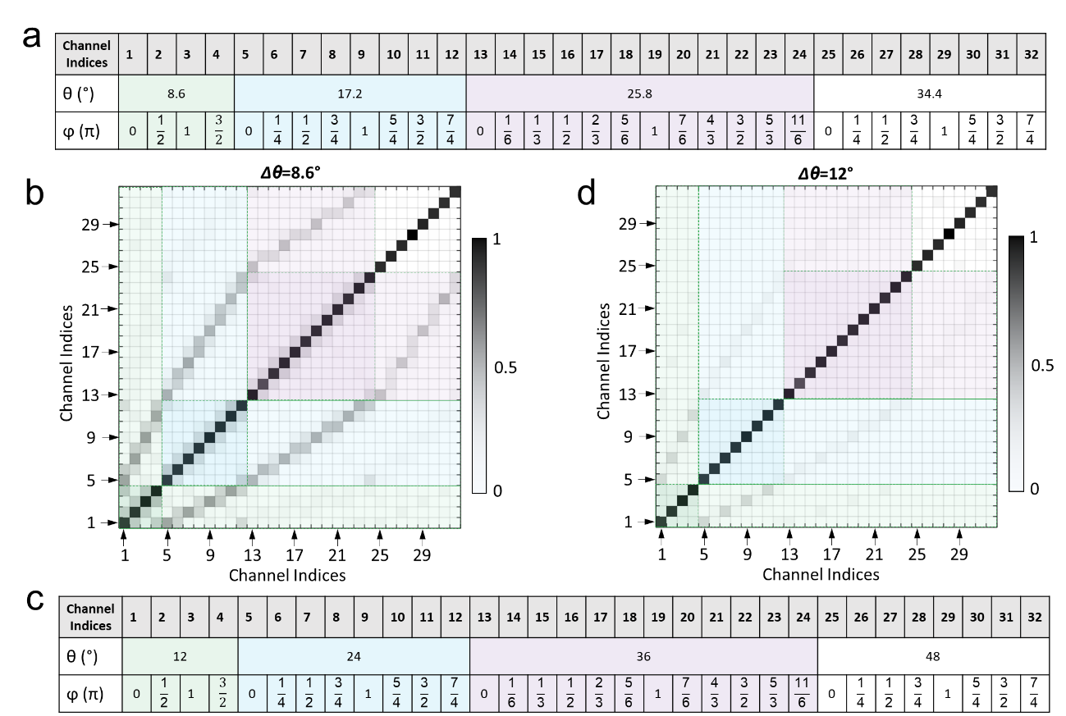
Fig. S3. Simulated orthogonality of channels in this work. (a) Channel parameters including the angular (θ) and azimuthal (φ) positions when the angular interval is Δθ=8.6°. (b) Simulated orthogonality of 32 channels for Δθ = 8.6°. (c) Channel parameters including the angular (θ) and azimuthal (φ) positions when the angular interval is Δθ = 12°. (d) Simulated orthogonality of 32 channels for Δθ = 12°.

S4. Optical data storage by using volume reduction and multiplexing technique
With different working principles, optical data storage can be divided into two approaches: reducing the volume of the recording spots and multiplexing technology. We list the reported capacities in Fig. S4. Our hybrid-layer ODS has the capacity of 2.5Tbit/cm³, which remains competitive among the multiplexing technologies. In addition, we have summarized details of volume-reduction and multiplexed channels optical data storage in Table S1 for better comparison.
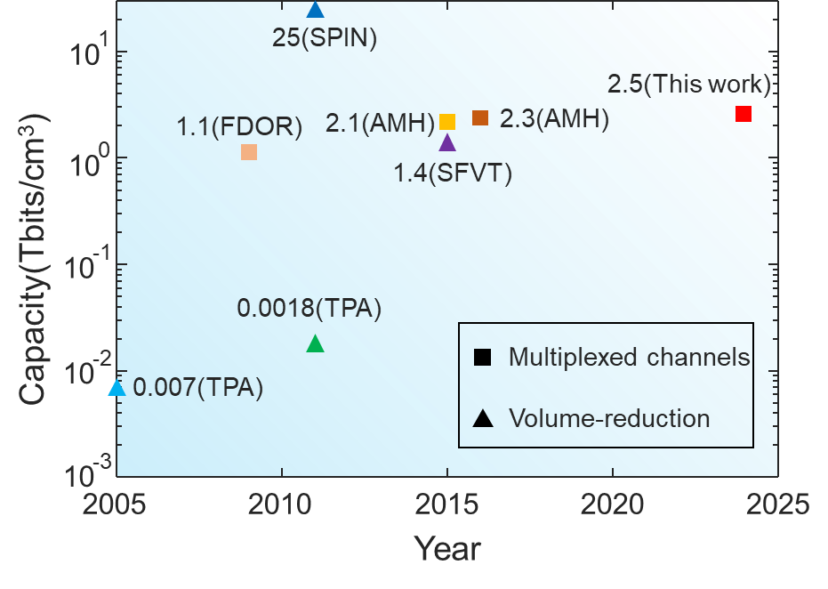
Fig. S4. Capacity of the reported optical data storage. TPA: two-photon absorption; SFVT: Superresolution-focal-volume technology; SPIN: super-resolution photoinduction-inhibition nanolithography; FDOR: five-dimensional optical recording; AMH: Angle-multiplexed holography; HORCH: high-orthogonality random-channel holography.

The volume of the recording spot in Refs. S1–S7 can be expressed as $V={pixel size}^{2}∙thickness$, so the data capacity is $1/V= 1/({pixel size}^{2}∙thickness$). By following the method of calculating the capacity for holographic data storage[S8,S9], the raw capacity in this work is calculated as $N_{bit}∙N_{image}/({total size}^{2}∙thickness$), where $N_{bit}$ is the number of bits in a single holographic image, $N_{image}$ is the number of stored images.
Table S1
Detailed comparison between volume-reduction and multiplexed channels optical data storage.
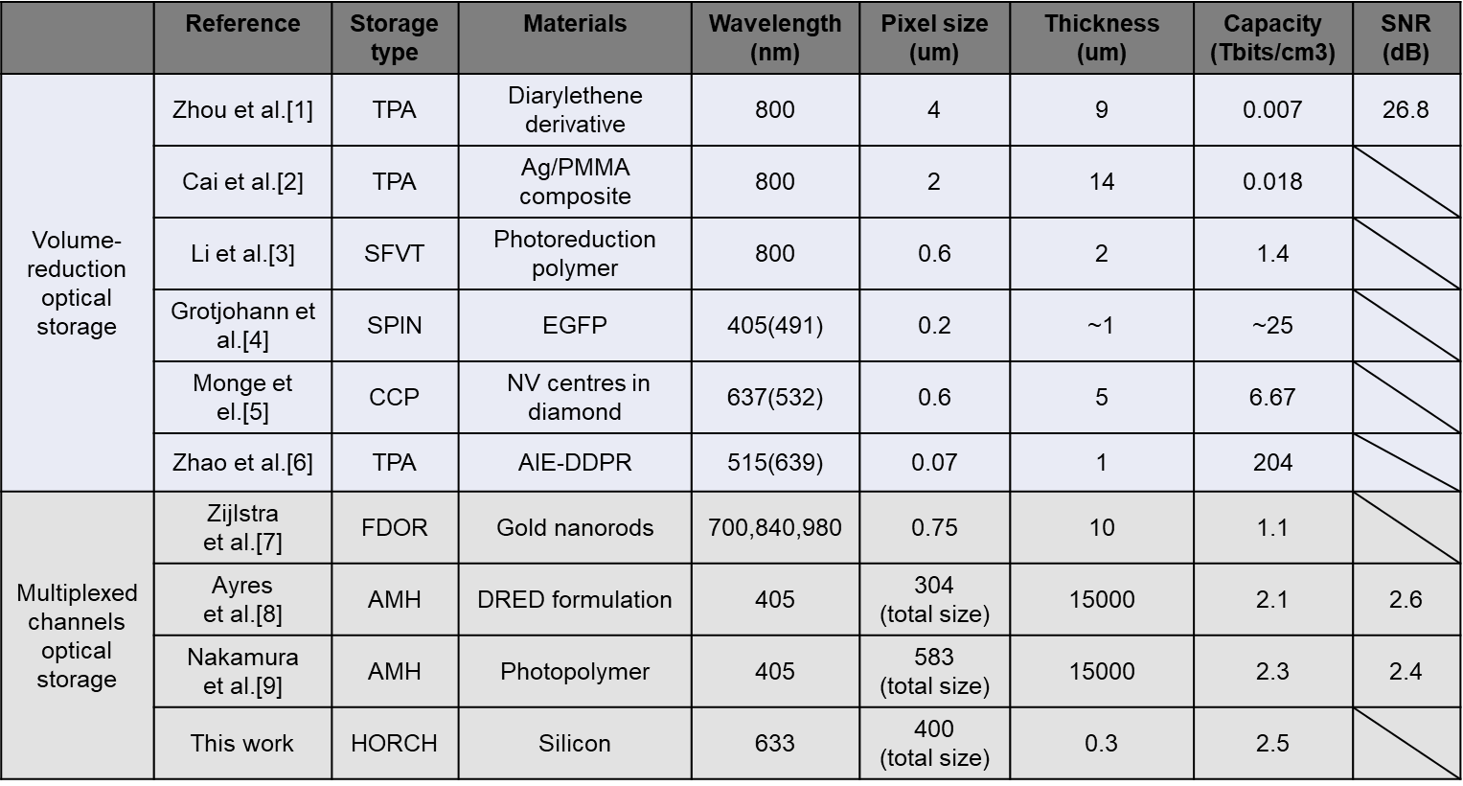
CCP: charge control protocols; AIE-DDPR: dye-doped photoresist with aggregation-induced emission; SNR: (Signal-to-noise ratio) =$20\log_{10}{\frac{μ_{1}-μ_{0}}{σ_{1}+σ_{0}}}$, where $μ_{1}$ and $μ_{0}$ are the means, and $σ_{1}$ and $σ_{0}$ are the standard deviations of the detected ones and zeros, respectively.

S5. Simulated holographic images in the double virtual layers
To verify the feasibility of more virtual layers by using monolayer metasurfaces, we utilize Adam gradient descent algorithm to balance the holographic performance of virtual layer 1 at z₁=1.5 mm and virtual layer 2 at z₂=2.5 mm. The detailed optimization processes are provided in our previous work [S10]. At the distance of z₁=1.5 mm, we can obtain the same uppercase letters and punctuation (Fig. S5(a)). After another propagation over a distance of 1 mm, we have the different lowercase letters and Greek letters (Fig. S5(b)), which gives additional information for data storage. Note that the speckles and noises in the holographic images for double virtual layers are more obvious than those for the single virtual layer. Therefore, further deep investigation into suppressing the speckles and crosstalk is an urgent requirement for this technology.
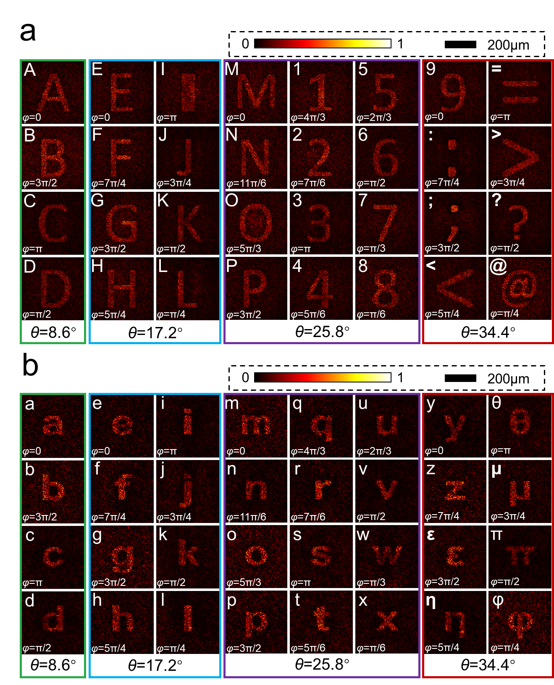
Fig. S5. Simulated holographic images with different polar angle θ and azimuthal angle φ in the distance of z₁ = 1.5 mm (a) and z₂ = 2.5 mm (b) for the proposed ODS with two virtual layers.
References
[1] Zhou Y, Tang H, Huang W, Xia A, Sun F, Zhang F. Three-dimensional optical data storage in a novel photochromic material with two-photon writing and one-photon readout. Optical Engineering 2005;44(3):035202.
[2] Cai J, Huang W. Three‐dimensional information storage of polymer doped with nano‐silver. Microwave and Optical Technology Letters 2015;57(11):2662–5.
[3] Grotjohann T, Testa I, Leutenegger M, Bock H, Urban N T, Lavoie-Cardinal F, et al. Diffraction-unlimited all-optical imaging and writing with a photochromic GFP. Nature 2011;478(7368):204–8.
[4] Li X, Cao Y, Gu M. Superresolution-focal-volume induced 3.0 Tbytes/disk capacity by focusing a radially polarized beam. Opt Lett 2011;36(13):2510–2.
[5] Monge R, Delord T, Meriles C A. Reversible optical data storage below the diffraction limit. Nat Nanotechnol 2024;19(2):202–7.
[6] Zhao M, Wen J, Hu Q, Wei X, Zhong Y-W, Ruan H, et al. A 3D nanoscale optical disk memory with petabit capacity. Nature 2024;626(8000):772–8.
[7] Zijlstra P, Chon J W M, Gu M. Five-dimensional optical recording mediated by surface plasmons in gold nanorods. Nature 2009;459(7245):410–3.
[8] Ayres M R, Anderson K, Askham F, Sissom B, Urness A C. Holographic data storage at 2+ Tbit/in2, Practical Holography XXIX: Materials and Applications, 2015, San Francisco; Washington: SPIE, 2015.
[9] Nakamura Y, Hoshizawa T. Two high-density recording methods with run-length limited turbo code for holographic data storage system. Jpn J Appl Phys 2016;55(9S):09SA1.
[10] Zhao D, Fu W, Li Z, He J, Huang K. Phase-probability shaping for speckle-free holographic lithography. 2022. arXiv:2211.09962 2022.

