Supplementary data for
Functional Capsules Encapsulating Molecular-Recognizable Nanogels for Facile Removal of Organic Micro-Pollutants from Water
Wen-Ying Liu ª, Xiao-Jie Ju ^{a,b,}*, Xing-Qun Pu ª, Quan-Wei Cai ª, Yu-Qiong Liu ª, Zhuang Liu ^{a,b}, Wei Wang ^{a,b}, Rui Xie ^{a,b}, Liang-Yin Chu ^{a,}*
ª School of Chemical Engineering & State Key Laboratory of Hydraulics and Mountain River Engineering, Sichuan University, Chengdu 610065, China
^{b} State Key Laboratory of Polymer Materials Engineering, Sichuan University, Chengdu 610065, China

Fig. S1. Schematic illustration of fabrication of the proposed functional capsules encapsulating PNCD nanogels. (a, b) Schematic illustration of the synthesis of molecular-recognizable (b) PNCD nanogels by chemically grafting CD moieties onto (a) PNA nanogels (a1→b1) via EDC condensation (a2→b2). (c,d) Schematic illustration of the fabrication of the functional capsules with co-extrusion technique by dripping (c) water-in-water (W/W) droplet templates into a Ca(NO₃)₂ solution to form (d) stable capsules through the cross-linking of Ca²⁺-triggered sol-gel transition of the capsule shells. The inner fluid is aqueous CMC solution containing PNCD nanogels, and the outer fluid is aqueous Na-Alg solution.

Fig. S2. The FT-IR spectra of CD, PNA nanogels, and PNCD nanogels.
Fig. S3. SEM image of PNA nanogels in dried state.

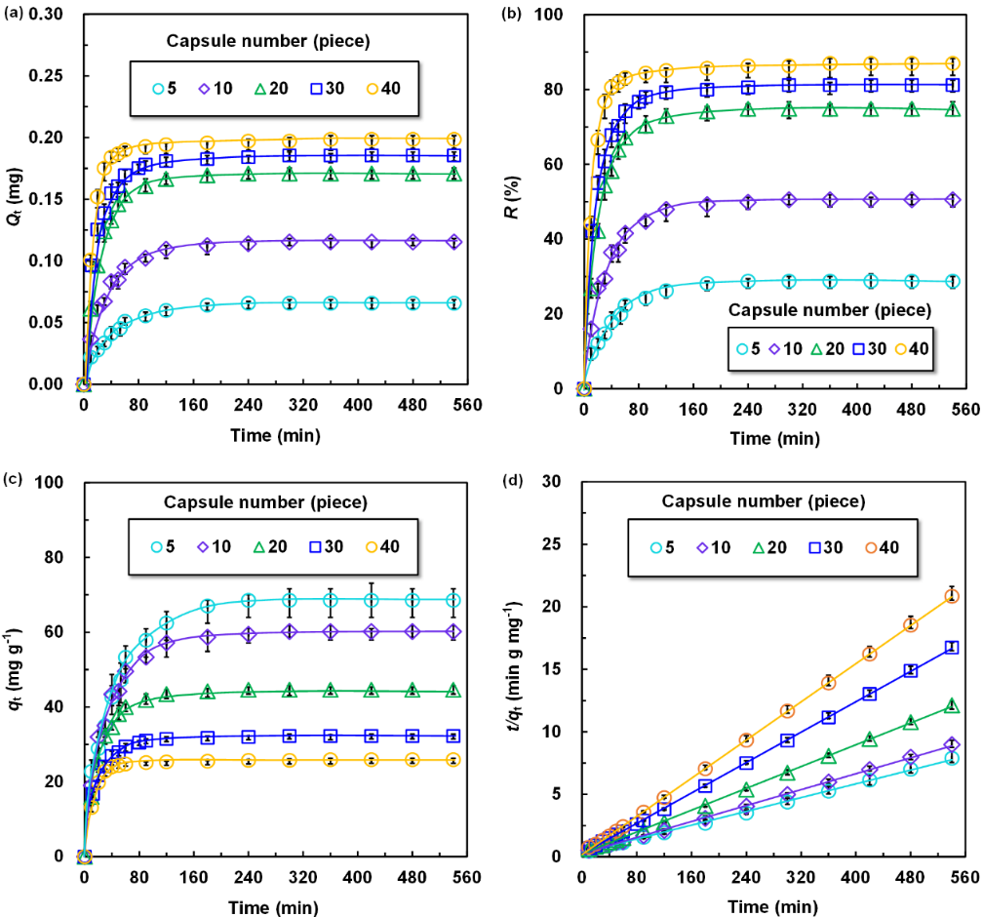
Fig. S4. Adsorption characteristics of capsules containing 10 mg·mL^{–1} PNCD nanogels in each capsule toward 0.5 mmol·L^{–1} BPA in water at 25 °C. (a) Q_{t}, (b) R, and (c) q_{t} changes in the BPA adsorbed by different numbers of capsules. (d) Pseudo-second-order plots of BPA adsorbed by different numbers of capsules.
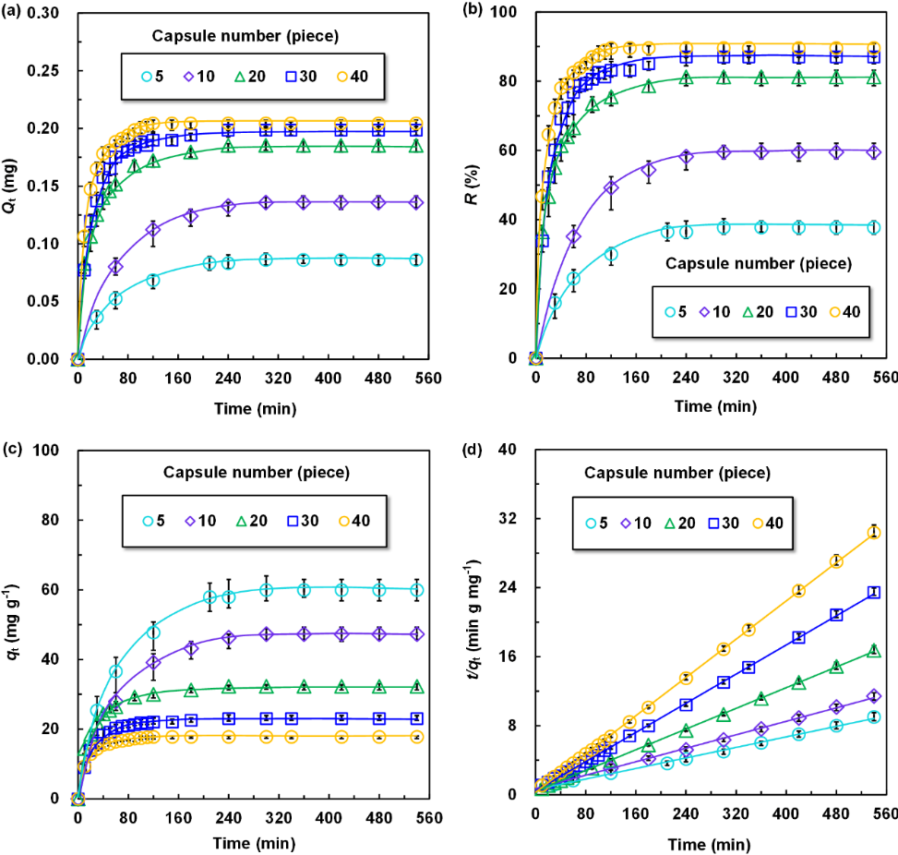
Fig. S5. Adsorption characteristics of capsules containing 15 mg·mL^{–1} PNCD nanogels in each capsule toward 0.5 mmol·L^{–1} BPA in water at 25 °C. (a) Q_{t}, (b) R, and (c) q_{t} changes in the BPA adsorbed by different numbers of capsules. (d) Pseudo-second-order plots of BPA adsorption by different numbers of capsules.
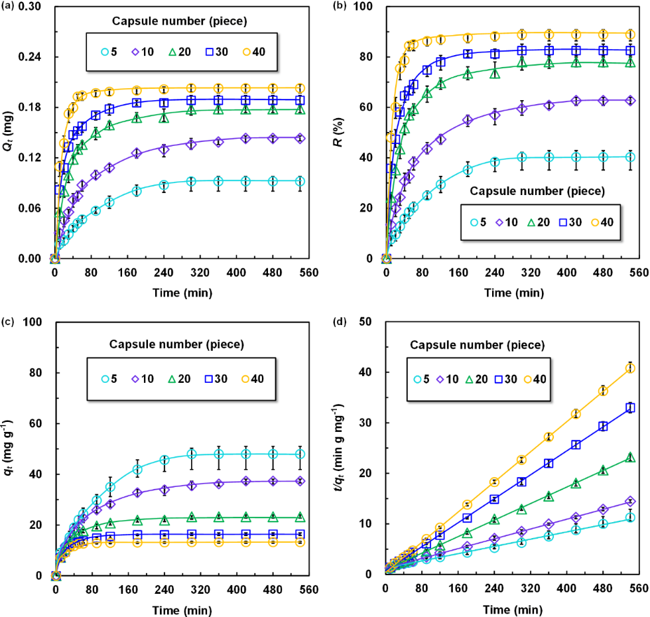
Fig. S6. Adsorption characteristics of capsules containing 20 mg·mL^{–1} PNCD nanogels in each capsule toward 0.5 mmol·L^{–1} BPA in water at 25 °C. (a) Q_{t}, (b) R, and (c) q_{t} changes in the BPA adsorbed by different numbers of capsules. (d) Pseudo-second-order plots of BPA adsorption by different numbers of capsules.
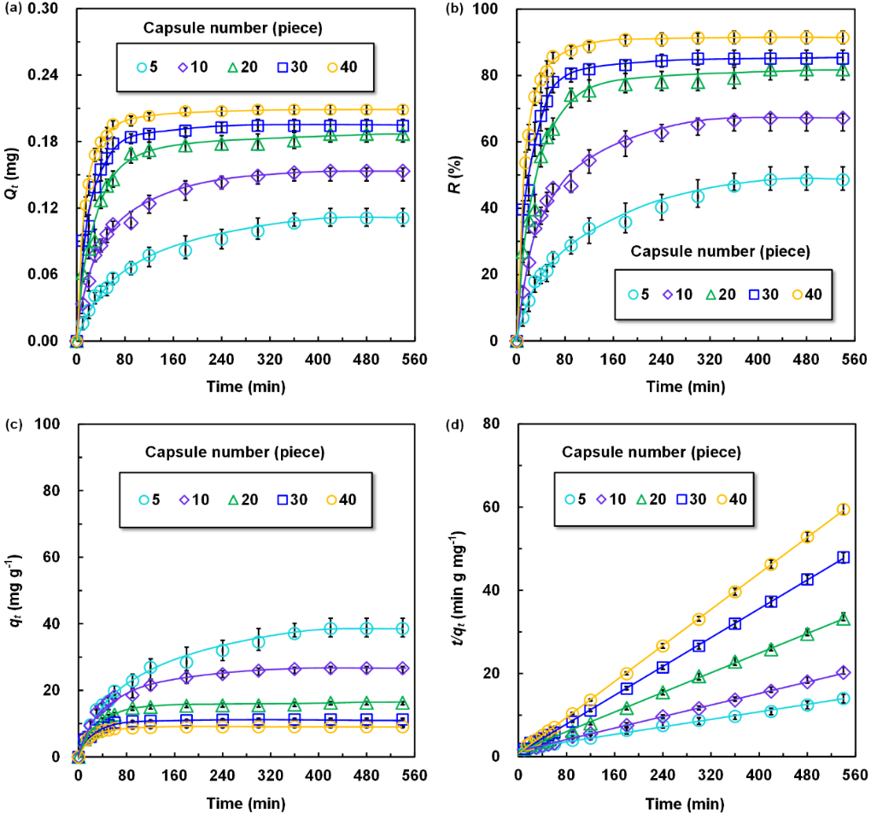
Fig. S7. Adsorption characteristics of capsules containing 30 mg·mL^{–1} PNCD nanogels in each capsule toward 0.5 mmol·L^{–1} BPA in water at 25 °C. (a) Q_{t}, (b) R, and (c) q_{t} changes in the BPA adsorbed by different numbers of capsules. (d) Pseudo-second-order plots of BPA adsorption by different numbers of capsules.

Fig. S8. Redlich-Peterson isothermal adsorption model of BPA adsorption by the capsules encapsulating 15 mg·mL^{–1} PNCD nanogels in each capsule at 25 °C.

Table S1
The pseudo-second-order plots results of BPA adsorption by capsules encapsulated with different concentrations of PNCD nanogels for 0.5 mmol·L^{–1} BPA-containing solutions.
[PNCD]  (mg·mL^{–1}) | No. of capsule | Pseudo-second-order model | R² | q_{e,exp} (mg·g^{–1}) | q_{e,cal} (mg·g^{–1}) | K_{obs} (g·mg^{–1}·min^{–1})
5 | 5 | y = 0.0115x + 0.0966 | 0.9997 | 85.2479 | 86.9565 | 0.0014
5 | 10 | y = 0.0141x + 0.0746 | 0.9995 | 70.0686 | 70.9220 | 0.0038
5 | 20 | y = 0.0170x + 0.1065 | 0.9996 | 57.9048 | 58.8235 | 0.0027
5 | 30 | y = 0.0183x + 0.1244 | 0.9999 | 53.8502 | 54.6448 | 0.0027
5 | 40 | y = 0.0222x + 0.0999 | 0.9999 | 44.5806 | 45.0450 | 0.0049
10 | 5 | y = 0.0138x + 0.3280 | 0.9991 | 68.5439 | 72.4638 | 0.0006
10 | 10 | y = 0.0159x + 0.2821 | 0.9995 | 60.1918 | 62.8931 | 0.0009
10 | 20 | y = 0.0218x + 0.2735 | 0.9996 | 44.5806 | 45.8716 | 0.0020
10 | 30 | y = 0.0304x + 0.2450 | 0.9999 | 32.2616 | 32.8947 | 0.0038
10 | 40 | y = 0.0382x + 0.1891 | 0.9999 | 25.9115 | 26.1780 | 0.0077
15 | 5 | y = 0.0152x + 0.6077 | 0.9976 | 59.9264 | 65.7895 | 0.0004
15 | 10 | y = 0.0195x + 0.7024 | 0.9974 | 47.2432 | 51.2821 | 0.0005
15 | 20 | y = 0.0298x + 0.4127 | 0.9998 | 32.2616 | 33.5570 | 0.0022
15 | 30 | y = 0.0423x + 0.4673 | 0.9998 | 23.0324 | 23.6407 | 0.0038
15 | 40 | y = 0.0572x + 0.2586 | 0.9999 | 17.7825 | 17.4825 | 0.0127
20 | 5 | y = 0.0179x + 1.2507 | 0.9955 | 47.9942 | 55.8659 | 0.0005
20 | 10 | y = 0.0243x + 1.2251 | 0.9994 | 37.3383 | 41.1523 | 0.0005
20 | 20 | y = 0.0409x + 0.9503 | 0.9996 | 23.2432 | 24.4499 | 0.0018
20 | 30 | y = 0.0592x + 0.7492 | 0.9998 | 16.3849 | 16.8919 | 0.0047
20 | 40 | y = 0.0745x + 0.4174 | 0.9999 | 13.2416 | 13.4228 | 0.0133
30 | 5 | y = 0.0226x + 1.7425 | 0.9967 | 38.6032 | 44.2478 | 0.0003
30 | 10 | y = 0.0348x + 1.4342 | 0.9975 | 26.6710 | 28.7356 | 0.0008
30 | 20 | y = 0.0590x + 1.3090 | 0.9991 | 16.2578 | 16.9491 | 0.0027
30 | 30 | y = 0.0866x + 0.9190 | 0.9997 | 11.2621 | 11.5473 | 0.0082
30 | 40 | y = 0.1082x + 0.7712 | 0.9999 | 9.0819 | 9.2421 | 0.0152

