Supplementary file for
Temporal and Spatial Distribution of SARS-CoV-2 Aerosols in a Large-Scale Fangcang Shelter Hospital in Shanghai, China
Jiafu Jiang ^{a,#}, Zhe Yin ^{a,#}, Jing Li ^{a,#}, Leili Jia ^{b,#}, Rulin He ^{d,#}, Wenhui Yang ^{a,#}, Jihu Yang ª, Hang Fan ª, Sen Zhang ª,Yunfei Wang ª, Zengming Zhao ^{b}, Haoran Peng ^{i}, Lizhong Li ^{b}, Yi Yang ^{b}, Shi-Yong Fan ^{j}, Rong Xiang ª, Jianshu Guo ª, Jinjin Wang ^{e}, Juanning Wei ^{f}, Fengling Zhou ^{g}, Ding Liu ^{h}, Ping Zhao ^{i}, Yujun Cui ª, Yunxi Liu ^{c,}*, Dongsheng Zhou ^{a,}*, Gang Dong ^{a,}*
ª Beijing Institute of Microbiology and Epidemiology, Academy of Military Medical Sciences, Beijing 100071, China
^{b} Chinese People’s Liberation Army Center for Disease Control and Prevention, Beijing 100071, China
^{c} Department of Disease Prevention and Control, the First Medical Center of Chinese People’s Liberation Army General Hospital, Beijing 100853, China
^{d} The 902 Hospital of People’s Liberation Army Joint Logistics Support Force, Bengbu 233015, China
^{e} General Hospital of Eastern Theater Command, People’s Liberation Army, Nanjing 210002, China
^{f} Fourth Military Medical University, Xijing Hospital, Xi’an 710032, China
^{g} General Hospital of Central Theater Command of Chinese People’s Liberation Army, Wuhan 430070, China
^{h} Third Military Medical University, Southwest Hospital, Chongqing 400038, China
^{i} Department of Microbiology, Faculty of Naval Medicine, Naval Medical University, Shanghai 200433, China
^{j} Academy of Military Medical Sciences Institute of Pharmacology and Toxicology, Beijing 100039, China

# These authors contributed equally to this work.
* Corresponding authors.
E-mail addresses: liuyunxi301@qq.com (Y. Liu); zhouds@bmi.ac.cn (D. Zhou); donggang@bmi.ac.cn (G. Dong).

1. Description of the performance evaluation of the aerosol sampling device

1.1. Aerosol sampling device
A high-volume bioaerosol sampling device (HRH-BSA350, Beijing Huironghe Tech Co., Ltd., China) based on the wet-wall cyclone principle was used in this study. It consisted of an air inlet, cyclone chamber, centrifugal fan, air outlet, liquid replenishment system, central control module and operation panel (Fig. S1(a)). When the device was in operation (Fig. S1(b)), the air entered the cyclone chamber with a flow rate of 350 L·min^{–1}, and the aerosol particles in the air separated from the main airflow in the cyclone and were trapped onto the liquid membranes generated by the cyclone. When aerosol sampling was completed, the collected aerosol particles were enriched in approximately 4 mL of sampling liquid for subsequent analysis. The sampler's internal high-capacity battery and liquid replenishment system allow the sampling device to perform continuous sampling for minutes to hours and tens of hours of sampling when connected to utility power, without worrying about the reduction of sampling liquid. The sampling device was integrated with a disinfection and cleaning function, which could perform quick disinfection and cleaning in the field to prevent contamination of collected samples from previous sampling. PBS buffer (Gibco) was usually used as the sampling medium, while virus transport medium (VTM) was more suited for virus sampling. It is important to mention that an additional 0.1% Antifoam B Emulsion (Sigma) can effectively reduce the generation of foam during the sampling process.

1.2. Performance of the aerosol sampling device
All performance tests were conducted in an aerosol wind tunnel with a cross-sectional area of 400 mm × 400 mm. The physical sampling efficiency was tested using polydisperse solid aerosols of the Arizona test dust described previously [1]. The evaluation showed that the cutoff size of HRH-BSA 350 was approximately 2.0 μm, reaching a maximum sampling efficiency of 80% at 5.1 μm (Fig. S1(c)). Three biological sampling efficiencies were evaluated using coronavirus GX_P2V (SARS coronavirus), a near-source strain of SARS-CoV-2, with a count median aerodynamic diameter (CMAD) of 0.83 μm and a geometric standard deviation (GSD) of 1.49. In the results (Fig. S1(d)), the enrichment ratio (virus concentration in sample compared to that in air) of HRH-BSA 350 when sampling GX_P2V was (3.9 ± 0.5) × 10⁴ min^{–1}, which was (62.0 ± 7.9) times higher than that of AGI-30. The total bioaerosol sampling efficiency (calculated virus concentration in air compared to real virus concentration in air) and the survival rate (alive virus proportion in sample compared to that in air) of HRH-BSA 350 were (44.2% ± 6.0%) and (96.0% ± 26.1%) of those of AGI-30, respectively. In conclusion, HRH-BSA350 showed a superior enrichment efficiency for aerosol collection at the cost of impaired accuracy for aerosol concentration quantification; hence, it was suitable for sampling bioaerosols at low concentrations in ambient air for subsequent virus qualitative detection.
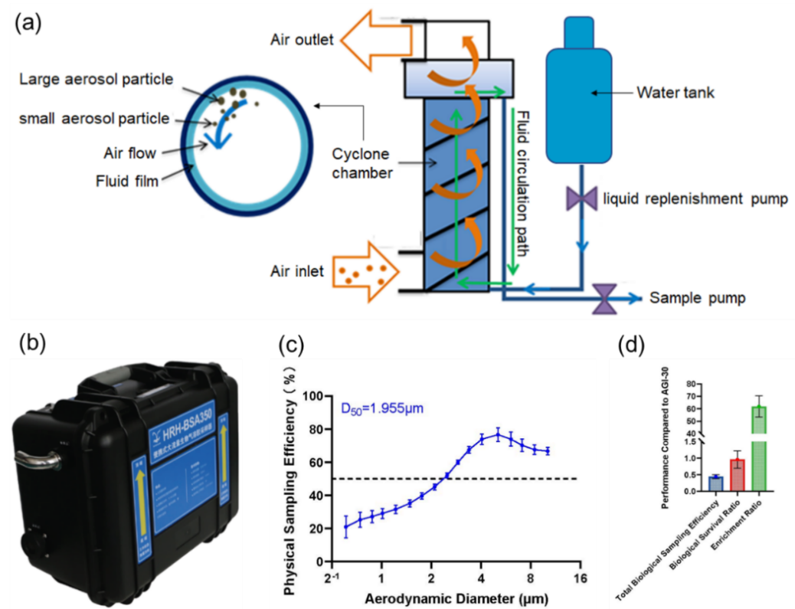
Fig. S1. Working principle and performance of the aerosol sampling device in this study. (a) Working principle diagram and (b) device image of HRH-BSA 350. (c) Physical sampling efficiency. (d) Biological sampling efficiencies. All experiments were replicated three times.

Table S1
Accession numbers in GISAID and the collection date of the 12 reference sequences.
Accession number | Collection date | Collection location
EPI ISL 16137928 | 2022/4/10 | Shanghai, China
EPI ISL 16137933 | 2022/4/9 | Shanghai, China
EPI ISL 16137940 | 2022/4/7 | Shanghai, China
EPI ISL 16137930 | 2022/4/10 | Shanghai, China
EPI ISL 13352744 | 2022/4/4 | Shanghai, China
EPI ISL 12461216 | 2022/3/14 | Shanghai, China
EPI ISL 12461212 | 2022/2/19 | Shanghai, China
EPI ISL 16137935 | 2022/4/9 | Shanghai, China
EPI ISL 16137925 | 2022/4/12 | Shanghai, China
EPI ISL 16137922 | 2022/4/19 | Shanghai, China
EPI ISL 16137929 | 2022/4/10 | Shanghai, China
EPI ISL 16137918 | 2022/4/18 | Shanghai, China

Fig. S2. Standard curves of the N and ORF1ab gene.

Fig. S3. Temporal distribution of the number of samples and positivity rates for SARS-CoV-2 collected from the Shanghai Fangcang hospital between April 23 and May 21, 2022. Dark blue bars represent the total number of samples positive for SARS-CoV-2. The light blue bars represent the total number of samples negative for SARS-CoV-2. The red, yellow and blue dotted lines indicate the positivity rates of air samples, surface samples and total samples, respectively.
Fig. S4. Quantitative and qualitative testing for SARS-CoV-2 spike RNA and antigen in the supernatant of incubated swab and aerosol samples in Vero-E6 cells. (a) Ct value of the supernatant of the Vero-E6 cells post-incubation for 0 or 96 h with the 1st and 10th aerosol samples and the 4th and 10th swab samples from the same patient 0512-K7-B8-188; the numbers above bars indicate virus multiplication values. (b) Colloidal gold test results for SARS-CoV-2 spike antigen for the supernatant samples for aerosol samples 1–5 and for swab samples 6–7 and 9–10 in two independent rounds of propagation.

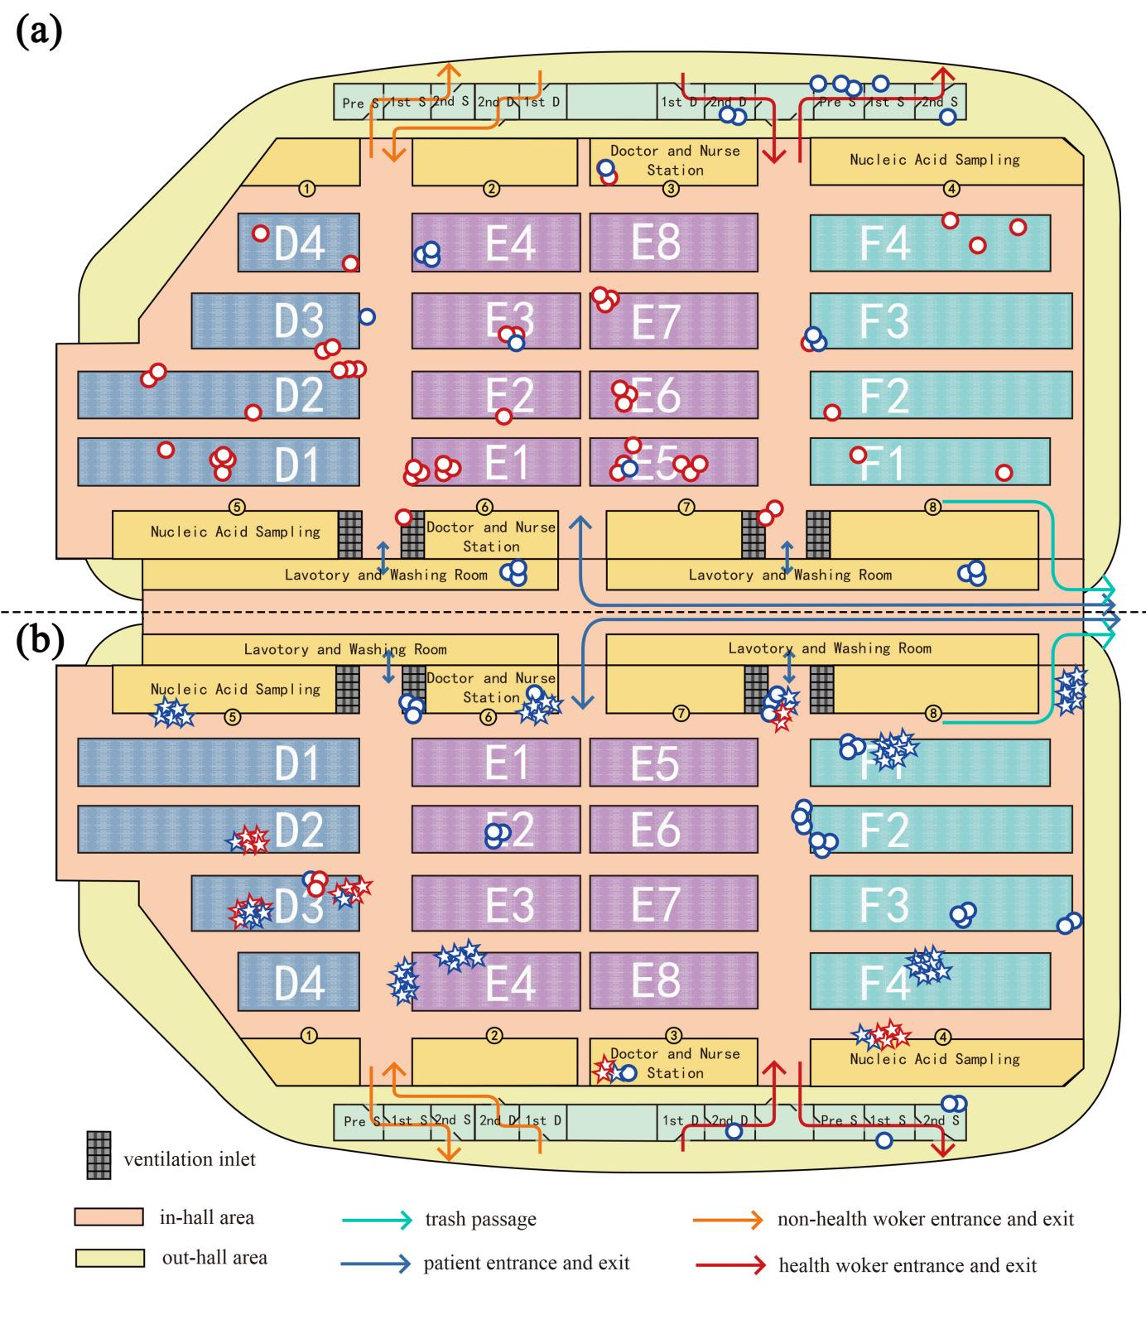
Fig. S5. Interior layout and air sample distribution in the halls. (a) Interior layout of hall 2.2. (b) Interior layout of hall 1.2. The blue and red rings represent negative and positive air samples, respectively. The blue stars and red stars represent negative and positive air samples from dynamic monitoring, respectively.

Table S2
The detection results of wind speed and direction using a PH-1 portable wind anemometer in the medical halls 1.2 and 2.2 at Fangcang hospital, 2022.
No. | Date | Location | Direction | Speed (m·s^{–1})
1 | 5.4 | No. 8 gate in hall 2.2 | Inward | 1.3
2 | 5.4 | 2 m from Gate3 (inward) in hall 2.2 | Inward | 0.5
3 | 5.4 | 4 m from Gate3 (inward) in hall 2.2 | Windless | 0
4 | 5.4 | No. 6 Gate in hall 2.2 | Outward | 0.2
5 | 5.4 | Passage between E5 and E6 in hall 2.2 | Outward | 0.2
6 | 5.4 | No. 7 nurse station in hall 2.2 | Outward | 0.2
7 | 5.4 | No. 5 Gate in hall 2.2 | Outward | 0.4
8 | 5.4 | Passage between E1and E2 in hall 2.2 | Outward | 0.4
9 | 5.4 | No. 6 nurse station in hall 2.2 | Outward | 0.4
10 | 5.4 | ventilation inlet in hall 2.2 | Outward | 3.0
11 | 5.4 | F1F3 passage in hall 2.2 | Windless | 0
12 | 5.4 | F2F3 passage in hall 2.2 | Windless | 0
13 | 5.4 | F3F4 passage in hall 2.2 | Windless | 0
14 | 5.3 | Hall 1.2 exit 1 | Windless | 0
15 | 5.3 | Hall 1.2 exit 2 | Windless | 0
16 | 5.3 | Hall 1.2 exit 3 | Inward | 0.5
17 | 5.3 | Hall 1.2 exit 4 | Outward | 0.5
18 | 5.3 | Hall 1.2 passage 1 | Windless | 0
19 | 5.3 | Hall 1.2 passage 2 | Windless | 0
20 | 5.3 | Hall 1.2 passage 3 | Windless | 0
21 | 5.3 | Hall 1.2 passage 4 | Windless | 0
22 | 5.3 | Hall 1.2 passage 5 | Windless | 0
23 | 5.3 | Hall 1.2 passage 6 | Windless | 0
24 | 5.3 | Hall 1.2 20 cm away from ventilation inlet P1 1 | Toward the inlet | 1.6
25 | 5.3 | Hall 1.2 20 cm away from ventilation inlet P1 2 | Toward the inlet | 0.3
26 | 5.3 | Hall 1.2 20 cm away from ventilation inlet P1 3 | Toward the inlet | 0.5
27 | 5.3 | Hall 1.2 20 cm away from ventilation inlet P1 4 | Toward the inlet | 0.3
28 | 5.3 | Hall 1.2 20 cm away from ventilation inlet P1 5 | Toward the inlet | 1.1
29 | 5.3 | Hall 1.2 20 cm away from ventilation inlet P1 6 | Toward the inlet | 0.3
30 | 5.3 | Hall1.2 20 cm away from ventilation inlet P2 1 | Toward the inlet | 0.6
31 | 5.3 | Hall1.2 20 cm away from ventilation inlet P2 2 | Toward the inlet | 0.9
32 | 5.3 | Hall1.2 20 cm away from ventilation inlet P2 3 | Toward the inlet | 1.6
33 | 5.3 | Hall 1.2 40 cm away from ventilation inlet P2 4 | Toward the inlet | 0.4
34 | 5.3 | Hall 1.2 40 cm away from ventilation inlet P2 5 | Toward the inlet | 0.4

Reference
[1] Guo JS, Zheng XY, Qin TT, Lv M, Zhang W, Song XL, et al. An experimental method for efficiently evaluating the size-resolved sampling efficiency of liquid-absorption aerosol samplers. Sci Rep 2022;12(1):4745.

