Supplementary file for
IgG N-Glycosylation Cardiovascular Age Tracks Cardiovascular Risk Beyond Calendar Age
Zhiyuan Wu ^{a,b,#}, Zheng Guo ^{a,#}, Yulu Zheng ^{a,#}, Yutao Wang ^{c}, Haiping Zhang ^{b}, Huiying Pan ^{b}, Zhiwei Li ^{b}, Lois Balmer ª, Xia Li ^{d}, Lixin Tao ^{b,}*, Xiuhua Guo ^{b,}*, Wei Wang ^{a,b,}*
ª Centre for Precision Health, Edith Cowan University, Joondalup, WA 6027, Australia
^{b} Beijing Municipal Key Laboratory of Clinical Epidemiology, School of Public Health, Capital Medical University, Beijing 100069, China
^{c} Shanghai Fufan Information Technology Co., Ltd., Shanghai 200433, China
^{d} Department of Mathematics and Statistics, La Trobe University, Melbourne, VIC 3086, Australia

S1. Calculations and data
Table S1
Calculation of ten-year cardiovascular risk using the Framingham Heart Study score.
Sex | Formula
Male | 1 – 0.88936^{exp(ΣβX – 23.9802)}
Male | ΣβX = 3.06117*log(age)+1.12370*log(total cholesterol (mg·dL^{–1})) – 0.93263*log(HDL cholesterol (mg·dL^{–1})) + 0.65451*smoker [yes or no] + 0.57367*diabetes [yes or no] + 1.93303*log(SBP not treated) or 1.99881*log(SBP if treated)
Female | 1 – 0.95012^{exp(ΣβX – 26.1931)}
Female | ΣβX = 2.32888*log(age) + 1.20904*log(total cholesterol (mg·dL^{–1})) – 0.70833*log(HDL cholesterol (mg·dL^{–1})) + 0.52873*smoker [yes or no] + 0.69154*diabetes [yes or no] + 2.76157*log(SBP not treated) or 2.82263*log(SBP if treated)
SI conversion factors: To convert total cholesterol and HDL cholesterol from mmol·L^{–1} to mg·dL^{–1}, multiply by 38.66.
SBP: systolic blood pressure; HDL: high-density lipoprotein; β: the regression coefficient; X: the level of each risk factor.

Table S2
Composition of CVDs.
Characteristic | Individuals with CVDs
Participants (n) | 107
Angina (n (proportion)) | 39 (36.4%)
Myocardial infarction/heart attack (n (proportion)) | 48 (44.9%)
TIA (n (proportion)) | 14 (13.1%)
Stroke (n (proportion)) | 13 (12.1%)
Coronary angioplasty or stent (n (proportion)) | 34 (31.8%)
Coronary bypass (n (proportion)) | 22 (20.6%)
Implant of cardiac pacemaker (n (proportion)) | 9 (8.4%)

Table S3
Characteristics of 1358 individuals without cardiovascular disease stratified by ten-year cardiovascular risk.
Characteristic | Low risk | High risk ª | P value
Participants (n (proportion)) | 982 | 376
Sex (male, n (proportion)) | 318 (32.4%) | 294 (78.2%) | < 0.001
Age (year, n (proportion)) | 58.28 (5.48%) | 62.34 (4.40%) | < 0.001
Marital status (n (proportion))
Married | 722 (73.5%) | 281 (74.7%) | 0.700
Others | 260 (26.5%) | 95 (25.3%)
Education level (n (proportion))
Primary school or below | 10 (1.0%) | 10 (2.7%) | 0.001
Secondary school | 489 (49.8%) | 218 (58.1%)
Above secondary school | 483 (49.2%) | 147 (39.2%)
Current smoking (n (proportion)) | 43 (4.4%) | 68 (18.1%) | < 0.001
Hypertension (n (proportion)) | 235 (23.9%) | 224 (59.6%) | < 0.001
Dyslipidemia (n (proportion)) | 279 (28.4%) | 193 (51.3%) | < 0.001
Diabetes (n (proportion)) | 82 (8.4%) | 185 (49.2%) | < 0.001
BMI ^{b} (kg·m^{–2}, mean (SD)) | 28.01(4.95) | 31.35(5.25) | <0.001
SBP (mmHg, mean (SD)) | 130.25(14.83) | 143.79(15.33) | <0.001
DBP (mmHg, mean (SD)) | 76.19(9.15) | 82.88(9.43) | <0.001
HDL cholesterol (mmol·L^{–1}, mean (SD)) | 1.55(0.35) | 1.20(0.28) | <0.001
Total cholesterol (mmol·L^{–1}, mean (SD)) | 5.58(1.02) | 5.48(1.32) | 0.134
Fasting glucose (mmol·L^{–1}, mean (SD)) | 5.15(1.13) | 6.37(2.13) | <0.001
HbA1c (mean (SD)) | 5.71(0.62) | 6.30(1.09) | <0.001
CRP (mg·L^{–1}, mean (SD)) | 2.98(4.67) | 3.40(3.76) | 0.111
ª Ten-year cardiovascular risk was calculated using the Framingham Heart Study score, and high risk refers to a ten-year CVD risk ≥ 20.0%.
^{b} Calculated as weight in kilograms divided by height in meters squared.
SI conversion factors: To convert fasting plasma glucose to mg·dL^{–1}, multiply by 18.0; to convert triglyceride to mg·dL^{–1}, multiply by 88.6; to convert cholesterol to mg·dL^{–1}, multiply by 38.66.
SD: standard deviation; SBP: systolic blood pressure; DBP: diastolic blood pressure. 1 mmHg = 0.133 kPa.

Table S4
Secondary selection of candidate IgG N-glycans using a multi-step logistics model.
Variable | Step 1 |  | Step 2 |  | Step 3
Variable | β | P value | β | P value | β | P value
Intercept | 1.375 | 0.205 | –10.511 | < 0.001 | –10.349 | < 0.001
Age |  |  | 0.168 | < 0.001 | 0.166 | < 0.001
Sex (Ref: male) |  |  | –2.626 | < 0.001 | –2.633 | < 0.001
GP6 | 0.185 | < 0.001 | 0.325 | < 0.001 | 0.296 | < 0.001
GP7 | –0.683 | 0.048 | –0.649 | 0.101
GP8 | –0.089 | 0.040 | –0.004 | 0.938
GP13 | –4.301 | 0.003 | –5.142 | 0.002 | –5.883 | < 0.001
GP20 | –1.557 | 0.093 | 0.293 | 0.784
Step 1: All candidate N-glycans included in regression model;
Step 2: All candidate N-glycans with age and sex included in regression model;
Step 3: Significant N-glycans in Step 2 with age and sex included in regression model.

Table S5
Calculation of GlyCage tracking cardiovascular risk.
No. | Formula
1 | IgG N-glycan cardiovascular risk = exp(0.16601*V – 2.63297*S + 0.29640*X₁ – 5.88346*X₂ – 10.34894)/(1 + exp(0.16601*V – 2.63297*S + 0.29640*X₁ – 5.88346*X₂ – 10.34894))
2 | GlyCage = (0.29640*(X₁ – 5.81422) – 5.88346*(X₂ – 0.22277))/0.16601 + V
The age of a person calculated using GlyCage is equivalent to the age of a person with the same predicted risk but with all IgG N-glycan expressions in the mean levels.
V is calendar age, S is sex, X₁ is the expression level of GP6, and X₂ is the expression level of GP13.

Table S6
Distributions of GP6 and GP13 stratified by CVDs risk and event.
Variable | Low CVDs risk | High CVDs risk | CVDs | P value
Participants (n) | 982 | 376 | 107
GP6 (median (IQR)) | 5.44 (4.54,6.52) | 6.00 (5.15,7.13) | 6.12 (5.30,7.15) | < 0.001
GP13 (median (IQR)) | 0.23 (0.19,0.27) | 0.20 (0.16,0.24) | 0.20 (0.16,0.24) | < 0.001
High CVDs risk refers to a Framingham ten-year CVDs risk ≥ 20.0%;
CVDs included angina, myocardial infarction or heart attack, TIA, stroke, experience of coronary angioplasty or stent, coronary bypass, and implant of cardiac pacemaker.
IQR: interquartile range.

Table S7
Comparison of calendar age and GlyCage according to ten-year cardiovascular risk and CVDs.
Population group | Calendar age (mean (SD)) | GlyCage (mean (SD))
Population without CVDs (n = 1358)
Low CVDs risk | 58.28 (5.48) | 57.71 (7.70)
High CVDs risk | 62.34 (4.40) | 63.84 (6.34)
Whole population (n = 1465)
Without CVDs | 59.40 (5.51) | 59.40 (7.84)
With CVDs | 61.75 (5.05) | 63.19 (6.78)
High CVDs risk refers to a Framingham ten-year cardiovascular risk ≥ 20%;
CVDs included angina, myocardial infarction or heart attack, TIA, stroke, experience of coronary angioplasty or stent, coronary bypass, and implant of cardiac pacemaker.
S2. Structures and description of IgG N-glycans
Glycan peak | Abbreviation | Structure | Description
GP1 | FA1 | 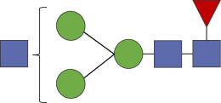 | Monoantennary glycan with core fucose
GP2 | A2 | 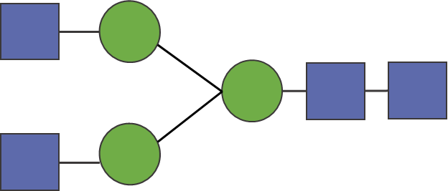 | Biantennary glycan
GP3 | A2B | 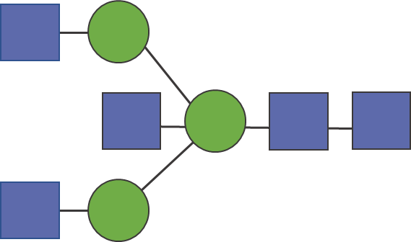 | Biantennary glycan with bisecting GlcNAc
GP4 | FA2 | 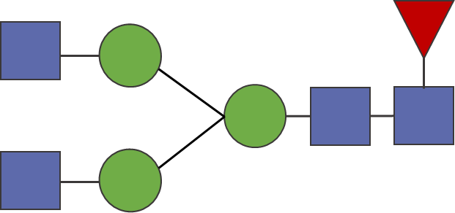 | Monoantennary glycan with core fucose
GP5 | M5 | 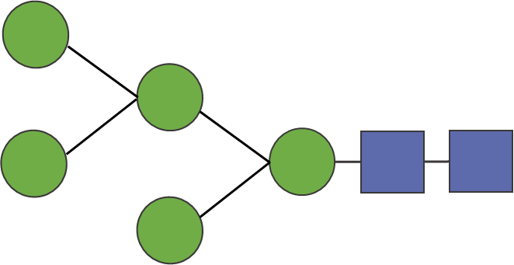 | High mannose glycan
GP6 | FA2B | 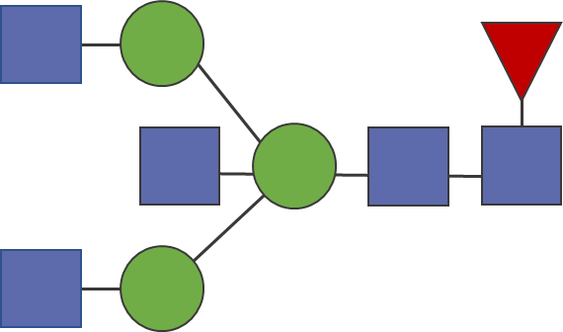 | Biantennary glycan with bisecting GlcNAc and core fucose
GP7 | A2(3)G1 | 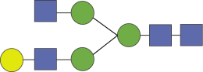 | Monogalactosylated biantennary glycan
GP8 | A2BG1 | 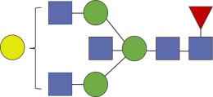 | Monogalactosylated, biantennary with bisecting GlcNAc
GP8 | FA2(6)G1 | 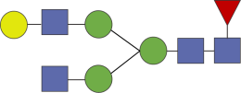 | Monogalactosylated biantennary glycan with 1-6 linkages with core fucose
GP9 | FA2(3)G1 | 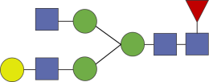 | Monogalactosylated biantennary glycan with 1–3 linkages with core fucose
GP10 | FA2[6]BG1 | 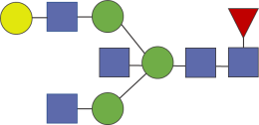 | Monogalactosylated biantennary glycan with 1–6 linkages with bisecting GlcNAc and core fucose
GP11 | FA2[3]BG1 | 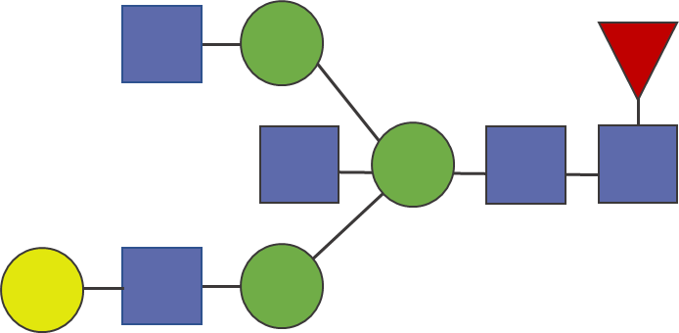 | Monogalactosylated biantennary glycan with 1–3 linkages with bisecting GlcNAc and core fucose
GP12 | A2G2 | 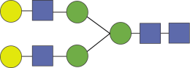 | Digalactosylated biantennary glycan
GP13 | A2BG2 | 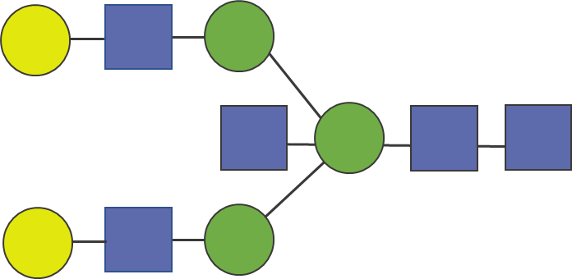 | Digalactosylated biantennary glycan with bisecting GlcNAc
GP14 | FA2G2 | 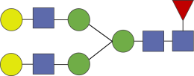 | Digalactosylated biantennary glycan with core fucose
GP15 | FA2BG2 | 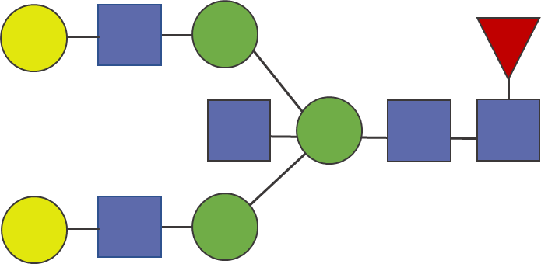 | Digalactosylated biantennary glycan with bisecting GlcNAc and core fucose
GP16 | FA2(6)G1S1 | 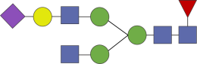 | Monogalactosylated monosialylated biantennary glycan with 1–6 linkages with core fucose
GP16 | FA2(3)G1S1 | 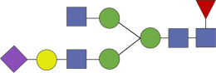 | Monogalactosylated monosialylated biantennary glycan with 1–3 linkages with core fucose
GP17 | A2G2S1 | 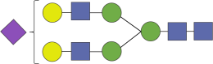 | Digalactosylated monosialylated biantennary glycan
GP18 | A2BG2S1 | 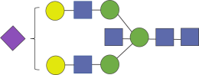 | Digalactosylated monosialylated biantennary with bisecting GlcNAc
GP18 | FA2G2S1 | 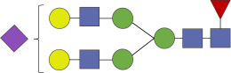 | Digalactosylated monosialylated biantennary glycan with core fucose
GP19 | FA2BG2S1 | 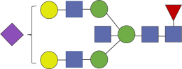 | Digalactosylated monosialylated biantennary glycan with bisecting GlcNAc and core fucose
GP20 | FA2FG2S1 | 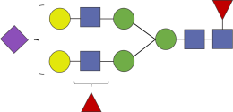 | Digalactosylated monosialylated biantennary with core and antennary fucose
GP21 | A2G2S2 | 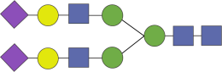 | Digalactosylated disialylated biantennary glycan
GP22 | A2BG2S2 | 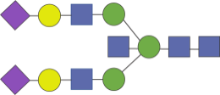 | Digalactosylated disialylated biantennary glycan with bisecting GlcNAc
GP23 | FA2G2S2 | 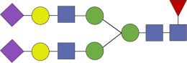 | Digalactosylated disialylated biantennary glycan with core fucose
GP24 | FA2BG2S2 | 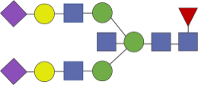 | Digalactosylated disialylated biantennary glycan with bisecting GlcNAc and core fucose
S3. Figures
GlcNAc
Gal
Fuc
Man
Neu5AC
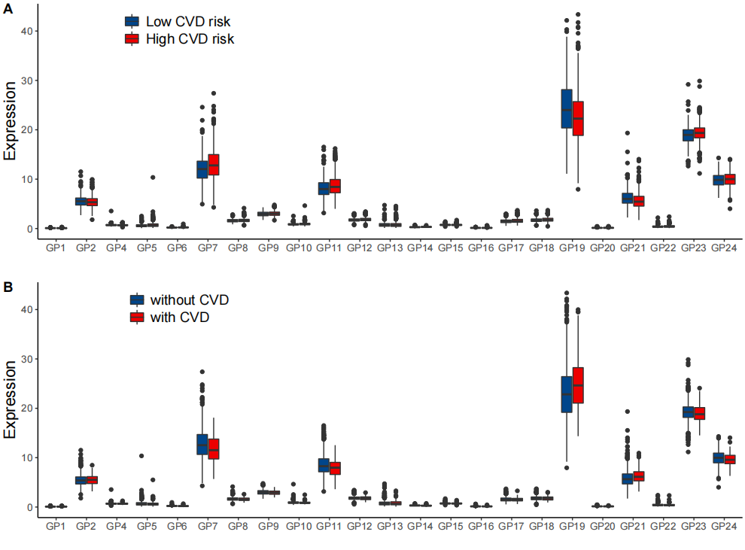
Fig. S1. Distribution of IgG N-glycans. (a) Distribution of IgG N-glycans among 1358 individuals without CVDs stratified by ten-year cardiovascular risk. (b) Distribution of IgG N-glycans among 1465 individuals stratified by CVDs.
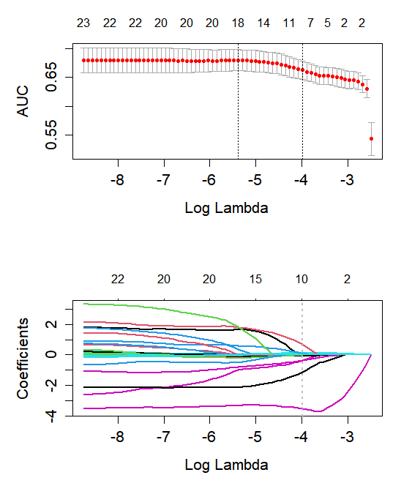
Fig. S2. Feature-selection process of the LASSO algorithm.

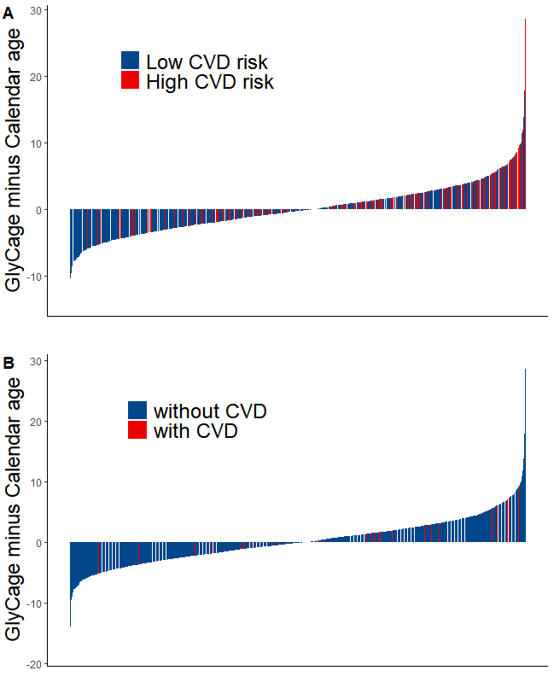
Fig. S3. Distribution of the distance between GlyCage and calendar age according to cardiovascular risk and CVDs. (a) Distribution of excessive GlyCage among 1358 individuals without CVDs stratified by ten-year cardiovascular risk. (b) Distribution of excessive GlyCage among 1465 individuals stratified by CVDs.

