Supplementary data for

Dual Effects of Feed-Additive-Derived Chelerythrine in Combating Mobile Colistin Resistance
Huangwei Song ^{a,b,#}, Xueyang Wang ^{a,b,#}, Muchen Zhang ^{a,b}, Zhiyu Zou ^{a,b}, Siyuan Yang ^{a,b}, Tian Yi ^{a,b}, Jianfeng Wang^{c}, Dejun Liu ^{a,b}, Yingbo Shen ^{a,b}, Chongshan Dai ^{a,b}, Zhihai Liu ^{d}, Timothy R. Walsh ^{e}, Jianzhong Shen ^{a,b}, Congming Wu ^{a,b}*, Yang Wang ^{a,b,}*
ª National Key Laboratory of Veterinary Public Health and Safety, College of Veterinary Medicine, China Agricultural University, Beijing 100193, China
^{b} Guangdong Laboratory for Lingnan Modern Agriculture, Guangzhou 510642, China
^{c} State Key Laboratory for Zoonotic Diseases, Key Laboratory of Zoonosis Research, Ministry of Education, Institute of Zoonosis, College of Veterinary Medicine, Jilin University, Changchun 130015, China
^{d} College of Chemistry and Pharmaceutical Sciences, Qingdao Agricultural University, Qingdao 266109, China
^{e} Ineos-Oxford Institute of Antimicrobial Research, Department of Biology, University of Oxford, Oxford OX1 3SZ, UK

* Corresponding author.
E-mail address: wucm@cau.edu.cn (C. Wu), wangyang@cau.edu.cn (Y. Wu)
# These authors contributed equally to this work.

1. Supplementary Methods
1.1 Cell-based antimicrobial combination screening.
The screening was applied in 100 μL in 96-well flat-bottom plate (Corning) in duplicate using Cation Adjusted Mueller-Hinton Broth and a library compound concentration of 10 μM. Then 100 μL bacterial suspension (1.8 × 10⁶ CFUs/mL) was added to the plate and incubated at 37 ℃ for 24 h. Wells contained final concentration of 0.5 μg/mL (1/4 × MIC) or 8 μg/mL (4 × MIC) colistin alone severed as positive or negative controls, respectively. Bacterial growth condition was monitored by measuring the absorbance at 600nm. The growth inhibition rate for each test well was calculated as (OD_{positive control} – OD_{sample})/(OD_{positive control} – OD_{negative control}) × 100%. The synergy effect was defined as the inhibition rate of ≥ 50% (1). The primary screening was independently conducted twice.

1.2. Time-dependent killing assay.
Overnight grown E. coli ZJ807 was diluted 1:1000 into fresh CAMHB and incubated at 37 ℃ for 4 h. Bacteria were then challenged with phosphate-buffered saline (PBS) (control), colistin (0.25 μg/mL) and CHE (16 μg/mL) monotherapy or combination therapy at 37 ℃ for 24 h in tubes. At 0, 2, 4, 8, 12, and 24h after different treatment, 100 μL aliquots were removed from each tube, centrifuged at 5000 rpm for 3 min and resuspended into 100 μL sterile PBS. Subsequently, ten-fold serially diluted suspensions were plated on MHA plates and incubated overnight at 37 ℃. Bacterial colonies were counted and the primary CFUs/mL were calculated. All experiments were performed with at least three biological replicates.

1.3. Membrane permeability assay.
Fluorescent dye Propidium Iodide (﻿Sigma-Aldrich, Cat No. P4170) was used to determine the integral cell membrane permeability of ZJ807 treated by CHE. Overnight grown ZJ807 was diluted 1:100 into fresh LB and incubated at 37 ℃ for 4-6 h. The cells were collected by centrifuged and resuspended in 0.1 M PBS (pH 7.4) to obtain an OD600 of 0.5. PI was added to a final concentration of 10 μM and the mixture was incubated at 37 ℃ for 30 min with shaking. And then 190μL of probe-labelled bacterial cells and 10μl CHE with different concentrations were added to a 96-well plate one after another. After incubation for 30 min at 37 ℃ fluorescence intensity was immediately measured with the excitation wavelength at 535 nm and the emission wavelength at 615 nm using the Infinite M200 Microplate reader (Tecan).
β-galactosidase determination. The activity of β-galactosidase was determined by the colorimetric substrate 2-nitrophenyl-β-d-galactopyranoside (ONPG, Aladdin, Cat No. N109040, 99%). Briefly, overnight grown ZJ807 was diluted 1:100 into fresh LB at 37 ℃ for 4-6 h. Then the culture was washed and resuspended in 0.1M (pH 7.4) PBS to obtain an OD₆₀₀ of 0.5. After treating with various concentrations (0, 1/2 ×,1 ×, 2 × and 4 × MIC) of CHE for 1 h at 37 ℃ and centrifugation at 12000 g for 10 min at 4 ℃. Then the supernatants were collected and were added 190 μL to each well in a 96-well microplate, with a final concentration of 3 mmol/L of ONPG added. After incubating at 37 ℃ for 30 min, the absorbance at 420 nm was measured using the Infinite M200 Microplate reader (Tecan). All experiments were performed with at least three biological replicates.

1.4. NADH/NAD⁺ measurement assay.
Overnight grown E. coli strain ZJ807 was diluted 1:100 into fresh LB and incubated at 37 ℃ for 4-6 h to exponential phase. After treated with different concentrations of CHE (0, 1 × and 2 × MIC), cultural cells were collected at 0.5 h, 1 h, and 2 h, respectively. Cells were lysed with 200 μL cold lysis buffer containing 1mg/mL lysozyme by incubation at 37 ℃ for 10 min. After being centrifuged, the supernatants were directly used to measure total [NADH] + [NAD⁺], and then the remaining supernatants were incubated at 60 ℃ for 30 min for determining the [NADH]. Subsequently, 20 μL supernatants were added into 96-well plate followed by adding 90 μL alcohol dehydrogenase and incubated 37 ℃ for 10 min. Finally, 10 μL chromogenic solution was added to the plate and the mixture was incubated at 37 ℃ for 30 min. All experiments were performed with at least three biological replicates. The standard curve was generated and measured at the same time as the samples. The absorbance values were measured at 450 nm using Infinite M200 Microplate reader (Tecan). The amount of NAD⁺ and ratio of NADH/NAD⁺ were calculated by following formula:
[NAD⁺] = [NADtotal] - [NADH];
[NADH]/[NAD⁺] = [NADH]/([NADtotal] - [NADH])

1.5. ROS level measurement
The levels of ROS in E. coli ZJ807 treated with different concentrations of CHE (0, 1 ×, 2 × and 4 × MIC) were measured with 10 μM of 2′,7′-dichlorofluorescein diacetate (DCFH-DA), following the manufacturer’s instruction (Beyotime,Cat No. S0033). Overnight grown ZJ807 was diluted 1:100 into fresh LB and incubated at 37 ℃ for 4-6 h. The cells were collected by centrifuged (4000 rpm, 8min, room temperature) and resuspended in 0.1 M PBS (pH 7.4) to obtain an OD₆₀₀ of 0.5. DCFH-DA was added to a final concentration of 10 μM and the mixture was incubated at 37 ℃ for 30 min. After washing with 0.1 M of PBS for three times, 190 μL of probe-labelled bacterial cells and 10 μL CHE with different concentration were added to a 96-well plate one after another. After incubation for another 30 min, fluorescence intensity was immediately measured with the excitation wavelength at 488 nm and the emission wavelength at 525 nm using the Infinite M200 Microplate reader (Tecan). The antioxidant NAC (6 mM) was used as a control to neutralize the production of ROS. All experiments were performed with at least three biological replicates. At CHE concentration (2, 4, 8 μg/mL) of conjugation, the levels of ROS of donor and recipient bacteria were consistent with the above method.

1.6. ROS scavenger protection assay.
To determine the role of ROS production for the antimicrobial effect of CHE, a ROS scavenger thiourea (150 mM) was applied in the time-dependent killing assay as described in a previous study (2). All experiments were performed with at least three biological replicates.

1.7. PMF measurement assay
For ΔΨ, cultures of ZJ807 were grown at 37 ℃ for 4-6 h to exponential phase, washed three times, and resuspended in 5 mM of HEPES (pH 7.0, plus 5 mM of glucose) to obtain an OD₆₀₀ of 0.5. The cells were loaded with DiSC₃(5) with the concentration of 1 μM and added into the assay 96-well plate to stabilize. Then CHE (0, 1/2 ×, 1 × and 4 × MIC) were dispensed into the 96-well plate containing dye loaded cells. Fluorescence was monitored using an excitation wavelength at 622 nm and an emission wavelength at 670 nm with the Infinite M200 Microplate reader (Tecan).
For ΔpH, cultures of ZJ807 in exponential phase were collected by centrifuging and resuspended in 5 mM of HEPES (pH 7.0, plus 5 mM of glucose). Cells were loaded with BCECF-AM with a final concentration of 20 μM and dispensed into the 96-well plate. After fluorescence stabilized, CHE with varying concentrations was added into the system. Fluorescenece was monitored using an excitation wavelength at 488 nm and an emission wavelength at 535 nm with the Infinite M200 Microplate reader (Tecan). All experiments were performed with at least three biological replicates.

1.8. Molecular dynamics simulations of CHE with lipid membrane
﻿﻿To mimic the plasma membrane of E. coli, a phospholipid bilayer composed of PE, PG and CL (70%: 25%: 5%) was used (3). The topologies and parameters of the compounds were generated by Ligand Reader & Modeler in CHARMM-GUI. ﻿The bilayer system contained a total of 100 lipids in each leaflet and about 8373 water molecules were built. ﻿Sodium ions were added to neutralize the negatively charged head groups of each PG and CL molecule. ﻿All system preparations were simultaneously performed using Bilayer Builder in CHARMM-GUI. ﻿The dimension size was in a rectangular box of 80 Å × 80 Å × 85 Å. All the atomistic MD simulations were performed using the Gromacs package (4). ﻿﻿To equilibrate the pure membrane system, 0.25 ns NVT and 1.625 ns NPT simulations were performed at 303 K and 1 atm. The time step was 2 fs. After a 10 ns initial equilibration of the pure membrane system, the compound was introduced into the water phase above the membrane using Gmx insert-molecules. For the complex membrane system, energy minimization was using the steepest descent algorithm. Afterwards, 0.1 ns NVT and 1 ns NPT simulations were performed at 303 K and 1 atm. The time step was 2 fs. Production simulations for complex membrane systems were conducted in the NPT ensemble at 303 K and 1 atm for 100 ns. All simulations used periodic boundary conditions. The Nose-Hoover and the Parrinello−Rahman algorithms were applied to couple the temperature and pressure.

1.9. Determine the effect of CHE on the activity of bacterial efflux pumps
Overnight grown E. coli strain ZJ807 was diluted 1: 100 to fresh LB broth and cultured at 37 ℃ for 4 h. Cells were collected by centrifuging (5000 rpm, 5min, room temperature) and adjusted to OD₆₀₀ = 0.2. Next, cells were treated with different concentration of CHE (0, 1 × MIC, 2 × MIC, 3 × MIC) and the positive control CCCP (10 μg/mL) at 37 ℃ for 30 min. After centrifugation and washing, cells were loaded with ethidium bromide (EB, final concentration of 10 μg/mL) and incubated for another 5 min. Finally, the EB fluorescence was monitored using an excitation wavelength at 488 nm and an emission wavelength at 535 nm with the Infinite M200 Microplate reader (Tecan). All experiments were performed with at least three biological replicates.

1.10. Determination of LPS modification by MALDI-TOF mass spectroscopy
The method for measuring the ratio of modified/unmodified LPS was according to the previous study (5). Briefly, overnight grown E. coli 807 was diluted 1: 100 into fresh LB and treated with different concentration of CHE. After incubation at 37 ℃ for 8 h, cells were washed three times with ddH₂O and acid hydrolyzed via 2% (vol/vol) acetic acid in ddH₂O at 100 ℃ for 30 min. Acid-treated cells were washed with ddH₂O and loaded immediately onto the target and overlaid with a matrix to a final concentration of 10 mg/mL. The bacterial suspension and matrix were then mixed on the target before drying under air at room temperature. MALDI-TOF mass spectroscopy analysis was undertaken with a MALDI Biotyper Sirius system (Bruker Daltonics, USA), using the linear negative-ion mode. To determine the ratio of modified LPS to unmodified LPS, the area under the pETN-modified lipid A peak (m/z 1,919.2) was divided by the area under the peak corresponding to native lipid A (m/z 1,796.2). All mass spectra were generated and analyzed with three biological replicates and two technical replicates. All experiments were performed with at least three biological replicates.

1.11. Antibiotic accumulation assay.
Overnight grown E. coli 807 was diluted 1: 100 into fresh LB and treated with CHE (0, 1 × MIC, 2 × MIC). After incubation at 37 ℃ for 4 h, the OD₆₀₀ of different treatments were adjusted to 0.5, where the number of CFUs was determined by a calibration curve. Then, 10 µg/mL of colistin was added into the system and incubated for another 15 min. ﻿The bacteria were pelleted at 3220 g for 10min at 4 ℃ and resuspended with 500 µL water. ﻿To lyse the samples, each suspension was subjected to three freeze-thaw cycles of three minutes in liquid nitrogen followed by three minutes in a water bath at 65 ℃. The lysates were pelleted at 13,000 g for 2min at 4 ℃ and the supernatant was collected (450 μL). The debris was re-suspended in 300 μL of cooled methanol and pelleted as before. The supernatants were removed and combined with the previous supernatants collected. Finally, the remaining debris was removed by centrifuging at 20,000 g for 10min at room temperature. Supernatants were analyzed by LC–MS/MS. All experiments were performed with at least three biological replicates.

1.12. Growth curves.
The concentration range in which the compounds do not affect the growth of donor bacteria and recipient bacteria is determined by the growth curve to facilitate the subsequent conjugation assay. Briefly, overnight grown donor (BW25113_IncI2) and recipient (J53) were diluted 1:100 into fresh LB at 37 ℃ for 4 h. The cultures were diluted to 0.5 McFarland turbidity standard and divided into a 96-well plate, and compounds were added to the cultures at 0 μg/mL, 2 μg/mL, 4 μg/mL, 8 μg/mL, 16 μg/mL, 32 μg/mL. The bacteria were cultured for up to 24 h, and growth curves were recorded under the wavelength of 600 nm with an interval of 30 min at 37 ℃, using an Infinite M200 Microplate reader (Tecan). All experiments were performed with at least three biological replicates.

1.13. RNA data analysis
After 2 h conjugation, the total RNA of each group was extracted using the RNA rapid extraction kit following manufacturer’s recommendations. Then RNA samples were submitted to Beijing Saimo Lily Biotechnology Co., LTD for the library preparation process. The library preparations were sequenced on an Illumina Hiseq X Ten platform with 150 bp paired-end module. The raw sequence data were quality filtered using the fastp software. Filtered fastq files were used for mapping to the reference genome using Rockhopper version 2.0 software with default parameters. After mapping, all novel transcripts and operon loci were extracted by in-house python scripts. rRNA reads were eliminated by using SortMeRNA v2.1 program together with silva database. Reads were mapped to ribosomal RNA genes by Hisat2. After that, FeatureCount was employed to do expression calibration. The DESeq2 suite of programs was used to analyze differential transcripts from in a pairwise fashion. Using the Benjamini–Hochberg false discovery rate, the adjusted P-values were calculated for each pairwise comparison. Gene expression was calculated as fragments per kilobase of a gene per million mapped reads (FPKM). Differences in fold changes between different groups were calculated by log2fold-change (LFC) between control and CHE-treated samples.

1.14. Mice.
6-8-week-old inbred BALB/c female mice weighing 18-20 g, purchased from ﻿Beijing Vital River Laboratory Animal Technology Co., Ltd (Beijing, China), were allowed to adjust for 5-7 days prior to experimentation in the animal lab at China Agricultural University (CAU), Beijing. All animal work was approved by the Beijing Association for Science and Technology (approval ID SYXK (Beijing) 2016-0008) and conducted in strict accordance with the CAU Laboratory Animal Welfare and Animal Experimental Ethical Inspection, as issued by the CAU committee on animal welfare and experimental ethics (approval no. AW01502202-2-1).

2. The flow chart of this study.
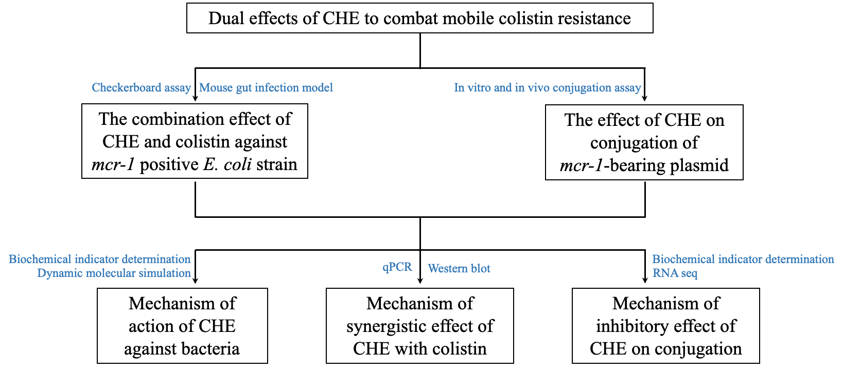

3. Supplementary figure legends

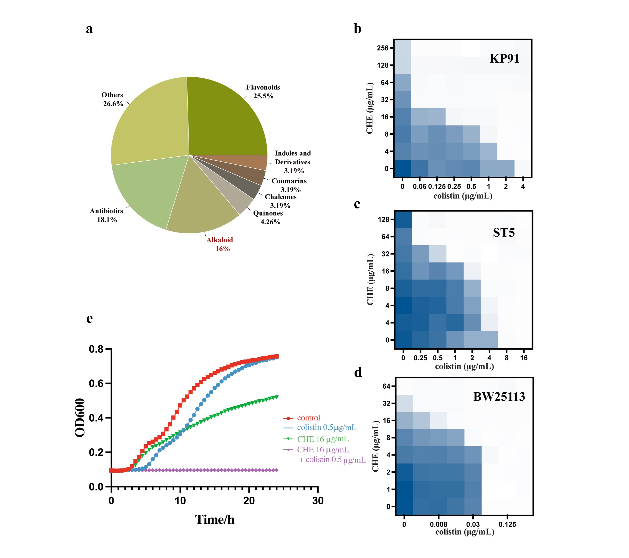
Fig. S1. a, The classification of natural compounds showed ≥90% growth inhibition in the combination with colistin. b, c and d, The checkerboard assay results of CHE and colistin against mcr-8-positive K. pneumoniae KP91, mcr-9-positive S. typhimurium ST5 and mcr-negative E. coli strain BW25113. e, The growth curve of ZJ807 treat with CHE or colistin alone, and the combination of CHE and colistin.
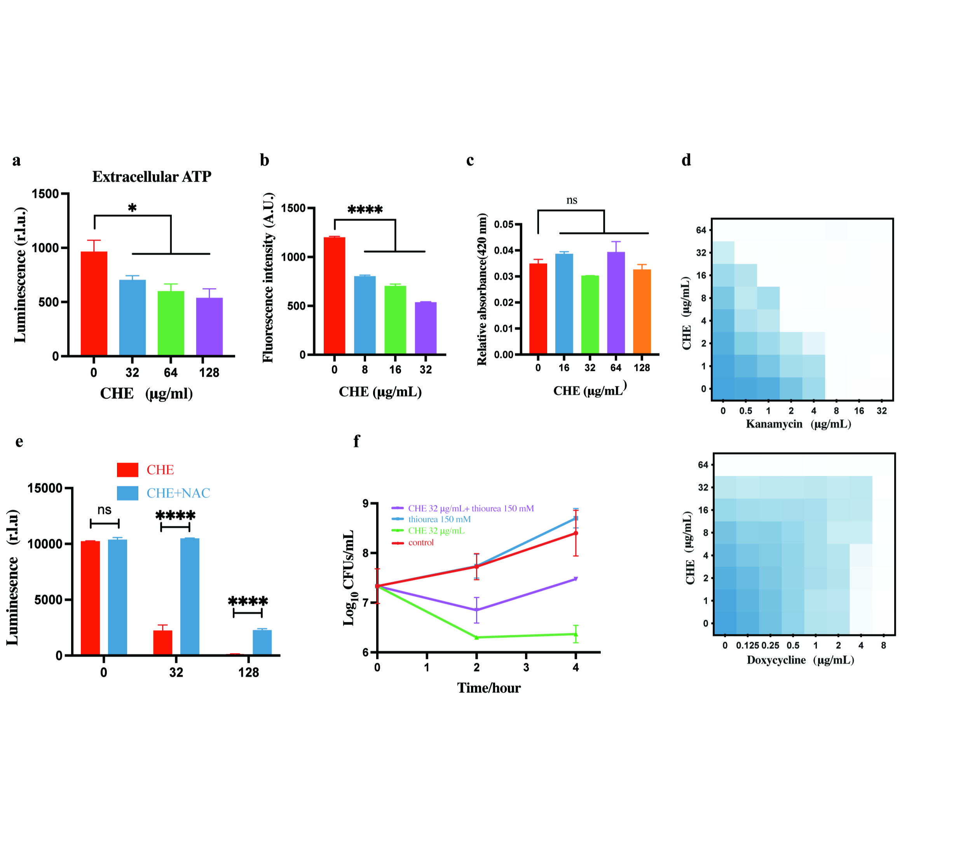

Fig. S2. Antimicrobial mechanism of CHE. a, Decreased levels of extracellular ATP in E. coli ZJ807 after the treatment of CHE. b, The changes of Fluorescence intensity of PI after mixing with CHE. c, The extracellular β-galactosidase of ZJ807 after treating with CHE. d, The growth inhibition checkerboards of CHE with kanamycin or doxycycline against E. coli ZJ807. Synergy is deﬁned as a FICI ≤ 0.5. e, The ATP level change of ZJ807 treat with CHE or CHE plus NAC. f, Time-killing curves of ZJ807 by treatment of CHE or thiourea alone, and the combination of CHE and thiourea. P value was detected using one-way ANOVA and corrected using "Dunnett" method. *, **** represent *P < 0.05,, ****P < 0.0001, respectively.

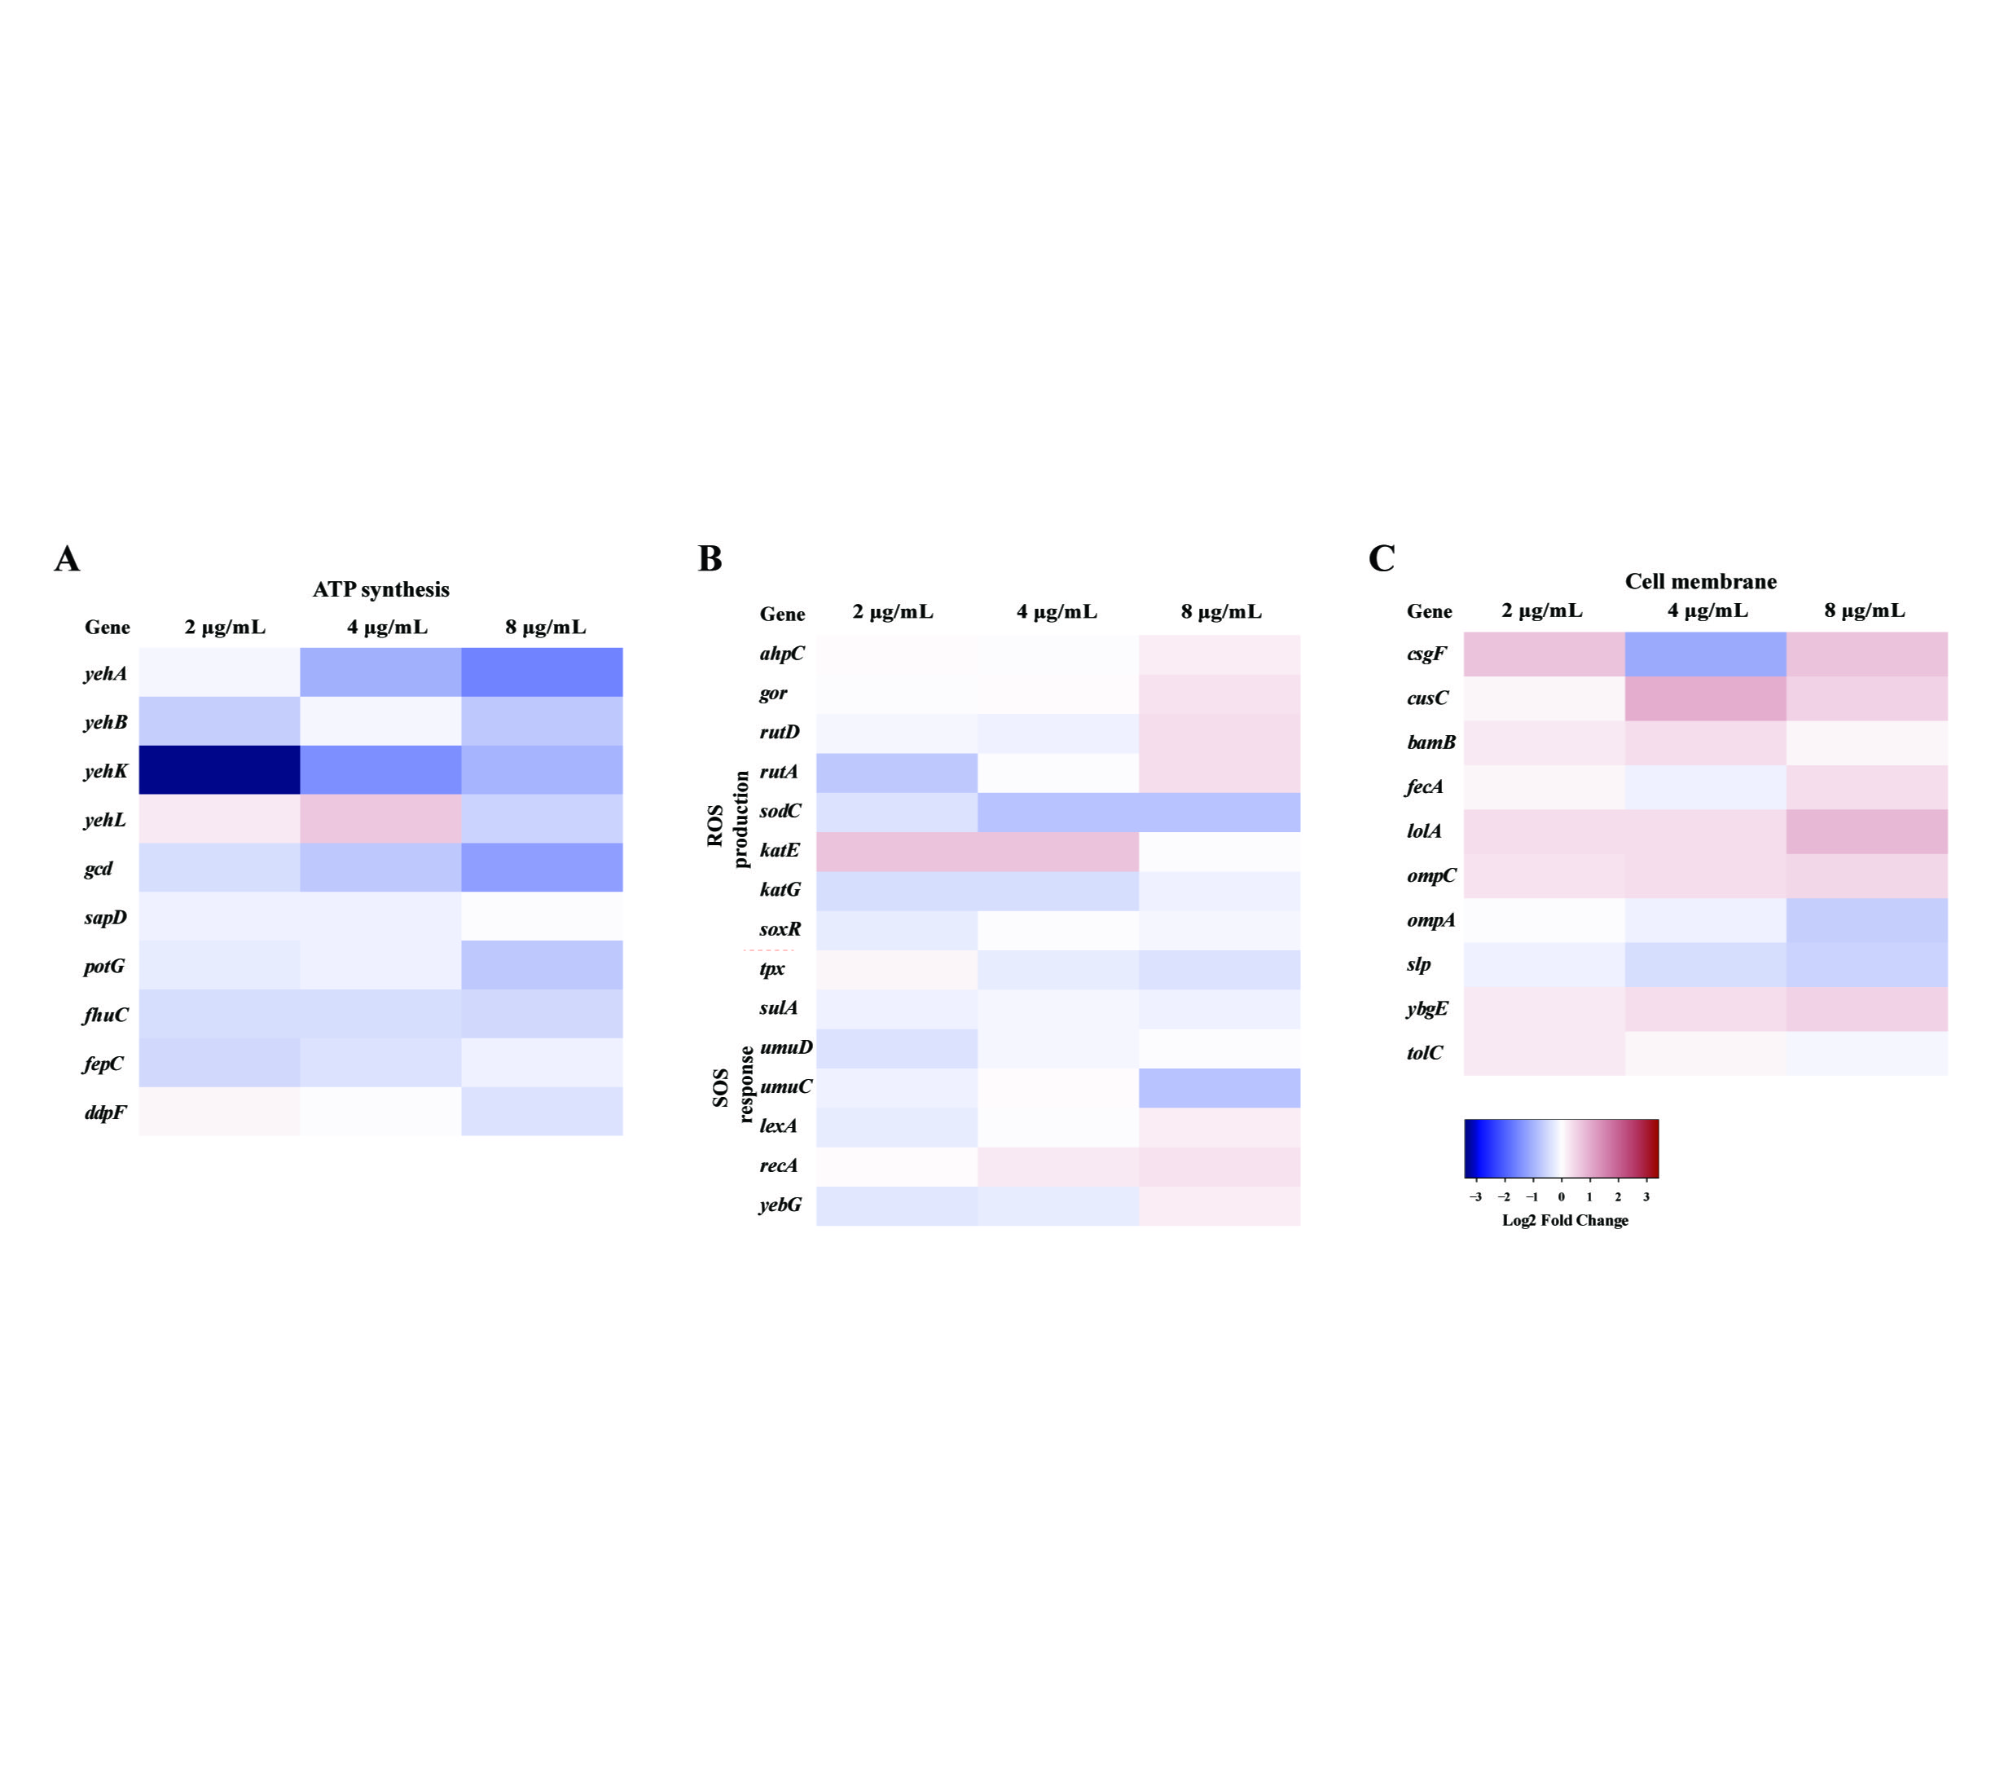
Fig. S3. Effects of CHE on transcription level of genes involved in ATP synthesis, ROS, SOS, and cell membrane in the recipient bacteria. a, Fold change of expression of core genes related to ATP synthesis in recipient bacteria. b, Fold change of expression of core genes related to ROS production and SOS response in recipient bacteria. c, Fold change of expression of core genes related to cell membrane in recipient bacteria.

4. Supplementary tables

Table S1 Genes relevant to ATP synthesis in donor bacteria after exposure of CHE
Gene | Fold change of FPKM*
Gene | 2 | 4 | 8
yehA | 0.72811251 | 0.43642143 | 0.39624308
yehB | 0.52427505 | 0.87362351 | 0.58238817
yehK | 0.45585773 | 0.73037122 | 0.52576042
yehL | 1.05232778 | 1.42181331 | 0.58868415
gcd | 0.75682246 | 0.63478744 | 0.43182005
sapD | 0.91542972 | 0.91111347 | 0.98093632
potG | 0.84165097 | 0.8694753 | 0.61902662
fhuC | 0.74084328 | 0.76036644 | 0.72671868
fepC | 0.75234282 | 0.79327037 | 0.89252186
ddpF | 0.92628828 | 0.85857367 | 0.73008217
*: Comparing with the control group without chelerythrine dosage.

Table S2 Genes relevant to ATP synthesis in recipient bacteria after exposure of CHE
Gene | Fold change of FPKM*
Gene | 2 | 4 | 8
yehA | 0.94600001 | 0.48903236 | 0.32764619
yehB | 0.62774115 | 0.93958614 | 0.60278445
yehK | 0.09424176 | 0.35530882 | 0.49748629
yehL | 1.18105285 | 1.57247175 | 0.67545415
gcd | 0.75291563 | 0.61706254 | 0.41660213
sapD | 0.90950688 | 0.90906812 | 0.96688799
potG | 0.83343682 | 0.87808162 | 0.60461737
fhuC | 0.74404899 | 0.73697715 | 0.71203486
fepC | 0.71744215 | 0.7685641 | 0.88660969
ddpF | 1.07784844 | 0.96683662 | 0.76212256
*: Comparing with the control group without chelerythrine dosage.

Table S3 Genes relevant to conjugation in donor bacteria after exposure of CHE
Gene | Fold change of FPKM*
Gene | 2 | 4 | 8
virB1 | 0.59015048 | 0.407473127 | 0.202908031
virB2 | 0.54451766 | 0.404819155 | 0.222242741
virB3 | 0.544555979 | 0.40593146 | 0.226247105
virB4 | 0.601443155 | 0.419059995 | 0.22808542
virB5 | 0.410310781 | 0.298165434 | 0.136244774
virB6 | 0.45522789 | 0.316794893 | 0.146984821
virB8 | 0.560694362 | 0.496293663 | 0.252149449
virB9 | 0.560166805 | 0.426798737 | 0.220779276
virB10 | 0.573603799 | 0.418241852 | 0.232577876
virB11 | 0.609631347 | 0.462170642 | 0.235673137
virD4 | 0.579401115 | 0.436054078 | 0.220189766
nikB | 0.642432833 | 0.548594867 | 0.45435918
traC | 0.459492471 | 0.346861446 | 0.167556735
pilV | 0.538311357 | 0.483353781 | 0.301914282
pilU | 0.535183355 | 0.43082133 | 0.243861604
pilT | 0.407020141 | 0.418701077 | 0.208094989
pilS | 0.517455879 | 0.421174936 | 0.242953676
pilR | 0.532490031 | 0.368994157 | 0.217208317
pilQ | 0.590640328 | 0.495314034 | 0.248207231
pilP | 0.579721158 | 0.495630821 | 0.248027129
pilO | 0.659416574 | 0.509241545 | 0.291349807
pilN | 0.629684925 | 0.494487556 | 0.266301483
*: Comparing with the control group without chelerythrine dosage.

Table S4 Genes relevant to pilus generation in donor bacteria after exposure of CHE
Gene | Fold change of FPKM*
Gene | 2 | 4 | 8
fimH | 0.660128271 | 0.596878556 | 0.442752799
fimF | 0.92847285 | 1.32727416 | 0.360509335
sfmC | 0.610556976 | 0.597513503 | 0.331774376
yadL | 0.463534339 | 0.961303578 | 0.827582045
ybgD | 1.267375823 | 0.927282552 | 0.552714808
ybgS | 0.579393936 | 0.469337659 | 0.289210248
yfcQ | 0.443519828 | 0.881743236 | 0.342109026
yraH | 0.835530517 | 0.712478566 | 0.620188502
yraJ | 0.721059327 | 0.703607858 | 0.582380203
yraK | 0.737747531 | 0.729823731 | 0.727832121
*: Comparing with the control group without chelerythrine dosage.

Table S5 Genes relevant to ROS and SOS in donor bacteria after exposure of CHE
Gene | Fold change of FPKM*
Gene | 2 | 4 | 8
ahpC | 1.015498947 | 0.999663789 | 1.120351044
alkB | 0.812313414 | 0.696951961 | 0.677737211
gor | 1.008701991 | 1.031039575 | 1.192852027
rutD | 0.827732224 | 0.824591177 | 0.927516491
rutC | 1.585868647 | 1.093434459 | 0.709246195
rutA | 0.805697575 | 0.844116511 | 0.930744402
sodC | 0.847202984 | 0.70396002 | 0.698451375
sodB | 0.78694333 | 0.767544722 | 0.662487245
katE | 1.419844053 | 1.417577774 | 1.027002095
katG | 0.807585114 | 0.82292187 | 0.946839286
soxR | 0.871042777 | 1.002122493 | 0.963789195
tpx | 1.049423848 | 0.900350042 | 0.872974093
sulA | 0.92171358 | 0.911705421 | 0.903610657
umuD | 0.851130003 | 0.978148807 | 1.014851352
umuC | 0.992557515 | 1.023539859 | 0.772998015
lexA | 0.915190819 | 0.995786986 | 1.115326549
recA | 1.016640286 | 1.119266484 | 1.172869435
yebG | 0.872265669 | 0.906320096 | 1.126602148
yedK | 0.74976766 | 0.69504051 | 0.543046585
dps | 0.665721538 | 0.596470222 | 0.492218719
phoP | 1.064797785 | 0.963876276 | 0.846169911
*: Comparing with the control group without chelerythrine dosage.

Table S6 Genes relevant to ROS and SOS in recipient bacteria after exposure of CHE
Gene | Fold change of FPKM*
Gene | 2 | 4 | 8
ahpC | 1.00274968 | 0.9877374 | 1.09963602
gor | 0.99653371 | 1.012954 | 1.16388211
rutD | 0.94468375 | 0.92740395 | 1.21107538
rutA | 0.70493884 | 0.99209829 | 1.19418894
sodC | 0.82102281 | 0.68718933 | 0.67879882
katE | 1.4085702 | 1.42094874 | 0.99948203
katG | 0.79502787 | 0.81173252 | 0.92518849
soxR | 0.88123421 | 0.97416724 | 0.96521062
tpx | 1.06143367 | 0.88183439 | 0.84570059
sulA | 0.93073218 | 0.95168686 | 0.93443332
umuD | 0.81920004 | 0.95513827 | 0.97171709
umuC | 0.92784503 | 1.01588215 | 0.67526864
lexA | 0.904442 | 0.9812643 | 1.10095714
recA | 1.01345751 | 1.1214431 | 1.16314258
yebG | 0.86028025 | 0.8906025 | 1.09504025
*: Comparing with the control group without chelerythrine dosage.

Table S7 Genes relevant to cell membrane in donor bacteria after exposure of CHE
Gene | Fold change of FPKM*
Gene | 2 | 4 | 8
csgF | 1.299125363 | 0.859570885 | 1.470978504
cusC | 0.907164413 | 1.206038179 | 1.132633599
bamB | 1.157092986 | 1.1881479 | 1.077286812
fecA | 1.041350743 | 0.926191513 | 1.182166223
lolA | 1.210526173 | 1.235804203 | 1.557984633
ompC | 1.189905492 | 1.2177659 | 1.250844776
ompA | 0.990368086 | 0.938017472 | 0.733453371
slp | 0.933559723 | 0.816396003 | 0.778078164
ybgE | 1.154005147 | 1.227842587 | 1.304607824
tolC | 1.136845298 | 1.073074818 | 0.967508731
*: Comparing with the control group without chelerythrine dosage.

Table S8 Genes relevant to cell membrane in recipient bacteria after exposure of CHE
Gene | Fold change of FPKM*
Gene | 2 | 4 | 8
csgF | 1.43928257 | 0.57648234 | 1.43334344
cusC | 1.05119945 | 1.61759864 | 1.29465864
bamB | 1.13919673 | 1.18622448 | 1.06405762
fecA | 1.04211671 | 0.9254663 | 1.20810588
lolA | 1.18719585 | 1.19732327 | 1.50828359
ompC | 1.16972481 | 1.19990686 | 1.22462103
ompA | 0.97749085 | 0.92651012 | 0.71966226
slp | 0.92015215 | 0.80584792 | 0.7617615
ybgE | 1.1386807 | 1.21025832 | 1.27933983
tolC | 1.11450764 | 1.06461524 | 0.94113659
*: Comparing with the control group without chelerythrine dosage.

Reference
1. Wang R, Lai TP, Gao P, Zhang H, Ho PL, Woo PC, Ma G, Kao RY, Li H, Sun H. 2018. Bismuth antimicrobial drugs serve as broad-spectrum metallo-beta-lactamase inhibitors. Nat Commun 9:439.
2. Kohanski MA, Dwyer DJ, Hayete B, Lawrence CA, Collins JJ. 2007. A common mechanism of cellular death induced by bactericidal antibiotics. Cell 130:797-810.
3. Fang G, Li W, Shen X, Perez-Aguilar JM, Chong Y, Gao X, Chai Z, Chen C, Ge C, Zhou R. 2018. Differential Pd-nanocrystal facets demonstrate distinct antibacterial activity against Gram-positive and Gram-negative bacteria. Nat Commun 9:129.
4. Hess B, Kutzner C, van der Spoel D, Lindahl E. 2008. GROMACS 4: Algorithms for Highly Efficient, Load-Balanced, and Scalable Molecular Simulation. J Chem Theory Comput 4:435-47.
5. Sabnis A, Hagart KL, Klockner A, Becce M, Evans LE, Furniss RCD, Mavridou DA, Murphy R, Stevens MM, Davies JC, Larrouy-Maumus GJ, Clarke TB, Edwards AM. 2021. Colistin kills bacteria by targeting lipopolysaccharide in the cytoplasmic membrane. Elife 10.

