Supplementary data for

A Shape-Memory Deployable Subsystem with a Large Folding Ratio in China’s Tianwen-1 Mars Exploration Mission
Chengjun Zeng a, Liwu Liu a, Yang Du b, Miao Yu b, Xiaozhou Xin a, Tianzhen Liu c, Peilei Xu a, Yu Yan a, Dou Zhang a, Wenxu Dai a, Xin Lan c, Fenghua Zhang c, Linlin Wang c, Xue Wan c, Wenfeng Bian d, Yanju Liu a,*, Jinsong Leng c,*
a Department of Astronautical Science and Mechanics, Harbin Institute of Technology, Harbin 150001, China
b Shanghai Institute of Satellite Engineering, Shanghai 201109, China
c Center for Composite Materials and Structures, Harbin Institute of Technology, Harbin 150080, China
d Department of Civil Engineering, Harbin Institute of Technology, Weihai 264209, China

* Corresponding authors.
E-mail addresses: yj_liu@hit.edu.cn (Y. Liu), lengjs@hit.edu.cn (J. Leng).

1. Design of SMPC-FDS
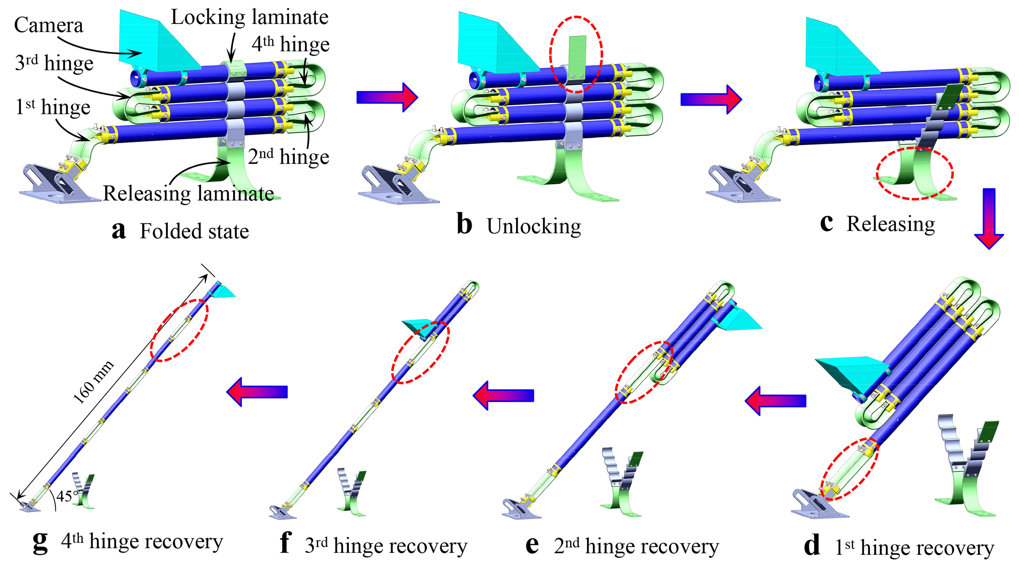
Fig. S1. Schematic diagram for the deployment process of SMPC-FDS.
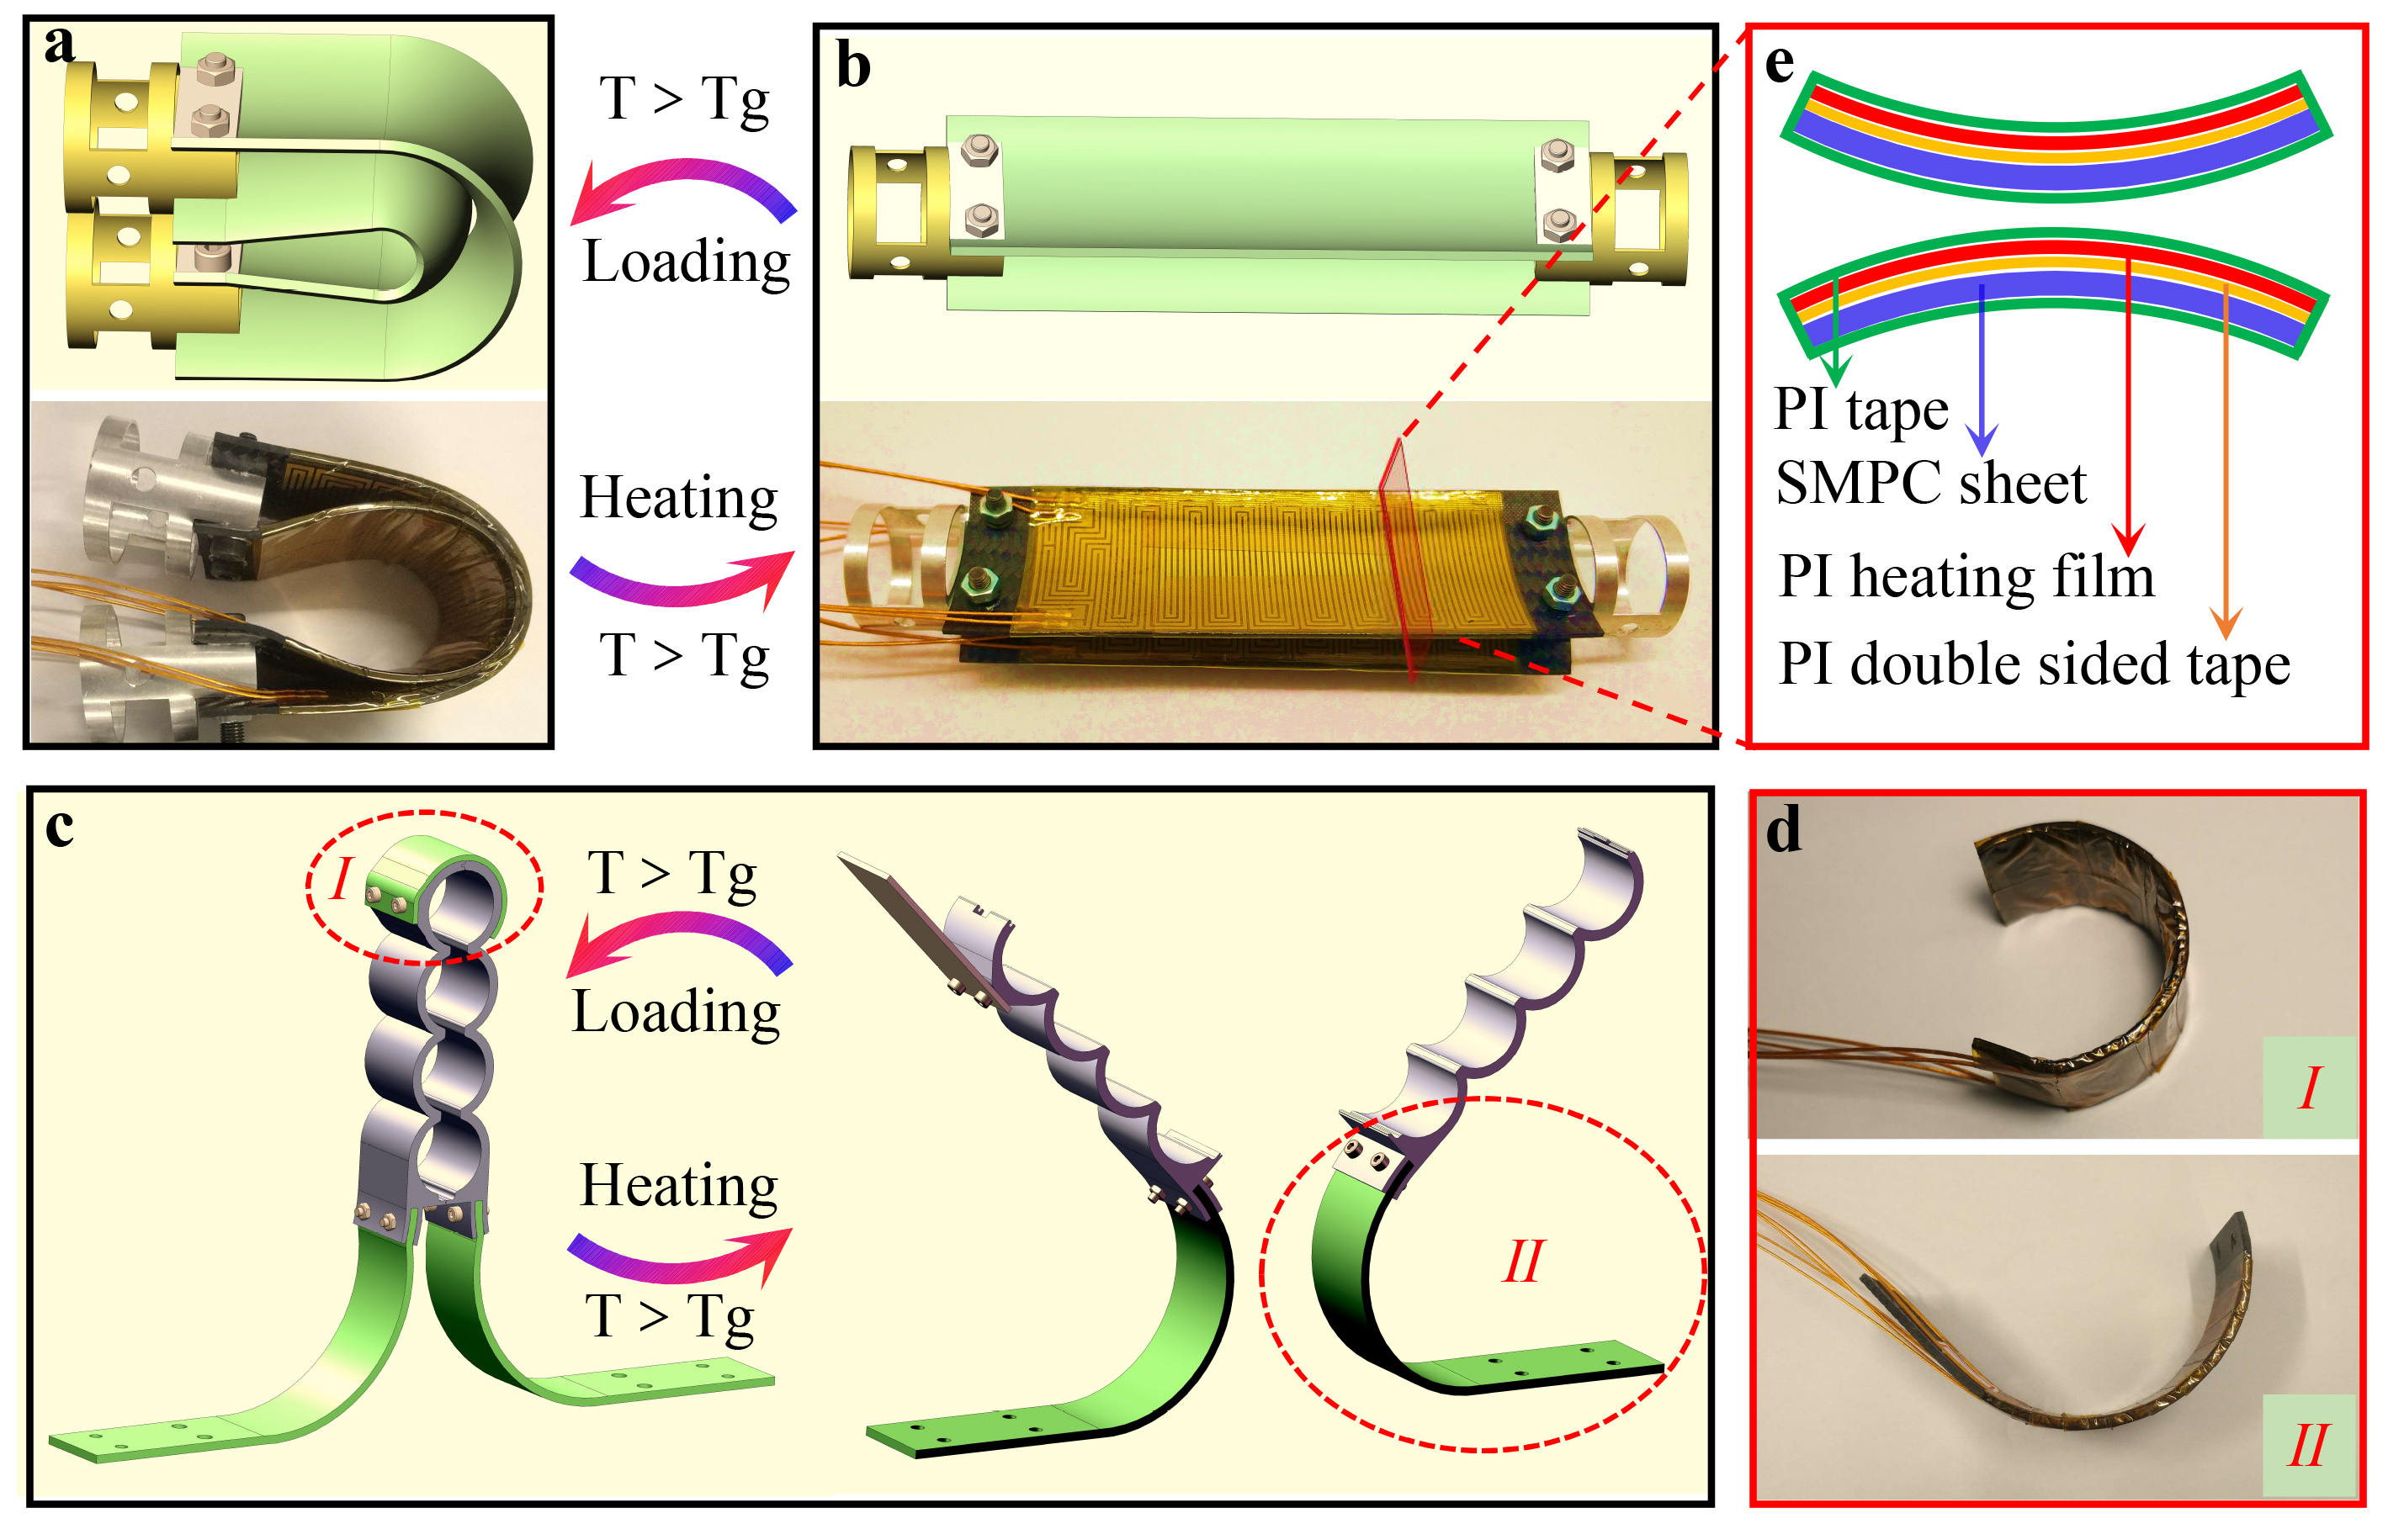
Fig. S2. Design of components of SMPC-FDS. (a) SMPC hinge in the folded state. (b) SMPC hinge in the deployed state. (c) Schematic diagram of the locked and unlocked states of the lock-release mechanism. (d) Physical diagram of the locking laminate and the releasing laminate. (e) Schematic diagram of the cross-section of the SMPC sheet with an electrically heating film attached to the surface.

Table S1
Parameters of 230-type film electric heater.
Components | Locking laminate | Releasing laminate | 1st hinge | 2nd/ 3rd/4th hinge
Size | 70 mm × 30 mm | 85 mm × 30 mm | 85 mm × 40 mm | 110 mm × 40 mm
Resistance | 28 Ω | 28 Ω | 24 Ω | 24 Ω
quantity | 1 | 2 | 2 | 2

Table S2
Test conditions for shocking test and random vibration test.
Test type | Frequency / Hz | Amplitude
Shocking test | 100~1500 |  | ＋6dB/oct
Shocking test | 1500~4000 |  | 2300 g
Random vibration test | 20~100 |  | ＋6dB/oct
Random vibration test | 100~2000 |  | 0.22 g²/Hz

2. Experimental methods and results
2.1 Fourier transform infrared spectroscopy (FTIR) analysis
The molecular structure of SMPCs before and after high or low temperature exposure was evaluated in a reflection mode using an FTIR spectrometer (Thermo Scientific Nicolet iS50). A wavelength range from 400 cm⁻¹ to 4000 cm⁻¹ was selected. The FTIR curves of ESMPC before and after high (or low) temperature exposure are given in Fig. S3a, from which it can be observed that there is no absorption for ESMPC at 910 cm⁻¹ which corresponds to the characteristic absorption of the epoxy group. In addition, ESMPC shows absorption at 1154 cm⁻¹, which is assigned to the C-O stretching. Overall, it can be concluded from the FTIR spectra that high or low temperature exposure did not affect the molecular structure of ESMPC. Fig. S3b presents the FTIR spectra of CSMPC before and after high (or low) temperature exposure, from which it can be found that CSMPC shows stretching vibrational absorption peaks of the 1,3,5-triazine ring at 1564 cm⁻¹ and 1366 cm⁻¹. Similar to ESMPC, the molecular structure of CSMPC did not change after high or low temperature exposure.
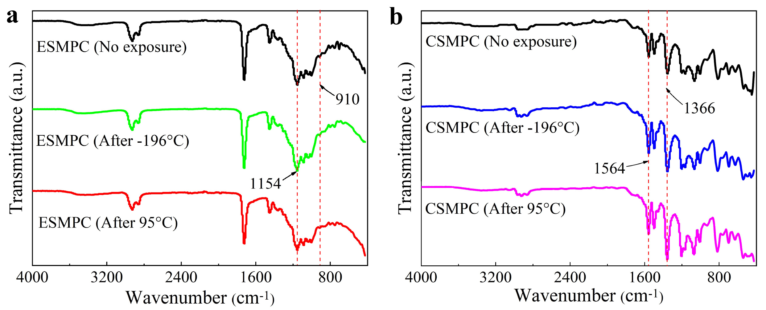
Fig. S3. FTIR spectra of (a) ESMPC and (b) CSMPC.
2.2 Thermogravimetric analysis (TGA)
In order to investigate the thermal stability of SMPCs after high and low temperature exposure, thermogravimetric analysis (TGA) was performed on SMPC samples using a thermogravimetric analyzer (NETZSCH TG 209). The samples were ramped up from 25 ℃ to 800 ℃ in a ceramic crucible at a rate of 10 ℃/min in nitrogen atmosphere. Fig. S4a illustrates the thermal stability of ESMPC in nitrogen environment. With or without heat treatment (high or low temperature exposure), ESMPC had a degradation stage, which was the weight loss caused by decomposition of the main carbon chain. The maximum thermal weight loss rate occurred at around 383 ℃ and the residual weight fraction at 800 ℃ was about 40%. It was verified that the thermal stability (or thermal degradability) of ESMPC was not adversely affected by high or low temperature exposure. Fig. S4b presents the thermogravimetric curves of CSMPC after high or low temperature exposure, from which similar conclusions to the above can be drawn.
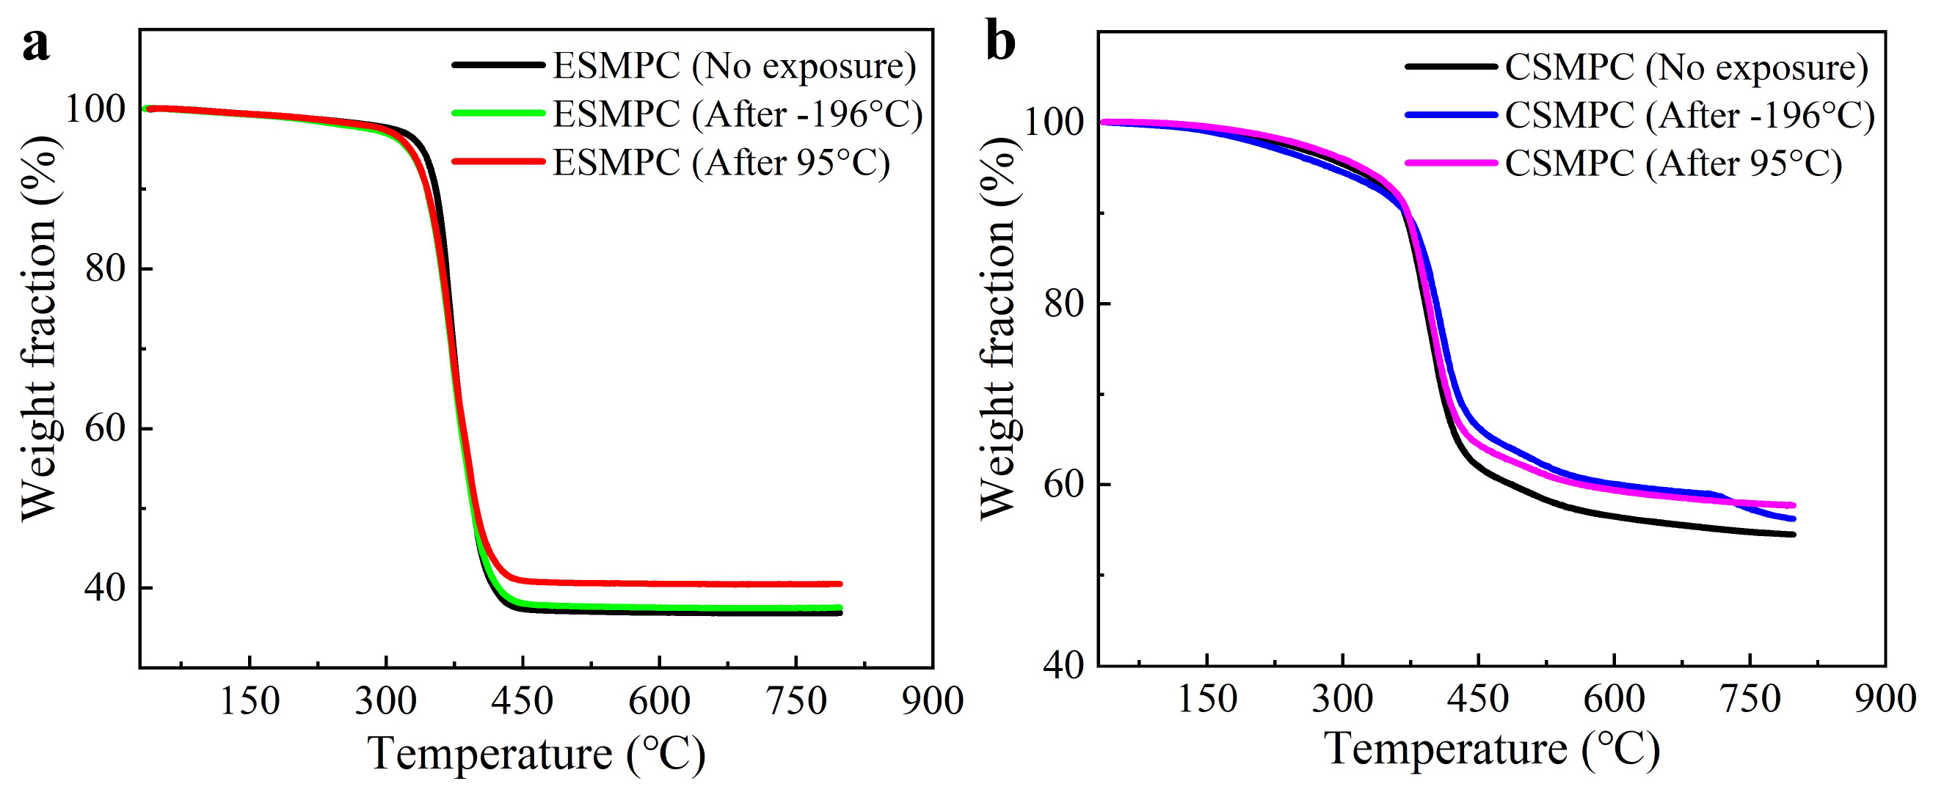
Fig. S4. The thermogravimetric curve of (a) ESMPC and (b) CSMPC.
2.3 Structural dynamics performance
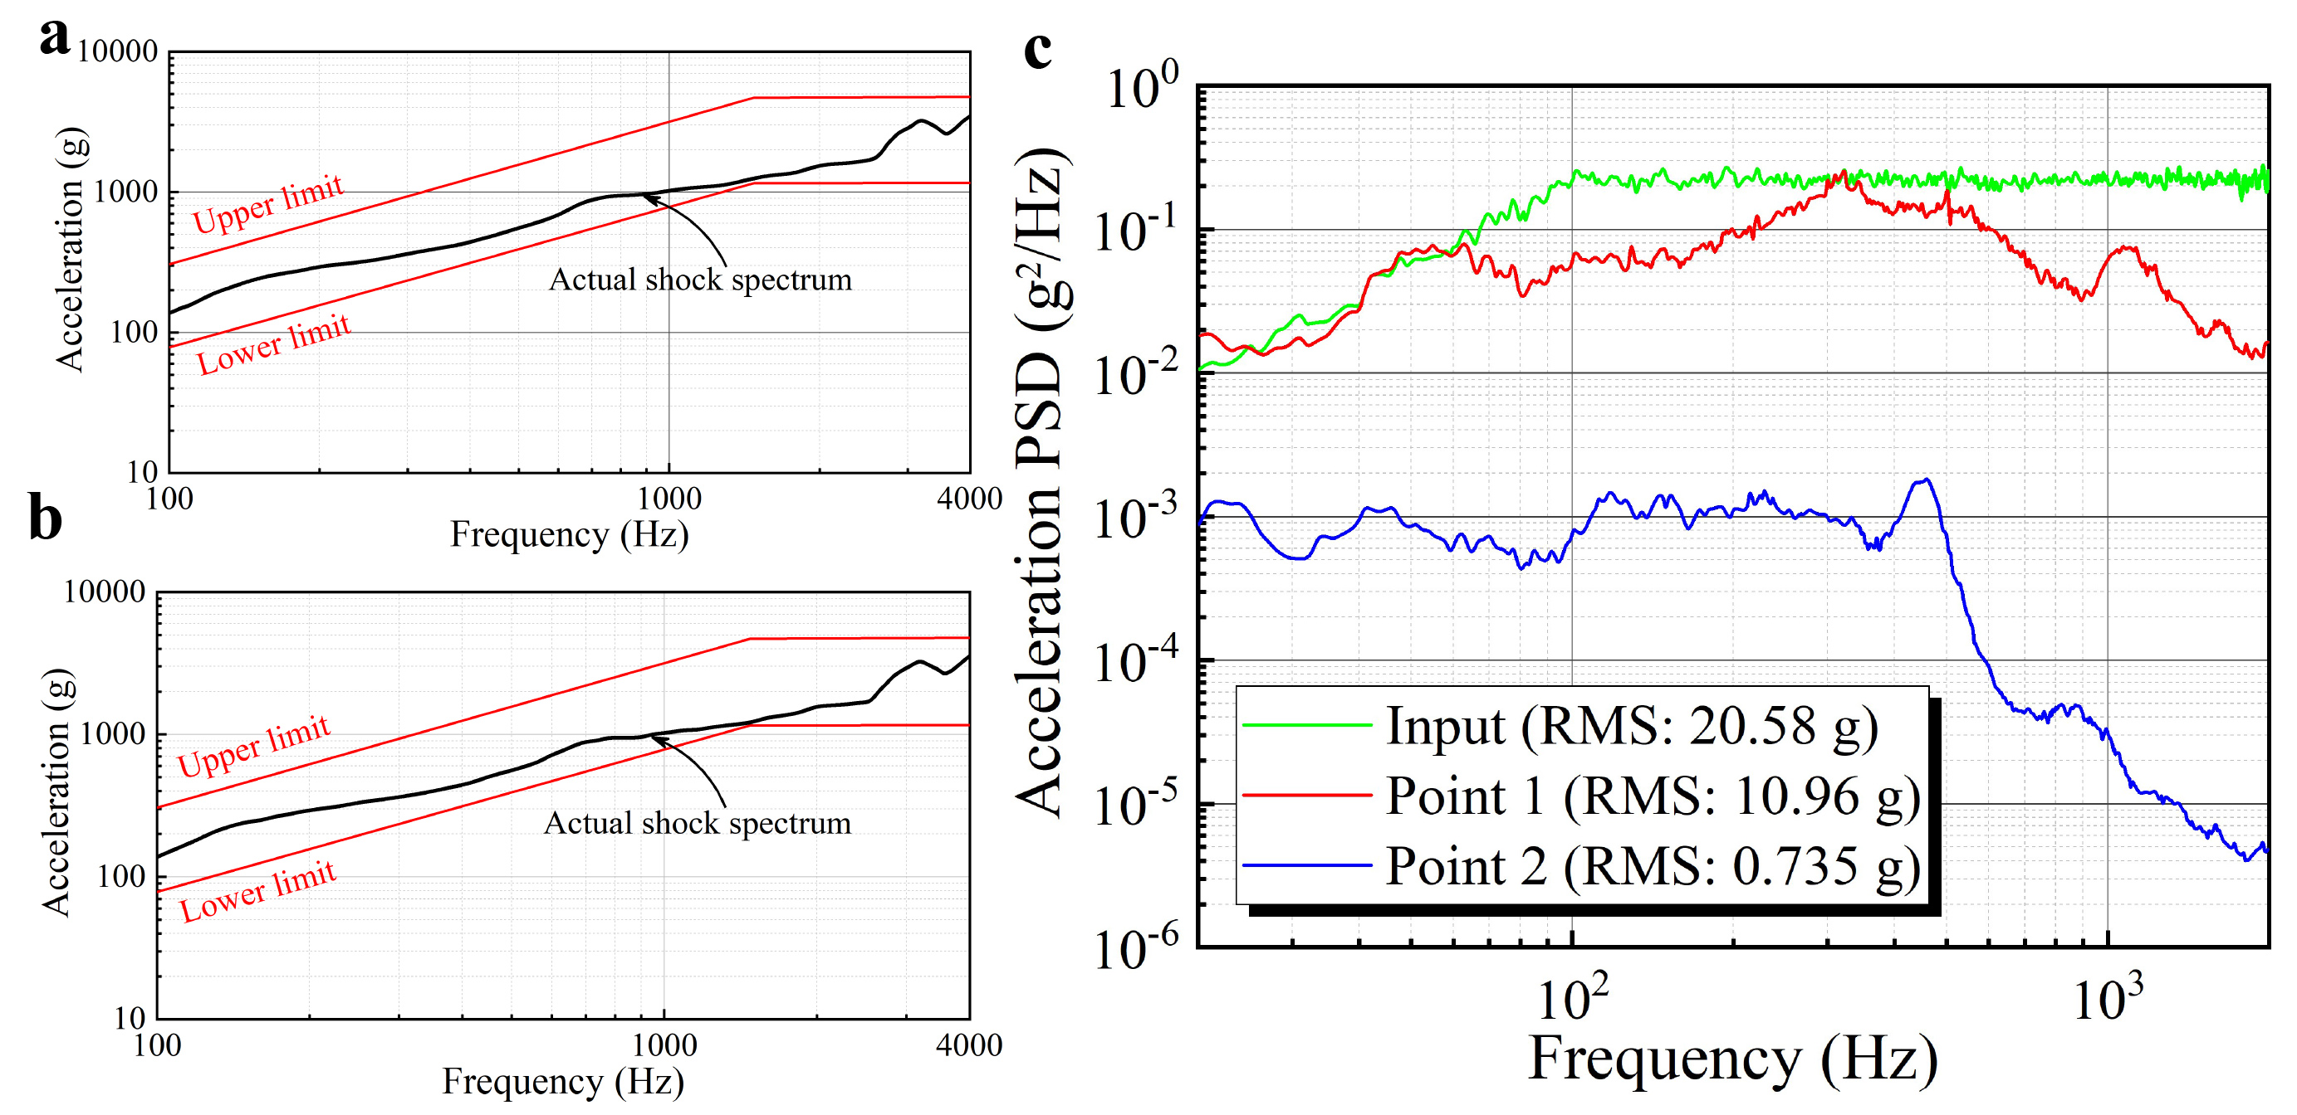
Fig. S5. Structural dynamics performance of SMPC-FDS. (a) Shock spectrum of SMPC-FDS loaded in the Y direction at −60 °C. (b) Shock spectrum of SMPC-FDS loaded in the Z direction at −60 °C. (c) Frequency response curves of SMPC-FDS when performing random vibration in the Y direction.
2.4 Thermal vacuum deployment reliability
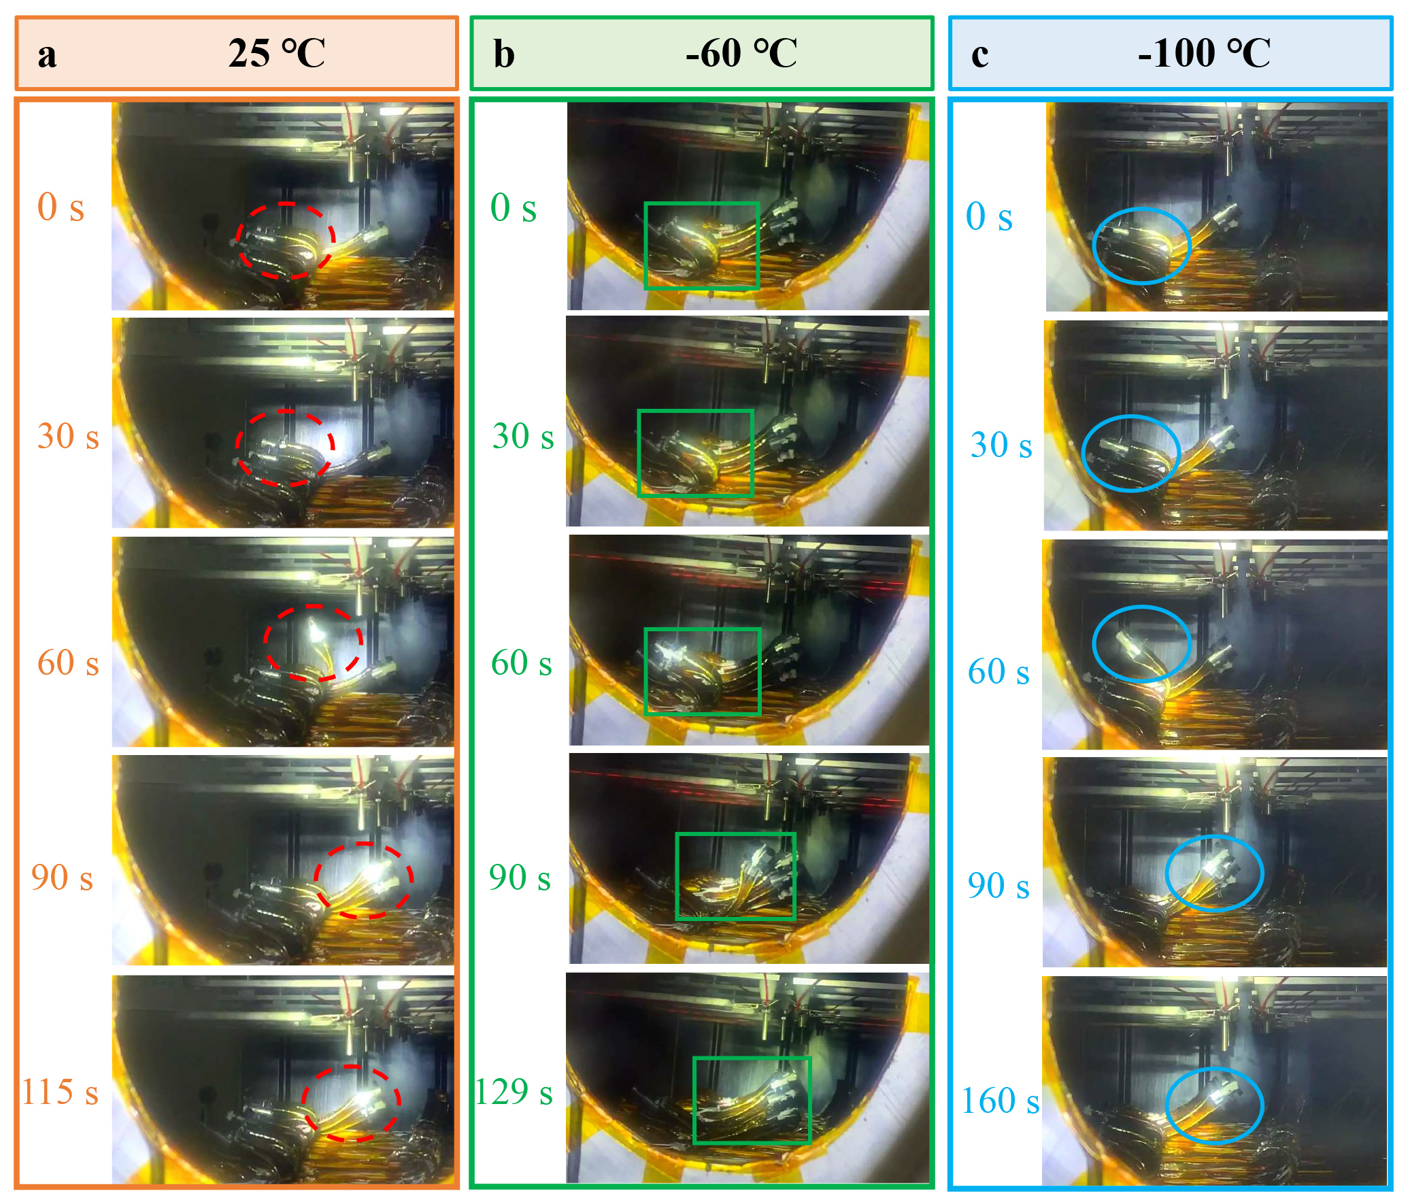
Fig. S6. Thermal vacuum deployment process of SMPC hinges at (a) 25 °C, (b) −60 °C and (c) −100 °C.
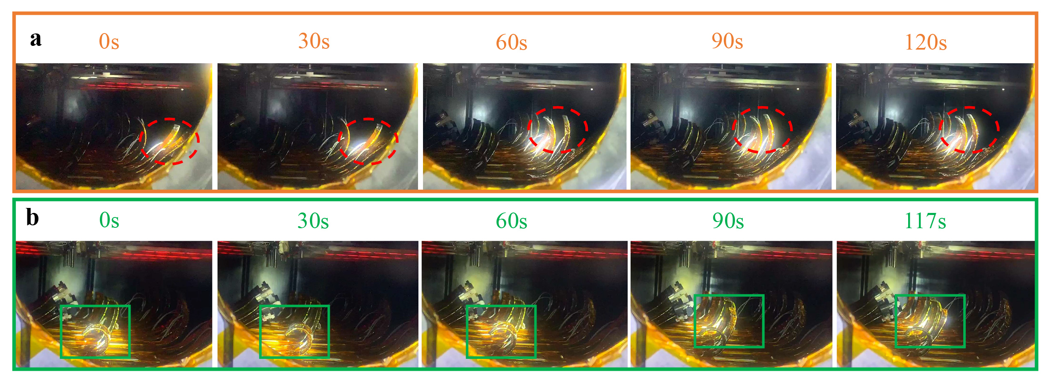
Fig. S7. Thermal vacuum deployment process of (a) releasing laminate and (b) locking laminate at −60 °C.
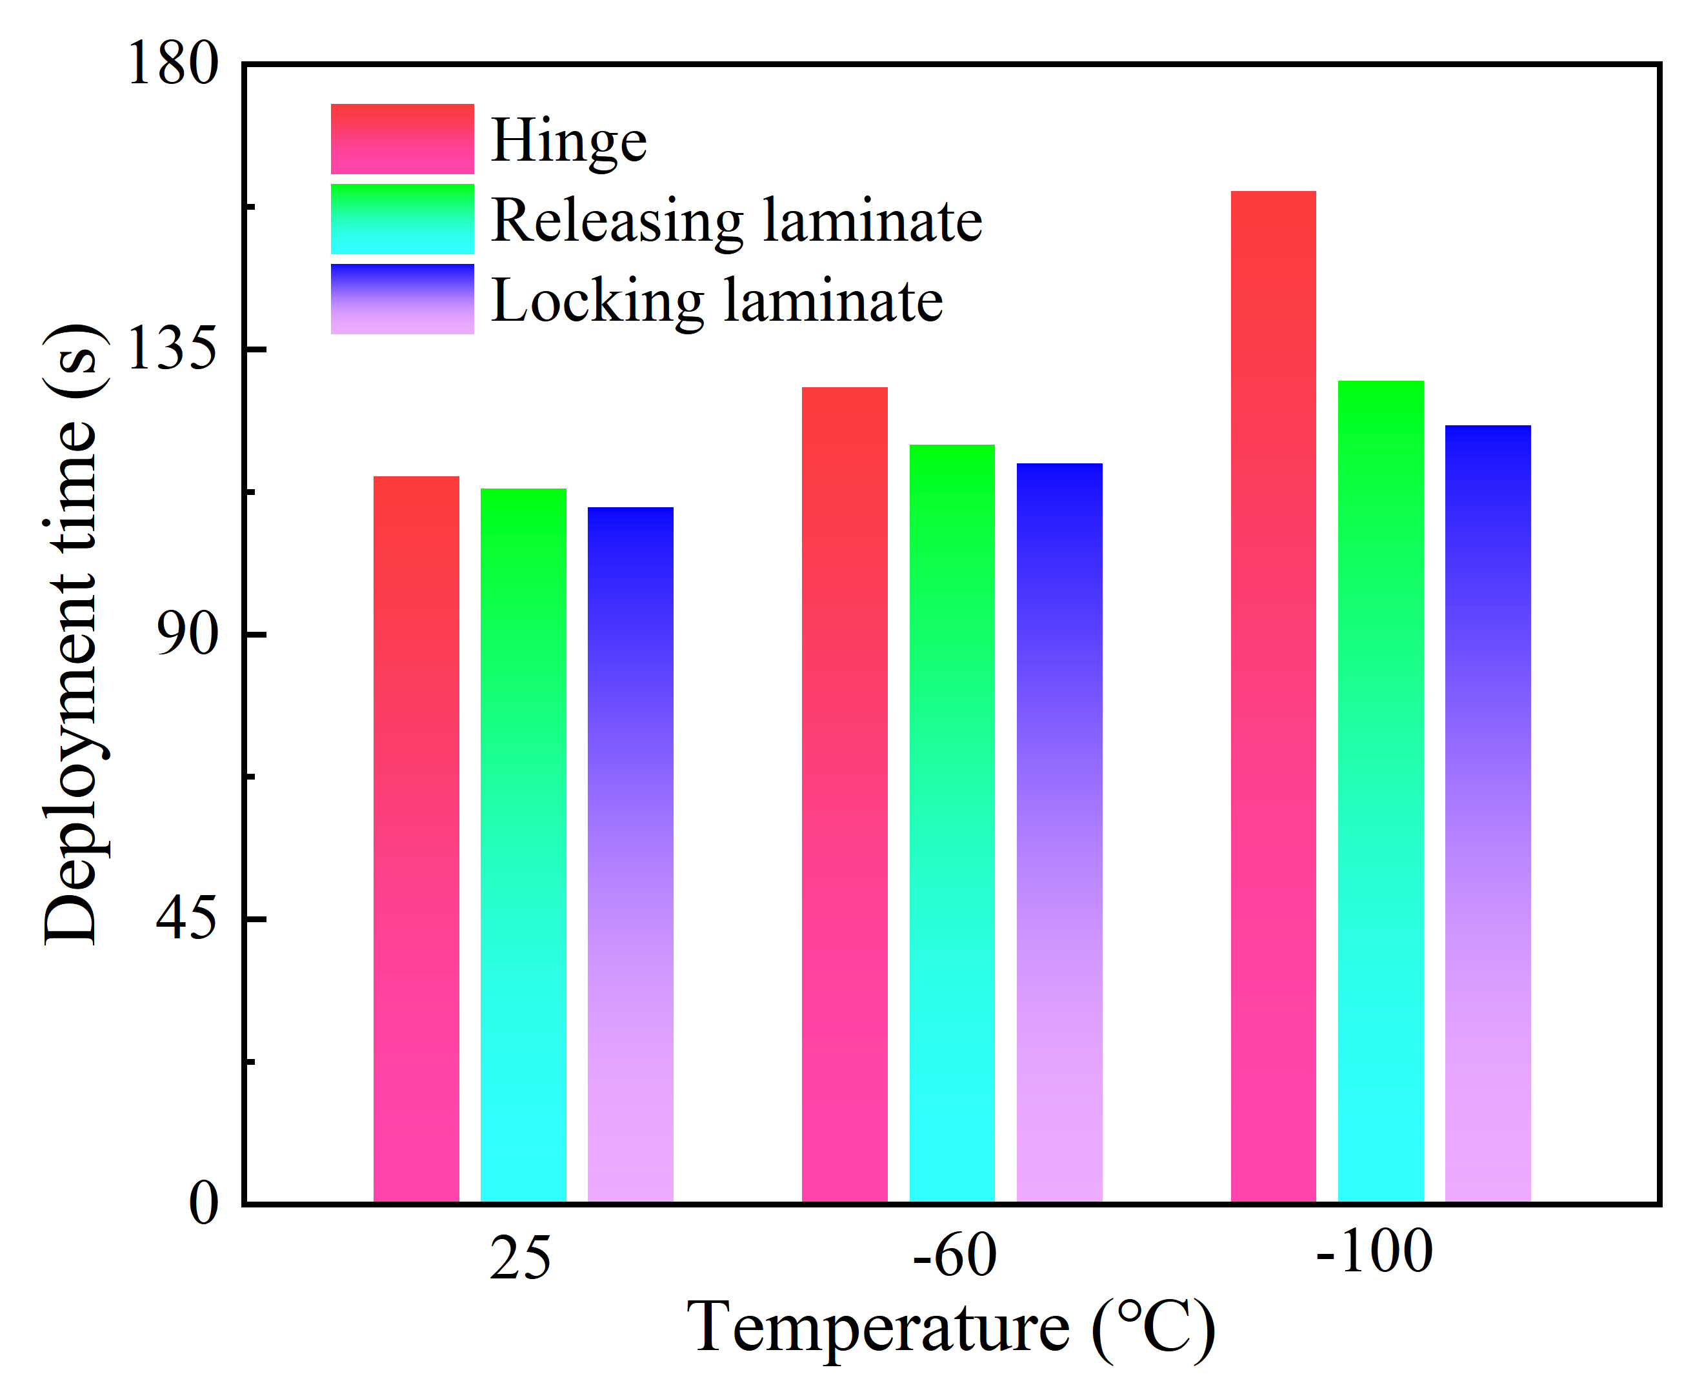
Fig. S8. The time required for full deployment of various components at different temperatures.

Table S3
Energized conditions during on-orbit deployment.
Components | Locking laminate | Releasing laminate 1/2 | 1st/2nd/ 3rd/4th hinge
Voltage / V | 29 | 29 | 29
Actuation power / W | 30 | 60 | 70
Actuation time / min | 3 | 4 | 3.5

