Supplementary file for
Targeted therapy of central nervous system acute lymphoblastic leukemia with an integrin α6-targeted self-assembling proapoptotic nanopeptide
Jia-Cong Ye ^{a,b,#}, Wan-Qiong Li ^{c,#}, Mei-Ling Chen ^{b,#}, Qian-Kun Shi ^{d,#}, Hua Wang ^{b}, Xin-Ling Li ^{b}, Ying-He Li ^{b}, Jie Yang ^{b}, Qiao-Li Wang ^{b}, Fang Hu ^{d}, Yan-Feng Gao ^{c,}*, Shu-Wen Liu ^{a,e,}*, Mu-Sheng Zeng ^{b,}*, Guo-Kai Feng ^{b,}*
ª Guangdong Provincial Key Laboratory of New Drug Screening & NMPA Key Laboratory of Drug Metabolism Research and Evaluation, School of Pharmaceutical Sciences, Southern Medical University, Guangzhou 510515, China
^{b} State Key Laboratory of Oncology in South China & Guangdong Key Laboratory of Nasopharyngeal Carcinoma Diagnosis and Therapy, Guangdong Provincial Clinical Research Center for Cancer, Sun Yat-sen University Cancer Center, Guangzhou 510060, China
^{c} School of Pharmaceutical Sciences (Shenzhen), Shenzhen Campus of Sun Yat-sen University, Shenzhen 518107, China
^{d} Guangdong Provincial Key Laboratory of Construction and Detection in Tissue Engineering, Biomaterials Research Center, School of Biomedical Engineering, Southern Medical University, Guangzhou 510515, China
^{e} State Key Laboratory of Organ Failure Research, Guangdong Provincial Institute of Nephrology, Southern Medical University, Guangzhou 510515, China

# These authors contributed equally to this work.

* Corresponding authors.
E-mail addresses: gaoyf29@mail.sysu.edu.cn (Y.F. Gao), liusw@smu.edu.cn (S.W. Liu), zengmsh@sysucc.org.cn (M.S. Zeng), fengguok@sysucc.org.cn (G.K. Feng).

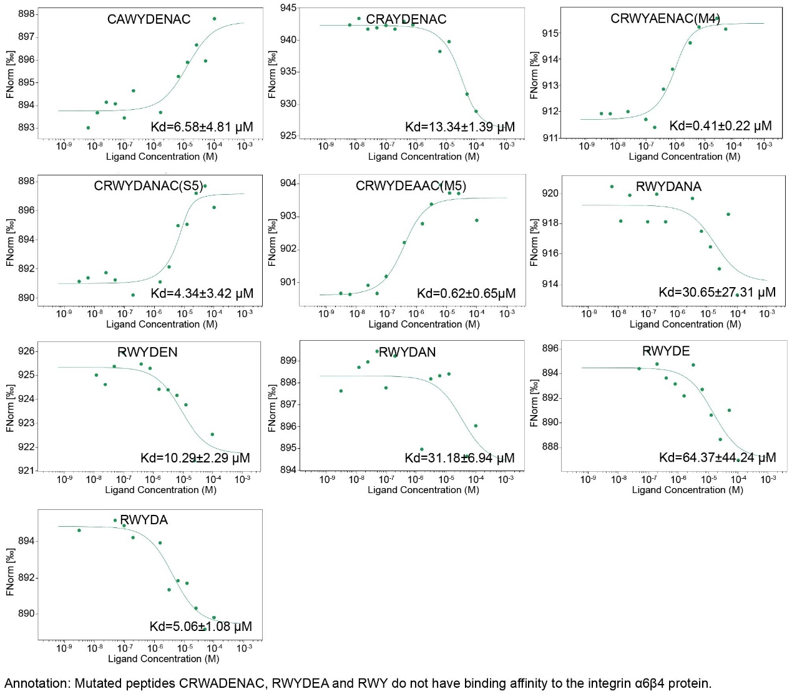
Fig. S1. Binding affinities of the peptides to integrin α6β4. Peptides were synthesized, and their binding affinities for integrin α6β4 were measured by using microscale thermophoresis (MST). Data are presented as the mean ± SD, n = 3.

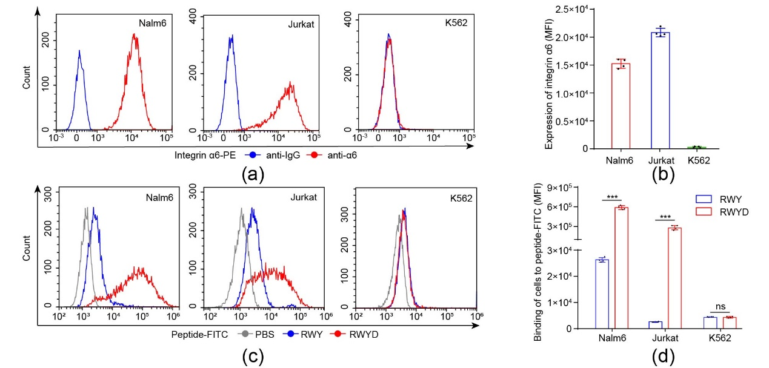
Fig. S2. Integrin α6-targeting fluorescent probes FITC-RWY/FITC-RWYD bind to leukemia cells. (a) Flow cytometry determined the surface expression of integrin α6 on human leukemia cell lines, including Nalm6, Jurkat and K562. (b) Quantitative analysis of the fluorescence intensity was used to evaluate the surface expression of integrin α6 on leukemia cells. (c) Flow cytometry was used to determine the binding between FITC-RWY/FITC-RWYD and leukemia cells. (d) Quantitative analysis of the fluorescence intensity of FITC-RWYD bound to leukemia cells.
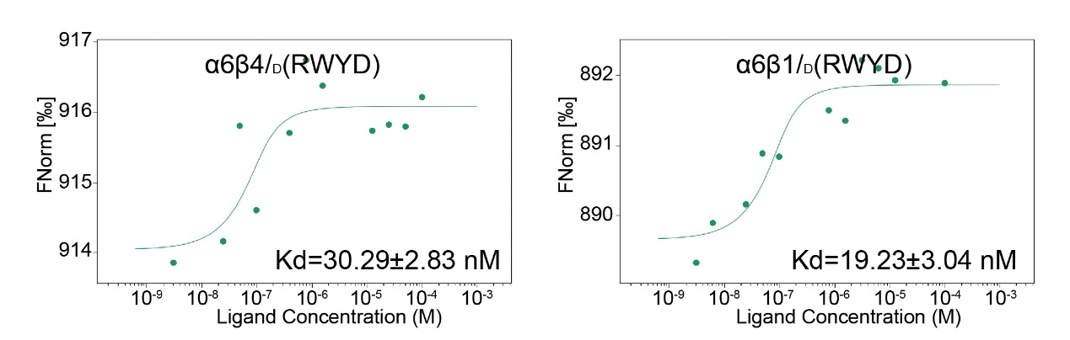
Fig. S3. The binding affinity of _{D}(RWYD) to integrins α6β4/α6β1 by MST. Data are presented as the mean ± SD, n = 3.
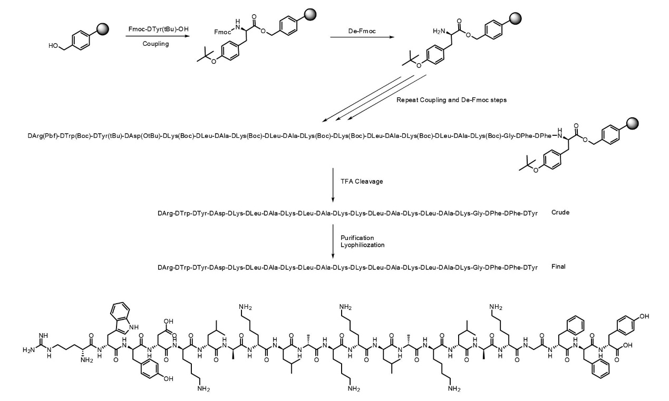
Fig. S4. Schematic diagram of the synthesis of the nanopeptide.
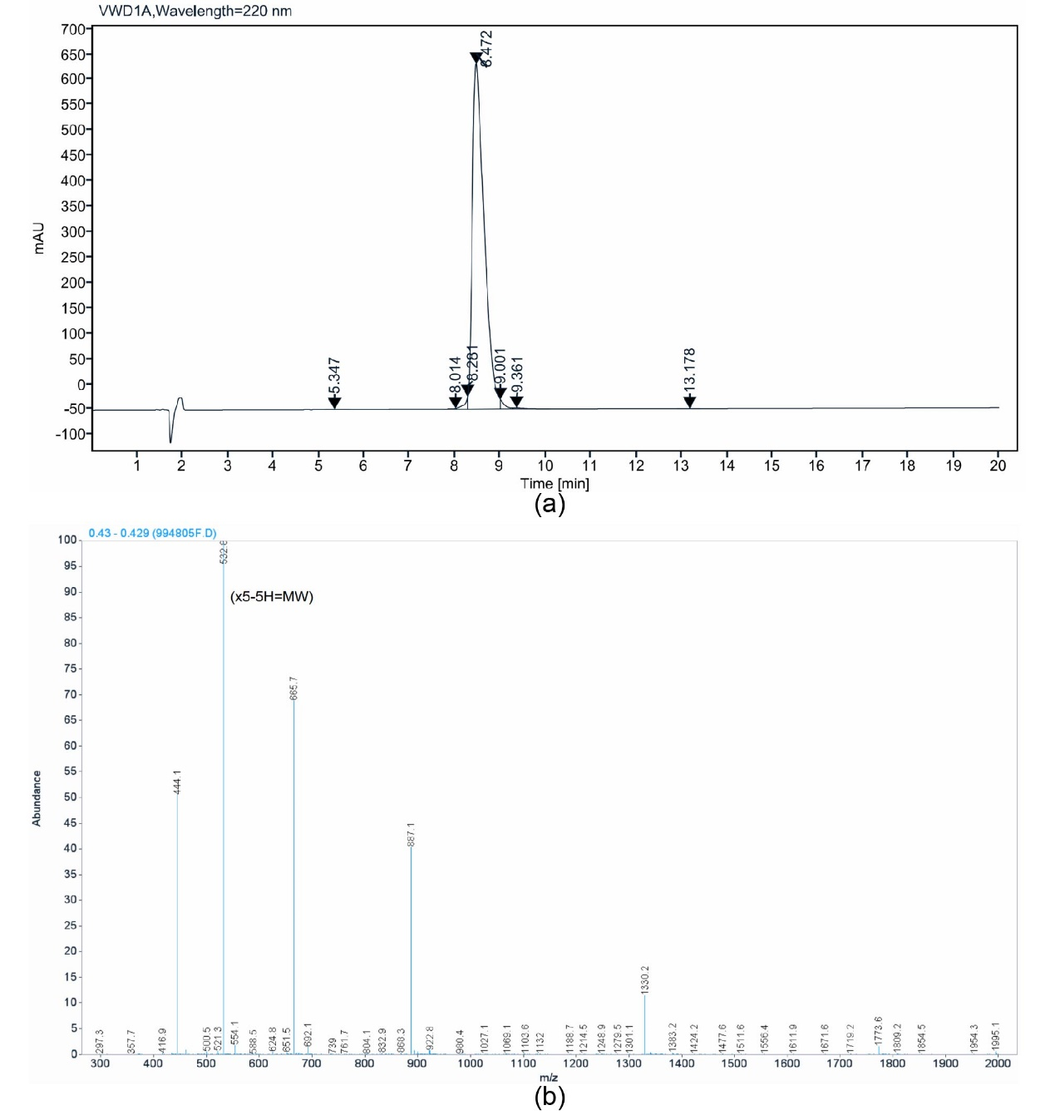
Fig. S5. Analytical high-performance liquid chromatography (HPLC) chromatograph (a) and mass spectrometry (MS) spectrum (b) of RD-KLA-Gffy.
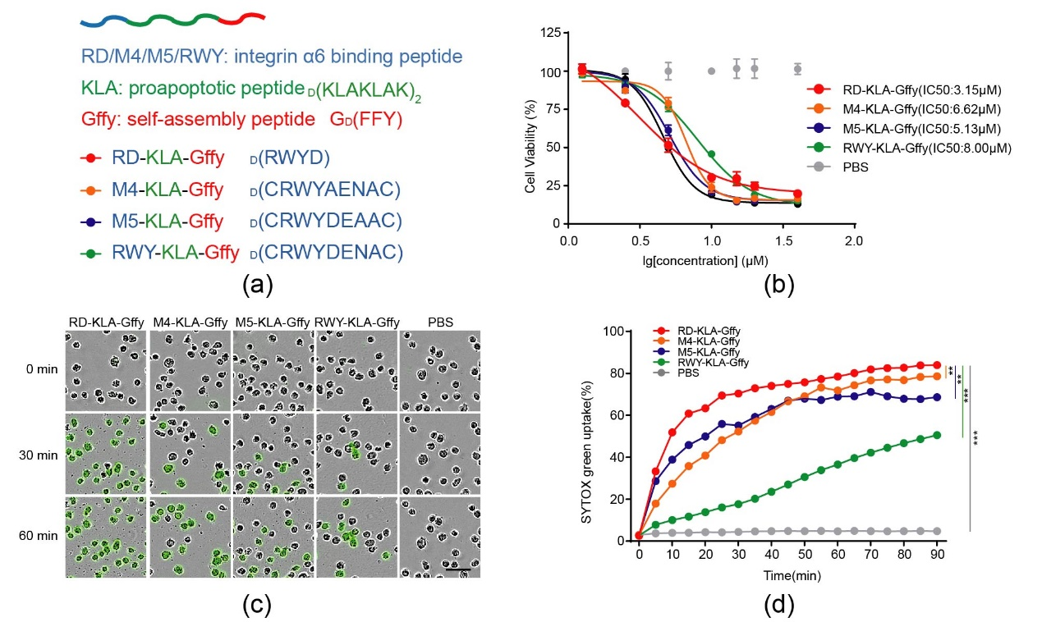
Fig. S6. Toxicity of the nanopeptides to Nalm6 leukemia cells. (a) Schematic diagrams of the nanopeptide RD-KLA-Gffy and the control peptides M4-KLA-Gffy, M5-KLA-Gffy and RWY-KLA-Gffy. (b) IC₅₀ values of RD-KLA-Gffy and control peptides in Nalm6 leukemia cells. (c) RD-KLA-Gffy and control peptides induced toxicity in Nalm6 cells, as detected by SYTOX green. Fluorescence microscopy images of Nalm6 cells treated with 5 μM peptides. Scale bars, 20 μm. (d) Time course plot of dead cells detected by SYTOX green with the Operetta cell imaging system. Significance was determined by two-way ANOVA, **p<0.01, ***p<0.001.
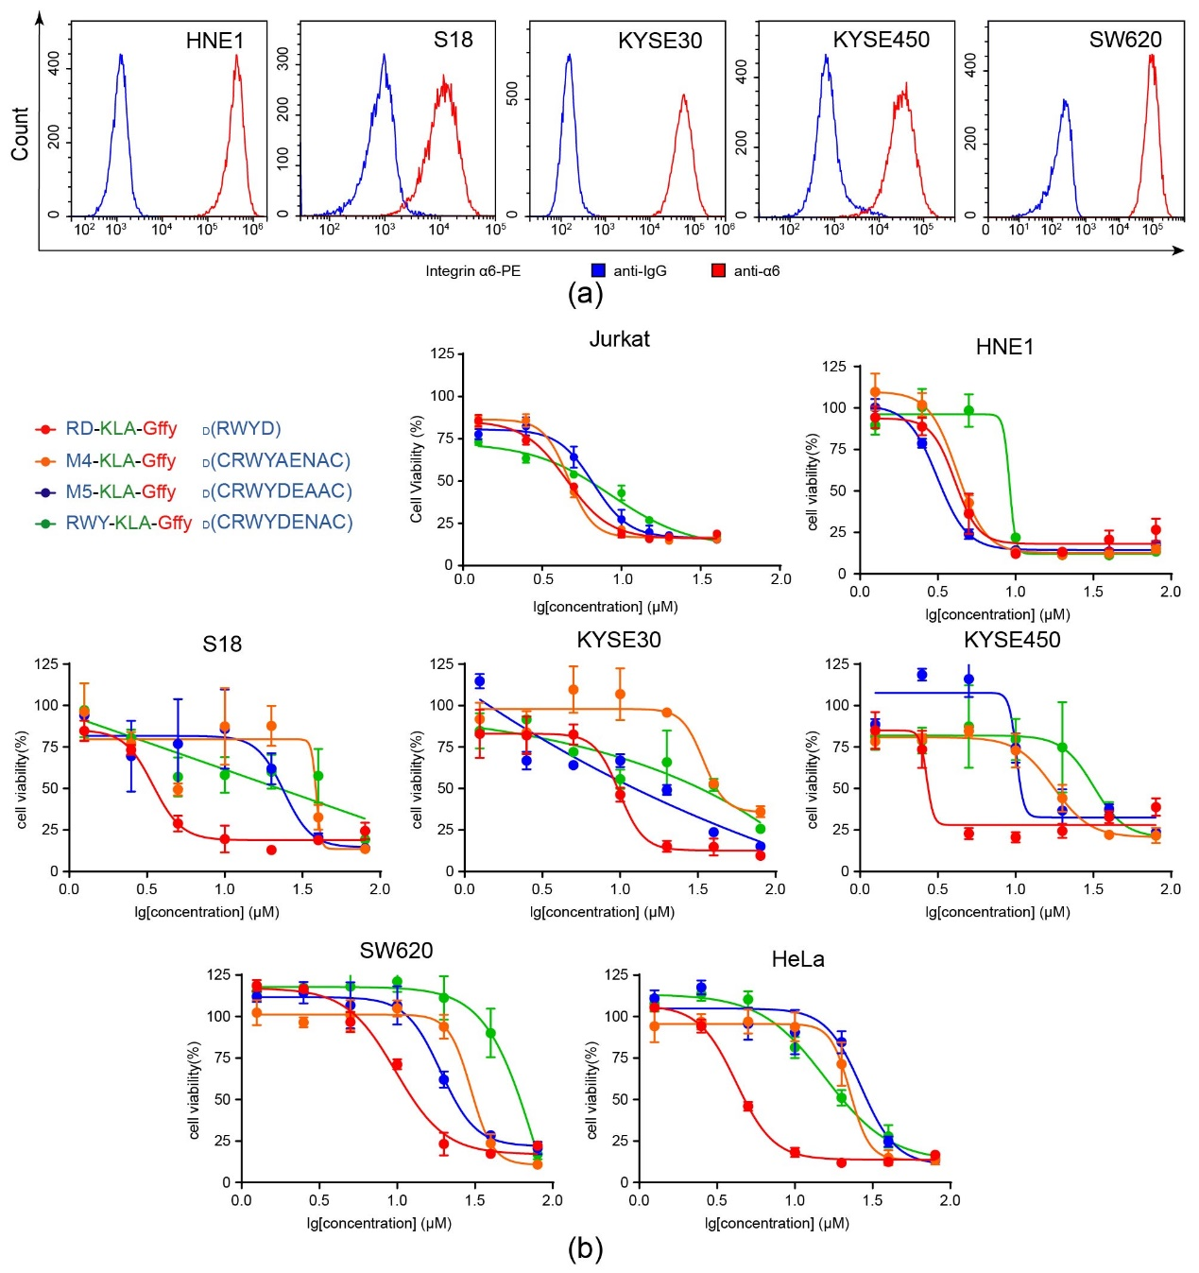
Fig. S7. Toxicity of the nanopeptides to tumor cell lines with high expression of integrin α6. (a) Flow cytometry was used to determine the surface expression of integrin α6 in cell lines, including HNE1, S18, KYSE30, KYSE450 and SW620 cells. (b) IC₅₀ values of RD-KLA-Gffy and control peptides M4-KLA-Gffy, M5-KLA-Gffy and RWY-KLA-Gffy in Jurkat, HNE1, S18, KYSE30, KYSE450, SW620 and HeLa cells.
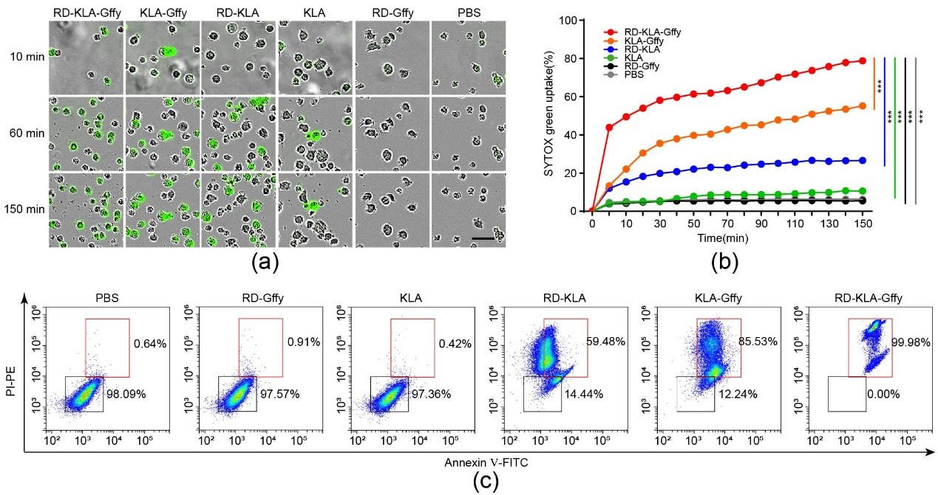
Fig. S8. Toxicity of the nanopeptide RD-KLA-Gffy to leukemia Jurkat cells. (a) RD-KLA-Gffy and control peptides induced cytotoxicity in Jurkat cells, as detected by SYTOX Green. Fluorescence microscopy images of Nalm6 cells treated with 5 μM peptides. Scale bars, 20 μm. (b) Time course plot of dead cells detected by SYTOX Green with the Operetta cell imaging system. Significance was determined by two-way ANOVA, ***p<0.001. (c) Flow cytometry analysis of Annexin V-FITC- and propidium iodide (PI)-stained Nalm6 cells treated with 5 μM peptides.
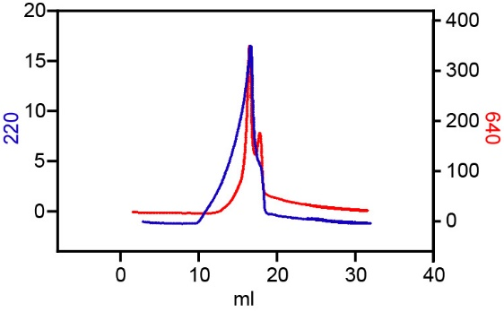
Fig. S9. Analytical HPLC chromatogram of Cy5-RD-KLA-Gffy.
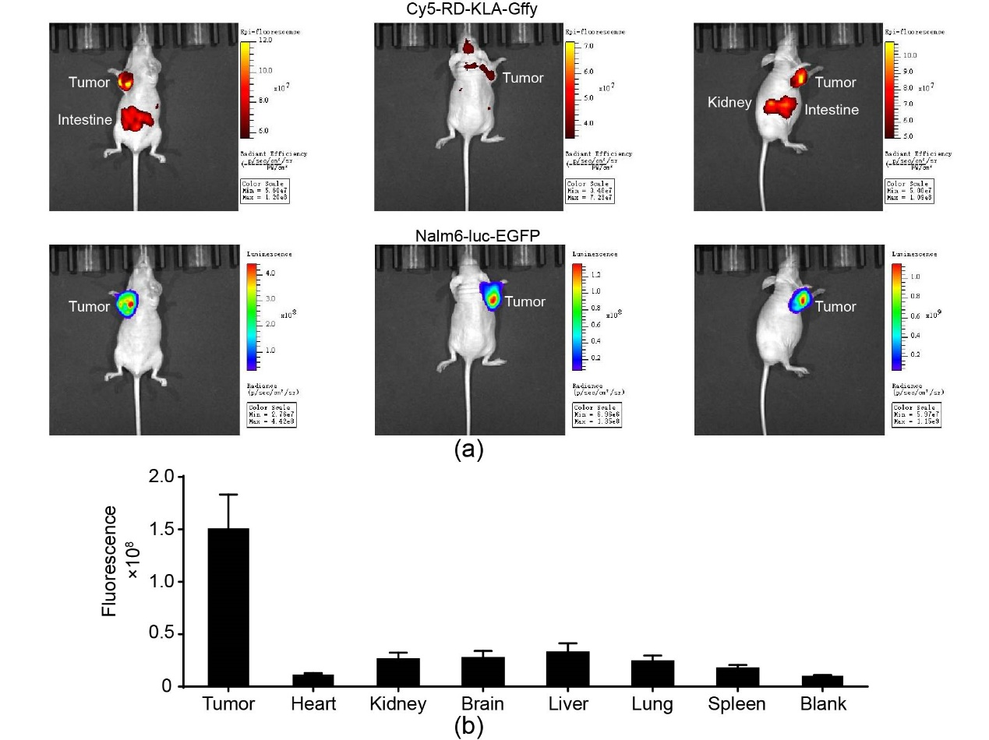
Fig. S10. The accumulation of RD-KLA-Gffy in Nalm6-luc-EGFP tumors. (a) In vivo imaging of Nalm6-luc-EGFP xenograft mice after treatment with Cy5-RD-KLA-Gffy showing the colocalization of luminescence and fluorescence. (b) Quantitative analysis of the fluorescence intensity in the tumor and normal organs, n = 3.
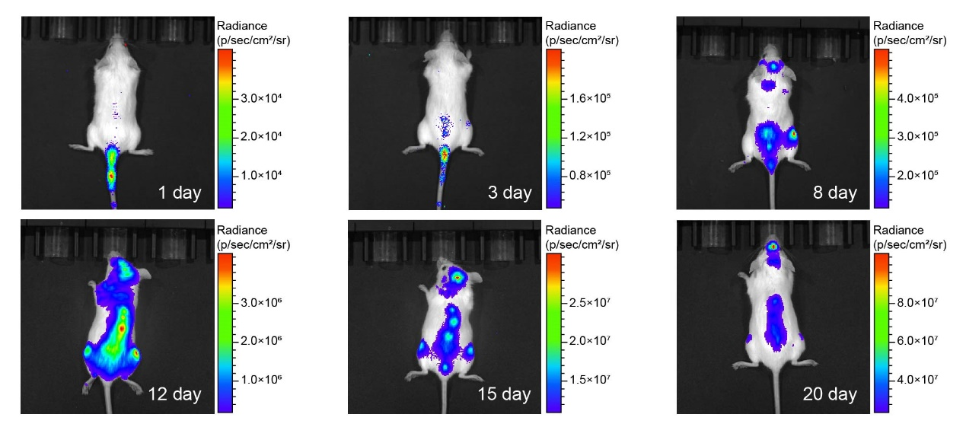
Fig. S11. Luminescence images of CNS-ALL mice injected with Nalm6-luc-EGFP cells. After Nalm6-luc-EGFP cells were intravenously injected into NSG mice, they moved upward from the tail bone to the spine and thigh bones on the 3rd day and gradually moved along the spine to the meninges on the 8th day. The aggregation of cells in the meninges on the 15th day exceeded that in the spine and thigh bones. When the cells had mainly accumulated in the meninges on the 20th day, the model mice gradually developed symptoms of hindlimb paralysis and died shortly thereafter.
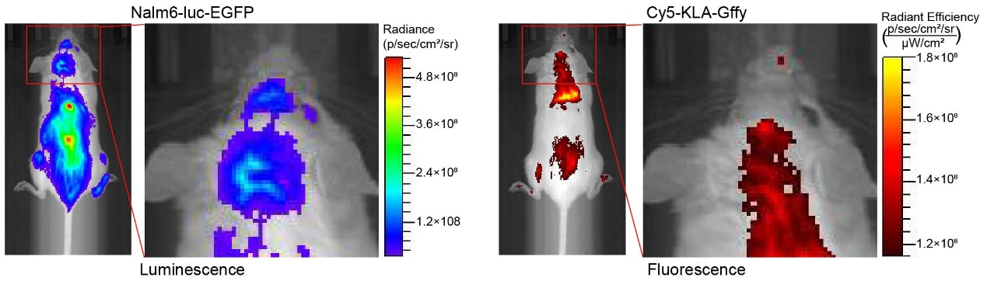
Fig. S12. In vivo imaging of CNS-ALL mice after treatment for 48 hours with Cy5-KLA-Gffy showing the slight colocalization of luminescence and fluorescence.
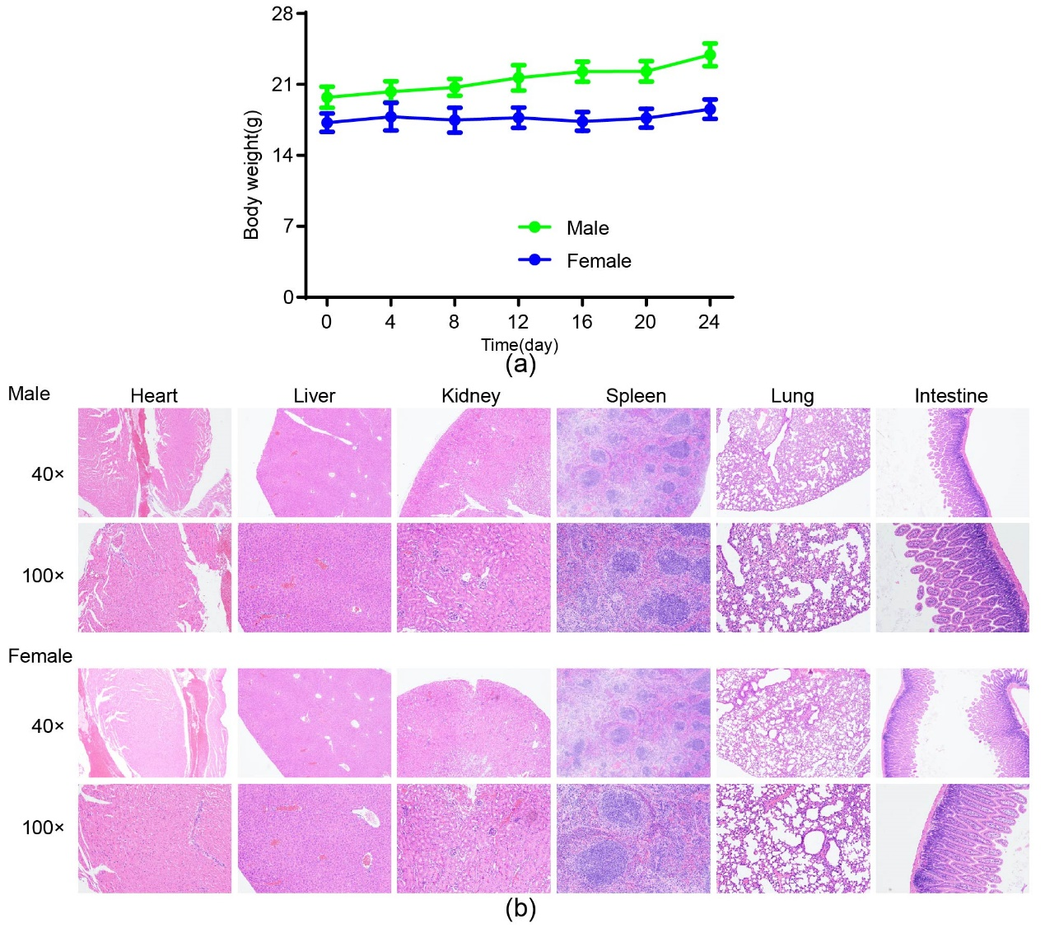
Fig. S13. Toxicity of RD-KLA-Gffy. RD-KLA-Gffy was injected intravenously every two days at a concentration of 5 mg/kg. (a) Body weights of the mice at the indicated time points. (b) HE staining of the major tissues from mice. No histological changes were observed. 40×, scale bar 2 mm= 250 μm, 100×, scale bar 2 mm= 100 μm.
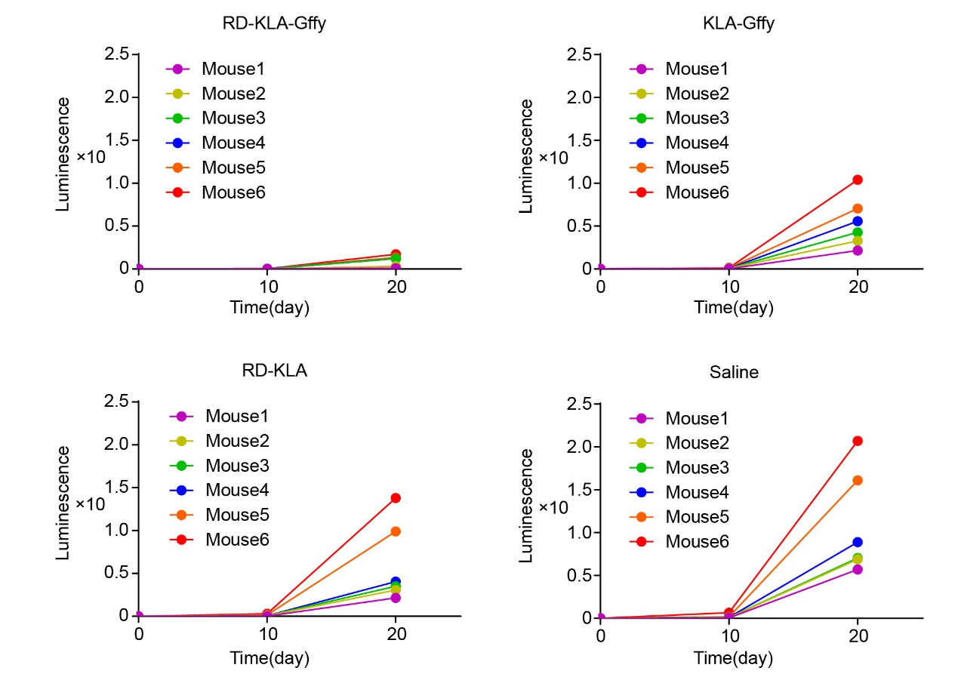
Fig. S14. Quantitative analysis of the luminescence signal of CNS-ALL mice. CNS-ALL mice were treated with RD-KLA-Gffy, control peptides or saline every two days at a peptide concentration of 5 mg/kg. Luminescence signals of the CNS-ALL mice were detected on days 0, 10 and 20.

Table S1
Expression of the ITGΑ6 gene in fifteen kinds of tumors from the GEPIA database. The T/N ratio indicates the tumor-to-normal tissue ratio.
Name | Full name | Tumor | Normal | T/N ratio
LAML | Acute Myeloid Leukemia | 28.86 | 0.08 | 360.75
THYM | Thymoma | 24.12 | 1.12 | 21.54
PCPG | Pheochromocytoma and Paraganglioma | 15.89 | 2.10 | 7.57
CHOL | Cholangio carcinoma | 19.67 | 3.00 | 6.56
ESCA | Esophageal carcinoma | 121.82 | 22.91 | 5.32
HNSC | Head and Neck squamous cell carcinoma | 169.81 | 35.86 | 4.74
READ | Rectum adenocarcinoma | 85.02 | 19.37 | 4.39
COAD | Colon adenocarcinoma | 94.34 | 23.53 | 4.01
LIHC | Liver hepatocellular carcinoma | 10.25 | 2.74 | 3.74
PAAD | Pancreatic adenocarcinoma | 58.82 | 17.50 | 3.36
STAD | Stomach adenocarcinoma | 63.35 | 22.03 | 2.88
GBM | Glioblastoma multiforme | 18.79 | 6.56 | 2.86
KICH | Kidney Chromophobe | 73.96 | 26.55 | 2.79
LUSC | Lung squamous cell carcinoma | 70.09 | 25.33 | 2.77
LGG | Brain Lower Grade Glioma | 17.52 | 6.56 | 2.67

Table S2
IC50 values of RD-KLA-Gffy and control peptides in tumor cells. Unit:μM
Tumor name | Cell line | RD-KLA-Gffy | M4-KLA-Gffy | M5-KLA-Gffy | RWY-KLA-Gffy
Leukemia | Nalm6 | 3.15 | 6.62 | 5.13 | 8.00
Leukemia | Jurkat | 4.50 | 4.63 | 6.65 | 8.59
Nasopharyngeal | HNE1 | 4.07 | 4.22 | 3.14 | 9.14
Nasopharyngeal | S18 | 4.84 | 21.15 | 24.05 | ＞80.00
Esophageal | KYSE30 | 9.68 | 34.34 | ＞80.00 | ＞80.00
Esophageal | KYSE450 | 3.60 | 17.55 | 9.41 | 33.37
Colorectal | SW620 | 9.78 | 29.85 | 19.11 | 79.89
Cervical | HeLa | 4.20 | 22.66 | 27.61 | 15.68

Table S3
Analyses of blood samples from mice injected with RD-KLA-Gffy.
 | Female (n=5) |  | Male (n=5)
Content | Before | After | Before | After | Reference
WBC (10^9/L) | 6.95±2.10 | 8.03±2.80 | 7.14±1.52 | 6.70±1.96 | 0.80-10.60
Neu (10^9/L) | 1.23±0.92 | 2.03±0.58 | 2.06±0.28 | 1.88±0.65 | 0.23-3.60
Lym (10^9/L) | 8.31±4.68 | 5.77±2.34 | 8.80±1.31 | 6.16±3.48 | 0.60-8.90
Mon (10^9/L) | 0.12±0.11 | 0.14±0.04 | 0.18±0.04 | 0.17±0.07 | 0.04-1.40
Eos (10^9/L) | 0.08±0.03 | 0.08±0.03 | 0.08±0.03 | 0.08±0.03 | 0.00-0.51
Bas (10^9/L) | 0.01±0.01 | 0±0 | 0.02±0.02 | 0.00±0.00 | 0.00-0.12
Neu (%) | 12.14±2.26 | 26.14±4.73 | 18.64±2.19 | 24.48±5.52 | 6.50-50.00
Lym (%) | 85.68±2.39 | 70.82±4.90 | 78.90±2.40 | 72.20±6.02 | 40.00-92.00
Mon (%) | 1.06±0.46 | 1.78±0.35 | 1.56±0.28 | 2.18±0.19 | 0.90-18.00
Eos (%) | 1.00±0.53 | 1.20±0.51 | 0.74±0.21 | 1.14±0.48 | 0.00-7.50
Bas (%) | 0.12±0.07 | 0.06±0.08 | 0.16±0.14 | 0.00±0.00 | 0.00-1.50
RBC (10^12/L) | 8.80±2.17 | 8.90±1.32 | 9.08±0.51 | 9.81±0.42 | 6.50-11.50
HGB (g/L) | 150.20±36.50 | 153.80±22.91 | 163.20±8.47 | 164.60±8.55 | 110.00-165.00
HCT (%) | 48.82±10.90 | 49.22±6.51 | 51.28±3.02 | 52.96±2.27 | 35.00-55.00
MCV (fL) | 54.78±1.41 | 55.44±1.36 | 54.50±0.74 | 53.98±0.77 | 41.00-55.00
MCH (pg) | 17.14±0.21 | 17.30±0.35 | 17.96±0.27 | 16.86±0.20 | 13.00-18.00
MCHC (g/L) | 306.80±7.52 | 312.20±9.11 | 318.00±6.66 | 312.40±7.39 | 300.00-360.00
RDW-CV (%) | 14.52±1.06 | 15.20±0.26 | 15.14±2.48 | 15.30±0.32 | 12.00-19.00
RDW-SD (fL) | 32.40±2.64 | 38.86±1.13 | 32.02±5.85 | 38.02±0.50 | 23.00-39.00
PLT (10^9/L) | 995.80±12.27 | 1315.00±201.27 | 1341.40±121.60 | 1234.40±396.43 | 400.00-1600.00
MPV (fL) | 5.18±0.15 | 4.88±0.16 | 4.98±0.12 | 5.04±0.10 | 4.00-6.20
PDW (%) | 15.90±0.38 | 15.46±0.30 | 15.58±0.18 | 15.94±0.23 | 12.00-17.50
PCT (%) | 0.66±0.15 | 0.64±0.10 | 0.67±0.05 | 0.62±0.19 | 0.10-0.78
RD-KLA-Gffy was injected intravenously every two days at a concentration of 5 mg/kg. Blood samples were analyzed before and 24 days after administration. WBC: white blood cell; Neu: neutrophil; Lym: lymphocyte; Mon: monocyte; Eos: eosinophil; Bas: basophil; RBC: red blood cell; HGB: hemoglobin; HCT: hematocrit; MCV: mean corpuscular volume; MCH: mean corpuscular hemoglobin; MCHC: mean corpuscular hemoglobin concentration; RDW-CV: coefficient of variation in red blood cell volume distribution width; RDW-SD: standard deviation in red cell distribution width; PLT: platelet; MPV: mean platelet volume; PDW: platelet distribution width; PCT: procalcitonin.

