Supplementary Data for

Biomimetic Erythrocyte-Like Particles from Microfluidic Electrospray for Tissue Engineering
Zhiqiang Luoª, Lijun Caiª, Hanxu Chenª, Guopu Chenª, Yuanjin Zhao^{a,b,}*
ª Department of Rheumatology and Immunology, Nanjing Drum Tower Hospital, School of Biological Science and Medical Engineering, Southeast University, Nanjing 210096, China
^{b} Oujiang Laboratory (Zhejiang Lab for Regenerative Medicine, Vision and Brain Health), Wenzhou Institute, University of Chinese Academy of Sciences, Wenzhou 325001, China
* Corresponding author.
E-mail addresses: yjzhao@seu.edu.cn (Y. Zhao)

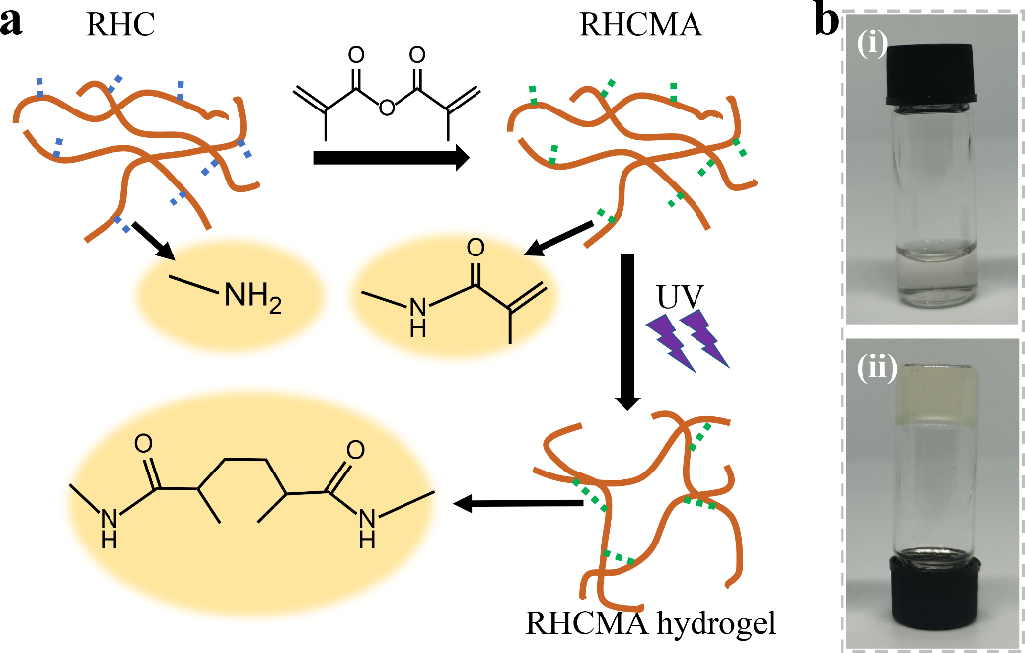

Fig. S1. (a) Schematic diagram of synthetic and crosslinking principle of RHCMA. (b) Images of RHCMA solution before (ⅰ) and after (ⅱ) photo-crosslinking.

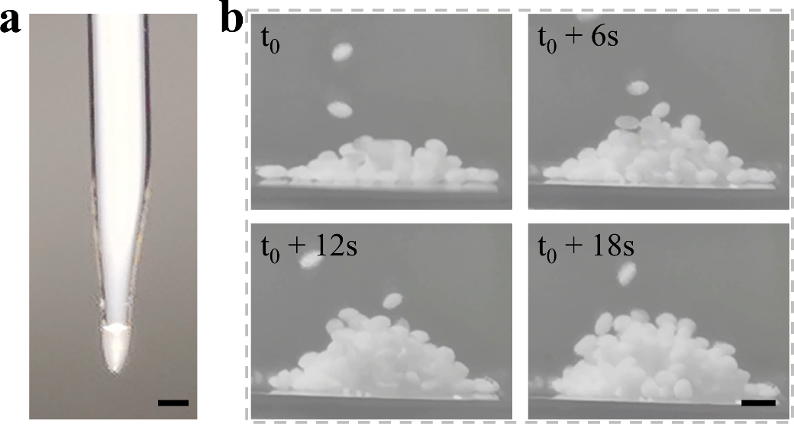

Fig. S2. Characterization of microfluidic electrospray process. (a) Image of the microfluidic electrospray process in real-time. (b) The stacking performance of ELMPs during the collection process. Stain was mixed with the precursor solution for clear observation. Scale bars are 500 μm in (a) and (b).
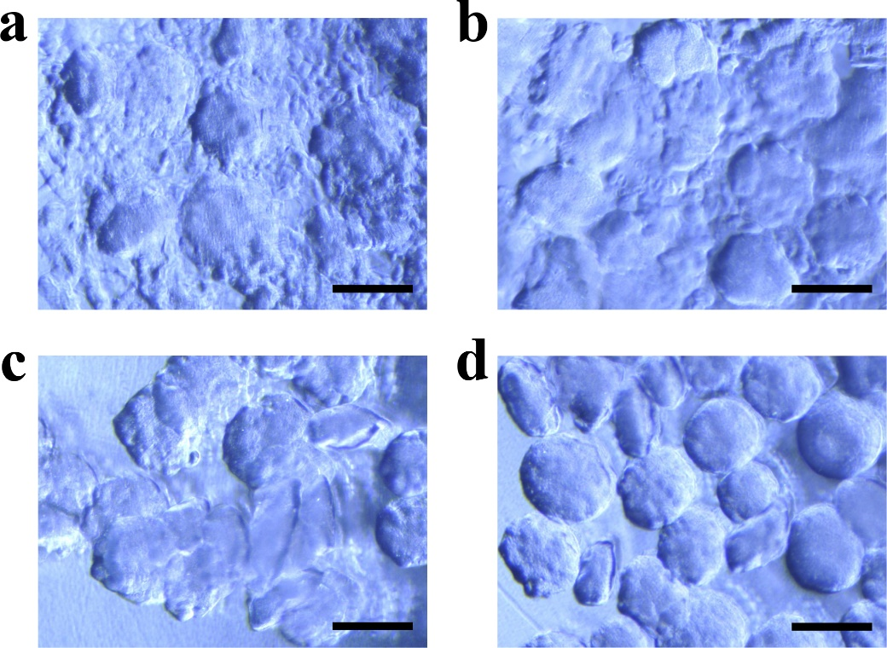

Fig. S3. Influence of KC concentration on dispersion of microspheres. The concentration of KC was 0.05% (w/v) in (a), 0.1% (w/v) in (b), 0.15% (w/v) in (c) and 0.2% (w/v) in (d). Scale bar are 500 μm in (a–d).

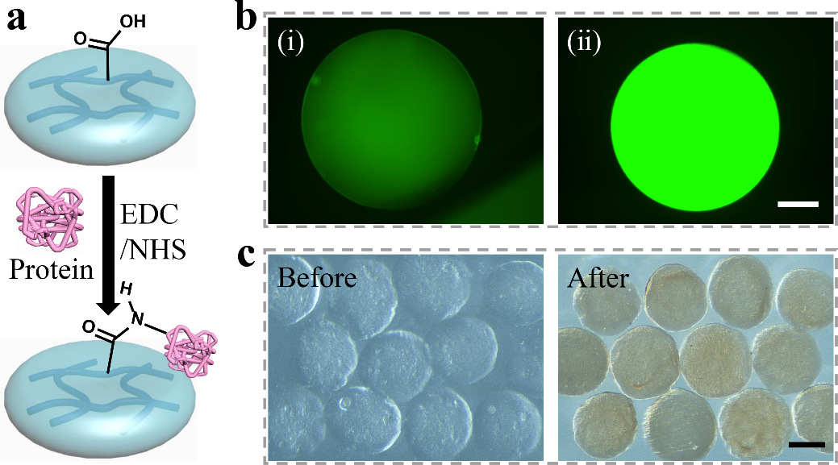

Fig. S4. Carbodiimide-based chemistry. (a) Schematic diagram about the modification principle that protein was coupled onto ELMPs. (b) The BSA-FITC was loaded by (ⅰ) soaking and (ⅱ) coupling through carbodiimide-based chemistry. (c) Images of ELMPs before and after Hb was coupled. Scale bars are 100 μm in (b) and 250 μm in (c).

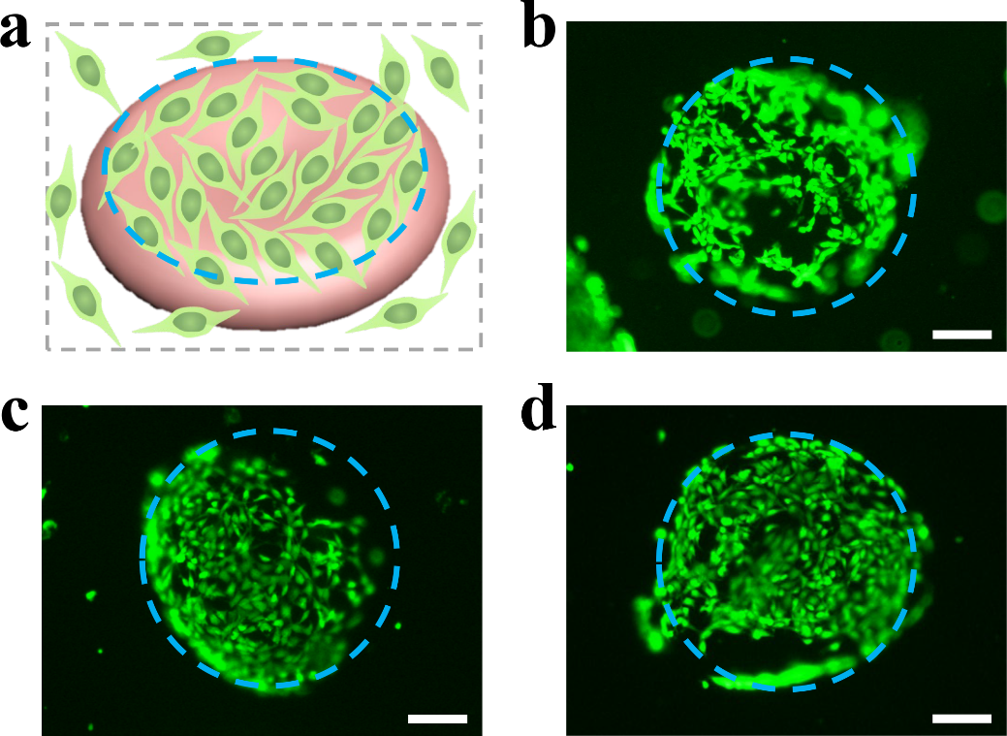

Fig. S5. Cell adhesion performance. (a) Schematic diagram about cell adhesion. Fluorescent images of cell adhesion in (b) ELMPs, (c) ELMPs@Hb and (d) ELMPs@Hb+NIR group. Scale bars are 100 μm in (b–d).

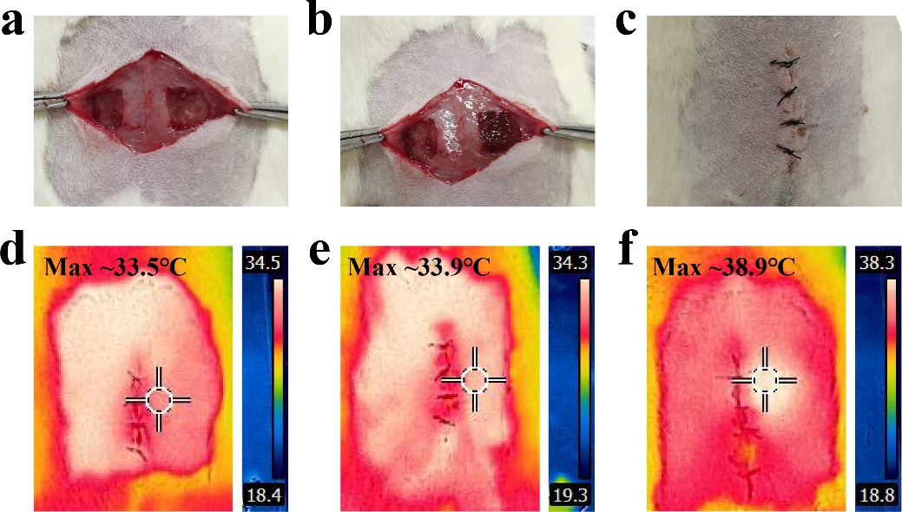

Fig. S6. Defect repair of abdominal wall. (a) Image of defected abdominal wall model. (b) Image of tissue that the left was not treated while the right was treated with ELMPs or ELMPs+drugs. (c) The sutured skin. (d) Thermal image of wound treated with ELMPs. (e) Thermal image of wound treated with ELMPs+drugs. (f) Thermal image of wound treated with ELMPs+drugs+NIR after NIR irradiating for 1 min.

Fig. S7. Quantitative statistical results of histological staining. (a) The thickness of regenerated tissues in different groups. (b) The vessel density in regenerated tissues in different groups.

