Supplementary file for
Oxygen Penetration through Full-Thickness Skin by Oxygen-Releasing Sutures for Skin Graft Transplantation
Wenjing Zai ^{a,c,#}, Yunong Yuan ^{b,#}, Lin Kang ^{a,f,#}, Jialong Xu ª, Yiqiao Hu ª, Lifeng Kang ^{b}, Jinhui Wu ^{a,d,e,}*
ª State Key Laboratory of Pharmaceutical Biotechnology, Medical School, Nanjing University, Nanjing 210093, China
^{b} School of Pharmacy, Faculty of Medicine and Health, University of Sydney, Sydney, NSW 2006, Australia
^{c} School of Biomedical Engineering, Shanghai Jiao Tong University, Shanghai 200240, China
^{d} Chemistry and Biomedicine Innovation Center, Nanjing University, Nanjing 210023, China
^{e} Jiangsu Provincial Key Laboratory for Nano Technology, Nanjing University, Nanjing 210093, China
^{f} Jiangsu Food & Pharmaceutical Science College, Huai’an 223003, China

# These authors contributed equally to this work.

* Corresponding author.
E-mail address: wuj@nju.edu.cn (J. Wu)

Fig. S1. (a) Meshed suture and gelatin-hydrogel (Gel) system with different boundary conditions. (b) Meshed TGO system with different boundary conditions.
Fig. S2. Curves of force with tensile displacement.

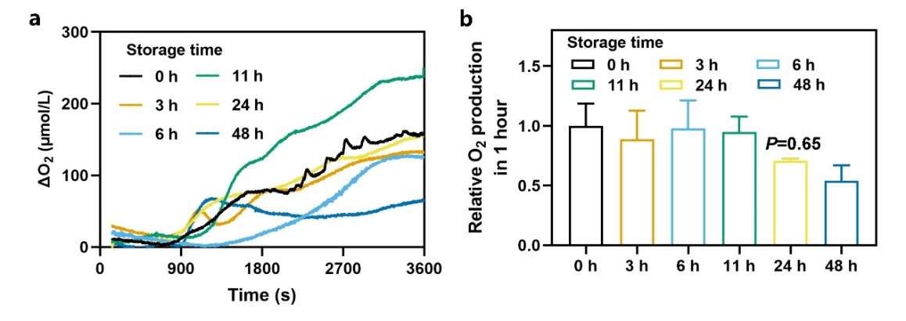
Fig. S3. Oxygen production of O₂ sutures after storage at 4 °C for different time. (a) Oxygen production curves of O₂ sutures stored in plastic wrap at 4 °C for different time. (b) Relative oxygen production in one hour of O₂ sutures stored for different time (relative to oxygen producing amount of O₂ suture stored for zero hour), n = 3 for each group.

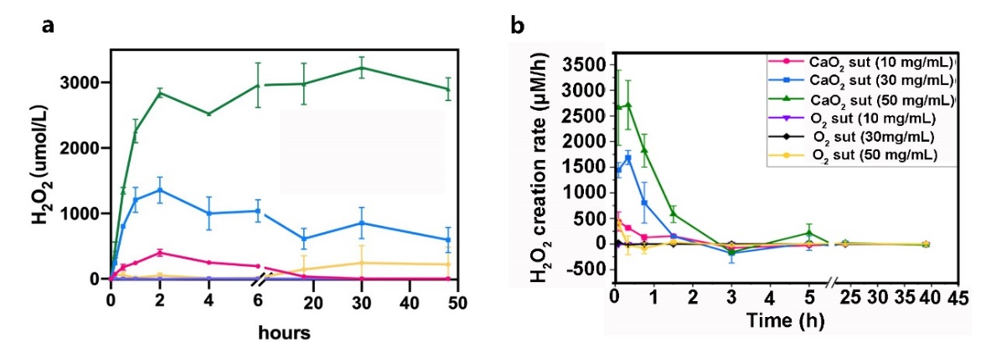
Fig. S4. Hydrogen peroxide concentration curves (a) and creation rate curves (b) of CaO₂ sutures and O₂ sutures.

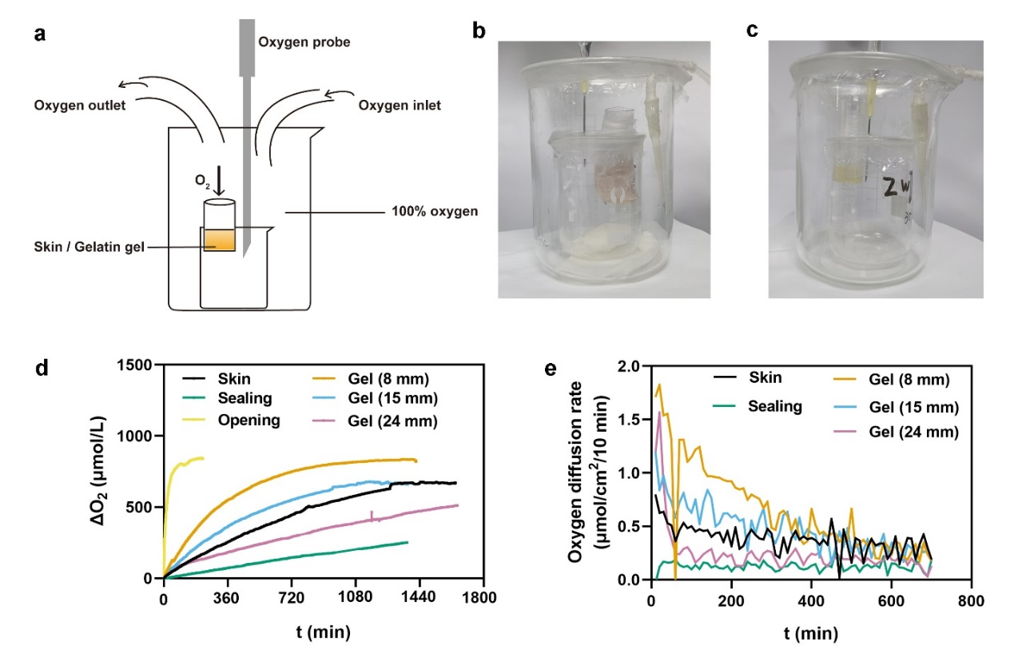
Fig. S5. Oxygen diffusion rates of real skin and the gelatin hydrogel (Gel) with different thicknesses. (a) Schematic illustration of equipment to measure oxygen diffusion rate. (b) Image of equipment to measure oxygen diffusion rate through skin. (c) Image of equipment to measure oxygen diffusion rate through Gel. (d) Oxygen curves in inside container. (e) Oxygen diffusion rate curves.
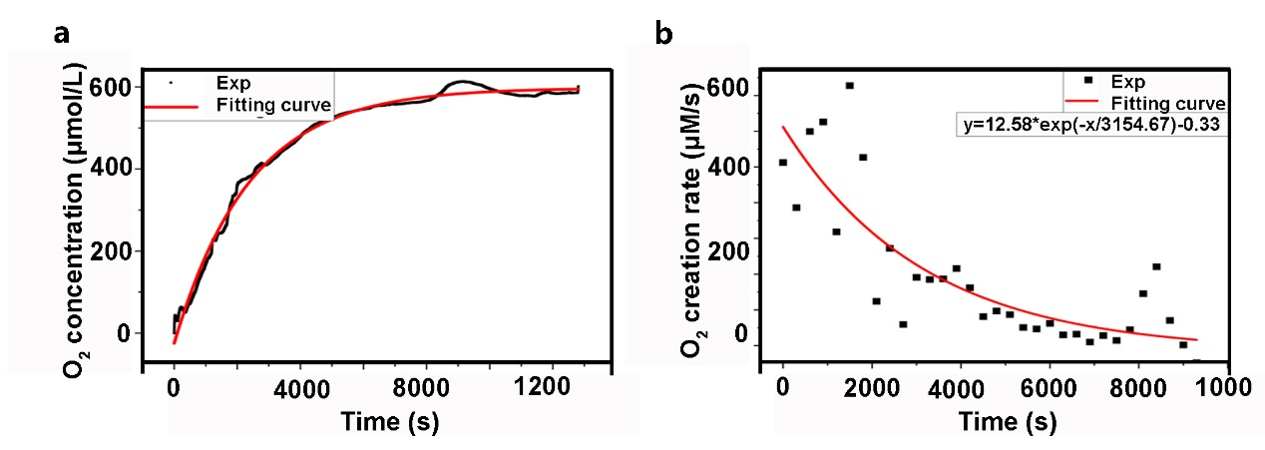
Fig. S6. (a) Oxygen concentration (black) and exponential fitting (red) curves of O₂ suture. (b) Oxygen creation rate of O₂ suture.
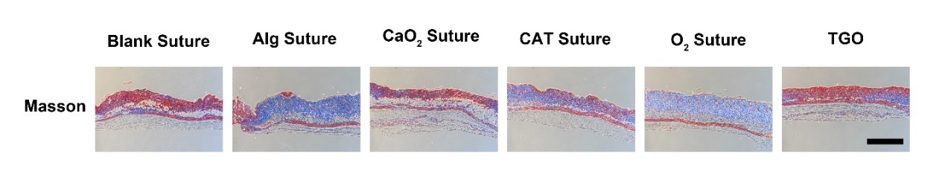
Fig. S7. Masson staining of skin grafts on Day 3. Scale bar = 1000 μm.
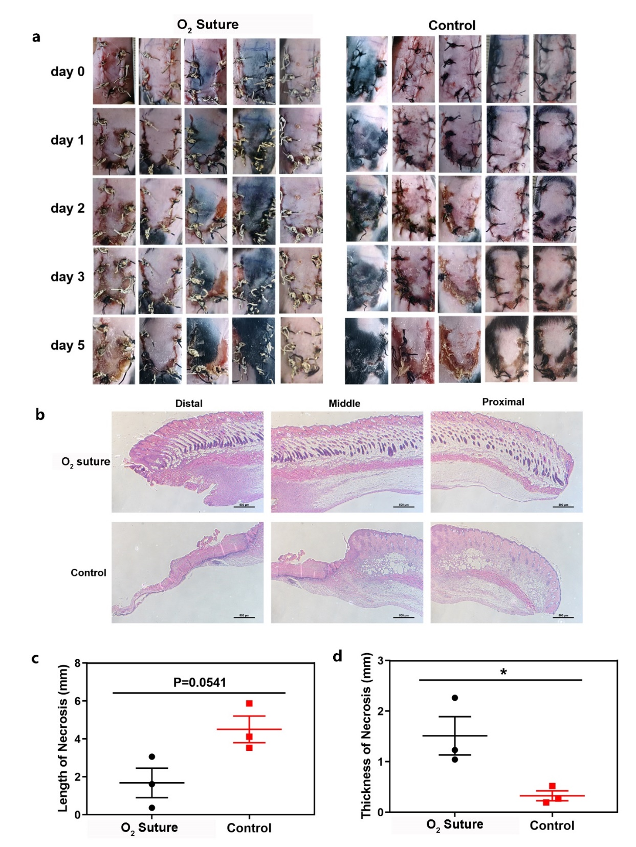
Fig. S8. Skin graft survival in C57BL/6 mice. (a) Images of transplanted skin grafts on C57BL/6 mice. (b) Representative H&E images of skin grafts. Scale bar: 500 μm. (c) Quantification of necrosis length of skin graft as displayed in (b). (d) Quantification of thickness of necrosis skin grafts as displayed in (b), n = 3 in (c) and (d).
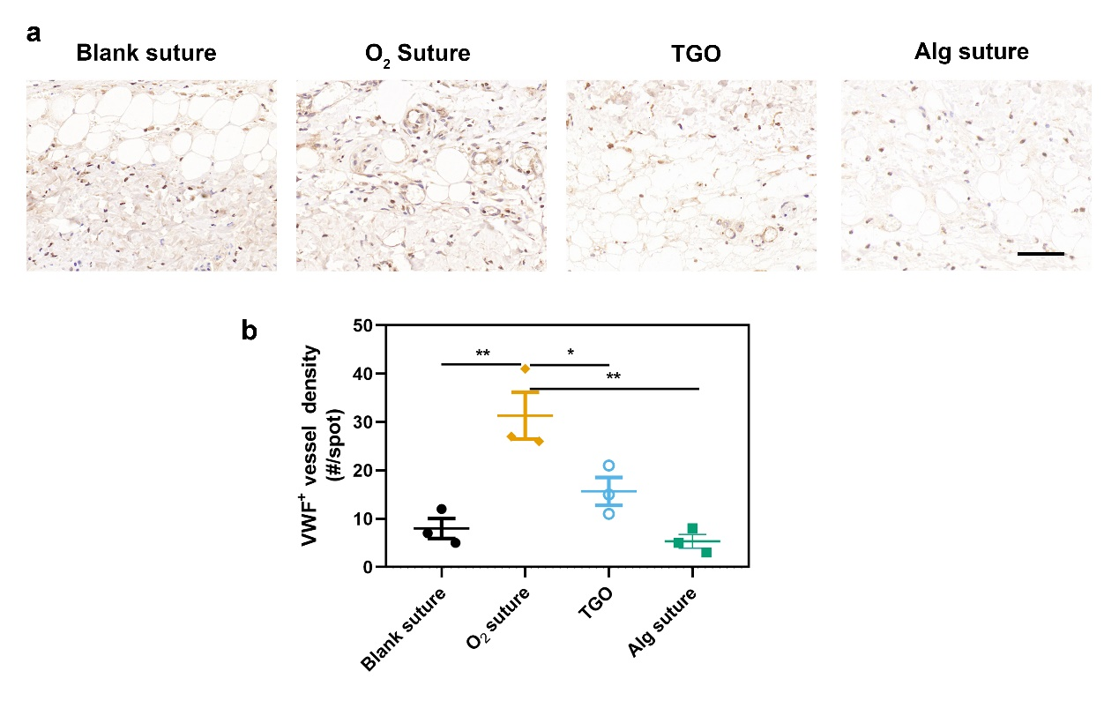
Fig. S9. (a) Representative images of VWF staining of skin grafts. Scale bar: 60 μm. (b) Quantification of VWF positive vessel densities of skin grafts, n = 3.

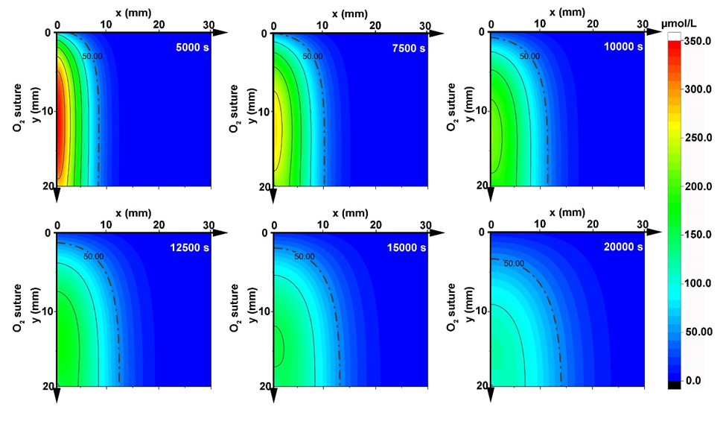
Fig. S10. Simulation results of oxygen distribution in Gel through O₂ sutures varied with time: 5000 s (top left); 7500 s (top middle); 10000 s (top right); 12500 s (bottom left); 15000 s (bottom middle); 20000 s (bottom right). Dotted line represents O₂ concentrations of 50 μmol·L^{–1}.

