Supplementary data

Incorporating Single-Copper Sites and Host Defense Peptides into a Nanoreactor for Antibacterial Therapy by Bioinspired Design
Xuan Chen ^{a,b}, Wei Luo ª, Qun Gao ª, Congrong Chen ª, Lichan Li ª, Dongbo Liu ^{b}, Shaoyun Wang ^{a,}*
ª College of Biological Science and Engineering, Fuzhou University, Fuzhou 350108, China
^{b} Horticulture College, Hunan Agricultural University, Changsha 410128, China

* Corresponding author.
E-mail address: shywang@fzu.edu.cn (S. Wang)

1. Materials and methods
1.1. Characterization
The Nova NanoSEM 230 (FEI CZECH REPUBLIC S.R.O., Czech Republic) was used to obtain scanning electron microscope (SEM) images. The TECNAI G2 F20 (FEI, USA) was applied to obtain transmission electron microscope (TEM) images. Meanwhile, the relevant elements were traced using a companion energy dispersive spectrometer (EDS). Ultraviolet and visible spectrophotometry (UV-Vis) was performed with Genesys 10s (200-600 nm) (Thermo Fisher Scientific, USA). Fourier transform infrared spectroscopy (FTIR) of nanomaterials was measured by AVATAR360 (Nicolet, USA). The Zeta potential of nanomaterials was gauged using Nano ZS (Malvern, UK). X-ray diffraction (XRD) of nanomaterials was tested using DY1602 (Spectris, China). The Themis Z (Thermo Fisher Scientific, USA) was used to obtain aberration-corrected high-angle annular dark-field scanning transmission electron microscopy (HAADF-STEM) images. The metal content in nanoparticles was determined by an inductively coupled plasma optical emission spectrometer (ICP-OES). Raman spectra of materials were measured using the Invia Reflex (Renishaw, UK). X-ray photoelectron spectroscopy (XPS) of nanomaterials was obtained by adopting ESCALAB 250 (VG, USA). X-ray absorption fine structure (XAFS) measurements were undertaken at the Taiwan Light Source (TLS).
1.2. Proteomics experiment
Peptide samples were analyzed using an high performance liquid chromatography (HPLC, EASY-nLC 1200) at nanoliter flow rates. Among them, formic acid aqueous solution (0.1%) was used as mobile phase A, and formic acid acetonitrile aqueous solution (0.1%) was used as mobile phase B. Subsequently, gradient-eluting peptide samples were statistically analyzed using mass spectrometry (Q Exactive HF-X). Specifically, the detection method was positive ion mode, the precursor scanning range was 300-1400 m/z, the resolution of primary mass spectrometry was 120,000, the maximum IT was 30 ms, and the dynamic exclusion time was 12 s. The Firmiana database was used to qualitatively and quantitatively analyze the mass spectrometry data detected here.
Bioinformatics analysis was performed on the identified proteins. Concretely, the protein sequences of the selected differentially expressed proteins were locally searched using the NCBI and InterProScan to find homologue sequences, then gene ontology (GO) terms were mapped and sequences were annotated using the software program Blast2GO. Furthermore, following annotation steps, the studied proteins were blasted against the online Kyoto Encyclopedia of Genes and Genomes (KEGG) database to retrieve their KEGG orthology identifications and were subsequently mapped to pathways in KEGG. Noticeably, enrichment analysis were applied based on the Fisher’ exact test, considering the whole quantified proteins as background dataset. Benjamini-Hochberg correction for multiple testing was further applied to adjust derived p-values.
1.3. Statistical analysis
The research data here were statistically analyzed and presented using SPSS 19 and GraphPad Prism 7 software. All data were represented by the mean ± standard deviations.

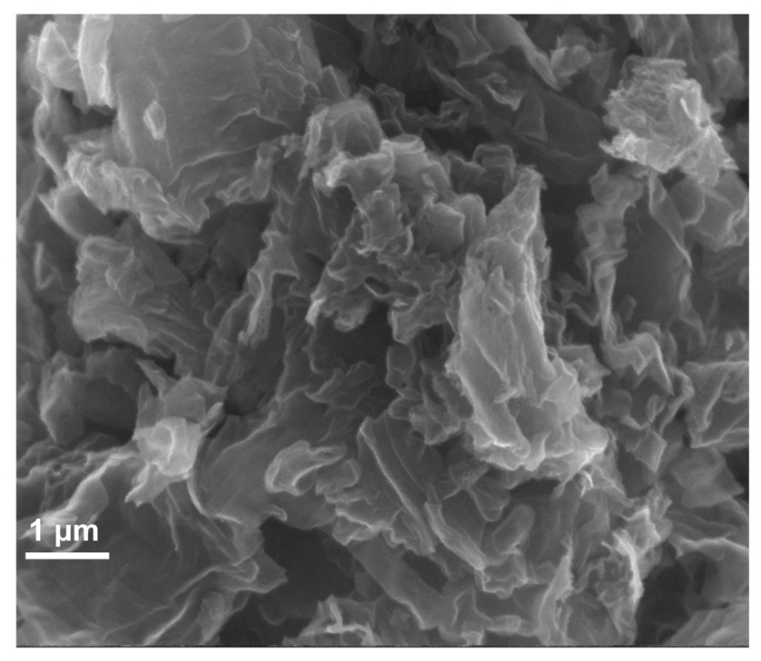
Fig. S1. SEM image of Cu@G.
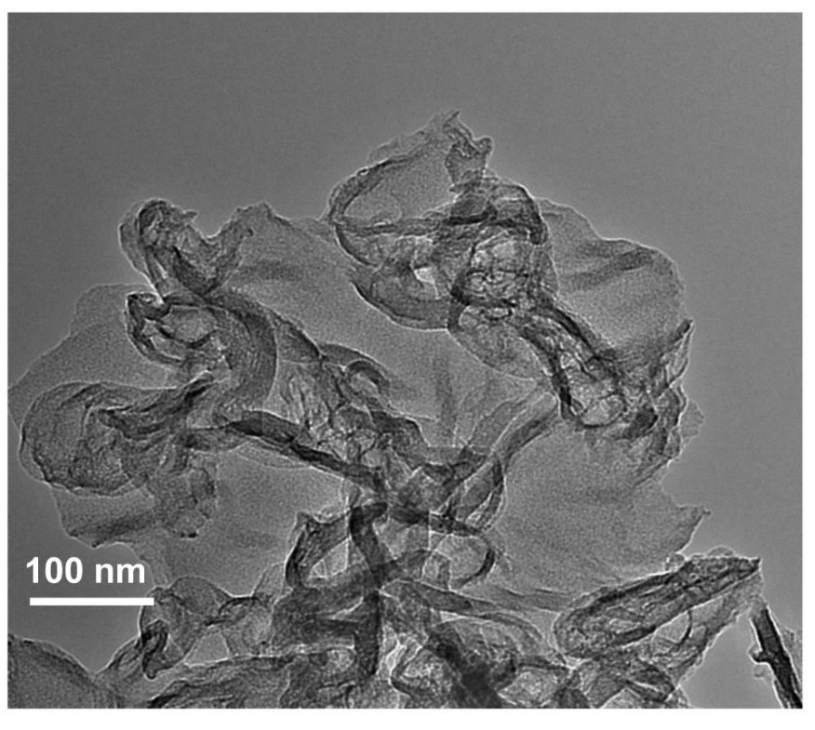
Fig. S2. TEM image of Cu@G.

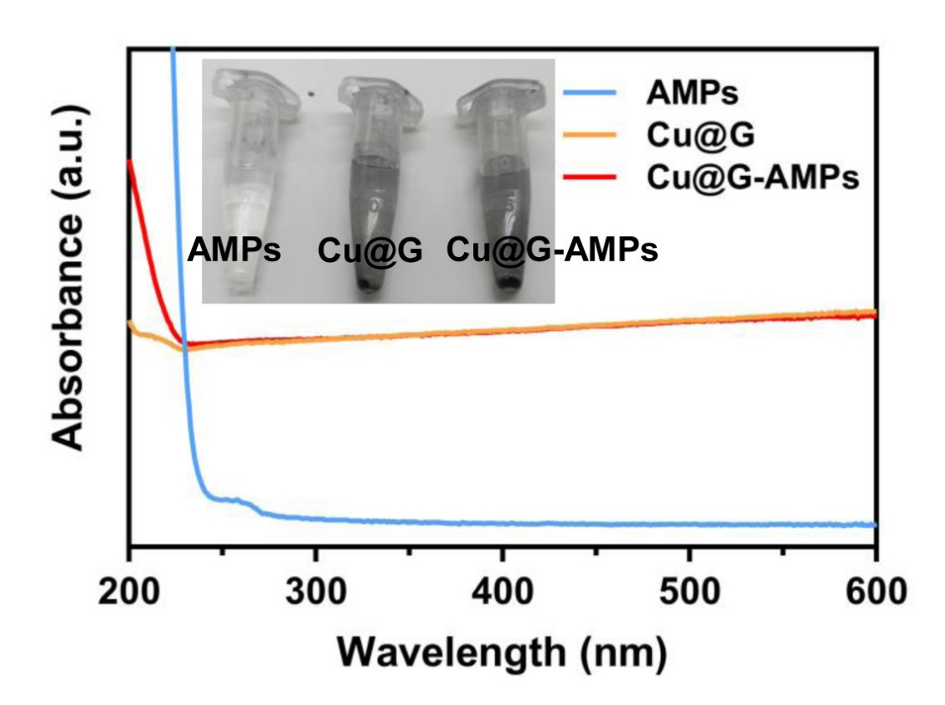
Fig. S3. Elemental mapping patterns of Cu@G (scale bar, 200 nm).
Fig. S4. UV-Vis of Cu@G and Cu@G-AMPs. The test concentrations of AMPs, Cu@G and Cu@G-AMPs are 128 μg mL⁻¹.

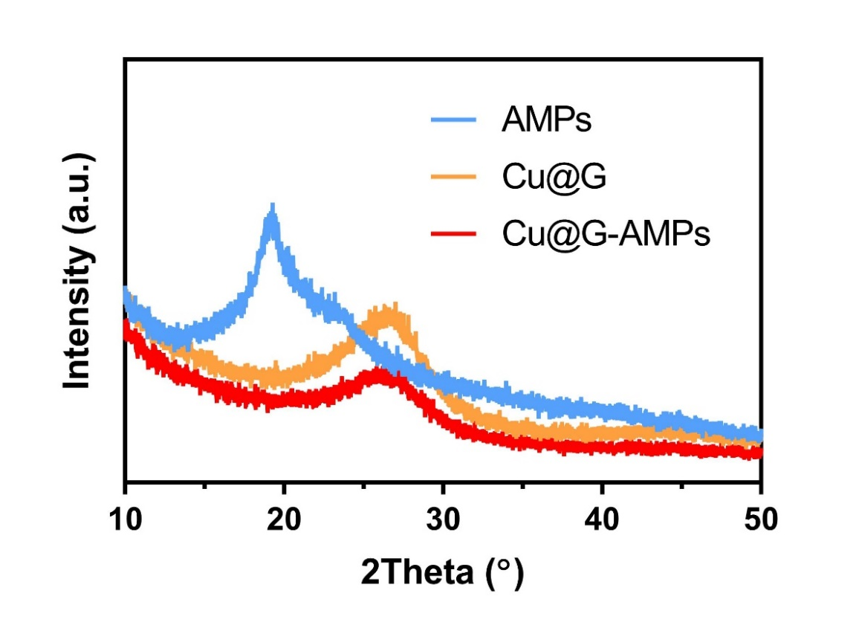
Fig. S5. XRD spectra of Cu@G and Cu@G-AMPs.
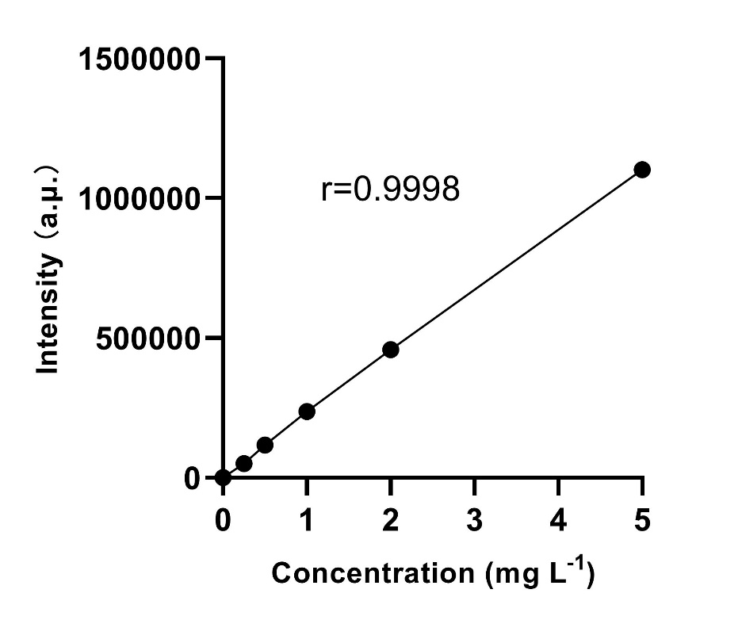
Fig. S6. Standard curve for ICP-OES.

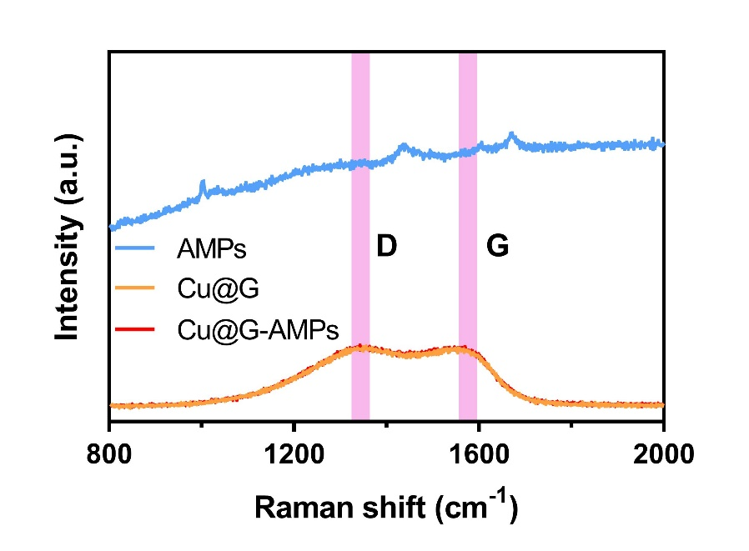
Fig. S7. Raman spectra of Cu@G and Cu@G-AMPs.
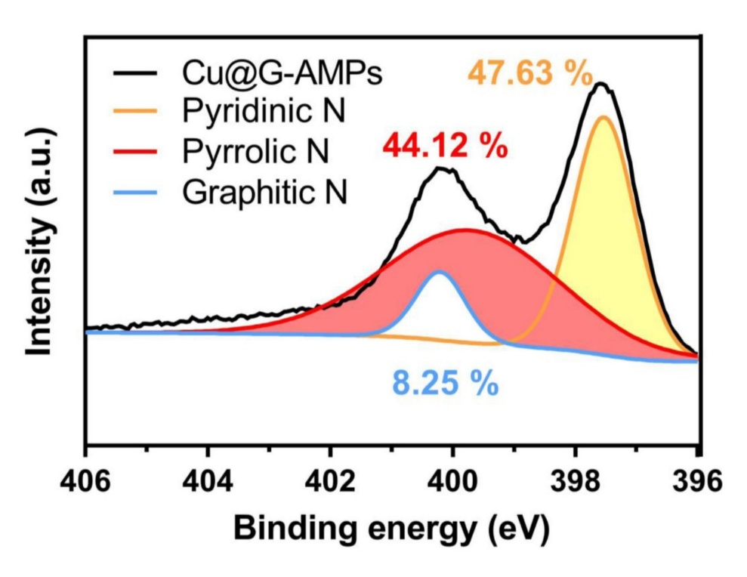
Fig. S8. High-resolution N 1s XPS spectra of Cu@G-AMPs. All the peaks are calibrated with the C 1s XPS spectra with a binding energy of 284.8 eV.

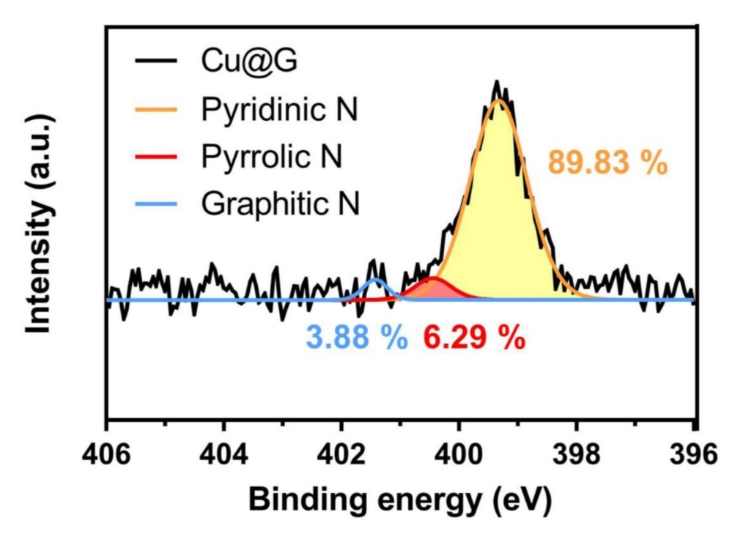
Fig. S9. High-resolution N 1s XPS spectra of Cu@G. All the peaks are calibrated with the C 1s XPS spectra with a binding energy of 284.8 eV.
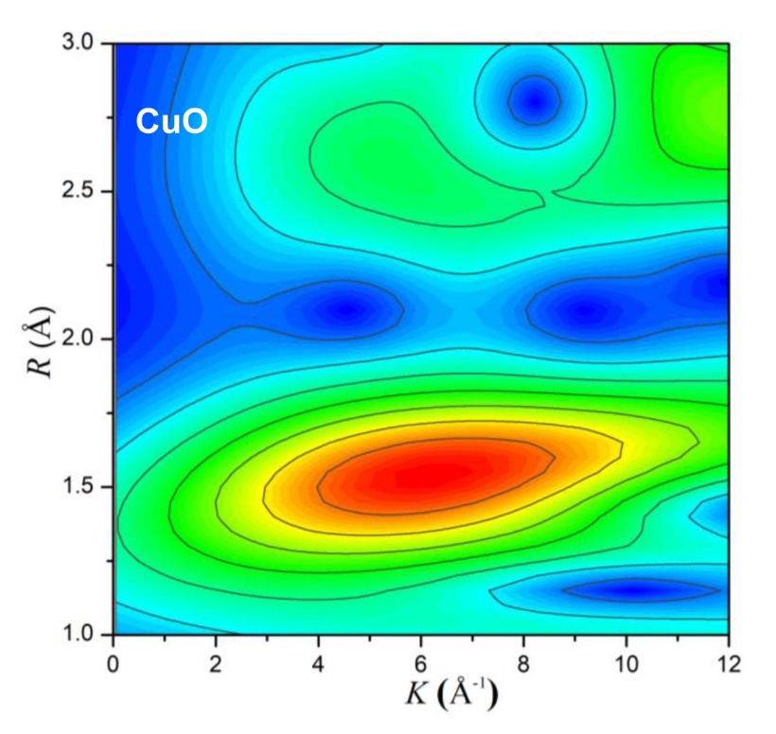
Fig. S10. WT of the Cu K-edge EXAFS signals for CuO.

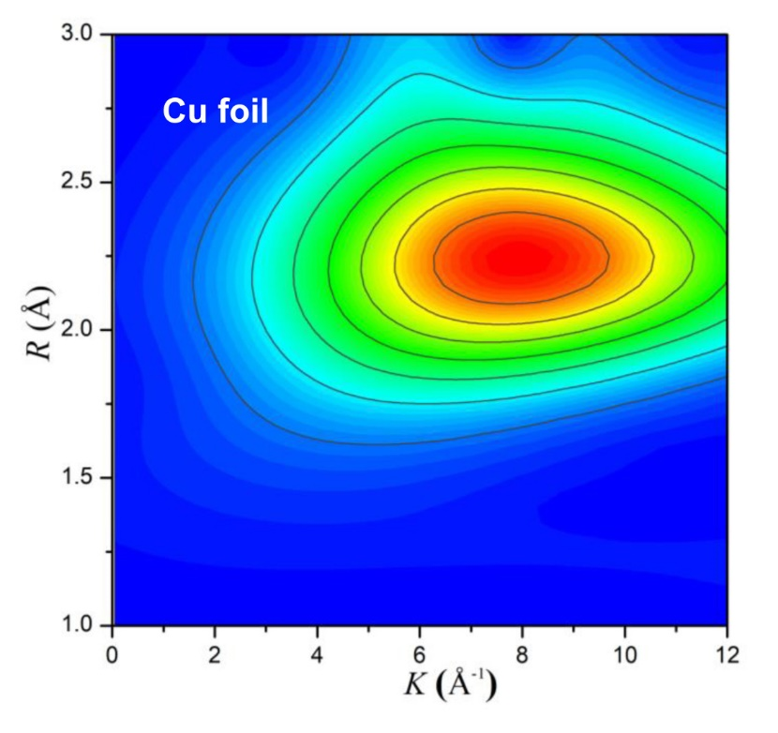
Fig. S11. WT of the Cu K-edge EXAFS signals for Cu foil.
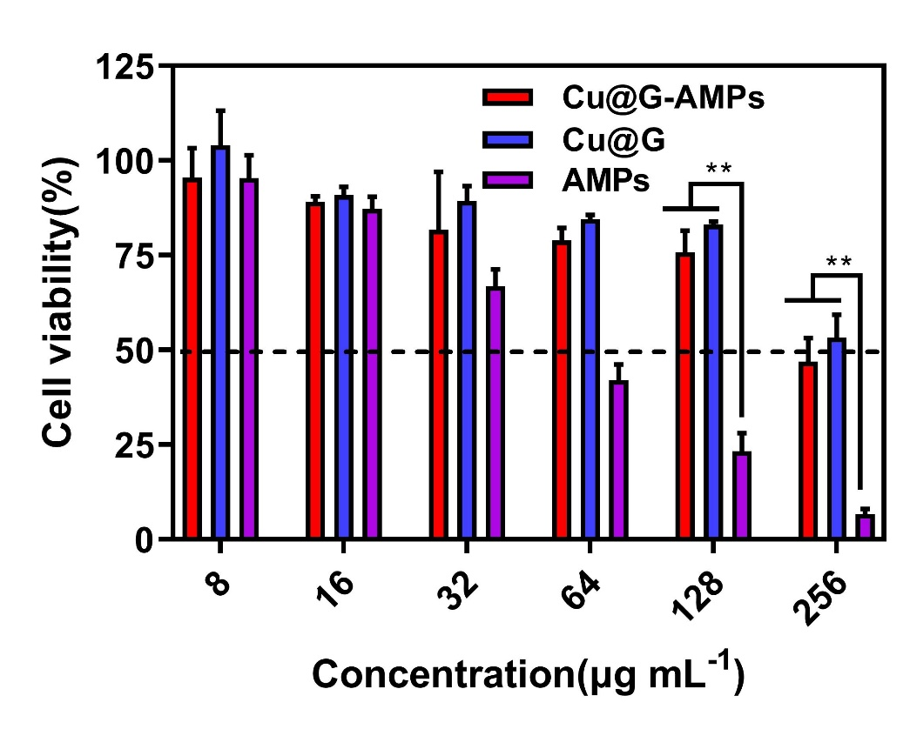

Fig. S12. Cytotoxicity of Cu@G-AMPs against MC3T3-E1 cells.
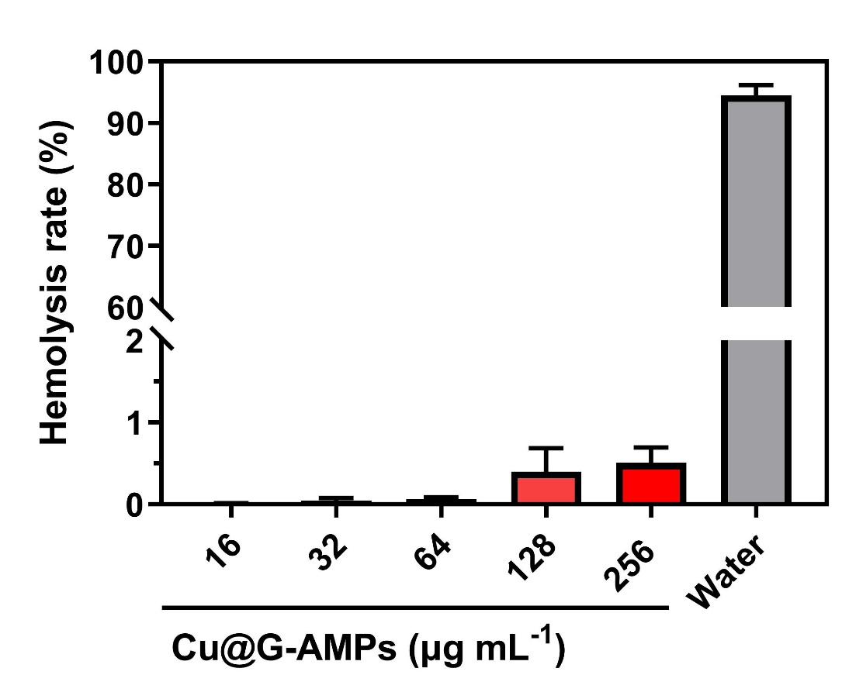
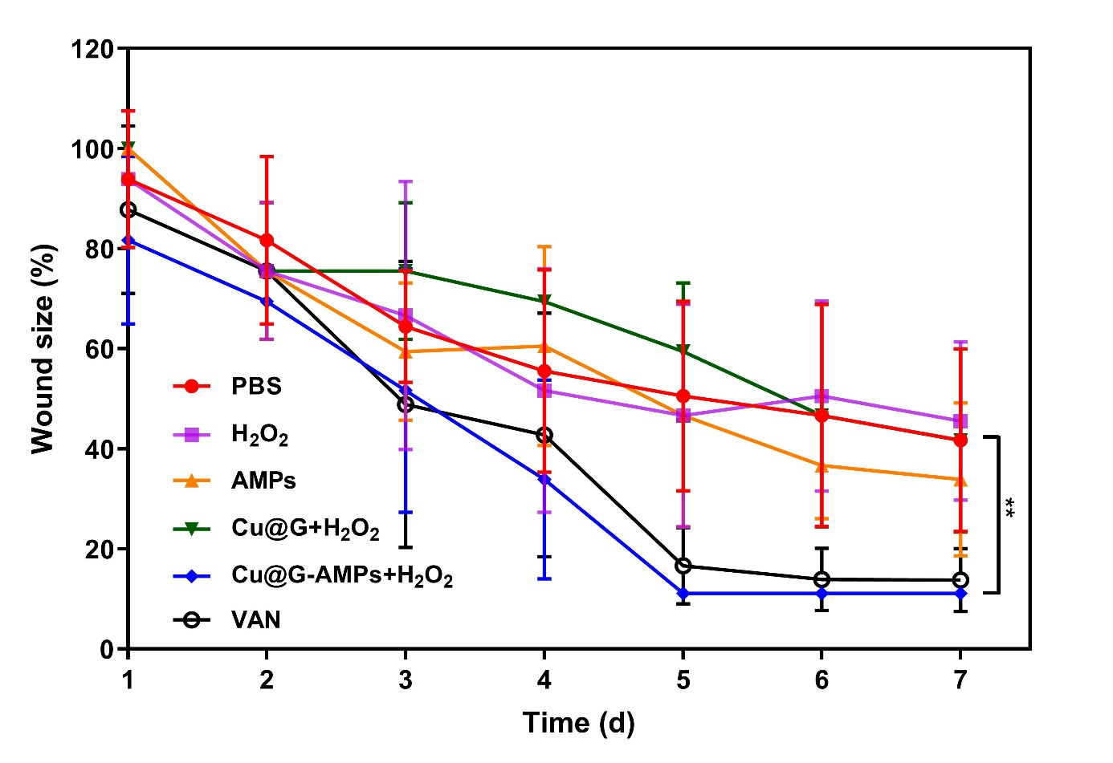
Fig. S13. Hemolysis rate of Cu@G-AMPs (n=5).
Fig. S14. Changes of wound area in group treatment mice (n=5).
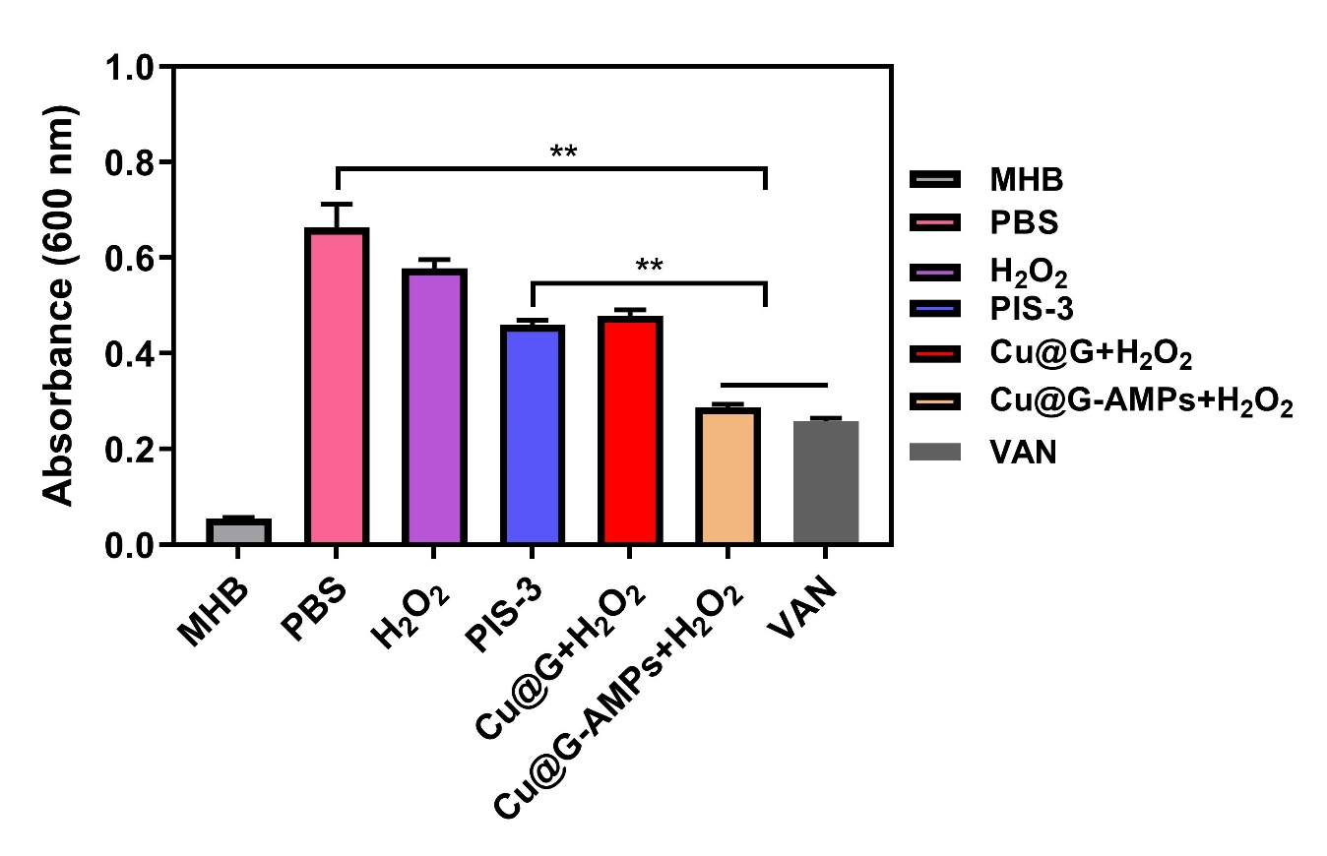
Fig. S15. Changes of colony number in group treatment mice (n=5).
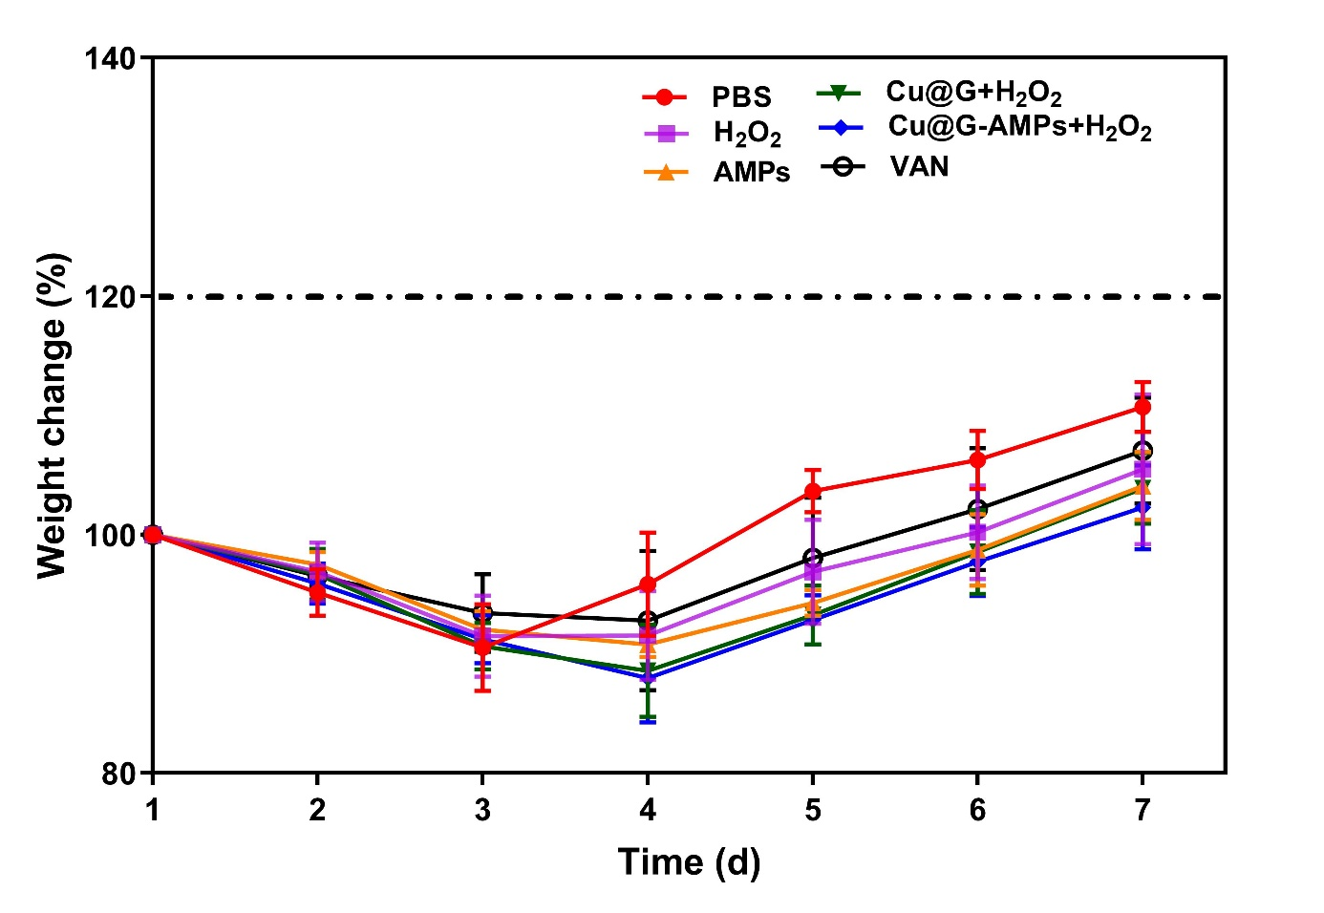
Fig. S16. Changes of weight in group treatment mice (n=5).

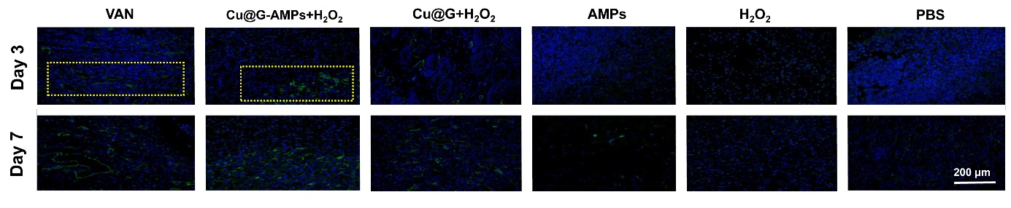
Fig. S17. CD31 intensity of wounds in group treated mice (n=5).

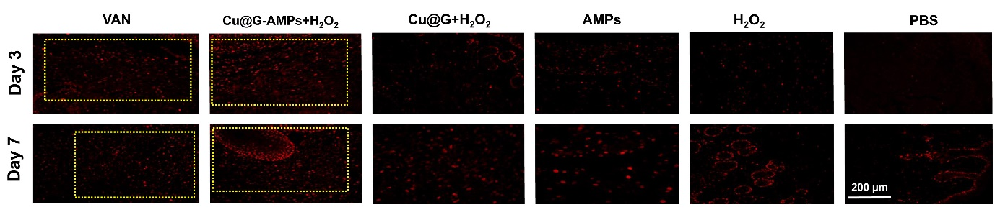
Fig. S18. PCNA intensity of wounds in group treated mice (n=5).

