Supplementary Information for
Fully Superhydrophilic, Self-floatable, and Multi-Contamination-Resistant Solar Steam Generator Inspired by Seaweed
Chiyu Wen ^{a,#}, Hongshuang Guo ^{a,#}, Yingnan Zhu ª, Haoyu Bai ^{b,c}, Weiqiang Zhao ª, Xinsheng Wang ^{b,c}, Jing Yang ª, Moyuan Cao ^{b,c,}*, Lei Zhang ^{a,}*
ª Frontier Science Center for Synthetic Biology & Key Laboratory of Systems Bioengineering (Ministry of Education), Department of Biochemical Engineering, School of Chemical Engineering and Technology, Tianjin University, Tianjin 300072, China.
^{b} Haihe Laboratory of Sustainable Chemical Transformations, School of Materials Science and Engineering, Nankai University, Tianjin 300071, China.
^{c} State Key Laboratory of Chemical Engineering, School of Chemical Engineering and Technology, Tianjin University, Tianjin 300072, China.

* Corresponding authors.
E-mail addresses: lei_zhang@tju.edu.cn (L. Zhang), moyuan.cao@tju.edu.cn (M. Cao).

# These authors contributed equally to this work.

S1. Supplementary materials and methods
S1.1. Characterization
The surface morphology of SIFS evaporator was observed via scanning electron microscope (SEM, Regulus 8100, HITACHI, Japan) test. The surface wettability was proved by water contact angle (WCA, JC2000DM, Powereach, China) test with the droplet volume of 5 μL. The mechanical capacity was evaluated by compression tests (WDW-5, Beijing Time Technology, China). The solar absorption and reflection were explored via a UV-visible-near-infrared spectrophotometer (Lambda 750, Perkin Elmer, USA). The heat conductivity efficient was measured by a conductometer (TPS2500S, Hot Disk, Sweden). The water diffusive permeability in SIFS evaporator was determined by water uptake tests.
S1.2. Actual evaporation enthalpy calculation
A controlled experiment was proceeded to estimate the actual evaporation enthalpy [1]. The ZSB/G, SIFS hydrogels and water with the same surface area were set in a closed case for the same time. The water mass change was measured to calculate the actual evaporation enthalpy ($E_{act}$) according to following Eq. (1):
$E_{act}=E_{0}×M$ (1)
where $E_{0}$ is the evaporation enthalpy of bulk water, and M is the ratio of mass change of water over the mass change of testing sample [1].
S1.3. Wastewater purification and outdoor test
Artificial wastewater samples (artificial industrial wastewater (AIW), artificial domestic wastewater (ADW), artificial oily wastewater (AOW), artificial medical wastewater (AMW), and artificial printing and dyeing wastewater (APW)) were prepared in the lab (see more details in Fig. S15). SIFS evaporators with a size of 5 cm × 5 cm were floated on wastewaters under 1 sun to evaluate the evaporation performance. SIFS floaters were also applied in wastewaters for 30 d to exhibit the physical and chemical stability.
The cytotoxicity of wastewaters was assessed via in vitro MTT test, mouse fibroblast NIH-3T3 cells with a concentration of 3 × 10³ were seeded in 96-well TCPS plate and cultured in DMEM complete medium containing 1% Penicillin–Streptomycin solution and 10% fetal bovine serum. After the cells were attached, a sterile mixture that containing 20% testing solution and 80% DMEM compete culture medium was applied. After 12 h co-culture, the mixture was replaced with 90 μL culture medium and 10 μL MTT solution, followed by 4 h co-incubation. Finally, 110 μL DMSO was applied to dissolve the formazan, and the absorbance was measured at 490 nm via a Microplate Reader (Infinite M200 PRO, Tecan, Switzerland).
An outdoor experiment was conducted in Jinnan District, Tianjin, China, in December. The sunlight density there was from 200 to 1000 W·m⁻² and the air temperature was from −5 to 10 °C at those time in sunny days. A SIFS evaporator with an area of 10 cm × 15 cm was floated in a rectangle trough that filled with artificial seawater (ASW). A transparent cage was employed to cover on the trough to provide an enclosed environment. The test was carried out from 9:00 to 16:00 under natural sunlight. The temperature of bulk water, floating SIFS evaporator and outdoor ground, the volume of collected water, and the sunlight flux were recorded versus time during the period.
S1.4. COMSOL simulation
The heat transfer inside SIFS floater could be described with the equations below:
$ρC_{p}\frac{∂T}{∂t}+ρC_{p}u∙∇T+∇q=Q$ (2)
$q=-k∇T$ (3)
where$ρ$ is the mass density, $C_{p}$ is the fluid capacity at constant pressure, T is the local temperature, t is the time, k is the thermal conductivity, q is the conductive heat flux, u is the velocity field, Q is the heat source [2]. The heat distribution simulation was conducted via COMSOL Multiphysics 5.5 software.
S2. Supplementary figures and tables
S2.1. Fabrication and characterization
Fig. S1. (a) Schematic diagram of SIFS preparation. (b) Hollow glass micro-bead (HGB) and pre-gel solution are thoroughly mixed, after 30 min standing, HGB floats at the upper layer.

Fig. S2. The FTIR spectra of ZSB, ZSB/G, and SIFS.

Fig. S3. (a) The XPS survey; and (b) Si spectra of ZSB, ZSB/G, and SIFS.

Fig. S4. (a) The densities of ZSB, ZSB/G, and SIFS gels in both dry and wet states. Photographs of SIFS (b) standing on the top of a dandelion and (c) supporting a 1 kg weight (scale bar: 1 cm).

Fig. S5. (a) Stress-strain curves of fully wetted ZSB, ZSB/G, and SIFS gels. (b) Compression modulus of fully wetted ZSB, ZSB/G, and SIFS gels.

Fig. S6. The surface wettability and water contact angles of (a) dry ZSB, (b) dry SIFS, (c) wet ZSB, and (d) wet SIFS gels.

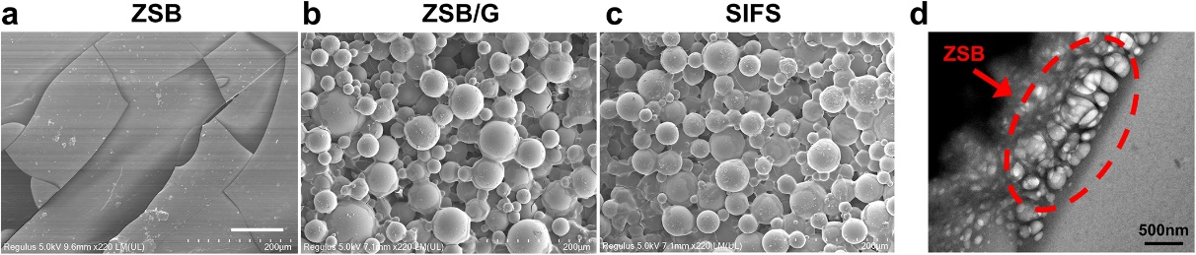
Fig. S7. SEM images of original (a) ZSB, (b) ZSB/G, and (c) SIFS gels (scale bar: 100 μm). (d) The TEM image of porous ZSB gel.
S2.2. Water transport
Fig. S8. Linear fitting of $M_{t}/M_{∞}$ as a function of $t^{1/2}$.

Table S1. Linear fitting parameters of $M_{t}/M_{∞}$ as a function of $t^{1/2}$.
Sample | Slope | R²
ZSB | 0.0214 | 0.9946
ZSB/G | 0.0399 | 0.9807
SIFS | 0.0413 | 0.9885

Table S2. Calculation of D_{W}.
Sample | l (mm) | d(M_{t}/M∞)/dt^{1/2} | D_{w} (m²·s⁻¹)
ZSB | 2 | 0.0214 | 3.59 × 10⁻¹⁰
ZSB/G | 2 | 0.0399 | 12.50 × 10⁻¹⁰
SIFS | 2 | 0.0413 | 13.39 × 10⁻¹⁰

Fig. S9. (a) The optical photos, (b) water delivery distance, and (c) water transport rate on a piece of filter paper versus time.

S2.3. Light reflection
Fig. S10. Solar reflection of ZSB, ZSB/G, and SIFS gels.

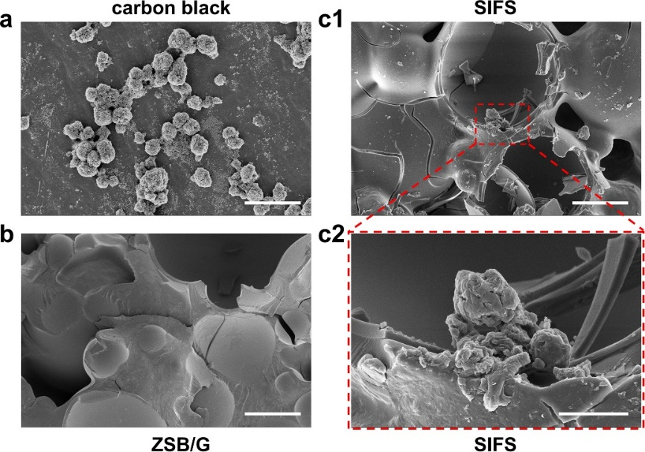
Fig. S11. SEM images of (a) carbon black, (b) ZSB/G and (c1 and c2) SIFS. The scale bar is 20 μm for (a), (b), and (c1); and 5 μm for (c2).

S2.4. Solar evaporation
Fig. S12 (a) The ratio of water evaporation rates1/M, and (b) the actual equivalent enthalpy of ZSB/G and SIFS.

Table S3. Comparison of water evaporation performance in recent literatures.
Materials or structures | Conversion efficiency under 1 sun (%) | Evaporation rate | Ref.
Nanosized titanium sesquioxide | 92.10 | 1.300 | [3]
Graphite oxide (GO), nanofibrillated cellulose, carbon nanotube (CNT) composed three dimensional (3D) printed structure | 85.60 | 1.200 | [4]
Hybrid hydrogel composed of hydrophilic polyvinyl alcohol (PVA) and reduced graphite oxide (rGO) | 95.00 | 2.500 | [5]
Hierarchical graphene foam | 93.40 | 1.400 | [6]
Silver nanoparticles packed asymmetric plasmonic structure | 80.00 | 1.200 | [7]
Gold deposited alumina nanoporous structures | — | 0.900 | [8]
Polydopamine (PDA) loaded bacterial nanocellulose bilayer structure | 78.00 | 1.100 | [9]
Vertically aligned graphene sheets membrane | 86.50 | 1.600 | [10]
GO based aerogel | 83.00 | 1.600 | [11]
PVA and PPy based hierarchically nanostructured gel | 94.00 | 3.200 | [12]
Polypyrrole (PPy) origami | 91.50 | 2.100 | [13]
Carbonized mushrooms | 78.00 | 1.500 | [14]
PVA, chitosan and PPy based hydrogels | 92.00 | 3.600 | [15]
GO based two dimensional (2D) water path | 80.00 | 1.300 | [16]
3D Miura-Ori tessellation origami structure | ~100.00 | 1.600 | [17]
Cotton cores wrapped with plant cellulose | ~100.00 | 1.600 | [18]
3D cylindrical cup-shaped structures | ~100.00 | 2.000 | [19]
In-air calcinated melamine sponges | 92.00 | 2.000 | [20]
CNT composed hydrophilic cellulose nanofibers | 95.80 | 1.400 | [21]
Multi-functional cobalt-containing perovskite | 92.00 | 1.670 | [22]
Tannic acid, aminopropyltriethoxysilane, and Fe³⁺ composite coating | 87.00 | 1.800 | [23]
Tannic acid and Fe³⁺ immersed wood | 90.00 | 1.800 | [24]
CNT, bacterial cellulose and glass bubbles based hierarchical structure | 80.00 | 2.900 | [25]
Konjac glucomannan and metal organic framework (MOF) composed PVA hydrogels | 90.00 | 3.200 | [26]
PVA hydrogel with hydrophobic island-shaped patches | 93.00 | 4.000 | [27]
Bilayered heterocyclic conjugated microporous aerogels | 80.00 | 1.400 | [28]
Hollow melamine foam, rGO composited bridge-arched and layer-structured | 92.90 | 1.500 | [29]
Surface-carbonized longitudinal wood | 74.00 | 1.100 | [30]
Wood membrane combining CuFeSe₂ nanoparticles | 67.70 | 1.100 | [31]
Carbonized moldy bread | 71.40 | 0.920 | [32]
Tailoring graphene oxide-based aerogels | 83.00 | 1.622 | [33]
Controlled carbonized waste PET using ZnCl₂/NaCl eutectic salts | 97.00 | 1.680 | [34]
Hollow glass micro-beads and carbon black packed zwitterionic poly(sulfobetaine) hydrogel | 63.27 | 1.350 | This work

Fig. S13. (a) The temperature changes of sample surface during 300 min illumination. (b) Infrared images of 5 mm SIFS evaporator under 1 sun versus time. (c) Optical image of SIFS floated at air/water interface.

Fig. S14. COMSOL simulated temperature distribution of (a) the bottom SIFS/water interface and (b) the top air/SIFS interface.

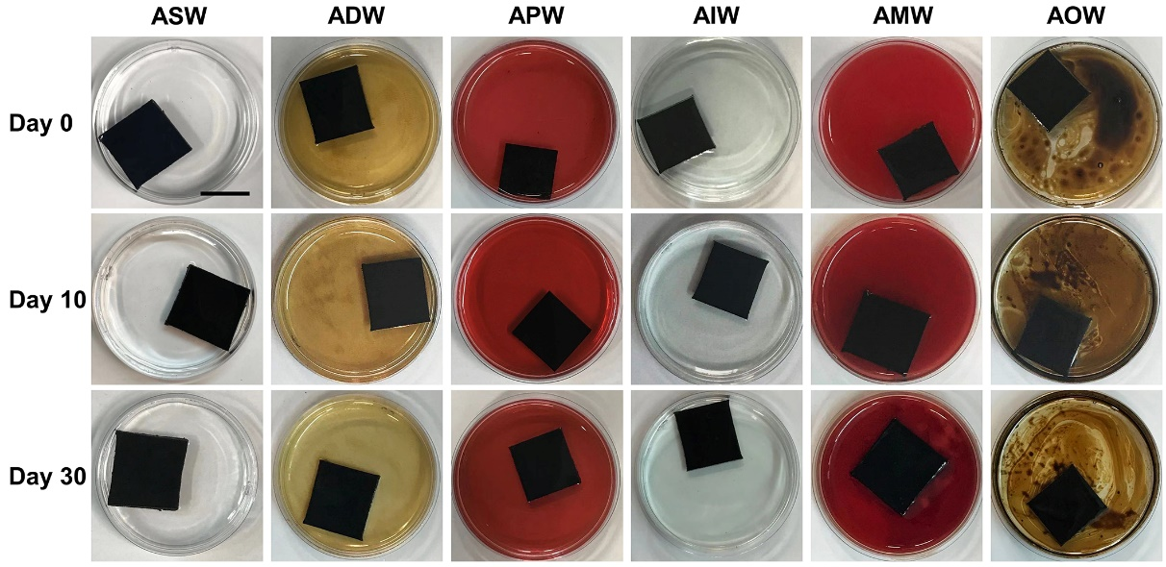
Fig. S15. 30 d stability of SIFS when floating in ASW and various wastewater samples (scale bar: 2 cm).
ADM contained glucose, C₂H₃NaO₂, yeast extract, NH₄Cl, K₂HPO₄, KH₂PO₄, FeCl₃, H₃BO₃, CuSO₄, KI, and MnSO₄. AIW contained (NH₄)₂SO₄, EDTANa₂, and Na₂SO₄. AOW contained crude oil, soybean oil, and surfactant. AMW contained whole blood, normal saline, and ethyl alcohol. APW contained rhodamine B, methylene blue, methyl orange, reactive yellow 3, and reactive brilliant red BS.

S2.5. Antifouling performance
Fig. S16. (a) The fluorescence images and (b) normalized relative fluorescence intensities of FITC-BSA adhesion on samples (scale bar: 200 μm).

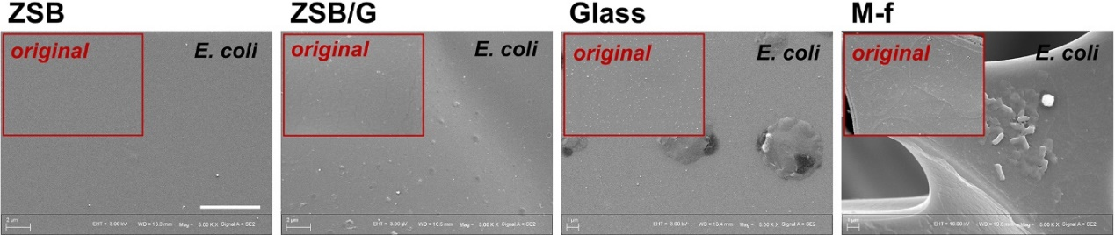
Fig. S17. SEM images of ZSB, ZSB/G, glass and melamine foam (M-f) after co-culture with E. coli (scale bar: 5 μm).

Fig. S18. Self-cleaning property of ZSB/G after soybean oil contamination.

Fig. S19. Swelling ratio of ZSB, ZSB/G and SIFS in DI and ASW during five cycles.
The swelling ratio of SIFS in ASW was higher than that in DI, it was due to the reversible reduce of electrostatic attraction between ZSB molecules in samples.

Fig. S20. The salt rejection ratios of ZSB, ZSB/G, and SIFS.

Fig. S21. The absorption spectra of wastewater samples before and after purification.

S3. Supplementary video captions
Video S1. The water contact angle and water spread on dry SIFS sheet.
Video S2. The water contact angle and water spread on wet SIFS sheet.
Video S3. The independent floatability of SIFS sheet. A fully wetted SIFS sheet is squeezed to the bottom. After release, the sheet floats to the surface again.
Video S4. The detachable floatability of SIFS sheet. A SIFS sheet is cut into pieces, after squeeze and release, each part of it is able to float again. And the fragments do not overlap each other, ensuring that the effective evaporation area will not decrease.
Video S5. The water transport of SIFS sheet. There is a thin water film on wet SIFS sheet, which is induced by ionic solvation effect of ZSB. Thus, the filter paper is fully infiltrated the moment it contacts with SIFS surface. The wetting boundary moves forward smoothly since SIFS sheet provides continuous water pumping.
Video S6. The self-cleaning ability of SIFS sheet after contamination with soybean oil. A wet SIFS sheet is immersed in Sudan III-labelled soybean oil to simulate oily working condition. After simple rinse, the SIFS sheet recovers clean without residue.
Video S7. The self-cleaning ability of SIFS sheet after contamination with crude oil. A wet SIFS sheet is immersed in crude oil to simulate oil spill event in the ocean. After simple rinse, the SIFS sheet recovers clean without residue.
Video S8. The crude oil resistance of SIFS sheet. The wet SIFS sheet can break the crude oil barrier and perform interfacial evaporation stably.
References
[1] Zhao F, Zhou X, Shi Y, Qian X, Alexander M, Zhao X, et al. Highly efficient solar vapour generation via hierarchically nanostructured gels. Nat Nanotechnol 2018;13(6):489–95. doi:10.1038/s41565-018-0097-z PMID:29610528
[2] Heat transfer module user's guide. Stockholm: Comsol AB; 2019.
[3] Wang J, Li Y, Deng L, Wei N, Weng Y, Dong S, et al. High-performance photothermal conversion of narrow-bandgap Ti₂O₃ nanoparticles. Adv Mater 2017;29(3):1603730. doi:10.1002/adma.201603730
[4] Li Y, Gao T, Yang Z, Chen C, Luo W, Song J, et al. 3D-printed, all-in-one evaporator for high-efficiency solar steam generation under 1 sun illumination. Adv Mater 2017;29(26):1700981. doi:10.1002/adma.201700981
[5] Zhou X, Zhao F, Guo Y, Zhang Y, Yu G. A hydrogel-based antifouling solar evaporator for highly efficient water desalination. Energy Environ Sci 2018;11(8):1985–92. doi:10.1039/C8EE00567B
[6] Ren H, Tang M, Guan B, Wang K, Yang J, Wang F, et al. Hierarchical graphene foam for efficient omnidirectional solar-thermal energy conversion. Adv Mater 2017;29(38):1702590. doi:10.1002/adma.201702590
[7] Chen C, Zhou L, Yu J, Wang Y, Nie S, Zhu S, et al. Dual functional asymmetric plasmonic structures for solar water purification and pollution detection. Nano Energy 2018;51: 451–6. doi:10.1016/j.nanoen.2018.06.077
[8] Zhou L, Tan Y, Ji D, Zhu B, Zhang P, Xu J, et al. Self-assembly of highly efficient, broadband plasmonic absorbers for solar steam generation. Sci Adv 2016;2(4):1501227. doi:10.1126/sciadv.1501227 PMID:27152335
[9] Jiang Q, Derami HG, Ghim D, Cao S, Jun YS, Singamaneni S. Polydopamine-filled bacterial nanocellulose as a biodegradable interfacial photothermal evaporator for highly efficient solar steam generation. J Mater Chem A 2017;5(35):18397–402. doi:10.1039/C7TA04834C
[10] Zhang P, Li J, Lv L, Zhao Y, Qu L. Vertically aligned graphene sheets membrane for highly efficient solar thermal generation of clean water. ACS Nano 2017;11(5):5087–93. doi:10.1021/acsnano.7b01965 PMID:28423271
[11] Hu X, Xu W, Zhou L, Tan Y, Wang Y, Zhu S, et al. Tailoring graphene oxide-based aerogels for efficient solar steam generation under one sun. Adv Mater 2017;29(5):1604031. doi:10.1002/adma.201604031
[12] Zhao F, Zhou X, Shi Y, Qian X, Alexander M, Zhao X, et al. Highly efficient solar vapour generation via hierarchically nanostructured gels. Nat Nanotechnol 2018;13(6):489–95. doi:10.1038/s41565-018-0097-z PMID:29610528
[13] Li W, Li Z, Bertelsmann K, Fan DE. Portable low-pressure solar steaming-collection unisystem with polypyrrole origamis. Adv Mater 2019;31(29):1900720. doi:10.1002/adma.201900720
[14] Xu N, Hu X, Xu W, Li X, Zhou L, Zhu S, et al. Mushrooms as efficient solar steam-generation devices. Adv Mater 2017;29(28):1606762. doi:10.1002/adma.201606762
[15] Zhou X, Zhao F, Guo Y, Rosenberger B, Yu G. Architecting highly hydratable polymer networks to tune the water state for solar water purification. Sci Adv 2019;5(6):aaw5484. doi:10.1126/sciadv.aaw5484 PMID:31259243
[16] Li X, Xu W, Tang M, Zhou L, Zhu B, Zhu S, et al. Graphene oxide-based efficient and scalable solar desalination under one sun with a confined 2D water path. Proc Natl Acad Sci USA, 2016;113(49):13953–8. doi:10.1073/pnas.1613031113 PMID:27872280
[17] Hong S, Shi Y, Li R, Zhang C, Jin Y, Wang P. Nature-inspired, 3D origami solar steam generator toward near full utilization of solar energy. ACS Appl Mater Interfaces 2018;10(34):28517–24. doi:10.1021/acsami.8b07150 PMID:30109921
[18] Li X, Li J, Lu J, Xu N, Chen C, Min X, et al. Enhancement of interfacial solar vapor generation by environmental energy. Joule 2018;2(7):1331–8. doi:10.1016/j.joule.2018.04.004
[19] Shi Y, Li R, Jin Y, Zhuo S, Shi L, Chang J, Hong S, Ng K C, Wang P. A 3D photothermal structure toward improved energy efficiency in solar steam generation. Joule 2018;2(6):1171–86. doi:10.1016/j.joule.2018.03.013
[20] Gong F, Li H, Wang W, Huang J, Xia D, Liao J, et al. Scalable, eco-friendly and ultrafast solar steam generators based on one-step melamine-derived carbon sponges toward water purification. Nano Energy 2019;58:322–30.
doi:10.1016/j.nanoen.2019.01.044
[21] Li K, Gao M, Li Z, Yang H, Jing L, Tian X, et al. Multi-interface engineering of solar evaporation devices via scalable, synchronous thermal shrinkage and foaming. Nano Energy 2020;74:104875. Corrected in: Nano Energy 2021;82:105662.
[22] Wang Y, Wang C, Liang W, Song X, Zhang Y, Huang M, et al. Multifunctional perovskite oxide for efficient solar-driven evaporation and energy-saving regeneration. Nano Energy 2020;70:104538. doi:10.1016/j.nanoen.2020.104538
[23] Wang Z, Han M, He F, Peng S, Darling SB, Li Y. Versatile coating with multifunctional performance for solar steam generation. Nano Energy 2020;74:104886. doi:10.1016/j.nanoen.2020.104886
[24] He F, Han M, Zhang J, Wang Z, Wu X, Zhou Y, et al. A simple, mild and versatile method for preparation of photothermal woods toward highly efficient solar steam generation. Nano Energy 2020;71:104650. doi:10.1016/j.nanoen.2020.104650
[25] Guan QF, Han ZM, Ling ZC, Yang HB, Yu SH. Sustainable wood-based hierarchical solar steam generator: a biomimetic design with reduced vaporization enthalpy of water. Nano Lett 2020;20(8):5699–704. doi:10.1021/acs.nanolett.0c01088 PMID:32638594
[26] Ghasemi H, Ni G, Marconnet AM, Loomis J, Yerci S, Miljkovic N, et al. Solar steam generation by heat localization. Nat Commun 2014;5(1):4449. doi:10.1038/ncomms5449 PMID:25043613
[27] Guo Y, Zhao X, Zhao F, Jiao Z, Zhou X, Yu G. Tailoring surface wetting states for ultrafast solar-driven water evaporation. Energy Environ Sci 2020;13(7):2087–95. doi:10.1039/D0EE00399A
[28] Zhu Z, Mu P, Fan Y, Bai W, Zhang Z, Sun H, et al. Highly efficient solar steam generation of bilayered ultralight aerogels based on N-rich conjugated microporous polymers nanotubes. Eur Polym J 2020;126:109560.
[29] Meng S, Zhao X, Tang CY, Yu P, Bao RY, Liu ZY, et al. A bridge-arched and layer-structured hollow melamine foam/reduced graphene oxide composite with an enlarged evaporation area and superior thermal insulation for high-performance solar steam generation. J Mater Chem A 2020;8(5):2701–11. doi:10.1039/C9TA12802F
[30] Liu H, Chen C, Chen G, Kuang Y, Zhao X, Song J, et al. High-performance solar steam device with layered channels: artificial tree with a reversed design. Adv Energy Mater 2018;8(8):1701616. doi:10.1002/aenm.201701616
[31] Liu H, Chen C, Wen H, Guo R, Williams NA, Wang B, et al. Narrow bandgap semiconductor decorated wood membrane for high-efficiency solar-assisted water purification. J Mater Chem A 2018;6(39):18839–46. doi:10.1039/C8TA05924A
[32] Zhang Y, Ravi SK, Vaghasiya JV, Tan SC. A barbeque-analog route to carbonize moldy bread for efficient steam generation. iScience 2018;3:31–9. doi:10.1016/j.isci.2018.04.003 PMID:30428328
[33] Hu X, Xu W, Zhou L, Tan Y, Wang Y, Zhu S, et al. Tailoring graphene oxide-based aerogels for efficient solar steam generation under one sun. Adv Mater 2017;29(5):1604031. doi:10.1002/adma.201604031
[34] Zhang B, Song C, Liu C, Min J, Azadmanjiri J, Ni Y, et al. Molten salts promoting the “controlled carbonization” of waste polyesters into hierarchically porous carbon for high-performance solar steam evaporation. J Mater Chem A 2019;7(40):22912–23. doi:10.1039/C9TA07663H

