Supplementary Data for

Phase Morphology Evolution and Rheological Behavior of Toughened Polypropylene Composite with Controllable Brittle–Ductile Transition Temperature Using SEPS@HDPE Core–Shell Structure
Jiahao Shen ª, Zhiyi Zhang ^{a,}*, Wenwen Yu ^{a,}*, Jiayi Wang ª, Weixuan Wang ª, Yonggang Shangguan ^{b}, Qiang Zheng ^{a,b,}*
ª College of Materials Science and Engineering, Taiyuan University of Technology, Taiyuan 030024, China
^{b} Department of Polymer Science and Engineering, Zhejiang University, Hangzhou 310027, China

* Corresponding authors.
E-mail addresses: zhangzhiyi@tyut.edu.cn (Z. Zhang), yuwenwen@tyut.edu.cn (W. Yu), zhengqiang@tyut.edu.cn (Q. Zheng).

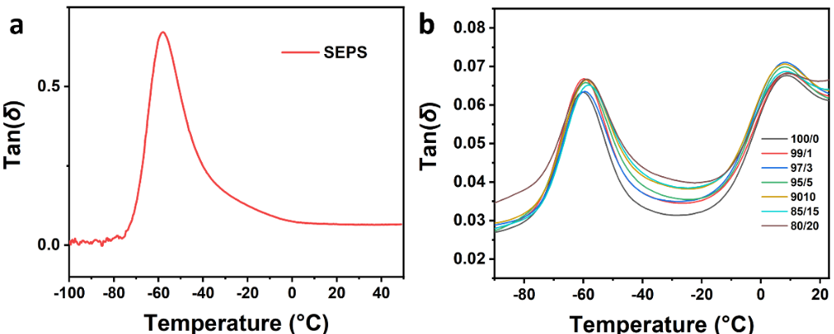
Fig. S1. DMA curves of (a) neat SEPS and (b) PPM/HDPE with different HDPE contents.

Fig. S2. Tensile characteristic curve of PPM/HDPE blends

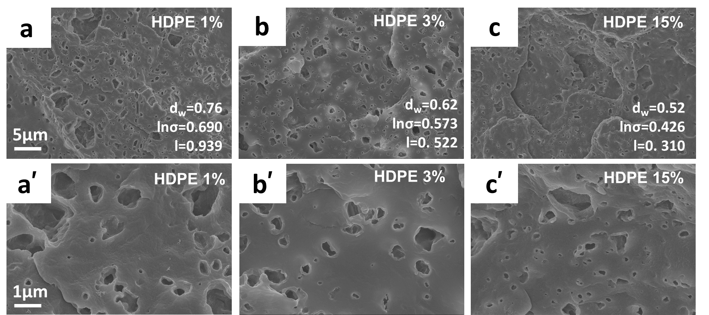
Fig. S3. SEM images of PPM/HDPE composites with different HDPE contents: (a) 99/1, (b) 97/3, and (c) 85/15; and (a′–c′) are the magnification of (a–c). The ruler of the same type of picture is kept consistent.

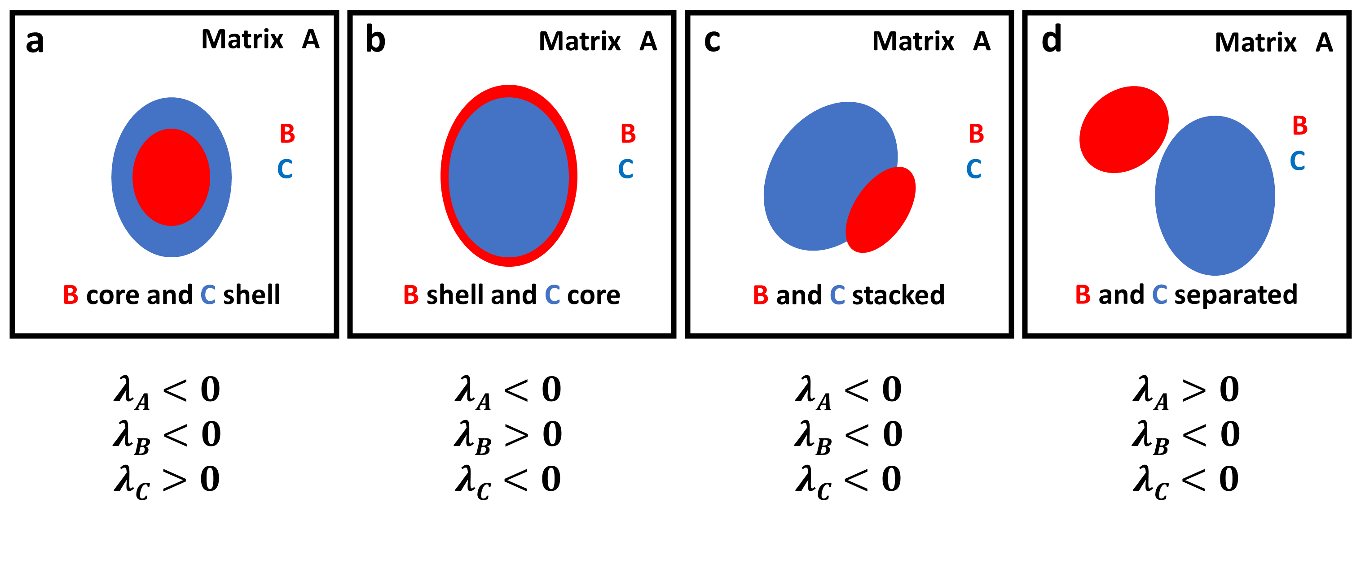
Fig. S4. Schematic illustration of the alternative phase morphologies in an A/B/C ternary blends system

Surface tensions and interfacial tensions measurement
The surface tensions of solid materials can be evaluated using static contact angle measurement. The surface tensions of three polymers pairs can be calculated by OWRK method [1–3].
$γ_{S}=γ_{S}^{D}+γ_{S}^{P}$ (S1)
$γ_{L}\left(1+\cos{θ}\right)=2\sqrt{γ_{S}^{D}γ_{L}^{D}}+2\sqrt{γ_{S}^{P}γ_{L}^{P}}$ (S2)
where θ is contact angle; γ represents the surface tension; the subscripts of S and L represent the solid and liquid portion, respectively; and the superscripts of D and P indicate the dispersive and polar portion, respectively. H₂O and CH₂I₂ were selected as a polar and a nonpolar liquid to measure the surface tensions at room temperature [4]. The results of contact angle and surface tension are listed in Table S1.

Table S1
Contact angle and surface tension results of different components at 25 °C.
Sample | Contact angle at 20 °C (° ) |  | Surface tension at 20 °C (mN∙m⁻¹)
Sample | Distilled water | Diiodomethane | γ | γ^{D} | γ^{P}
PP | 102.84 | 69.46 | 23.85 | 23.18 | 0.67
HDPE | 109.32 | 69.19 | 23.39 | 23.33 | 0.06
SEPS | 104.47 | 59.80 | 28.85 | 28.69 | 0.16

But the melt blending was carried out at an elevated temperature and the spreading behaviors of three components occurred at processing temperature (195 °C). Thus, the surface tensions of materials may change dramatically with the increasing temperature. The surface tensions at given temperature can be evaluated from the following Guggenheim empirical formula [5].
$γ_{S, T_{M}}=γ_{{S,T}_{0}}{(1-\frac{T_{0}}{T_{M}})}^{{11}/9}$ (S3)
where the $γ_{S, T_{M}}$ and $γ_{{S,T}_{0}}$ represent the surface tensions at processing temperature (T_{M}) and testing temperature (T₀), respectively. The calculated surface tensions of three components at 195 °C are shown in Table S2. The harmonic mean equation had been used to calculate the interfacial tensions of different polymer pairs:
$γ_{A/B}=γ_{A}+γ_{B}-4(\frac{γ_{A}^{D}γ_{B}^{D}}{γ_{A}^{D}+γ_{B}^{D}}+\frac{γ_{A}^{P}γ_{B}^{P}}{γ_{A}^{P}+γ_{B}^{P}})$ (S4)
where γ_{A} and γ_{B} are the surface tensions of two components (i.e., A and B) in contact, and γ_{A/B} is the interfacial tension between components A and B. Table 2 shows the interfacial tensions between different components at 195 °C. Then, the morphology of a ternary polymer blend can be predicted by the concept of spreading coefficients according to Hobbs [6] and Harkin [7].
$λ_{k}=γ_{i/j}-{(γ}_{i/k}+γ_{j/k})$ (S5)
where γ_{i/j}, γ_{i/k}, and γ_{j/k} are the interfacial tensions for each polymer pair and λ_{k} is the spreading coefficient giving the tendency of component k to spontaneously spread at the interface between components i and j. If λ_{k} > 0, component k can spread at the interface between components i and j, otherwise the spreading does not occur [7]. The spreading coefficients λ_{PP}, λ_{SEPS}, and λ_{HDPE} were calculated to be −0.68, −0.83, −0.17, respectively. According to the spreading coefficients, we can predict the concrete phase morphology of the mixture [4], HDPE and SEPS have no driving force to diffuse between each other and PP. Because PP also has no tendency to spread between the two, a stacked thus formed in PP matrix.

Table S2
Surface tension and interfacial tensions between different components at 195 °C.
Sample | Surface tension at 195 °C (mN∙m⁻¹) |  |  | Component couple | Interfacial tension, γ_{i/j} (mN∙m⁻¹)
Sample | γ | γ^{D} | γ^{P} | Component couple | Interfacial tension, γ_{i/j} (mN∙m⁻¹)
PP | 20.16 | 19.60 | 0.57 | PP/SEPS | 0.76
HDPE | 19.77 | 19.72 | 0.05 | PP/HDPE | 0.43
SEPS | 24.39 | 24.26 | 0.14 | HDPE/SEPS | 0.50

References
[1] Owens DK, Wendt RC. Estimation of the surface free energy of polymers. J Appl Polym Sci 1969;13(8):1741–7.
[2] Kaelble DH. Dispersion-polar surface tension properties of organic solids. J Adhes 1970;2(2):66–81.
[3] Nemirovski N, Siegmann A, Narkis M. Morphology of ternary immiscible polymer blends. J Macromol Sci Part B Phys 1995;34(4):459–75.
[4] Mao Z, Zhang J. Largely improved the low temperature toughness of acrylonitrile–styrene–acrylate (ASA) resin: fabricated a core–shell structure of two elastomers through the differences of interfacial tensions. Appl Surf Sci 2018;444:345–54.
[5] Valera TS, Morita AT, Demarquette NR. Study of morphologies of PMMA/PP/PS ternary blends. Macromolecules 2006;39(7):2663–75.
[6] Hobbs SY, Dekkers MEJ, Watkins VH. Effect of interfacial forces on polymer blend morphologies. Polymer 1988;29(9):1598–602.
[7] Li H, Xie XM. Morphology development and superior mechanical properties of PP/PA6/SEBS ternary blends compatibilized by using a highly efficient multi-phase compatibilizer. Polymer 2017;108:1–10.

