Supplementary data for

Pure Ru n-TSV Processing and Extreme All-Dry SOI Wafer Thinning for a Backside Power-Delivery Network
Biao Wang ^{a,b}, Feifeng Huang ^{a,b}, Qiancheng Wang ^{a,b}, Zhao Chen ^{a,b}, Hongbin Chen ^{a,b}, Quan Wang ª, Qiu Shao ^{a,b}, Yiqin Chen ^{a,b}, Zhengyuan Wu ^{c}, Bo Feng ^{a,b,}*, Ming Ji ^{d}, Huigao Duan ^{a,b}
ª College of Mechanical and Vehicle Engineering & National Engineering Research Center for High-Efficiency Grinding, Hunan University, Changsha 410082, China
^{b} Greater Bay Area Institute for Innovation, Hunan University, Guangzhou 511300, China
^{c} Institute of Optoelectronics and School of Information Science and Technology, Fudan University, Shanghai 200433, China
^{d} IBD Technology Co., Ltd., Zhongshan 528225, China
* Corresponding author.
E-mail address: fengbo36@hnu.edu.cn (B. Feng).

S1. Process flow
Ruthenium (Ru) is one of the most widely studied metals as a next-generation material. The process flow for integrating Ru nano through-silicon vias (n-TSVs) into a backside power delivery network (BSPDN) is illustrated in Fig. S1.
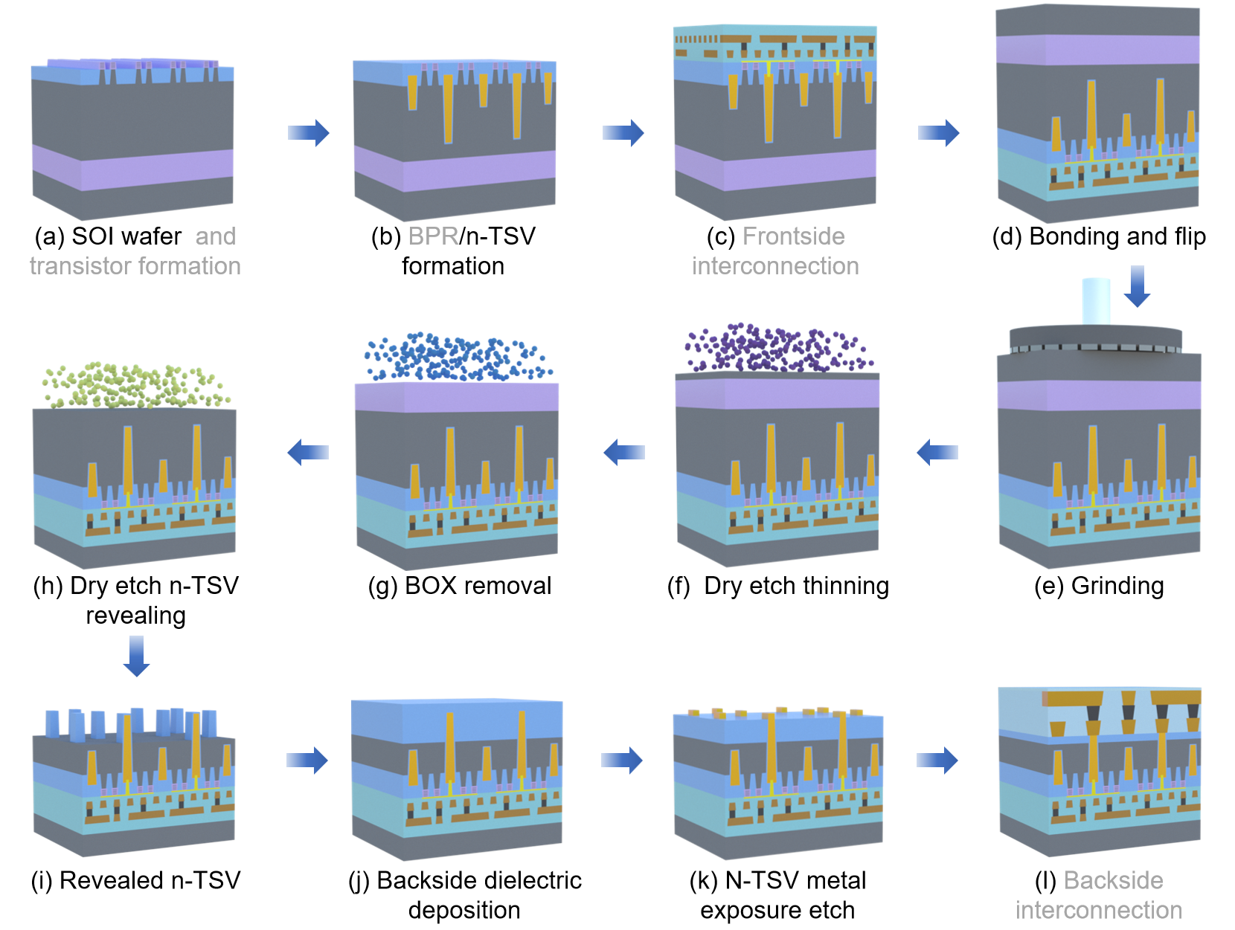
Fig. S1. Manufacturing process flow in this passage (processing steps for integrated manufacturing with FinFET are represented in gray).

S2. n-TSV patterning
Prior to n-TSV patterning, a 200-nm SiO₂ hard mask (HM) is deposited via inductively coupled plasma chemical vapor deposition (ICPCVD, Plasma Pro 100, Oxford) at 260 °C with 800 W ICP power. The n-TSV patterning process flow is shown in Fig. S2. First, a 160-nm-thick ARP-6200 photoresist (PR) layer is spin-coated. Then, electron-beam lithography (EBL, Raith EBPG 5200) under a 30-kV exposure voltage is employed to pattern the PR.
In this work, the n-TSVs were fabricated by means of EBL. This technique was selected for its high-resolution patterning and rapid prototyping capabilities, which were essential for validating the feasibility of the nano-TSV design on 200-mm (8-inch) wafers. However, EBL suffers from inherent limitations in wafer-scale processing. Specifically, its exposure throughput is substantially lower than those of mass-production lithography tools (e.g., deep ultraviolet, DUV). Consequently, the patterned area was confined to the central region of the 8-inch wafer to balance resolution requirements against processing time. Thus, given these constraints, the yield of n-TSVs across the entire 8-inch wafer was not systematically estimated.
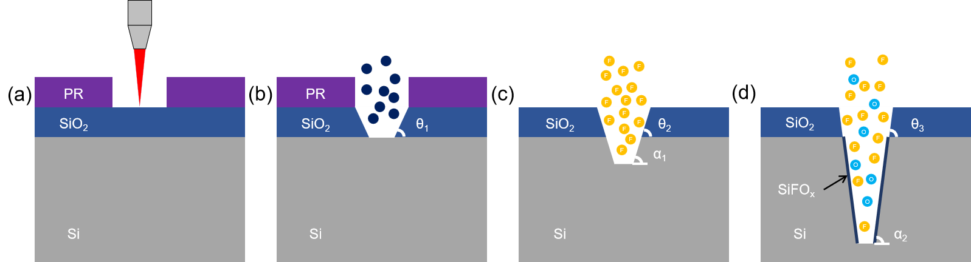
Fig. S2. Process flow for n-TSV patterning. (a) PR patterning; (b) hard mask opening; (c) first silicon etching; (d) second silicon etching.

An inductively coupled plasma (ICP; GSE-C200, NAURA) etch system is used to pattern the HM and the silicon (Si) substrate. The etching process comprises three steps; the detailed procedure is provided in Table S1. First, pure trifluoromethane (CHF₃) gas is used to open the HM for high PR selectivity (2.7:1). In this step, the chamber pressure is set at 15 mTorr to create a slight tilt angle (θ₁) on the HM sidewall after etching. Second, pure sulfur hexafluoride (SF₆) gas is employed to etch the Si substrate. Fluorine (F) from the SF₆ reacts rapidly with Si and SiO₂, which results in the expansion of the angle θ₁ to θ₂. Finally, a mixed SF₆/O₂ gas is used for etching. Oxygen (O₂) in the mixture inhibits isotropic etching and generates a SiFO_{x} compound, which serves as a passivation layer deposited on the bottom and sidewalls of the Si via. During etching, ions vertically bombard the bottom of the Si via, continuously removing the formed SiFO_{x} passivation layer. This exposes fresh Si to F* ions for the etching reaction. The gas ratio of SF₆ to O₂ is adjusted in this step to balance sidewall passivation and bottom silicon etching, achieving a sidewall morphology with an angle (α₂). The sequential plasma strategy allows precise control over sidewall morphology and etching anisotropy, which are critical for fabricating high-aspect-ratio (AR) n-TSVs.

Table S1
Process conditions in n-TSV patterning.
Process stage | Pressure (mTorr) | Gas flow (sccm) | Power (W) | Bias (W) | Temperature (℃)
HM opening | 15 | CHF₃ (240) | 360 | 50 | 0
Si etching 1 | 10 | SF₆ (400) | 400 | 50 | 0
Si etching 2 | 5 | O₂/SF₆ (340/200) | 400 | 50 | 0

After completing the n-TSV patterning, a narrow critical dimension (CD), high-AR n-TSV array is formed, as shown in Fig. S3. The characteristics of n-TSVs with various PR CDs are measured and listed in Table S2. The smaller CD structure makes it more difficult for reactants to enter and products to evaporate, which causes a reduction in etching depth.

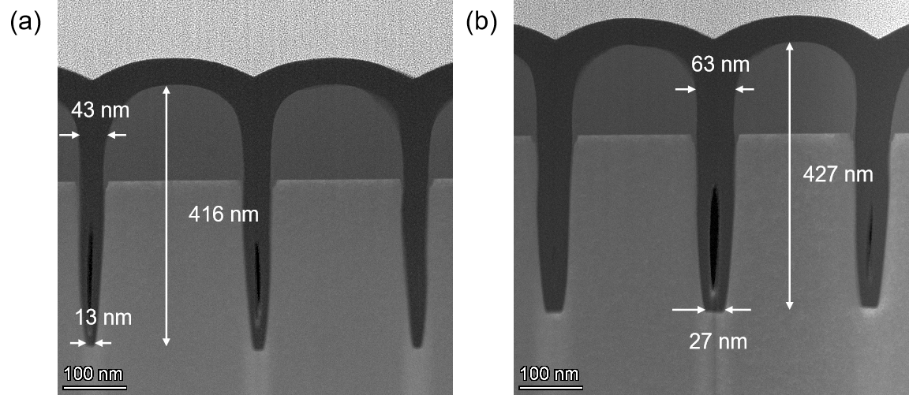
Fig. S3. The n-TSV cross-section transmission electron microscopy (TEM) images after patterning. (a) 55-nm PR CD n-TSV; (b) 70-nm PR CD.

Table S2
Different etching experiments (each result averaged from three representative data).
 | PR CD (nm) | 70 | 65 | 60 | 55 | 50
Parameters
Top CD (nm) |  | 63.2 | 54.7 | 48.8 | 43.2 | 39.3
Bottom CD (nm) |  | 26.5 | 23.2 | 17.9 | 13.3 | 6.5
Height (nm) |  | 433.1 | 425.8 | 420.4 | 416.6 | 406.7
AR |  | 6.8 | 7.7 | 8.6 | 9.5 | 10.4
Sidewall angle (α₂) |  | 87.1° | 87.4° | 87.5° | 87.5° | 87.2°

S3. Insulator and metal filling process
To achieve a uniformly conformal dielectric liner in the high-AR n-TSVs, a 10-nm silicon dioxide (SiO₂) insulator is deposited using an atomic layer deposition (ALD; NCE-200R) system onto the n-TSV array. This process utilizes bis(diethylamino)silane (BDEAS) as a precursor, which reacts with ozone (O₃) to deposit the dielectric at 270 ℃. Subsequently, bis(ethylcyclopentadienyl)ruthenium ([Ru(EtCp)₂]) serves as the precursor, reacting with oxygen (O₂) to deposit Ru with conformal coverage and void-free filling characteristics. Oxide thickness is measured at discrete positions throughout the n-TSV depth (Fig. S4). Because the SiO₂ HM obscured direct top-surface liner measurement, the film thickness at the TSV top was recorded from the Si substrate top instead. The results in Table S3 list the thicknesses (T₁, T₂, and T₃) of the dielectric inside the n-TSVs. These values are used to evaluate the step coverage of the dielectric liner deposition. The step coverage of TSV dielectric liner is defined as follows:

$$\text{Step} \text{coverage} \text{=} \frac{\text{Thinnest} \text{film} \text{thickness} \text{within} \text{TSV}}{\text{Film} \text{thickness} \text{at} \text{TSV} \text{top}}$$
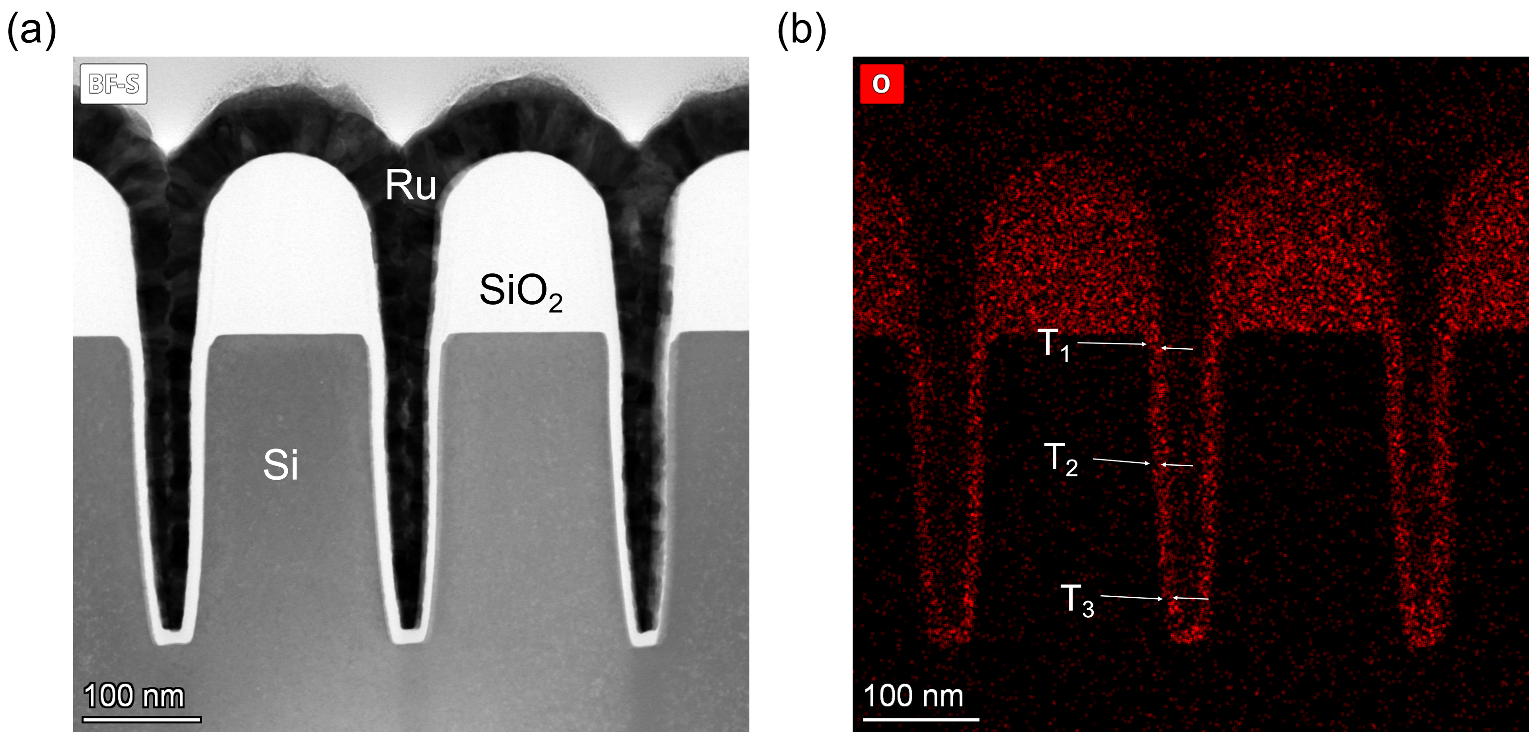
Fig. S4. Measurement of liner thickness. (a) Cross-section view of Ru-filled n-TSVs; (b) EDS mapping.
Table S3
Various top CD n-TSV liner thickness uniformities in the substrate (each result averaged from three representative data).
 | Top CD # (nm) | 63.2 | 54.7 | 48.8 | 43.2 | 39.3
Position | Thickness (nm)
T₁ |  | 10.9 | 10.9 | 10.9 | 10.9* | 10.9*
T₂ |  | 10.2 | 10.2 | 10.2 | 9.5 | 9.2
T₃ |  | 9.9 | 9.9 | 9.9 | 9.2 | 8.8
Step coverage |  | 91% | 91% | 91% | 84% | 81%
Notes: #From Table S2 top CD; *Thickness from larger n-TSVs.

S4. Bonding process
Cu–Cu thermal compression bonding exhibits superior electrical characteristics and high bonding strength [1]. In this work, a low-temperature Cu–Cu thermal compression process was employed to bond the carrier and device wafers. A Cr/Cu bilayer (10/100 nm) was directly deposited on carrier wafer surfaces, and Cu (100 nm) was deposited on a device wafer as the bonding material. The wafer pairs were then bonded (SUSS microTech XB8) at 350 °C for 30 min under a pressure of 2.5 MPa and a vacuum of 5e-6 mbar, promoting interdiffusion at the Cu–Cu interface. To increase bond strength, a post-bonding annealing step was performed in a nitrogen ambient at 350 °C for 1 h, further improving the interfacial cohesion and reducing residual stress.

S5. Backside thinning and revealing process
A silicon-on-insulator (SOI) wafer with top Si of 500-nm on buried oxide (BOX) is used to control the total thickness variation (TTV). The BOX layer is 2 μm thick. The thinning process begins with mechanical grinding (IVG-2020, Tesidi) to reduce the thick Si substrate to 50 μm. A subsequent high-selectivity dry etching step employs pure SF₆ gas in a deep reactive ion etching (DRIE; HSE-M200, NAURA) system, achieving 66:1 Si-to-SiO₂ selectivity that is well-controlled to terminate at the BOX layer. The dry etching parameters include a 900-sccm SF₆ flow, 2700-W ICP power, and 30-W bias power.
To remove the BOX layer, a vapor-phase hydrofluoric acid (HF; uEtch, SPTS) etching system is employed. The etching of silicon in HF-based solutions follows a sequential oxidation-dissolution mechanism. In the absence of oxidants, HF exhibits negligible reactivity toward silicon, yielding an extremely high SiO₂-to-Si etch selectivity that approaches infinity under dilute pure HF conditions [2]. Leveraging this intrinsic selectivity, the etching process can be well-controlled to stop on the Si layer. The process parameters include 900-sccm HF, 1500-sccm nitrogen (N₂), and 600-sccm ethanol, achieving consistent BOX layer removal across the wafer.
Additionally, the TTV measured at each process stage, as detailed in Table S4, confirms that the combination of SOI wafer selection and the optimized etching process minimizes thickness fluctuations.

Table S4
TTV in thinning process.
Process | Before thinning | Grinding | Dry etch thinning | BOX removal
TTV | 15 μm | 10 μm | 226 nm | 11 nm

The n-TSV exposure process starts with a pure HBr plasma etch to remove the initial 200 nm of the 500-nm Si layer. This step eliminates surface contaminants and enables unobstructed access for subsequent silicon etching. A thinning process follows, reducing the silicon layer to the target depth using a mixed plasma (HBr/O₂). Near-isotropic silicon etching is first performed to ensure a uniform etch depth across the wafer. The process conditions are listed in Table S5. The n-TSV-revealing silicon thinning (300 to 190 nm) with HBr/O₂ etching achieves consistent material removal and reduces surface roughness. The 153:1 selectivity ratio of mixed plasma (HBr/O₂) for n-TSV revealing, validated via spectroscopic ellipsometry, underscores the capability of this process to protect the dielectric liners while enabling precise control over the n-TSV exposure profile.

Table S5
Process conditions in n-TSV revealing.
Thickness change (nm) | Pressure (mTorr) | Gas flow (sccm) | Power (W) | Bias (W) | Temperature  (℃)
500 to 300 | 8 | HBr (320) | 500 | 60 | 0
300 to 190 | 8 | HBr/O₂ (380/20) | 500 | 15 | 0

Following backside exposure of the n-TSVs, a 300-nm spin-on-glass (SOG) layer is spin-coated to planarize the substrate surface and electrically isolate the backside metallization from the silicon substrate. The SOG thickness is optimized to fully encapsulate the n-TSV structures while ensuring uniform planarization.
A non-contact ion beam etch process with a 45° incidence angle is employed to remove the SOG over the n-TSVs, exposing the underlying Ru interconnects while preserving the planarized SOG in the non-metallized regions. Photolithographic patterning with 200-nm CD is then performed. Finally, Au (20 nm) backside interconnects are formed via lift-off patterning. This sequential SOG planarization, selective etching, and metallization strategy ensures the robust electrical isolation and low-resistance interconnection critical for 3D integrated circuit performance.

S6. Electrical test scheme
The four-probe Kelvin method, which effectively mitigates the influence of contact and wire resistance, is widely employed for resistance extraction. As illustrated in Fig. S5, the measurement scheme involves positioning two current-source probes at opposing ends of the conductor and four potential-sensing probes along its central region. This configuration enables direct measurement of the voltage drop across the conductor.

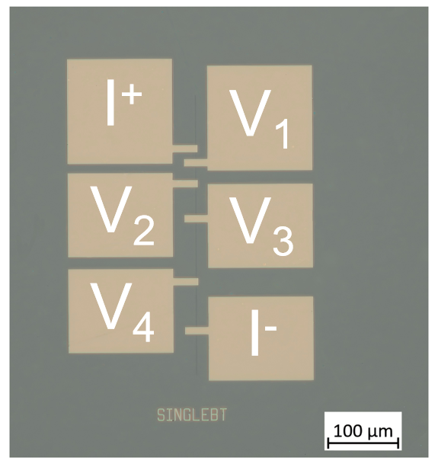
Fig. S5. Optical microscopy image of four-probe test configuration for n-TSV characterization.
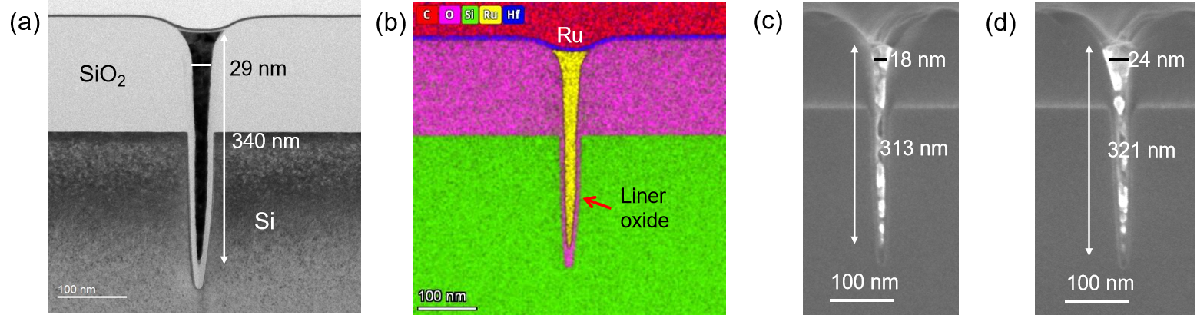
Fig. S6. Structural and compositional analysis of Ru n-TSVs with varied CDs. (a) TEM cross-section of a 29-nm CD structure; (b) EDS elemental mapping of the structure in part (a); (c) cross-sectional SEM image of an 18-nm CD n-TSV; (d) 24-nm CD n-TSV profile.

Table S6
N-TSV cross-sectional parameters.
Top CD (nm) | Height (nm) | Electrical area (nm²)
29 | 340 | 6839
24 | 321 | 4296
18 | 313 | 2864

The resistivity of Ru is influenced by grain size in the n-TSVs. To characterize this, the resistivities of three Ru-filled slit-shaped n-TSVs with various cross-sectional areas were measured. The scan electron microscopy (SEM) images and TEM images in Fig. S6 depict the profile of the n-TSVs in the test structure. Table S6 lists the cross-sectional areas for n-TSVs with various CDs. By combining these geometric measurements with four-probe resistance data, the resistivity of each structure can be derived.

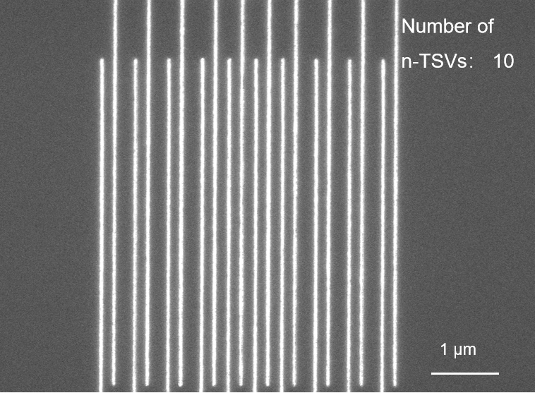
Fig. S7. SEM image of the leakage current test.

The SEM image (Fig. S7) shows a test structure with 10 lines and an overlap length of 5 μm, demonstrating excellent electrical isolation between the n-TSVs and uniform line geometry.

S7. Stress measurement by Raman spectroscopy

Raman spectroscopy was used to characterize the stress distribution within the n-TSV array. This method is based on the principle that mechanical strain in the Si alters the phonon frequencies. Consequently, the position of the Raman scattering peak is shifted compared with its stress-free state ($ν_{0}$, 520.7 cm⁻¹ for unstrained Si) [3-5]. If the peak frequency is higher than the stress-free reference value, it indicates the presence of compressive stress. For silicon with a <001> crystal plane, a linear relationship between stress and Raman shift can be obtained, which is theoretically given in Refs. [6, 7]:
 | $$\text{σ}\text{(}\text{MPa}\text{)} \text{=} \text{–434} \left(\text{ν }\text{–} {\text{ν}}_{\text{0}}\right)\text{(}{\text{cm}}^{\text{–}\text{1}}\text{)}$$ | (2)
where $ν$ is the measured Raman frequency.
Measurements were performed using a WITec alpha300R spectrometer in line-scan mode. The spectrometer scanned a 16-μm path across the surface of the Si substrate (scan step resolution: 0.5 μm). Each position was sampled 10 times to ensure measurement repeatability. A 532-nm laser was used for sampling. A 4-inch single-polished Si wafer served as the stress-free reference for calibration, with the unstrained Si Raman peak confirmed at 520.7 cm^{–1}. Sequential Ru recess etching and buffered oxide removal exposed the die surface, ensuring unobstructed optical access to the underlying Si structure for reliable signal acquisition.

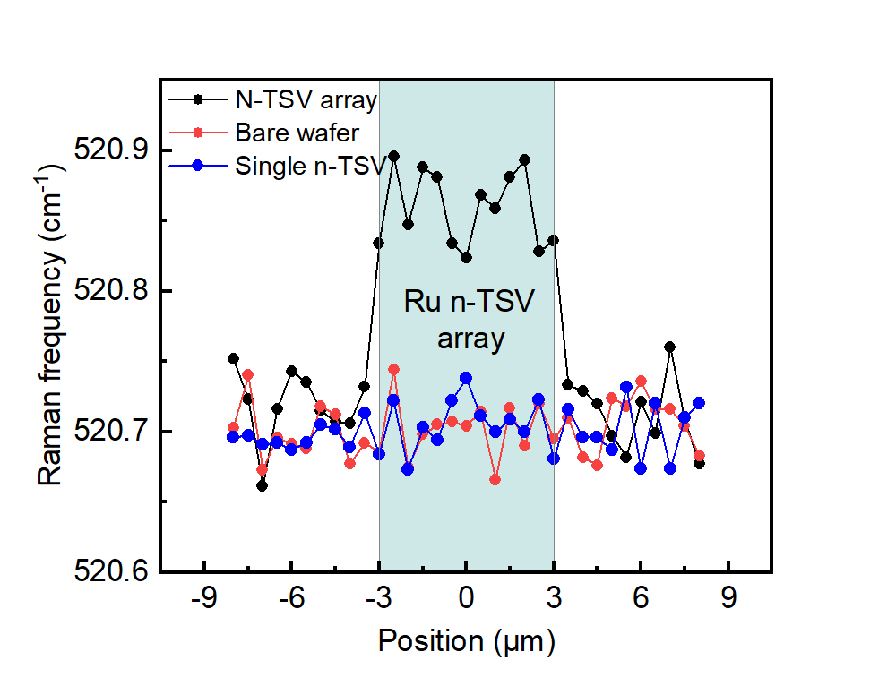
Fig. S8. Stress distribution of tapered n-TSVs analyzed through Raman spectroscopy.

The near-surface stress distribution along the scan path is shown in Fig. S8. Although the single-tapered n-TSV with a top CD of 26 nm and a depth of 320 nm exhibited undetectable stress deviations from the bare Si substrates due to Raman spatial resolution constraints [8], aggregated measurements across high-density n-TSV arrays (top CD: ~26 nm; depth: ~ 320 nm; pitch: 200 nm; total array area: ~6 μm × 6 μm) resolved a maximum frequency shift of 0.159 cm⁻¹. This finding means that the calculated stress intensity was as low as 69 MPa, indicating that the extreme nanoscale size of the conical n-TSV can effectively alleviate stress propagation while maintaining structural integrity under severe scaling constraints.

References
[1] Jang E-J, Kim J-W, Kim B, Matthias T, Park Y-B. Annealing temperature effect on the Cu–Cu bonding energy for 3D-IC integration. Met Mater Int. 2011;17(1):105-09.
[2] Schwartz B, Robbins H. Chemical etching of silicon: IV. Etching technology. J Electrochem Soc.1976;123(12):1903.
[3] Vogel D, Rzepka S, Michel B, Gollhardt A. Local stress measurement on metal lines and dielectrics of BEoL pattern by stress relief technique. 2011 Semiconductor Conference Dresden. 2011;1-3.
[4] Ryu S-K, Zhao Q, Hecker M, Son H-Y, Byun K-Y, Im J, et al. Micro-Raman spectroscopy and analysis of near-surface stresses in silicon around through-silicon vias for three-dimensional interconnects. J App Phys. 2012;111(6).
[5] Jian C, De Wolf I. Theoretical and experimental Raman spectroscopy study of mechanical stress induced by electronic packaging. IEEE Trans Compon Packag Manuf Technol. 2005;28(3):484-92.
[6] Wu X, Yu J, Ren T, Liu L. Micro-Raman spectroscopy measurement of stress in silicon. Microelectron J. 2007;38(1):87-90.
[7] Li X, Jin S, Zhang R, Gao Y, Liu Z, Yao Y, et al. The resolution and repeatability of stress measurement by Raman and EBSD in silicon. Vacuum. 2022;203.
[8] Lin H, Seitz S, Tan Y, Lugagne JB, Wang L, Ding G, et al. Label-free nanoscopy of cell metabolism by ultrasensitive reweighted visible stimulated Raman scattering. Nat Methods. 2025;22(5):1040-50.

