Supplementary material for
Influenza’s Plummeting during the COVID-19 Pandemic: The Roles of Mask-Wearing, Mobility Change, and SARS-CoV-2 Interference
Shasha Han ^{a,b,#}, Ting Zhang ^{c,#}, Yan Lyu ^{d,#}, Shengjie Lai ^{e}, Peixi Dai ^{f}, Jiandong Zheng ^{g}, Weizhong Yang ^{c}, Xiao-Hua Zhou ^{a,g,h,}*, Luzhao Feng ^{c,}*
ª Beijing International Center for Mathematical Research, Peking University, Beijing 100871, China
^{b} Harvard Medical School, Harvard University, Boston, MA 02115, USA
^{c} School of Population Medicine and Public Health, Chinese Academy of Medical Sciences & Peking Union Medical College, Beijing 100730, China
^{d} Academy for Advanced Interdisciplinary Studies, Peking University, Beijing 100871, China
^{e} WorldPop, School of Geography and Environmental Science, University of Southampton, Southampton SO17 1BJ, UK
^{f} Division for Infectious Diseases, Chinese Center for Disease Control and Prevention, Beijing 102206, China
^{g} Department of Epidemiology and Biostatistics, School of Public Health, Peking University, Beijing 100871, China
^{h} National Engineering Laboratory of Big Data Analysis and Applied Technology, Peking University, Beijing 100871, China

1. Supplementary methods

1.1. Domestic mobility-related NPIs
The change in domestic mobility during the COVID-19 pandemic represents several mobility-related NPIs. We estimated the Pearson’s correlation between our real-time domestic mobility data and the domestic movement restriction (denoted with categorical levels), as well as the Pearson’s correlation between mobility-related NPIs, using the data from the Oxford COVID-19 Government Response Tracker [1]. The levels of domestic movement restriction and other mobility-related NPIs in each area were estimated using averages over the local places. The results are shown in Fig. S14 and Table S2.

1.2. Mask-wearing intervention estimation
To account for the influence of COVID-19 vaccination on mask-wearing intervention [2,3], we assumed that the values of $D_{t}^{mas}$ decreased with the vaccination coverage rate $r_{t}$, which was estimated according to the percentage of daily administered doses in the total population (Fig. S13) [4–6]. We considered a linear decreasing pattern and adjust the mask index accordingly:
$D_{t}^{mas}=Mask index×max\left\{δ,1-π∙r_{t}\right\}$ (1)
The adjusted term indicates that the mask-wearing intervention relaxes at a rate $π$ as the vaccination campaign continues, and it decreases until a value of . Their best-fitted values were selected according to the $R^{2}$ criteria from the sets $\left\{0.0, 0.01, 0.05, 0.1, 0.5\right\}$ and $\left\{0.0, 0.1, 0.2, 0.3, 0.4, 0.5, 0.6, 0.7, 0.8, 0.9, 1.0\right\}$. The mask-wearing intervention $D_{t}^{mas}$ was equivalent to the mask-wearing index before the start of the COVID-19 vaccination campaigns, that is, $r_{t}=0$.

1.3. Normal mobility estimation
In England and the United States, normal mobility in 2020–2022 under no movement mitigation measures was projected by a regression model using normal mobility in 2011–2019 before NPIs start. A separate regression model was fitted for each month to maintain the inter-month variation the same as in the history. In northern China and southern China, because the 2019 mobility data are the only available data before NPIs start, we leveraged the observed mobility data in 2020 and 2021 to impute normal mobility. For the months from January to June, we used the yearly difference estimated from the 2019 and 2021 data, and for the months from July to December, we used the yearly difference from the 2019 and 2020 data.

1.4. Baseline analysis
We used a look-back window of 52 weeks (i.e., $N=52$) to capture the within-year seasonality in influenza percent positivity and the mobility data to account for variations due to changes in human mobility. To avoid overfitting with a large number of input variables, we used least absolute shrinkage and selection operator (LASSO) regression and imposed L1-regularization for parameter estimation [7]. The mobility data were normalized to the same scale as the percent positivity for regularization. For simplicity, the regularization strength parameter was set at the same level, and the best model was selected through bootstrap validation from the set {10−5,10−4,10−3,10−2,10−1}. Separate autoregressive models were fit for northern China, southern China, England, and the United States. A rolling window of over 400 weeks was used to dynamically train all parameters in Model (1) in the main text. When investigating the impact of mobility mitigations, the window covers the period from Week 40 of 2011 to the week before the start of any NPIs. To investigate the impact of SARS-COV-2 interference, it corresponds to the period from Week 40 of 2011 to the week before the arrival of SARS-COV-2 transmission. In England, since the mask-wearing law was implemented starting from Week 30 of 2020, much later than the start of mobility mitigation (Week 11 of 2020), we tested an alternative analysis in which the training window ended at Week 29 of 2020.
We estimated the effect of mask-wearing interventions using a lag of up to 52 observations. The best fitted values of $L$ were selected according to the $R^{2}$ criteria. The parameters in Model (2) in the main text are dynamically trained every week from the start of the NPIs until the end of the NPIs and are further used to forecast the influenza activity under the mask intervention alone. The model was implemented in scikit-learn 0.24.2 with Python (version 3.6.13; Python Software Foundation, USA).

1.5. Sensitivity analysis

1.5.1. Validation
We conducted a cross-validation analysis through the forward chaining approach, using ① the 2011–2016 data for training and the 2017 data for test; ② the 2011–2017 data for training and the 2018 data for test; and ③ the 2011–2018 data for training and the 2019 data for testing. The results are shown in Figs. S15–S17.

1.5.2. Modeling assumptions
Three sensitivity analyses of the modeling assumptions were performed. First, we analyzed the scenario in which the seasonal indicator is excluded in Model (1) in the main text and a scenario in which the seasonal indicators are included for both international and domestic mobility. Second, we conducted an extensive sensitivity analysis on the lags of mobility data used in the smoothing average ($M=2, 3, 4$) for all four areas. Finally, since the mask-wearing law was implemented in England starting from Week 30 of 2020, we tested an alternative analysis for England, where the training window in Model (1) in the main text continued until Week 29 of 2020.

1.5.3. Analysis for the US states
We also conducted a state-level analysis for the United States using the influenza data reported by states [8]. As an illustration, we considered four US states: Colorado, Indiana, Minnesota, and Washington. We estimated their domestic mobility in 2020–2021 using state-level data from Google Mobility Reports [9] and the mask index using the state-level mask-wearing order. The full analysis conducted for the United States was repeated for all four states.

2. Supplementary tables and figures
Table S1
Summary of data.
Data | Description | Baseline value | References
$$Y_{t}^{mob}$$ | Influenza percent positivity at time t under the mobility change only | Fig. S4 | [8,10,11]
$$V_{t}$$ | Domestic mobility at time t | Fig. S2 | [12–15]
$$W_{t}$$ | International mobility at time t | Fig. S2 | [14,16,17]
$S_{t}$ | Indicator of influenza season at time t | Estimated from influenza activity | [8,10,11]
N | Number of the lag of influenza activity included in Model (1) in the main text | 52
Mask index | Mask-wearing intervention | Fig. S3 | [18–20]
$$r_{t}$$ | Cumulative COVID-19 vaccine does at time t | Fig. S13 | [4–6]
$$D_{t}^{mas}$$ | Mask-wearing intervention adjusted by vaccination coverage | Derived through mask index through Equation (1)
$$I$$ | Indicator of the existence of minor NPI along with mask-wearing intervention | 1 during the NPI period, 0 otherwise | [18–20]
$$Y_{t}^{npi}$$ | Influenza percent positivity at time t under the all NPIs | Fig. S4 | [8,10,11]
$$L$$ | Number of the lag of mask-wearing intervention included in Model (2) in the main text | Table S1
$$M$$ | Number of the lag of mobility used in the moving average method | 4 for China; 2 for England and the United States
π | Decreasing rate of mask-wearing intervention with the vaccination coverage | Best fitted based on $R^{2}$criteria
$$δ$$ | Immediate reduction of mask-wearing intervention with the vaccination coverage | Best fitted based on $R^{2}$criteria

Table S2
The Pearson’s correlation between domestic mobility change during the COVID-19 pandemic and the domestic movement restriction level, and the correlations between mobility related NPIs from the Oxford COVID-19 Government Response Tracker.
 | Northern China |  | Southern China |  | England |  | The United States
Pearson’s correlation | Estimate | P-valueª | Estimate | P-valueª | Estimate | P-valueª | Estimate | P-valueª
Correlation between domestic mobility change and domestic movement restriction | 0.518 | < 0.0001 | 0.715 | < 0.0001 | 0.408 | 0.002 | 0.487 | < 0.0001
Correlation between domestic movement restriction and school-closing | 0.806 | < 0.0001 | 0.671 | < 0.0001 | 0.667 | < 0.0001 | 0.882 | < 0.0001
Workplace closing | 0.894 | < 0.0001 | 0.681 | < 0.0001 | 0.862 | < 0.0001 | 0.910 | < 0.0001
Cancel public events | 0.934 | < 0.0001 | 0.853 | < 0.0001 | 0.775 | < 0.0001 | 0.956 | < 0.0001
Restrictions on gatherings | 0.848 | < 0.0001 | 0.827 | < 0.0001 | 0.738 | < 0.0001 | 0.824 | < 0.0001
Close public transport | 0.924 | < 0.0001 | 0.920 | < 0.0001 | 0.718 | < 0.0001 | 0.873 | < 0.0001
Stay at home | 0.851 | < 0.0001 | 0.746 | < 0.0001 | 0.848 | < 0.0001 | 0.824 | < 0.0001
ª P values are calculated by two-sided t-test.

Table S3
Summary of mobility data used in the study.
Mobility | Studying area | Measurements | Time period | Data source | Data processing
International | Northern China | Monthly inbound travel in Shanghai | 2011–2021 | Shanghai Bureau of Statistics [17] | (a) and (b)
International | Southern China | Monthly inbound travel in Shanghai | 2011–2021 | Shanghai Bureau of Statistics [17] | (a) and (b)
International | England | Quarterly inbound travel in the UK | 2011–2021 | Office for National Statistics [13] | (a) and (b)
International | The United States | (1) Monthly international air passenger and freight statistics in the United States; (2) monthly international percent change in US airlines scheduled service from the same month of the previous year | (1) 2011–2020; (2) 2021 | US Department of Transportation [14,21] | (a) and (b)
Domestic | Northern China | Daily relative inflow of smartphone users for each of the city covered by National Influenza Surveillance Network in northern China | 2019–2021 | Gaode Map API [12] | (a) and (b)
Domestic | Southern China | Daily relative inflow of smartphone users for each of the city covered by National Influenza Surveillance Network in southern China | 2019–2021 | Gaode Map API [12] | (a) and (b)
Domestic | England | Quarterly road traffic (vehicle miles) by vehicle type (TRA2501e) and monthly traffic flows by vehicle type, UK (TRA0305_B) | TRA2501e, 2010–2021; TRA0305_B, 2020 | UK Department for Transport [16] | (a) and (b)
Domestic | The United States | Monthly transportation services index (TSI) | 2011–2021 | US Department of Transportation [15] | (a) and (b)
(a) Use the moving average method to obtain the weekly estimated data; (b) scale down the weekly estimates using the average value in the first month for each year.

Table S4
Estimated effects for one-week increase of NPIs, the lag of mask-wearing interventions included and the percentage of the effects due to mobility change attributable to the international travel mitigation.
 | Northern China |  | Southern China |  | England |  | The USA
 | Mean | 95%CI | Mean | 95%CI | Mean | 95%CI | Mean | 95%CI
One-week increase in the percent reduction
Mask-wear intervention | 29.5% | (26.6%, 32.2%) | 35.2% | (31.5%, 38.6%) | 11.3% | (9.0%, 13.7%) | 12.2% | (9.4%, 14.7%)
Domestic mobility | 2.0% | (–1.7%, 7.8%) | 2.8% | (–2.3%, 9.3%) | 1.6% | (0, 13.1%) | 2.6% | (0, 14.1%)
International mobility | 4.5% | (2.3%, 6.9%) | 1.7% | (0.5%, 2.9%) | 6.5% | (2.5%, 10.7%) | 3.3% | (1.3%, 5.2%)
Lag of intervention included mask-wearing intervention (week) | 13 | —ª | 11 | —ª | 24 | —ª | 35 | —ª
Mobility effect attributable to the international mitigation measure
2019–2020 influenza season | 80.4 | (41.6, 100.0) | 60.0 | (0.0, 100.0) | 89.3 | (37.7, 100.0) | 80.5 | (26.3, 100.0)
2020–2021 influenza season | 96.0 | (80.5, 100.0) | 98.2 | (87.5, 100.0) | 93.6 | (62.0, 100.0) | 79.8 | (26.3, 100.0)
ª Best fitted based on $R^{2}$criteria.
Fig. S1. Influenza activity in 2011–2021. (a) Observed and fitted influenza activities in northern China. (b) As (a), but in southern China. (c) As (a), but in England. (d) As (a), but in the United States.

Fig. S2. Domestic and international mobility (normalized indexes) in 2011–2021. (a) Domestic and international mobility in northern China. (b) As (a), but in southern China. (c) As (a), but in England. (d) As (a), but in the United States.
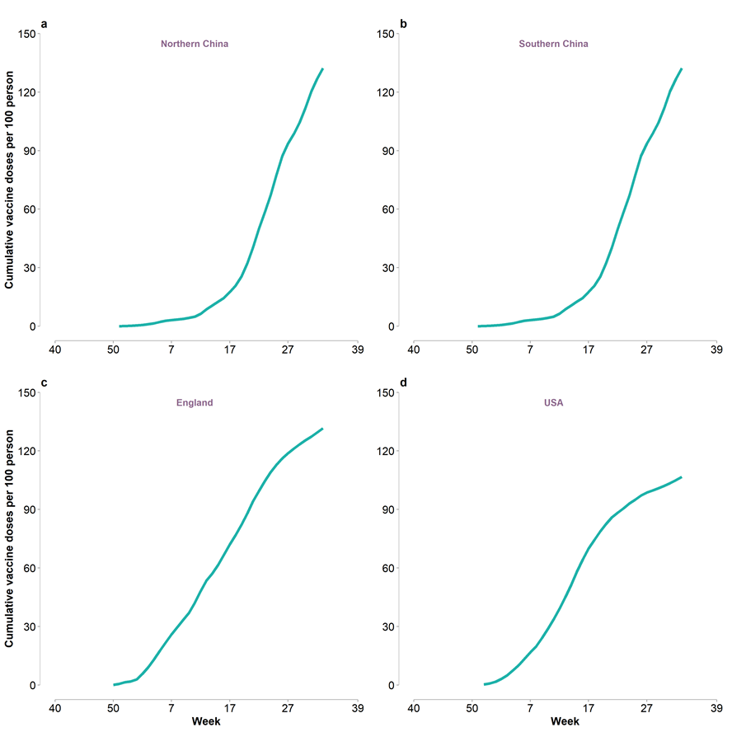
Fig. S3. Vaccination coverage during the COVID-19 pandemic in 2020–2021. (a) Cumulative vaccine doses per 100 persons in northern China. (b) As (a), but in southern China. (c) As (a), but in England. (d) As (a), but in the United States.

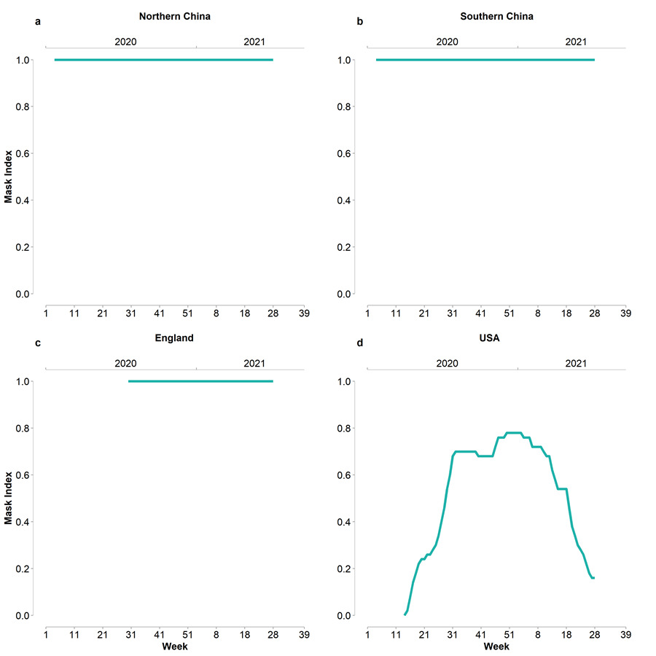
Fig. S4. Mask-wearing intervention during the COVID-19 pandemic. (a) Mask index in northern China. (b) As (a), but in southern China. (c) As (a), but in England. (d) As (a), but in the United States.
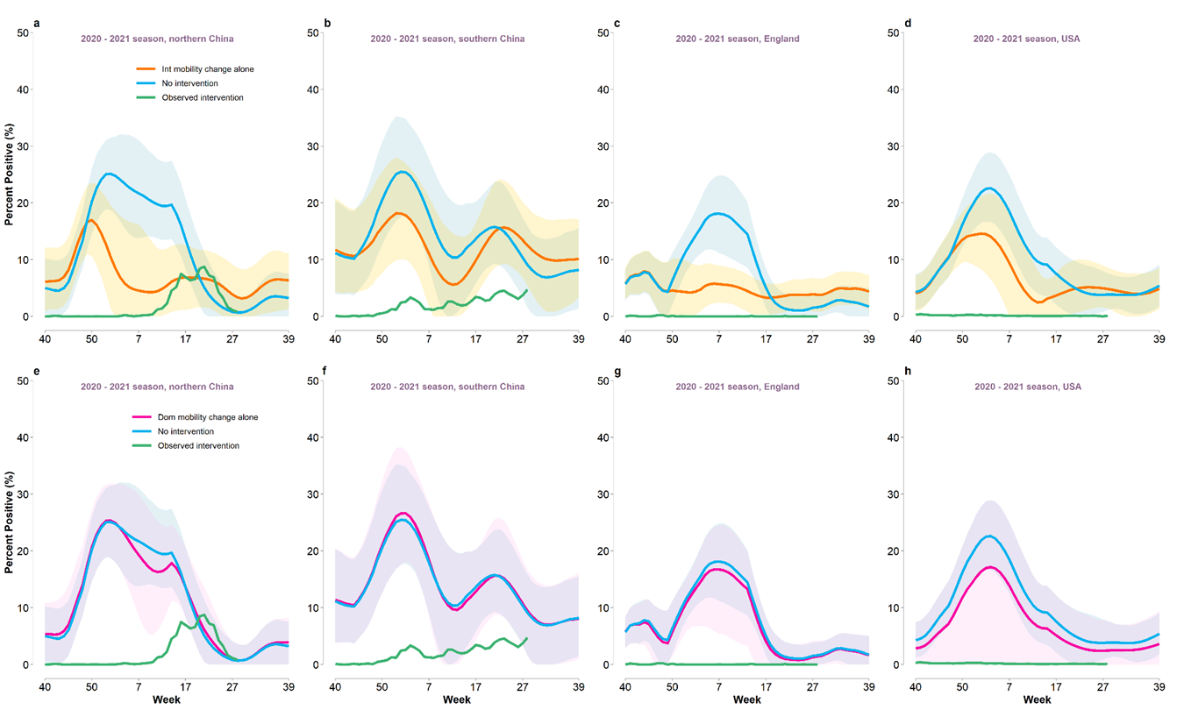
Fig. S5. Estimated influenza activities under the international (Int) mobility change alone, the domestic (Dom) mobility changes alone and no intervention as well as the observed activity. (a) Weekly percent positivity in 2019–2020 season for northern China. (b) As (a), but for southern China. (c) As (a), but for England. (d) As (a), but for the United States. (e) As (a), but in 2020–2021. (f) As (e), but for southern China. (g) As (e), but for England. (h) As (e), but for the United States. Shaded area refers to 95%CI.
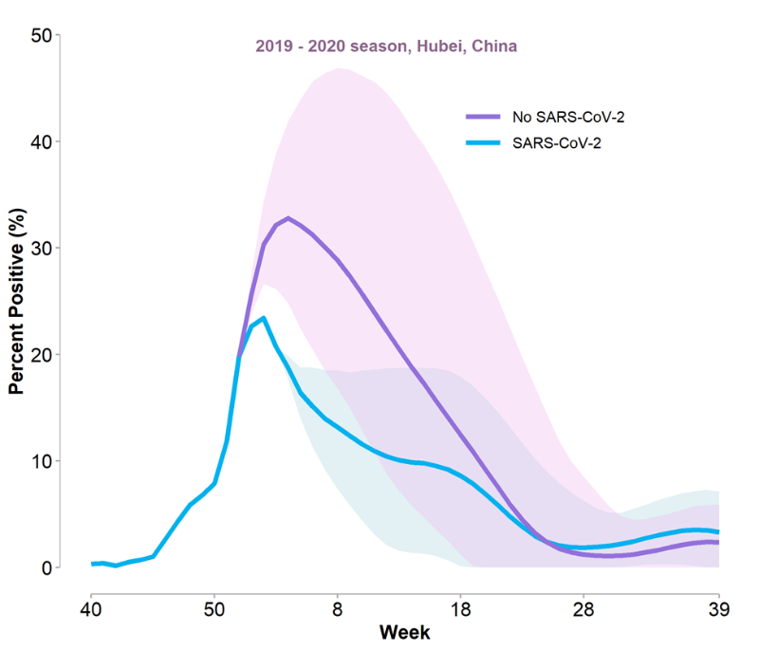
Fig. S6. Estimated influenza activities under the scenarios with no SARS-COV-2 transmission and with SARS-COV-2 transmission, both without COVID-19 NPIs in Hubei Province, China.

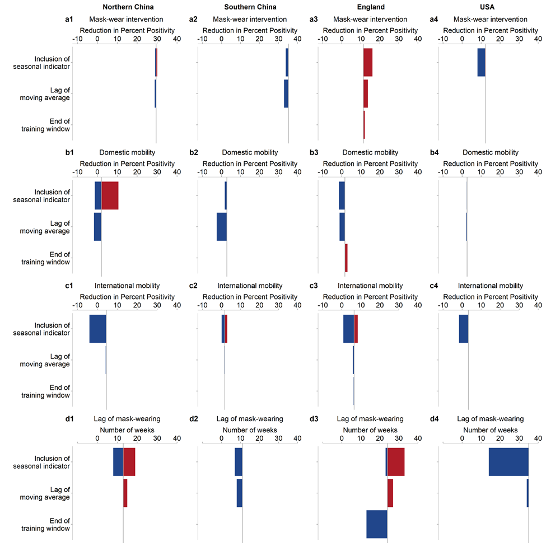
Fig. S7. Variations of estimated effects for one-week increase of NPIs and the accumulated time of mask-wearing interventions to achieve the maximal weekly reduction. (a1)–(a4) Changes of reduction in positive percentage for one-week increase of mask-wearing intervention under different manners in inclusion of the influenza seasonal indicator, different lags used for smoothing the mobility data and an increase of training window until the start of the mask-wearing intervention in northern China, southern China, England, and the United States. (b1)–(b4) As (a1)–(a4), but for domestic mobility mitigation. (c1)–(c4) As (a1)–(a4), but for international mobility mitigation. (d1)–(d4) As (a1)–(a4), but for the lags of mask-wearing intervention included.

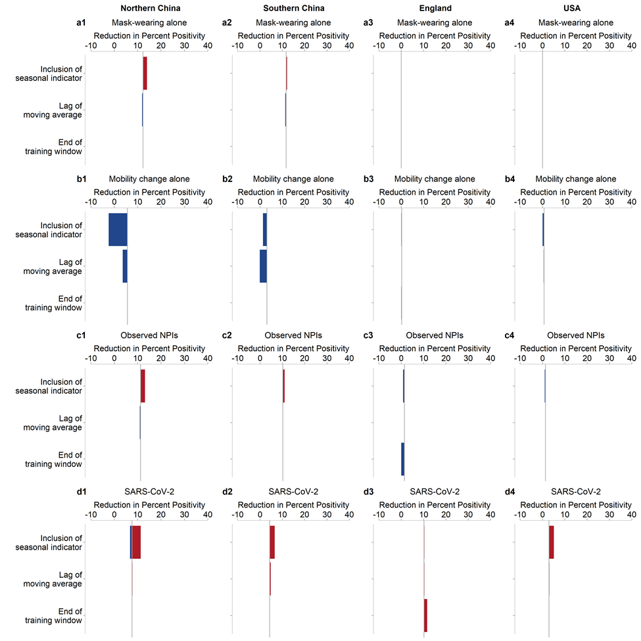
Fig. S8. Variations of estimated effects of mask-wearing and mobility mitigation and SARS-CoV-2 interference in the 2019-2020 influenza season. (a1)–(a4) Changes of reduction in percent positive for mask-wearing interventions under different manners in inclusion of the influenza seasonal indicator, different lags used for smoothing the mobility data and an increase of training window until the start of the mask-wearing intervention in Northern China, Southern China, England, and the United States. (b1)–(b4) As (a1)–(a4), but for domestic mobility mitigation. (c1)–(c4) As (a1)–(a4), but for international mobility mitigation. (d1)–(d4) As (a1)–(a4), but for the SARS-CoV-2 interference.

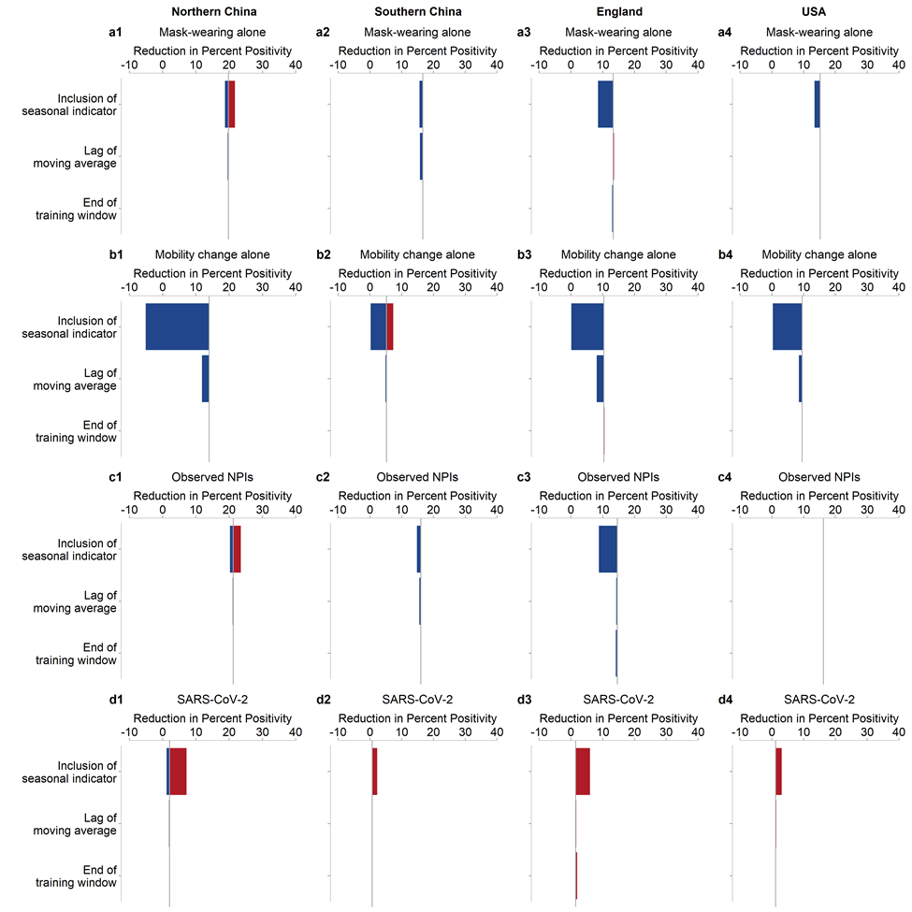
Fig. S9. Variations of estimated effects of mask-wearing and mobility mitigation and SARS-CoV-2 interference in the 2020–2021 influenza season. (a1)–(a4) Changes of reduction in percent positive for mask-wearing interventions under different manners in inclusion of the influenza seasonal indicator, different lags used for smoothing the mobility data and an increase of training window until the start of the mask-wearing intervention in northern China, southern China, England, and the United States. (b1)–(b4) As (a1)–(a4), but for domestic mobility mitigation. (c1)–(c4) As (a1)–(a4), but for international mobility mitigation. (d1)–(d4) As (a1)–(a4), but for the SARS-CoV-2 interference.
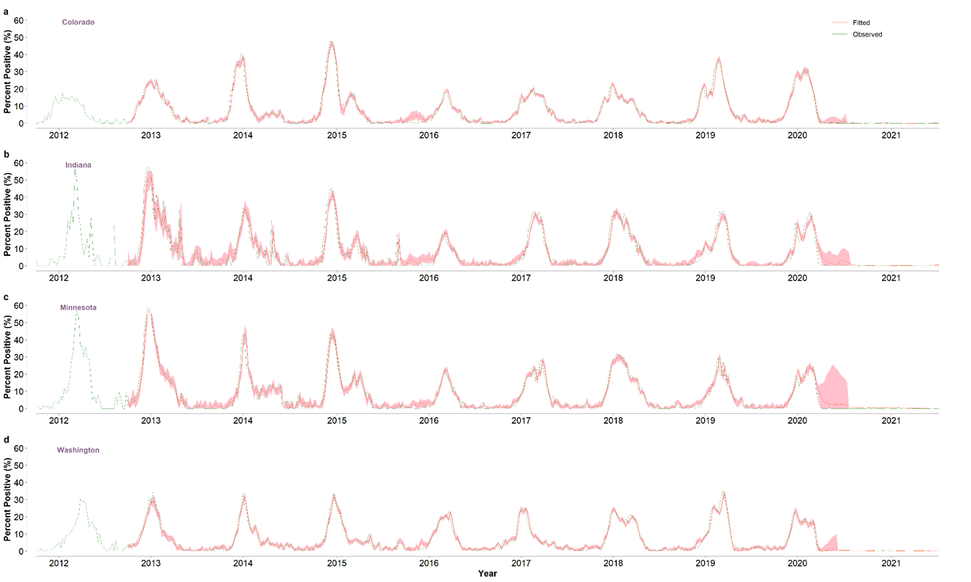
Fig. S10. Influenza activity across four US states. (a) Observed and fitted influenza activities in Colorado. (b) As (a), but in Indiana. (c) As (a), but in Minnesota. (d) As (a), but in Washington.

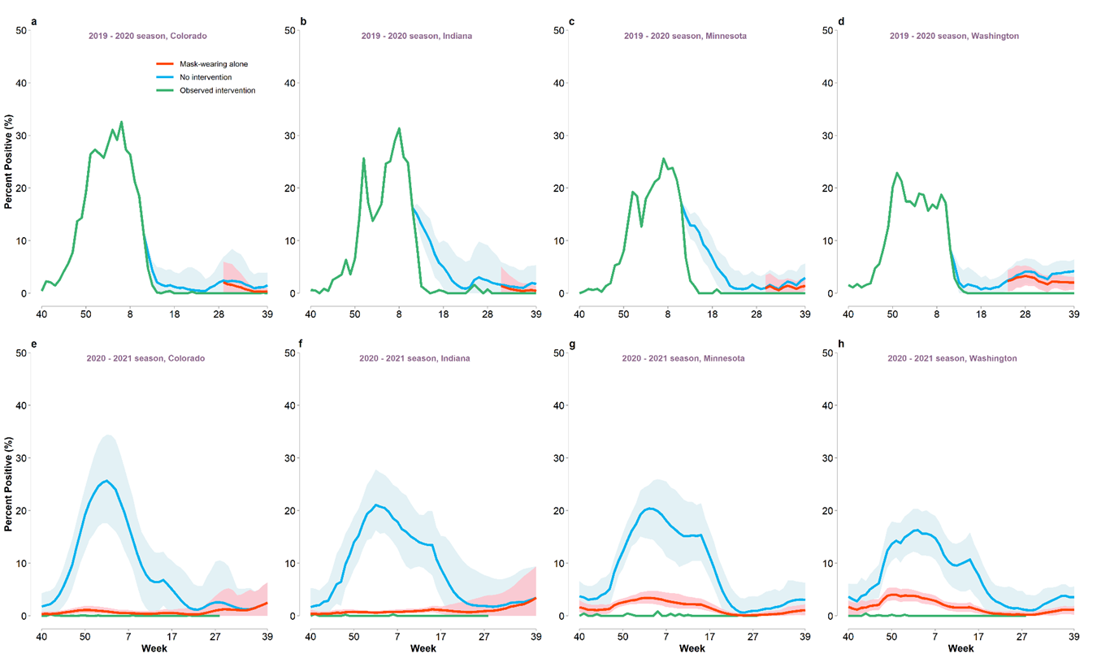
Fig. S11. Estimated influenza activities across four US states under the mask-wearing order alone and no intervention as well as the observed activity. (a) Weekly percent positivity in 2019–2020 season for Colorado. (b) As (a), but for Indiana. (c) As (a), but for Minnesota. (d) As (a), but for Washington. (e) As (a), but in 2020–2021. (f) As (e), but for Indiana. (g) As (e), but for Minnesota. (h) As (e), but for Washington. Shaded area refers to 95%CI.

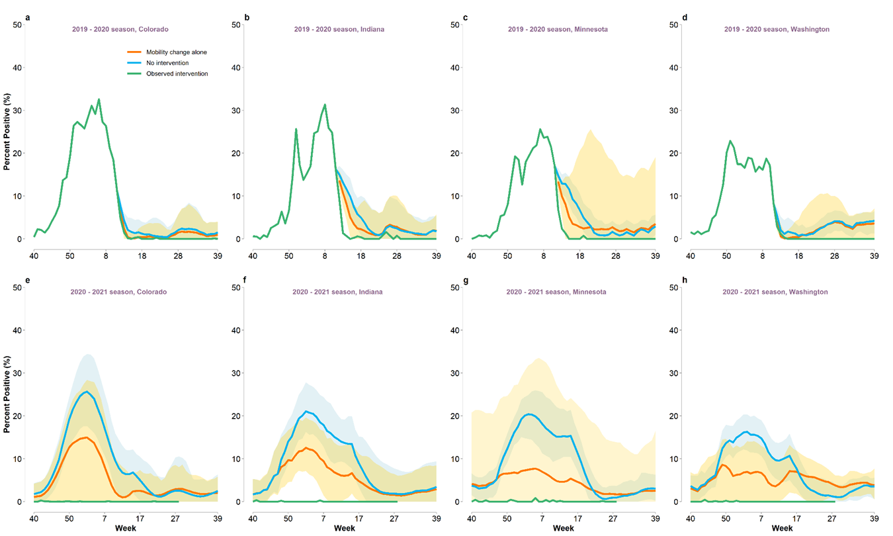
Fig. S12. Estimated influenza activities across four US states under the mobility change alone and no intervention as well as the observed activity. (a) Weekly percent positivity in 2019–2020 season for Colorado. (b) As (a), but for Indiana. (c) As (a), but for Minnesota. (d) As (a), but for Washington. (e) As (a), but in 2020–2021. (f) As (e), but for Indiana. (g) As (e), but for Minnesota. (h) As (e), but for Washington. Shaded area refers to 95%CI.
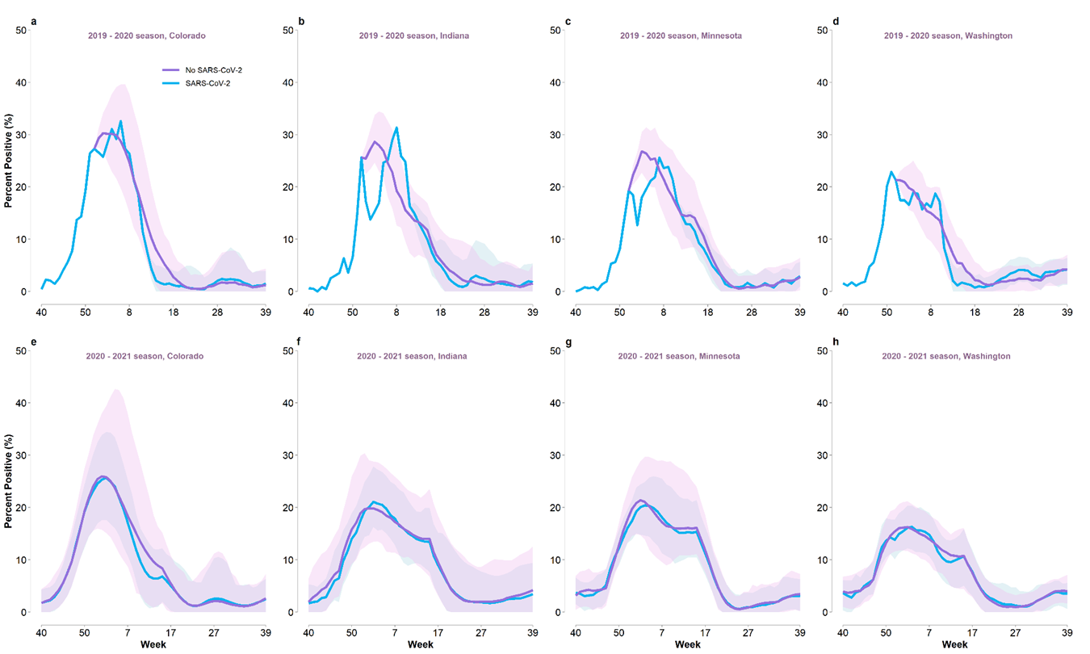
Fig. S13. Estimated influenza activities across four US states under the scenarios with no SARS-COV-2 transmission and with SARS-COV-2 transmission, both without COVID-19 NPIs. (a) Weekly percent positivity in 2019–2020 season for Colorado. (b) As (a), but for Indiana. (c) As (a), but for Minnesota. (d) As (a), but for Washington. (e) As (a), but in 2020–2021. (f) As (e), but for Indiana. (g) As (e), but for Minnesota. (h) As (e), but for Washington. Shaded area refers to 95%CI.
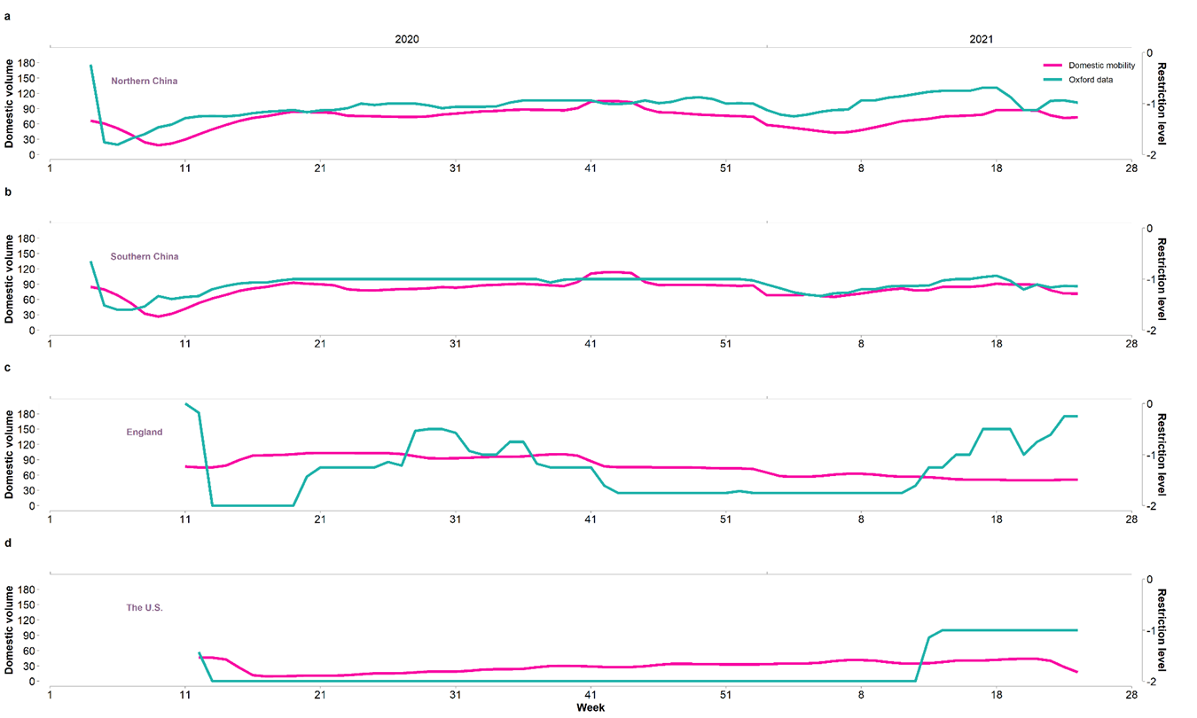
Fig. S14. Domestic mobility (normalized indexes) and restriction level in the COVID-19 period. Restriction levels are estimated using the data from the Oxford COVID-19 Government Response Tracker and were added a negative sign for illustration. Domestic mobility is more variable than the domestic restriction policy but the two are still moderately correlated (Table S2).
Fig. S15. Fitted influenza activity that is obtained from using the 2011–2016 data for training and the 2017 data for test, in comparison to observed influenza activity.
Fig. S16. Fitted influenza activity that is obtained from using the 2011–2017 data for training and the 2018 data for test, in comparison to observed influenza activity.
Fig. S17. Fitted influenza activity that is obtained from using the 2011–2018 data for training and the 2019 data for test, in comparison to observed influenza activity.

References
[1] Hale T, Angrist N, Goldszmidt R, Kira B, Petherick A, Philips T, et al. A global panel database of pandemic policies (Oxford COVID-19 Government Response Tracker). Nat Hum Behav 2021;5(4):529–38.
[2] National Center for Immunization and Respiratory Diseases Division of Viral Diseases. Interim public health recommendations for fully vaccinated people [Internet]. US CDC Centers for Disease Control and Prevention; [updated 2021 Nov 19; cited 2021 Aug 26]. Available from: https://www.cdc.gov/coronavirus/2019-ncov/vaccines/fully-vaccinated-guidance.html.
[3] Goldfarb JL, Kreps S, Brownstein JS, Kriner DL. Beyond the first dose—COVID-19 vaccine follow-through and continued protective measures. N Engl J Med 2021;385:101–3.
[4] National Health Commission of the People's Republic of China. COVID-19 vaccines vaccination status [Internet]. Beijing: National Health Commission of the People's Republic of China; 2021 May 9 [cited 2021 Aug 26]. Available from: http://www.gov.cn/xinwen/2021-05/09/content_5605500.htm.
[5] Vaccinations in the UK [Internet]. London: UK Health Security Agency; [updated 2021 Dec 22; cited 2021 Aug 26]. Available from: https://coronavirus.data.gov.uk/details/vaccinations?areaType=nation&areaName=England.
[6] CDC COVID Data Tracker. COVID-19 vaccinations in the United States [Internet]. US CDC Centers for Disease Control and Prevention; [cited 2021 Aug 26]. Available from: https://covid.cdc.gov/covid-data-tracker/#vaccinations_vacc-total-admin-rate-total.
[7] Yang S, Santillana M, Kou SC. Accurate estimation of influenza epidemics using Google search data via ARGO. Proc Natl Acad Sci USA 2015;112(47):14473–8.
[8] National Center for Immunization and Respiratory Diseases Centers for Disease Control and Prevention. Interim guidance for the use of masks to control seasonal influenza virus transmission [Internet]. US CDC Centers for Disease Control and Prevention; [updated 2019 Mar 5; cited 2021 Aug 26]. Available from: https://www.cdc.gov/flu/professionals/infectioncontrol/maskguidance.htm.
[9] Google. COVID-19 community mobility reports [Internet]. Google; [cited 2021 Aug 26]. Available from: https://www.google.com/covid19/mobility/.
[10] Chinese National Influenza Center. Chinese influenza weekly report [Internet]. Beijing: Chinese National Influenza Center; 2021 Jul 23 [cited 2021 Aug 26]. Available from: http://www.chinaivdc.cn/cnic/en/Surveillance/WeeklyReport/202107/t20210723_232159.htm.
[11] Public Health England. Surveillance of influenza and other respiratory viruses in the UK [Internet]. London: Public Health England; 2021 Jun [cited 2021 Aug 26]. Available from: https://www.gov.uk/government/statistics/annual-flu-reports.
[12] Gaode Map. Ranking of major cities in China on their willingness to migrate [Internet]. Gaode Map; [cited 2021 Aug 26]. Available from: https://trp.autonavi.com/migrate/page.do.
[13] Office for National Statistics. OS visits to the UK: thousands—NSA [Internet]. London: Office for National Statistics; [cited 2021 Aug 26]. Available from: https://www.gov.uk/government/organisations/office-for-national-statistics.
[14] US Department of Transportation Bureau of Transportation Statistics. Data bank 28IM-T-100 and T-100(f) international market data, U.S. and foreign air carriers traffic and capacity data [Internet]. Washington, DC: US Department of Transportation Bureau of Transportation Statistics; 2020 Mar 12 [updated 2021 Dec 21; cited 2021 Aug 26]. Available from: https://www.bts.gov/browse-statistical-products-and-data/bts-publications/data-bank-28im-t-100-and-t-100f-international.
[15] US Department of Transportation. Transportation services index [Internet]. Washington, DC: US Department of Transportation; [updated 2021 Dec 21; cited 2021 Aug 26]. Available from: https://www.transtats.bts.gov/OSEA/TSI/.
[16] UK Department for Transport. Road traffic statistics: statistics and data about the vehicle miles travelled by vehicle type, road category and region [Internet]. Londong: UK Department for Transport; [updated 2021 Dec 14; cited 2021 Aug 26]. Available from: https://www.gov.uk/government/collections/road-traffic-statistics.
[17] Shanghai Bureau of Statistics. International travel statistics [Internet]. Shanghai: Shanghai Bureau of Statistics; [updated 2021 Dec 21; cited 2021 Aug 26]. Available from: https://tjj.sh.gov.cn/ydsj56/.
[18] UK Public Health. The health protection (coronavirus, wearing of face coverings in a relevant place) (England) regulations 2020 (revoked) [Internet]. 2020 Jul 24 [cited 2021 Aug 26]. Available from: https://www.legislation.gov.uk/uksi/2020/791/2021-03-08.
[19] National Center for Immunization and Respiratory Diseases Centers for Disease Control and Prevention. Interim guidance for the use of masks to control seasonal influenza virus transmission [Internet]. US CDC Centers for Disease Control and Prevention; [updated 2019 Mar 5; cited 2021 Aug 26]. Available from: https://www.cdc.gov/flu/professionals/infectioncontrol/maskguidance.htm.
[20] Chen W, Wang Q, Li Y, Yu H, Xia Y, Zhang M, et al. Early containment strategies and core measures for prevention and control of novel coronavirus pneumonia in China. Chin J Prev Med 2020;54(3):239–44.
[21] US Department of Transportation. US international air passenger and freight statistics report [Internet]. Washington, DC: US Department of Transportation; 2021 Oct 8 [cited 2021 Aug 26]. Available from: https://www.transportation.gov/policy/aviation-policy/us-international-air-passenger-and-freight-statistics-report

