Supporting Information for

Landslide damming threats along the Jinsha River, China
Shihao Xiaoª, Limin Zhang^{a,b,*}, Te Xiaoª, Ruochen Jiangª, Dalei Peng^{a,c}, Wenjun Luª, Xin Heª
ª Department of Civil and Environmental Engineering, The Hong Kong University of Science and Technology, Kowloon, Hong Kong 999077, China.
^{b} The Hong Kong University of Science and Technology Shenzhen-Hong Kong Collaborative Innovation Research Institute, Futian, Shenzhen 518000, China.
^{c} State Key Laboratory of Geo-hazard Prevention and Geo-environment Protection, Chengdu University of Technology, Chengdu 610000, China.
* Corresponding author. E-mail: cezhangl@ust.hk (Limin Zhang)

Contents of this file
Fig. S1. Spatial distribution of damming landslides and non-damming landslides along large rivers, as well as cities and key infrastructure along the Jinsha River.
Fig. S2. Spatial distributions of the triggering factors in the study area. (a) Annual precipitation, P_{A} (mm); (b) Expected peak ground acceleration, PGA (g), with a 475-year return period; (c) Distance to fault, Dist_{F} (m); (d) Fault density, Dens_{F} (km km⁻²).
Fig. S3. Comparison of smoothed damming probabilities with different moving average windows: (a) 6 km; (b) 10 km; (c) 20 km; (d) 40 km.

Section S1. Method for mapping damming landslides and non-damming landslides.
Section S2. Method for deriving valley floor width.
Section S3. Method for automatic identification of the valley domain.
Section S4. Method for calculating damming probability with the total probability theorem.

Table S1. Summary of historical landslide dams along the Jinsha River. (Numbers are ordered from upstream to downstream)
Table S2. Summary of the spatial distribution of mapped landslides.
Table S3. Top five candidate models ranked by BIC values.

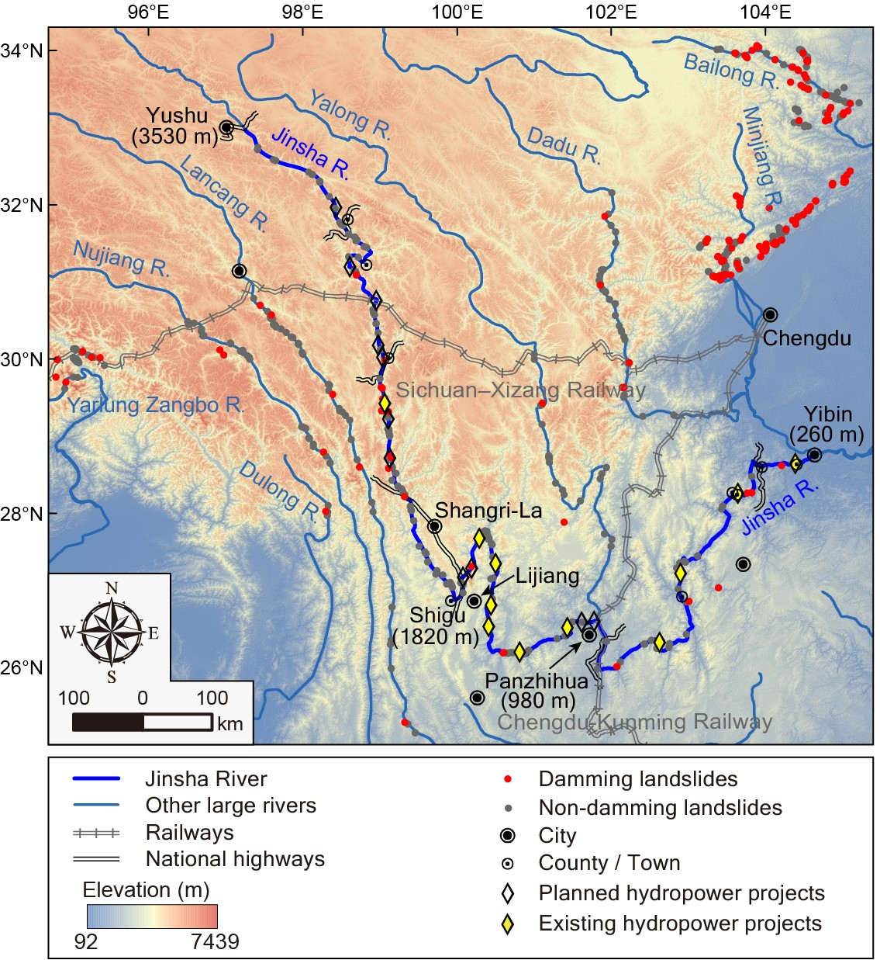
Fig. S1. Spatial distribution of damming landslides and non-damming landslides along large rivers, as well as cities and key infrastructure along the Jinsha River.

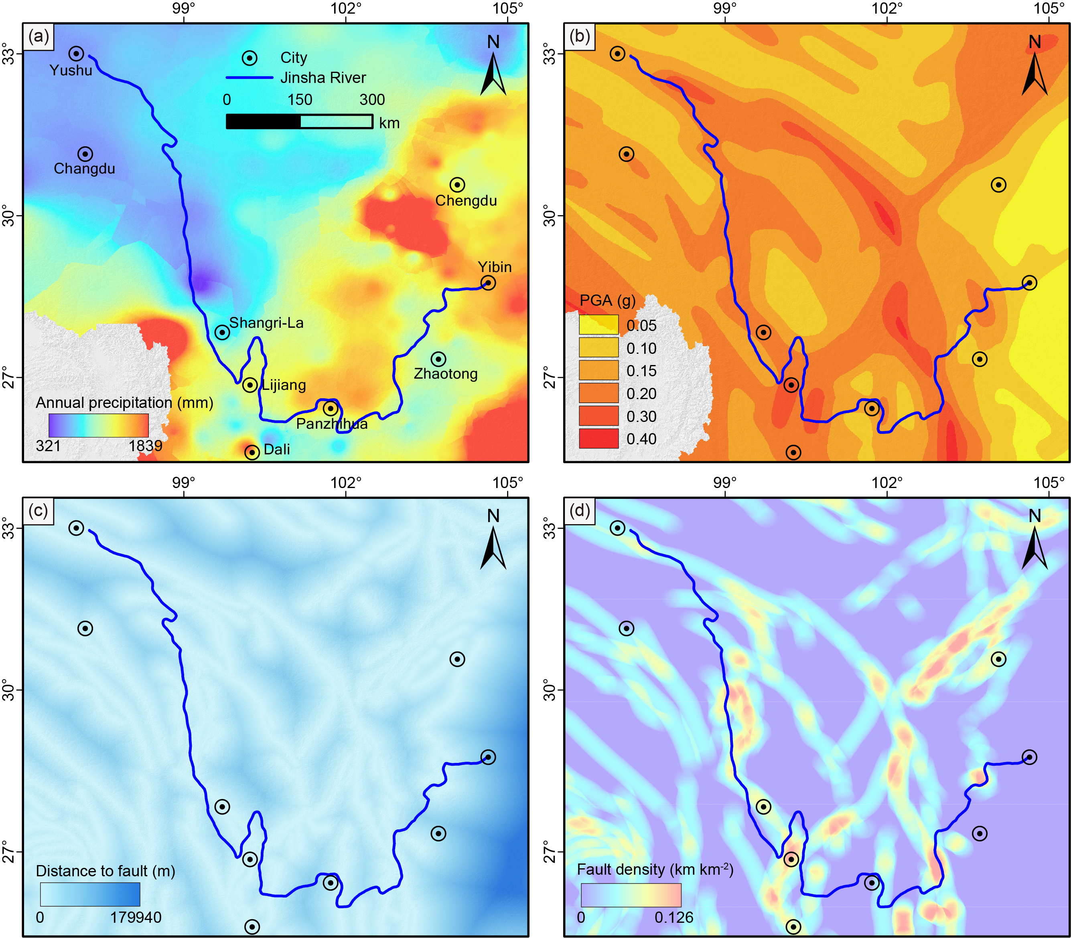
Fig. S2. Spatial distributions of the triggering factors in the study area. (a) Annual precipitation, P_{A} (mm); (b) Expected peak ground acceleration, PGA (g), with a 475-year return period; (c) Distance to fault, Dist_{F} (m); (d) Fault density, Dens_{F} (km km⁻²).
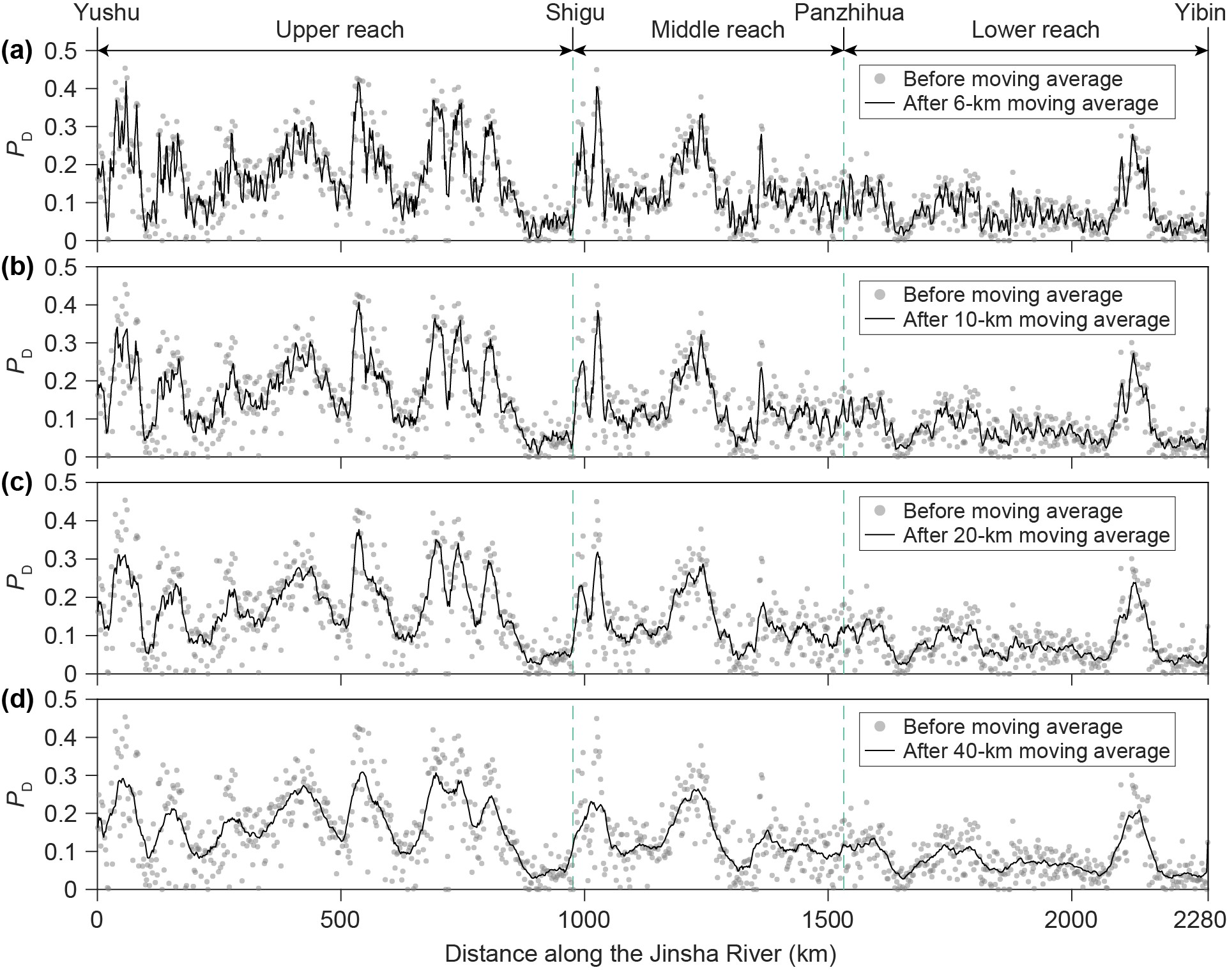
Fig. S3. Comparison of smoothed damming probabilities with different moving average windows: (a) 6 km; (b) 10 km; (c) 20 km; (d) 40 km.
Text S1. Method for mapping damming landslides and non-damming landslides.
The inventory includes both damming landslides and non-damming landslides. All landslides are mapped through visual interpretation of multitemporal high-resolution satellite images on the Google Earth platform, augmented by relevant literature surveys and field investigations. It is important to note that only the landslides whose boundaries can be reliably identified were included in this inventory. Along the Jinsha River, we collected 29 historical landslide dams with explicit damming locations (Table S1). Of these 29 landslides, six damming landslides have unclear boundaries. Hence, we mapped the boundaries of the remaining 23 damming landslides and included them in the inventory (Table S2).
To map damming landslides, the first step is to collect the locations (i.e., longitude and latitude) of the historical damming landslides documented in the literature. This ensures that all the mapped damming landslides are well documented. Then, the boundary of each damming landslide was determined, including the landslide source zone and deposition zone. The boundary of the deposition zone (i.e., relict landslide dam) could be identified through the following interpretation features [1,2]: (1) a hummocky and asymmetric relict landslide dam; (2) lacustrine sediments upstream of the damming site; (3) dam breaching-induced fluvial sediments downstream of the damming site; and (4) abrupt changes in river channel morphology. The boundary of the landslide source zone (i.e., landslide scarp) can be identified through the following geomorphological features [3,4]: (1) the main scarp is arc-shaped or armchair-like; (2) the sliding body has a gentler slope than the surrounding hillslopes; (3) the landslide can damage vegetation and induce discontinuous vegetation distribution; (4) multiple gullies are developed on the sliding body; (5) the toe of the landslide bulges and shows tongue-like geometry; and (6) the toe of the landslide may travel to the river channel, narrowing the river channel.
The non-damming landslides are mapped close to the damming landslides. The mapped damming landslides and non-damming landslides are located within the overlapping river reaches so that their features are comparable. This ensures that the developed damming criterion can be effectively constrained. The identification of landslide scarps for non-damming landslides follows the same geomorphological features as for damming landslides.

Text S2. Method for deriving valley floor width.
The valley floor width is defined as the width of flat, low-lying areas that represent the maximum extent of river movement and flood-carrying capacity [5-7]. It is important to distinguish the valley floor width from the river channel width. Unlike the river channel width, which can vary considerably between wet and dry seasons, the valley floor width depends solely on the valley topography, offering a more consistent measurement.
The valley floor is relatively flat compared with the two valley flanks. Therefore, we can find the breakpoints between the valley floor and the valley flanks according to a slope threshold θ. The valley floor width can be calculated as the horizontal distance between the two breakpoints defined by abrupt changes in slopes, as shown in Fig. S4(c). Different slope thresholds from 10° to 30° are compared to extract the valley floor width, and 20° is found to be the optimal slope threshold that produces the valley floor width best fit with the real valley floor width manually measured through satellite images in the study area. Thus, 20° is used as a slope threshold to extract the valley floor width in this study.

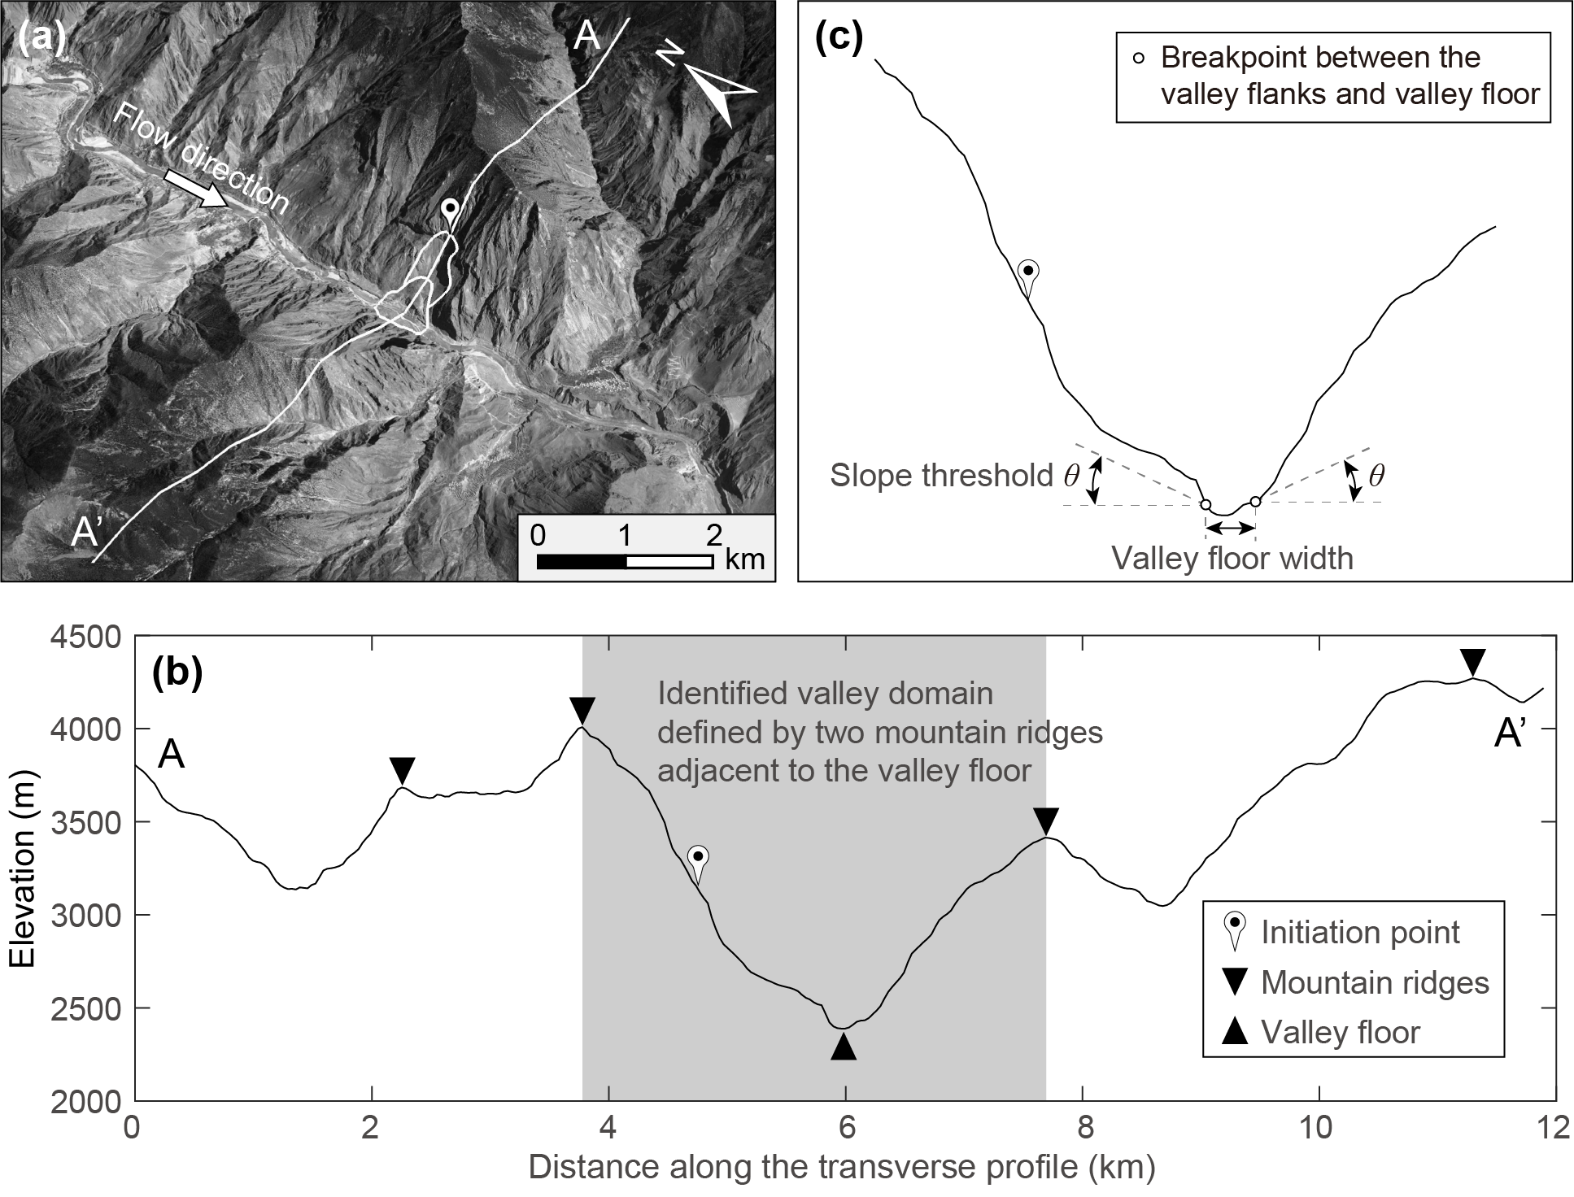
Fig. S4. Schematic diagram illustrating the valley domain and valley floor width. (a) Rongcharong landslide (99°3'55.92"E, 29°21'35.76"N); image credit: Google Earth; (b) Digitized A-A' profile showing the automatically identified valley domain; (c) Schematic diagram illustrating the valley floor width.

Text S3. Method for automatic identification of the valley domain.
The Rongcharong landslide is used as an example to demonstrate this method (Fig. S4). First, the valley profile is digitized (Figs. S4(a)-(b)). The local maxima here are endowed with the physical meaning of mountain ridges. Second, all local maxima are identified using three constraints to avoid the local maxima being too close to each other: (1) the horizontal distance between any two adjacent local maxima should be greater than 200 m; (2) the elevation amplitude of each local maximum should be larger than 50 m; and (3) the elevation drops on both sides of each local maximum should be larger than 50 m before it reaches a higher value. Third, the point with the minimum elevation represents the lowest point of the valley floor. Fourth, the two local maxima adjacent to the valley floor define the valley domain that can flow into the river channel of the corresponding river stretch. A landslide that occurs outside the valley domain cannot travel into the river channel.

Text S4. Method for calculating damming probability with the total probability theorem.
To calculate the landslide damming probability for a transverse profile using Eq. (6), the damming probabilities controlled by the left valley flank (i.e., Eq. (4)) and right valley flank (i.e., Eq. (5)) should first be determined. However, Eqs. (4) and (5) involve double integrations that cannot be solved directly. As an illustration, we present the procedure for discretizing the double integral for Eq. (4) and obtaining an approximate solution through the total probability theorem:
(1) A_{L} and L follow a bivariate lognormal distribution. Thus, ln A_{L} and ln L follow a bivariate normal distribution. This distribution is established based on the data in the inventory. The bivariate distribution is truncated at the maximum and minimum values of A_{L} and L in the inventory. Fig. S5(a) shows the parametric domain of the bivariate distribution, g (ln A_{L}, ln L).

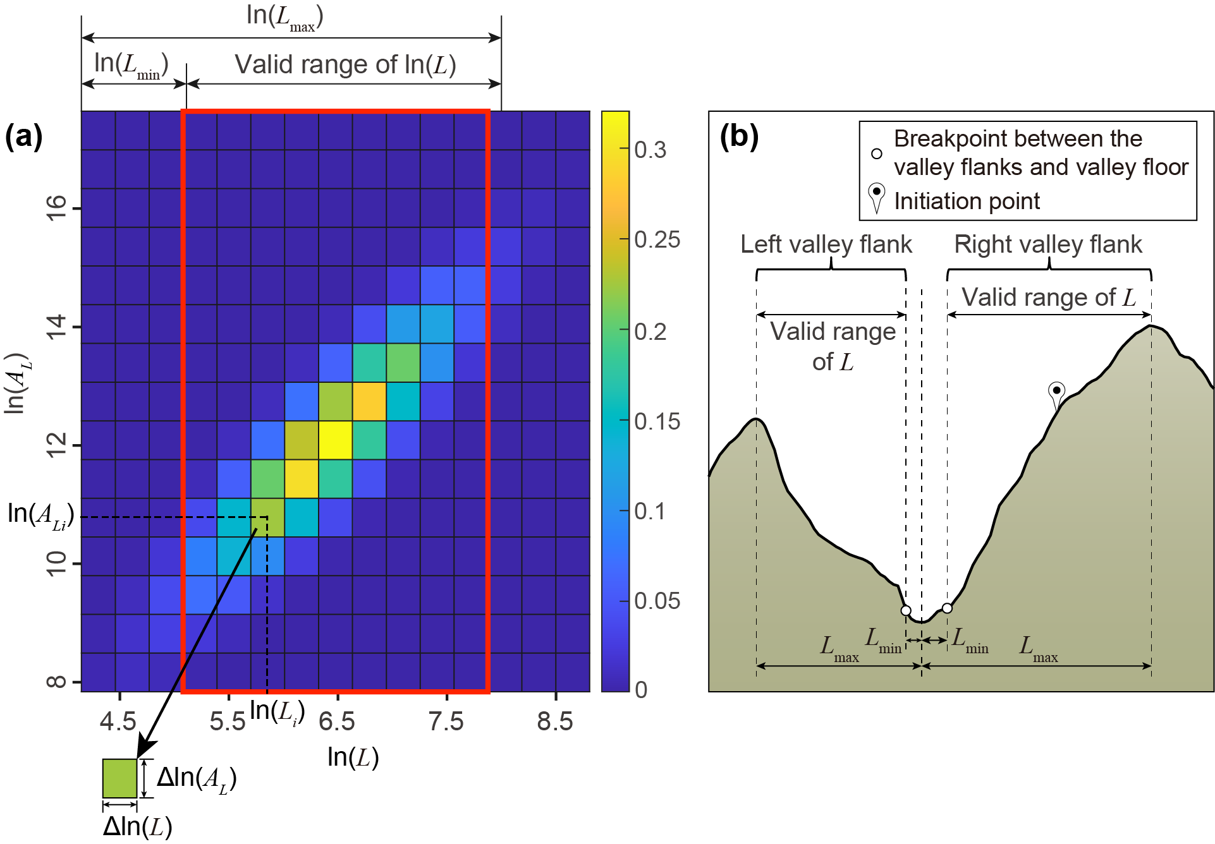
Fig. S5. Schematic diagram illustrating the procedure for discretizing the double integral. (a) Truncated and discretized bivariate normal distribution of ln(A_{L}) and ln(L); (b) Schematic diagram illustrating the valid range of L.

(2) The parametric domain is divided into small subregions, each characterized by an equal area of ΔA = Δln A_{L} * Δln L (see Fig. S5(a)). It should be noted that the large subregions employed in Fig. S5(a) are used for only demonstrative purposes. In practice, the parametric domain should be divided into sufficiently small and densely distributed subregions to enhance the approximation accuracy.
(3) For the i-th subregion, we compute the value of the function g (ln A_{L}, ln L) at its center point (ln A_{Li}, ln L_{i}), denoted as g (ln A_{Li}, ln L_{i}) (see Fig. S5(a)). Consequently, the product g (ln A_{Li}, ln L_{i}) * ΔA represents the probability of taking the pair of values (A_{Li}, L_{i}).
(4) Under the condition of taking (A_{Li}, L_{i}), the damming probability can be expressed as P(D_{left} = 1 | A_{Li}, L_{i}). Note that not all values of L are valid for a given transverse profile. The valid L value falls within a specific range, bounded by the minimum extent, L_{min} (i.e., the horizontal distance from the breakpoint to the centerline of the river channel), and the maximum extent, L_{max} (i.e., the horizontal distance from the mountain ridge to the centerline of the river channel) (see Fig. S5(b)). Consequently, the valid subregions are determined by the central points of the subregions falling within the valid range of L, representing all potential combinations of (A_{Li}, L_{i}) (as depicted by the red box in Fig. S5(a)).
(5) The original bivariate integral in Eq. (4) can be approximated as the summation of products over the valid subregions, utilizing the total probability theorem, as follows:
(S1)
where ∑ signifies the summation over all valid subregions, P(D_{left} = 1 | A_{Li}, L_{i}) represents the value of the function P(D_{left} = 1 | A_{L}, L) at the center point of the ith subregion, g (ln A_{Li}, ln L_{i}) denotes the value of the bivariate distribution at the center point of the ith subregion, and ΔA represents the area of each subregion.

Table S1
Summary of historical landslide dams along the Jinsha River. (Numbers are ordered from upstream to downstream)
No. | Event | Longitude | Latitude | Formation Time | Blockage duration | Landslide volume (10⁴ m³) | Landslide dam volume (10⁴ m³) | Dam height (m) | Barrier lake capacity (10⁴ m³) | Peak discharge (m³/s) | Trigger factor | Reference
1 | Baige #1 | 98°42'45.93" E | 31° 5'2.62" N | 2018.10.10; 22:06 | 2.7 days | 2500 |  | 61 | 29000 | 10000 | Strong fluvial incision; Rainwater infiltration and a long-term creep | [8,9]
2 | Baige #2 | 98°42'45.93" E | 31° 5'2.62" N | 2018.11.03; 17:15 | 10.6 days | 1100 |  | 96 | 75000 (reduced to 50000 with a 15-m deep diversion channel) | 33900 |  | [8]
3 | Temi | 99° 3'3.11" E | 29°58'30.48" N | 1.8 ka BP | 400 years | 3500 |  | 173 | 146000 | 55858 | Earthquakes (near Xiongsong-Suwalong fault) | [10]
4 | Guanre | 99° 0'43.67" E | 29°37'36.12" N |  |  |  |  |  |  |  | Earthquakes (near Xiongsong-Suwalong fault) | [2]
5 | Laoyi | 99° 1'36.17" E | 29°35'56.13" N |  |  |  |  |  |  |  | Earthquakes (near Xiongsong-Suwalong fault) | [2]
6 | Xuelongnang | 99° 3'16.78" E | 29°29'10.38" N | 1117 (time for dam breaching |  | 4100 |  | 84 | 31000 | 10786 | Earthquakes (near Xiongsong-Suwalong fault) | [11-13]
7 | Suoduoxi | 99° 3'42.09" E | 29°27'6.76" N | 6.3 ka BP |  |  | 6200 | 59 | 19000 | 14003 | Earthquakes (near Xiongsong-Suwalong fault) | [12,13]
8 | Suwalong 1# | 99°04'5.17" E | 29°25'34.97" N | 1997.12.01 | 4 mins |  | 25 |  |  |  | Earthquake | [14,15]
9 | Suwalong 2# | 99° 4'2.38" E | 29°25'28.27" N | 1.355 ka BP |  | 216 |  | 35 |  |  | A paleoearthquake or combination of paleoearthquake and rainfall events | [16,17]
10 | Rongcharong | 99° 3'56.01" E | 29°21'36.00" N |  |  |  | 2200 | 107 | 81800 | 41195 | Earthquakes (near Xiongsong-Suwalong fault) | [12,13]
11 | Wangdalong | 99° 4'12.24" E | 29°19'41.90" N |  |  | 6000 |  | 137 | 121900 | 51685 | Earthquakes (near Xiongsong-Suwalong fault) | [12,13,18]
12 | Samaoding | 99° 8'3.44" E | 28°43'51.30" N | 10.6 ± 0.5 ka BP |  | 3300 |  | 200 |  |  |  | [19,20]
13 | Duirongtong | 99° 7'53.83" E | 28°42'37.62" N |  |  | 28000 |  | 149 |  |  |  | [17,21]
14 | Qulong | 99°10'20.34" E | 28°36'50.77" N | 0.15 Ma BP |  |  | 21433 |  |  |  |  | [20,22]
15 | Benzilan | 99°19'18.55" E | 28°13'5.81" N | 122.0 ± 12.4 ka BP |  |  |  | 120 |  |  |  | [17,23]
16 | Shigu | 100° 2'32.32" E | 26°55'28.76" N | 33.5 ± 1.4 ka BP |  |  |  | 105 |  |  | Earthquake with the synergistic action of climate | [24]
17 | Huashiban | 100°11′45.21″E | 27°17′52.25″N | 1996.10.28 | 2 hours | 135 | - | 100 |  |  | Earthquake (Mw 7.0) on 3 February 1996; Severe rainfall between May and October in 1996 | [25,26]
18 | Zhaizicun 1# | 100°35'43.27" E | 26°11'7.64" N | 60.3 ± 9.0 ka BP |  | 12000 | 180 |  |  |  | Earthquakes (near Chenghai fault) | [27,28]
19 | Zhaizicun 2# | 100°36'1.32" E | 26°11'28.35" N | 260.7 ± 39 ka BP |  | 13000 | 150 |  |  |  | Earthquakes (near Chenghai fault) | [27,28]
20 | Baimakou | 102° 5'19.61" E | 25°59'48.42" N | 12.1 ka BP |  |  | 34000 | 120 | 750000 | 82000 |  | [29]
21 | Luchedu | 102°18'38.54" E | 26°13'48.56" N | 1935.12 | 3 days | 13000 | 16000 | 50 |  |  | Rainstorm | [18,30,31]
22 | Wudongde | 102°38'10.58" E | 26°18'34.31" N | 19 ka BP |  |  | 6400 |  |  |  |  | [32]
23 | Lannigou | 102°38'58.30" E | 26°10'41.70" N | 1965.11.22; 1965.11.24 | Blocked the Pufu River, a tributary of the Jinsha River, for 8 months | More than 17000 | 45000 | 167 | 500 |  | Rainstorm | [33,34]
24 | Laojuntan | 102°45'34.20" E | 26°16'43.96" N | 1932 | 12 hours |  |  |  |  |  |  | [14]
25 | Jintang | 102°59'14.88" E | 26°46'41.14" N | 20 ka BP |  | 600000 |  | More than 200 | More than 2000000 |  |  | [35,36]
26 | Shigaodi | 102°58'3.59" E | 26°50'15.24" N | 1880.04.13 | 3 days | 53600 |  | 200 |  |  | Earthquakes (near Xiaojiang fault); Strong fluvial incision | [14,37]
27 | Shunhe | 103°46'36.24" E | 28°14'39.98" N |  |  | 7820 |  |  |  |  |  | [15]
28 | Wujiawan | 103°48'49.24" E | 28°16'16.05" N | 1887.03.17 | 7 days | 3375 |  |  |  |  | Rainfall | [14,15]
29 | Dongyemiao | 104°12'35.41" E | 28°38'22.23" N |  |  | 7100 |  |  |  |  | Strong fluvial incision | [38]

Table S2
Summary of the spatial distribution of mapped landslides.
Regions | Number of damming landslides | Number of non-damming landslides | Reference
The mainstream of Jinsha River | 23 | 137 | [2,12,16,20,26]
Impact zone of 2008 Wenchuan earthquake | 69 | 104 | [39-41]
Yarlung Zangbo River | 6 | 24 | [42]
Lancang River and Nujiang River | 8 | 67 | [17]
Yalong River | 2 | 21 | [15]
Dadu River | 5 | 25 | [15]
Bailong River Basin | 35 | 52 | [43]
Distributed scarcely in the study area | 9 | 3 | [15]
Total | 157 | 433 | [14,15,37]

Table S3
Top five candidate models ranked by BIC values.
 |  | Landslide factors |  |  |  | Valley topographic factors |  |  |  | Trigger factors |  |  |  | Hydrologic factor | Geology
 | Intercept | ln(A_{L}) | ln(H) | ln(L) | S | ln(W) | H_{V} | R | C | P_{A} | PGA | ln(Dist_{F}) | Dens_{F} | ln(A_{W}) | Lithology | nVar | BIC
M1 (optimal model) | -16.219 | 5.653 | / | -5.863 | / | -1.223 | / | / | / | / | / | / | 38.196 | -1.185 | / | 5 | -3459
M2 | -13.997 | 5.649 | / | -5.741 | / | -1.280 | / | / | / | / | / | -0.316 | 33.381 | -1.168 | / | 6 | -3458
M3 | -18.498 | 5.806 | 1.440 | -7.194 | / | -1.062 | / | / | / | / | / | / | 37.189 | -1.242 | / | 6 | -3457
M4 | -20.079 | 5.770 | / | -5.737 | 1.929 | -1.106 | / | / | / | / | / | / | 37.723 | -1.225 | / | 6 | -3456
M5 | -16.281 | 5.810 | 1.484 | -7.117 | / | -1.115 | / | / | / | / | / | -0.325 | 31.820 | -1.225 | / | 7 | -3456
nVar: number of selected variables; “/” denotes the variable is not selected in the model; The definitions of the features are summarized in Table 2.

References
[1] Zhang Y, Chen J, Zhou F, Bao Y, Yan J, Zhang Y, et al. Combined numerical investigation of the Gangda paleolandslide runout and associated dam breach flood propagation in the upper Jinsha River, SE Tibetan Plateau. Landslides 2022;19(4):941-962.
[2] Chen J, Dai F, Lv T, Cui Z. Holocene landslide-dammed lake deposits in the Upper Jinsha River, SE Tibetan Plateau and their ages. Quatern Int 2013;298:107-113.
[3] Sun X, Chen J, Han X, Bao Y, Zhan J, Peng W. Application of a GIS-based slope unit method for landslide susceptibility mapping along the rapidly uplifting section of the upper Jinsha River, South-Western China. Bull Eng Geol Environ 2020;79(1):533-549.
[4] Guzzetti F, Mondini AC, Cardinali M, Fiorucci F, Santangelo M, Chang K-T. Landslide inventory maps: New tools for an old problem. Earth Sci Rev 2012;112(1-2):42-66.
[5] Gallant JC, Dowling TI. A multiresolution index of valley bottom flatness for mapping depositional areas. Water Resour Res 2003;39(12).
[6] Fryirs KA, Wheaton JM, Brierley GJ. An approach for measuring confinement and assessing the influence of valley setting on river forms and processes. Earth Surf Process Landf 2016;41(5):701-710.
[7] Zhao Y, Wu P, Li J, Lin Q, Lu Y. A new algorithm for the automatic extraction of valley floor width. Geomorphology 2019;335:37-47.
[8] Zhang LM, Xiao T, He J, Chen C. Erosion-based analysis of breaching of Baige landslide dams on the Jinsha River, China, in 2018. Landslides 2019;16(10):1965-1979.
[9] Cai Y, Luan Y, Yang Q, Xu F, Zhang S, Shi Y, et al. Study on structural morphology and dam-break characteristics of Baige barrier dam on Jinsha River. Yangtze River 2019;50(3):15-22. Chinese.
[10] Chen J, Cui Z, Chen R, Zheng X. The origin and evolution of the Temi paleolandslide-dammed lake in the upper Jinsha River. Earth Sci Front 2021;28(2):85.
[11] Chen J, Cui Z. Discovery of outburst deposits induced by the Xuelongnang Paleolandslide-dammed lake in the upper Jinsha River, China and its environmental and hazard significance. Acta Sedimentol Sin 2015;33(2):275-284. Chinese.
[12] Li Y, Chen J, Zhou F, Song S, Zhang Y, Gu F, et al. Identification of ancient river-blocking events and analysis of the mechanisms for the formation of landslide dams in the Suwalong section of the upper Jinsha River, SE Tibetan Plateau. Geomorphology 2020;368:107351.
[13] Li Y. Identification and evolution of the paleo-landslide dam events in the Suwalong reach of the upper Jinsha River. PhD dissertation, Jilin University; 2021. Chinese.
[14] Cai Y, Luan Y, Peng W, Li J, Xu Y. Analysis on typical cases of barrier lake: causes, disaster and emergency response. Wuhan:Changjiang Press; 2021. Chinese.
[15] Liu W, Carling PA, Hu K, Wang H, Zhou Z, Zhou L, et al. Outburst floods in China: A review. Earth Sci Rev 2019;197:102895.
[16] Wang P, Chen J, Dai F, Long W, Xu C, Sun J, et al. Chronology of relict lake deposits around the Suwalong paleolandslide in the upper Jinsha River, SE Tibetan Plateau: Implications to Holocene tectonic perturbations. Geomorphology 2014;217:193-203.
[17] Gao Y, Zhao S, Deng J. Developing law of damming landslide and challenges for disaster prevention and mitigation in the Three-river-parallel Territory in the Tibetan Plateau. Adv Eng Sci 2020;52(5):50-61. Chinese.
[18] Wen B, Zeng Q, Yan T. Preliminary analysis on initial failure modes of large rock avalanches' source slopes in the southeastern Qinghai-Tiber Plateau. Adv Eng Sci 2020;52(5):38-49. Chinese.
[19] Bao Y, Zhai S, Chen J, Xu P, Sun X, Zhan J, et al. The evolution of the Samaoding paleolandslide river blocking event at the upstream reaches of the Jinsha River, Tibetan Plateau. Geomorphology 2020;351:106970.
[20] Chen J, Li H. Genetic mechanism and disasters features of complicated structural rock mass along the rapidly uplift section at the upstream of Jinsha River. J Jilin Univ (Earth Sci Ed) 2016;46(4):1153-1167. Chinese.
[21] Chang H, Chang Z, Liu C. The relationship between activity of Jinsha River fault zone and large-scale landslides: a case study of the section between Narong and Rongxue along the Jinsha River. Seismol Geol 2021;43(6):1435. Chinese.
[22] Sun X. Study on Landslide Susceptibility and Risk Mapping Along the Rapidly Uplifting Section of the Upper Jinsha River: A Case of Xulong to Benzilan Reach. PhD dissertation, Jilin University; 2020. Chinese.
[23] Zhang Y, Zhao X, Lan H, Xiong T. A Pleistocene landslide-dammed lake, Jinsha River, Yunnan, China. Quatern Int 2011;233(1):72-80.
[24] Li Y, Chen J, Yan J, Zhou F, Wang Q, Li Z, et al. Formation and evolution of a giant old deposit in the First Bend of the Yangtze River on the southeastern margin of the Qinghai-Tibet Plateau. Catena 2022;213:106138.
[25] Liu HQ, Hu R, Tan R, Chen J. Huashiban loose deposit landslide, Tiger-Leaping-Gorge, China: analysis and prediction. Bull Eng Geol Environ 2007;66(2):197-202.
[26] Zhou JW, Xu WY, Yang XG, Shi C, Yang ZH. The 28 October 1996 landslide and analysis of the stability of the current Huashiban slope at the Liangjiaren Hydropower Station, Southwest China. Eng Geol 2010;114(1-2):45-56.
[27] Xu Z, Liu W, Huang R. Geomorphological effects of landslide damming. Quat Sci 2013;33(3):490-500. Chinese.
[28] Li Q. The Zhaizicun Landslide in Jinsha River and its deposits of landslide-dammed lake. Master’s thesis, Kunming University of Science and Technology; 2009. Chinese.
[29] Liu W, Hu K, Carling PA, Lai Z, Cheng T, Xu Y. The establishment and influence of Baimakou paleo-dam in an upstream reach of the Yangtze River, southeastern margin of the Tibetan Plateau. Geomorphology 2018;321:167-173.
[30] Feng Z, Wu ZH, Cao JW, Hu MM, Ha GH, Kang HX. Engineering geological characteristics of gigantic pre-historic landslide along Qiaojia section of the Xiaojiang Fault. Acta Geosci Sin 2019;(4):629-636. Chinese.
[31] Liu X, Qiao J, Li N. Landfall-landslide disaster in Yunnan Province and the preventive measures against them. Bull Soil Water Conserv 1987;7(6):38-44. Chinese.
[32] Cui J, Wang L, Xu J, Wang X, Yao Q. Stability analysis of old landslide for a possible ancient landslide event blocking middle of Jinsha river. J Eng Geol 2008;16(1):6-10. Chinese.
[33] Cheng X, Zhu C, Qi W, Xu J, Yuaqn J. Formation conditions, development tendency and preventive measures of Pufu landslide in Luquan of Yunnan. Miner Resour Geol 2015;29:395-401. Chinese.
[34] Wen B, Wang F. Precursors and motion characteristics of the 1965 Lannigou rockslides and the subsequent evolution. Hydrogeol Eng Geol 2021;48(6):72-80. Chinese.
[35] Wang Y. Landslide-dammed lake deposits and landslide hazards in Qiaojia-Dongchuan section of Jinsha River. Master’s thesis, Institute of Geology, China Earthquake Administrator; 2019. Chinese.
[36] Zhang X, Higgitt D, Liu W, Tang Q. Terraces of ancient giant Jintang landslide-dammed lake in Jinsha River. J Mt Sci 2013;31(1):127. Chinese.
[37] Chai H, Liu H, Zhang Z. The catalog of Chinese landslide dam events. J Geol Hazards Environ Preserv 1995;6(4):1-9. Chinese.
[38] Li H, Yang J, Xiong J, Zeng X, Zhong H. Genetic analysis and stability assessment of a landslide in a reservoir area of Jinshajiang River. Chin J Geol Hazards Control 2007;18(2):13-16. Chinese.
[39] Fan R. Long-Term Evolution of Post-earthquake Landslides and Debris Flows in The Epicentral Area of the 2008 Wenchuan Earthquake. PhD dissertation, Hong Kong University of Science and Technology; 2021.
[40] Cui P, Zhu Y, Han Y, Chen X, Zhuang J. The 12 May Wenchuan earthquake-induced landslide lakes: distribution and preliminary risk evaluation. Landslides 2009;6(3):209-223.
[41] Fan R, Zhang LM, Wang H, Fan X. Evolution of debris flow activities in Gaojiagou Ravine during 2008–2016 after the Wenchuan earthquake. Eng Geol 2018;235:1-10.
[42] Wang H, Cui P, Zhou L, Liu W, Yang A, Yao S, et al. Spatial and temporal distribution of landslide-dammed lakes in Purlung Tsangpo. Eng Geol 2022;308:106802.
[43] Jin J, Chen G, Meng X, Zhang Y, Shi W, Li Y, et al. Prediction of river damming susceptibility by landslides based on a logistic regression model and InSAR techniques: A case study of the Bailong River Basin, China. Eng Geol 2022;299:106562.

