Supplementary data for

The Increasing Role of Synergistic Effects in Carbon Mitigation and Air Quality Improvement, and Its Associated Health Benefits in China
Jie Wang ª, Xi Lu ^{a,b,c,d,}*, Pengfei Du ª, Haotian Zheng ^{a,d}, Zhaoxin Dong ^{a,d}, Zihua Yin ª, Jia Xing ^{a,d}, Shuxiao Wang ^{a,d}, Jiming Hao ^{a,c,d,}*
ª State Key Joint Laboratory of Environment Simulation and Pollution Control, School of the Environment, Tsinghua University, Beijing 100084, China
^{b} Institute for Carbon Neutrality, Tsinghua University, Beijing 100084, China
^{c} Beijing Laboratory of Environmental Frontier Technologies, Tsinghua University, Beijing 100084, China
^{d} State Environmental Protection Key Laboratory of the Sources and Control of Air Pollution Complex, Beijing 100084, China

*Corresponding authors.
E-mail addresses: xilu@tsinghua.edu.cn (X. Lu), hjm-den@tsinghua.edu.cn (J. Hao)

Supporting Data Content
13 Pages
9 Figures
3 Tables
2 Boxs
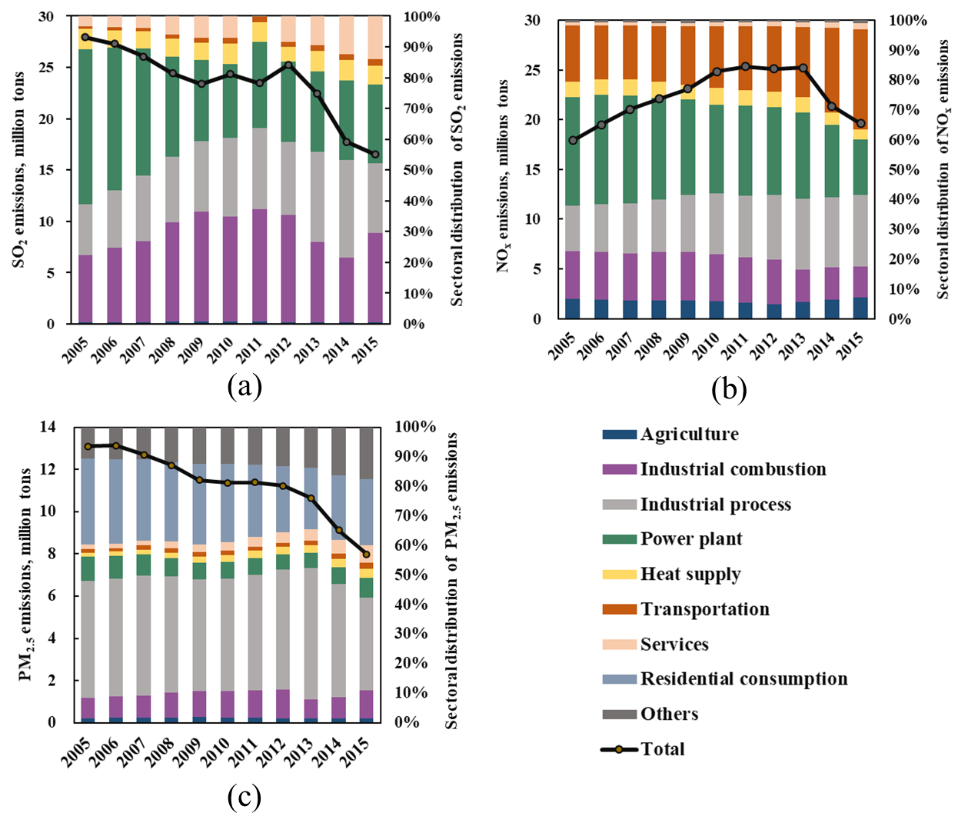
Fig. S1. Emission structure of three criteria air pollutants in China during 2005-2015. a. SO₂. b. NO_{x}. c. primary PM_{2.5}.
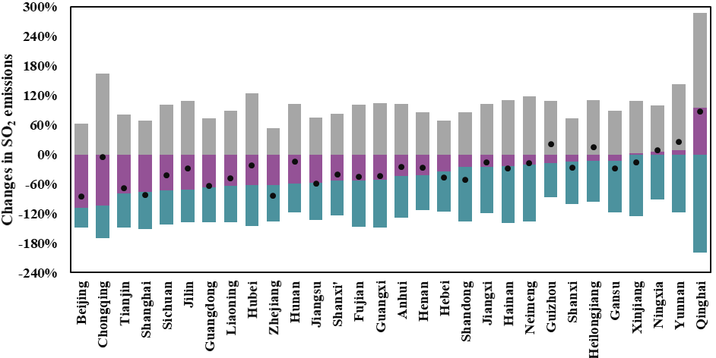
(a)
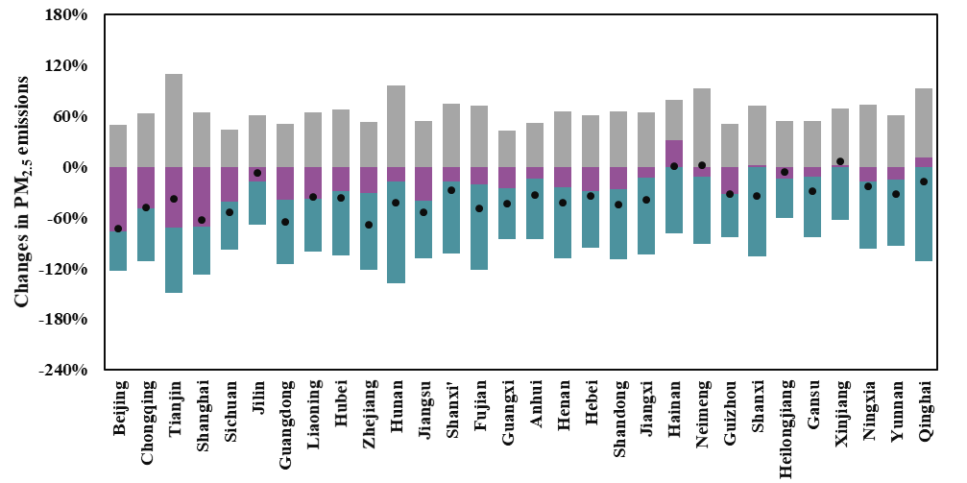
(b)
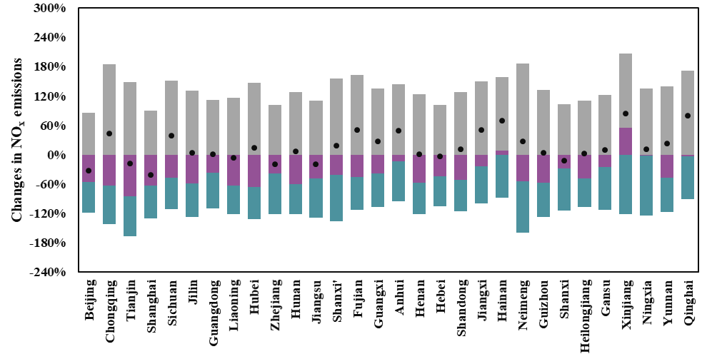
(c)
Fig. S2. Changes in regional air pollutants emissions contributed by socioeconomic development, synergistic effects and end-of-pipe control, respectively, in 2005 realtive to 2005 for 30 provinces in China(excluding Tibet, Hongkong, Macao and Taiwan). a: SO₂; b: primary PM_{2.5}; c: NO_{x}.
Fig.S3. Spatial distribution of annual mean PM_{2.5} concentrations under three scenarios in China. (a) Non-control scenario; (b) Control scenario; (c) Baseline scenario; (d) Concentration reductions between non-control scenario and baseline scenario.
Fig. S4. (a) Reductions of China’s PM_{2.5} concentrations due to synergistic effects. (b) Ratio of synergistic effects to end-of-pipe impacts on PM_{2.5} concentration. (c) Reductions of China’s population-weighted PM2.5 concentrations contributed by synergistic effects. (d) Prevented PM_{2.5}-attributable excess mortality per square kilometer due to synergistic effects.
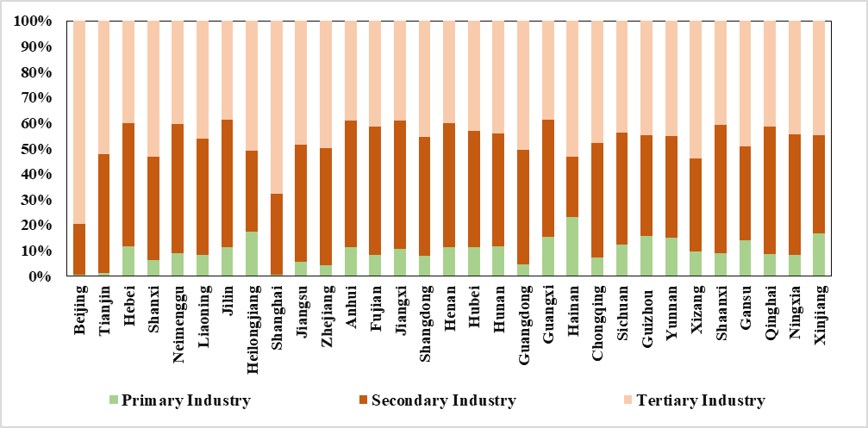
(a)
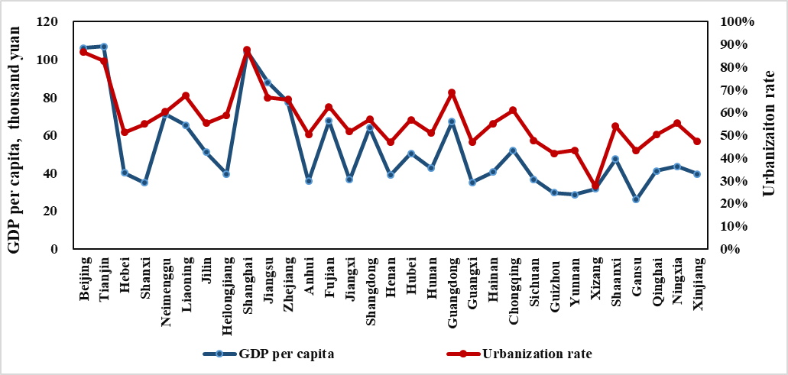
(b)
Fig. S5. Factors of socioeconomic development at the provincial level. a Proportion of the three industries in terms of GDP in the economic structure in 2015. b GDP per capita and urbanization rate in 2015.

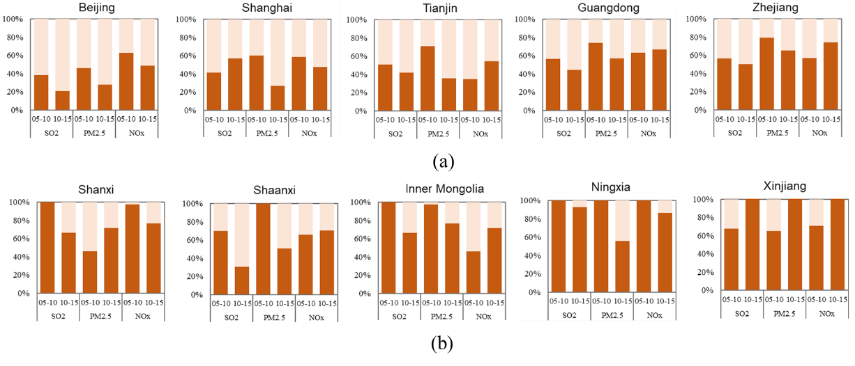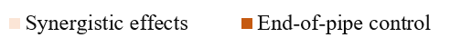
Fig. S6. The relative reduction of synergistic effects and end-of-pipe control among two types of provinces. (a) developed regions with relatively high ratio of service sectors including Beijing, Shanghai, Tianjin, Guangdong and Zhejiang. (b) Resource-intensive developing regions including Shanxi, Shaanxi, Inner Mongolia, Ningxia and Xinjiang, which are the major provinces rich in coal resources in China.
Fig. S7. Spatial distribution of China’s population-weighted annual mean PM_{2.5} concentrations under three scenarios. (a) Non-control scenario; (b) Control scenario; (c) Baseline scenario; (d) Concentration reductions between non-control scenario and baseline scenario.
Table S1.The reduction contribution of synergistic effects and end-of-pipe control on PM_{2.5} concentrations relatively to non-control scenario, and the ratio of reductons from synergistic effects to those from end-of-pipe control.
 | Synergistic effects |  | End-of-pipe control |  | The ratio of synergistic effects to end-of-pipe control’s impact
Anhui |  | 13.1% |  | 38.1% | 0.34
Beijing |  | 51.6% |  | 35.5% | 1.45
Fujian |  | 15.2% |  | 43.4% | 0.35
Gansu |  | 13.2% |  | 39.1% | 0.34
Guangdong |  | 25.1% |  | 43.6% | 0.58
Guangxi |  | 17.8% |  | 42.1% | 0.42
Guizot |  | 18.0% |  | 34.9% | 0.52
Hainan |  | 10.7% |  | 42.2% | 0.25
Hebei |  | 13.3% |  | 37.4% | 0.36
Henan |  | 14.6% |  | 38.7% | 0.38
Heilongjiang |  | 8.7% |  | 29.1% | 0.30
Hubei |  | 16.7% |  | 38.7% | 0.43
Hunan |  | 14.6% |  | 43.7% | 0.33
Jilin |  | 13.3% |  | 31.2% | 0.43
Jiangsu |  | 23.6% |  | 39.4% | 0.60
Jiangxi |  | 11.4% |  | 42.6% | 0.27
Liaoning |  | 19.0% |  | 34.7% | 0.55
Inner Mongolia |  | 9.5% |  | 37.5% | 0.25
Ningxia |  | 11.4% |  | 39.7% | 0.29
Qinghai |  | 3.0% |  | 44.2% | 0.07
Shandong |  | 14.6% |  | 39.7% | 0.37
Shanxi |  | 8.2% |  | 44.4% | 0.18
Shaanxi |  | 15.1% |  | 40.4% | 0.37
Shanghai |  | 35.6% |  | 40.7% | 0.87
Sichuan |  | 25.2% |  | 34.5% | 0.73
Tianjin |  | 26.2% |  | 34.4% | 0.76
Xizang |  | 2.3% |  | 5.2% | 0.44
Xinjiang |  | -2.2% |  | 34.5% | -0.06
Yunnan |  | 13.1% |  | 34.3% | 0.38
Zhejiang |  | 29.5% |  | 47.5% | 0.62
Chongqing |  | 23.2% |  | 34.7% | 0.67

Box: Monte Carlo Simulation
We have run the Monte Carlo simulation for 100000 times to estimate the uncertainties of results of PM_{2.5}, SO₂, NO₂ reductions. The uncertainties of results of PM_{2.5}, SO₂, NO₂ reductions mainly cone from the multiple categories of data: the emission inventories of air pollutants, emission removal efficiency, the energy consumption data and economic data. The uncertainty ranges of each data categories are discussion below:
The PM_{2.5}, SO₂, and NO₂ emission inventories are assumed to follow the triangular distribution, based on the Zhao et al.’s study [1]. The upper and lower limit of the emissions from each industrial sources, transportation and residential consumption are shown in the table S2. We further assume the uncertainty range of emission from agriculture and services are the same as the total industrial sector.

Table S2. The upper and lower limit of the triangular distribution for air pollutants emission (presented as the percentage around the central estimate).
 | NO_{x} | SO₂ | Primary PM_{2.5}
Power plant | [-21%, 28%] | [-33%, 71%] | [-37%, 60%]
Cement | [-62%, 74%] | [-53%, 55%] | [-68%, 197%]
Steel | [-57%, 23%] | [-56%, 90%] | [-49%, 63%]
Other industrial process | [-37%, 43%] | [-28%, 36%] | [-29%, 55%]
Other industrial combustion | [-47%, 151%] | [-40%, 59%] | [-59%, 256%]
Total industrial sector | [-21%, 35%] | [-17%, 37%] | [-21%, 54%]
Transportation | [-29%, 70%] | [-21%, 43%] | [-36%, 63%]
Residential consumption | [-34%, 96%] | [-53%, 43%] | [-50%, 91%]

Emission removal efficiency is also assumed to obey triangular distributions, with the variation range set as [22%, 84%] and [55%, 95%] for SO₂ and NO_{x} control devices, respectively [1, 2]. Referencing Zhao et al.’s study [3], we assume the removal efficiency of PM_{2.5} emission control device follows the log-normal distribution, with a 95% confidence interval (CI) varying from 90.9% to 97.9%.
Based on the evaluation on the uncertainties of energy consumption data reported by Zhao et al. and IPCC [2, 4], the 95% CI of [-9.8%, 9.8%] is set for the energy consumption in the power plant, and [-19.6%, 19.6%] for the energy consumption in the industries and transportation. Due to the poor statistics on fuel combustion by household stoves in rural areas, larger uncertainty exists in the residential fossil fuel consumption. Its 95% CI of [-39.2%, 39.2%] is suggested by IPCC [4]. The energy consumption data are assumed to follow normal distributions. The assumptions about the uncertainties of energy consumption data above have also been adopted in the Lin et al.’s research [5].
As to the economic data, we assume them obeying normal distribution with a 95% CI of [-5%, 5%], following the practice of Lin et al. [5].
The Monte Carlo simulation results of emission reduction attributed to the synergistic effects are shown in Fig. S8. The 95% CI of SO₂ emissions reduction contributed by synergistic effect in the 2005-2010 and 2010-2015 are [-18.47%, -2.08%] (-10.50%) and [-29.48 %, -14.09%] (-21.95%), respectively. Those are [-9.73 %, 4.62%] (-2.42%) and [-32.36 %, -6.52%] (-19.47%) for the primary PM_{2.5} emission reduction, and [-14.46%, -0.94%] (-7.72%) and [-21.39%, -6.65%] (-14.32%) for the NO_{x} emission reduction. In the whole period from 2005-2010 to 2010-2015, the uncertainty of primary PM_{2.5} reductions is much larger than that of NO_{x} and SO₂, due to the larger uncertainty of primary PM_{2.5} emission inventory.
Fig. S8. The Monte Carlo simulation results for the emission reduction contributed by synergistic effects with 100,000 trials. The blue bars represent the results within the 95% CI, and red bars represent those beyond the 95% CI. (a1) and (a2): SO₂; (b1) and (b2): primary PM_{2.5}; (c1) and (c2): NO_{x}.

We also conducted the similar Monte Carlo simulation to estimate the uncertainties of avoided deaths, with a particular focus on the parameter of θ derived from the GEMM and the concentration of PM_{2.5} from the simulation of RSM model. The uncertainty ranges of each data categories are discussion below:
We assume the parameter θ in the GEMM obeying normal distribution, following Burnett et al.’s study [6]. The 95% CI of θ is set at [-18.3%, 18.3%]. The simulation difference between RSM and its origin CMAQ simulation is within 3% [7, 8]. Here, we assume the PM_{2.5} concentration following uniform distribution. The lower and upper limit of uniform distribution is [-3%, 3%].
The Monte Carlo results of avoid deaths attributed to the synergistic effects are illustrated in Fig. S9. The 95% CI of avoid deaths contributed by synergistic effect are [0.28 million, 0.30 million] (0.29 million). The results of avoid deaths at the provincial level are shown in the table S3.
Fig. S9. The Monte Carlo simulation results for the avoid PM_{2.5}-related deaths attributed to the synergistic effects. The blue bars represent the results within the 95% CI, and red bars represent those beyond the 95% CI.

Table S3. The 95% confidence intervals (CI) of the avoided PM_{2.5}-attributable excess deaths due to synergistic effects and end-of-pipe control and its proportion of total population for 30 provinces in China.
 | Synergistic effects |  |  | End-of-pipe control
PM_{2.5}-attributable excess deaths | Mean | 95% CI | Proportion | Mean | 95% CI | Proportion
Anhui | 9.0 | 8.6-9.4 | 0.14‰ | 26.5 | 25.1-27.4 | 0.42‰
Beijing | 16.5 | 15.7-17.1 | 0.76‰ | 11.4 | 10.8-11.8 | 0.52‰
Fujian | 5.6 | 5.2-5.9 | 0.14‰ | 16.0 | 14.9-16.9 | 0.41‰
Gansu | 3.5 | 3.2-3.7 | 0.13‰ | 10.2 | 9.6-10.9 | 0.39‰
Guangdong | 37.3 | 35.1-39.0 | 0.33‰ | 64.4 | 60.8-67.6 | 0.58‰
Guangxi | 11.4 | 10.8-12.0 | 0.23‰ | 27.2 | 25.6-28.5 | 0.56‰
Guizot | 7.8 | 7.3-8.2 | 0.22‰ | 15.0 | 14.1-15.8 | 0.42‰
Hainan | 0.7 | 0.7-0.8 | 0.08‰ | 2.9 | 2.7-3.0 | 0.31‰
Hebei | 11.3 | 10.6-11.7 | 0.15‰ | 31.4 | 29.9-32.9 | 0.42‰
Henan | 16.2 | 15.3-16.7 | 0.17‰ | 42.7 | 40.7-44.5 | 0.45‰
Heilongjiang | 3.8 | 3.5-3.9 | 0.10‰ | 12.5 | 11.8-13.2 | 0.33‰
Hubei | 11.7 | 11.1-12.2 | 0.20‰ | 27.2 | 25.8-28.3 | 0.46‰
Hunan | 13.2 | 12.6-14.0 | 0.19‰ | 40.1 | 37.8-41.8 | 0.59‰
Jilin | 4.5 | 4.3-4.7 | 0.17‰ | 10.6 | 10.0-11.1 | 0.39‰
Jiangsu | 19.1 | 18.2-19.7 | 0.24‰ | 31.8 | 30.4-32.9 | 0.40‰
Jiangxi | 7.0 | 6.5-7.3 | 0.15‰ | 25.9 | 24.4-27.2 | 0.56‰
Liaoning | 9.9 | 9.3-10.3 | 0.23‰ | 18.0 | 17.0-18.8 | 0.41‰
Inner Mongolia | 2.0 | 1.9-2.2 | 0.08‰ | 8.1 | 7.5-8.5 | 0.32‰
Ningxia | 0.6 | 0.6-0.7 | 0.10‰ | 2.2 | 2.1-2.4 | 0.33‰
Qinghai | 0.1 | 0.1-0.1 | 0.02‰ | 1.7 | 1.5-1.8 | 0.28‰
Shandong | 15.7 | 14.8-16.2 | 0.16‰ | 42.4 | 40.3-44.0 | 0.42‰
Shanxi | 3.7 | 3.6-4.0 | 0.10‰ | 20.7 | 19.4-21.7 | 0.56‰
Shaanxi | 7.7 | 7.3-8.1 | 0.20‰ | 20.7 | 19.4-21.7 | 0.54‰
Shanghai | 7.7 | 7.4-8.0 | 0.32‰ | 8.8 | 8.4-9.1 | 0.36‰
Sichuan | 26.8 | 25.3-28.0 | 0.32‰ | 36.7 | 34.6-38.3 | 0.44‰
Tianjin | 3.7 | 3.5-3.8 | 0.24‰ | 4.9 | 4.6-5.0 | 0.31‰
Xizang | 0.1 | 0.1-0.1 | 0.02‰ | 0.2 | 0.1-0.2 | 0.05‰
Xinjiang | -0.3 | -0.3--0.3 | -0.01‰ | 4.6 | 4.3-4.9 | 0.19‰
Yunnan | 5.5 | 5.1-5.8 | 0.11‰ | 14.4 | 13.4-15.3 | 0.30‰
Zhejiang | 20.0 | 18.9-20.8 | 0.35‰ | 32.2 | 30.4-33.6 | 0.57‰
Chongqing | 9.4 | 8.8-9.8 | 0.30‰ | 14.0 | 13.2-14.6 | 0.45‰
Note: Unit for the PM_{2.5}-attributable excess deaths is thousand individuals.

Box: Supplementary Methods
Simulation of PM_{2.5} concentrations in Response Surface Modeling (RSM) developed from Community Multiscale Air Quality (CMAQ) model
Community Multiscale Air Quality (CMAQ) model is developed by the United States Environmental Protection Agency and is widely used in air quality evaluation. For the chemical processes in CMAQ, we adopted the latest chemical mechanism CB6 including the aerosol reaction mechanism AERO6 with the CMAQ 5.2.1 version. The input anthropogenic emission data used in this research are from the three scenarios describled in the maintext. MEGANv2.10 is used to provide biogenic emission for the simulation domain. Other settings of CMAQ model is followed by our previous study [9-11].
Statistical response surface model (RSM) is successfully applied for a CMAQ analysis of ozone and particle mass sensitivity studies, using advanced statistical techniques to characterize the relationship between model output and input parameters in a fast-resposne manner. It is essentially a reduced-form prediction model using statistical correlation structures to approximate model functions through the design of complex multi-dimension experiments. The simulation difference between RSM and its origin CMAQ simulation is within 3%. It has been continuously developed under the framework of the Air Benefit and Cost and Attainment Assessment System (ABaCAS, http://www.abacas-dss.com) led by an international team of scientists from the United States and China, and has recently been successfully tested and evaluated for a series of PM_{2.5} and ozone assessment and policy analyses [12, 13]. The basic principle of RSM is referred to the Xing et al. [7, 8]. The spatial resolution of RSM and CMAQ are both 27 km×27 km from the same root of 27 km anthropogenic emission from the ABaCAS.

The specific values for parameters in the Global Exposure Mortality Model (GEMM)
According to the Burnett et al.’s study [6], the specific values for θ, α, μ and v in the exposure–response functions were decided based on the results of 41 cohort studies of outdoor PM_{2.5} and mortality. As show in the following Table S4, θ is estimated by age for adults with every 5-year interval from 25 to larger than 85, and other parameters are not affected by age.

Table S4: The value of parameters in the GEMM
Age Range | θ | α | Μ | Ν
>25 | 0.143 | 1.6 | 15.5 | 36.8
27.5 | 0.1585 | 1.6 | 15.5 | 36.8
32.5 | 0.1577 | 1.6 | 15.5 | 36.8
37.5 | 0.157 | 1.6 | 15.5 | 36.8
42.5 | 0.1558 | 1.6 | 15.5 | 36.8
47.5 | 0.1532 | 1.6 | 15.5 | 36.8
52.5 | 0.1499 | 1.6 | 15.5 | 36.8
57.5 | 0.1462 | 1.6 | 15.5 | 36.8
62.5 | 0.1421 | 1.6 | 15.5 | 36.8
67.5 | 0.1374 | 1.6 | 15.5 | 36.8
72.5 | 0.1319 | 1.6 | 15.5 | 36.8
77.5 | 0.1253 | 1.6 | 15.5 | 36.8
85 | 0.1141 | 1.6 | 15.5 | 36.8

References Cited in Box: Supplementary Methods
[1] Zhao Y, Zhou Y, Qiu L, Zhang J. Quantifying the uncertainties of China's emission inventory for industrial sources: From national to provincial and city scales. Atmospheric Environment 2017; 165:207-221.
[2] Zhao Y, Nielsen C P, Lei Y, McElroy M B, Hao J M. Quantifying the uncertainties of a bottom-up emission inventory of anthropogenic atmospheric pollutants in China. Atmos. Chem. Phys. 2011; 11:2295–2308.
[3] Zhao Y, Wang S X, Nielsen C P, Li X H, Hao J M. Establishment of a database of emission factors for atmospheric pollutants from Chinese coal-fired power plants. Atmospheric Environment 2010; 44:1515-1523.
[4] Intergovernmental Panel on Climate Change (IPCC): 2006 IPCC Guidelines for National Greenhouse Gas Inventories. IPCC National Greenhouse Gas Inventories Programme, 2006.
[5] Lin J, Pan D, Davis S J, Zhang Q, He K B, Wang C, et al. China’s international trade and air pollution in the United States. Proc Natl Acad Sci USA. 2014; 111(5): 1736-1741.
[6] Burnett R, Chen H, Szyszkowicz M, Fann N, Hubbell B, Pope C A, et al. Global estimates of mortality associated with long-term exposure to outdoor fine particulate matter. Proc Natl Acad Sci USA. 2018; 115(38):9592-9597.
[7] Xing J, Wang S X, Jang C, Zhu Y, Hao J M. Nonlinear response of ozone to precursor emission changes in China: a modeling study using response surface methodology. Atmos. Chem. Phys 2011; 11:5027–5044.
[8] Xing J, Wang S X, Zhao B, Wu W, Ding D, Jang C, et al. Quantifying Nonlinear Multiregional Contributions to Ozone and Fine Particles Using an Updated Response Surface Modeling Technique. Environ. Sci. Technol. 2017; 51(20):11788–11798.
[9] Ding D, Xing J, Wang S X, Chang X, Hao J M. Impacts of emissions and meteorological changes on China’s ozone pollution in the warm seasons of 2013 and 2017. Frontiers of Environmental Science & Engineering 2019; 13(5).
[10] Ding D, Xing J, Wang S X, Liu K, Hao J M. Estimated Contributions of Emissions Controls, Meteorological Factors, Population Growth, and Changes in Baseline Mortality to Reductions in Ambient PM_{2.5} and PM_{2.5}-Related Mortality in China, 2013-2017. Environ Health Perspect 2019; 127(6): p. 67009.
[11] Xing J, Zhang F, Zhou Y, Wang S X, Ding D, Jiang C, et al. Least-cost control strategy optimization for air quality attainment of Beijing-Tianjin-Hebei region in China. J Environ Manage 2019; 245: p. 95-104.
[12] U.S. Environmental Protection Agency: Technical Support Document for the Proposed Mobile Source Air Toxics Rule: Ozone Modeling, Office of Air Quality Planning and Standards, Research Triangle Park, NC, 2006a.
[13] U.S. Environmental Protection Agency: Technical Support Document for the Proposed PM NAAQS Rule: Response Surface Modeling, Office of Air Quality Planning and Standards, Research Triangle Park, NC, 2006b.

