Supplementary data for
High-Affinity Decoy PD-1 Mutant Screened from an Epitope-Specific Cell Library
Hao Liu ^{a,b,#}, Chunxia Qiao ^{a,#}, Naijing Hu ^{a,c,#}, Zhihong Wang ^{a,d}, Jing Wang ª, Jiannan Feng ª, Beifen Shen ª, Yuanfang Ma ^{b,}*, Longlong Luo ^{a,}*
ª State Key Laboratory of Toxicology and Medical Countermeasures, Beijing Institute of Pharmacology and Toxicology, Beijing 100850, China.
^{b} Laboratory of Cellular and Molecular Immunology, Institute of Immunology, Henan University, Kaifeng 475001, China
^{c} School of Life Science and Biopharmaceutics, Shenyang Pharmaceutical University, Shenyang 110016, China
^{d} School of Basic Medicine and Clinical Pharmacy, China Pharmaceutical University, Nanjing 210009, China

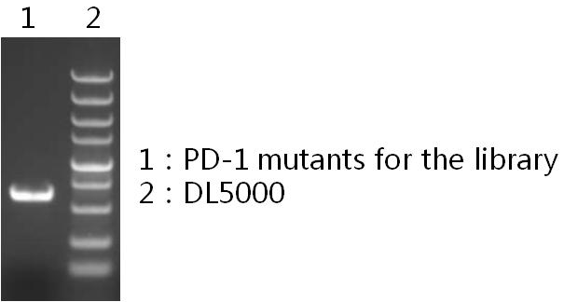
Fig. S1. Electrophenisis data of PD-1 mutants (molecular weight ~650 bp) for the library using overlap PCR.

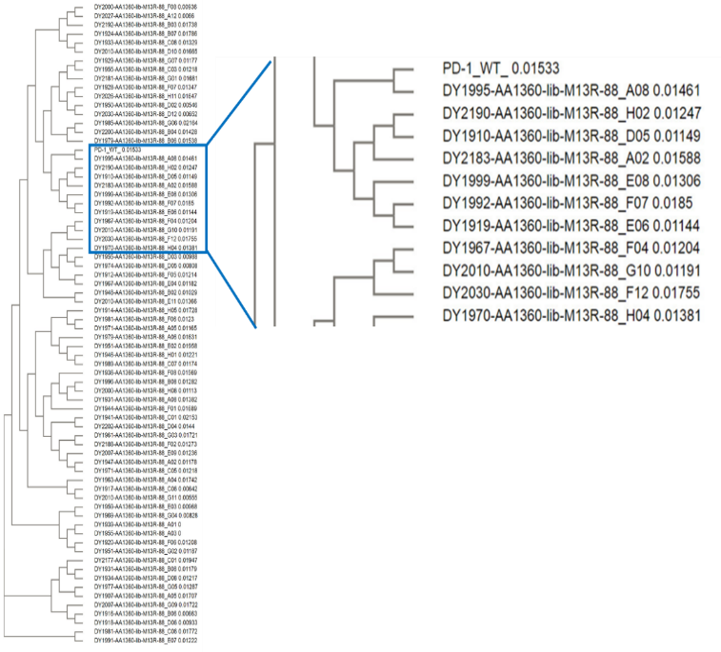
(a)
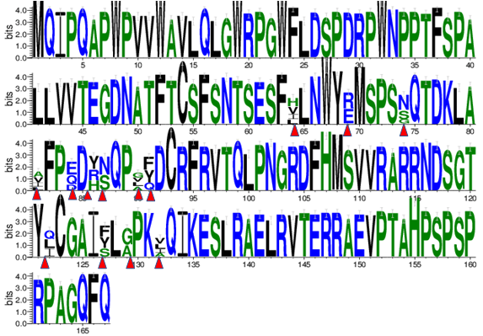
(b)
Fig. S2. The genes of the library varied, indicating the good viability of the sequences in the library. (a) Alignment of sequenced genes from the library; (b) distribution of the designed amino acids in the library.

Fig.S3. ELISA detection of 29 PD-1 mutants bound to PD-L1 or PD-L2. Those clones with enhanced binding capacity were chosen for further identification.

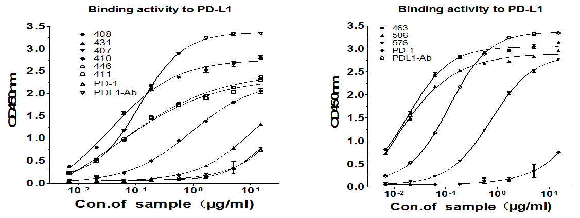
Fig. S4. ELISA detection of nine selected PD-1 mutants to bind to PD-L1 on a dose-dependent manner.

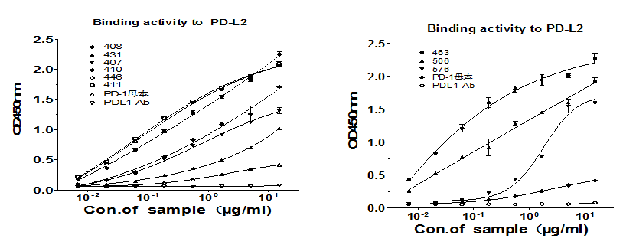
Fig. S5. ELISA detection of nine selected PD-1 mutants to bind to PD-L2 on a dose-dependent manner.

(a)
(b)

(c)

Fig. S6. Nine clones selected from the cell library inhibited PD-1 were found to bind to (a) PD-L1 or (b) PD-L2, as shown by ELISA detection. The nine clones (463, 407, 431, 446, 506, 411, 576, 408, and 410) were screened out because of their higher affinity. The heavy chain and light chain variable genes were amplified and transiently expressed to form full Ig in the 293T cells. The supernatant of the transfected cells was collected, diluted, and incubated with coated (a) PD-L1 or (b) PD-L2 to compete with the WT PD-1. Two mutants, 463 and 506, showed the best inhibition of PD-1 binding to PD-L1. (c) 463 or 506 antagonized with PD-1 to bind to the PD-L1 expressed on the CHO-K1 cell surface. The commercial anti-PD-L1 antibody ATE and the anti-PD-1 antibody Opdivo were set as positive controls. 463 and 506 blocked PD-1 binding to membrane PD-L1 in a dose-dependent manner, and showed similar or even better inhibitory activity in comparison with the positive control antibodies.

Fig. S7. The PD-1 mutant 463, Opdivo, or Atezolizumab inhibited PD-1 (biotin conjugated, 1.25 μg·mL^{–1}) binding to PD-L1 on a dose-dependent manner.

Fig.S8. The PD-1 mutant 463 inhibited PD-1 (biotin conjugated, 1.25 μg·mL^{–1}) binding to PD-L2 on a dose-dependent manner.
Fig. S9. The PD-1 mutant 463 inhibited PD-L1 (biotin conjugated, 5 μg·mL^{–1}) binding to CD80 on a dose-dependent manner.

